1.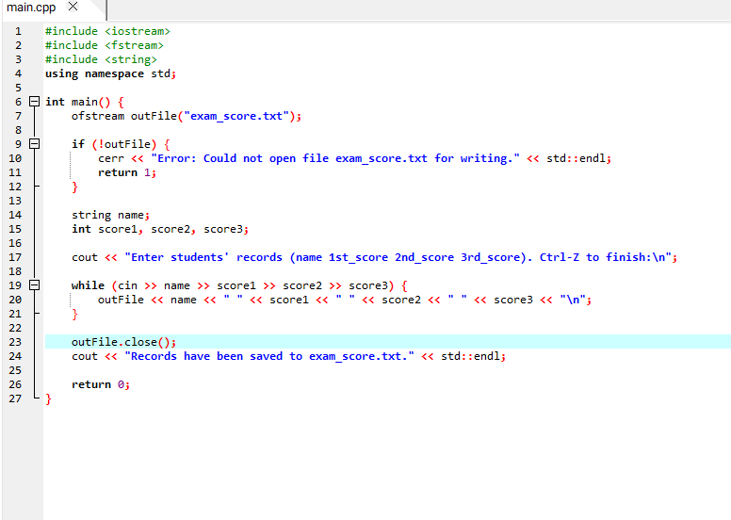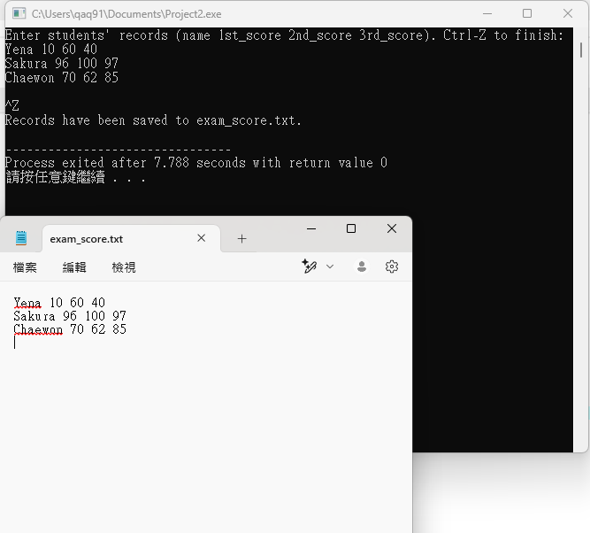
Code
#include <iostream>
#include <fstream>
#include <string>
using namespace std;

int main() {
ofstream outFile("exam_score.txt");

if (!outFile) {
cerr << "Error: Could not open file exam_score.txt for writing." << std::endl;
return 1;
}

string name;
int score1, score2, score3;

cout << "Enter students' records (name 1st_score 2nd_score 3rd_score). Ctrl-Z to finish:\n";

while (cin >> name >> score1 >> score2 >> score3) {
outFile << name << " " << score1 << " " << score2 << " " << score3 << "\n";
}

outFile.close();
cout << "Records have been saved to exam_score.txt." << std::endl;

return 0;
}

2.
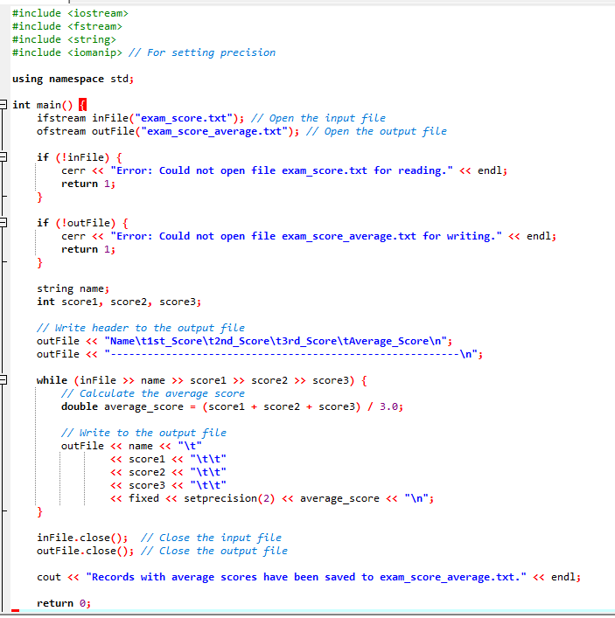
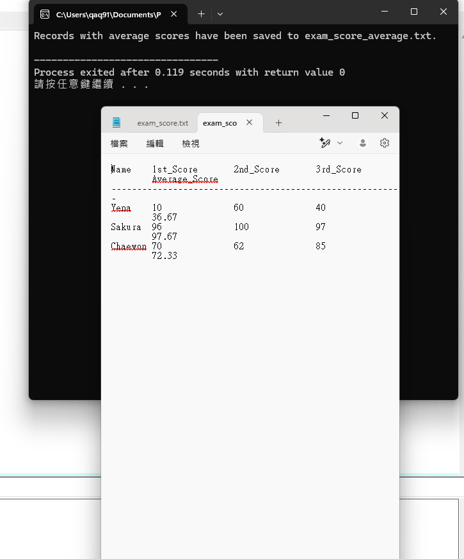
Code

#include <iostream>
#include <fstream>
#include <string>
#include <iomanip>

using namespace std;

int main() {
ifstream inFile("exam_score.txt");
ofstream outFile("exam_score_average.txt");

if (!inFile) {
cerr << "Error: Could not open file exam_score.txt for reading." << endl;
return 1;
}

if (!outFile) {
cerr << "Error: Could not open file exam_score_average.txt for writing." << endl;
return 1;
}

string name;
int score1, score2, score3;

outFile << "Name\t1st_Score\t2nd_Score\t3rd_Score\tAverage_Score\n";
outFile << "---------------------------------------------------------\n";

while (inFile >> name >> score1 >> score2 >> score3) {
double average_score = (score1 + score2 + score3) / 3.0;

outFile << name << "\t"
<< score1 << "\t\t"
<< score2 << "\t\t"
<< score3 << "\t\t"
<< fixed << setprecision(2) << average_score << "\n";
}

inFile.close();
outFile.close();

cout << "Records with average scores have been saved to exam_score_average.txt." << endl;

return 0;
}

