1.
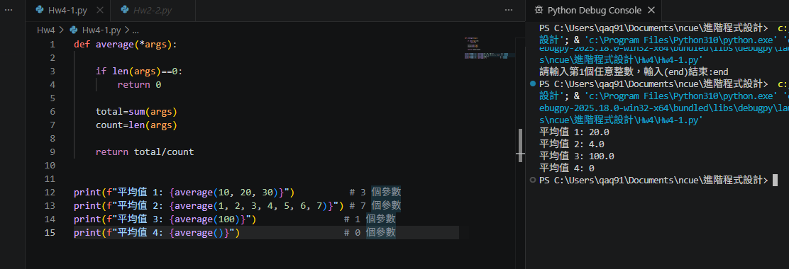
def average(*args):

if len(args)==0:
return 0

total=sum(args)
count=len(args)

return total/count

print(f"平均值 1: {average(10, 20, 30)}") # 3 個參數
print(f"平均值 2: {average(1, 2, 3, 4, 5, 6, 7)}") # 7 個參數
print(f"平均值 3: {average(100)}") # 1 個參數
print(f"平均值 4: {average()}") # 0 個參數

2. 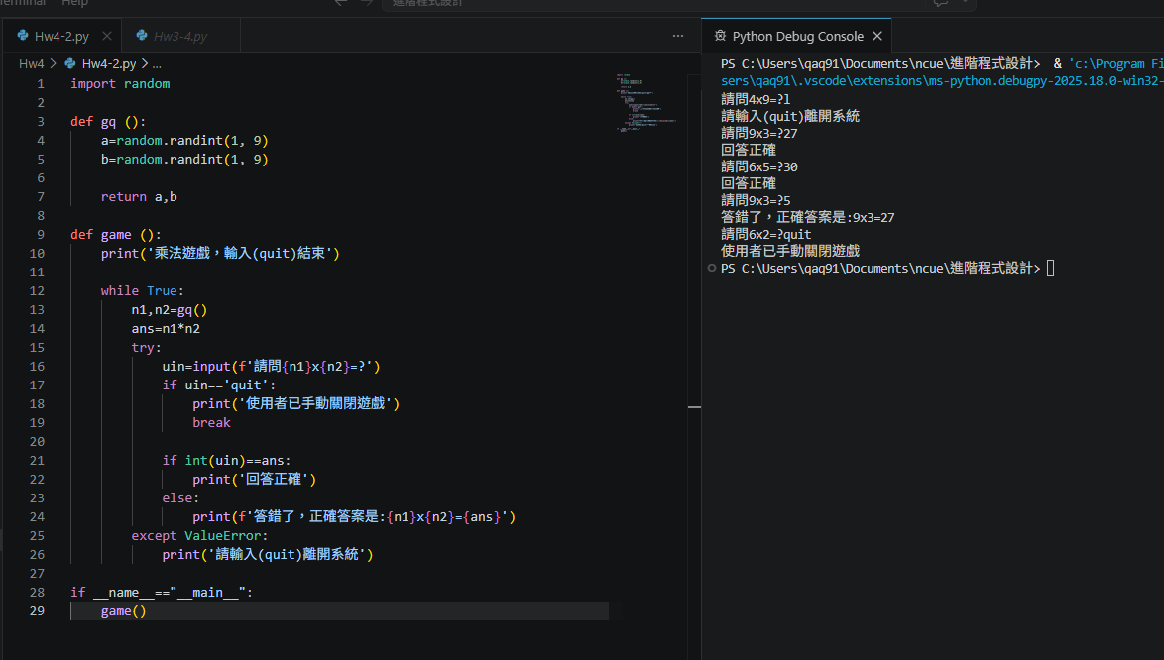
import random

def gq ():
a=random.randint(1, 9)
b=random.randint(1, 9)

return a,b

def game ():
print('乘法遊戲，輸入(quit)結束')

while True:
n1,n2=gq()
ans=n1*n2
try:
uin=input(f'請問{n1}x{n2}=?')
if uin=='quit':
print('使用者已手動關閉遊戲')
break

if int(uin)==ans:
print('回答正確')
else:
print(f'答錯了，正確答案是:{n1}x{n2}={ans}')
except ValueError:
print('請輸入(quit)離開系統')

if __name__=="__main__":
game()

3. 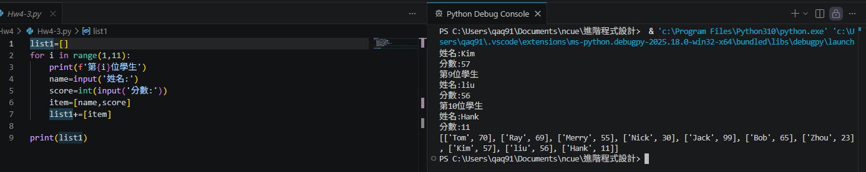

list1=[]
for i in range(1,11):
print(f'第{i}位學生')
name=input('姓名:')
score=int(input('分數:'))
item=[name,score]
list1+=[item]

print(list1)

