1.
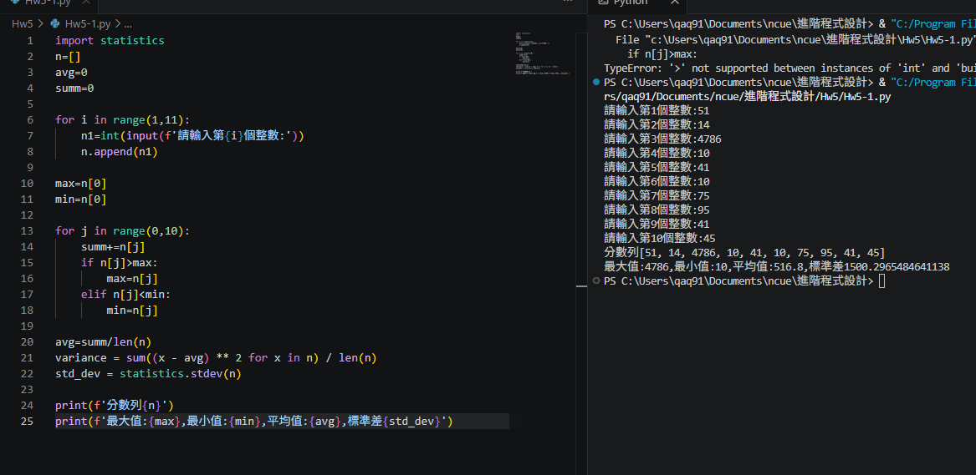
import statistics
n=[]
avg=0
summ=0

for i in range(1,11):
n1=int(input(f'請輸入第{i}個整數:'))
n.append(n1)

max=n[0]
min=n[0]

for j in range(0,10):
summ+=n[j]
if n[j]>max:
max=n[j]
elif n[j]<min:
min=n[j]

avg=summ/len(n)
std_dev = statistics.stdev(n)

print(f'分數列{n}')
print(f'最大值:{max},最小值:{min},平均值:{avg},標準差{std_dev}')

2. 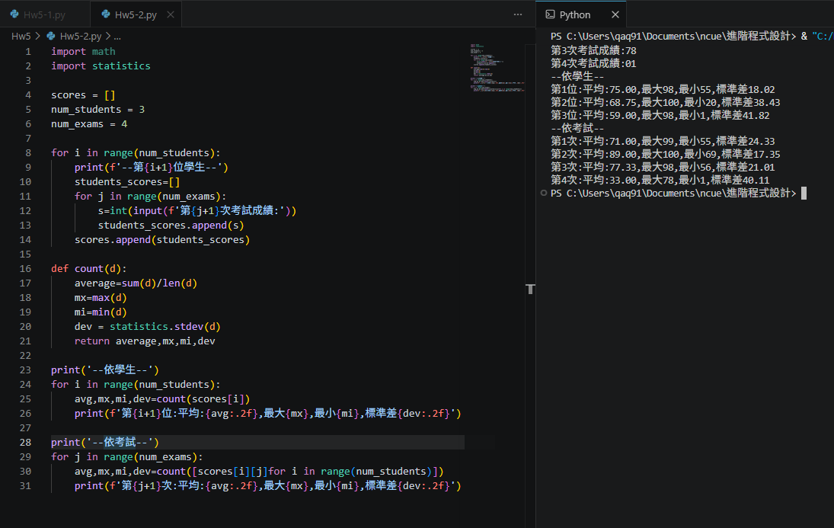
import math
import statistics

scores = []
num_students = 3
num_exams = 4

for i in range(num_students):
print(f'--第{i+1}位學生--')
students_scores=[]
for j in range(num_exams):
s=int(input(f'第{j+1}次考試成績:'))
students_scores.append(s)
scores.append(students_scores)

def count(d):
average=sum(d)/len(d)
mx=max(d)
mi=min(d)
dev = statistics.stdev(d)
return average,mx,mi,dev

print('--依學生--')
for i in range(num_students):
avg,mx,mi,dev=count(scores[i])
print(f'第{i+1}位:平均:{avg:.2f},最大{mx},最小{mi},標準差{dev:.2f}')

print('--依考試--')
for j in range(num_exams):
avg,mx,mi,dev=count([scores[i][j]for i in range(num_students)])
print(f'第{j+1}次:平均:{avg:.2f},最大{mx},最小{mi},標準差{dev:.2f}')

3. 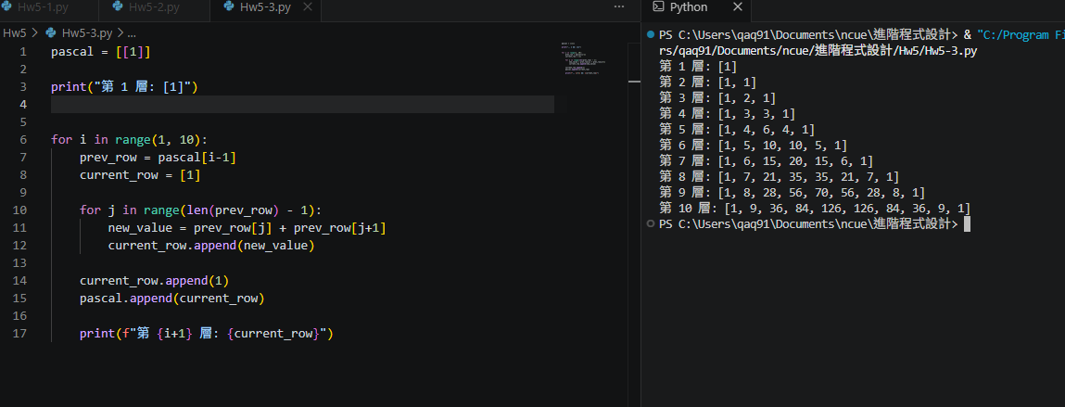

pascal = [[1]]

print("第 1 層: [1]")

for i in range(1, 10):
prev_row = pascal[i-1]
current_row = [1]

for j in range(len(prev_row) - 1):
new_value = prev_row[j] + prev_row[j+1]
current_row.append(new_value)

current_row.append(1)
pascal.append(current_row)

print(f"第 {i+1} 層: {current_row}")

