Week 1 Practical Report
Project Title: Student Task Management System – TaskFlow
During Week 1, our team selected the project topic and decided to develop a student task management website called TaskFlow. The system is designed to help students manage tasks, deadlines and priorities.
We created a GitHub repository and updated the README.md with the basic project information. We also prepared an initial backlog with several user stories, including account registration, login, creating tasks, setting deadlines, updating tasks and marking tasks as completed.
By the end of Week 1, the basic project structure and initial development plan were completed.

Week 2 Practical Report
During Week 2, our team focused on collecting user requirements for the TaskFlow website. We asked target users what features they expected from a student task management system. Most users wanted the website to be simple and easy to use, with functions such as creating tasks, setting deadlines, choosing task priorities, editing tasks and marking tasks as completed.
Based on the feedback, we converted the requirements into user stories. Each user story was given a priority level and an estimated development time. Registration, login, task creation and task completion were considered the highest-priority features because they are essential for the basic operation of the system.
By the end of Week 2, we had a clearer understanding of user needs and a more organised list of requirements to guide the next stage of development.

Week 3 Practical Report – Iteration 1
During Week 3, our team started Iteration 1 of the TaskFlow project. We reviewed the planned user stories and allocated them into different iterations based on priority and estimated development effort.
For Iteration 1, we created a GitHub project board and added the selected user stories. The tasks were organised using labels such as Todo, In Progress, and Done so that the development progress could be monitored clearly.
During this iteration, we also started implementing the selected user stories. At least two user stories were developed and tested, including basic task management functions such as creating tasks and updating task status.
A burn-down graph was also used to monitor the remaining work and show the progress of Iteration 1 over time.
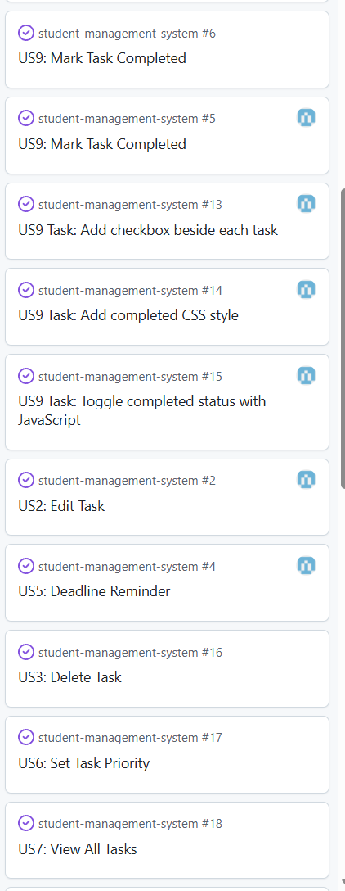
By the end of Week 3, the Iteration 1 tasks had been organised, development had started, and progress was being tracked through GitHub.

Week 4 Practical Report – Iteration 1 Execution & Tracking
During Week 4, our team continued working on Iteration 1 of the TaskFlow project. The main focus was on developing the planned features and tracking the progress of each task.
We divided the user stories into smaller development tasks and estimated the time required for each task. The tasks were monitored using Todo, In Progress, and Done statuses on GitHub. Team members also updated issues and task statuses to make the development progress easier to track.
During development, we created a class diagram to describe the main structure of the system and a sequence diagram to show how important operations, such as user login or task creation, work step by step.
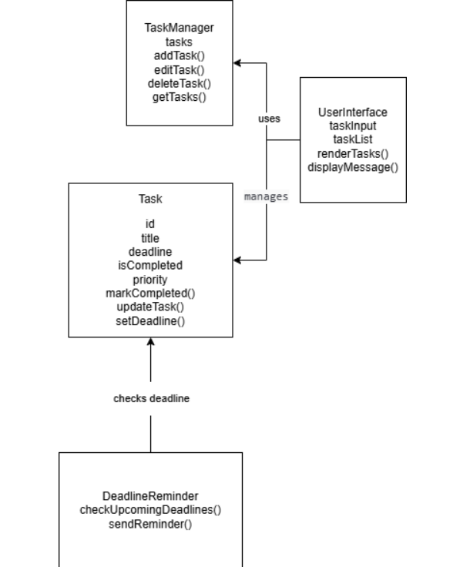
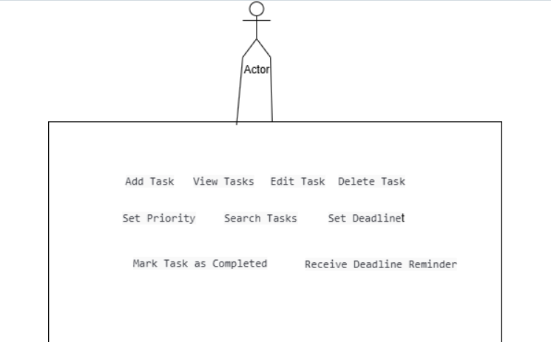
We also continued committing code to GitHub with meaningful commit messages and used GitHub issues to record development tasks and completed features.
By the end of Week 4, the Iteration 1 features had progressed further, and the project tasks were being actively developed and tracked through GitHub.

Week 5 Practical Report – Iteration 1 Reflection
During Week 5, our team reviewed the work completed during Iteration 1 of the TaskFlow project. We checked the code structure and considered whether the implementation followed the Single Responsibility Principle (SRP) and DRY principle. Some repeated code was identified and simplified to improve maintainability.
We also reviewed all user stories and tasks using Todo, In Progress, and Done labels. Completed and unfinished user stories were documented, and the GitHub project information was updated to reflect the final status of Iteration 1.
The team then calculated the actual velocity of Iteration 1 based on the number of completed user stories compared with the planned work.
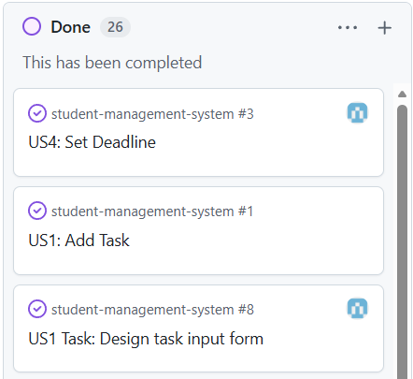
By the end of Week 5, Iteration 1 had been reviewed and documented, and the team identified improvements that could be applied in the next iteration.

Week 6 Practical Report – Iteration 2
During Week 6, our team reviewed the results of Iteration 1 and used the completed work to prepare for Iteration 2. We checked the actual velocity from the previous iteration and reviewed the code structure based on SRP and DRY principles.
The Iteration 1 burn-down graph was reviewed to understand the team’s progress. Based on the previous velocity, we updated the backlog and selected suitable user stories for Iteration 2.
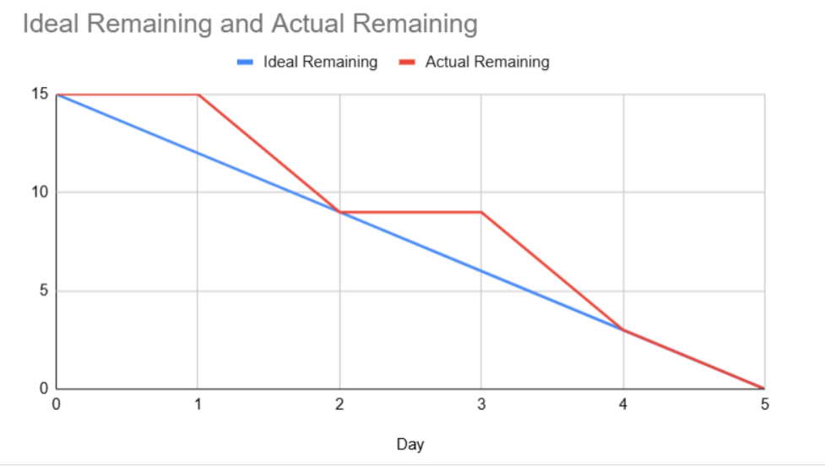
We also organised the Iteration 2 tasks using Todo, In Progress, and Done labels on GitHub. Completed and unfinished user stories were reviewed and the project board was updated for the new iteration.
By the end of Week 6, the Iteration 2 plan had been prepared and the team had a clearer workload based on the progress and velocity from Iteration 1.

Week 7 Practical Report – Iteration 2
During Week 7, our team focused on Test-Driven Development (TDD) and planned the testing strategy for the TaskFlow project. We reviewed the main user stories and identified suitable functions that could be tested automatically.
At least five user stories were selected, including user login, task creation, task completion, task editing and task deletion. For each selected user story, multiple test cases were prepared to check normal inputs, incorrect inputs and expected results.

We also implemented automated tests for the project. The tests were used to check important functions and confirm that the system behaved correctly after code changes.
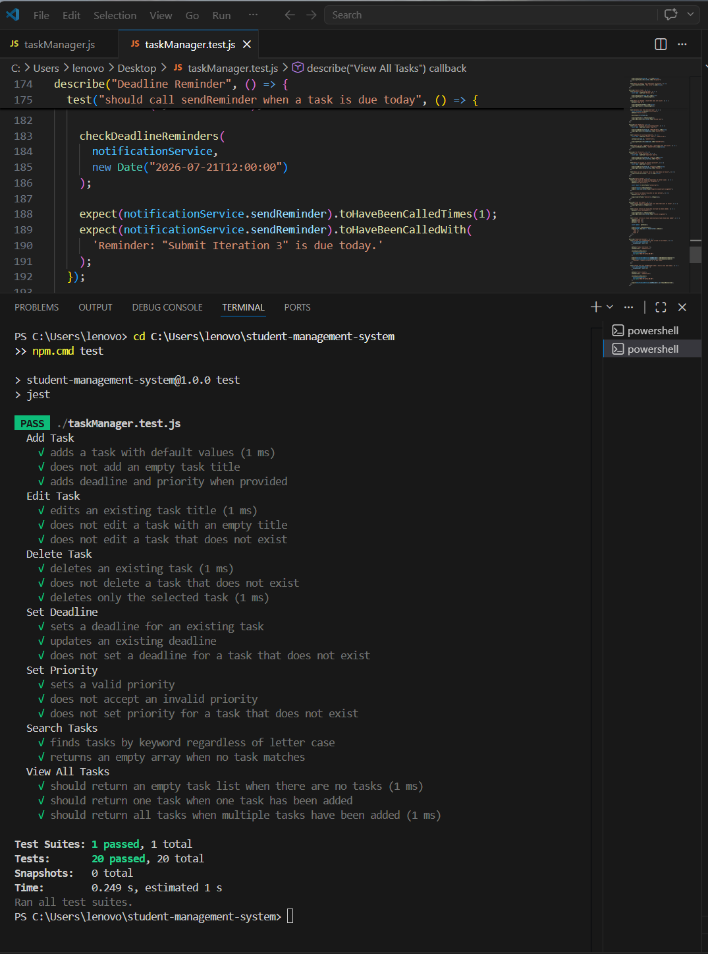

By the end of Week 7, the testing plan had been documented and automated testing had been added to improve the reliability of the TaskFlow system.

Week 8 Practical Report – Iteration 3
During Week 8, our team started Iteration 3 and continued practising Test-Driven Development. We reviewed the results of Iteration 2, calculated the actual velocity, and used this inform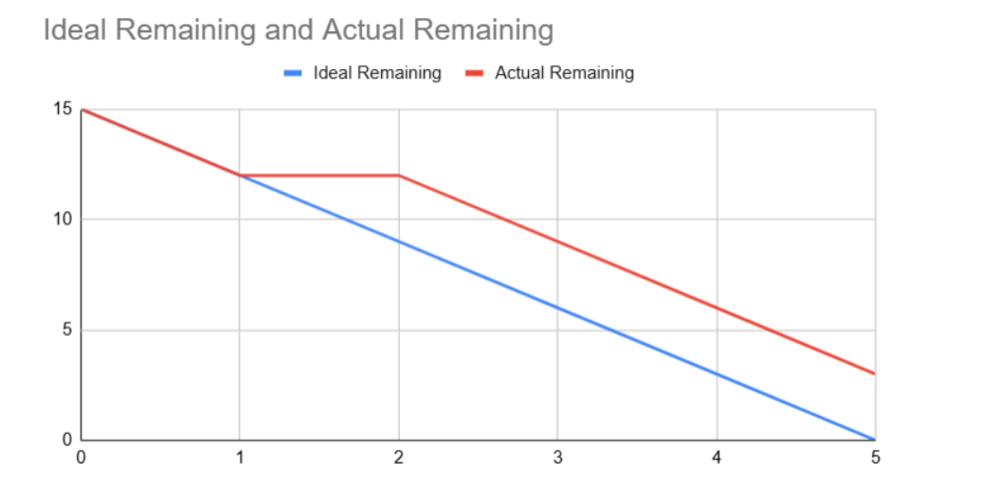ation to update the backlog and plan the work for Iteration 3.

We also used the user stories and UI designs as test specifications. Tasks were monitored using Todo, In Progress, and Done labels. In addition, we researched the use of mock objects and explored how mock objects could simulate functions such as user login during testing.
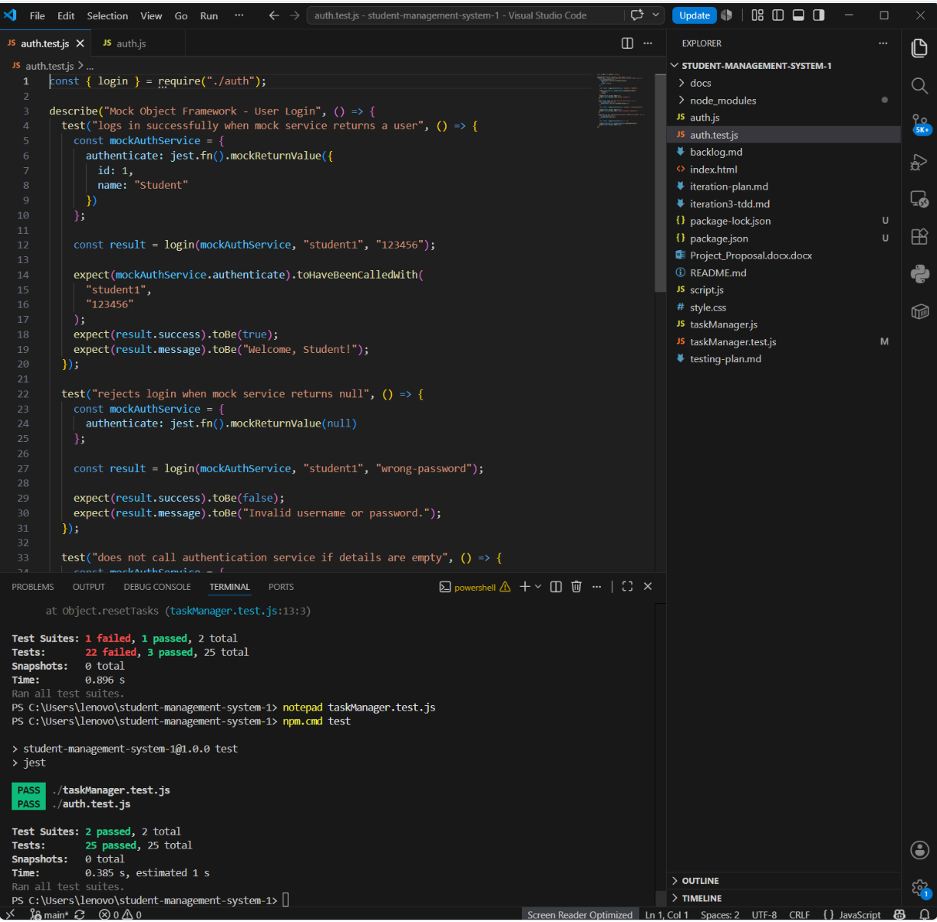
By the end of Week 8, Iteration 3 had been planned and testing activities were integrated further into the development process.

Week 9 Practical Report – Bug Tracking and System Testing
During Week 9, our team focused on bug and error tracking for the TaskFlow project. We reviewed issues discovered during system testing and used GitHub Issues to record, monitor, and update bugs.
Each issue included a description of the problem and its current status. We also reviewed completed user stories and updated the GitHub project board where necessary.
A system testing plan was prepared for the final demonstration. The plan included testing important functions such as registration, login, task creation, task editing, task completion, and task deletion.
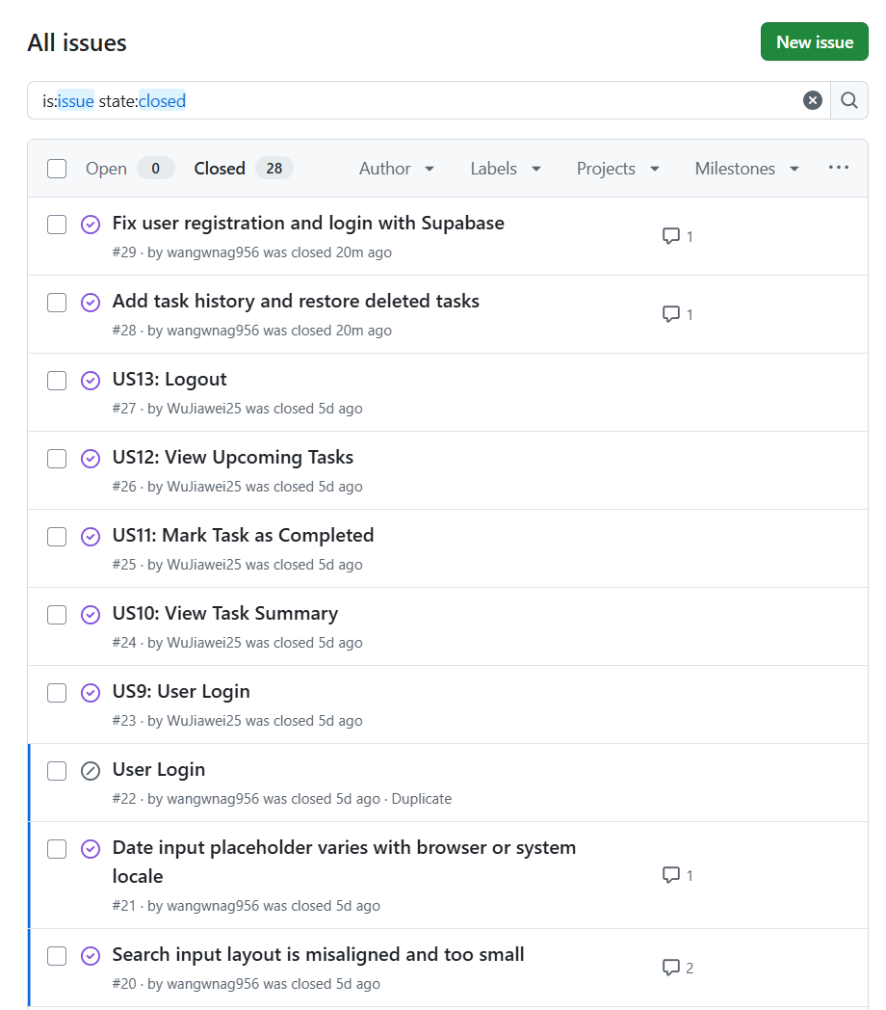
By the end of Week 9, the main bugs had been documented and the system testing plan was prepared for the final demonstration.

Week 10 Practical Report – Final Demonstration
During Week 10, our team completed the final stage of Iteration 3 and prepared the TaskFlow project for demonstration.
The completed website was demonstrated during the practical class. The demonstration included the main functions of the system, such as user registration and login, creating tasks, setting deadlines and priorities, completing tasks, editing tasks, and managing deleted tasks.
We also reviewed the marking rubric and checked that the required project documentation, testing evidence, GitHub activities, and implemented features were included.
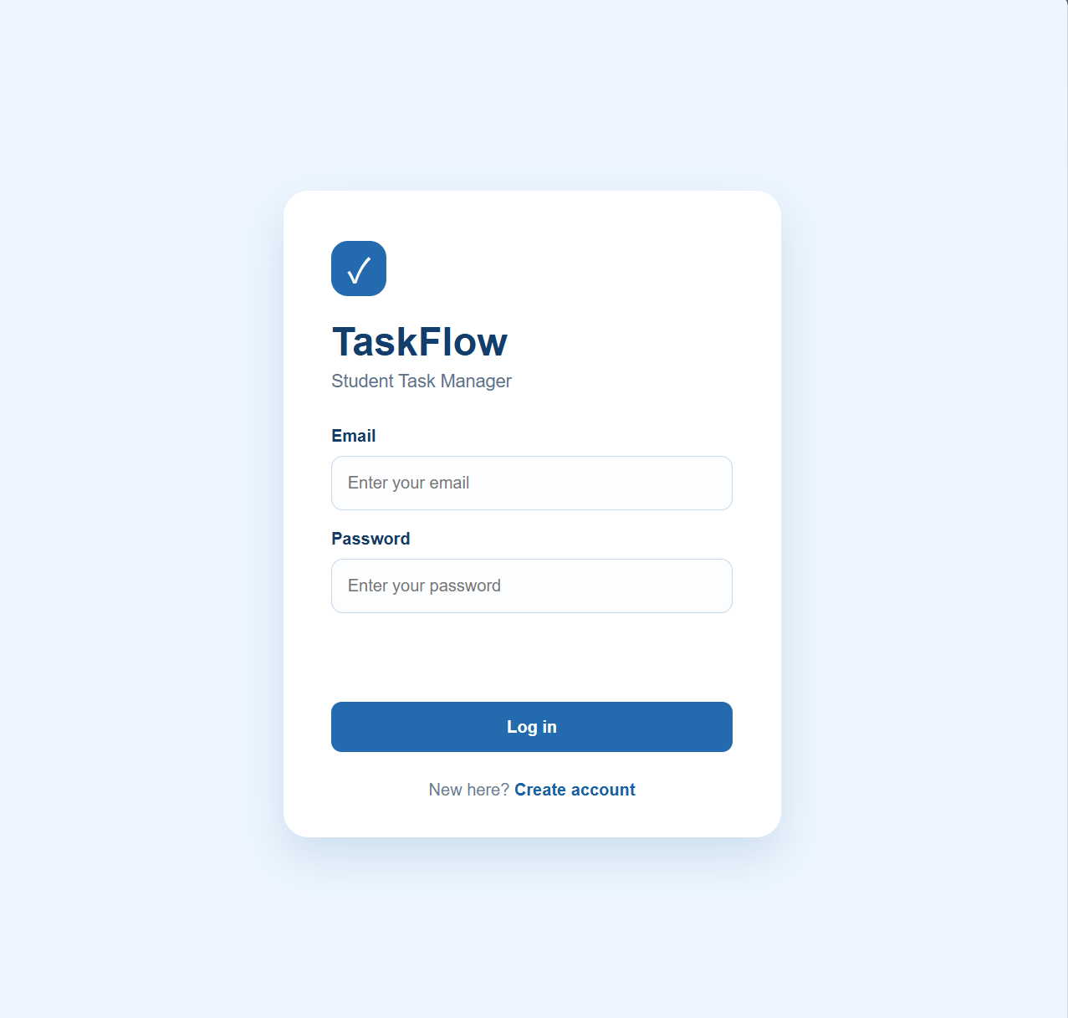
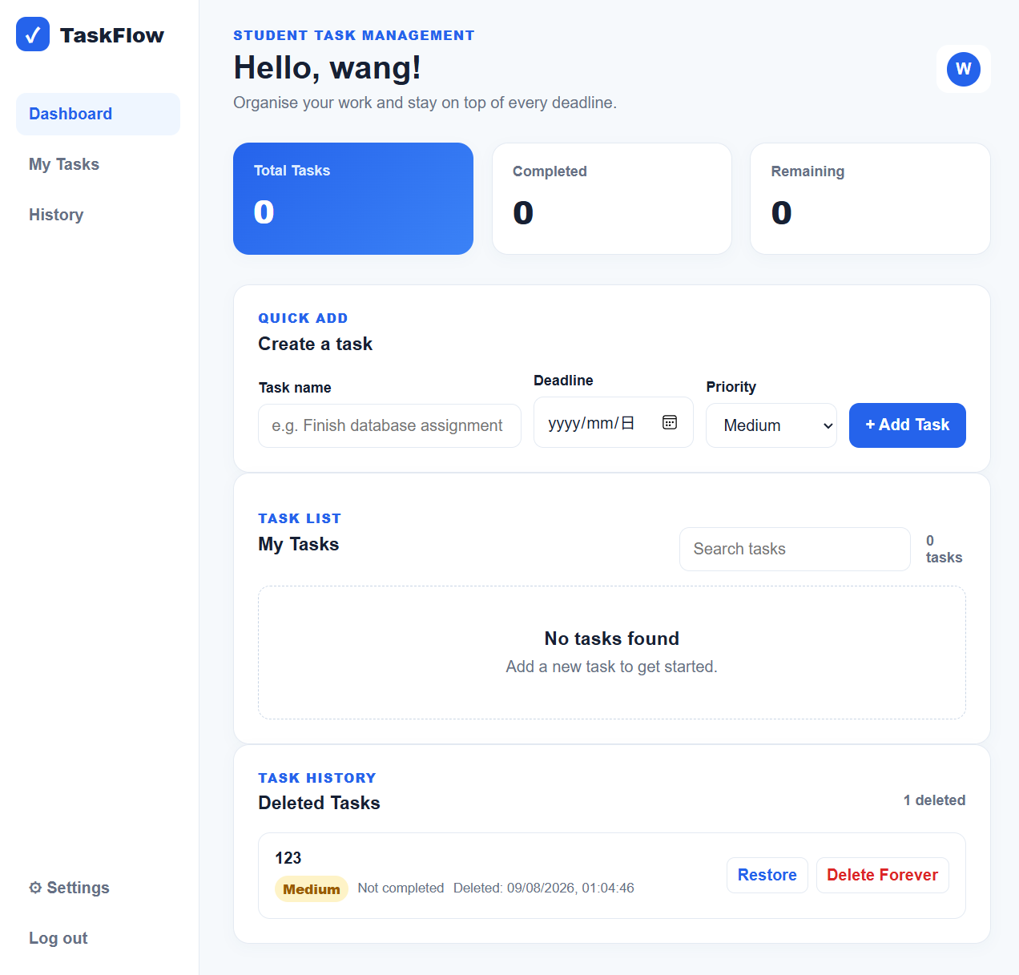
By the end of Week 10, the project had been demonstrated and the final report and project evidence were reviewed for submission.

