RGB to YCrCb
Down sample

Jerror.c : contains simple error-reporting and trace-message routines
Cdjpeg.h : common decls for cjpeg/djpeg applications
jidctred.c: Inverse-DCT Routine
jcapistd.c: jpeg compressor API stdandard
jmemmgr.c：contains the JPEG system-independent memory management routines.

http://en.wikipedia.org/wiki/Truevision_TGA
Truevision TGA, often referred to as TARGA, is a raster graphics file format created by Truevision In
重要概念:
NB:Nota Bene, note well
MCU: Minimum coded unit
Back link
Four distinct modes of operation: sequential DCT-based, progressive DCT-based, lossless and hierarchical.
Entropy encoder:

主要数据结构
jpeg_compress_struct:压缩实例的数据结构
cjpeg_source_struct:压缩操作的数据源
Create Compressor
(jpeg_create_compress)
Default parameter setup for compression
(jpeg_set_defaults)

函数说明:
jsimd_rgb_ycc_convert_sse2:源文件jcclrss2.asm

Q: rdbmp.c中的source->whole_image->mem_buffer到底在哪实现的
A:通过调用函数request_virt_sarray将新的jvirt_sarray_control节点加入到链表
cinfo->mem->virt_sarray_list中去。

Q:jmemmgr.c中的函数access_virt_sarray的功能是什么
access_virt_sarray (j_common_ptr cinfo, jvirt_sarray_ptr ptr,
JDIMENSION start_row, JDIMENSION num_rows,
boolean writable)
返回
ptr->mem_buffer + (start_row - ptr->cur_start_row)
这里ptr->cur_start_row指的是jvirt_sarray的起始逻辑行号。

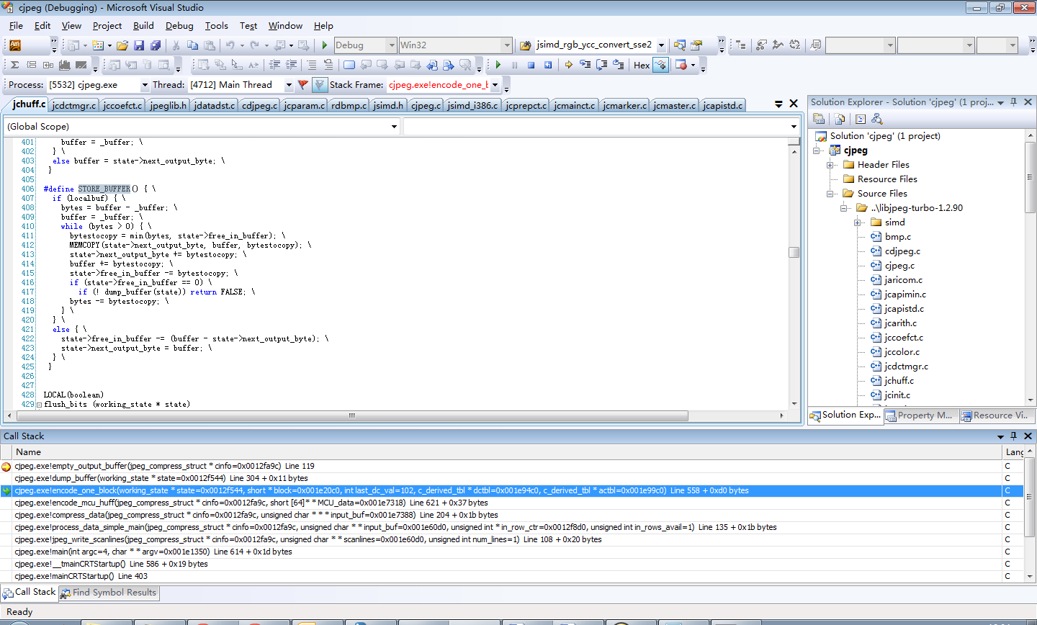
写入JPEG数据到文件中去
jpeg_start_compress
+->jinit_compress_master
+->realize_virt_arrays

jpeg_write_scanlines
+-> pass_startup[jcmaster.c]
+->process_data_simple_main [jcprepct.c]
+-> pre_process_data[jcmainct.c]
+->compress_data[jccoefct.c]
+->forward_DCT[jcdctmgr.c]
+-> jsimd_convsamp[]
+-> jsimd_convsamp_sse2
+-> jsimd_fdct_islow
+-> jsimd_fdct_islow_sse2
+-> jsimd_quantize
+-> jsimd_quantize_sse2

+->encode_mcu_huff[jchuff.c]
+->encode_one_block[jchuff.c]

METHODDEF(void)
process_data_simple_main (j_compress_ptr cinfo,
JSAMPARRAY input_buf, JDIMENSION *in_row_ctr,
JDIMENSION in_rows_avail)

bitmap最后一行末尾的数据
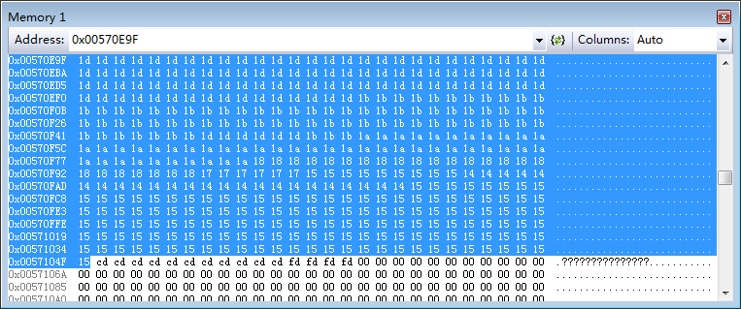
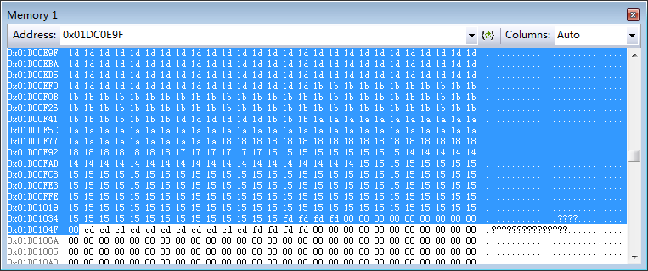

最后一行像素的起始数据
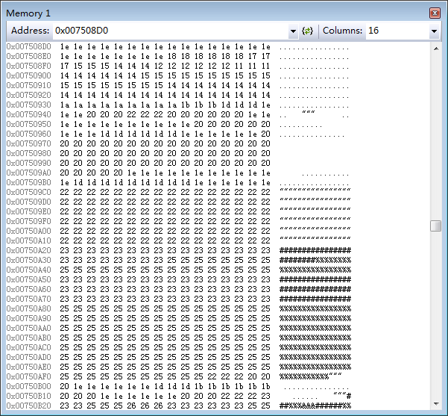
Jchuff.c写入JPEG数据流。
LOCAL(boolean)
dump_buffer (working_state * state)
/* Empty the output buffer; return TRUE if successful, FALSE if must suspend */
{
struct jpeg_destination_mgr * dest = state->cinfo->dest;

dest->free_in_buffer = state->free_in_buffer;

if (! (*dest->empty_output_buffer) (state->cinfo))
return FALSE;
/* After a successful buffer dump, must reset buffer pointers */
state->next_output_byte = dest->next_output_byte;
state->free_in_buffer = dest->free_in_buffer;
return TRUE;
}

METHODDEF(boolean)
empty_output_buffer (j_compress_ptr cinfo)
{
my_dest_ptr dest = (my_dest_ptr) cinfo->dest;

if (JFWRITE(dest->outfile, dest->buffer, OUTPUT_BUF_SIZE) !=
(size_t) OUTPUT_BUF_SIZE)
ERREXIT(cinfo, JERR_FILE_WRITE);

dest->pub.next_output_byte = dest->buffer;
dest->pub.free_in_buffer = OUTPUT_BUF_SIZE;

return TRUE;
}

Jcmarker.c
LOCAL(void)
emit_byte (j_compress_ptr cinfo, int val)
/* Emit a byte */
{
struct jpeg_destination_mgr * dest = cinfo->dest;

*(dest->next_output_byte)++ = (JOCTET) val;
if (--dest->free_in_buffer == 0) {
if (! (*dest->empty_output_buffer) (cinfo))
ERREXIT(cinfo, JERR_CANT_SUSPEND);
}
}

METHODDEF(void)
write_frame_header (j_compress_ptr cinfo)

cinfo->quant_tbl_ptrs在何处赋值？
jpeg_set_quality
+->jpeg_set_linear_quality
+->jpeg_add_quant_table

Jccoefct.c
Compress_data

Jcdctmgr.c

METHODDEF(void)
forward_DCT (j_compress_ptr cinfo, jpeg_component_info * compptr,
JSAMPARRAY sample_data, JBLOCKROW coef_blocks,
JDIMENSION start_row, JDIMENSION start_col, JDIMENSION num_blocks)
Jchuff.c
METHODDEF(boolean)
encode_mcu_huff (j_compress_ptr cinfo, JBLOCKROW *MCU_data)

霍夫曼编码核心函数
边编码边输出
LOCAL(boolean)
encode_one_block (working_state * state, JCOEFPTR block, int last_dc_val,
c_derived_tbl *dctbl, c_derived_tbl *actbl)

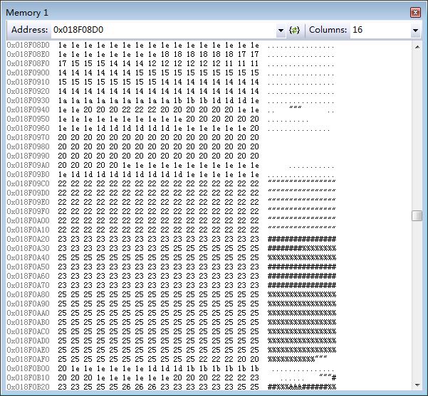

Tubojpeg.h中有自turbojpeg.dll导出的JPEG编码和解码函数声明。
Turbojpeg.c 函数tjCompress2将RGB数据

