Name: Xiaoyou Wang
Andrew ID: xiaoyouw

18-756 Coursework 1 Answer sheet

Please keep any code change descriptions and explanations (in this document) to under 10 lines – the code comments and structure should allow the TA to easily see what you have done. Also, remember to comment in your source code where you have made changes. Example:
On answer this sheet: “
Ex1)
Explanation: I changed the SONETRouter.receiveFrame to start a fire when it receives a frame. I did this using if(receive==true) and the .setIsOnFire(true)
Code:
//Added question 1.h) onFire code below
public SONETRouter.receiveFrame(){
// check that we did receive a frame
If(receive==true){
// as we have received a frame set the datacenter on fire, and update the isOnFire variable
this.startFire();
this.setIsOnFire(true);

// Do the next thing
….
}
}”

ANSWERS

1.a)
Explanation:
I filled the method SONETRouter.receiveFrame with code to deal with each received SONETFrame. If the wavelength of the frame belongs to the router’s drop frequencies, then forward the frame to sink method. If not, send it out using sendRingFrame method.
Code:
public void receiveFrame(SONETFrame frame, int wavelength, OpticalNICTA nic){
// check if the wavelength is in the dropFrequency, if yes forward it to the sink, if not send it out
if(this.dropFrequency.contains(wavelength)) {
sink(frame, wavelength);
} else {
sendRingFrame(frame, wavelength, nic);
}
}

1.b)
Explanation:
Because router1 send the frame out via all the interfaces it has. Router1 has two links to router2, so the frame arrive at router2(88:77:66) twice.

1.c)
Explanation:
“00:11:22 has received a frame at the sink on wavelength 1310 frame delay: 0 SPE delay: 0” will happen.
Because the drop frequency of router1 is 1310. So if router1 creates a frame of frequency set to 1310, then the frame will be forwarded to the sink method and be taken off the line immediately.

1.d)
Explanation:
I called frame.addDelay(5) in the last condition of OtoOLink.sendData(). And then finish the addDelay function in both SPE.java and SONETFrame.java.
Code:
public void sendData(SONETFrame frame, int wavelength, OpticalNICTA source){
……
else{
//add delay of 5 each time
frame.addDelay(5);
frame.getSPE().addDelay(5);
this.dest.receiveData(frame, wavelength);
}
}
public void addDelay(int delay){
this.delay += delay;
}

1.e)
Explanation:
I finished the SPE.clone() function by create a new SPE with the same VTPointer and delay. Then I modified the SONETRouter.sendRingFrame function by sending out newly created frames containing a copy of the SPE object.
Code:
public SPE clone(){
//create a new SPE with the same VTPointer and delay
SPE newSpe = new SPE(this.getVTPointer());
newSpe.delay = this.delay;
return newSpe;
}
public void sendRingFrame(SONETFrame frame, int wavelength, OpticalNICTA nic){
for(OpticalNICTA NIC:NICs)
if(NIC.getIsOnRing() && !NIC.equals(nic)) {
//send out the copy of the frame and SPE
NIC.sendFrame(new SONETFrame(frame.getSPE().clone()), wavelength);
}
}

1.f)
Explanation:
I added the prejudgment code in the SONETRouter.receiveFrames function. If the frequency of the frame is not in destinationFrequencies object, then the frame will be jonored.
Code:
public void receiveFrame(SONETFrame frame, int wavelength, OpticalNICTA nic){
// check if the frequency is in destinationFrequencies object
if(!this.destinationFrequencies.containsValue(wavelength))
return;
……
}

2.a)
Explanation:
I created three routers, added new destination and frequency in each routers and added NICs and links among them to create the ring topology.
Code:
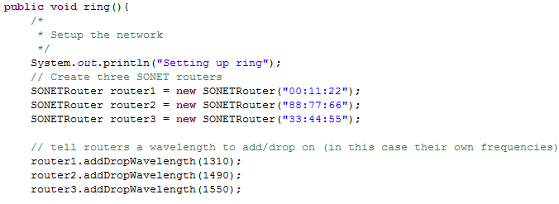
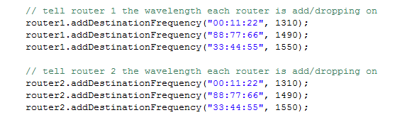
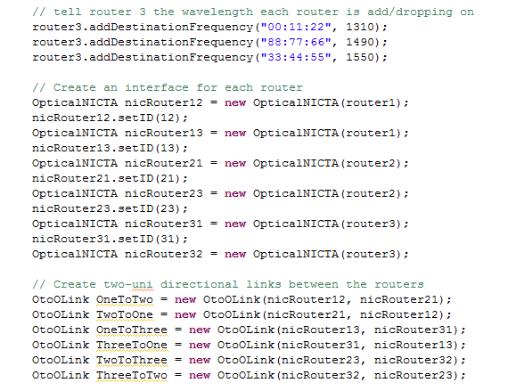

2.b)
Explanation:
According to 1.d and 1.e, each time the SPE travels over a link, the delay of Frame and SPE will be added 5. Each time the frame is sent out in a router, the frame is newly created with a cloned SPE. So the delay of Frame remains 5 unchanged. The delay of SPE is accumulated through the travel.
One of the frame is forwarded directly from 00:11:22 to 88:77:66, travelling over one link. So the delay of SPE is 5.
Another frame is forwarded with the path 00:11:22 -> 33:44:55 -> 88:77:66, travelling over two links. So the delay of SPE is 10.

2.c)
Explanation:
I just created two sets of routers, NICs and links as those in 2.a.

2.d)
Explanation:

Code:

Grade: / 40 /40 /20 /100

