Design Documentation of IRC Server (Final)
10302010023 Wang Xin

Brief Introduction
The standalone IRC server is a central server in the IRC network. It was designed to handle the instructions from the clients and transmit the appropriate messages in response. The project was mainly implemented in C language using library functions declared in “csapp.h”. It has been tested valid in Linux Debian 2.6.32(gcc 4.4.5) and Linux Ubuntu 3.5.0(gcc 4.4.7).

Data structure
Until now the server introduces three data structures: client, client pool and channel according to the need of the server, which are both defined in sircd.h. Here is the overview of the three structs(Figure 1).
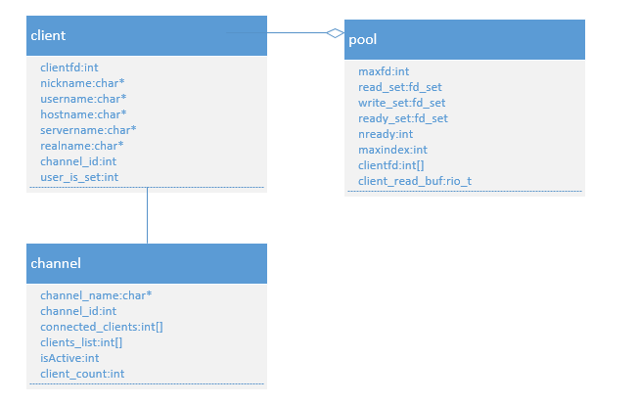
Figure 1 Structs

Client
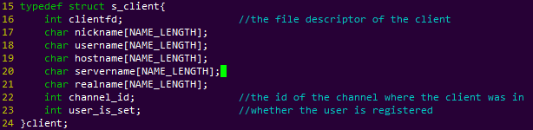
Figure 2 Client

Pool
The client pool was used to store the client in this session.
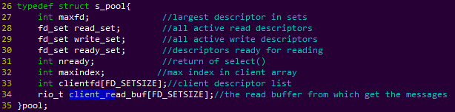
Figure 3 Pool

Channel
In this IRC server, a client can only join one channel. Joining in a new channel means departure from the old one. The channel uses a bit-vector to manage the connection state of each client. When the last client leaves the channel, the channel is no longer active and should be deleted from the global channel list.
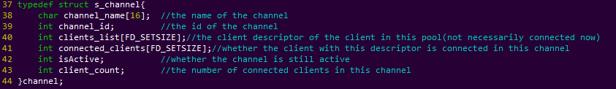
Figure 4 Channel

Process
Here is the overall process of the server(Figure 5).
- The server first create a socket descriptor (typically 3) and bind the socket descriptor with a local protocol. Then listen on the descriptor and get ready to accept connection requests. These are compacted in the function Open_listenfd(). Some global variables such as client_pool, global_client_queue and global_channel_list was initialized.
- Use function Select() to get the ready descriptor set. If the listening descriptor was ready for read, use function Accept() to create a socket descriptor for a new client (the first was typically 4).
- Add the new client to the client pool.
- Read the commands from each client, check the type and format of each commands and echo the appropriate message. The server will distinguish the commands according to the first several letters and check the parameter list, then dispatch the different commands to the corresponding handler.
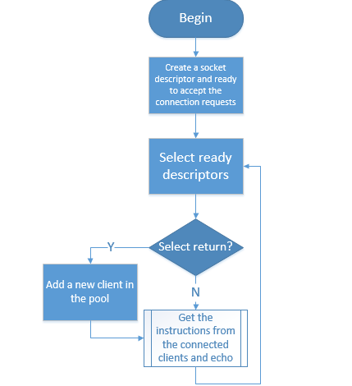
Figure 5 Overall Process

NICK
Command: NICK
Parameters: <nickname> [ <hopcount> ]

NICK message is used to give user a nickname or change the previous one. According to the protocol defined in RFC1459, the nickname should be unique and the operation should only be valid to registered users, however, to unregistered users, the server still set the nickname just without the success message (Figure 6). The length of all names (including nickname, hostname, servername, channel_name, etc.) was restricted less than 32.
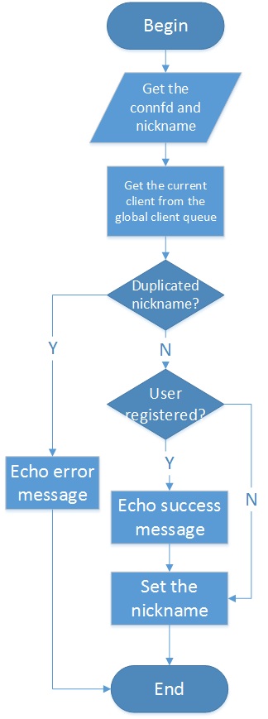
Figure 6 NICK

USER
Command: USER
Parameters: <username> <hostname> <servername> :<realname>

According to RFC1459, the USER message is used at the beginning of connection to specify the username, hostname, servername and realname of a new user. It is also used in communication between servers to indicate new user arriving on IRC, since only after both USER and NICK have been received from a client does a user become registered.

QUIT
Command: QUIT
Parameters: NULL

A client session is ended with a quit message. The server closes the connection to a client which sends a QUIT message. If a "Quit Message" is given, this will be sent instead of the default message, the nickname. The server must inform other users of the client's departure by echoing the QUIT command to all users sharing channels with the departing client, in the same manner as for a nickname change.

JOIN

Command: JOIN
Parameters: <channel>{,<channel>}

The JOIN command is used by client to start listening a specific channel. If the user is already on the channel, the message is silently ignored. Joining a new channel should implicitly cause the client to leave the current channel (Figure 7). If the channel does not exist, it is created automatically. The leaving step must precede the creation step, for the global channel list was a single-direction linked list.
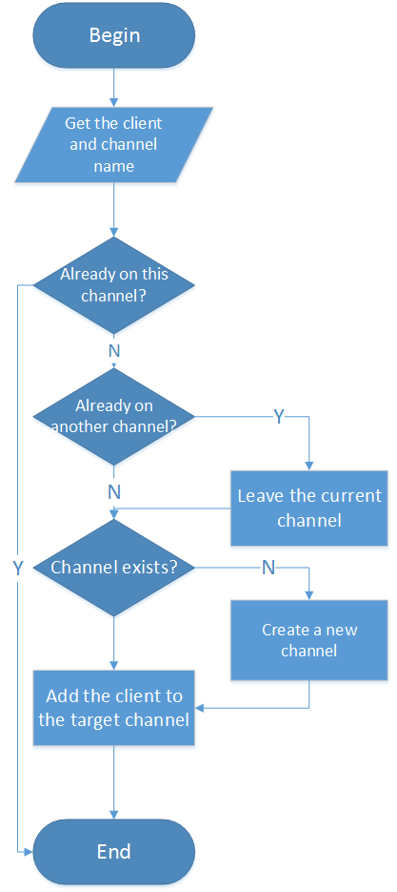
Figure 7 JOIN

PART
Command: PART
Parameters: <channel>{,<channel>}

The PART message causes the client sending the message to be removed from the list of active users for all given channels listed in the parameter string (Figure 8).
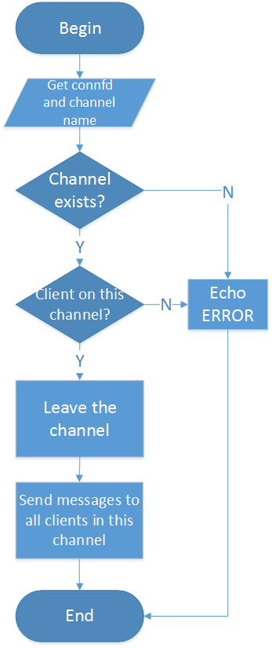
Figure 8 PART

LIST
Command: LIST
Parameters: NULL

According to RFC1459, the list message is used to list channels and their topics. If the <channel> parameter is used, only the status of that channel is displayed. Otherwise, list all channels. In this design, the server just simply ignore all parameters and list all channels to the client.

PRIVMSG
Command: PRIVMSG
Parameters: <target>{,<target>} <text to be sent>

PRIVMSG is used to send private messages between users. <target> is the nickname of the receiver of the message. <target> can also be a list of names or channels separated with commas (Figure 9). The length of messages was restricted less than 512.

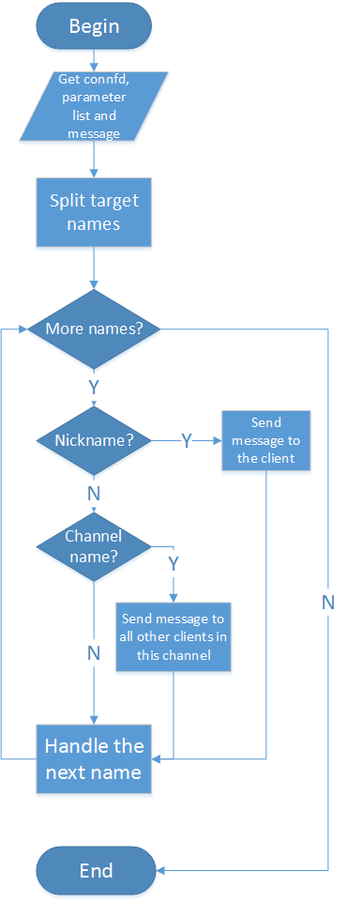
Figure 9 PRIVMSG

WHO
Command: WHO
Parameters: [<channel_name>]

The WHO message is used by a client to generate a query which returns a list of information which 'matches' the <name> parameter given by the client (Figure 10).
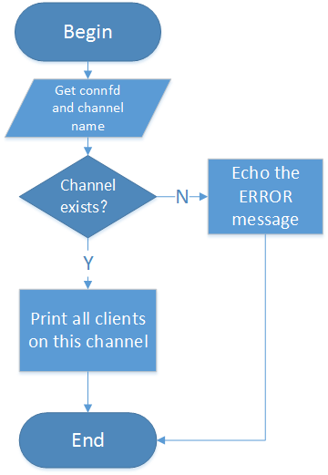
Figure 10 WHO

Verbosity
For debug use, I also set the verbosity level switch. “./sircd 1 node.conf –v <verbosity_level>” will print some vital debug information of the server, otherwise the server will run silently (Table 1).
Verbosity level | behavior
0 | Run silently
1 | Print logging of users with signed on
2 | Print logging of users, channels, messages
Table 1 verbosity level

