‘A Fine Balance’: Exploring the Interplay of Reproductive Strategies and Growth Dynamics in Trees

Xiaomao Wang April 28, 2025

# Introduction

The fundamental processes in a plant’s life cycle—growth, reproduction, defense—all compete for the same resources. Plants must apply trade-offs to maximize their fitness when resources are limited. One of the most significant of these is the growth-reproduction trade-off, which is influenced by both environmental conditions and a plant’s life history strategy (Grime, 1977; Stearns, 1998). In resource-rich environments, plants are able to allocate resources both to rapid growth and reproduction, while in resource-poor environments, plants often face a decision: they can either allocate resources to growth, ensuring their long-term survival, or they can invest in reproduction, which may come at the expense of growth (Bazzaz, 1997). This trade-off can lead to high variability in reproduction across years, which is manifested as mast seeding, an important reproductive strategy for many plant species (Pearse *et al.*, 2016).

Mast seeding is the phenomenon of synchronized and variable seed production within plant pop- ulations. It determines regeneration within a population and is closely related to ecosystem-level functions that influence processes such as seed dispersal, predation and plant recruitment, since seeds can be food resources for many mammals or hosts for pathogens (Davies & MacPher- son, 2024; Janzen, 1971; Kelly, 1994). Mast seeding is widely observed in wind-pollinated tree species, but also occurs in *Poaceae* as well as *Diperocarpaceae* (Kelly & Sork, 2002). Although there are several hypotheses explaining the potential mechanism selecting for mast seeding (e.g., predator satiation, resource matching, etc., discussed more in Chapter 2, Koenig, 2021), the

exact environmental factors that trigger it in different species and ecosystems are not fully un- derstood. Current data suggest that it is mainly driven by specific climatic conditions that cause synchronized reproductive efforts of the species at population level (Pearse *et al.*, 2016).

Research on masting has often focused on its unique features, which make it distinct from annual fluctuations in seed production of non-masting species—specifically its interannual variation, synchrony, temporal autocorrelation, and frequency (Hacket-Pain & Bogdziewicz, 2021). While annual fluctuations in seed production for non-masting species are generally more closely tied to short-term environmental factors (or may appear random), interannual variation in masting is not entirely random or caused by immediate environmental conditions; instead it should be synchronous across large spatial areas (e.g., hundreds of kilometers, Kelly, 1994), and show distinct temporal autocorrelation, where a mast year is typically followed by several years of low or no seed production. Finally, mast years often occur at a certain frequency, with some species exhibiting a more fixed interval (e.g., every 2-3 years) and others a more irregular pattern (e.g., 2-5 years).

Masting plays an important ecological role by influencing seed dynamics and broader ecosystem processes. According to the predator satiation hypothesis, mast years overwhelm seed predators by producing abundant seeds, ensuring that some seeds will survive and germinate. In this way, plants can regulate predator populations and enhance seedling establishment. Mast seeding also contributes to the creation of seed banks for some species, which provide a reserve of seeds that help the population buffer against environmental variability, allowing seeds to wait for favorable conditions to germinate (Venable, 1989). This strategy not only improves seedling survival in the short term but also promotes long-term regeneration, helping to maintain a plant population over time.

Ongoing anthropogenic climate change is extending growing seasons, shifting precipitation pat- terns, and likely making environmental variability less predictable (Calvin *et al.*, 2023). These changes may influence the balance of the growth-reproduction trade-off through altered plant resource availability and consequently, masting behavior, which will not only affect the forest population dynamics itself, but also the seed predator community that relies on the forests. Understanding how these dynamics function, and the role that climate plays, is critical for pre- dicting future forest composition and natural regeneration, but the complexity of masting has slowed progress. Currently, we lack a comprehensive model to predict how climate change will af-

fect masting that includes the relationship between growth and reproduction, and can make predictions across different species and ecosystems.

The aim of my thesis is to investigate how masting as a reproductive strategy is related to the growth dynamics of tree species and their role in forest ecosystems, particularly in the context of climate change. Using Mount Rainier as a case study, my proposed research will address three key questions: (1) Which reproductive traits are associated with masting? Addressing this will help to potentially identify what triggers masting across species, and in different environments.

(2) Is there a detectable trade-off between mast seeding events and tree growth? (3) How will changing climate conditions affect seed dynamics? Answering these questions will contribute to our understanding of how masting shapes the growth and regeneration dynamics of coniferous forests in Mount Rainier, with inference on how masting dynamics might be related to growth and environmental changes in other coniferous forests.

# Explore which reproductive traits are relevant to masting

Masting is widely observed across different plant lineages in different biomes, with several ma- jor hypotheses for how masting could yield fitness benefits, compared to reproducing every year (Koenig, 2021; Waller, 1979). The most commonly accepted hypothesis for masting is the predator satiation hypothesis, which suggests that masting overwhelms seed predators with a large seed crop in one year, then starves these predators during the following years with a low seed crop (Janzen, 1971). By manipulating the seed predator population, masting should thus increase the likelihood of seed survival and germination. Another widely accepted hypothesis focuses on the benefits of masting for pollination success—the pollination coupling hypothesis (Crone & Rapp, 2014). Under this hypothesis, highly synchronized flowering improves pollina- tion success and results in more seeds. While both of these hypotheses focus on reproductive success, the resource matching hypothesis focuses more on resource constraints. It suggests that a fixed fraction of resources is allocated to reproduction every year (Kelly, 1994). In years when environmental conditions are favorable, plants accumulate more resources, which allows them to produce a larger seed crop during a masting event. Under this hypothesis, masting is not driven by a selective advantage per se, but rather a result of a resource availability constraint, with the potential for increased reproductive output when resources are abundant. Thus, masting may

appear as a neutral or incidental outcome of environmental conditions rather than an adaptive strategy to increase fitness (Isagi *et al.*, 1997). Closely related to this is the environmental cues hypothesis, which suggests that certain environmental events trigger masting (Pearse *et al.*, 2016). These hypotheses are not mutually exclusive and may operate for different species in different environments.

Based on these hypotheses, we can link specific traits to the phenomenon of masting. Since masting is a reproductive event, the most relevant traits are likely related to seed reproduc- tion, which occurs through at least three critical stages: pollination, seed maturation and seed dispersal (Satake & Kelly, 2021). Each stage presents unique opportunities that can influence the overall success of mast seeding. During pollination, traits can be linked to the pollination coupling hypothesis, which suggests that synchronized flowering improves pollination success and then seed production, such as whether a plant is monoecious or dioecious. Because monoe- cious plants may have higher pollination success, compared to dioecious plants (where separate genders for each individual plant may reduce pollination success in low-density populations, Bawa, 1980) we predict that monoecious plants, by ensuring higher fertilization success, may be more likely to mast. Another important trait is duration of flowering, since a longer flowering period might increase pollination success (Knight *et al.*, 2005), thus increasing seed set. Masting species are also most likely to be wind-pollinated, so pollination is not restricted by the number of pollinators when large numbers of flowers bloom simultaneously (Bogdziewicz *et al.*, 2017, 2020).

After pollination, fertilized seeds enter the maturation stage, which is more related to the re- source matching hypothesis. Traits such as leaf longevity and determinacy, which influence the timing of seed development and a plant’s ability to invest in reproduction, are thus likely important at this stage. Determinacy (whether the leaf material is prebuilt the year before or not, Lechowicz, 1984) may influence how quickly plants can shift their resource allocation into reproduction. Plants with determinate growth—because they have prebuilt and thus have ‘ready’ buds—may be able to shift resources more rapidly toward reproduction, potentially leading to higher reproductive output in a favorable year. In contrast, indeterminate growth could be slower to respond since new bud tissues need to be built, which could result in more prolonged resource allocation to other growth functions, possibly reducing the ability to invest heavily in a single reproductive event like masting. Our understanding of determinacy across species,

however, is still poor (Hall´e *et al.*, 1978; Kozlowski & Clausen, 1966; Marks, 1975) and thus an alternative prediction is also possible, where plants with determinate buds must invest too far in advance to shift enough in response to favorable years, while indeterminate species can rapidly develop new buds and thus shift resources quickly to reproduction. Leaf longevity could also play a role in addition to determinacy. As greater longevity facilitates more carbon fixation and thus could enhance the resources available for reproduction (Adler *et al.*, 2014), species with greater longevity may more easily build up resources for pollen and seed production and thus be more like to mast.

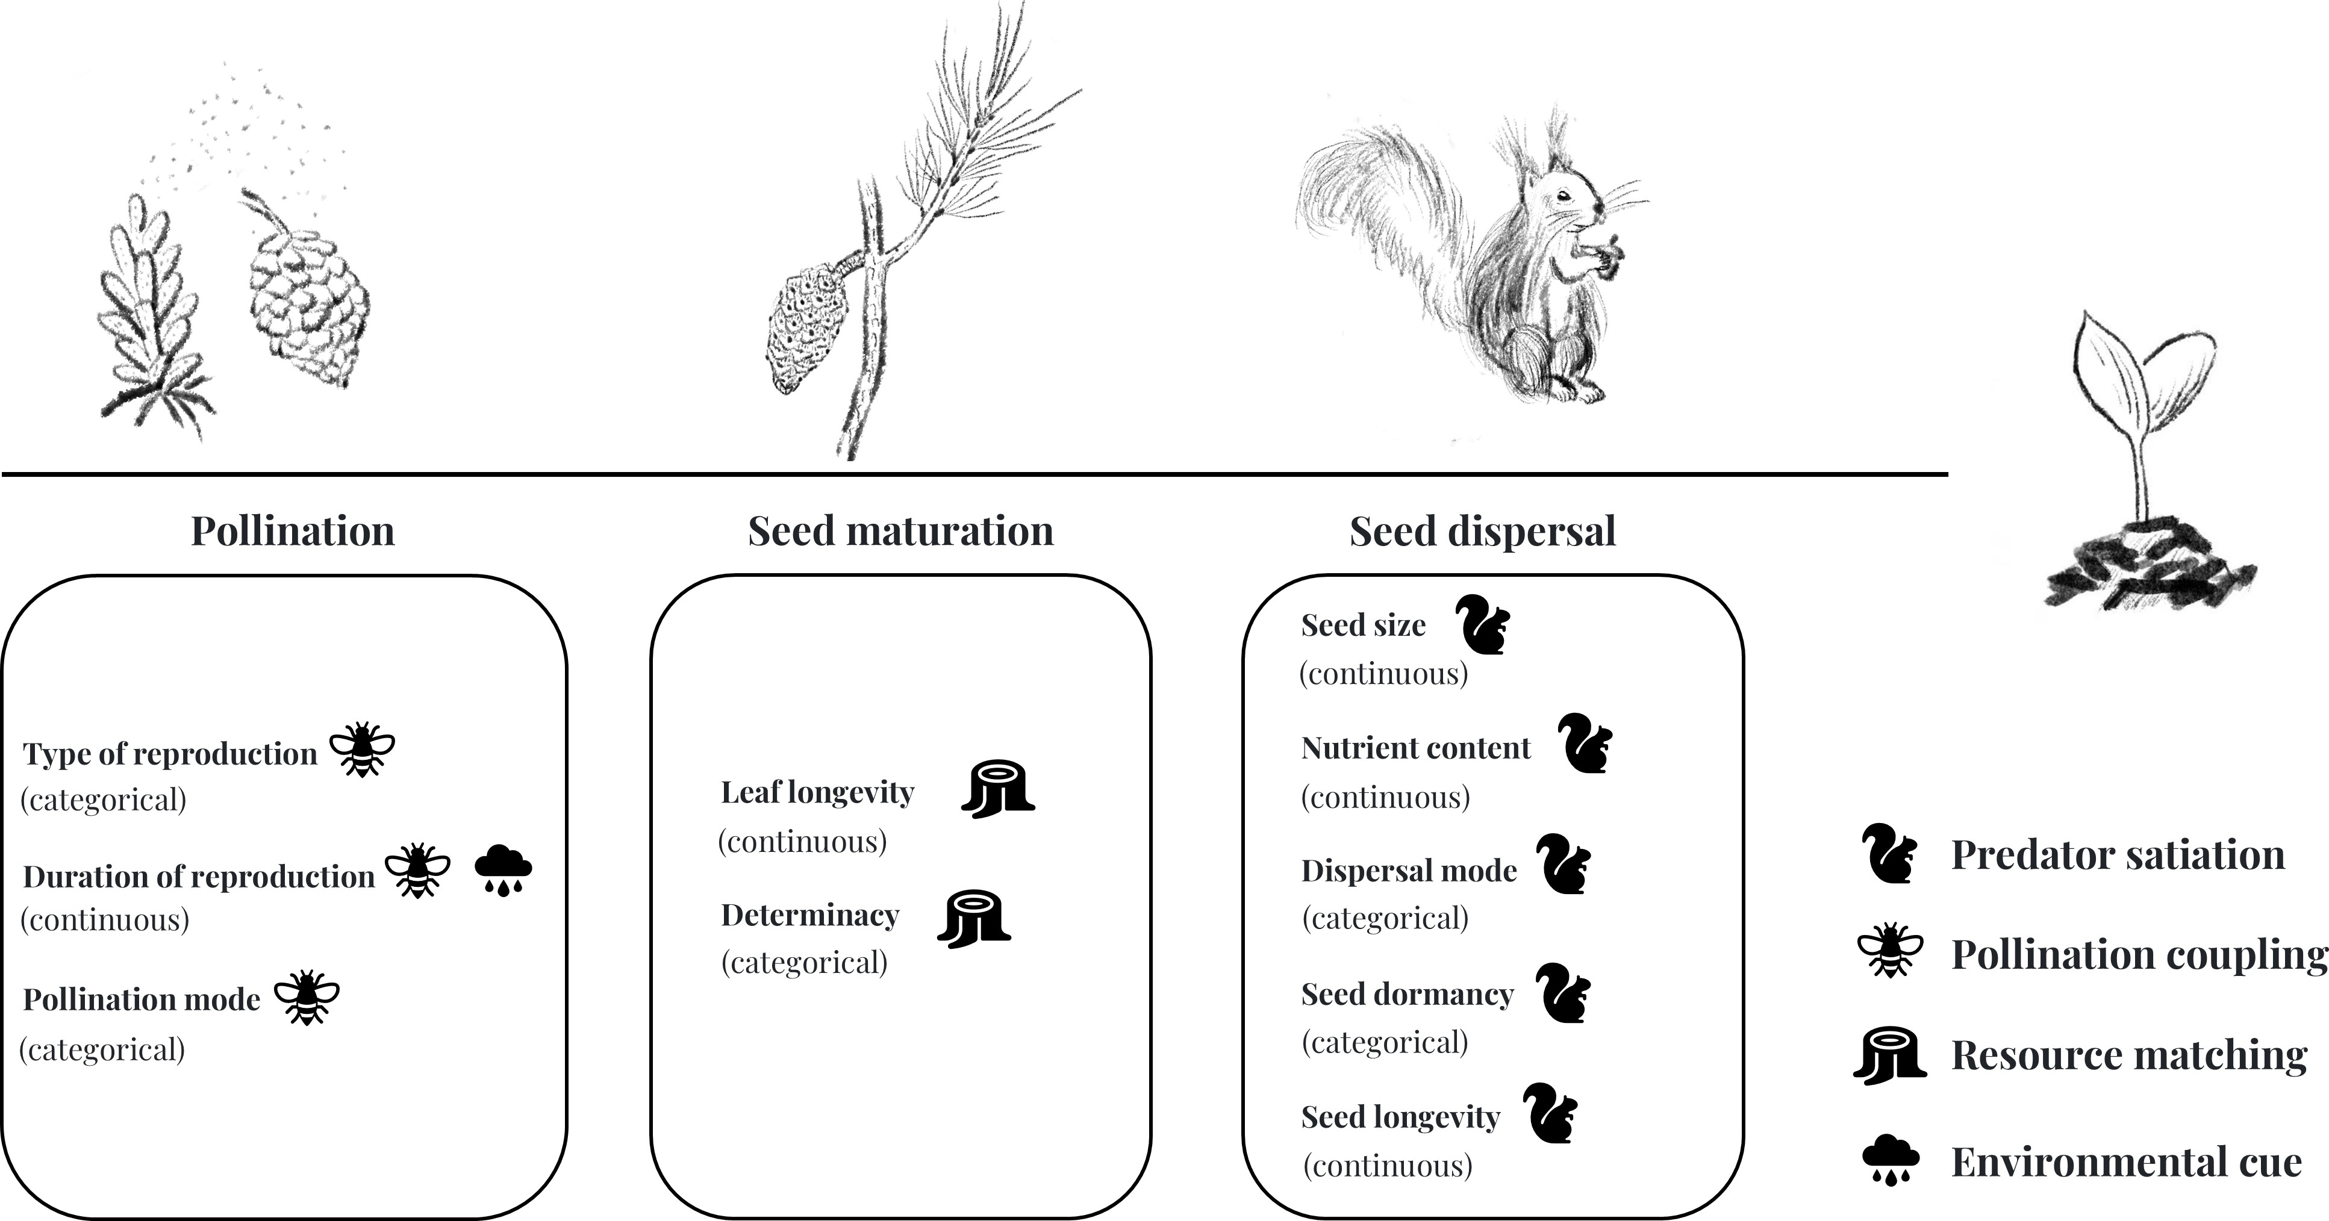

Figure 1: Conceptual framework linking reproductive traits to the phenomenon of masting across critical stages of seed reproduction. The symbols indicate different hypotheses. I include the information on whether the traits are categorical or continuous below each trait.

When seeds mature and are ready for dispersal, the role of seed predators becomes crucial. According to the predator satiation hypothesis, plants can manipulate the population of seed predators by producing large numbers of seeds in masting year and low number of seeds in following years. Masting species, however, may also rely on seed dispersers to carry seeds away from the parent tree, increasing the chances of seedling survival (Janzen, 1971; Silvertown,

1980). In this context, seed traits such as seed size, nutrient content, dispersal mode, seed dormancy and seed longevity all can play important roles. Larger seeds with higher nutrient content may be more attractive to seed predators, so they are more likely to benefit from masting events. Seed dormancy and seed longevity help ensure that seeds do not germinate immediately after dispersal, allowing them to wait for better conditions to establish in a more favorable environment since mast events only occur once every few years.

My proposed work advances on previous studies in this area, which have explored the relationship between a limited number of traits and interannual variability in seed production to test for support for different hypotheses (Fern´andez-Mart´ınez *et al.*, 2019; Journ´e *et al.*, 2023; Pearse *et al.*, 2020), but did not explain how different environmental conditions may link to which reproductive traits are more critical. In this meta-analysis, I will include more reproductive traits associated with different hypotheses (Figure 1) to investigate how these traits are related to a species’ tendency to mast in different forest types and biomes.

## Research Question and Objectives

Which seed traits are related to masting? Additionally, do these traits that relate to different masting hypotheses vary by species or environment?

* + - **Investigate trait associations:** Analyze the relationships between specific reproductive traits and masting and their frequency to determine which traits are more important in masting for different species.
    - **Compare across different environments:** Compare the most critical traits across different forest types and biomes to determine if they vary.

## Methods

This chapter aims to explore the relationship between reproductive traits and the tendency of a species to mast in different environments through a meta-analysis.

### Data collection

Data for this meta-analysis will be primarily sourced from following resources:

* **Silvics of North America** (Burns, 1990): Provides a comprehensive database of tree species and their reproductive characteristics in North America, and will be our main dataset. It includes flowering traits, seed dispersal traits, mast cycles and forest types. For biomes, I will use the information in the distributional map provided by the book and categorized into temperate, subtropical and tropical. For forest type, I will extract information from the section of associated forest cover, and aim to categorize it according to North American forest cover types.
* **MASTREE+** (Hacket-Pain *et al.*, 2022): This is a specialized database focused on tree species’ mast seeding behavior, which will be a supplemental source for identifying species tendencies for mast seeding and interannual variability.
* **Co-mast** (Nigro *et al.*, 2025): This is a specific database on harmonized seed production data for woody plants across US, which will also be a supplemental source for mast cycles.
* **Kew Seed Dataset, Worldwide Seed Mass Dataset, USDA Seed Manual** (Bonner & Karrfalt, 2008; Royal Botanic Gardens, 2007; Moles, 2015): These sources will offer supplementary information on seed mass and other reproductive traits.

### Statistical Analysis and Model Development

The main analysis will involve logistic regression to determine the likelihood of mast seeding for a species based on the selected reproductive traits and environmental variables. The response variables, whether a species masts or not and the coefficient of variation (CV) of the mean annual seed crop, which is widely used in masting-related research to describe the highly variable year- to-year production of seeds, will be analyzed separately to evaluate the occurrence and variability of mast seeding behavior (Kelly & Sork, 2002).

## Significance

Studying the reproductive traits related to masting can provide valuable insights into repro- ductive strategies and the broader ecological impacts on forest ecosystems. First, it can help explain the potential mechanisms that drive this complex reproductive strategy, shedding light

on why certain species mast while others do not in different environments. Examining traits such as seed size, nutrient content, dormancy, and longevity can yield insights into how these characteristics influence the success of seed production and dispersal during mast years, which may then relate to seed predators’ population dynamics.

Additionally, understanding these relationships can help us to predict how environmental factors, such as climate change, may impact masting behavior in the future. For example, knowing which seed traits are most relevant to masting behavior in specific ecological contexts can help us anticipate how shifts in temperature, precipitation, and other environmental cues might change masting patterns. By addressing the question of what causes masting by examining reproductive traits, we may better understand the dynamics of forest ecosystems.

# Understanding the relationship between masting and growth

The growth-reproduction trade-off suggests that increased investment in one process often comes at the expense of the other (Grime, 1977; Stearns, 1998). For trees, the decision to allocate resources to a large seed crop during a masting year can significantly affect overall growth dynamics (Hacket-Pain *et al.*, 2016a). This relationship between growth and reproduction can be complex, as the years leading up to a masting event may involve resource accumulation for reproductive efforts, while the years following masting could exhibit a different pattern, influenced by less demand for reproduction (Kelly, 1994).

With anthropogenic climate change, tree growth is generally expected to increase, as warmer temperatures increase growth rates and provide trees with more time to growth each year with extended growing seasons (Keenan *et al.*, 2014; Finzi *et al.*, 2020). Most climate models predict a positive relationship between temperature and growth (Friedlingstein *et al.*, 2022; Ito *et al.*, 2020). However, recent studies have questioned whether extended growing seasons due to warm- ing has actually led to increased tree growth (Dow *et al.*, 2022; Green & Keenan, 2022). Studies have suggested that biotic factors, such as intrinsic species differences, and how plants allocate the additional carbon gained during warmer seasons, also play a significant role (Hacket-Pain *et al.*, 2016b). In the context of masting, these dynamics become even more complex, underscor- ing the importance of understanding how different tree species will behave in future climates.

While many studies have examined how climate influences both growth and reproduction, of- ten comparing responses to various climate factors (Bajocco *et al.*, 2021; Koenig *et al.*, 2020; Redmond *et al.*, 2019; S´anchez-Humanes *et al.*, 2011), only a few have directly investigated the growth-reproduction trade-off in the context of masting. The majority of these studies have focused on oak and pine species. Studies on pines have emphasized on the allocation to de- fence, rather than looking at trade-off between growth and reproduction specifically (Larrinaga *et al.*, 2024; Redmond *et al.*, 2019). Research on oaks found little evidence of a strong, consis- tent trade-off between radial growth and seed production (Koenig *et al.*, 2020; Patterson *et al.*, 2023). However, this lack of evidence may be due to a large biomass allocation to roots, as oaks generally have deep root systems and tend to allocate more resources to root development from youth to maturity (Burns, 1990). In contrast, the species I will use in this study, either have shallow roots or do not develop resources-expansive taproots, thus they may exhibit a different response.

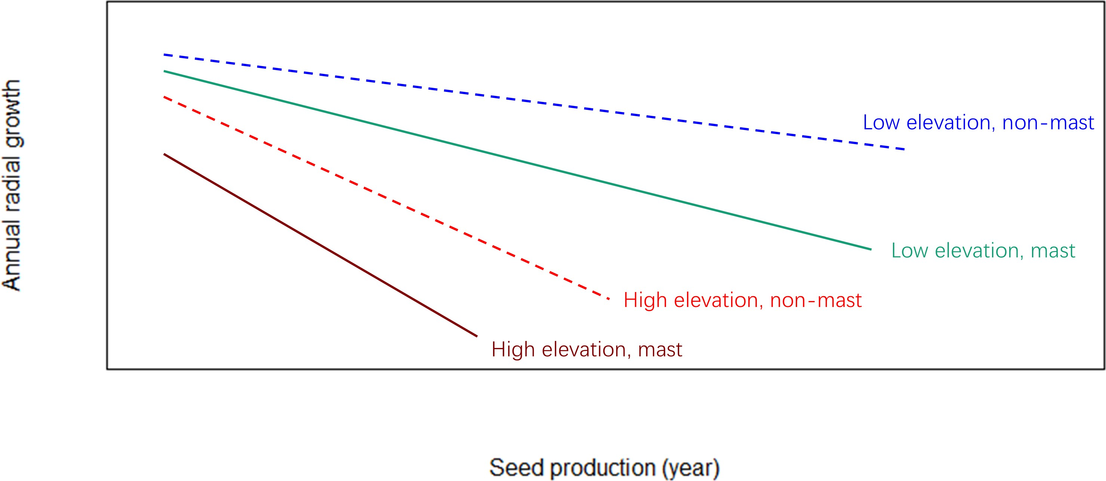

Figure 2: A conceptual figure showing the expected trend of a hypothesized growth-reproduction trade-off in masting years vs. non-masting years at different elevations. I predict that the trade-off is more pronounced in masting years compared to non-masting years in general and individuals at higher elevation stands would experience a stronger trade-off.

The relationship between masting and growth could also differ across elevations, where resource

availability and environmental stresses vary. Trees at higher elevations may experience a more pronounced trade-off between growth and reproduction due to increased resource limitation and harsher environmental conditions (Figure 2). By examining different species at varying elevations, we can gain a better understanding of the potentially complex relationship among resources, growth, and reproduction.

Combining Mount Rainier’s unique elevational gradient with long-term tree growth data from tree rings, this chapter explores the relationships between resource availability, growth and reproduction in six common coniferous species. It emphasizes how the strength of trade-offs that shape reproductive strategies may differ across varying ecological conditions.

## Research Question and Objectives

Is there a detectable trade-off between mast seeding events and growth?

* + - **Assess Growth Patterns:** Test for a trade-off by analyzing historical annual growth of selected tree species in relation to their masting events.
    - **Compare Species Responses:** Evaluate the differences in masting and growth responses among six tree species across different elevations.

## Methods

This chapter aims to examine the growth-reproduction trade-off in relation to mast seeding for six common conifer species at Mount Rainier across different elevations. To explore this relationship, I will incorporate long-term seed trap data with historical growth data derived from tree core samples, and use statistical approaches to analyze their relationship.

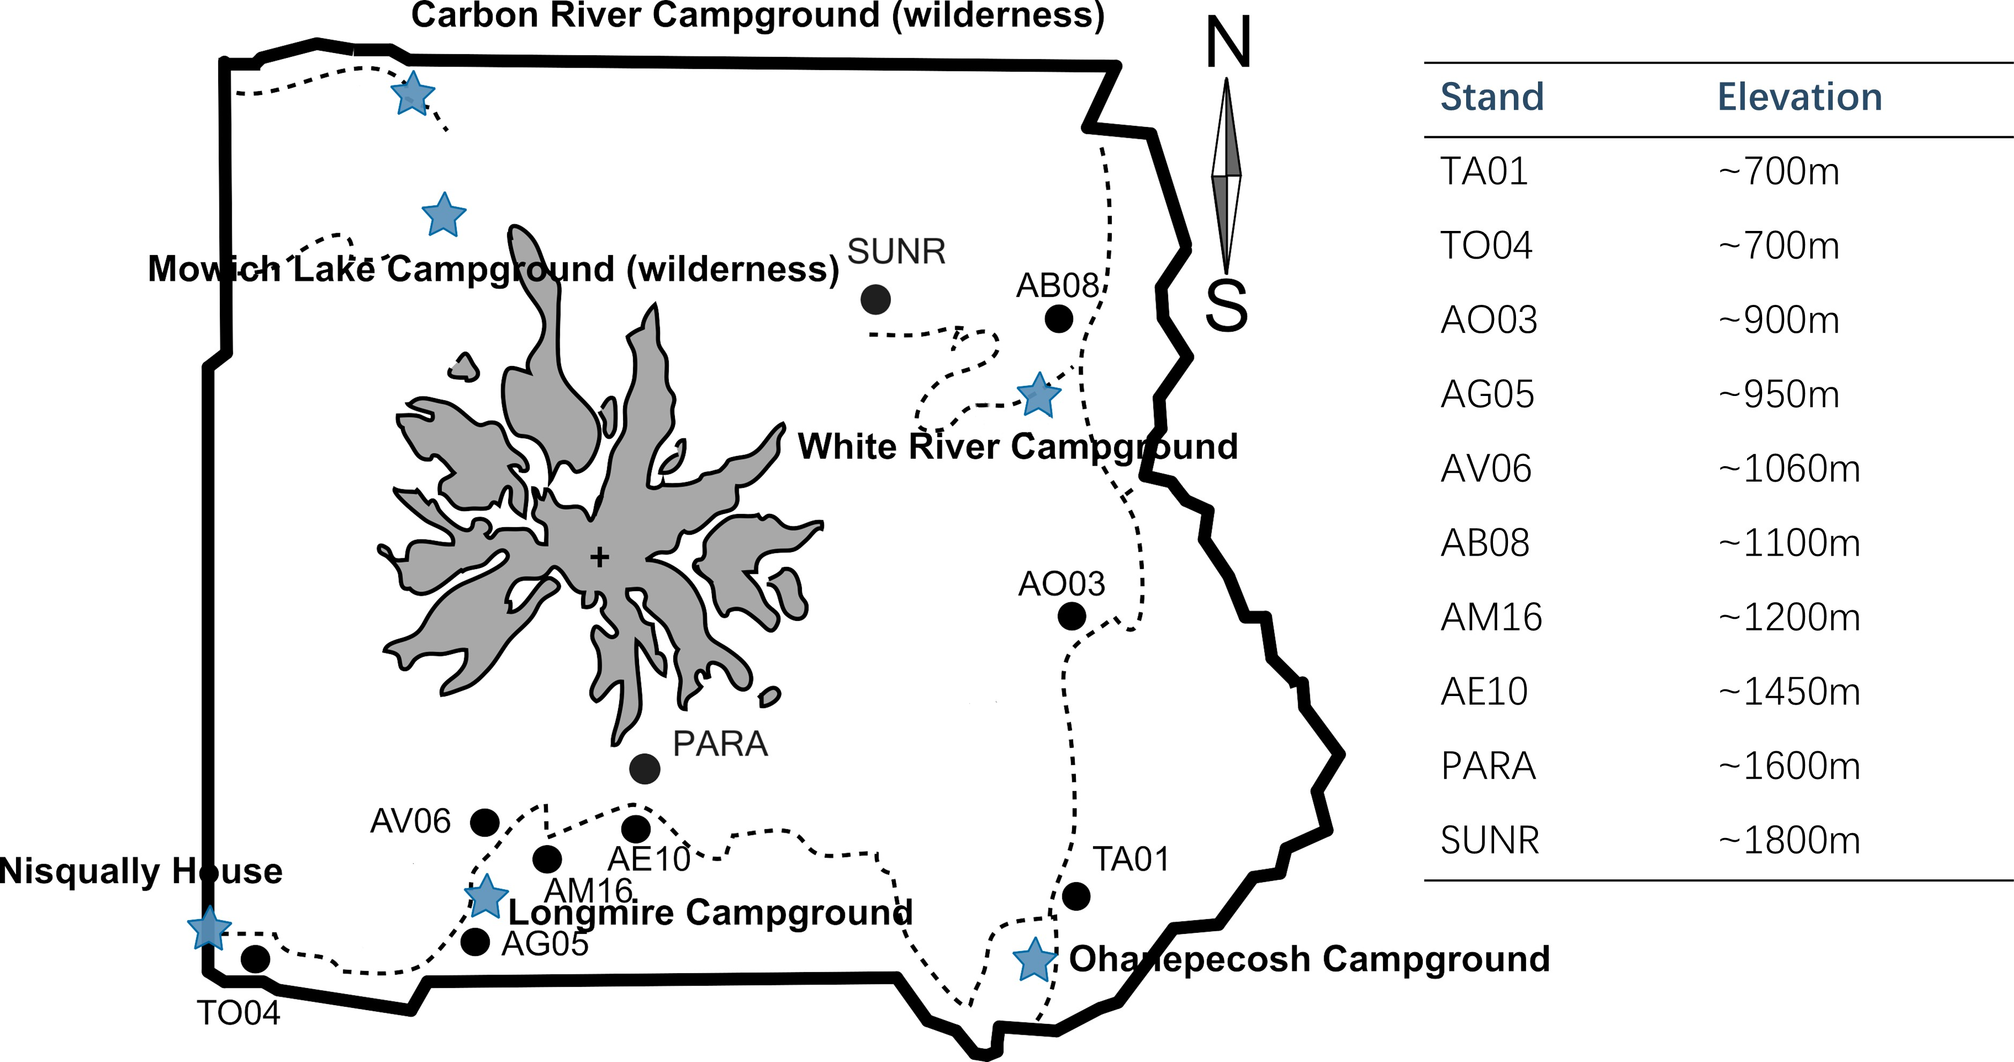

Figure 3: A map of Mount Rainier with all the sampling stands for this study and the elevation of each stand. The black dots are the stands with their elevations shown in table at right (blue stars are campgrounds).

### Study site and sample collection

I will conduct this study in Mount Rainier National Park, Washington, USA, focusing on six common conifer species that exhibit varying masting behaviors and occur across different eleva- tions in the park (Figure 3).

The data I plan to use in this chapter include two components:

– **Long-term seed data:** Our collaborator Dr. Janneke Hille Ris Lambers, has been collecting stand-level seed production data using seed traps since 2008, which will provide a valuable record of masting events across different stands and elevations at Mount Rainier (Figure 4).

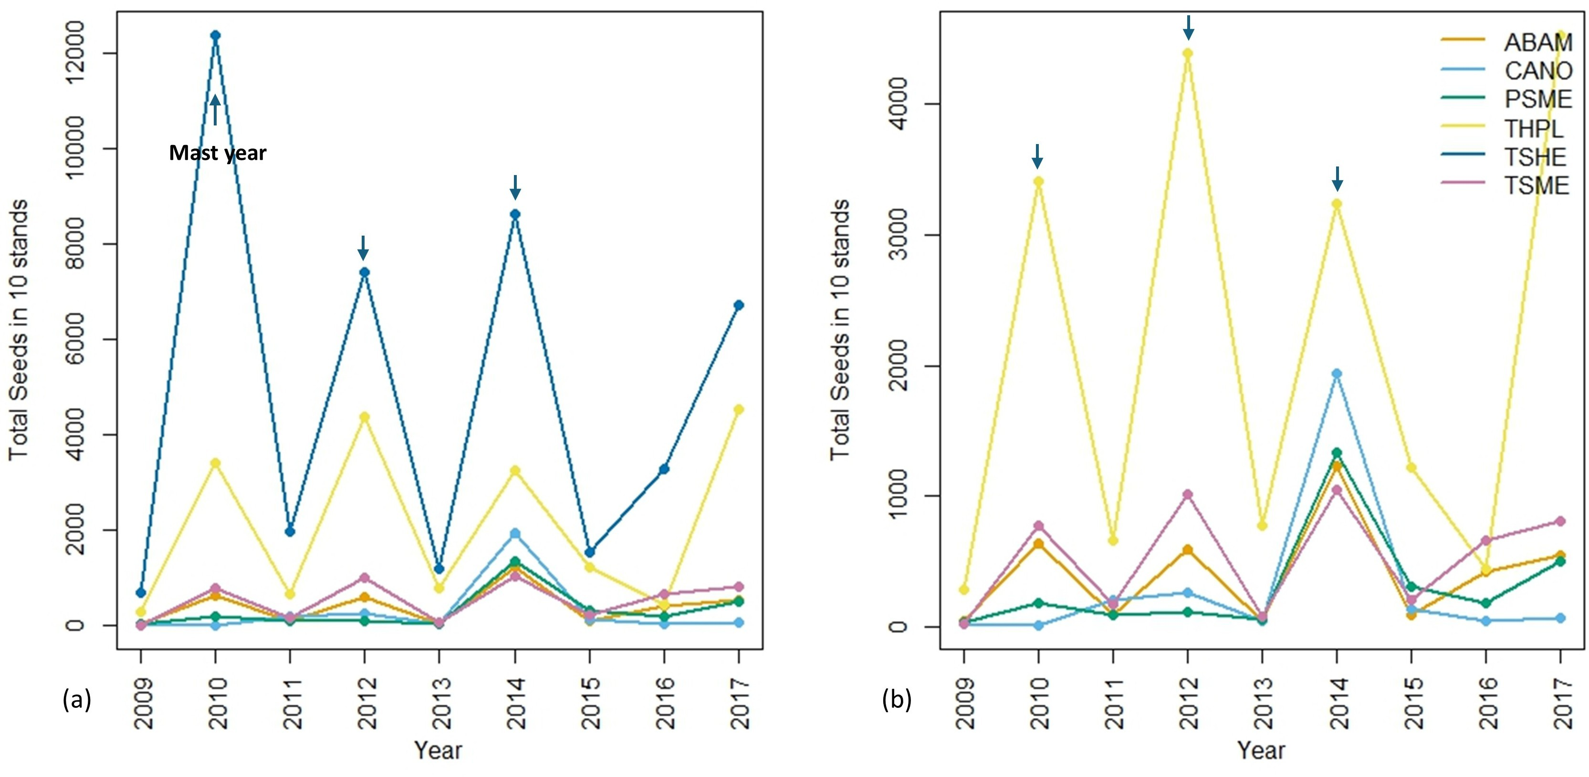

Figure 4: Seed data across all 10 stands collected by seed traps from 2009-2017 at Mount Rainier. (a) total seeds (sum of filled and empty seeds) for all six species; (b) total seeds for only five species excluding TSHE in finer resolution with different y-axis scale. Short blue arrows indicate potential masting years. ABAM: *Abies amabilis*, CANO: *Callitropsis nootkatensis*, PSME: *Pseudotsuga menziesii*, THPL: *Thuja plicata*, TSHE: *Tsuga heterophylla*, TSME: *Tsuga mertensiana*.

Table 1: Targeted species for Chapter 2-3

|  |  |
| --- | --- |
| **Tree species** | **Common name** |
| *Abies amabilis* | Pacific silver fir |
| *Pseudotsuga menziesii* | Douglas-fir |
| *Tsuga heterophylla* | Western hemlock |
| *Tsuga mertensiana* | Mountain hemlock |
| *Thuja plicata* | Western redcedar |
| *Callitropsis nootkatensis* | Yellow cedar |

– **Tree growth data:** To assess the historical growth of individual trees, I will collect cores from targeted species in Table 1 in each stand with long-term seed data. Within each stand, there are at least two targeted species, and each species appears in at least four stands. I plan to collect tree cores from 25 individuals per species per stand, covering a

size gradient. To make sure the trees we core are mature enough to reproduce at least 10 years ago to match with seed trap time window, I will only collect from trees with DBH greater than 25 cm. Additionally, I will prioritize individuals that are close to seed traps to better correlate with seed data. I will core trees at breast height using increment borers, taking two tree cores from the opposite sides of the tree while avoiding slopes. To account for at least 15 years of growth and for cross-dating purposes, I will collect long cores of 25 cm from larger trees with a DBH above 50 cm, while for smaller trees, I will core to the center if possible.

### Tree core processing

I will prepare the cores for analysis by sanding them with fine grit sandpaper (up to 2000 grit depending on the visibility of rings) to ensure a smooth, clear surface. For cores with rings that are difficult to distinguish, I will use a microtome to further enhance the visibility of the rings, creating a clear surface for better quality.

After preparation, I will scan the cores using a high-resolution camera to capture detailed images of the growth rings, then I will analyze the images with CooRecorder, a software used to measure tree ring width. I will also double check the cross-dating results with COFECHA, a computer program that assesses the quality of crossdating and measurement accuracy of tree-ring series (Cook & Kairiukstis, 2013; Speer, 2010).

### Statistical analysis

My proposed model investigates the trade-offs between growth (radial growth) and reproduction (seed production). It partially pools species and stands to allow for variation, while sharing information between groups to produce an overall estimate. Thus far, I have developed the model for seed production (below) and am developing the model for radial growth. This part is more complex, as it requires determining an appropriate method for removing size effects at the individual tree level, followed by scaling up to stand-level estimates. These estimates will then inform the modeling of the relationship between growth and reproduction. The full development of this model will be a key part of this chapter.

### Likelihood for Seed Production

The seed count for a particular stand *j*, species *sp*, and year *y* follows a negative binomial

distribution with mean *λj,sp,y* and dispersion term *ϕ*:

Seed*j,sp,y* ∼ NegBinomial(*λj,sp,y, ϕ*)

The modeled seed count (*λj,sp,y*) for stand *j*, species *sp*, and year *y* is:

log(*λj,sp,y*) = *α*0 + *α*sp + *α*j + *β*1,sp · Growth*j,sp,y* + *β*2,sp · Growth*j,sp,y−*1 + *β*3,sp · Elevation*j*

Where:

*α*0 is the grand mean across all species, stands and years;

*α*sp is the species-specific intercept for species *sp*; *α*j is the stand-specific intercept for stand *j*;

*β*1,sp is the slope for the relationship between current-year growth and seed production for species

*sp*;

*β*2,sp is the slope for the relationship between previous-year growth and seed production as the lag effect for species *sp*;

*β*3,sp is the effect of elevation on seed production for species *sp*.

## Significance

Understanding the relationship between masting and growth is important for predicting how tree species will respond to changing environmental factors, particularly in the context of extended growing seasons with climate change, where how trees allocate additional carbon can impact the global carbon cycle. By examining how these processes interact, we can gain insights into the adaptive strategies of different species and their potential resilience or vulnerability to future climate changes. This knowledge could help us make more informed predictions about future forest dynamics, including shifts in species composition, regeneration, and ecosystem health. As climate conditions continue to shift, understanding the masting behavior and growth responses will be essential for effective forest management and conservation efforts, helping us to anticipate changes and make management plans that will support the sustainability and resilience of forest ecosystems.

# Investigate how changing climate affect masting dynamics

Plants need to assimilate enough resources to produce seeds, a process that requires a com- bination of environmental conditions including sufficient light, water, nutrients and suitable temperature. These factors directly influence mast seeding by affecting the seed development process or affect it indirectly through their effects on flowering and growth. Flowering, for instance, is regulated by daylength, with light influencing the production of hormones that con- trol both flowering and growth (Lau & Deng, 2010). Light is also crucial for photosynthesis, which supports healthy plant growth. Water is another essential element for both flowering and fruiting. When water is limited, plants conserve energy, leading to fewer or smaller flowers, reduced pollination, or early flower shedding (Gallagher & Campbell, 2017). After fertilization, water continues to play an important role in the expansion and maturation of seeds. Aside from its direct effects on reproduction, water stress also inhibits growth, limiting the resources avail- able for reproduction (Hsiao, 1973; Anjum *et al.*, 2011). Nutrients, both macronutrients and micronutrients, as well as photosynthate, are essential for both energy transfer and storage, playing a significant role in the formation of flowers and seed development. Nutrient availability influences the timing of flowering and seed formation, with well-nourished plants more likely to flower at the appropriate time and set seeds successfully. Temperature, especially spring temperature, is one of the most widely studied climatic factors linked to masting events (Bajocco *et al.*, 2021; Moreira *et al.*, 2015; Schauber *et al.*, 2002; Bogdziewicz *et al.*, 2024), as it plays a critical role in successful pollination and seed development.

Exploring the relationship between environmental factors and mast seeding behavior can help us to understand how climate change may impact masting events. The four main features of masting: interannual variation, synchrony, temporal autocorrelation, and frequency are all likely affected by climate change in different ways (Hacket-Pain & Bogdziewicz, 2021). Additionally, warmer temperatures could increase the frequency of droughts, which would limit water supply. In areas with year-round snow cover, temperature changes may also alter water dynamics, af- fecting the timing and availability of water, which is critical for tree growth and reproduction. These shifts could have profound implications for the frequency and intensity of masting events.

Another important factor in the flowering and fruiting process is environmental ‘vetoes’, which occur when weather events or environmental conditions prevent plant processes, even when

resources are adequate (Bogdziewicz, 2022). Environmental vetoes can take two forms: (1) a lack of weather cues, such as when specific weather conditions required to trigger flowering or fruit maturation are not met, preventing reproduction despite adequate resources; and (2) extreme weather events, such as frost, drought, or heavy rainfall, which can directly damage plant tissues, including shoots, buds, flowers and fruits, thereby preventing successful reproduction. With climate change, environmental vetoes may become more frequent, which is generally considered detrimental to plants. However, studies have shown that environmental vetoes preventing seed production in certain years can actually facilitate masting, allowing for higher regeneration success (Bogdziewicz *et al.*, 2018, 2019). Therefore, understanding how environmental vetoes influence seed production in different species and regions is critical for predicting future forest dynamics. Once we understand how various environmental factors influence different aspects of masting, we can make better predictions of masting events and thus have a better understanding of how future changing climate may shape the seed dynamics (Hacket-Pain & Bogdziewicz, 2021).

Elevation has long been used as a proxy for climate change in ecological studies, since it is closely linked to a variety of climatic factors, particularly temperature and water availability (K¨orner, 2007). It provides a natural system to study the long-term, large-scale effects of climate change on communities and ecosystems, which cannot be accomplished by experiments (Sundqvist *et al.*, 2013). By using elevation as a proxy for climate change, we can better understand how plant populations at different elevations respond to environmental factors and refine predictive models that incorporate shifting climatic variables at finer spatial resolutions. This approach also helps us understand vegetation shifts in ecosystem within a region.

Mount Rainier provides an ideal location for studying how climate change may impact forest dynamics, as it features a distinct elevation gradient with diverse snowmelt patterns. The rain shadow effect on different sides of the mountain also creates varying water availability. The climate in this region has already undergone significant changes in recent decades and, by combining historical seed data with climate data, we can explore the relationship between climatic variables and various aspects of mast seeding.

This chapter aims to understand how masting patterns are influenced by environmental factors. By investigating the large variance in interannual masting patterns, and exploring the relation- ship between spatial as well as temporal changes in masting across elevational gradients, we can

better understand how climate change will impact seed dynamics in this area.

## Research Question and Objectives

How does the changing climate affect seed dynamics at Mount Rainier?

* + - **Identify Environmental Influences:** Investigate how key environmental factors (e.g., temperature, precipitation) are related to masting events at Mount Rainier.
    - **Climate change proxy:** Use the elevational gradient at Mount Rainier as a proxy for changing climate conditions to compare how masting behavior varies across different ele- vations.
    - **Develop Predictive Models:** Develop predictive models of masting behavior across elevations to forecast future seed dynamics under changing climate conditions.

## Methods

This chapter aims to investigate how climate change influences seed dynamics at Mount Rainier, focusing on the relationship between mast seeding patterns adapted to local climatic conditions across different elevations. By using long-term seed trap data and corresponding climate data, I will assess how seed production synchrony and variability change along the elevation, which is used as a proxy for climate change for the same set of species we used in last chapter. **Data collection**

* + - **Long-term seed data:** The same long-term seed trap data from last chapter.
    - **Local climate data:** Our collaborator Dr. Janneke Hille Ris Lambers has data loggers in the stands recording long-term soil moisture, ambient temperature and light data.

### Statistical Analysis and Model Development

* + - **Time series model, mixed-effect models:** I will build on the model developed in Chapter 2, which explores the growth-reproduction trade-off during mast seeding events,

to create a more climate-sensitive model of mast seeding dynamics. This extended model will incorporate climate variables such as temperature and precipitation to assess how changing climatic conditions may alter the frequency, magnitude, and synchrony of mast seeding events.

* + - **Predictive modeling:** I will develop predictive models to forecast future trends in mast- ing behaviours at Mount Rainier under projected climate scenarios. These models will use climate projections for this region to predict how seed dynamics might shift in response to future climate change.

## Significance

Changes in masting behavior can have cascading effects on forest dynamics, including seed preda- tor interactions and the regeneration success of tree species. Since masting events can provide a large food source drives population dynamics of lots of mammals in the forest, changes of mast- ing patterns will alter these ecological relationships, and the overall structure of ecosystems. For example, if climate change causes masting events to be less synchronized across species or eleva- tions, it will affect seed availability for animals that rely on them as a food source, potentially impacting their survival and reproduction.

Masting could also affect the regeneration of the studied tree species themselves. Many species rely on mast seeding years to establish successful new seedlings in the face of competition and predation. If climate change affects the frequency or intensity of mast seeding events, the successful regeneration of some tree species might be affected. Thus, understanding how these characteristics of masting might be influenced by climate change is essential for predicting the resilience of forest ecosystems.

# References

Adler, P.B., Salguero-G´omez, R., Compagnoni, A., Hsu, J.S., Ray-Mukherjee, J., Mbeau-Ache,

C. & Franco, M. (2014) Functional traits explain variation in plant life history strategies.

*Proceedings of the National Academy of Sciences* **111**, 740–745.

Anjum, S.A., Xie, X.Y., Wang, L.C., Saleem, M.F., Man, C., Lei, W. *et al.* (2011) Morpholog- ical, physiological and biochemical responses of plants to drought stress. *African journal of agricultural research* **6**, 2026–2032.

Bajocco, S., Ferrara, C., Bascietto, M., Alivernini, A., Chirichella, R., Cutini, A. & Chianucci,

F. (2021) Characterizing the climatic niche of mast seeding in beech: Evidences of trade-offs between vegetation growth and seed production. *Ecological Indicators* **121**, 107139.

Bawa, K.S. (1980) Evolution of dioecy in flowering plants. *Annual review of ecology and system- atics* **11**, 15–39.

Bazzaz, F.A. (1997) Allocation of resources in plants: state of the science and critical questions.

*Plant resource allocation* **1**, 1–37.

Bogdziewicz, M. (2022) How will global change affect plant reproduction? a framework for mast seeding trends. *New Phytologist* **234**, 14–20.

Bogdziewicz, M., Kelly, D., Ascoli, D., Caignard, T., Chianucci, F., Crone, E.E., Fleurot, E., Foest, J.J., Gratzer, G., Hagiwara, T. *et al.* (2024) Evolutionary ecology of masting: mecha- nisms, models, and climate change. *Trends in Ecology & Evolution* .

Bogdziewicz, M., Pesendorfer, M., Crone, E.E., P´erez-Izquierdo, C. & Bonal, R. (2020) Flowering synchrony drives reproductive success in a wind-pollinated tree. *Ecology Letters* **23**, 1820– 1826.

Bogdziewicz, M., Steele, M.A., Marino, S. & Crone, E.E. (2018) Correlated seed failure as an environmental veto to synchronize reproduction of masting plants. *New Phytologist* **219**, 98–108.

Bogdziewicz, M., Szymkowiak, J., Kasprzyk, I., Grewling, L- ., Borowski, Z., Borycka, K., Kan- torowicz, W., Myszkowska, D., Piotrowicz, K., Ziemianin, M. *et al.* (2017) Masting in wind- pollinated trees: system-specific roles of weather and pollination dynamics in driving seed production. *Ecology* **98**, 2615–2625.

Bogdziewicz, M.,

Z˙ ywiec, M., Espelta, J.M., Fern´andez-Martinez, M., Calama, R., Ledwon´,

M., McIntire, E. & Crone, E.E. (2019) Environmental veto synchronizes mast seeding in four contrasting tree species. *The American Naturalist* **194**, 246–259.

Bonner, F.T. & Karrfalt, R.P. (2008) *The woody plant seed manual*. 727, Forest Service. Burns, R.M. (1990) *Silvics of north America*. 654, US Department of Agriculture, Forest Service.

Calvin, K., Dasgupta, D., Krinner, G., Mukherji, A., Thorne, P.W., Trisos, C., Romero, J., Aldunce, P., Barret, K., Blanco, G. *et al.* (2023) Ipcc, 2023: Climate change 2023: Synthesis report, summary for policymakers. contribution of working groups i, ii and iii to the sixth assessment report of the intergovernmental panel on climate change [core writing team, h. lee and j. romero (eds.)]. ipcc, geneva, switzerland. *IPCC, 2023: Climate Change 2023: Synthesis Report. Contribution of Working Groups I, II and III to the Sixth Assessment Report of the Intergovernmental Panel on Climate Change [Core Writing Team, H. Lee and J. Romero (eds.)]. IPCC, Geneva, Switzerland.* pp. 1–34.

Cook, E.R. & Kairiukstis, L.A. (2013) *Methods of dendrochronology: applications in the envi- ronmental sciences*. Springer Science & Business Media.

Crone, E.E. & Rapp, J.M. (2014) Resource depletion, pollen coupling, and the ecology of mast seeding. *Annals of the New York Academy of Sciences* **1322**, 21–34.

Davies, T.J. & MacPherson, A. (2024) Seed masting as a mechanism for escape from pathogens.

*Current Biology* **34**, R120–R125.

Dow, C., Kim, A.Y., D’Orangeville, L., Gonzalez-Akre, E.B., Helcoski, R., Herrmann, V., Harley, G.L., Maxwell, J.T., McGregor, I.R., McShea, W.J. *et al.* (2022) Warm springs alter timing but not total growth of temperate deciduous trees. *Nature* **608**, 552–557.

Fern´andez-Mart´ınez, M., Pearse, I., Sardans, J., Sayol, F., Koenig, W., LaMontagne, J.M., Bogdziewicz, M., Collalti, A., Hacket-Pain, A., Vacchiano, G. *et al.* (2019) Nutrient scarcity as a selective pressure for mast seeding. *Nature Plants* **5**, 1222–1228.

Finzi, A.C., Giasson, M.A., Barker Plotkin, A.A., Aber, J.D., Boose, E.R., Davidson, E.A., Dietze, M.C., Ellison, A.M., Frey, S.D., Goldman, E. *et al.* (2020) Carbon budget of the harvard forest long-term ecological research site: pattern, process, and response to global change. *Ecological Monographs* **90**, e01423.

Friedlingstein, P., O’sullivan, M., Jones, M.W., Andrew, R.M., Gregor, L., Hauck, J., Le Qu´er´e, C., Luijkx, I.T., Olsen, A., Peters, G.P. *et al.* (2022) Global carbon budget 2022. *Earth System Science Data* **14**, 4811–4900.

Gallagher, M.K. & Campbell, D.R. (2017) Shifts in water availability mediate plant–pollinator interactions. *New Phytologist* **215**, 792–802.

Green, J.K. & Keenan, T.F. (2022) The limits of forest carbon sequestration. *Science* **376**, 692–693.

Grime, J.P. (1977) Evidence for the existence of three primary strategies in plants and its relevance to ecological and evolutionary theory. *The american naturalist* **111**, 1169–1194.

Hacket-Pain, A. & Bogdziewicz, M. (2021) Climate change and plant reproduction: trends and drivers of mast seeding change. *Philosophical Transactions of the Royal Society B* **376**, 20200379.

Hacket-Pain, A., Foest, J.J., Pearse, I.S., LaMontagne, J.M., Koenig, W.D., Vacchiano, G., Bogdziewicz, M., Caignard, T., Celebias, P., Van Dormolen, J. *et al.* (2022) Mastree+: Time- series of plant reproductive effort from six continents. *Global Change Biology* **28**, 3066–3082.

Hacket-Pain, A., Friend, A., Lageard, J. & Thomas, P. (2016a) Tree rings and masting: con- sidering reproductive phenomena when interpreting tree rings? *Tree Rings in Archaeology, Climatology and Ecology* **14**, 78–85.

Hacket-Pain, A.J., Cavin, L., Friend, A.D. & Jump, A. (2016b) Consistent limitation of growth by high temperature and low precipitation from range core to southern edge of european beech indicates widespread vulnerability to changing climate. *European Journal of Forest Research* **135**, 897–909.

Hall´e, F. *et al.* (1978) Architectural variation at the specific level in tropical trees. *Tropical trees as living systems* pp. 209–221.

Hsiao, T.C. (1973) Plant responses to water stress. *Annual review of plant physiology* **24**, 519– 570.

Isagi, Y., Sugimura, K., Sumida, A. & Ito, H. (1997) How does masting happen and synchronize?

*Journal of Theoretical Biology* **187**, 231–239.

Ito, G., Romanou, A., Kiang, N.Y., Faluvegi, G., Aleinov, I., Ruedy, R., Russell, G., Lerner, P., Kelley, M. & Lo, K. (2020) Global carbon cycle and climate feedbacks in the nasa giss modele2. 1. *Journal of Advances in Modeling Earth Systems* **12**, e2019MS002030.

Janzen, D.H. (1971) Seed predation by animals. *Annual review of ecology and systematics* pp.

465–492.

Journ´e, V., Hacket-Pain, A. & Bogdziewicz, M. (2023) Evolution of masting in plants is linked to investment in low tissue mortality. *Nature Communications* **14**, 7998.

Keenan, T.F., Gray, J., Friedl, M.A., Toomey, M., Bohrer, G., Hollinger, D.Y., Munger, J.W., O’Keefe, J., Schmid, H.P., Wing, I.S. *et al.* (2014) Net carbon uptake has increased through warming-induced changes in temperate forest phenology. *Nature Climate Change* **4**, 598–604.

Kelly, D. (1994) The evolutionary ecology of mast seeding. *Trends in ecology & evolution* **9**, 465–470.

Kelly, D. & Sork, V.L. (2002) Mast seeding in perennial plants: why, how, where? *Annual review of ecology and systematics* **33**, 427–447.

Knight, T.M., Steets, J.A., Vamosi, J.C., Mazer, S.J., Burd, M., Campbell, D.R., Dudash, M.R., Johnston, M.O., Mitchell, R.J. & Ashman, T.L. (2005) Pollen limitation of plant reproduction: pattern and process. *Annu. Rev. Ecol. Evol. Syst.* **36**, 467–497.

Koenig, W.D. (2021) A brief history of masting research. *Philosophical Transactions of the Royal Society B* **376**, 20200423.

Koenig, W.D., Knops, J.M. & Carmen, W.J. (2020) Can mast history be inferred from radial growth? a test using five species of california oaks. *Forest ecology and management* **472**, 118233.

K¨orner, C. (2007) The use of ‘altitude’in ecological research. *Trends in ecology & evolution* **22**, 569–574.

Kozlowski, T.T. & Clausen, J.J. (1966) Shoot growth characteristics of heterophyllous woody plants. *Canadian Journal of Botany* **44**, 827–843.

Larrinaga, A.R., Sampedro, L. & Zas, R. (2024) Resource availability and herbivory alter defence-growth-reproduction trade-offs in a masting mediterranean pine. *Environmental and Experimental Botany* **217**, 105546.

Lau, O.S. & Deng, X.W. (2010) Plant hormone signaling lightens up: integrators of light and hormones. *Current opinion in plant biology* **13**, 571–577.

Lechowicz, M.J. (1984) Why do temperate deciduous trees leaf out at different times? adaptation and ecology of forest communities. *The American Naturalist* **124**, 821–842.

Marks, P. (1975) On the relation between extension growth and successional status of deciduous trees of the northeastern united states. *Bulletin of the Torrey Botanical Club* pp. 172–177.

Moles, A. (2015) Worldwide seed mass dataset. Accessed: 2025-04-27.

Moreira, X., Abdala-Roberts, L., Linhart, Y.B. & Mooney, K.A. (2015) Effects of climate on reproductive investment in a masting species: assessment of climatic predictors and underlying mechanisms. *Journal of Ecology* **103**, 1317–1324.

Nigro, K.M., Barton, J.H., Macias, D., Chaudhary, V.B., Pearse, I.S., Bell, D.M., Chen, A., Cleavitt, N.L., Crone, E.E., Greene, D.F. *et al.* (2025) Co-mast: Harmonized seed production data for woody plants across us long-term research sites. *Ecology* **106**, e4463.

Patterson, T.W., Greenberg, C.H. & Hacket-Pain, A. (2023) Acorn production, climate, and tree-ring growth of five oak species in southern appalachian forests. *Forest Ecology and Man- agement* **546**, 121310.

Pearse, I.S., Koenig, W.D. & Kelly, D. (2016) Mechanisms of mast seeding: resources, weather, cues, and selection. *New Phytologist* **212**, 546–562.

Pearse, I.S., LaMontagne, J.M., Lordon, M., Hipp, A.L. & Koenig, W.D. (2020) Biogeography and phylogeny of masting: do global patterns fit functional hypotheses? *New Phytologist* **227**, 1557–1567.

Redmond, M.D., Davis, T.S., Ferrenberg, S. & Wion, A.P. (2019) Resource allocation trade-offs in a mast-seeding conifer: pin˜on pine prioritizes reproduction over defence. *AoB Plants* **11**, plz070.

Royal Botanic Gardens, K. (2007) Seed information database (sid). Accessed: 2025-04-27.

S´anchez-Humanes, B., Sork, V.L. & Espelta, J.M. (2011) Trade-offs between vegetative growth and acorn production in quercus lobata during a mast year: the relevance of crop size and hierarchical level within the canopy. *Oecologia* **166**, 101–110.

Satake, A. & Kelly, D. (2021) Studying the genetic basis of masting. *Philosophical Transactions of the Royal Society B* **376**, 20210116.

Schauber, E.M., Kelly, D., Turchin, P., Simon, C., Lee, W.G., Allen, R.B., Payton, I.J., Wilson, P.R., Cowan, P.E. & Brockie, R. (2002) Masting by eighteen new zealand plant species: the role of temperature as a synchronizing cue. *Ecology* **83**, 1214–1225.

Silvertown, J.W. (1980) The evolutionary ecology of mast seeding in trees. *Biological journal of the Linnean Society* **14**, 235–250.

Speer, J.H. (2010) *Fundamentals of tree-ring research*. University of Arizona Press. Stearns, S.C. (1998) *The evolution of life histories*. Oxford university press.

Sundqvist, M.K., Sanders, N.J. & Wardle, D.A. (2013) Community and ecosystem responses to elevational gradients: processes, mechanisms, and insights for global change. *Annual review of ecology, evolution, and systematics* **44**, 261–280.

Venable, D.L. (1989) Modeling the evolutionary ecology of seed banks. *Ecology of soil seed banks*

pp. 67–90.

Waller, D.M. (1979) Models of mast fruiting in trees. *Journal of theoretical biology* **80**, 223–232.