# Manual of 3GPP TDoc batch downloader

## Information

The author's job occasionally involves downloading 3GPP TDocs in batches. More specifically, TDocs related to a particular meeting (e.g. RAN1#113, as shown in Fig. 1) need to be downloaded for study. To simplify this process and save time, this python code is written to to release people like author from repetitive manual downloading tasks.

Fig.1 TDocs to be downloaded on 3GPP website

Fig.2 The UI of TDocs downloader

This 3GPP TDoc batch downloader has two key features as shown in Fig. 2:

1. Only three configurations/steps are needed before the download starts, namely:
2. Specifying the TDocs URL on 3GPP website.
3. Setting the local save path of TDocs to be downloaded.
4. Entering the number for each TDoc.
5. Failed files report. After the downloading process finishes, it will report the files which encounter failure such that user can copy the failed files list to re-download.

Note:

1. The code has been tested only on windows. For other platforms, it may need further development.
2. This is an initial version, therefore the code is unpolished. Please feel free to contact the author for bugs or other issues, as well as job-related topics. Hope you enjoy the journey of 3GPP study.

**Author Information：**Xiaonan ([wangxn_007@163.com](mailto:wangxn_007@163.com)) currently working at Baicells

**Version Information:**

|  |  |  |  |
| --- | --- | --- | --- |
| 2023.7.29 | v1.0.1 | Add progress indicator in log；  Solve the error when click the close button. | Xiaonan |
| 2023.7.28 | v1.0.0 | First version. | Xiaonan |

## Dependency installation

You can skip this chapter and go directly to chapter 3 – “How to use it” if you are familiar with python.

1. Download the folder. The python script in the folder that we will use is “simple-tdoc-batch-download.py”
2. Use command line to install the dependencies。【windows PowerShell】is used below as an example.
3. Open PowerShell. Press the window button on your keyboard, type“powershell” and then click “Windows PowerShell” to run it.

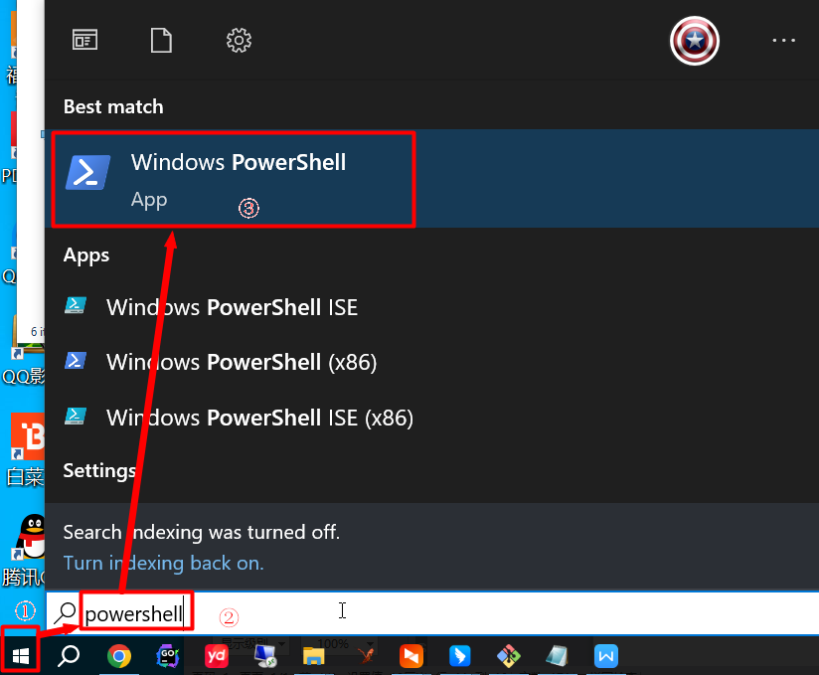

Fig. 3 open windows powershell

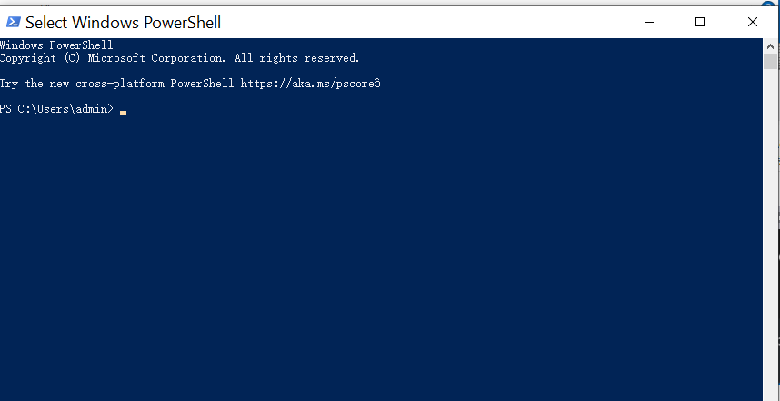

Fig. 4 windows powershell UI

1. In powershell, use “cd” command to enter the directory of 3gpp-tdoc-batch-downloader we downloaded.

For example, in Fig. 5 the file python script “simple-tdoc-batch-download.py” we have downloaded is at: C:\Users\admin\Desktop\3gpp-tdoc-batch-downloader

**Accordingly, in Fig. 6, “cd” command is used to enter the folder we already downloaded.**

**cd C:\Users\admin\Desktop\3gpp-tdoc-batch-downloader**

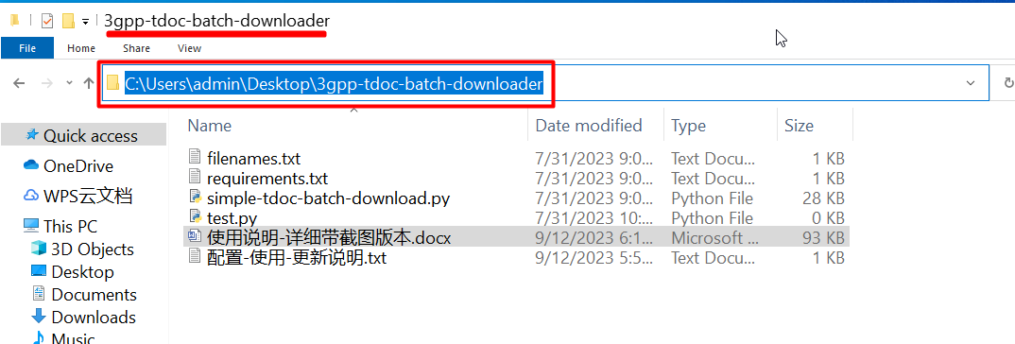

Fig 5. The directory of 3gpp-tdoc-batch-downloader. In this example, the downloaded folder is at C:\Users\admin\Desktop\3gpp-tdoc-batch-downloader

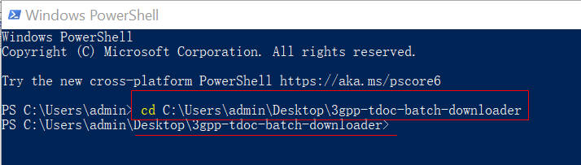

Fig 6. Use “cd” to enter the directory of 3gpp-tdoc-batch-downloader

1. Use “pip” command to install dependencies as shown in Fig. 7.

**pip install -r .\requirements.txt**

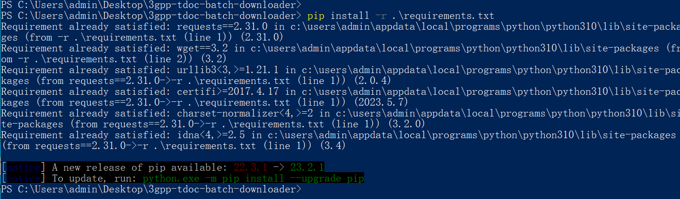

Fig. 7 use “pip install -r .\requirements.txt” to install dependencies

note：in Fig 7, it says ”requirements already satisfied” as we already installed it before on the demonstration laptop.

## How to use it?

In powershell (on windows as an example), run the python script.

**python .\simple-tdoc-batch-download.py**

As shown in Fig. 8, three configuration steps are needed before clicking Download button:

1. Specifying the TDocs URL on 3GPP website. For this step, you need to know the URL as the Step 1 in Fig 8.
2. Setting the local save path of TDocs to be downloaded. For this step, a local save path needs to be specified as Step 2 in Fig 8.
3. Entering the number for each TDoc. Befor Step 3, usually you will need to find the “TDoc_list” file for each meeting from 3GPP website. For example “TDoc_List_Meeting_RAN1#113.xlsx” in Step 3 of Fig. 8.

After the Download button is clicked, the downloader will start downloading all the files in Step 3. If there are files encounter download failure due to network anomaly, the file names will be listed in “Failed files”, then you can copy these filenames back to Step 3 and restart the download.

Enjoy your 3GPP journey!

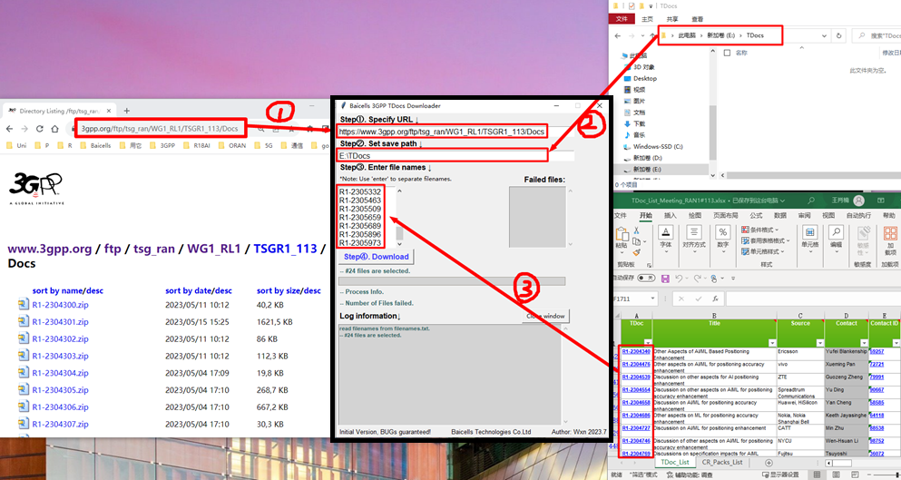

Fig 8. How to config the first three steps