Title: Strategy-dependent coding of reward and delay during temporal discounting in macaque dorsolateral prefrontal cortex

Authors: Rossella Falcone^{1,3,†,*}, Siyu Wang^{1,†}, David B. Weintraub², Mariko McDougall¹, Mark A. G. Eldridge^{1,4}, and Barry J. Richmond^{1,5}.

Author affiliations:
¹Laboratory of Neuropsychology, NIMH, Bethesda, MD, USA
²Surgical Neurology Branch, NINDS, Bethesda, MD, USA
³Leo M. Davidoff Department of Neurological Surgery, Albert Einstein College of Medicine Montefiore Medical Center Bronx, NY USA.
⁴Newcastle University, Newcastle upon Tyne, NE1 7RU.
⁵Senior Investigator, Emeritus.
†Equal contribution.

*Corresponding author:
Rossella Falcone, PhD
Assistant Professor
Albert Einstein College of Medicine, Bronx, NY, 10461
e-mail: rossella.falcone@einsteinmed.edu

Abstract
Some rewards are worth the wait, while others are not. This behavior is governed by temporal discounting, whereby delays reduce the value of future rewards, such that only sufficiently large rewards justify long waits. Individuals differ widely in their strategies to weigh temporally delayed rewards. Prefrontal neurons are known to encode reward and delay; however, it remains unclear whether these neural representations reflect a common temporal discounting computation process, or whether they depend on the individual behavioral strategies for trading off reward and time.
We trained two monkeys to choose whether to accept or reject delayed reward offers by releasing a lever at different times contingent on a go signal. We analyzed how the unforeseen go signals, which introduced different additional delays before an offer can be accepted, changed animals’ temporal discounting decisions. Behavioral modeling revealed that the two monkeys adopted distinct strategies in re-evaluating the original reward offer in response to the go signal. Monkey S re-calculated the discounted value of the original offer by accounting for the additional delay associated with the go signal, whereas Monkey T treated the go signal as having additive values without re-evaluating the original offer. Although neurons in the dorsolateral prefrontal cortex (dlPFC) of both monkeys encoded reward and delay, we found important differences in how neurons represented these factors, which reflected monkeys’ respective behavioral strategies. Our results revealed a strategy-dependent coding of reward and delay in dlPFC.
Introduction
Temporal discounting, the tendency to assign less value to delayed rewards (1, 2), is central to many everyday decisions, such as deciding whether to wait in line to dine at a restaurant.
People differ widely in their temporal discounting preferences. For example, the “marshmallow” test (3) showed that some children can resist immediate gratification, while others succumb to it. Similar heterogeneity has been observed in animals (4-6). This diversity in temporal discounting preferences reflects the diverse strategies individuals adopt for trading off reward and time.
Temporal discounting preferences are usually considered static traits of an individual. Individual differences in temporal discounting behavior have been associated with a wide range of cognitive factors (7-10), changes in environmental conditions (11-13), and abnormal behaviors (14-17). How individuals adjust their temporal discounting behavior when the expectations for the delay or the reward change (e.g., a person’s decision to wait in line for a restaurant table may change if a large group of people in front of them suddenly decided to leave the line) is less studied.
The dorsal lateral prefrontal cortex (dlPFC) encodes variables important for making temporal discounting calculations, such as reward size and delay. In animal studies, it has been suggested that dlPFC explicitly supports temporally discounted value computations via a shared value coding dimension across reward magnitude and delay (18, 19). In humans, the involvement of dlPFC during intertemporal choice is also well documented (20, 21). However, it remains unclear whether the dlPFC coding of reward and time reflects a common temporal discounting process shared across individuals, or whether it depends on the specific strategies used to compute discounted values.
In this work, we trained two monkeys to perform a two-step temporal discounting task, in which they chose between accepting or rejecting a delayed reward offer. Crucially, to indicate an accept vs reject choice, monkeys had to release a lever in one of two different time windows, contingent on a go signal. In theory, the additional delay associated with different go signals modifies the discounted value of the original delayed reward offer. This allowed us to study how animals re-evaluated a delayed reward offer when an additional delay was introduced by the go signal. Behavioral modeling showed that our monkeys adopted different strategies. Neural analysis showed that, although dlPFC neurons of both animals encoded reward size and delay, their neural coding reflected the distinct behavioral strategies adopted by each animal.

Results
Two monkeys performed a two-step temporal discounting task (see Fig. 1A and Methods), in which they chose whether to accept or reject an offer of a delayed reward. Animals were pretrained on nine visual cues (Fig. 1B) that signaled different combinations of reward size (2, 4, or 6 drops of liquid reward) and delay (1, 5, or 10 seconds). Animals indicated their choice, accept or reject, by releasing a lever following one of the two go signals. Releasing the bar following a purple go signal accepts the offer and releasing the bar following a yellow go signal rejects the offer. In each trial, after the reward offer was presented, one of the yellow/purple go signals (randomly drawn) was presented first. If monkey did not respond to the first go signal, the other go signal was presented after a fixed delay (1100ms). For instance, if the purple go signal appeared first, the animal could either release the lever immediately to accept the offer, or hold the lever and wait for the yellow go signal and then release the lever to reject the offer. Conversely, if the yellow go signal appeared first, the animal could either release the lever immediately to reject the offer, or wait for the purple go signal to accept the offer (Fig. 1A). If the animal accepted the offer, the cue-defined drops were delivered after the corresponding delay. If an offer was rejected, the next trial began immediately with a new offer chosen randomly among the nine available.

- The go signal alters the temporal discounting behavior.
Across all the neural recording days (7 for Monkey T, 16 for Monkey S), both monkeys showed similar patterns of choice consistent with temporal discounting. They were more likely to accept offers of large rewards with short delays, and less likely to accept small rewards with long delays (Fig. 2A-B). This temporal discounting behavior was modelled using a hyperbolic discounting function to compute the discounted value, and a softmax function to compute the acceptance probability by comparing the discounted value against a decision threshold (Fig. 2A-B; see Model 1).
In our task, to accept an offer, monkeys must release the lever when the purple go signal appears. If the first go signal is purple, animals can release the lever and accept the offer immediately. However, if the first go signal is yellow, animals must wait an additional delay (1100ms) until the purple go signal appears to accept the offer. This additional delay, when the yellow go signal appears first, effectively increases the waiting time and reduces the offer value. Consequently, we expected that animals would have a lower probability of accepting the offer when yellow go signal shows first. Indeed, both animals showed lower probability of accepting an offer when the first go signal was yellow compared to purple (Fig. 3A-B).

- Animals show distinct strategies for adjusting temporal discounting behavior in response to the go signal.
Although Monkey S rarely accepted the worst offers (e.g., 2 drops after 10 seconds) regardless of whether the first go signal was yellow or purple (Fig. 3A), Monkey T only showed low probability of accepting the worst offers when the first go signal was yellow (Fig. 3B). Interestingly, Monkey T accepted all offers at rates above 80% when the first go signal was purple (Fig. 3B).
The behavioral differences between monkeys prompted us to investigate the different strategies that can be used to adjust temporal discounting behavior based on the go signal. The baseline strategy (Model 1; see Methods) ignores the go signal and maintains a fixed acceptance preference for each of the nine offers. Clearly, neither of our monkeys used this strategy, but we included it as a control. The second simplistic strategy (Model 2; see Methods) assumes that the go signals biases animals towards either being more (or less) likely to accept an offer, in a way that is independent of the value of the original offer. This model operates by assigning a value to each go signal, and adding the value of the go signal to the value of the original reward offer to bias decisions. The third optimal strategy (Model 3; see Methods), accounts for the anticipated delay predicted by the go signal when re-calculating the temporally discounted value. The yellow and purple go signals modify the offer value differently based on the additional delay introduced by each go signal. In addition to these three base models, we also considered three model variants (Models 1v, 2v, 3v; see Methods) that explicitly account for discounted values of both the offer in the current trial and offers from future trials.
We fitted all six models to the monkey behavior (Fig. 4, Fig S1). As expected, model comparison showed that Model 1, which assumed independent preference for each offer regardless of the go signal, was the worst fit for both animals. Model 3v best explained Monkey S’s behavior, suggesting a recalculation of the discounted value when accounting for the go signal induced delay (Fig. 4A and 4C). In contrast, Monkey T’s behavior was best explained by Model 2v (Fig. 4B and D), suggesting the use of a simpler heuristic. These models suggest that the two animals employed distinct strategies to adjust temporal discounting behavior based on the go signal.

3. Prefrontal neurons encode reward size and delay.
We first examined single neuron responses to reward magnitude and delay. We recorded 170 neurons in dlPFC (107 neurons in Monkey T and 63 neurons in Monkey S; Fig. S2A) while the animals performed the task. During the offer period, 121 out of 170 neurons were significantly modulated by reward magnitude and/or delay (2-way ANOVA, p < 0.05; Fig. S2B). Sliding-window ANOVA analysis showed that the proportion of neurons modulated by each factor increased shortly after cue presentation (Fig. S2C-D). To quantify the strength of encoding for each variable (reward magnitude, delay, and their interaction), we computed omega squared (ω²), which estimates the proportion of variance in neural activity explained by each factor (Fig. S2E-F). Neither monkey showed a significant representation of the upcoming choice (accept vs. reject) following the offer onset, suggesting that dlPFC activity during this epoch primarily reflected the offer evaluation rather than the commitment to a choice.
We performed a moving window decoding analysis in which we decoded reward magnitude, delay and their interaction (or offer identity) for each trial based on spike count in each time bin (see Methods). For both animals, decoding accuracy was significantly above chance for all three variables (reward magnitude, delay, and offer identity). Peak decoding accuracy reached above 70% for reward magnitude (chance is 33%, Fig. 5 A-B) and above 60% for delay (chance is 33%, Fig. 5 C-D), and over 40% for offer identity (chance is 11%) (Fig. 5 E-F, colored lines), indicating that all variables were robustly represented in dlPFC.

4. The inverse coding of reward and delay in dlPFC reflects temporal discounting computation.
To assess how discounted value is constructed and represented in dlPFC, we measured the alignment between the neural subspaces that encode reward magnitude and delay. Each coding dimension was defined as a normalized vector of neuron-wise regression coefficients in the population activity space, in which each axis represents the firing rate of an individual neuron (see Methods). The coefficients were obtained from an ANOVA model predicting firing rate from reward magnitude and delay. Thus, neurons that more strongly encoded reward magnitude or delay received greater weights in their respective population coding dimensions.
Prior to the go signal, in both animals, prefrontal neurons showed an inverse alignment between the encoding of reward and delay, reflecting temporal discounting computation (Fig. 6A-B). As a negative control, we performed the same analysis in the 250ms window before offer onset, and no significance was found (Fig. S3A, F), suggesting that the negative alignment is genuine and reflects offer evaluation. We repeated the analysis in 250ms windows from 0 to 1000ms after offer onset and observed that the inverse relationship became stronger as the offer epoch progressed (Fig. S3B-E, G-J). The inverse alignment became robust prior to the go signal and persisted after the go signal (Fig. S4).
Although the inverse coding was present in both monkeys, we observed differences in the timing and duration of the inverse relationship between the two monkeys. In Monkey S, the inverse relationship emerged rapidly within 250ms after offer onset and persisted throughout the offer presentation (Fig. S3B–E). In Monkey T, a similar trend was observed, but it did not reach statistical significance during the early epochs (Fig. S3G–J).

5. Neural differences between animals during offer evaluation.
The negative alignment between reward magnitude and delay coding dimensions potentially reflects the integration of drop and delay information. In this analysis, we used an alternative approach and directly quantified the presence and absence of integration between reward and delay in dlPFC, by assessing whether the decoding accuracy for offer identity (i.e., the interaction between reward and delay) can be fully predicted by assuming the independence of coding for reward magnitude and delay. Specifically, if the dlPFC neural population encodes reward magnitude and delay independently, without integration, then the expected decoding accuracy for offer identity (i.e., the interaction between reward and delay), $\overline{P}\left(\text{offer identity}\right)$, should equal the product of their individual decoding accuracies $P\left(\text{reward size}\right) and P\left(\text{delay}\right)$:
$$\overline{P}\left(\text{offer identity}\right)=P\left(\text{reward size}\right)⋅P\left(\text{delay}\right)$$
If the observed decoding performance $P\left(\text{offer identity}\right)$ exceeds the predicted level $\overline{P}\left(\text{offer identity}\right)$, it would suggest that reward magnitude and delay are integrated and not represented independently. We compared the predicted decoding performance of offer identity$\overline{P}\left(offer identity\right),$with the actual decoding performance $P\left(\text{offer identity}\right)$ for the two monkeys. For Monkey S, we found that$P\left(\text{offer identity}\right)$ was significantly higher than $\overline{P}\left(offer identity\right)$, from around 200ms after the offer onset (Fig. 5E), suggesting integration. In contrast, no such difference was observed in Monkey T, suggesting that reward and delay were represented independently without integration in Monkey T (Fig. 5F).
The differences between animals are also reflected in the percentage of individual neurons that encode value. At the single-neuron level, we tested whether firing rates during the first 750ms of the offer period were linearly modulated by the discounted value inferred from the behavioral Model 1. Only 6 out of 63 neurons (10%) in Monkey S showed a significant linear correlation between spike count and discounted value (Fig. S5A), whereas in Monkey T, 35 out of 107 neurons (33%) exhibited linear coding (Fig. S5B). Despite similar decoding performance of drop and delay (Fig. 5A-D), we observed, in Monkey S compared to Monkey T, higher population-level value integration via coordinated negative alignment between drop and delay and lower individual-neuron-level value coding, suggesting a potential tradeoff between value representation via population versus individual neuron.

6. Neural signatures of the go signal modulation of value coding.
Behaviorally, we observed that monkeys’ acceptance rates for offers were modulated by the go signal. Specifically, the animals were more likely to accept an offer if the first go signal was purple. In this section, we analyzed the neural signatures of the go signal.
To assess how go signal modulates the population activity, we first defined a value coding dimension (similar to methods to obtain drop/delay coding dimensions, see Methods). As expected, we observed a positive alignment between the value and the drop coding dimensions (Fig. 7A-B) and a negative alignment between the value and the delay coding dimensions (Fig. 7C-D). Population activity projected onto this value coding axis represents the behaviorally inferred discounted value monotonically (Fig. 7E-F).
Next, we analyzed how the go signal shifts population activity along the value coding dimension. If the temporally discounted value is adjusted based on the additional delay introduced by the go signal (see behavioral Model 3/3v in the Methods), then compared to the purple go signal which allows immediate acceptance of the offer, the yellow go signal which requires an additional delay should decrease the discounted value of the original offer. Therefore, we predicted that the population activity would increase after the purple go signal and decrease after the yellow go signal. We observed this pattern in Monkey S (Fig. 8A), but not in Monkey T (Fig. 8B). Within 250ms after the go signal, the population activity along the value axis is significantly higher following a purple go signal compared to yellow (p < 0.05) in Monkey S. This was not the case for Monkey T, in fact, both purple/yellow trajectories move downward shortly after the go signal, reflecting shared neural trajectories outside of the value subspace. In other words, purple/yellow trajectories might diverge in dimensions other than the value-coding axis.
To test this, we performed a separate analysis to define the coding dimension for purple versus yellow go signal. We then analyzed how well the go signal coding dimension aligned with the value coding dimension. Indeed, we observed a significant positive alignment between go signal coding dimension and value coding dimension in Monkey S (Fig. 8E) and not Monkey T (Fig. 8F). Qualitatively, we can also see there is a rotation of population activity to the orthogonal dimension in the principal component space in Monkey T around the go signal (Fig. S6).
Together, the differences in neural responses to the go signal reflected the distinct behavioral strategies employed by the two monkeys.

Discussion
In this work, we trained two monkeys to perform a two-step temporal discounting task. They were required to make accept or reject decisions regarding delayed reward offers by releasing a lever when the purple ‘accept’ or yellow ‘reject’ go signal was presented. We showed that both of our monkeys adjusted their temporal discounting behavior based on the go signal. Specifically, when the first go signal was yellow (animals have to wait an additional delay after the yellow go signal to turn purple to accept the offer) compared to purple (animals can accept the offer immediately), both monkeys were less likely to accept the original reward offer due to the additional wait time. Behavioral modeling revealed differences in strategy between monkeys. Monkey S recomputed the temporally discounted value by considering the additional delay associated with the go signal. In contrast, Monkey T treated the go signal as a separate cue having additive value, without recomputing the temporally discounted value of the original offer. At the neural level, we found evidence of temporal discounting computation in dlPFC of both monkeys. The population encoding dimensions for reward magnitude and delay were inversely aligned in the dlPFC, in line with previous research (18, 19). Despite these similarities, we found that dlPFC neurons encoded reward magnitude and delay in ways that reflected the behavioral differences between the animals, suggesting that the coding of reward and time in dlPFC depends on the strategy employed.
Specifically, for monkey S, we observed that the go signals shift the population activity along the value coding axis. The purple go signal increases the value-axis activity and the yellow go signal decreases it (Fig. 8A, C). In an alternative analysis, we showed that the population coding dimension for the go signal aligns with the value axis, suggesting that go signal operates by directly modifying the value representation (Fig. 8E). This is consistent with Monkey S’s behavior that he re-computed the temporally discounted value by considering the additional delay associated with the go signal.
For Monkey T, on the other hand, we observed that the value-axis activity did not diverge based on the go signal immediately after the presentation of the go signal (Fig. 8B). Instead, we observed a rotation of population activity following the go signal in the principal component space (Fig. S6). In fact, the go signal was initially (0-250ms) represented in a neural subspace orthogonal to the value subspace (Fig. 8F), and the co-evolution of the purple/yellow trajectories on the value-axis is a consequence of an orthogonal projection. Even though yellow/purple trajectories separate in high dimensional space, their projections onto the value axis did not separate until after 250ms (Fig. 8D). This early rotation of population activity to the value-orthogonal subspace following the go signal, suggests that the go signal did not directly modify value representation. This is consistent with Monkey T’s behavioral strategy in which the go signal acts as an additional cue that biases decisions without modifying the value of the original offer.
Additional analyses revealed that the neural differences between animals existed prior to the go signal, further supporting the behavioral differences between animals. In both animals, drop and delay are reliably encoded in dlPFC and can be decoded at high accuracy. The peak of the sliding-window decoding analysis suggested that both drop and delay are maximally separable at around 250ms after the offer onset (Fig. 5A-D). Despite similar decoding accuracy, we observed a difference between animals in how individual neurons and the population encode value. For individual neurons, In Monkey S, only 10% of the neurons showed linear modulation by discounted value; in Monkey T, a larger proportion of neurons (> 30%) showed linear value coding. On the population level, however, the negative alignment of the drop versus delay coding dimension emerges early in Monkey S (within 250ms, Fig. S3), but much later in Monkey T (~750ms). The differences between animals suggest a possible tradeoff between value coding in individual neurons versus population. Monkey S relied more on the coordinated activity in the population to represent temporally discounted value, achieved through the opposite alignment of the drop and delay coding subspace. By contrast, Monkey T relied more on individual neurons to encode value. These two modes of information coding strategies, population versus single neuron, were previously reported in prefrontal cortex during a working memory task (22).
The decoding analysis further corroborated this view. We used this analysis to evaluate whether drop and delay were represented independently, or integrated interactively. If reward and delay were encoded independently, we should be able to predict the offer identity (i.e., which of the nine reward offers was presented to the animal) by decoding reward and delay separately. On the other hand, if reward and delay information were integrated non-linearly, then we would expect to be able to decode offer identity more accurately than predicted by independence. We found statistical evidence that the decoding accuracy of offer identity exceeded the independence prediction for monkey S, but not for monkey T. In Monkey S, the integrated coding of drop and delay emerges around 200ms after the offer is presented (Fig. 5E). The emergence of non-linear integration is possibly related to the early negative alignment of drop and delay in Monkey S (Fig. S3B). This non-linear way of drop/delay integration is consistent with the behavioral modeling result that Monkey S’ acceptance threshold was delay dependent (Fig. S1H). It is also consistent with the fact that Monkey S, and not Monkey T, was the one able to re-adjust discounted value incorporating the additional delay predicted by the go signal.
One possible confound for the neural differences between animals concerns the anatomical locations of the electrodes placed in the dlPFC. Two Utah arrays were implanted in Monkey S: only the anterior array overlaps with the anatomical location in Monkey T (Fig. S2A). To control for variations in electrode location between animals, we performed a separate analysis of the anterior array in Monkey S that anatomically overlaps with Monkey T. Removing the non-overlapping array did not alter the main results. In particular, the anterior array alone revealed that Monkey S had 3 linearly coding neurons out of 44 recorded neurons (~7%), which was substantially lower than the proportion observed in Monkey T (33%). Therefore, differences in recording location alone are unlikely to account for the higher prevalence of linear value coding observed in Monkey T. Nevertheless, this comparison is limited by the relatively small number of neurons recorded and the lack of precise anatomical correspondence between recording sites across animals.
The strategy-dependent coding that we observed is consistent with theories that dlPFC can operate in multiple computational modes (22, 23), depending on the environmental demands and the cognitive strategy employed by the subject. This flexibility is enabled by mechanisms including mixed selectivity (24), which enables neurons to process multiple task-related information (e.g., reward and delay), and working memory gating (25), which selectively maintains task-relevant information during deliberation. dlPFC is also thought to play as a key node in the interaction between attention and motor planning (26, 27), providing the neural substrate that supports switching between the distinct strategies. The neural differences observed between animals may also arise from variations in prefrontal dopamine signaling and cognitive control (28). Our findings raise important questions about how prefrontal circuits may shift between different computational modes, and how these shifts may support adaptive or contribute to maladaptive behavior (29-31). Further research is needed to characterize the dynamical systems mechanisms underlying strategy shifts in temporal discounting (19).
Our findings also contribute to the recent efforts to identify the neural underpinnings of individual differences in behavior. For example, Pagan et al., (2025; 32) showed that rats can use different combinations of dynamic solutions to make context-dependent decisions, despite uniformly good task performance, resulting in heterogeneous neural and behavioral signatures. Similarly, Fascianelli et al., (2024; 33) found that differences in the geometry of prefrontal neural representations reveal distinct strategies that can be linked to behavioral differences.
One factor that may have contributed to the behavioral differences in strategy observed in this study is training history. We examined early training data in Monkey S, looking for evidence of early adoption of a simpler strategy (Model 2) before transitioning to the more complex strategy (Model 3), but found none. Nevertheless, the question of whether prolonged training would induce systematic shifts in temporal discounting strategies in animals remains interesting. Future longitudinal studies would help to clarify whether these strategies reflect innate individual traits or learned responses based on experience.
In summary, our results support strategy-dependent coding of reward and time in dlPFC during temporal discounting, and suggest that dlPFC activity reflects individual differences in temporal discounting strategies. These results also emphasize the importance of considering individual differences when studying the neural basis of behavior.

Methods
Subjects
Two male rhesus monkeys, both weighing 9.0 kg each were used. All experimental procedures followed the Institute of Laboratory Animal Research Guide for the Care and Use of Laboratory Animals and were approved by the National Institute of Mental Health Animal Care and Use Committee.

Surgical procedures
The surgical procedures were performed using sterile techniques and under general anaesthesia in a fully equipped operating room. The first surgery was performed to place a head fixation post. Monkey T received an eye coil, but eye movement was not monitored. A second surgery was performed to implant the Utah recording arrays. One Utah array was implanted in Monkey T, and two Utah arrays were implanted in Monkey S. MR scans were obtained 2-4 months after the Utah arrays were implanted to define the recording area (Fig. S1A).

Data collection
A non-commercial software package (REX, https://nei.nih.gov/intramural/software; 34) was used to control stimuli presentation, reward delivery and bar touches Eye position was monitored by using the Eye Position Measuring System (https://staff.aist.go.jp/k.matsuda/eye/indexe.html), but only during some sessions with Monkey S. Neural activity of single units was recorded using Utah arrays (Blackrock Microsystems, Salt Lake City, USA; blackrockmicro.com). For Monkey T, electrical signals were captured, and single units were isolated online with a TDT (Tucker-Davis Technologies, TDT, Alachua, USA; tdt.com) system. For Monkey S, single units were isolated online with Grapevine system (Ripple Neuro, Salt Lake City, USA; rippleneuro.com) and then revised offline with Plexon offline sorting system. Data analyses were performed in MATLAB (http://www.mathworks.com/; version R2024b).

Task
The monkey sat in a primate chair with its head fixed 57 cm away from a video screen (47 x 30 cm; 1024 x 768 pixel; 120 Hz), that was placed in front of it. A touch-sensitive bar was mounted on the chair at the level of the monkeys’ hands. A metal tube was positioned in front of the monkey’s lips to allow the monkey to drink when a reward was delivered.
The monkey participated in a temporal discounting task (Fig. 1A). To start a trial, the monkey had to touch and hold a lever for 1000ms until a red square (0.40º x 0.40º) appeared at the center of the screen. After a variable time of 250-500ms one of 9 possible visual cues (9.2º x 7.3º) appeared at the center of the screen for one of five durations between 750 and 2000ms (step size 313ms). Each visual cue corresponded to a specific offer. These offers were made by combining one of three reward sizes (2, 4 or 6 drops of liquid reward) with one of three reward delivery delays (1, 5 or 10 seconds). The monkey was required to continue holding the lever and, if necessary, to maintain their gaze within the virtual window until the red square changed color to purple or yellow with equal probability (Fig. 1A). The purple or yellow go signals indicated that the monkeys could release the lever. Releasing the bar while the purple go signal was present indicated that the monkey accepted the offer. Releasing the bar while the yellow go signal was present indicated that the monkey rejected the offer. If the monkey held the bar for the entire 1100ms purple or yellow period, the color of the go signal would change (from purple to yellow, or from yellow to purple), allowing the monkey to make the other choice.
For example, if the monkey did not release the bar during the initial purple go signal period, it could hold the bar until the yellow go signal replaced the purple one. Alternatively, if the monkey did not release the bar during the initial yellow go signal period, he could hold the bar until the purple go signal replaced the yellow one and then release the bar. With this design, we prevented the monkey from anticipating which go signal would appear first and preprograming the motor response in the cue period.
If the offer was accepted, the purple go signal turned blue (the feedback signal), and the reward drops were delivered after the delay. If the offer was rejected, the cue and fixation target disappeared, and a new trial would begin immediately with a new offer.
The eye of Monkey S was monitored for 12 out of 16 sessions. A virtual window 20 x 20 degrees was built around the cue. The monkey was required to maintain his gaze within the virtual window until the go signal appeared.
An error was registered if the monkey (a) released the bar during the cue period, (b) did not maintain gaze in the virtual window, or (c) failed to release the bar during any of the go periods. In this case, an error feedback image (a white rectangle with a red cross measuring 28.7 º x 17.8 º) appeared on the screen for 1000ms. Following an error, the next trial was a correction trial, during which the offer was repeated.

Behavior
For the behavioral analyses, we used data from all the neural recording days (7 for monkey T and 16 for monkey S). All analyses were separately carried out in the two monkeys.
Overview of behavioral models
We fitted a total of six behavioral models to the data, consisting of three base models (Model 1, 2, 3) and three model variants (Model 1v, 2v, 3v). The three sets of models (Model 1/1v, 2/2v, 3/3v) made different assumptions on the decision processes (i.e., how the go signal modifies the temporally discounted value). We will first describe the common assumptions adopted by all models.
In all models, it is assumed that animals compute the expected value for accepting the offer $V^{\text{accept}}$, and the expected value for rejecting the offer $V^{\text{reject}}$, and accept/reject decisions are made by comparing $V^{\text{accept}}$ and $V^{\text{reject}}$ using the softmax decision rule:
$$p\left(accept\right)=\frac{1}{1+e^{-\frac{V^{accept}-V^{reject} }{σ}}}$$
Here, $σ$ is a decision noise parameter that captures choice stochasticity.
In all models, it is also assumed that the hyperbolic discounting function $h(R, D)$ is used to calculate temporally discounted values. A reward $R$ at a delay $D$ has temporally discounted value $h\left(R,D\right)$
$$h\left(R, D\right)=\frac{R}{1+k⋅D}$$
𝑤here $k$ is the hyperbolic discounting parameter.

Model 1
Model 1 is a baseline model which assumes that temporal discounting decisions are made, independent of the go signal. The accept/reject decisions are made by comparing the temporally discounted value DV of the offers against a decision threshold $θ$. Animals will be more likely to accept an offer when DV is above θ, and more likely to reject it otherwise.
The temporally discounted values are computed for each of the 9 offers. For the drop and delay associated with each offer, we have
$$DV= h\left(\text{drop}, \text{delay}\right)=\frac{\text{drop}}{1+k⋅\text{delay}}$$
The value for accepting the offer is simply the discounted value, $V^{\text{accept}}=DV$, and the value for rejecting the offer is the decision threshold $V^{reject}=θ$.
Thus, via the softmax decision rule, we have
$$p\left(accept\right)=\frac{1}{1+e^{-\frac{DV-θ}{σ}}}$$

Model 2
In Model 2, we assume that the go signals have additive values which can bias decisions towards accepting or rejecting. In other words, the go signal may increase or decrease the value of the reward offer by a constant amount, independent of the original discounted value of the offer. The additive value is parameterized symmetrically for the two go signals: $β$ for purple, and $-β$ for yellow. The value for accepting the offer $V^{\text{accept}}$ is the sum of the discounted value of the offer, and the value of the go signal:
$$V^{\text{accept}}=\left\{\begin{aligned}DV+β, &\text{go=purple} \\ DV-β, &\text{go=yellow}\end{aligned}\right.$$
The value for rejecting the offer $V^{\text{reject}}=θ$, as in Model 1$.$
The acceptance probability is then:
$$p\left(accept\right)=\frac{1}{1+e^{-\frac{V^{\text{accept}}-θ}{σ}}}$$
Model 3
In Model 3, we assume that animals re-calculate the discounted value of offers, in anticipation of an additional delay predicted by the go signal.
If the go signal is purple, animals can accept the offer right away. However, if the go signal is yellow, animals must wait for an additional delay Δt, for the go signal to turn purple, in order to accept the offer. This effectively decreases the value for accepting the offer following the yellow go signal.
On the other hand, if the go signal is yellow, animals can reject right away. However, if the go signal is purple, they must wait for an addition delay, for the go signal to turn yellow, in order to reject the offer. This effectively decreases the value for rejecting the offer following the purple go signal.
Formally, following yellow go signals, the value for accepting the offer $V^{\text{accept}}$ equals the re-computed discounted value
$$V^{\text{accept}}=h\left(drop,delay+Δt\right)=\frac{drop}{1+k⋅(delay+Δt)}$$
and the value for rejecting the offer
$${ V}^{\text{reject}}=θ$$
where $θ$ is the decision threshold.
Following purple go signals, $V^{\text{accept}}$ is the original discounted value
$$V^{\text{accept}}=DV$$
and the value for rejecting the offer is discounted
$${ V}^{\text{reject}}=h\left(θ, Δt\right)=\frac{θ}{1+k⋅Δt}$$
As in previous models, decisions are made via the softmax rule, by comparing $V^{\text{accept}}$ and $V^{\text{reject}}$.
Extended Models
In the base models, the value for accepting the offer is assumed to be the adjusted discounted value of the current offer, without considering discounted values from future trials. Since accepting an offer with longer delay would postpone the start of the next trial, the discounted future reward should be less when accepting offers with longer delays.
The decision threshold $θ$ (or the value for immediately rejecting the offer) can be viewed as the discounted value of all future trials in a continuous task. When accepting an offer, the value for future trials should be discounted as $h\left(θ, delay\right).$ As a result, the value for accepting the offer, should be the sum of the value of the current offer, and the expected discounted value of all future trials.
$$V^{\text{accept}}={DV}^{current}+ h\left(θ, delay\right)$$
The models Model 1v, Model 2v, Model 3v are variants of Model 1, Model 2, Model 3, respectively, and they explicitly account for the discounted value for future trials.
For Model 1v,
$$V^{\text{accept}}=h\left(drop, delay\right)+h\left(θ, delay\right)=DV+h(θ, delay)$$
$$V^{reject}=θ$$
For Model 2v,
$$V^{\text{accept}}=\left\{\begin{aligned}DV+β+h(θ, delay), &\text{go=purple} \\ DV-β+h(θ, delay), &\text{go=yellow}\end{aligned}\right.$$
$$V^{reject}=θ$$
For Model 3v,
$$V^{\text{accept}}=\left\{\begin{aligned}h\left(drop,delay\right)+h(θ, delay), &\text{go=purple} \\ h\left(drop,delay+Δt\right)+h(θ, delay+Δt), &\text{go=yellow}\end{aligned}\right.$$
$$V^{reject}=\left\{\begin{aligned}h(θ, Δt), &\text{go=purple} \\ θ, &\text{go=yellow}\end{aligned}\right.$$
Maximum likelihood estimation was used to estimate the parameters in all models.

ANOVA-sliding window Analysis
A sliding window analysis was performed using the neural activity from all 170 recorded cells. Starting 500ms before and ending 1000ms after visual cue onset, 100ms bins were created with a step size of 10ms. The spike count within each bin was used in the ANOVA sliding window analysis, with drops, delay, their interaction and choice as predictors. For each bin, we estimated the proportion of cells that were significantly modulated by each factor (p < 0.05).
Additionally, we extracted the variance explained by each factor, including the interaction between drops and delay, expressed as omega squared (35):
ω² = (SS_{effect} – (df_{effect})(MS_{error}))/ MS_{error} + SS_{total}

Population coding dimensions
In this analysis, we calculate the population coding dimensions for drop, delay, value and the go signal. The population coding dimension is a direction, represented by a vector of weights of neurons, in the population activity space that tracks a variable of interest (e.g., drop).
To obtain the population coding dimension for delay and drop, for each neuron and time window of interest, we fitted a general linear model in which firing rate of the neuron $i$ in time window $t$ was predicted by drop and delay. Here, both drop and delay are continuous variables.
$$r_{i}=β_{i}^{0}+β_{i}^{\text{drop}}⋅drop+β_{i}^{\text{delay}}⋅delay+ε_{i}$$
Here, $β_{i}^{\text{drop}}$ represents the expected change in neuron $i$’s firing rate associated with a one-unit increase in drop, holding delay constant. $β_{i}^{\text{delay}}$ represents the expected change in neuron $i$’s firing rate associated with a one-unit increase in delay, holding drop constant.
To construct population coding axes, we concatenate the coefficients for a given predictor, e.g. $β_{i}^{\text{drop}}$, across neurons into a population vector,
$$w^{\text{drop}}={\left[β_{1}^{\text{drop}},…,β_{N}^{\text{drop}}\right]}^{T}$$
and constructed an analogous vector for delay
$$w^{\text{delay}}={\left[β_{1}^{\text{delay}},…,β_{N}^{\text{delay}}\right]}^{T}$$
These vectors define one-dimensional encoding axes in the N-dimensional neural activity space. Their elements are the contributions, or tuning weights, of individual neurons. Because neurons were pooled across recording sessions, these axes were constructed in pseudo-population space.
To compare the similarity of coding dimensions, we computed the cosine similarity, $CS(w^{\text{drop}},w^{\text{delay}})$ between the population vectors.
$$CS(w^{drop},w^{delay}) \text{= }\frac{w^{\text{drop}}⋅w^{\text{delay}}}{|w^{\text{drop}}||w^{\text{delay}}|}$$
This measure reflects the geometric angle between the regression-derived axes in neural population space.
Since $w^{\text{drop}}$ and $w^{\text{delay}}$are obtained from the same regression, to exclude the possibility that the coding dimension similarity between them is an artifact of the fitting process, we adopted a cross-validated cosine similarity metric instead. To do this, we split the data into two halves, and repeated the regression separately on the two halves, and then computed the similarity between $w_{(1)}^{\text{drop}}$ from regression 1, and $w_{(2)}^{\text{delay}}$ from regression 2, and vice versa.
$$CS_{\text{cross-validated}}=\frac{1}{2}\left[CS\left(w_{(1)}^{\text{drop}},w_{(2)}^{\text{delay}}\right)+CS\left(w_{(1)}^{\text{delay}},w_{(2)}^{\text{drop}}\right)\right]$$
A permutation test was adopted to assess statistical significance of the similarity. Specifically, we shuffle the weights across neurons for delay and compute a null distribution of $CS_{\text{cross-validated}}$ by repeating the shuffling 10000 times and computing $CS_{\text{cross-validated}}$ for the shuffled data. Population coding dimension alignments for drop and delay were calculated for five 250ms windows: [-250 0], [0 250], [250 500], [500 750], [750 1000], relative to the offer onset. We also computed it for -250ms to 0ms before the go signal and 0ms to 250ms after the go signal.
We used a similar approach for defining the population coding dimension for discounted value and the population coding dimension for the go siganl.
Population coding dimension for value was computed from -250ms to 0ms before the go signal. A separate regression was carried out with DV as the predictor
$$r_{i}=β_{i}^{0}+β_{i}^{\text{value}}⋅DV+ε_{i}$$
and$w^{\text{value}}={\left[β_{1}^{\text{value}},…,β_{N}^{\text{value}}\right]}^{T}$.
Similarly, we computed the population coding dimension for the go signal. Population coding dimension for the go signal was computed from 0ms to 250ms after the presentation of the go signal. Since after the go signal was presented, animals could plan a motor movement (release/hold the bar), we also included the upcoming motor response and its interaction with the go signal as covariates in the regression. Here $\text{GO}=\left\{\begin{aligned}-1 \text{(}\text{yellow}\text{)} \\ 1 \text{(}\text{purple}\text{)}\end{aligned}\right.$, $\text{Motor}=\left\{\begin{aligned}-1 \text{(hold)} \\ 1 \text{(release)}\end{aligned}\right.$
$$r_{i}=β_{i}^{0}+β_{i}^{\text{value}}⋅DV+β_{i}^{\text{GO}}⋅\text{GO}+β_{i}^{\text{Motor}}⋅\text{Motor}+β_{i}^{\text{GO x Motor}}⋅\text{GO ⋅ Motor}+ε_{i}$$
and $w^{\text{GO}}={\left[β_{1}^{\text{GO}},…,β_{N}^{\text{GO}}\right]}^{T}$.
The cosine similarity between $w^{\text{value}}$ and $w^{\text{GO}}$ was computed, and a similar permutation test was used for assessing statistical significance.

Decoding analysis
A support vector machine was used as the classifier. Training and testing comprised of non-overlapping trials (75% of trials for training and 25% for testing). This procedure was repeated 10 times, and the average decoding accuracy was recorded. Decoding of drops, delays and offer identity were carried out separately. For each factor, decoding was performed using a sliding window (step size: 20ms, window size: 100ms).

References
- G. Ainslie. Specious reward: A behavioral theory of impulsiveness and impulse control. Psychol. Bull. 82, 463-496 (1975).
- J. E. Mazur. An adjusting procedure for studying delayed reinforcement. In M. L. Commons, J. E. Mazur, J. A. Nevin, & H. Rachlin (Eds.), The effect of delay and of intervening events on reinforcement value (pp. 55–73). Lawrence Erlbaum Associates, Inc. (1987).
- W. Mischel, E. B. Ebbesen. Attention in Delay of Gratification. J. Pers. Soc. Psychol. 16, 329-337 (1970).
- A. M. Trevail et al., Environmental heterogeneity decreases reproductive success via effects on foraging behaviour, Proc. Biol. Sci. 286, 20190795 (2019).
- J. A. Eccard, T. Liesenjohann, M. Dammhahn. Among-individual differences in foraging modulate resource exploitation under perceived predation risk. Oecologia 194, 621-634 (2020).
- R. H. Walker, M. C. Hutchinson, A. B. Potter, J. A. Becker, R. A. Long, R. M. Pringle. Mechanisms of individual variation in large herbivore diets: Roles of spatial heterogeneity and state-dependent foraging. Ecology 104, e3921 (2023).
- Keidel K, Rramani Q, Weber B, Murawski C, Ettinger U. Individual Differences in Intertemporal Choice. Front Psychol 12, 643670 (2021).
- Shamosh NA, Deyoung CG, Green AE, Reis DL, Johnson MR, Conway AR, Engle RW, Braver TS, Gray JR. Individual differences in delay discounting: relation to intelligence, working memory, and anterior prefrontal cortex. Psychol Sci 19, 904-911 (2008).
- Lempert KM, Mechanic-Hamilton DJ, Xie L, Wisse LEM, de Flores R, Wang J, Das SR, Yushkevich PA, Wolk DA, Kable JW. Neural and behavioral correlates of episodic memory are associated with temporal discounting in older adults. Neuropsychologia 146, 107549 (2020).
- Sadeghiyeh H, Wang S, Alberhasky MR. et al. Temporal discounting correlates with directed exploration but not with random exploration. Sci Rep 10, 4020 (2020).
- Felton JW, Kahn G, Johnson J, Ali H, Saleh S, Habib N, Maher B, Strickland JC, Cheong J, Yi R, Rabinowitz JA. A systematic review and meta-analysis of the impact of environmental disadvantage on youth delayed reward discounting. Dev Psychopathol 12, 1-16. (2025).
- Downey H, Haynes JM, Johnson HM, Odum AL. Deprivation Has Inconsistent Effects on Delay Discounting: A Review. Front Behav Neurosci 16, 787322 (2022).
- Han X, Wang Y, Mu Y. The impact of pandemic threats on intertemporal choices in Chinese and Americans. Sci Rep 14, 25672 (2024).
- Bickel WK, Yi R, Kowal BP, Gatchalian KM. Cigarette smokers discount past and future rewards symmetrically and more than controls: is discounting a measure of impulsivity? Drug Alcohol Depend 96, 256-262 (2008).
- Vuchinich RE, Simpson CA. Hyperbolic temporal discounting in social drinkers and problem drinkers. Exp Clin Psychopharmacol 6, 292-305 (1998).
- Reynolds B. A review of delay-discounting research with humans: relations to drug use and gambling. Behav Pharmacol 17, 651-667 (2006).
- MacKillop J, Amlung MT, Few LR, Ray LA, Sweet LH, Munafò MR. Delayed reward discounting and addictive behavior: a meta-analysis. Psychopharmacology (Berl) 216, 305-321 (2011).
- S. Kim, J. Hwang, D. Lee, Prefrontal coding of temporally discounted values during intertemporal choice. Neuron 59, 161-172 (2008).
- S. Wang #, R. Falcone # , B. Richmond , B. B. Averbeck, Attractor dynamics reflect decision confidence in macaque prefrontal cortex. Nat. Neurosci. 26, 1970-1980 (2023). #Equal contribution.
- S. M. McClure, D. I. Laibson, G. Loewenstein, J. D. Cohen, Separate neural systems value immediate and delayed monetary rewards. Science 306, 503-507 (2004).
- S.C. Tanaka, K. Doya, G. Okada, K. Ueda, Y. Okamoto, S. Yamawaki, Prediction of immediate and future rewards differentially recruits cortico-basal ganglia loops. Nat. Neurosci. 7, 887- 893 (2004).
- Chiang FK, Wallis JD, Rich EL. Cognitive strategies shift information from single neurons to populations in prefrontal cortex. Neuron 2022 Feb 16;110(4):709-721.e4
- E. Koechlin, C. Ody, F. Kouneiher, The architecture of cognitive control in the human prefrontal cortex. Science 302, 1181-1185 (2003).
- M. Rigotti, O. Barak, M. R. Warden, X.-J. Wang, N. D. Daw, E. K. Miller, S. Fusi, The importance of mixed selectivity in complex cognitive tasks. Nature 497, 585-590 (2013).
- E. K. Miller, J. D. Cohen, An integrative theory of prefrontal cortex function. Annu. Rev. Neurosci. 24, 167-202 (2001).
- Tremblay S, Doucet G, Pieper F, Sachs A, Martinez-Trujillo J. Single-Trial Decoding of Visual Attention from Local Field Potentials in the Primate Lateral Prefrontal Cortex Is Frequency-Dependent. J Neurosci. 35, 9038-9049 (2015).
- Di Bello F, Ceccarelli F, Messinger A, Genovesio A. Endogenous and exogenous attentional interplay through mixed prefrontal cortex resources. Curr Biol 35, 3825-3838.e3 (2025).
- R. Cools, M. D' Esposito, Inverted-U–shaped dopamine actions on human working memory and cognitive control. Biol. Psychiatry 69, e113-e125 (2011).
- N. D. Daw, S. J. Gershman, B. Seymour, P. Dayan, R. J. Dolan, Model-based influences on humans’ choices and striatal prediction errors. Neuron 69, 1204-1215 (2011).
- V. Voon, et al., Disorders of compulsivity: A common bias towards learning habits. Mol. Psychiatry 20, 345-352 (2015).
- C. M. Gillan, M. Kosinski, R. Whelan, E. A. Phelps, N. D. Daw, Characterizing a psychiatric symptom dimension related to deficits in goal-directed control. eLife 5, e11305 (2016).
- Pagan M, Tang VD, Aoi MC, Pillow JW, Mante V, Sussillo D, Brody CD. Individual variability of neural computations underlying flexible decisions. Nature 639, 421-429 (2025).
- Fascianelli V, Battista A, Stefanini F, Tsujimoto S, Genovesio A, Fusi S. Neural representational geometries reflect behavioral differences in monkeys and recurrent neural networks. Nat Commun 15, 6479 (2024).
- A. V. Jr. Hays, B. J. Richmond, L. M. Optican, A UNIX-based multiple process system for real-time data acquisition and control. WESCON Conference Proceeding, pp 2/1–1 to 2/1–10. OSTI ID: 5213621 (1982).
- S. Olejnik, J. Algina, Generalized Eta and Omega Squared Statistics: Measures of Effect Size for Some Common Research Designs. Psychol. Methods 8, 434-447 (2003).

Additional information
Data availability
Codes and data will be available once the manuscript has been accepted.

Conflicts of interest
The authors declare no conflicts of interest.
Author contributions
DW, BR and RF conceived and designed the task. RF and DW collected the data. SW, RF, ME, and BR analyzed the data. MMc was involved in the initial analysis of the data. RF, DW and ME performed the surgeries and MRIs. SW, RF, ME and BR wrote the paper.

Acknowledgements
This research was supported in part by the Intramural Research Program of the National Institutes of Health (NIH). The contributions of the NIH author(s) are considered Works of the United States Government. The findings and conclusions presented in this paper are those of the author(s) and do not necessarily reflect the views of the NIH or the U.S. Department of Health and Human Services. The authors thank Dr. Andrew Mitz for his help in setting up the recording system, and Dr. Richard Saunders for his assistance with the surgeries.

Figures
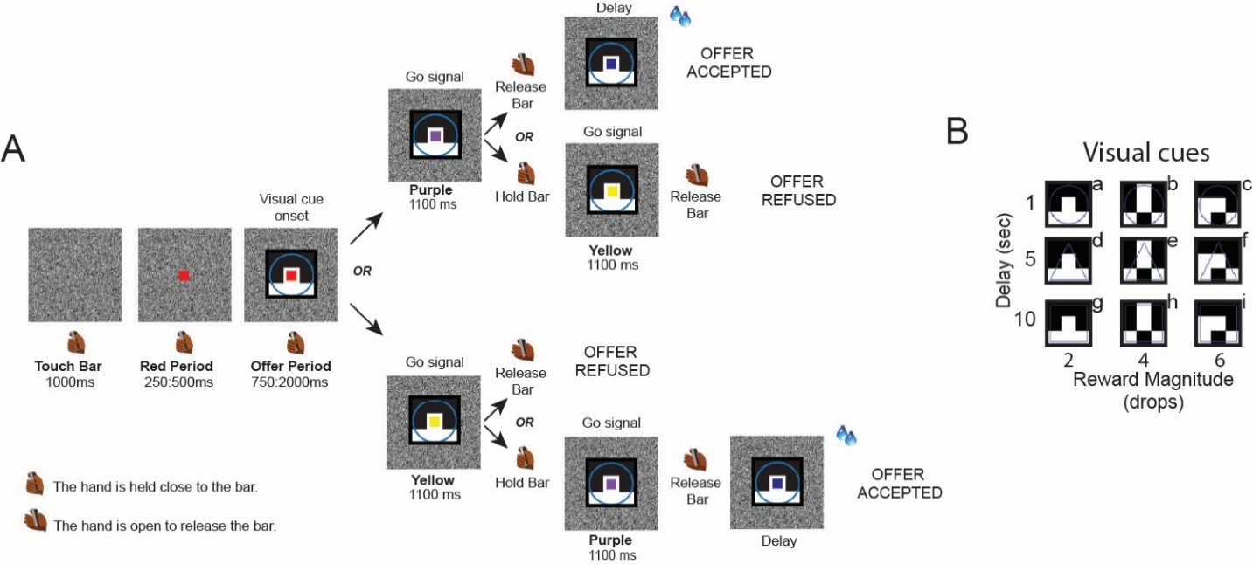

Figure 1. Task description. (A) Each trial begins when the monkey touches and holds a bar. A red square then appears in the center of the screen, followed by a visual cue presented behind the red square. This cue indicates the offer, which is defined by a combination of reward magnitude (2, 4, or 6 drops) and delay (1, 5, or 10 s). Next, the red square changes color to either purple or yellow, serving as a go signal. Releasing the bar following a purple go signal accepts the offer and releasing the bar following a yellow go signal rejects the offer. Specifically, if the go signal is purple, the monkey can release the bar to accept the offer or continue holding the bar until the purple square turns yellow to reject the offer. If the go signal is yellow, the monkey can release the bar to reject the offer or continue holding the bar until the yellow square turns purple to accept the offer. If an offer is accepted, the offer-indicated reward is then delivered after the indicated delay. If an offer is rejected, a new trial will start immediately. (B) The set of nine visual cues used in the task are labeled from “a” to “i”.

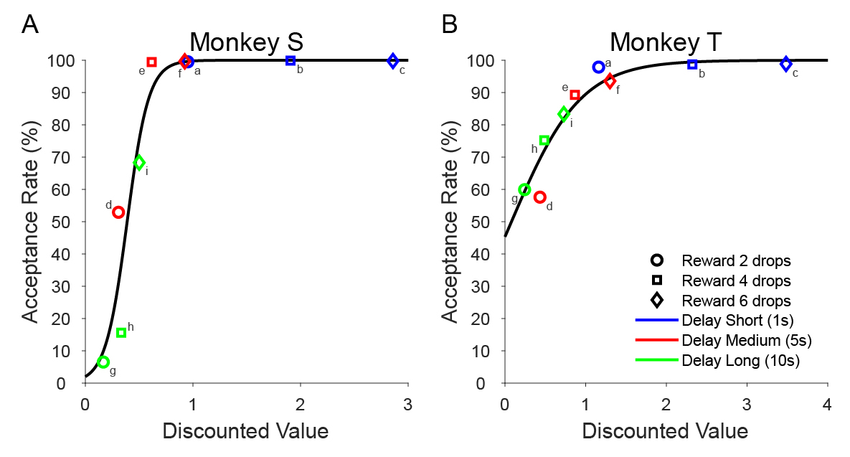
Figure 2. Temporal discounting behavior. Acceptance rate as a function of the discounted value inferred by the model (data: colored points; model: black line) in Monkey S (A) and Monkey T (B). Letters from “a” to “i” indicate the nine possible offers. The three colors represent the different delays (1 s, 5 s or 10 s) and the three shapes represent the reward magnitude (2, 4 or 6 drops).

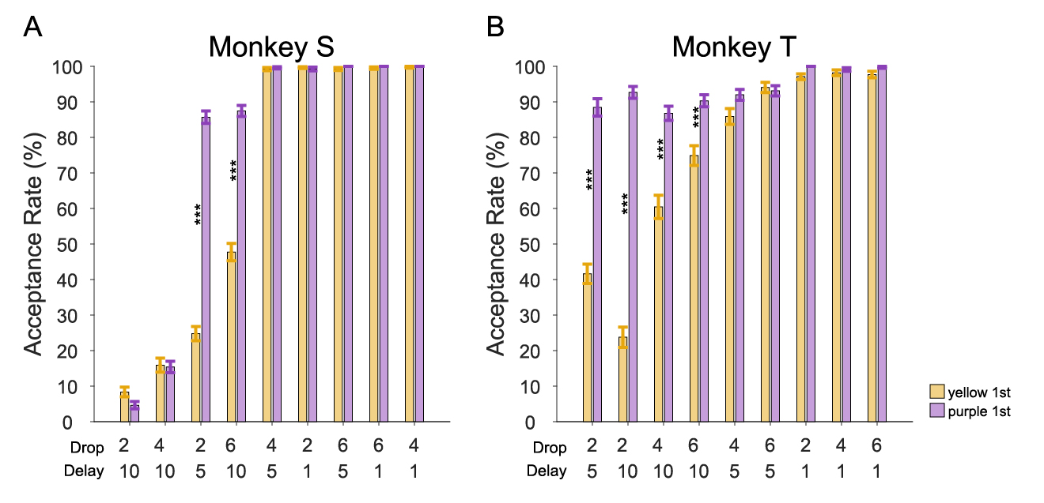Figure 3. Temporal discounting behavior is modulated by the go signal. Acceptance rate for each offer, separated by whether the first go signal was yellow or purple, for Monkey S (A) and Monkey T (B). The offers are sorted by their overall acceptance rate across the nine offers.

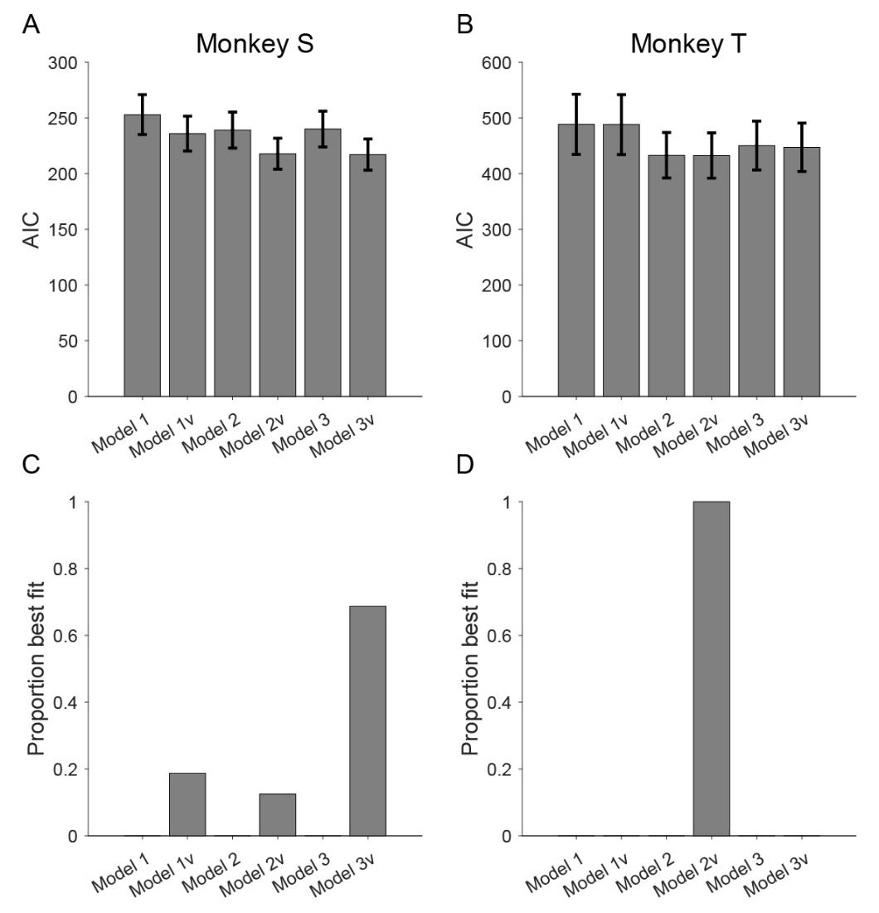
Figure 4. Behavioral Models. Model comparison of AIC values (A and B) and the proportion of best fit models across sessions (C and D) for the six behavioral models in Monkey S (A and C) and Monkey T (B and D).

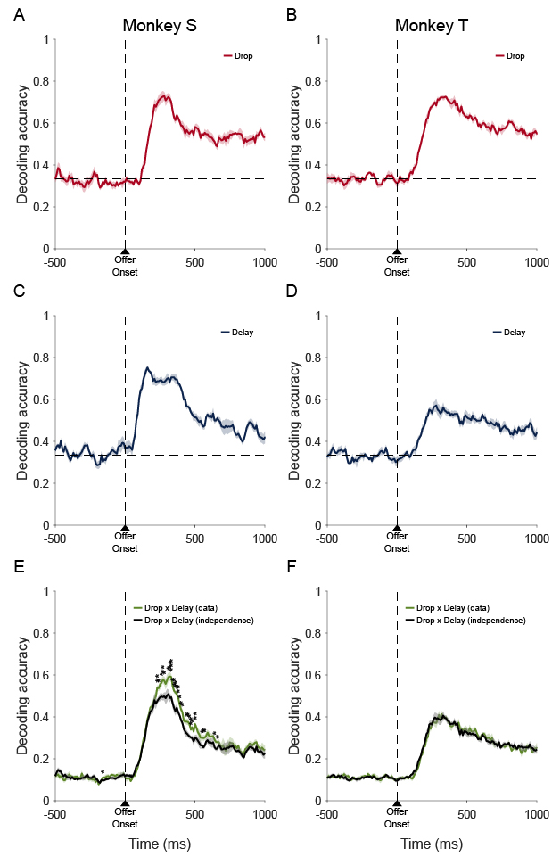
Figure 5. Decoding Analysis and the assessment of the independence of coding for drop vs delay. Decoding accuracy (left for Monkey S; right for Monkey T) was calculated for each task factor: drops (A, B), delay (C, D), and offer identity (E, F). In E and F, the black line represents predicted decoding accuracy, assuming independent neural representation of drop and delay, and the colored (green) line represents actual decoding accuracy from data.

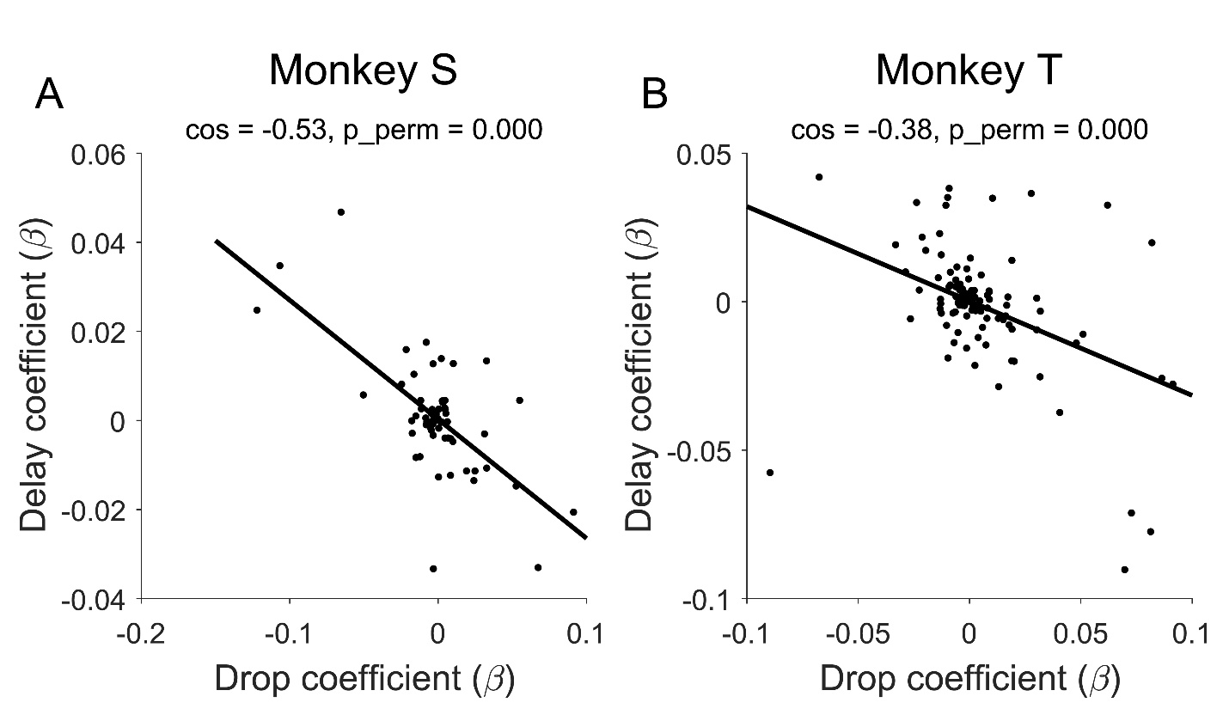
Figure 6. The population coding dimension for drop and delay are anti-aligned. The population encoding dimensions for drop and delay are negatively aligned, measured by cosine similarity, in Monkey S (A) and Monkey T (B). The population encoding dimensions were estimated in a time window from -250ms to 0ms before the go signal.

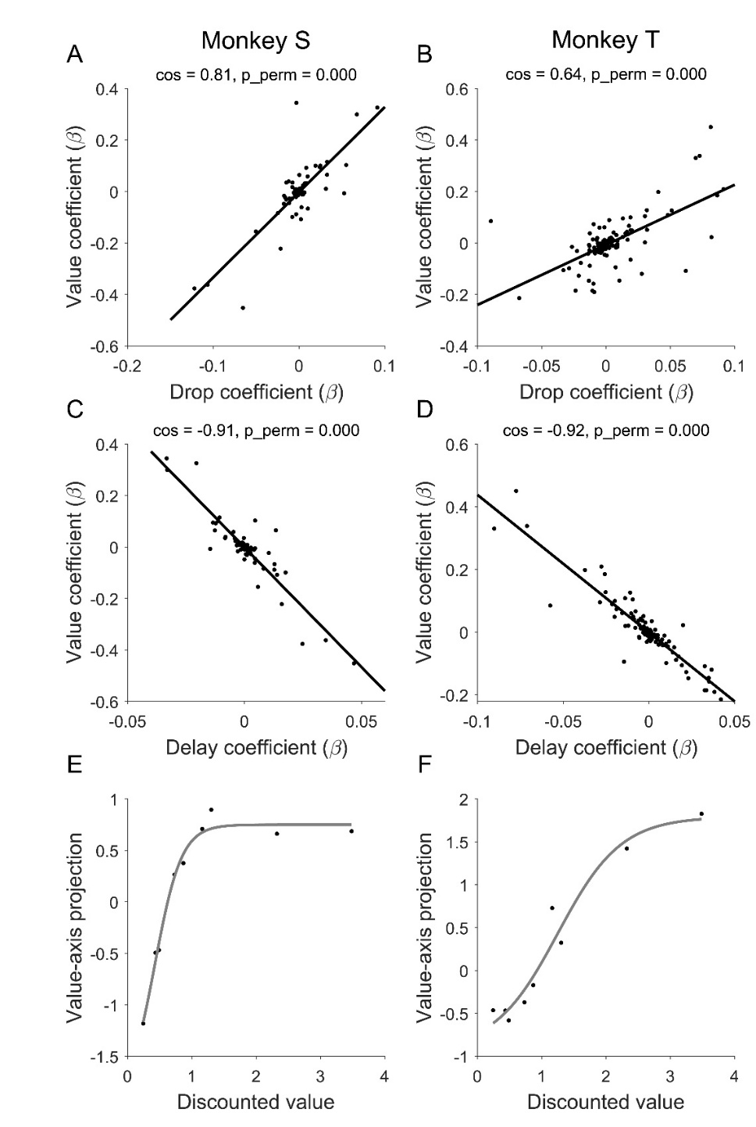
Figure 7. The value coding dimension (left for Monkey S; right for Monkey T). We estimated the population coding dimension for value, this dimension positively aligns with the drop dimension (A, B) and negatively aligns with the delay dimension (C, D). The projected value-axis activity for the nine offers at -250ms to 0ms before the go signal are shown in E and F. The overlayed gray line is a logistic fit to the data.

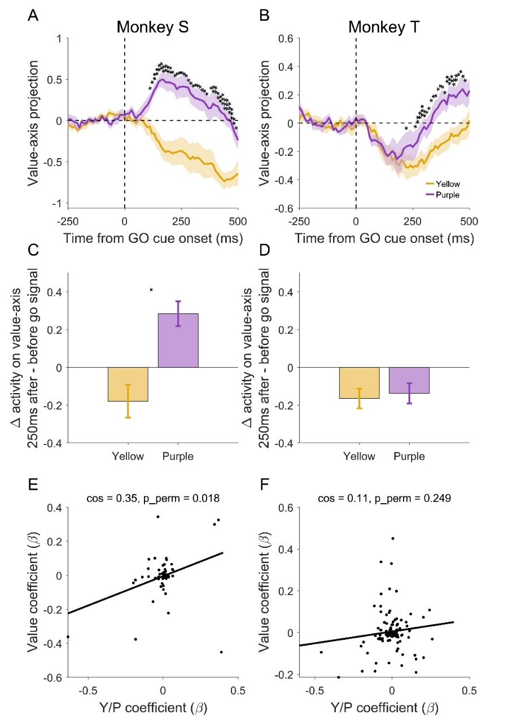
Figure 8. Go signal modulates population activity (left for Monkey S, right for Monkey T). The projected value-axis population activity diverges following the purple vs yellow go signal (A and B). The trajectories are calculated for each offer and then averaged across offers. Baseline activity from -250ms to 0ms before the go signal is subtracted to show the changes of neural activity relative to before the go signal. In Monkey S, within 250ms after the go signal, the purple go signal increases value-axis activity and the yellow go signal decreases value-axis activity (C). The population coding dimension for the go signal positively aligns with the value axis (E). In Monkey T, however, no differences were observed within 250ms after the go signal (D). The coding dimension for the go signal is orthogonal to the value axis (F), suggesting that the processing of the go signal operates in a different subspace than the value-axis.
Supplementary Information
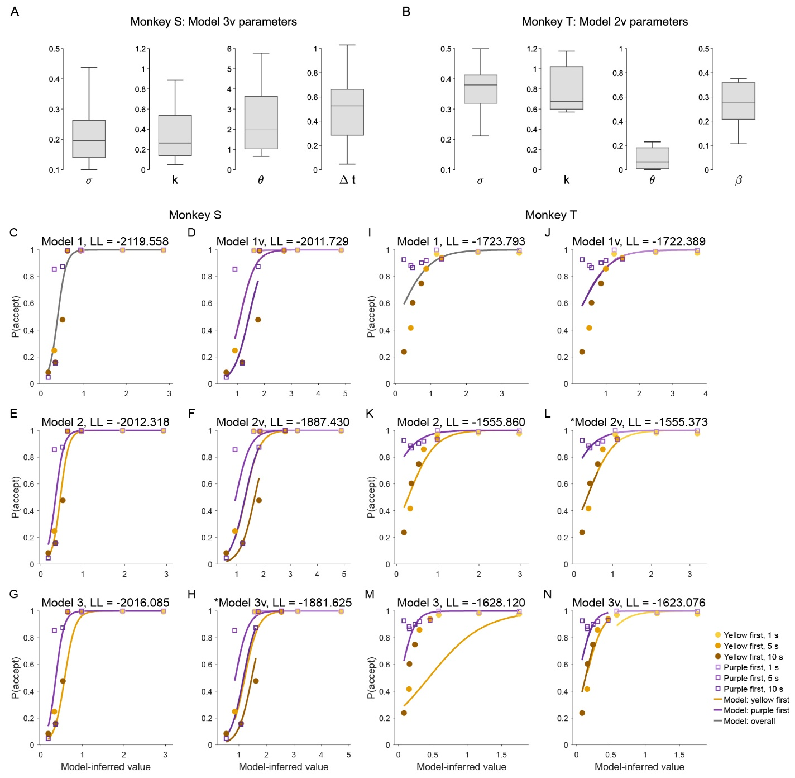
Figure S1. Model parameters and predictions. (A-B). Parameter values from the best-fit models for Monkey S and Monkey T. (C-N). Model-predicted acceptance probability versus data. C-H represent Model 1/1v, 2/2v, 3/3v for Monkey S, and I-N are for Monkey T. Discounted values (using best-fit discounting factor from each model) are plotted on the x-axis. For extended Models 1v/2v/3v, the models predict different p(accept) for different delays for Monkey S, and predict similar p(accept) for different delays for Monkey T.
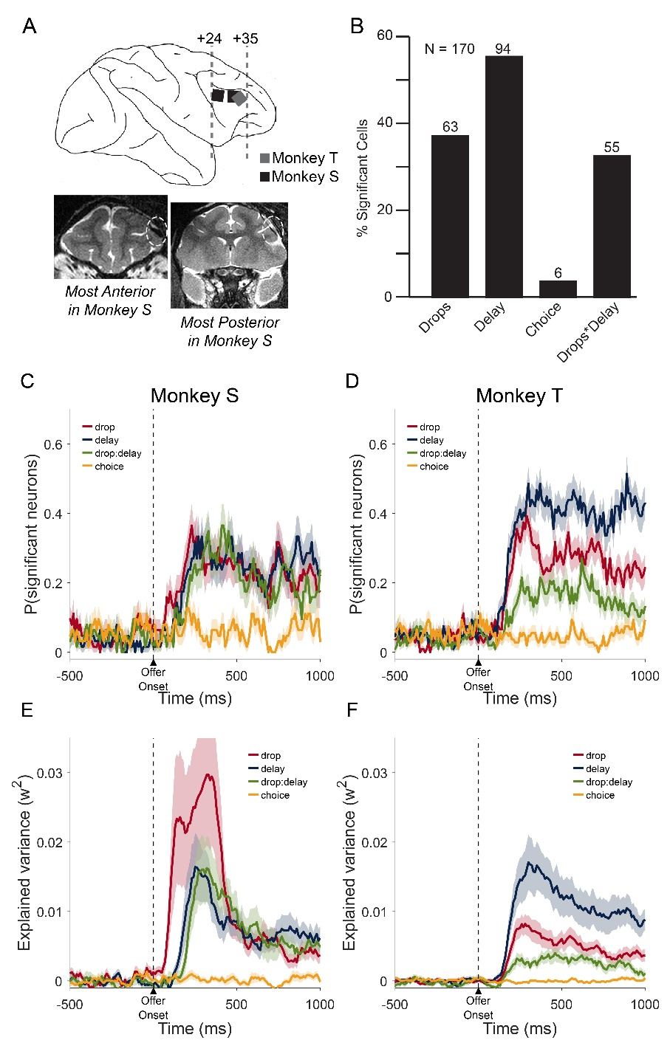
Figure S2. Recording sites and neural modulation by task factors. (A) Schematic representation of the Utah array positions in the dlPFC, reconstructed from MRI scans of Monkeys S and T. Bottom panel: the most anterior and posterior MRI slices of Monkey S, with the Utah arrays highlighted by yellow dashed circles. (B) Percentage of neurons that were significantly modulated by reward drops, delay, their interaction, and upcoming choice. (C–D) The time course of the percentage of neurons modulated significantly by each factor. (E–F) The variance explained for each task factor over time.
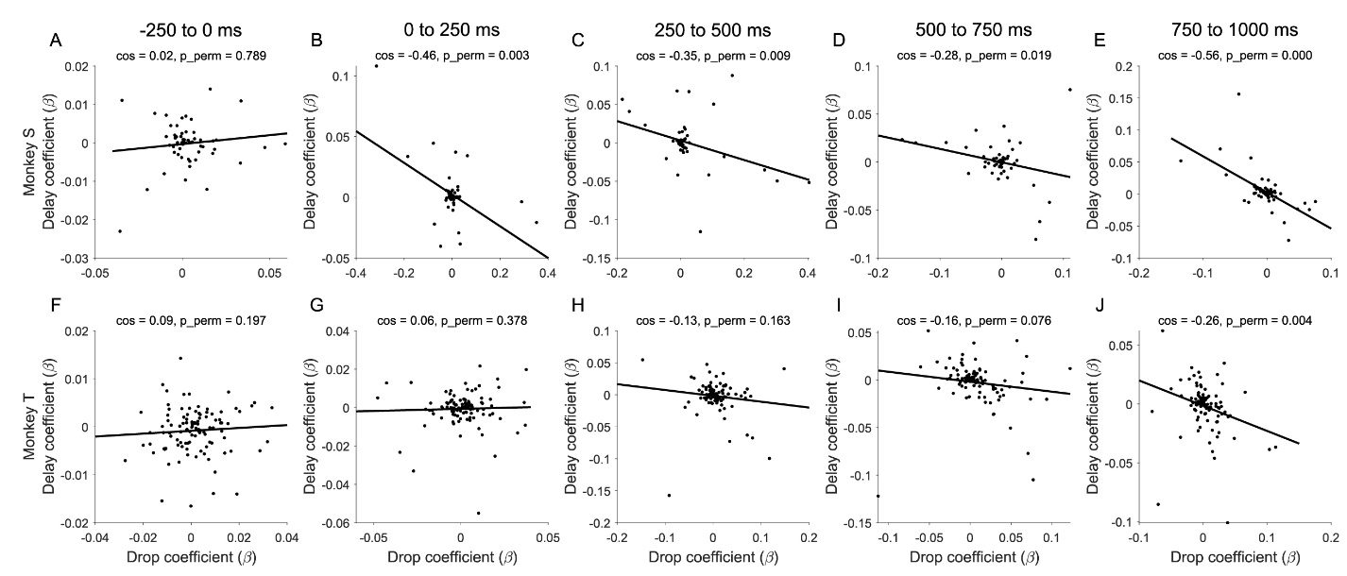
Figure S3. The negative alignment between drop and delay neural encoding dimensions. The population encoding dimensions for drops and delays were calculated in 250ms time bins, before and after the visual offer cue onset for Monkey S (A–E) and Monkey T (F–J).

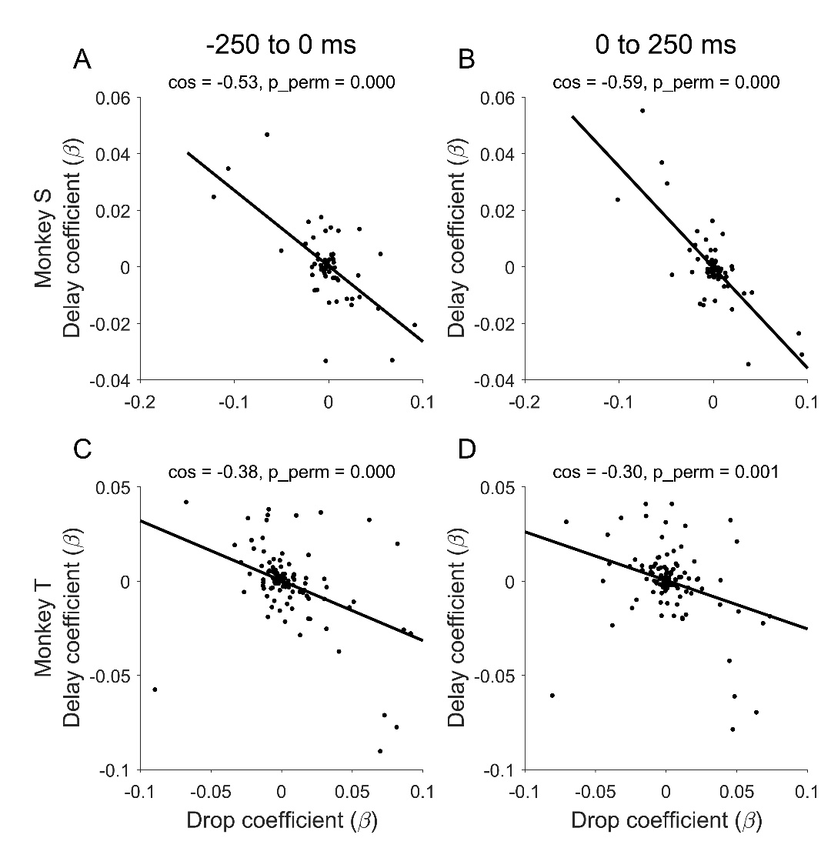
Figure S4. The negative alignment between drop and delay neural encoding dimensions persists after the go signal. The population encoding dimensions for drops and delays were calculated in 250ms time bins, before and after the go signal for Monkey S (A–B) and Monkey T (C–D).

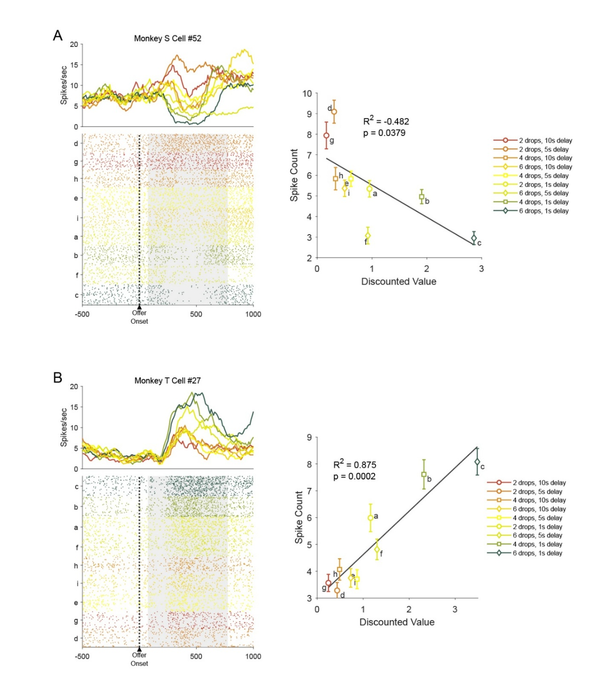
Figure S5. Raster plots and correlation between mean spike count and discounted value. Left panels: example neurons from Monkey S (A) and Monkey T (B). Spike density functions are shown above each raster. The neural activity is aligned to the offer onset and divided into nine offers, which are ordered from the highest to the lowest mean firing rate. The mean firing rate is calculated from 75 to 750ms after the offer onset (shown by the grey shade). Right panels: the linear correlation between the mean spike count for each offer and the model inferred discounted value, corresponding to the neurons shown in the left panels.

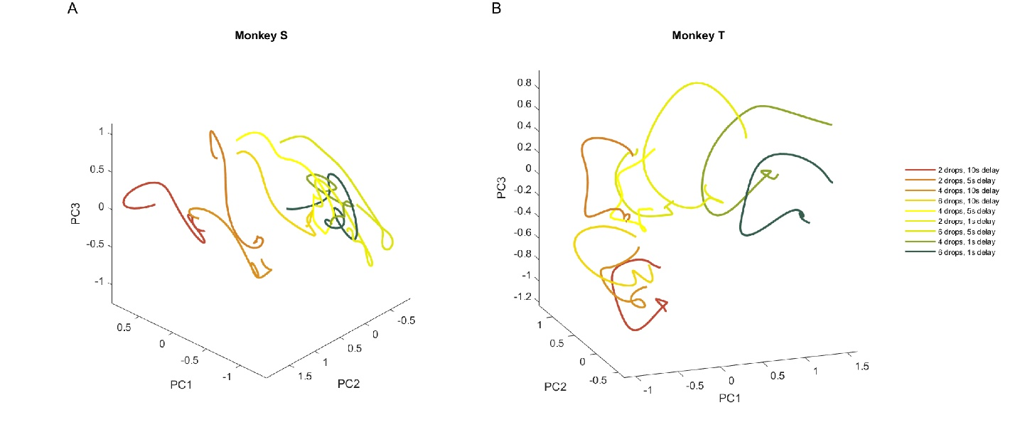
Figure S6. Population trajectories around the go signal. Population trajectories for each offer were plotted in the principal component space, from -250ms before the go signal, to 500ms after the go signal, for Monkey S (A) and Monkey T (B). Qualitatively, the trajectories show more rotations in Monkey T (B) compared to Monkey S (A).

