We thank the reviewers for the thoughtful and constructive feedback. We have substantially revised the manuscript and believe that our revisions have strengthened the manuscript. Please see our point-to-point response below.
Reviewer #1: The manuscript addresses the question of whether there is a temporal discounting computation carried out in the prefrontal cortex, and if this is universal or strategy specific. Two monkeys were trained on a two-step temporal discounting task, and neural recordings were conducted in the dlPFC with seven recordings from one monkey and sixteen from the other. The monkeys showed different strategies for temporal discounting, with only Monkey S adjusting the temporally discounted value based on the go signal. The encoding of reward and delay in dlFPC appeared to be integrated in Monkey S, but encoded independently in the Monkey T, reflecting their different temporal discounting strategies. Both monkeys perform temporal discounting; however, the two-step design of the task doesn't impose a necessity for the animals to update primary temporal discounting computations, demonstrated by the monkeys' use of different strategies. The results are interesting and most of my questions are centered on trying to clarify similarities and differences across the animals.
Main comments
1. Monkey T didn't seem to integrate the delay presented by the go signal with the evaluation of reward and delay of the original offer, and encoded reward and delay independently. Inverse coding of reward and delay following cue onset, during the 'evaluation period,' provides evidence for temporal discounting computations in both monkeys, however does this inverse coding persist following the go signal? Monkey S adjusted the temporal discounted value based on the go signal, but Monkey T did not, therefore there could be a presumed difference in this inverse coding following presentation of the go signal.
Response R1-1:
We thank the reviewer for this suggestion. We have repeated the analysis of the inverse alignment between drop and delay coding dimensions in 250ms windows both before and after the go signal. We found that, in both monkeys, the inverse coding persisted after the go signal (see Figure S4 in the revised manuscript). This suggests that both monkeys continue to have a representation of the offer value even after the go signal.
We have now described this analysis in the main text, as follows, and added the corresponding figure S4.
Copy here!
In response to a comment raised by Reviewer 2, we performed additional analyses to show how the go signal modulates the value coding activity. We reproduce below our response to that comment, and we added Figure 8 in the main text.
Copy text here!

2. Recording sites on Monkey S and Monkey T were quite different. Do the differences in the linearity of coding between the monkeys (10% in Monkey S and 33% in Monkey T) reflect a true difference in linear processing, or is it due to the neurons being sampled from different sites? Is this difference in coding demonstrated in the neurons that are sampled from overlapping areas recorded across the two monkeys?
Response R1-2.1:
We thank the reviewer for raising this important point. Monkey S had two electrode arrays, with the most anterior array mainly overlapping with the location of Monkey T’s array. To control for potential differences in electrode location between animals, we re-analyzed the percentage of linearly coding neurons in Monkey S using only data from the array which mainly overlapped with Monkey T’s array. We found that 7% (3/44) of neurons showed significant linear coding. For comparison, when including all data from Monkey S, the overall percentage of linearly coding neurons was 33% in Monkey T and 10% in Monkey S. Thus, the difference in electrode placement alone is unlikely to account for the between-monkey neural differences we observed.

We discuss this point further in the discussion:
Copy here!

In addition, during the revision, we re-examined our interpretation of “linear coding” and came across an alternative explanation that might be more plausible. This alternative interpretation is inspired by a recent paper by Erin Rich’s group (ref Here) that showed that prefrontal neurons can shift from individual coding to population coding, based on task demand.
We have modified the Discussion accordingly to address this point, as follows:
Copy here

Are there any other differences in distributions for the other analyses that might correlate with anatomical location?
Response R1-2.2:
As for other analyses, we repeated the decoding analysis for Monkey S using only data from the anterior array, which largely overlapped with Monkey T’s array. The results are qualitatively similar to those obtained using all data. This further supports the fact that differences in the array location between the monkeys are unlikely to fully account for the neural differences we observed.
The figure below shows these results.

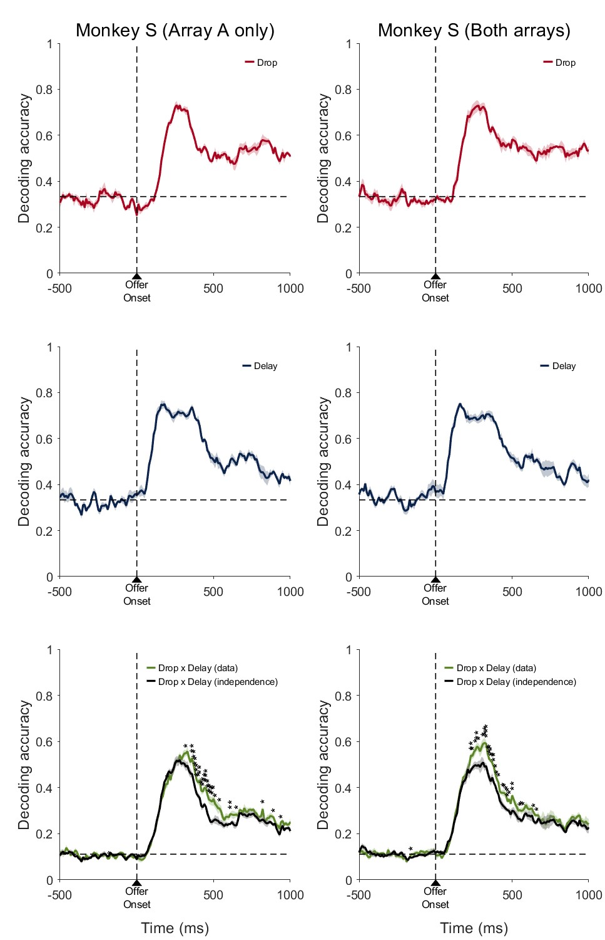
3. How much more training did Monkey S have compared to Monkey T? Perhaps this task would not evoke different strategies for temporal discounting if training was comparable between monkeys. Did early sessions with Monkey S reflect the strategy that Monkey T used, suggesting that increased experienced in the task resulted in shifting strategies?
Response R1-3:
We appreciate this important comment. It is a fair hypothesis that animals’ training history might have contributed to the individual differences observed in our paper.
Since Monkey S shows a more sophisticated strategy than Monkey T, to test this hypothesis, we analyzed pre-recording sessions of Monkey S. If there is a big training effect, we would expect to see a transition phase in Monkey S in which Model 2 best predicts behavior, before entering the final phase in which Model 3 best predicts behavior.

In the figure below, we show, for each session, which model provided the best fit to Monkey S’s behavior, including sessions before and after the neural recording period.

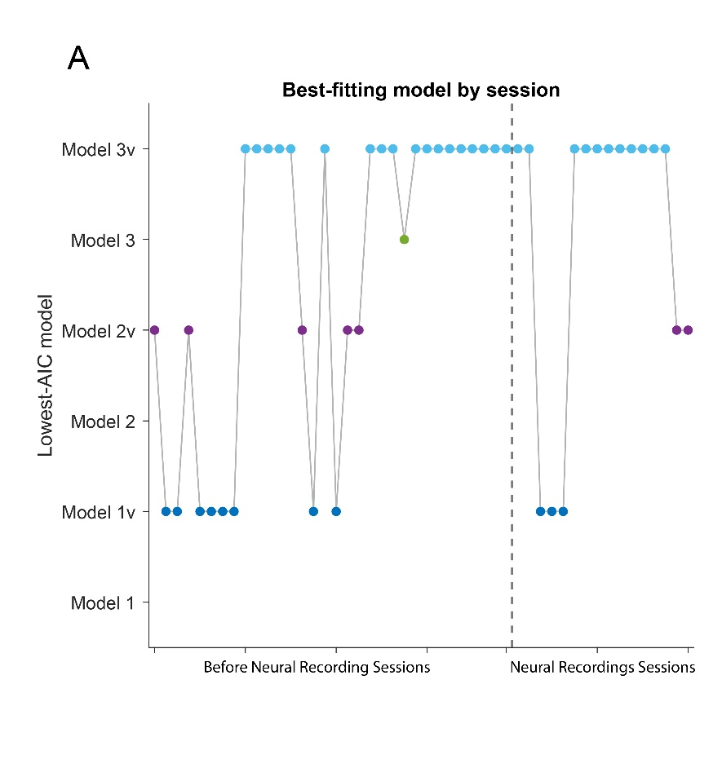
The dash line is the start of recording sessions. The first data point was the first session that Monkey S is exposed to 9 offers. Prior to that, Monkey S was only pre-trained on the purple/yellow go signal with one of the three offers (2 drops, 10 seconds; 4 drops, 5 seconds; 6 drops, 1 second), to teach him about rules for accepting/rejecting the offer.
As you can see, there is no obvious phase of Model 2 domination, in the first 10 sessions. Model 1 dominates behavior, and then it is quite consistent that Model 3 is the best model for Monkey S.
Of course, this analysis is preliminary, but it suggests that is less likely that only training history may have contributed to the individual strategies adopted by the animals.

In order to truly understand how behavioral strategies and their neural correlates evolve with training experience would require longitudinal studies tracking the same animals across different stages of training, but the current dataset does not include such longitudinal information.

We have modified the discussion section accordingly.
Copy the piece here
4. It seems that the majority of the neural results presented are different between the two animals, which is understandable given the goal of the manuscript and the apparent behavioral differences between the two animals. However, it would be nice to have a positive control. Is there some aspect of the animal behavior and corresponding neural coding that is the same?
Response R1-4:

Although the manuscript has a focus on the neural differences that correspond to the different strategies adopted by the two monkeys, there are many common features shared by the two animals, which we outline here.

- Prefrontal cortex encodes drop and delay, features required for temporal discounting computation (Figure S2 C-F). In both animals, the peak decoding accuracy is ~75% for drop, and above 60% for delay (chance level is 33%; Figure 6).
- An inverse alignment of the population coding dimension for drop and delay emerges before the go signal, representing monkey’s choice preference prior to the go signal (Figure S3E and J; Figure S4 A and C).
This finding has been reported in a previous landmark paper (Lee et al., Neuron, 2014) and was interpreted as a hall mark for temporal discounting. Our paper confirmed this finding in both animals, and in addition showed that this inverse coding does not necessarily reflect a unitary strategy/neural computational process.
- When the go signal appears, we observe a purple/yellow difference on the value-coding axis, in both animals (although the story is more complicated in Monkey T, see Figure 8).

Responses on opt in vs opt out? Errors? I am curious about those responses as well even if they aren't the same.
We thank the reviewer for this curious suggestion. However, we were unable to perform this analysis, due to a combination of limited number of abort/opt-out trials, and difficulty in carrying out such analysis thoroughly.
Monkey S aborted fewer than 5% of trials overall, and Monkey T aborted around 14% of trials overall. These are too few trials to perform meaningful analyses. In addition, animals abort for different reasons, and it is not straightforward to combine opt-out trials with different causes. For instance, animals can opt-out by releasing the bar too soon, both during the cue period or within the first 100 ms of the go signal (Monkey S: 2% ± 0.3; Monkey T: 8% ± 0.8). They can also opt-out by releasing the bar too late or never releasing the bar (Monkey S: 2% ± 0.4; Monkey T: 6% ± 1.1; mean ± SEM). Due to these complications, we don’t think such analyses are feasible in the current dataset.
Other comments
1. The cues in the task have visual similarities that co-vary with the delay and drops of juice. There are visually responsive neurons in dlPFC. Is it possible to at least partially isolate responses due the cue by examining when the same cue is in different "roles" (e.g., behind a purple vs yellow cue or when it's accepted vs rejected?)
We thank the reviewer for this critical point. The reviewer is absolutely correct that visual identity of the cue is correlated with drop and delay. It is possible that at least partially, the isolated response to drops/delays are visual responses to the offer cue.
However, we would argue that the responses we observe are driven primarily by the meaningful features of the visual stimulus, such as drops and delays, rather than being merely a visual response. This is because we observed the inverse coding of drop and delay, which is structured and not random, as has also been reported in previous temporal discounting research (Lee et al., year). If these are purely visual responses, it is highly unlikely that the coding dimensions for drop and delay are anti-aligned; they should be nearly orthogonal instead.
2. The explanation (in words) of Model 2 was even more simple and straightforward in the methods, whereas it was a little hard to follow in the results. Would recommend clarifying/rephrasing in the results.
We thank the reviewer for asking us to clarify the description of Model 2 in the main text. In addressing this comment, together with a related point raised by Reviewer 2, we revised the description of the models more broadly to improve clarity and consistency throughout the manuscript. We have revised the Results section accordingly, as follows:

Copy here!
3. The hand/bar icon on Figure 1 (and the difference between open and closed) is a bit hard to see and it made it a little confusing to initially understand the task.
We thank the reviewer for pointing this out. We have revised Figure 1 by adding explanatory text next to the hand icons to clarify that the closed hand represents the monkey holding the response bar, whereas the open hand represents the bar after its release. This should make the task sequence easier to interpret.

Reviewer #2: This review identifies several areas where the manuscript would benefit from clearer conceptual and analytical presentation. The main concerns are that the computational models are not specified sufficiently to evaluate the proposed decision processes, key neural analysis terms and methods require clearer definition, and the link between go-signal-related neural activity, recalculated value, and behavioral strategy remains underdeveloped. Overall, the manuscript addresses an interesting question, but stronger model clarity, methodological transparency, and tighter integration between behavioral and neural findings would substantially improve the interpretation of the results.
1. Clarification of the computational models
To model the differential effects of the purple and yellow go signals, the authors compare three models, Models 1-3, that appear to correspond to different hypothesized decision processes. However, in the current version of the manuscript, the models are difficult to evaluate because their details are not described with sufficient clarity. In particular, the same notation appears to be used for different model components, notation is not always consistent within a given model, and some of the equations may contain errors. These issues make it difficult to determine precisely what decision processes the models are intended to represent.

Response R2-1.0:
We thank the reviewer for carefully assessing our behavioral models. We have unified the notations across models to minimize confusion. In addition, in response to a subsequent comment from the reviewer (see response R2-1.3) we fitted 3 additional models to the data

In the main text, we added a paragraph to describe the common features of these models, before diving into each one, as follows

COPY HERE!

First, the baseline model, which does not incorporate a go-signal-dependent decision process, does not appear to be a reinforcement-learning model as currently described. Rather, it seems to be identical to Model 1, with the parameters V, θ, and βreplaced by DV, θ, and σ, respectively. In addition, in Model 1, if the discounted value is being compared against a decision threshold, the exponent term would seem more naturally expressed as DV-θ, rather than -V-θ.

Response R2-1.1:

We thank the reviewer for carefully examining our behavioral models. The reviewer is correct that the “baseline model” in Figure 2 is equivalent to “Model 1” in Figure 4. The reviewer is also correct that this is not a reinforcement learning model, but rather a simple decision-making model.
We have modified the manuscript to improve clarity, see below:

COPY HERE!

Second, the authors appear to assume that the yellow and purple go signals add or subtract a fixed bias from the discounted value, and that this bias-modulated discounted value is then compared with a decision threshold to determine whether the offer is accepted or rejected. However, the manuscript formulates this process using (-U-θ±β)/σas the exponent of the softmax function. This expression is difficult to interpret because Uis not defined, and βis also used as the inverse-temperature parameter in the baseline model. To improve clarity, the authors may wish to define all variables explicitly and use distinct notation for different quantities. If the intended model is a threshold-based comparison of a bias-modulated discounted value, the exponent might be more clearly written as:
(DV±Bias-θ)/σ
where DVis the discounted value, Biasis the go-signal-dependent bias, θis the decision threshold, and σcontrols choice stochasticity.

Response R2-1.2:
We apologize for the lack of clarity in our description. The reviewer understood our model correctly. We have modified the manuscript to improve the clarity of description. Please see below:

COPY HERE!

Third, Model 3 appears to incorporate a hypothesized process in which the discounted value of the offer is recalculated in anticipation of an additional delay, ΔT. The authors then define a quantity referred to as "total value," which appears to be the sum of the recalculated discounted value of the current offer and the average discounted value of future offers in the task, presumably reflecting the expected value associated with rejecting the current offer.
This "total value" formulation would benefit from further clarification. In response to a go signal, the monkeys are presumably deciding whether to accept or reject the current offer. Therefore, it seems that the quantity entering the softmax function should reflect the relative value of accepting versus rejecting the offer, rather than the sum of these values. Specifically, the exponent of the softmax function would seem to depend on:
V_"accept" -V_"reject"
Under this interpretation, for the yellow go signal, the value of accepting would be the recalculated discounted value of the offer incorporating the additional delay:
V_"accept,yellow" =R/(1+k(D+ΔT))
For the purple go signal, the value of accepting would be the original discounted value of the offer:
V_"accept,purple" =DV
The value of rejecting would also depend on the go-signal condition. For the yellow go signal, if the monkey can reject the offer immediately, then:
V_"reject,yellow" =θ
For the purple go signal, if rejection is associated with an additional delay, then the rejection value should be discounted as:
V_"reject,purple" =θ/(1+kΔT)
Thus, if this is the intended decision process, the softmax exponent should be based on the difference between the value of accepting and the value of rejecting, with each term defined according to the specific go-signal condition.

Response R2-1.3:

The reviewer understood our model conceptually. However, Model 3 (in the original manuscript) had an additional component. We explicitly compared our model and the reduced model that the reviewer described here.

To explain our original model:
In our model, we considered the discounted value of future trials, in addition to the offer value at the current trial. The decision threshold $θ$ (or the value for immediately rejecting the offer) can be viewed as the discounted value of all future trials in a continuous task. When accepting an offer, the value for future trials should be discounted as $h\left(θ, delay\right).$ $h$ is the hyperbolic discounting function (see Response R2-1.0). As a result, the value for accepting the offer $V^{\text{accept}}$, should be the sum of the value of the current offer, and the expected discounted value of all future trials.
$$V^{\text{accept}}={DV}^{current}+ h\left(θ, delay\right)$$

In fact, we realize that we only considered the value of future trials in Model 3, and not in Model 1 and 2. To make a fare comparison, we fitted 6 models in the update manuscript: Model 1,2,3 (without considering value of future trials) and Model 1v,2v,3v (considering future trials).

To clarify, Model1, Model2, and Model 3v are the three models reported in the original manuscript. Model 3 in the original manuscript is renamed to Model 3v in the new manuscript. And the model that the reviewer described here is named Model 3.

We have substantially revised the Methods section and provide the updated text below. We believe that these revisions clarify the model and its implementation. Please see below:

COPY HERE!

More generally, the manuscript would be strengthened by explicitly describing the differential predictions generated by the three models and by reporting the estimated parameters of the best-fitting model. In the absence of these details, it is difficult to assess how the models were fit to the data and how the resulting model comparison supports the authors' interpretation, particularly given the apparent inconsistencies in the current model formulations.

Response R2-1.4:
By comparing goodness-of-fit of the behavioral models to the data, we infer which of the three strategies (Model 1/1v, 2/2v, 3/3v) best describes each animal’s behavior. The best-fit models (among the 6 models) are Model 3v for Monkey S, and Model 2v for Monkey T (see Figure 4).

Following the reviewer’s suggestion, we report the parameters of the best-fit models from the two animals. The parameter values look reasonable. For example, the bias parameter $β$ from Model 2v is positive, suggesting that purple go signal increases $V^{\text{accept}}$, and yellow go signal decreases${ V}^{\text{accept}}$ (see Figure S1A-B).

To assess whether the model captures behavior, we also plotted and visually examined model predicted acceptance probability against data (see Figure S1C-N). Discounted values using best-fit discounting factor $k$ from each model are plotted on the x-axis. For the extended models 1v/2v/3v, given the same discounted value of the offer, the models predict different p(accept) for different delays for Monkey S, but predict similar p(accept) for different delays for Monkey T. This agrees with our interpretation that Monkey S uses additional delays carried by the go signal to adjust temporal discounting calculations (their decision thresholds are delay sensitive), whereas Monkey T treats different go signals just as additional cues and their decision threshold is not adjusted based on delays.
2. Clarification of population coding dimensions
In reporting neural modulation by reward and delay, the authors repeatedly refer to "population coding dimensions" based on beta coefficients from an ANOVA analysis. This approach would benefit from further clarification. In particular, beta coefficients are typically associated with regression models rather than ANOVA, so it would be helpful for the authors to explain how these beta coefficients were obtained from the ANOVA analysis and what specific quantities they represent.
In addition, the definition of "population coding dimensions" should be clarified. For example, are these dimensions intended to represent coordinates or axes defining a subspace of high-dimensional neural activity? Providing a more explicit description of how these dimensions were constructed and how they should be interpreted would make the neural population analyses and the corresponding figures much easier to evaluate.

Response R2-2:
We apologize for the lack of clarity. We rewrote this part of the methods section, and significantly expanded on the method details, as follows:
Copy here
Briefly, the reviewer is correct that the beta coefficients were computed from a linear regression analysis. About the confusion for “beta coefficients from an ANOVA model”: We used the term ANOVA, since ANOVA is a special form of general linear regression. The linear regression model was implemented using MATLAB’s anovan function, which returns both ANOVA statistics and the coefficient estimates from the underlying linear regression model. The β coefficients reported in the manuscript are the slopes from this underlying linear model, rather than ANOVA effect sizes.
The reviewer is also correct that the population dimension is an axes defining a subspace of high-dimensional neural activity.
Please see below the modified Methods section for details.
Copy here!

Population coding dimensions for drop and delay were computed for [-250 0], [0 250], [250 500], [500 750], [750 1000] ms time windows, relative to the offer onset (see Figure). We also computed it for [-250 0] ms before and after the go signal (Figure S4).
Population coding dimension for value was computed at [-250 0] ms before the go signal. ”
3. Clarification of the analysis relating go-signal modulation to recalculated discounted value
To test whether dlPFC neurons represent a recalculated discounted value at the time of the go signal, the authors examine whether neural activity is modulated by the yellow versus purple go signal in a manner similar to its modulation by reward and/or delay, which are integrated into discounted value. This is an interesting analysis, but several aspects would benefit from further clarification.
First, in the figure corresponding to this analysis, the authors correlate "inferred time" with reward and delay modulation. However, the manuscript does not clearly describe what "inferred time" measures or how it was estimated. Providing a more explicit definition of this variable would help readers interpret the analysis.

Response R2-3.1:
We apologize for the confusion. This was actually a mistake on our end, and the “inferred time” was an incorrect label (the figure had the correct data, but the wrong label was from an outdated version). We apologize for not detecting this error in the original submission. The correct label should be “Yellow/Purple coding dimension”. This analysis was intended to show that in Monkey S, and not Monkey T, the population coding dimension for the go signal aligns with the value dimension (which agrees with the hypothesis that Monkey S, and not Monkey T, processes/adjusts the temporally discounted value based on the go signal). Since the reviewer’s next comment is closely related, we will address the methodological details of this analysis as well as the interpretation in Response R2-3.2 (Part II).
Second, it is unclear how neural modulation by the go signal was measured independently of modulation by offer value. The authors present neural activity during the cue period, but not during the period when the go signal was presented, when the potential recalculation of discounted value would presumably occur. In addition, Figures S1 and S2 appear to show that dlPFC neurons exhibit little modulation by the go signal itself. Given this, it is difficult to understand how go-signal-related neural modulation was analyzed in relation to the proposed recalculated discounted value.

Response R2-3.2 (Part I):
Before we dive into the analyses (see Part II below), we want to briefly clarify Figures S1 and S2 in the old manuscript (Figure S2 C-F in the revised manuscript). The ANOVA in Figure S2C-D were carried out at [-500 1000]ms around the offer onset, and not around the go signal. So those figures did not carry any information about whether dlPFC neurons are modulated by the go signal itself. In Response 2-3.2 (Part II), we will explicitly show how the population activity changes around the go signal.
If the authors' interpretation is that dlPFC neurons encode an adjustment of discounted value after the go signal, it would be helpful to show this more directly. For example, the analysis would be more compelling if it demonstrated how neural activity changes from the pre-go-signal to post-go-signal period in a way that reflects the proposed value adjustment.

Response R2-3.2 (Part II): We thank the reviewer for the great suggestion. We carried out additional analyses to explicitly show how go signal shifts population activity along the value-coding dimension, shortly after the go signal.

In the original submission, we showed the population coding dimension for drop and delay are oppositely aligned to each other. We first repeated the same analysis, around the go signal. In both [-250 0]ms before and [0 250]ms after the go signal, we observed a significant negative alignment, between drop and delay, in both animals (Figure S4).
The drop/delay alignment analysis suggests that, drop increases discounted value by pushing population activity in one dimension, whereas delay decreases discounted value by pushing population activity in the opposite direction.
To more explicitly characterize the value coding dimension, we performed a separate regression analysis that extracts the coding dimension for discounted value, using data from -250ms to 0ms before the go signal.

Next, we did a quick sanity check, to confirm that this independently estimated value dimension positively aligns with drop, and negatively aligns with delay (see Figure 7 A-D).

To assess the effect of the go signal on dlPFC neural activity, we projected the population activity along the 1-dimensional value axes defined above, and computed the mean trajectory for each offer, following a yellow versus purple go signal. The average yellow/purple trajectory across all nine offers (baseline corrected by each offer) are plotted in Figure 8 A-B.

In Monkey S, as expected from his behavior, purple offer temporally increases the “value” dimension activity, whereas yellow offer temporally decreases it. In Monkey T, however, we see a different pattern, there is no yellow/purple difference along the value-coding dimension in the first 250ms after the go signal (Figure 8C – D).

For Monkey T, instead of modifying the temporally discounted value, population activity gets routed to a different subspace than the value coding subspace, before returning the value-coding axes. To quantify this, we estimated the population dimension that best encodes yellow/purple go signal using an independent regression (see Methods).
The go signal coding dimension positively aligns with the value dimension in Monkey S, and not in Monkey T (Figure 8E – F).
4. Relating individual differences in neural modulation to behavioral strategy
The authors report that the two monkeys may have used different behavioral strategies and also describe individual differences in several aspects of neural modulation. It would be helpful if the authors could further discuss how these individual differences in neural activity might relate to the observed differences in decision strategy. For example, do the monkey-specific patterns of neural modulation provide a possible mechanistic explanation for differences in how each animal evaluated or responded to the offers? Clarifying this relationship would help strengthen the link between the neural findings and the behavioral interpretation.

Response R2-4:
We thank the reviewer for this important comment. We have partially addressed this comment in Response R2-3.2. We will discuss this again here.

In our paper, we found that while the go signal affected both animals’ acceptance behavior. Behavioral modeling suggests that Monkey S adjusts the temporally discounted value by factoring in the additional delay associated with the go signal, whereas Monkey T treated the go signal as an additional cue, and the go signal simply biases Monkey T’s decision towards accepting (for purple) or rejecting (for yellow), without explicitly re-computing the discounted value.

In the neural analysis, we found two main differences between monkeys that are relevant to the respective behavioral strategy.
Decoding analysis shows that Monkey S forms a neural representation of the interaction of drops and delay, as the neural representation of their interaction could not be explained by the independent representations of the two variables (Figure 5). This suggests that Monkey S had already formed an integrated representation of the offer value before the go signal.
The analysis of the temporal evolution of the coding dimensions of drop and delay further supports this interpretation. In Monkey S, we observed an early inverse alignment between the two coding dimensions, indicating that their relationship was already established early in the offer period and was consistent with the computation of discounted value.
When the go signal appeared, Monkey S could therefore incorporate the additional delay associated with the go signal into this already established value representation, effectively updating the discounted value before making its choice. We further confirm this pattern in Figure 8.

In monkey T, instead, decoding analysis shows that drops and delay are represented independently (Figure 5).
Their integration emerges later. In fact, the inverse alignment between drop and delay only emerged later in the offer period (Figure S3J; 750 ms after cue onset, which is the earliest time point in relation to the first go signal). Although the inverse alignment was present 250 ms before the go signal, we believe that, when the go signal appeared, the relationship between drop and delay was probably just forming.
This is consistent with the behavioral model that suggests Monkey T did not use the go signal to update an already established discounted value, but rather treated it as an additional cue that biased the decision.

The additional analysis suggested by the reviewer further supports this interpretation. As explained in Response R2-3.2, in Monkey S, the purple go signal increased activity along the value dimension, whereas the yellow go signal decreased it within 250 ms after go-signal onset. In contrast, in Monkey T, population activity was routed to a different subspace, orthogonal to the value dimension. This suggests that Monkey T treated the go signal as an additional cue, with a neural representation separate from the value dimension.

We have revised the discussion accordingly, as follows:

COPY HERE!

