We thank the reviewers for their thoughtful and constructive feedback. We have substantially revised the manuscript and believe that our revisions have strengthened the manuscript. Please see our point-to-point response below.
Reviewer #1: The manuscript addresses the question of whether there is a temporal discounting computation carried out in the prefrontal cortex, and if this is universal or strategy specific. Two monkeys were trained on a two-step temporal discounting task, and neural recordings were conducted in the dlPFC with seven recordings from one monkey and sixteen from the other. The monkeys showed different strategies for temporal discounting, with only Monkey S adjusting the temporally discounted value based on the go signal. The encoding of reward and delay in dlFPC appeared to be integrated in Monkey S, but encoded independently in the Monkey T, reflecting their different temporal discounting strategies. Both monkeys perform temporal discounting; however, the two-step design of the task doesn't impose a necessity for the animals to update primary temporal discounting computations, demonstrated by the monkeys' use of different strategies. The results are interesting and most of my questions are centered on trying to clarify similarities and differences across the animals.
Main comments
1. Monkey T didn't seem to integrate the delay presented by the go signal with the evaluation of reward and delay of the original offer, and encoded reward and delay independently. Inverse coding of reward and delay following cue onset, during the 'evaluation period,' provides evidence for temporal discounting computations in both monkeys, however does this inverse coding persist following the go signal? Monkey S adjusted the temporal discounted value based on the go signal, but Monkey T did not, therefore there could be a presumed difference in this inverse coding following presentation of the go signal.
Response R1-1:
We thank the reviewer for this suggestion. We have repeated the analysis of the inverse alignment between drop and delay coding dimensions in 250ms windows both before and after the go signal. We found that, in both monkeys, the inverse coding persisted after the go signal (see Figure S4 in the revised manuscript). This suggests that both monkeys continue to have a representation of the offer value even after the go signal.
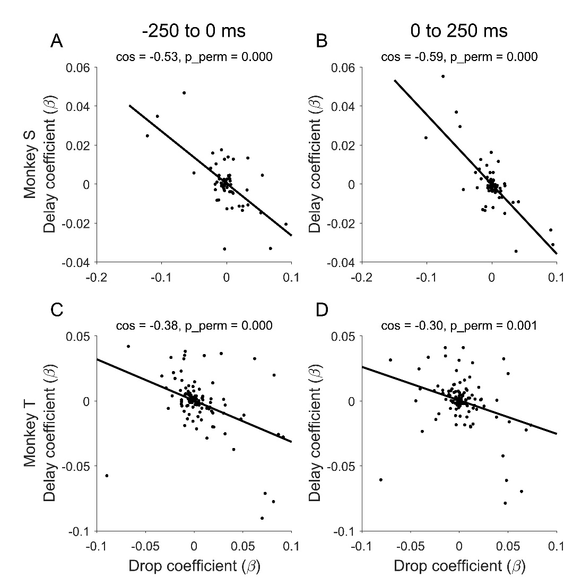
Figure S4. The negative alignment between drop and delay neural encoding dimensions persists after the go signal. The population encoding dimensions for drops and delays were calculated in 250ms time bins, before and after the go signal for Monkey S (A–B) and Monkey T (C–D).

Although both monkeys maintained the value representation (via the negative alignment of drop and delay) after the go signal, the go signal modulates the population activity differently. We performed additional analyses to show how the go signal modulates value coding population activity (We also reported these new analyses in Response R2-3.2 and R2-4 for addressing related comments from Reviewer #2).:
To more explicitly characterize the value coding dimension, we performed a separate regression analysis that extracts the coding dimension for discounted value, using data from -250ms to 0ms before the go signal.

Next, we did a quick sanity check, to confirm that this independently estimated value dimension positively aligns with drop, and negatively aligns with delay (see Figure 7 A-D).
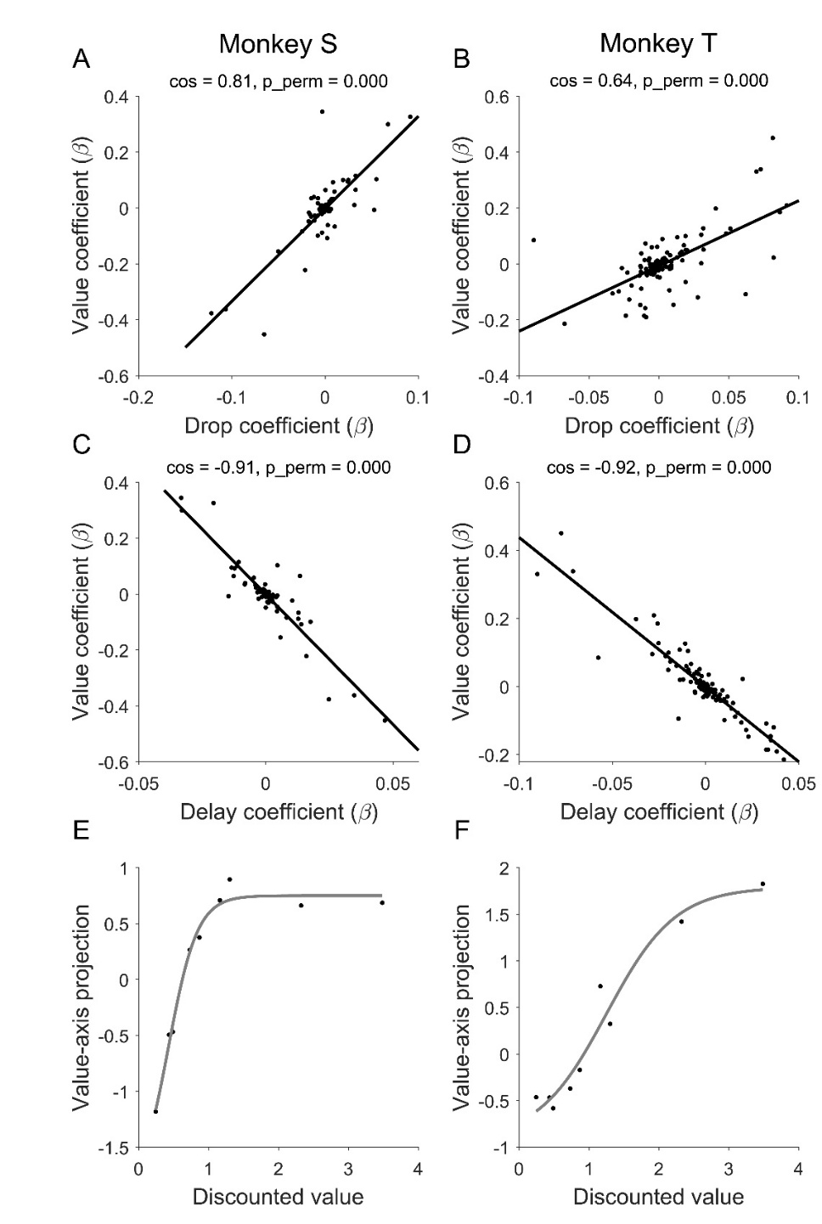
Figure 7. The value coding dimension (left for Monkey S; right for Monkey T). We estimated the population coding dimension for value, this dimension positively aligns with the drop dimension (A, B) and negatively aligns with the delay dimension (C, D). The projected value-axis activity for the nine offers at -250ms to 0ms before the go signal are shown in E and F. The overlayed gray line is a logistic fit to the data.

To assess the effect of the go signal on dlPFC neural activity, we projected the population activity along the 1-dimensional value axis defined above, and computed the mean trajectory for each offer, following a yellow versus purple go signal. The average yellow/purple trajectory across all nine offers (baseline corrected by each offer) are plotted in Figure 8 A-B.

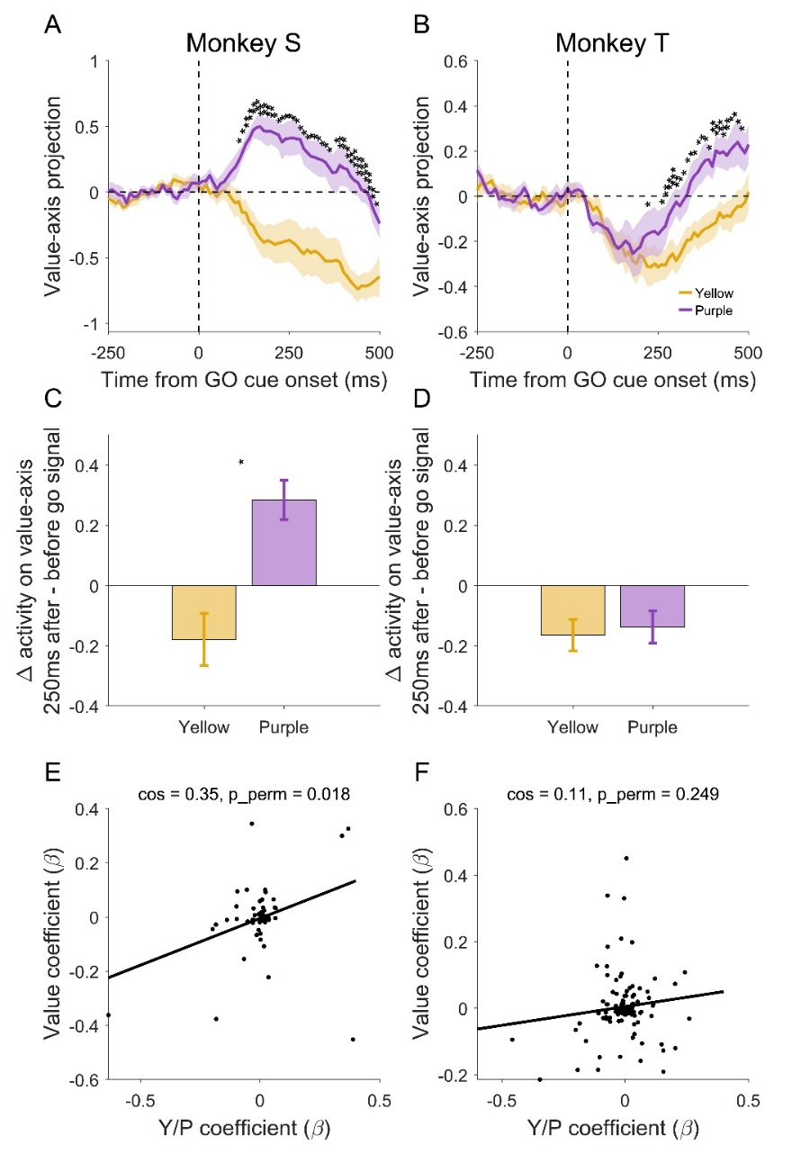
Figure 8. Go signal modulates population activity (left for Monkey S, right for Monkey T). The projected value-axis population activity diverges following the purple vs yellow go signal (A and B). The trajectories are calculated for each offer and then averaged across offers. Baseline activity from -250ms to 0ms before the go signal is subtracted to show the changes of neural activity relative to before the go signal. In Monkey S, within 250ms after the go signal, the purple go signal increases value-axis activity and the yellow go signal decreases value-axis activity (C). The population coding dimension for the go signal positively aligns with the value axis (E). In Monkey T, however, no differences were observed within 250ms after the go signal (D). The coding dimension for the go signal is orthogonal to the value axis (F), suggesting that the processing of the go signal operates in a different subspace than the value-axis.

In Monkey S, as expected from his behavior, purple offer temporally increases the “value” dimension activity, whereas yellow offer temporally decreases it (Figure 8A, C). In Monkey T, however, we see a different pattern, there is no yellow/purple difference along the value-coding dimension in the first 250ms after the go signal (Figure 8D).

For Monkey T, instead of modifying population activity along the value axis, population activity gets routed to a different subspace instead. In fact, both purple/yellow trajectories move downward shortly after the go signal, reflecting shared neural trajectories outside of the value subspace. In other words, purple/yellow trajectories might diverge in dimensions other than the value-coding axis. To test this, we performed a separate analysis to define the coding dimension for purple versus yellow go signal. We then analyzed how well the go signal coding dimension aligned with the value coding dimension. Indeed, we observed a significant positive alignment between go signal coding dimension and value coding dimension in Monkey S (Fig. 8E) and not Monkey T (Fig. 8F).

We have also modified the discussion section and elaborated on the interpretation of the above results, see below:

“Specifically, for monkey S, we observed that the go signals shift the population activity along the value coding axis. The purple go signal increases the value-axis activity and the yellow go signal decreases it (Fig. 8A, C). In an alternative analysis, we showed that the population coding dimension for the go signal aligns with the value axis, suggesting that go signal operates by directly modifying the value representation (Fig. 8E). This is consistent with Monkey S’s behavior that he re-computed the temporally discounted value by considering the additional delay associated with the go signal.
For Monkey T, on the other hand, we observed that the value-axis activity did not diverge based on the go signal immediately after the presentation of the go signal (Fig. 8B). Instead, we observed a rotation of population activity following the go signal in the principal component space (Fig. S6). In fact, the go signal was initially (0-250ms) represented in a neural subspace orthogonal to the value subspace (Fig. 8F), and the co-evolution of the purple/yellow trajectories on the value-axis is a consequence of an orthogonal projection. Even though yellow/purple trajectories separate in high dimensional space, their projections onto the value axis did not separate until after 250ms (Fig. 8D). This early rotation of population activity to the value-orthogonal subspace following the go signal, suggests that the go signal did not directly modify value representation. This is consistent with Monkey T’s behavioral strategy in which the go signal acts as an additional cue that biases decisions without modifying the value of the original offer.”

2. Recording sites on Monkey S and Monkey T were quite different. Do the differences in the linearity of coding between the monkeys (10% in Monkey S and 33% in Monkey T) reflect a true difference in linear processing, or is it due to the neurons being sampled from different sites? Is this difference in coding demonstrated in the neurons that are sampled from overlapping areas recorded across the two monkeys?
Response R1-2.1:
We thank the reviewer for raising this important point. Monkey S had two electrode arrays (one anterior, and one posterior), with the anterior array overlapping with the location of Monkey T’s array. To control for potential differences in electrode location between animals, we re-analyzed the percentage of linearly coding neurons in Monkey S using only data from the anterior array which overlapped with Monkey T’s array. We found that 7% (3/44) of neurons showed significant linear coding. For comparison, when including all data from Monkey S, the overall percentage of linearly coding neurons 10% in Monkey S and was 33% in Monkey T. Thus, the difference in electrode placement alone is unlikely to account for the between-monkey differences we observed.

We now explicitly discuss this potential confound in the discussion section:

“ One possible confound for the neural differences between animals concerns the anatomical locations of the electrodes placed in the dlPFC. Two Utah arrays were implanted in Monkey S: only the anterior array overlaps with the anatomical location in Monkey T (Fig. S2A). To control for variations in electrode location between animals, we performed a separate analysis of the anterior array in Monkey S that anatomically overlaps with Monkey T. Removing the non-overlapping array did not alter the main results. In particular, the anterior array alone revealed that Monkey S had 3 linearly coding neurons out of 44 recorded neurons (~7%), which was substantially lower than the proportion observed in Monkey T (33%). Therefore, differences in recording location alone are unlikely to account for the higher prevalence of linear value coding observed in Monkey T. Nevertheless, this comparison is limited by the relatively small number of neurons recorded and the lack of precise anatomical correspondence between recording sites across animals.”

In addition, during the revision, we re-examined our interpretation of the “linear coding” differences between animals. The low percentage of linear-coding neurons in Monkey S might reflect a more distributed population coding strategy (via the early negative alignment between drop and delay coding) rather than relying on linear-coding in individual neurons. We have expanded our discussion section to further discuss our interpretation of the linear-coding differences between monkeys.

We have modified the corresponding Discussion section, as follows:
“Additional analyses revealed that the neural differences between animals existed prior to the go signal, further supporting the behavioral differences between animals. In both animals, drop and delay are reliably encoded in dlPFC and can be decoded at high accuracy. The peak of the sliding-window decoding analysis suggested that both drop and delay are maximally separable at around 250ms after the offer onset (Fig. 5A-D). Despite similar decoding accuracy, we observed a difference between animals in how individual neurons and the population encode value. For individual neurons, In Monkey S, only 10% of the neurons showed linear modulation by discounted value; in Monkey T, a larger proportion of neurons (> 30%) showed linear value coding. On the population level, however, the negative alignment of the drop versus delay coding dimension emerges early in Monkey S (within 250ms, Fig. S3), but much later in Monkey T (~750ms). The differences between animals suggest a possible tradeoff between value coding in individual neurons versus population. Monkey S relied more on the coordinated activity in the population to represent temporally discounted value, achieved through the opposite alignment of the drop and delay coding subspace. By contrast, Monkey T relied more on individual neurons to encode value. These two modes of information coding strategies, population versus single neuron, were previously reported in prefrontal cortex during a working memory task (22).”

Are there any other differences in distributions for the other analyses that might correlate with anatomical location?
Response R1-2.2:
As for other analyses, we repeated the decoding analysis for Monkey S using only data from the anterior array, which overlapped with Monkey T’s array. The results are qualitatively similar to those obtained using all data (Fig. R1, see below). This further supports that the anatomical variations in electrode locations in dlPFC are unlikely to explain the neural differences we observed between animals.

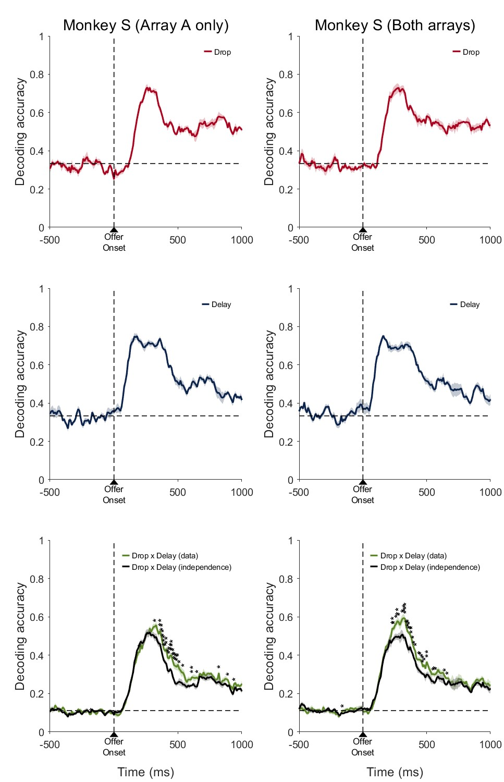
Figure R1 – Decoding analysis for Monkey S. Left: anterior array only. Right: both arrays.
3. How much more training did Monkey S have compared to Monkey T? Perhaps this task would not evoke different strategies for temporal discounting if training was comparable between monkeys. Did early sessions with Monkey S reflect the strategy that Monkey T used, suggesting that increased experienced in the task resulted in shifting strategies?
Response R1-3:
We appreciate this interesting comment. It is a fair hypothesis that animals’ training history might have contributed to the individual differences observed in our paper.
Since Monkey S shows a more sophisticated strategy than Monkey T, to test this hypothesis, we analyzed pre-recording sessions of Monkey S. If there is a big training effect on strategy, we would expect to see a transition phase in Monkey S during which Model 2 (the simplistic strategy adopted by Monkey T) best predicts Monkey S’ behavior, before entering the final phase in which Model 3 best predicts Monkey S’ behavior.

We show, for each session, which model provided the best fit to Monkey S’s behavior, including sessions before and after the neural recording period (Fig. R2, see below).

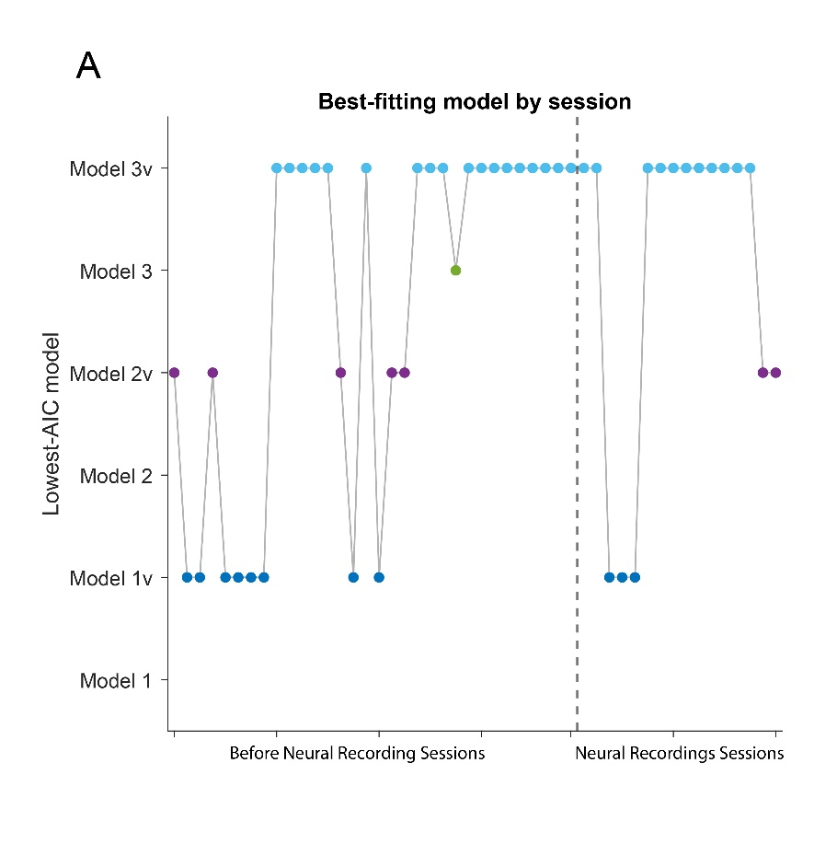
Figure R2 – Best-fit models over all sessions for Monkey S.

The dash line is the start of recording sessions. The first data point was the first session that Monkey S was exposed to the 9 offers. Prior to that, Monkey S was only pre-trained on the purple/yellow go signal with one of the three offers (2 drops, 10 seconds; 4 drops, 5 seconds; 6 drops, 1 second), to teach him about rules for accepting/rejecting the offer.
As you can see, there is no obvious phase that Model 2 dominates Monkey S’ behavior at any point, in the first 8 sessions. Model 1 dominates behavior, and then it is quite consistent that Model 3(or 3v, a variant of Model 3, see Methods) is the best model for Monkey S.
Of course, this analysis is preliminary, but at least in Monkey S, there is no obvious training induced shifts in strategy (from Model 2 to Model 3).

In order to truly understand how behavioral strategies and their neural correlates evolve with training experience would require longitudinal studies tracking the same animals across different stages of training, but the current dataset does not include such longitudinal information.

We have modified the discussion section accordingly.
“One factor that may have contributed to the behavioral differences in strategy observed in this study is training history. We examined early training data in Monkey S, looking for evidence of early adoption of a simpler strategy (Model 2) before transitioning to the more complex strategy (Model 3), but found none. Nevertheless, the question of whether prolonged training would induce systematic shifts in temporal discounting strategies in animals remains interesting. Future longitudinal studies would help to clarify whether these strategies reflect innate individual traits or learned responses based on experience.”
4. It seems that the majority of the neural results presented are different between the two animals, which is understandable given the goal of the manuscript and the apparent behavioral differences between the two animals. However, it would be nice to have a positive control. Is there some aspect of the animal behavior and corresponding neural coding that is the same?
Response R1-4.1:

Although the manuscript has a focus on the neural differences that correspond to the different strategies adopted by the two monkeys, there are several common neural responses shared by the two animals, which we outline here.

- Prefrontal cortex encodes drop and delay, features required for temporal discounting computation (Figure S2 C-F). In both animals, we can reliably decode drop and delay. The peak decoding accuracy is ~75% for drop, and ~60% for delay (chance level is 33%; Figure 5).
- An inverse alignment of the population coding dimension for drop and delay emerges before the go signal in both animals, representing monkey’s choice preference prior to the go signal (Figure 6; S3E and J; Figure S4).
This finding has been reported in a previous landmark paper (Kim et al., Neuron, 2008) and was interpreted as a hallmark for temporal discounting. Our paper confirmed this finding in both animals, and in addition showed that this inverse coding does not necessarily reflect a unitary strategy/neural computational process.
- After the go signal appears, we observe a purple/yellow difference, in both animals (although the story is more complicated in Monkey T, see Figure 8).

Responses on opt in vs opt out? Errors? I am curious about those responses as well even if they aren't the same.
Response R1-4.2:
We thank the reviewer for this curious suggestion. However, we were unable to perform this analysis, due to a combination of limited number of abort/opt-out trials, and the difficulty in analyzing opt-out trials.
Monkey S aborted fewer than 5% of trials overall, and Monkey T aborted around 14% of trials overall. These are too few trials to perform meaningful neural analyses. In addition, animals abort/opt-out for different reasons, and it is not straightforward to combine opt-out trials with different causes. For instance, animals can opt-out by releasing the bar too soon, both during the cue period or within the first 100ms of the go signal (Monkey S: 2% ± 0.3; Monkey T: 8% ± 0.8). They can also opt-out by releasing the bar too late or never releasing the bar (Monkey S: 2% ± 0.4; Monkey T: 6% ± 1.1; mean ± SEM). Due to these complications, we don’t think such analyses are feasible in the current dataset.
Other comments
1. The cues in the task have visual similarities that co-vary with the delay and drops of juice. There are visually responsive neurons in dlPFC. Is it possible to at least partially isolate responses due the cue by examining when the same cue is in different "roles" (e.g., behind a purple vs yellow cue or when it's accepted vs rejected?)
We thank the reviewer for this critical point. The reviewer is absolutely correct that visual identity of the cue is correlated with drop and delay. It is possible that at least partially, the isolated response to drops/delays are visual responses to the offer cue.

However, we would argue that the responses we observe are driven primarily by the meaningful features of the visual stimulus, namely drops and delays, rather than being merely a visual response. This is because we observed the inverse alignment of coding dimensions of drop and delay, which is structured and not random, as has also been reported in previous temporal discounting research (Kim et al., Neuron, 2008). If these are purely visual responses, it is highly unlikely that the coding dimensions for drop and delay are anti-aligned; they should be nearly orthogonal instead.
2. The explanation (in words) of Model 2 was even more simple and straightforward in the methods, whereas it was a little hard to follow in the results. Would recommend clarifying/rephrasing in the results.
We thank the reviewer for asking us to clarify the description of Model 2 in the main text. In addressing this comment, together with a related point raised by Reviewer 2 (See Response R2-1 to Reviewer #2), we revised the description of the models more broadly to improve clarity and consistency throughout the manuscript. We have revised the Results section accordingly, as follows:

“The second simplistic strategy (Model 2; see Methods) assumes that the go signals biases animals towards either being more (or less) likely to accept an offer, in a way that is independent of the value of the original offer. This model operates by assigning a value to each go signal, and adding the value of the go signal to the value of the original reward offer to bias decisions.”
3. The hand/bar icon on Figure 1 (and the difference between open and closed) is a bit hard to see and it made it a little confusing to initially understand the task.
We thank the reviewer for pointing this out. We have revised Figure 1 (see below) by adding explanatory text next to the hand icons to clarify that the closed hand represents the monkey holding the response bar, whereas the open hand represents the bar after its release. This should make the task sequence easier to interpret.

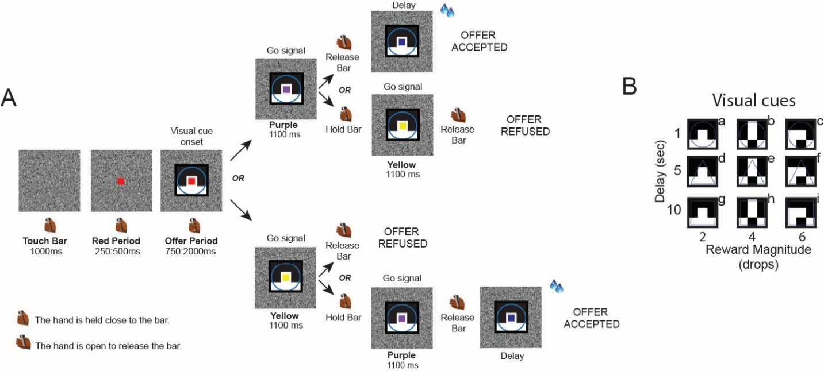

Reviewer #2: This review identifies several areas where the manuscript would benefit from clearer conceptual and analytical presentation. The main concerns are that the computational models are not specified sufficiently to evaluate the proposed decision processes, key neural analysis terms and methods require clearer definition, and the link between go-signal-related neural activity, recalculated value, and behavioral strategy remains underdeveloped. Overall, the manuscript addresses an interesting question, but stronger model clarity, methodological transparency, and tighter integration between behavioral and neural findings would substantially improve the interpretation of the results.
1. Clarification of the computational models
To model the differential effects of the purple and yellow go signals, the authors compare three models, Models 1-3, that appear to correspond to different hypothesized decision processes. However, in the current version of the manuscript, the models are difficult to evaluate because their details are not described with sufficient clarity. In particular, the same notation appears to be used for different model components, notation is not always consistent within a given model, and some of the equations may contain errors. These issues make it difficult to determine precisely what decision processes the models are intended to represent.

Response R2-1.0:
We thank the reviewer for carefully assessing our behavioral models. We have unified the notations across models to minimize confusion. In addition, in response to a subsequent comment from the reviewer (see response R2-1.3) we fitted 3 additional models to the data.

In the Methods section, we added a paragraph to describe the common features of these models, before diving into each one, as follows

“Overview of behavioral models
We fitted a total of six behavioral models to the data, consisting of three base models (Model 1, 2, 3) and three model variants (Model 1v, 2v, 3v). The three sets of models (Model 1/1v, 2/2v, 3/3v) made different assumptions on the decision processes (i.e., how the go signal modifies the temporally discounted value). We will first describe the common assumptions adopted by all models.
In all models, it is assumed that animals compute the expected value for accepting the offer $V^{\text{accept}}$, and the expected value for rejecting the offer $V^{\text{reject}}$, and accept/reject decisions are made by comparing $V^{\text{accept}}$ and $V^{\text{reject}}$ using the softmax decision rule:
$$p\left(accept\right)=\frac{1}{1+e^{-\frac{V^{accept}-V^{reject} }{σ}}}$$
Here, $σ$ is a decision noise parameter that captures choice stochasticity.
In all models, it is also assumed that the hyperbolic discounting function $h(R, D)$ is used to calculate temporally discounted values. A reward $R$ at a delay $D$ has temporally discounted value $h\left(R,D\right)$
$$h\left(R, D\right)=\frac{R}{1+k⋅D}$$
𝑤here $k$ is the hyperbolic discounting parameter.”

First, the baseline model, which does not incorporate a go-signal-dependent decision process, does not appear to be a reinforcement-learning model as currently described. Rather, it seems to be identical to Model 1, with the parameters V, θ, and βreplaced by DV, θ, and σ, respectively. In addition, in Model 1, if the discounted value is being compared against a decision threshold, the exponent term would seem more naturally expressed as DV-θ, rather than -V-θ.

Response R2-1.1:

We thank the reviewer for carefully examining our behavioral models. The reviewer is correct that the “baseline model” in Figure 2 is equivalent to “Model 1” in Figure 4. The reviewer is also correct that this is not a reinforcement learning model, but rather a simple decision-making model.
We have modified the manuscript to improve clarity, see below:

“Model 1
Model 1 is a baseline model which assumes that temporal discounting decisions are made, independent of the go signal. The accept/reject decisions are made by comparing the temporally discounted value DV of the offers against a decision threshold $θ$. Animals will be more likely to accept an offer when DV is above θ, and more likely to reject it otherwise.
The temporally discounted values are computed for each of the 9 offers. For the drop and delay associated with each offer, we have
$$DV= h\left(\text{drop}, \text{delay}\right)=\frac{\text{drop}}{1+k⋅\text{delay}}$$
The value for accepting the offer is simply the discounted value, $V^{\text{accept}}=DV$, and the value for rejecting the offer is the decision threshold $V^{reject}=θ$.
Thus, via the softmax decision rule, we have
$$p\left(accept\right)=\frac{1}{1+e^{-\frac{DV-θ}{σ}}}$$
”

Second, the authors appear to assume that the yellow and purple go signals add or subtract a fixed bias from the discounted value, and that this bias-modulated discounted value is then compared with a decision threshold to determine whether the offer is accepted or rejected. However, the manuscript formulates this process using (-U-θ±β)/σas the exponent of the softmax function. This expression is difficult to interpret because Uis not defined, and βis also used as the inverse-temperature parameter in the baseline model. To improve clarity, the authors may wish to define all variables explicitly and use distinct notation for different quantities. If the intended model is a threshold-based comparison of a bias-modulated discounted value, the exponent might be more clearly written as:
(DV±Bias-θ)/σ
where DVis the discounted value, Biasis the go-signal-dependent bias, θis the decision threshold, and σcontrols choice stochasticity.

Response R2-1.2:
We apologize for the lack of clarity in our description. The reviewer understood our model correctly. We have modified the manuscript to improve the clarity of description. Please see below:

“Model 2
In Model 2, we assume that the go signals have additive values which can bias decisions towards accepting or rejecting. In other words, the go signal may increase or decrease the value of the reward offer by a constant amount, independent of the original discounted value of the offer. The additive value is parameterized symmetrically for the two go signals: $β$ for purple, and $-β$ for yellow. The value for accepting the offer $V^{\text{accept}}$ is the sum of the discounted value of the offer, and the value of the go signal:
$$V^{\text{accept}}=\left\{\begin{aligned}DV+β, &\text{go=purple} \\ DV-β, &\text{go=yellow}\end{aligned}\right.$$
The value for rejecting the offer $V^{\text{reject}}=θ$, as in Model 1$.$
The acceptance probability is then:
$$p\left(accept\right)=\frac{1}{1+e^{-\frac{V^{\text{accept}}-θ}{σ}}}$$
”
Third, Model 3 appears to incorporate a hypothesized process in which the discounted value of the offer is recalculated in anticipation of an additional delay, ΔT. The authors then define a quantity referred to as "total value," which appears to be the sum of the recalculated discounted value of the current offer and the average discounted value of future offers in the task, presumably reflecting the expected value associated with rejecting the current offer.
This "total value" formulation would benefit from further clarification. In response to a go signal, the monkeys are presumably deciding whether to accept or reject the current offer. Therefore, it seems that the quantity entering the softmax function should reflect the relative value of accepting versus rejecting the offer, rather than the sum of these values. Specifically, the exponent of the softmax function would seem to depend on:
V_"accept" -V_"reject"
Under this interpretation, for the yellow go signal, the value of accepting would be the recalculated discounted value of the offer incorporating the additional delay:
V_"accept,yellow" =R/(1+k(D+ΔT))
For the purple go signal, the value of accepting would be the original discounted value of the offer:
V_"accept,purple" =DV
The value of rejecting would also depend on the go-signal condition. For the yellow go signal, if the monkey can reject the offer immediately, then:
V_"reject,yellow" =θ
For the purple go signal, if rejection is associated with an additional delay, then the rejection value should be discounted as:
V_"reject,purple" =θ/(1+kΔT)
Thus, if this is the intended decision process, the softmax exponent should be based on the difference between the value of accepting and the value of rejecting, with each term defined according to the specific go-signal condition.

Response R2-1.3:

The reviewer understood our model conceptually. However, Model 3 (in the original manuscript) had an additional component. We explicitly compared our model and the reduced model that the reviewer described here.

To explain our original model:
In our model, we considered the discounted value of future trials, in addition to the offer value at the current trial. The decision threshold $θ$ (or the value for immediately rejecting the offer) can be viewed as the discounted value of all future trials in a continuous task. When accepting an offer, the value for future trials should be discounted as $h\left(θ, delay\right).$ $h$ is the hyperbolic discounting function (see Response R2-1.0). As a result, the value for accepting the offer $V^{\text{accept}}$, should be the sum of the value of the current offer, and the expected discounted value of all future trials.
$$V^{\text{accept}}={DV}^{current}+ h\left(θ, delay\right)$$

In fact, we realize that we only considered the value of future trials in Model 3, and not in Model 1 and 2. To make a fare comparison, we fitted 6 models in the update manuscript: Model 1,2,3 (without considering value of future trials) and Model 1v,2v,3v (considering future trials).

To clarify, Model1, Model2, and Model 3v were the three models reported in the original manuscript. Model 3 in the original manuscript is renamed to Model 3v in the new manuscript. And the model that the reviewer described here is named Model 3.

We have substantially revised the Methods section and provide the updated text below. We believe that these revisions clarify the model and its implementation. Please see below:

“Model 3
In Model 3, we assume that animals re-calculate the discounted value of offers, in anticipation of an additional delay predicted by the go signal.
If the go signal is purple, animals can accept the offer right away. However, if the go signal is yellow, animals must wait for an additional delay Δt, for the go signal to turn purple, in order to accept the offer. This effectively decreases the value for accepting the offer following the yellow go signal.
On the other hand, if the go signal is yellow, animals can reject right away. However, if the go signal is purple, they must wait for an addition delay, for the go signal to turn yellow, in order to reject the offer. This effectively decreases the value for rejecting the offer following the purple go signal.
Formally, following yellow go signals, the value for accepting the offer $V^{\text{accept}}$ equals the re-computed discounted value
$$V^{\text{accept}}=h\left(drop,delay+Δt\right)=\frac{drop}{1+k⋅(delay+Δt)}$$
and the value for rejecting the offer
$${ V}^{\text{reject}}=θ$$
where $θ$ is the decision threshold.
Following purple go signals, $V^{\text{accept}}$ is the original discounted value
$$V^{\text{accept}}=DV$$
and the value for rejecting the offer is discounted
$${ V}^{\text{reject}}=h\left(θ, Δt\right)=\frac{θ}{1+k⋅Δt}$$
As in previous models, decisions are made via the softmax rule, by comparing $V^{\text{accept}}$ and $V^{\text{reject}}$.
Extended Models
In the base models, the value for accepting the offer is assumed to be the adjusted discounted value of the current offer, without considering discounted values from future trials. Since accepting an offer with longer delay would postpone the start of the next trial, the discounted future reward should be less when accepting offers with longer delays.
The decision threshold $θ$ (or the value for immediately rejecting the offer) can be viewed as the discounted value of all future trials in a continuous task. When accepting an offer, the value for future trials should be discounted as $h\left(θ, delay\right).$ As a result, the value for accepting the offer, should be the sum of the value of the current offer, and the expected discounted value of all future trials.
$$V^{\text{accept}}={DV}^{current}+ h\left(θ, delay\right)$$
The models Model 1v, Model 2v, Model 3v are variants of Model 1, Model 2, Model 3, respectively, and they explicitly account for the discounted value for future trials.
For Model 1v,
$$V^{\text{accept}}=h\left(drop, delay\right)+h\left(θ, delay\right)=DV+h(θ, delay)$$
$$V^{reject}=θ$$
For Model 2v,
$$V^{\text{accept}}=\left\{\begin{aligned}DV+β+h(θ, delay), &\text{go=purple} \\ DV-β+h(θ, delay), &\text{go=yellow}\end{aligned}\right.$$
$$V^{reject}=θ$$
For Model 3v,
$$V^{\text{accept}}=\left\{\begin{aligned}h\left(drop,delay\right)+h(θ, delay), &\text{go=purple} \\ h\left(drop,delay+Δt\right)+h(θ, delay+Δt), &\text{go=yellow}\end{aligned}\right.$$
$$V^{reject}=\left\{\begin{aligned}h(θ, Δt), &\text{go=purple} \\ θ, &\text{go=yellow}\end{aligned}\right.$$

”
More generally, the manuscript would be strengthened by explicitly describing the differential predictions generated by the three models and by reporting the estimated parameters of the best-fitting model. In the absence of these details, it is difficult to assess how the models were fit to the data and how the resulting model comparison supports the authors' interpretation, particularly given the apparent inconsistencies in the current model formulations.

Response R2-1.4:
By comparing goodness-of-fit of the behavioral models to the data, we infer which of the three strategies (Model 1/1v, 2/2v, 3/3v) best describes each animal’s behavior. The best-fit models (among the 6 models) are Model 3v for Monkey S, and Model 2v for Monkey T (Figure 4, see below).
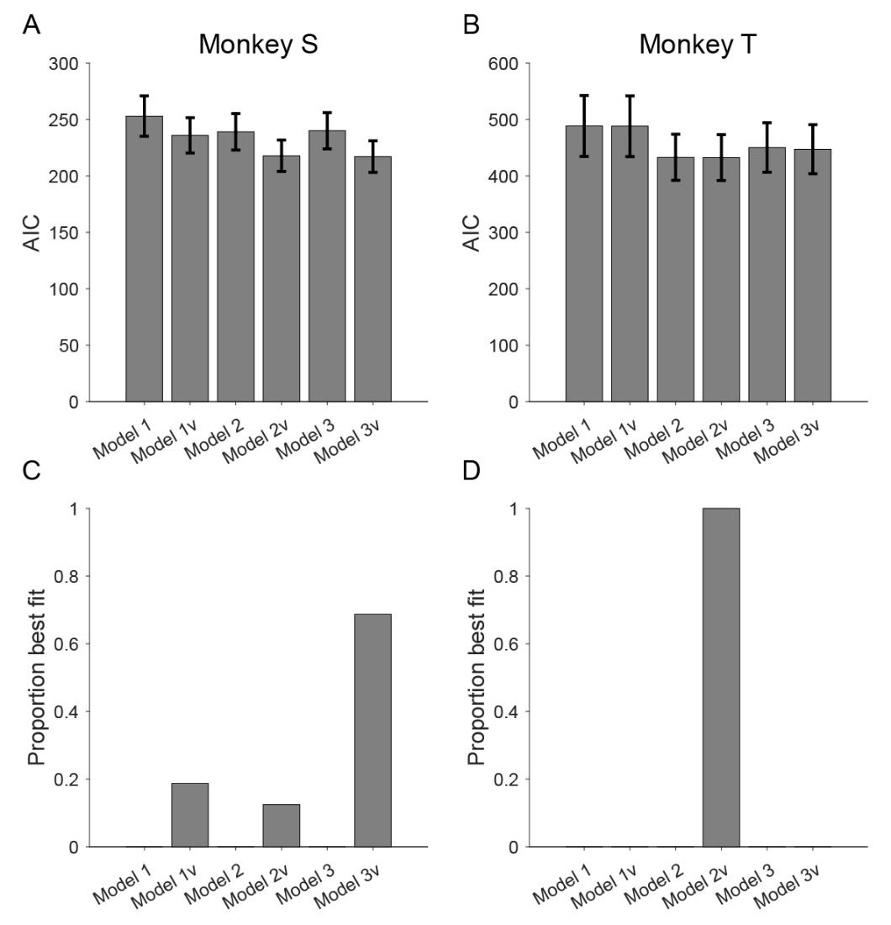
Figure 4. Behavioral Models. Model comparison of AIC values (A and B) and the proportion of best fit models across sessions (C and D) for the six behavioral models in Monkey S (A and C) and Monkey T (B and D).

Following the reviewer’s suggestion, we report the parameters of the best-fit models from the two animals. The parameter values look reasonable. For example, the bias parameter $β$ from Model 2v is positive, suggesting that purple go signal increases $V^{\text{accept}}$, and yellow go signal decreases${ V}^{\text{accept}}$ (Figure S1A-B, see below).
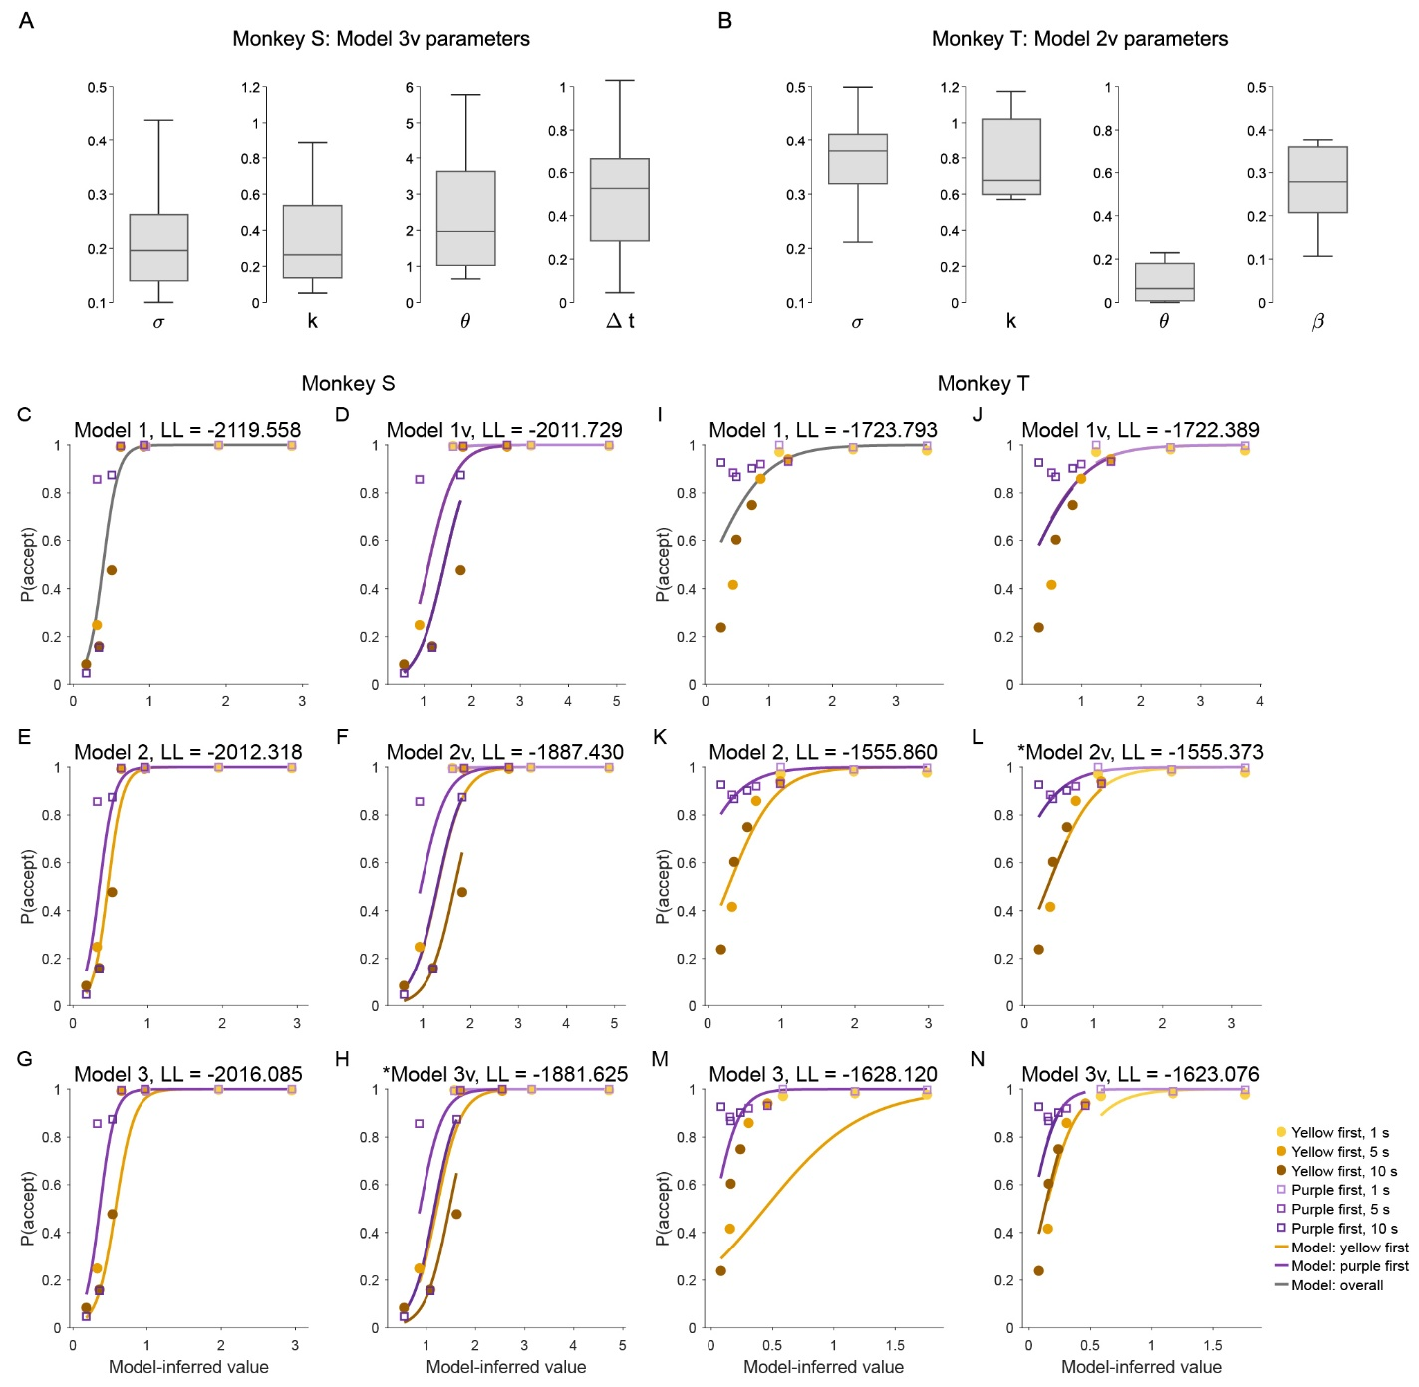
Figure S1. Model parameters and predictions. (A-B). Parameter values from the best-fit models for Monkey S and Monkey T. (C-N). Model-predicted acceptance probability versus data. C-H represent Model 1/1v, 2/2v, 3/3v for Monkey S, and I-N are for Monkey T. Discounted values (using best-fit discounting factor from each model) are plotted on the x-axis. For extended Models 1v/2v/3v, the models predict different p(accept) for different delays for Monkey S, and predict similar p(accept) for different delays for Monkey T.
To assess whether the model captures behavior, we also plotted and visually examined model predicted acceptance probability against data (Figure S1C-N). Discounted values using best-fit discounting factor $k$ from each model are plotted on the x-axis. For the extended models 1v/2v/3v, given the same discounted value of the offer, the models predict different p(accept) for different delays for Monkey S, but predict similar p(accept) for different delays for Monkey T. This agrees with our interpretation that Monkey S uses additional delays carried by the go signal to adjust temporal discounting calculations (their decision thresholds are delay sensitive), whereas Monkey T treats different go signals just as additional cues and their decision threshold is not adjusted based on delays.
2. Clarification of population coding dimensions
In reporting neural modulation by reward and delay, the authors repeatedly refer to "population coding dimensions" based on beta coefficients from an ANOVA analysis. This approach would benefit from further clarification. In particular, beta coefficients are typically associated with regression models rather than ANOVA, so it would be helpful for the authors to explain how these beta coefficients were obtained from the ANOVA analysis and what specific quantities they represent.
In addition, the definition of "population coding dimensions" should be clarified. For example, are these dimensions intended to represent coordinates or axes defining a subspace of high-dimensional neural activity? Providing a more explicit description of how these dimensions were constructed and how they should be interpreted would make the neural population analyses and the corresponding figures much easier to evaluate.

Response R2-2:
We apologize for the lack of clarity. We rewrote this part of the methods section, and significantly expanded on the method details.
Briefly, the reviewer is correct that the beta coefficients were computed from a linear regression analysis. About the confusion for “beta coefficients from an ANOVA model”: We used the term ANOVA, since ANOVA is a special form of general linear regression. The linear regression model was implemented using MATLAB’s anovan function, which returns both ANOVA statistics and the coefficient estimates from the underlying linear regression model. The β coefficients reported in the manuscript are the slopes from this underlying linear model, rather than ANOVA effect sizes.
The reviewer is also correct that the population dimension is an axis defining a subspace of the high-dimensional neural activity.
Please see below the modified Methods section for details.
“Population coding dimensions
In this analysis, we calculate the population coding dimensions for drop, delay, value and the go signal. The population coding dimension is a direction, represented by a vector of weights of neurons, in the population activity space that tracks a variable of interest (e.g., drop).
To obtain the population coding dimension for delay and drop, for each neuron and time window of interest, we fitted a general linear model in which firing rate of the neuron $i$ in time window $t$ was predicted by drop and delay. Here, both drop and delay are continuous variables.
$$r_{i}=β_{i}^{0}+β_{i}^{\text{drop}}⋅drop+β_{i}^{\text{delay}}⋅delay+ε_{i}$$
Here, $β_{i}^{\text{drop}}$ represents the expected change in neuron $i$’s firing rate associated with a one-unit increase in drop, holding delay constant. $β_{i}^{\text{delay}}$ represents the expected change in neuron $i$’s firing rate associated with a one-unit increase in delay, holding drop constant.
To construct population coding axes, we concatenate the coefficients for a given predictor, e.g. $β_{i}^{\text{drop}}$, across neurons into a population vector,
$$w^{\text{drop}}={\left[β_{1}^{\text{drop}},…,β_{N}^{\text{drop}}\right]}^{T}$$
and constructed an analogous vector for delay
$$w^{\text{delay}}={\left[β_{1}^{\text{delay}},…,β_{N}^{\text{delay}}\right]}^{T}$$
These vectors define one-dimensional encoding axes in the N-dimensional neural activity space. Their elements are the contributions, or tuning weights, of individual neurons. Because neurons were pooled across recording sessions, these axes were constructed in pseudo-population space.
To compare the similarity of coding dimensions, we computed the cosine similarity, $CS(w^{\text{drop}},w^{\text{delay}})$ between the population vectors.
$$CS(w^{drop},w^{delay}) \text{= }\frac{w^{\text{drop}}⋅w^{\text{delay}}}{|w^{\text{drop}}||w^{\text{delay}}|}$$
This measure reflects the geometric angle between the regression-derived axes in neural population space.
Since $w^{\text{drop}}$ and $w^{\text{delay}}$are obtained from the same regression, to exclude the possibility that the coding dimension similarity between them is an artifact of the fitting process, we adopted a cross-validated cosine similarity metric instead. To do this, we split the data into two halves, and repeated the regression separately on the two halves, and then computed the similarity between $w_{(1)}^{\text{drop}}$ from regression 1, and $w_{(2)}^{\text{delay}}$ from regression 2, and vice versa.
$$CS_{\text{cross-validated}}=\frac{1}{2}\left[CS\left(w_{(1)}^{\text{drop}},w_{(2)}^{\text{delay}}\right)+CS\left(w_{(1)}^{\text{delay}},w_{(2)}^{\text{drop}}\right)\right]$$
A permutation test was adopted to assess statistical significance of the similarity. Specifically, we shuffle the weights across neurons for delay and compute a null distribution of $CS_{\text{cross-validated}}$ by repeating the shuffling 10000 times and computing $CS_{\text{cross-validated}}$ for the shuffled data. Population coding dimension alignments for drop and delay were calculated for five 250ms windows: [-250 0], [0 250], [250 500], [500 750], [750 1000], relative to the offer onset. We also computed it for -250ms to 0ms before the go signal and 0ms to 250ms after the go signal.
We used a similar approach for defining the population coding dimension for discounted value and the population coding dimension for the go siganl.
Population coding dimension for value was computed from -250ms to 0ms before the go signal. A separate regression was carried out with DV as the predictor
$$r_{i}=β_{i}^{0}+β_{i}^{\text{value}}⋅DV+ε_{i}$$
and$w^{\text{value}}={\left[β_{1}^{\text{value}},…,β_{N}^{\text{value}}\right]}^{T}$.
Similarly, we computed the population coding dimension for the go signal. Population coding dimension for the go signal was computed from 0ms to 250ms after the presentation of the go signal. Since after the go signal was presented, animals could plan a motor movement (release/hold the bar), we also included the upcoming motor response and its interaction with the go signal as covariates in the regression. Here $\text{GO}=\left\{\begin{aligned}-1 \text{(yellow)} \\ 1 \text{(purple)}\end{aligned}\right.$, $\text{Motor}=\left\{\begin{aligned}-1 \text{(hold)} \\ 1 \text{(release)}\end{aligned}\right.$
$$r_{i}=β_{i}^{0}+β_{i}^{\text{value}}⋅DV+β_{i}^{\text{GO}}⋅\text{GO}+β_{i}^{\text{Motor}}⋅\text{Motor}+β_{i}^{\text{GO x Motor}}⋅\text{GO }\text{⋅}\text{ Motor}+ε_{i}$$
and $w^{\text{GO}}={\left[β_{1}^{\text{GO}},…,β_{N}^{\text{GO}}\right]}^{T}$.
The cosine similarity between $w^{\text{value}}$ and $w^{\text{GO}}$ was computed, and a similar permutation test was used for assessing statistical significance.”
3. Clarification of the analysis relating go-signal modulation to recalculated discounted value
To test whether dlPFC neurons represent a recalculated discounted value at the time of the go signal, the authors examine whether neural activity is modulated by the yellow versus purple go signal in a manner similar to its modulation by reward and/or delay, which are integrated into discounted value. This is an interesting analysis, but several aspects would benefit from further clarification.
First, in the figure corresponding to this analysis, the authors correlate "inferred time" with reward and delay modulation. However, the manuscript does not clearly describe what "inferred time" measures or how it was estimated. Providing a more explicit definition of this variable would help readers interpret the analysis.

Response R2-3.1:
We apologize for the confusion. This was actually a mistake on our end, and the “inferred time” was an incorrect label (the figure had the correct data, but the wrong label was from an outdated version). We apologize for not detecting this error in the original submission. The correct label should be “Yellow/Purple coding dimension”. This analysis was intended to show that in Monkey S, and not Monkey T, the population coding dimension for the go signal aligns with the value dimension (which agrees with the hypothesis that Monkey S, and not Monkey T, processes/adjusts the temporally discounted value based on the go signal). Since the reviewer’s next comment is closely related, we will address the methodological details of this analysis as well as the interpretation in Response R2-3.2 (Part II).
Second, it is unclear how neural modulation by the go signal was measured independently of modulation by offer value. The authors present neural activity during the cue period, but not during the period when the go signal was presented, when the potential recalculation of discounted value would presumably occur. In addition, Figures S1 and S2 appear to show that dlPFC neurons exhibit little modulation by the go signal itself. Given this, it is difficult to understand how go-signal-related neural modulation was analyzed in relation to the proposed recalculated discounted value.

Response R2-3.2 (Part I):
Before we dive into the analyses (see Part II below), we want to briefly clarify Figures S1 and S2 in the old manuscript (Figure S2 C-F in the revised manuscript). The ANOVA in Figure S2C-D were carried out at [-500 1000]ms around the offer onset, and not around the go signal. So those figures did not carry any information about whether dlPFC neurons are modulated by the go signal itself. In Response 2-3.2 (Part II), we will explicitly show how the population activity changes around the go signal.
If the authors' interpretation is that dlPFC neurons encode an adjustment of discounted value after the go signal, it would be helpful to show this more directly. For example, the analysis would be more compelling if it demonstrated how neural activity changes from the pre-go-signal to post-go-signal period in a way that reflects the proposed value adjustment.

Response R2-3.2 (Part II): We thank the reviewer for the great suggestion. We carried out additional analyses to explicitly show how the go signal shifts population activity along the value-coding dimension, shortly after the go signal.

In the original submission, we showed the population coding dimension for drop and delay are oppositely aligned to each other. We first repeated the same analysis, around the go signal. In both [-250 0]ms before and [0 250]ms after the go signal, we observed a significant negative alignment, between drop and delay, in both animals (Figure S4).

Figure S4. The negative alignment between drop and delay neural encoding dimensions persists after the go signal. The population encoding dimensions for drops and delays were calculated in 250ms time bins, before and after the go signal for Monkey S (A–B) and Monkey T (C–D).

The drop/delay alignment analysis suggests that, drop increases discounted value by pushing population activity in one dimension, whereas delay decreases discounted value by pushing population activity in the opposite direction.

To more explicitly characterize the value coding dimension, we performed a separate regression analysis that extracts the coding dimension for discounted value, using data from -250ms to 0ms before the go signal.

Next, we did a quick sanity check, to confirm that this independently estimated value dimension positively aligns with drop, and negatively aligns with delay (see Figure 7 A-D).

Figure 7. The value coding dimension (left for Monkey S; right for Monkey T). We estimated the population coding dimension for value, this dimension positively aligns with the drop dimension (A, B) and negatively aligns with the delay dimension (C, D). The projected value-axis activity for the nine offers at -250ms to 0ms before the go signal are shown in E and F. The overlayed gray line is a logistic fit to the data.

To assess the effect of the go signal on dlPFC neural activity, we projected the population activity along the 1-dimensional value axis defined above, and computed the mean trajectory for each offer, following a yellow versus purple go signal. The average yellow/purple trajectory across all nine offers (baseline corrected by each offer) are plotted in Figure 8 A-B.


Figure 8. Go signal modulates population activity (left for Monkey S, right for Monkey T). The projected value-axis population activity diverges following the purple vs yellow go signal (A and B). The trajectories are calculated for each offer and then averaged across offers. Baseline activity from -250ms to 0ms before the go signal is subtracted to show the changes of neural activity relative to before the go signal. In Monkey S, within 250ms after the go signal, the purple go signal increases value-axis activity and the yellow go signal decreases value-axis activity (C). The population coding dimension for the go signal positively aligns with the value axis (E). In Monkey T, however, no differences were observed within 250ms after the go signal (D). The coding dimension for the go signal is orthogonal to the value axis (F), suggesting that the processing of the go signal operates in a different subspace than the value-axis.

In Monkey S, as expected from his behavior, purple offer temporally increases the “value” dimension activity, whereas yellow offer temporally decreases it (Figure 8A, C). In Monkey T, however, we see a different pattern, there is no yellow/purple difference along the value-coding dimension in the first 250ms after the go signal (Figure 8D).

For Monkey T, instead of modifying population activity along the value axis, population activity gets routed to a different subspace instead. In fact, both purple/yellow trajectories move downward shortly after the go signal, reflecting shared neural trajectories outside of the value subspace. In other words, purple/yellow trajectories might diverge in dimensions other than the value-coding axis. To test this, we performed a separate analysis to define the coding dimension for purple versus yellow go signal. We then analyzed how well the go signal coding dimension aligned with the value coding dimension. Indeed, we observed a significant positive alignment between go signal coding dimension and value coding dimension in Monkey S (Fig. 8E) and not Monkey T (Fig. 8F).

We will further interpret these results in Response R2-4 below.
4. Relating individual differences in neural modulation to behavioral strategy
The authors report that the two monkeys may have used different behavioral strategies and also describe individual differences in several aspects of neural modulation. It would be helpful if the authors could further discuss how these individual differences in neural activity might relate to the observed differences in decision strategy. For example, do the monkey-specific patterns of neural modulation provide a possible mechanistic explanation for differences in how each animal evaluated or responded to the offers? Clarifying this relationship would help strengthen the link between the neural findings and the behavioral interpretation.

Response R2-4:
We thank the reviewer for this important comment. We have partially addressed this comment in Response R2-3.2. We will discuss more here.

In our paper, we found that while the go signal affected both animals’ acceptance behavior. Behavioral modeling suggests that Monkey S adjusts the temporally discounted value by factoring in the additional delay associated with the go signal, whereas Monkey T treated the go signal as an additional cue, and the go signal simply biases Monkey T’s decision towards accepting (for purple) or rejecting (for yellow), without re-computing the discounted value.

These behavioral strategies make different predictions about neural responses to the go signal. For Monkey S, since he recomputes the temporally discounted value of the offer, we expect the go signal to shift the population activity that encodes the value of the offer. For Monkey T, since go signal biases decisions without modifying values of the original offers, we do not expect changes in the value coding of the original offers, but instead expect an overall shift in population activity based on the go signal in dimensions other than the value axis.

Indeed, these are the patterns we see in the data (Fig. 8). We have modified the discussion section and elaborate on the connection between behavioral strategy and the neural responses to the go signal, see below:

“Specifically, for monkey S, we observed that the go signals shift the population activity along the value coding axis. The purple go signal increases the value-axis activity and the yellow go signal decreases it (Fig. 8A, C). In an alternative analysis, we showed that the population coding dimension for the go signal aligns with the value axis, suggesting that go signal operates by directly modifying the value representation (Fig. 8E). This is consistent with Monkey S’s behavior that he re-computed the temporally discounted value by considering the additional delay associated with the go signal.
For Monkey T, on the other hand, we observed that the value-axis activity did not diverge based on the go signal immediately after the presentation of the go signal (Fig. 8B). Instead, we observed a rotation of population activity following the go signal in the principal component space (Fig. S6). In fact, the go signal was initially (0-250ms) represented in a neural subspace orthogonal to the value subspace (Fig. 8F), and the co-evolution of the purple/yellow trajectories on the value-axis is a consequence of an orthogonal projection. Even though yellow/purple trajectories separate in high dimensional space, their projections onto the value axis did not separate until after 250ms (Fig. 8D). This early rotation of population activity to the value-orthogonal subspace following the go signal, suggests that the go signal did not directly modify value representation. This is consistent with Monkey T’s behavioral strategy in which the go signal acts as an additional cue that biases decisions without modifying the value of the original offer ”

In addition to the neural differences between animals after the go signal, there are other less direct, but related neural differences between animals prior to the go signal, which are consistent with animals’ behavior. We have expanded the discussion section to discuss these additional results as well.

“Additional analyses revealed that the neural differences between animals existed prior to the go signal, further supporting the behavioral differences between animals. In both animals, drop and delay are reliably encoded in dlPFC and can be decoded at high accuracy. The peak of the sliding-window decoding analysis suggested that both drop and delay are maximally separable at around 250ms after the offer onset (Fig. 5A-D). Despite similar decoding accuracy, we observed a difference between animals in how individual neurons and the population encode value. For individual neurons, In Monkey S, only 10% of the neurons showed linear modulation by discounted value; in Monkey T, a larger proportion of neurons (> 30%) showed linear value coding. On the population level, however, the negative alignment of the drop versus delay coding dimension emerges early in Monkey S (within 250ms, Fig. S3), but much later in Monkey T (~750ms). The differences between animals suggest a possible tradeoff between value coding in individual neurons versus population. Monkey S relied more on the coordinated activity in the population to represent temporally discounted value, achieved through the opposite alignment of the drop and delay coding subspace. By contrast, Monkey T relied more on individual neurons to encode value. These two modes of information coding strategies, population versus single neuron, were previously reported in prefrontal cortex during a working memory task (22).
The decoding analysis further corroborated this view. We used this analysis to evaluate whether drop and delay were represented independently, or integrated interactively. If reward and delay were encoded independently, we should be able to predict the offer identity (i.e., which of the nine reward offers was presented to the animal) by decoding reward and delay separately. On the other hand, if reward and delay information were integrated non-linearly, then we would expect to be able to decode offer identity more accurately than predicted by independence. We found statistical evidence that the decoding accuracy of offer identity exceeded the independence prediction for monkey S, but not for monkey T. In Monkey S, the integrated coding of drop and delay emerges around 200ms after the offer is presented (Fig. 5E). The emergence of non-linear integration is possibly related to the early negative alignment of drop and delay in Monkey S (Fig. S3B). This non-linear way of drop/delay integration is consistent with the behavioral modeling result that Monkey S’ acceptance threshold was delay dependent (Fig. S1H). It is also consistent with the fact that Monkey S, and not Monkey T, was able to re-adjust discounted value incorporating the additional delay predicted by the go signal.”

