Title: Temporal discounting strategies are represented in the dorsolateral prefrontal cortex of monkeys.

Authors: Rossella Falcone^{1,3}, Siyu Wang¹, David B. Weintraub², Mariko McDougall¹, Mark A. G. Eldridge^{1,4}, and Barry J. Richmond^{1*}.

Affiliations:
¹Laboratory of Neuropsychology, NIMH, Bethesda, MD, USA
²Surgical Neurology Branch, NINDS, Bethesda, MD, USA
³Leo M. Davidoff Department of Neurological Surgery, Albert Einstein College of Medicine Montefiore Medical Center Bronx, NY USA.
⁴Newcastle University, Newcastle upon Tyne, NE1 7RU

*Corresponding authors:
Rossella Falcone, PhD
Assistant Professor
Albert Einstein College of Medicine, Bronx, NY, 10461
e-mail: rossella.falcone@einsteinmed.edu

Barry J. Richmond, MD
Senior Investigator, Emeritus. Laboratory of Neuropsychology, NIMH/NIH/DHHS, Bethesda, MD, 20892
e-mail: barry@richmond-family.org

Numbers of pages:
Numbers of figures:
Numbers of words for Abstract:
Numbers of words for Introduction:
Numbers of words for Discussion:

Conflict of interests: The authors declare no competing financial interests.

Acknowledgments:
This research was supported in part by the Intramural Research Program of the National Institutes of Health (NIH). The contributions of the NIH author(s) were made as part of their official duties as NIH federal employees, are in compliance with agency policy requirements, and are considered Works of the United States Government. However, the findings and conclusions presented in this paper are those of the author(s) and do not necessarily reflect the views of the NIH or the U.S. Department of Health and Human Services.
We thank Dr. Andrew Mitz for helping with setting up the recording system, and Dr. Richard Saunders for assisting with surgeries.

Authors contribution:
DW, BR and RF conceived and designed the task. RF, DW collected the data. RF and DW sorted the data. SW, RF, MMcD, ME, BR analyzed the data. RF, DW and ME performed surgeries and MRIs. RF, ME, SW, and BR wrote the paper.

Abstract
Imagine being offered two options: a small reward now or a larger reward later. Which would you choose? This behavior is governed by temporal discounting, in which temporal delay reduces the value of future rewards. Although this phenomenon is well established,
individuals differ widely in the strategies they use to weigh future benefits against immediate gratification. Such variability in behavior reflects differences in how the brain integrates reward magnitude and delay during deliberation.
In many real-life situations, such as whether to accept a new job position or when to retire or when to make an investment, the opportunity to choose may be delayed, or the rules governing the choice may only become clear later. To capture this phenomenon, we designed a temporal discounting task with a two-step go-signal that introduced an element of temporal uncertainty that could potentially influence not only when the animal acts but also the type of choice it makes (accept or reject). This setup allowed us to examine how the timing and structure of the choice affects both behavior and single-neuron activity in the dorsolateral prefrontal cortex (dlPFC) in two monkeys.
Although both monkeys encoded reward and delay in dlPFC, consistent with previous literature, the temporal dynamics and integration of these signals differed between monkeys, supporting distinct temporal discounting strategies. Crucially, these neural differences tightly relate with differences in how each animal behaved under temporal uncertainty.
In one animal, reward and delay were integrated early and flexibly into a unified representation, and this early integration predicted more goal-directed choices, reflecting a goal-directed strategy. In the other, integration occurred closer to the go-signal, with more independent coding of reward and delay, corresponding to a more reactive, stimulus-driven strategy. These strategies were confirmed through analyses of representational geometry and decoding of reward and delay signals, providing quantitative support for the observed behavioral differences.

Introduction
Temporal discounting refers to the tendency to assign less value to rewards that are delayed in time (Ainslie, 1975; Mazur, 1987). This trade-off between reward magnitude and delay is central to many everyday decisions that involve choosing something small now vs. waiting for something larger later. A well-known example is the ‘marshmallow’ test, in which children were given a choice between eating one marshmallow immediately or waiting to receive two (Mischel and Ebbesen, 1970). Although confounded with socioeconomic background, this test revealed individual differences in how children tolerate delay and self-control, with some children resisting immediate gratification and others succumbing to it.
Similar variability has been observed in animals. In natural foraging scenarios, animals often face choices between immediate but smaller food sources and delayed but more substantial ones. Their preferences can vary with environmental conditions, prior experience, and individual differences (Trevail et al., 2019; Eccard et al., 2020; Walker et al., 2023).
Although temporal discounting is commonly viewed as the result of general valuation processes, emerging evidence suggests that decisions may also reflect adaptive strategies. These strategies can be shaped by both internal states, such as motivation (Kable & Glimcher, 2007), and by external demands, including the timing and the structure of the choice. We hypothesize that the time required to make a choice and the nature of the choice, such as accepting or rejecting sooner or later, can impose an additional temporal cost that can influence the evaluation process, similar to findings of Shadmehr and colleagues (2010), who showed that the brain treats the duration of movements as a cost, such that longer delays reduce the subjective value of rewards and influence motor planning.
Most studies on temporal discounting present options simultaneously and allow immediate choice. However, in real-life situations, the opportunity to act may be delayed, or the rules governing the choice may become clear only later. To capture this, we designed a temporal discounting task with a two-step go-signal that controlled both when the animal could act and whether it could accept or reject the offer at different times. This design separates offer evaluation from action execution: a visual cue signals that the offer is available for consideration, and the type of the go-signal indicates when the animal can act and which rules apply, adding unpredictability to the timing of the choice and allowing us to investigate how temporal structure shapes neural computations of reward and delay. It also offered us the opportunity to identify possible individual strategies that may be reflected in distinct neural coding.
We recorded single-neuron activity in the dorsolateral prefrontal cortex (dlPFC) of two monkeys. The dlPFC is implicated in value-guided behavior (Barraclough et al., 2004; Hutcherson et al., 2012) and self-control (Figner et al., 2010; Hare et al., 2009), with neurons encoding reward magnitude, delay, and interaction, supporting the computation of temporally discounted value (Kim et al., 2008; Wang, Falcone et al., 2023). Human dlPFC is active in intertemporal choice (McClure et al., 2004), and during the learning of actions for gaining great future rewards while suffering small immediate losses (Tanaka et al., 2004).
Our results reveal two complementary findings. First, consistent with previous studies, dlPFC neurons encode reward magnitude and delay with an inverse linear relationship (Kim et al., 2008; Wang, Falcone et al., 2023), supporting temporal discounting computations. Second, and crucially, the temporal dynamics and integration of these signals differed between the two animals, supporting distinct behavioral strategies each animal adopted under temporal uncertainty: one monkey integrated reward and delay early and flexibly, forming a unified value representation (goal-directed strategy), whereas the other integrated these features later and more independently, consistent with a reactive, stimulus-driven strategy.
Additional analyses, including correlation with discounted value, representational geometry and decoding confirmed these differences, showing unified value signals in the first monkey but more independent reward and delay representations in the second monkey.
Together, these results show that dlPFC computations underlying temporal discounting are dynamically shaped by both offer features and task demands, and that individual differences in neural integration processes contribute to variability in temporal discounting strategies.

Results
1. Behavioral evidence of temporal discounting
Two monkeys performed a temporal discounting task (Fig. 1A; see Methods); each of nine visual cues signaled an offer of reward (Fig. 1B). Each offer combined reward magnitude (2, 4, or 6 drops of liquid reward) with a delay before delivery (1, 5, or 10 seconds).
By varying reward and delay independently across trials in an orthogonal design, we could dissociate their individual and combined effects on both behavior and neural activity.
On each trial, the animal viewed one of the nine visual cues and chose whether to accept or reject the offer by releasing a lever at a go-signal. A two-step go-signal determined when each action was available: a yellow dot indicated that refusal was allowed, and a purple dot indicated that acceptance was allowed. One color appeared first at random, introducing further temporal unpredictability in when the animal could act. For example, if purple appeared first, the animal could release the bar immediately to accept the offer or wait until the purple turned yellow to refuse the offer. Conversely, if yellow appeared first, the animal could release the bar immediately to refuse the offer or wait for the yellow spot to turn purple to accept the offer. If the offer was accepted (irrespective of choice order), the cue-defined drops were delivered after the corresponding delay (Fig. 1A). If the offer was rejected, a new trial began immediately.
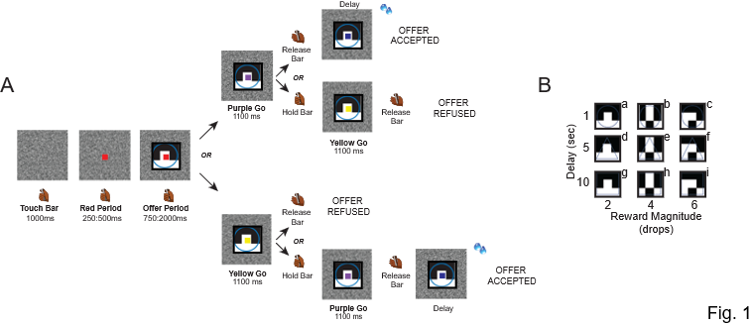
Figure 1. Task description. (A) Each trial begins with the monkey touching and holding a bar. A red square appears at the center of the screen, followed by a visual cue presented behind the red square. The cue indicates the offer, defined by a combination of reward magnitude (2, 4, or 6 drops) and delay (1, 5, or 10 s). Next, the red square changes color to either purple or yellow, serving as a go-signal. If the square turns purple, the monkey can release the bar to accept the offer, and the reward is delivered after the indicated delay. Alternatively, the monkey can continue holding the bar until the purple turns yellow to refuse the offer.
If the square turns yellow, the monkey can release the bar to refuse the offer, immediately starting a new trial, or continue holding until the yellow turns purple to accept the offer.
(B) Set of nine visual cues used in the task, labeled from “a” to “i”.

Behavior was analyzed across all neural recording days (7 for Monkey 1, 16 for Monkey 2).
As expected, both animals were more likely to accept larger, earlier rewards and less likely to accept smaller, delayed ones (e.g. Monkey S accepted almost 100% of 6-drop/1s offers versus 7% of 2-drop/10s offer; Fig. 2A-B). Choices were fit with a hyperbolic discounting function to estimate discounted value, and a logistic function captured the acceptance probability as a smooth function of discounted value (Fig. 2A-B; see Methods).

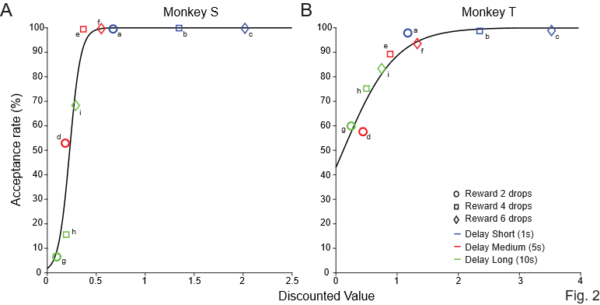
Figure 2. Behavioral performance. Acceptance rate as a function of model-inferred discounted value (data: colored points, model: black line) in Monkey S (A) and Monkey T (B). The acceptance probability was fitted with a logistic choice model, based on the discounted value, and an accepting threshold.. Letters from “a” to “i” indicate the nine possible offers. In this analysis the total delay was the cue-indicated delay (1 s, 5 s or 10 s) and the reward size was the cue-indicated drops (2, 4 or 6).

2. dlPFC neurons encode offer value but not upcoming choice
We recorded 170 neurons in dlPFC, from the lower bank of the principal sulcus (107 neurons in Monkey 1 and 63 neurons in Monkey 2; Fig. 3A) while the animals performed the task.
Following offer onset, 121 out of 170 neurons were significantly modulated by reward magnitude and/or delay (2-way ANOVA, p < 0.05; Fig. 3B). A sliding window ANOVA analysis showed that the proportion of neurons modulated by each factor began to increase shortly after cue presentation (Fig. 3C-D). We did not find significant numbers of cells encoding the upcoming choice outcome (accept vs. refuse) during the offer period – i.e. before the first choice option had been presented - in either monkey (Fig. 3C-D, yellow line).
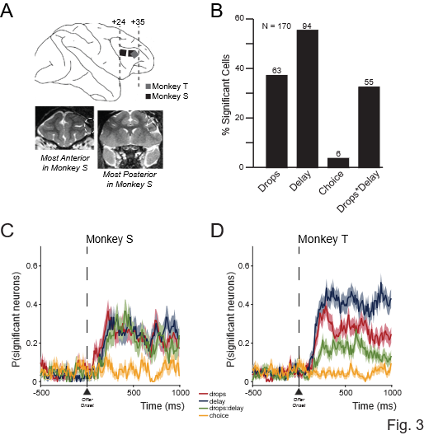
Figure 3. Recording sites and neural modulation by task factors. A. Schematic representation of the Utah array positions in the dlPFC, reconstructed from MRI scans in Monkeys S and T. Bottom panel: Most anterior and posterior MRI slices of Monkey S, with Utah arrays highlighted by yellow dashed circles.
B. Percentage of neurons significantly modulated by reward magnitude (drops), delay, their interaction, and upcoming choice.
C–D. Time course of the percentage of neurons significantly modulated by each factor, from 500 ms before to 1000 ms after cue onset, in monkey S and monkey T, respectively.

To quantify the strength of encoding for each variable (reward magnitude, delay, and their interaction), we computed omega squared (ω²), which captures the proportion of variance in neural activity explained by each factor (see Methods).
We found that modulation by reward appeared earlier and larger than modulation by delay, in Monkey S during the first 500 ms of the offer period. Monkey T showed stronger delay modulation than reward size (Fig. S1A-B).

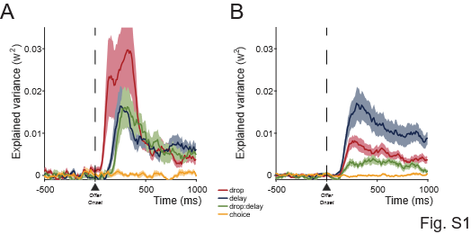
Figure S1. Explained variance calculated for each task factor over time, from 250 ms before to 1000 ms after the cue onset in Monkey S (A) and Monkey T (B).

We found no evidence of modulation of neural activity during the offer period by the upcoming choice outcome (accept vs. reject) in either animal (Fig. S1A-B, yellow line).
A 1-way ANOVA for each condition for each cell, confirmed that spike counts during the offer period did not differ significantly between accepted and rejected offers (see Methods; N = 770 conditions; 35/598 for monkey T and 8/172 for monkey S; 1-way ANOVAs (p < 0.05); Fig. S2A), nor between action taken in the first go-signal vs the second (N = 1195 conditions; 53/903 for monkey T and 16/292 for monkey S; 1-way ANOVAs (p < 0.05); Fig. S2B).
These results indicate that dlPFC neurons encode the value attributes of the offer (reward and delay) during the offer evaluation, but do not represent the animal’s commitment to a choice or when to respond.
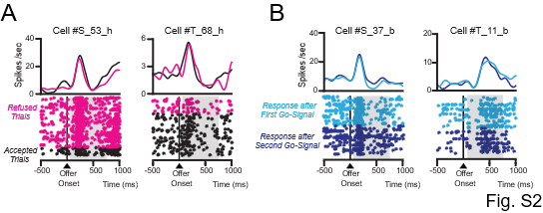
Figure S2. Neural response is not related to predicted choice and to motor response. Raster displays with spike densities on top of four different neurons when visual cue “h” indicating 4 drops/10 secs of delay (A-B), and when visual cue “b” indicating 4 drops/1 sec of delay (C-D) are shown to monkey S and monkey T.
The activity is aligned to the cue onset (time 0); grey rectangles show the 75–750 ms analysis interval. Trials are sorted based on the choice, accept (black) or refuse (magenta) in A, and based on whether the response is made after the first go-signal (cyan) or after the second go-signal (blue) in B.

3. Inverse encoding of reward magnitude and delay in dlPFC neurons
In both animals, dlPFC neurons showed an inverse correlation between reward magnitude and delay encoding, consistent with temporal discounting. This relationship became particularly evident after 750 ms from offer onset, a point corresponding to the earliest possible appearance of the first go-signal (Fig. 4A-B; see Methods).
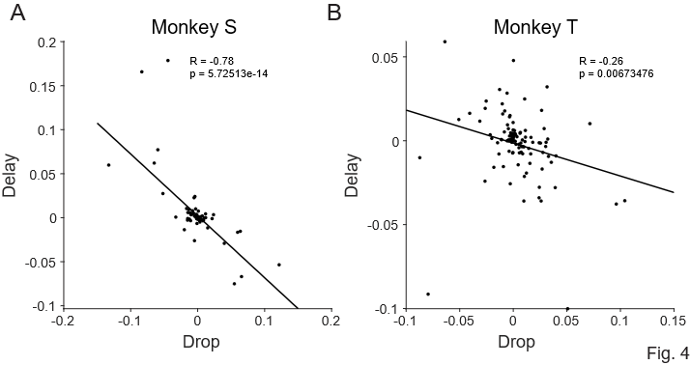
Figure 4. The population encoding dimensions of Drop and Delay are negatively correlated, in Monkey S (A) and Monkey T (B). Population encoding dimensions were estimated using time window 750ms to 1000ms after cue onset.

In Monkey S, this inverse relationship emerged rapidly, within the first 250 ms of the offer period and persisted throughout cue presentation (Fig. S3 B–D). In Monkey T there was a similar trend during the first 750 ms, but it was weaker and did not reach statistical significance (Fig. S3 G–I). No significant correlation was observed in the 250 ms before cue onset (Fig. S3A, E), indicating that these relationships were specific to the evaluation period.

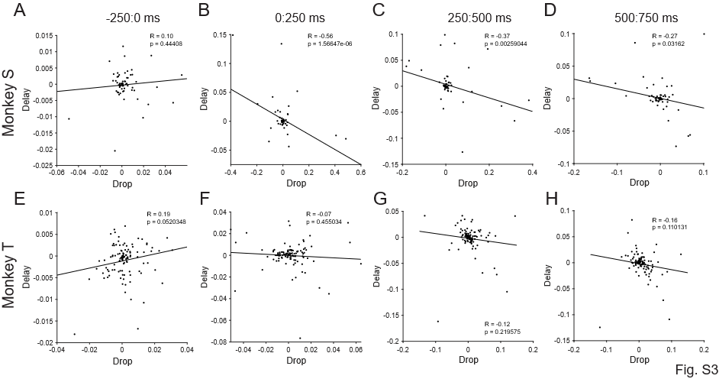
Figure S3. Linear correlations between Drops and Delay neural encoding calculated in 250 ms time bins before and after offer onset (time 0) for Monkey S (A–D) and Monkey T (E–H).

4. Choice order influences delay discounting
Our task design included two possible go-signals: purple (accept) and yellow (reject). The first signal determined which action could be taken immediately; the alternative required waiting until the color switched (see Methods). For example, if the yellow signal appeared first, the animal could refuse right away or wait for the purple to accept the offer.
This two-step go-signal design allowed us to hypothesize that if the yellow signal appeared first, delaying the opportunity to act for acceptance, the offer might seem less attractive, reducing acceptance rates. For highly valuable offers, acceptance rates were similar whether yellow or purple appeared, in both monkeys (Fig. 5A-B). For less valuable offers, acceptance rates were significantly lower when the yellow go-signal was presented first, in both monkeys. However, for less valuable offers we found differences in the acceptance rate if the first go-signal was purple between the two animals: Monkey T was more likely to accept them (Fig. 5A-B).
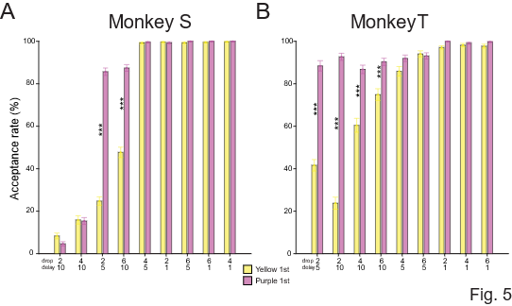
Figure 5. Acceptance rate for each offer when the first go-signal was yellow or purple, shown for Monkey S (A) and Monkey T (B). Offers are sorted by their empirical acceptance rate across the nine cues.

Overall, both animals preferred when the purple signal appeared first. This suggests an intrinsic motivational asymmetry tied to the meaning of the signal. However, the two animals appeared to interpret the go-signal differently. One possibility is that the go-signal was processed in terms of its temporal implication, effectively becoming part of the temporal discounting computation. Alternatively, it may have been treated merely as an additional visual cue, required to trigger the choice but not integrated into the valuation process.
To distinguish these possibilities, we compared three behavioral models. The base model considered only the offer attributes (reward magnitude and delay; see Methods for details), ignoring the color and order of the go-signals. This is the classic temporal discounting model, whereby value depends solely on reward magnitude and delivery delay (as for previous analysis which results were reported in figure 2).
The ‘full’ temporal discounting model added an extra waiting cost, including the wait imposed by the first go-signal (see Methods).
Finally, the ‘bias’ model assumed that the go-signal color introduced a categorical bias and assumed that choices were driven by both the temporal discounted value associated with each offer, and the bias associated with the go-signal (see Methods).
Model comparison showed that the base model, with only the offer attributes, fit worst for both animals.
Monkey S’s behavior was best explained by the full temporal discounting model (Fig. 6A&C), suggesting integration of both offer and go-signal timing into value computations. In contrast, Monkey T’s behavior fits the bias model, indicating a strong cue-based preference rather than temporal integration (Fig. 6B&D).
These models show that the two animals treat offer information and go-signal timing in different ways, which helps us look at the corresponding neural responses.
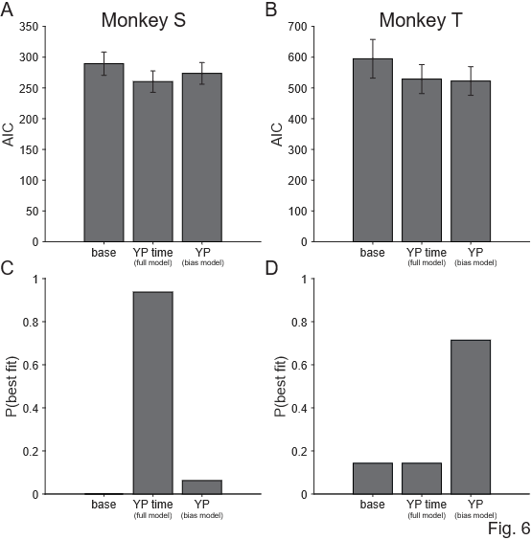
Figure 6. Model comparison. AIC values (A-B) and probability of best fit (C-D) for the base, full, and bias models in Monkey S (A&C) and Monkey T (B& D).

5. Neural signatures of go-signal timing and value integration
The two-step go-signal design introduced uncertainty about the timing and the structure of the choice, whether the animal could act immediately or had to wait. This allowed us to test how the timing constraint interacted with the integration of reward and delay in shaping value signals in dlPFC neural activity.
We investigated how the neural encoding of reward magnitude and delay changed when the additional time, including the first go-signal, was considered.
If temporally discounted value is calculated on the fly, we would expect that compared to the yellow go-cue which signals an accept, the yellow go-cue which signals a reject would decrease the value of the option, since animals have to wait for an additional delay and wait for the purple go-cue to accept the offer. Specifically, we would expect that the population encoding dimension for Yellow vs Purple go-cue, to be positively correlated with the population encoding dimension of reward magnitude, and negatively correlated with the population encoding dimension for delay. We find support for this in Monkey S (Fig. 7A, C), and not Monkey T (Fig. 7B, D). This agrees with the different behavioral strategies utilized by Monkey S vs Monkey T. Monkey S is computing temporally discounted value on the fly whose behavior is best-fit by the YP time model, whereas Monkey T does not re-calculate the temporally discounted value based on the go-cue but instead learned to simply approach vs avoid the go-cue itself, whose behavior is better explained by the YP bias model.

These findings indicate that in Monkey S, the timing differences imposed by the two-step go-signal sequence dynamically influenced the neural representation of offer value in the dlPFC, whereas in Monkey T, such modulation was not evident, consistent with their distinct behavioral strategies.
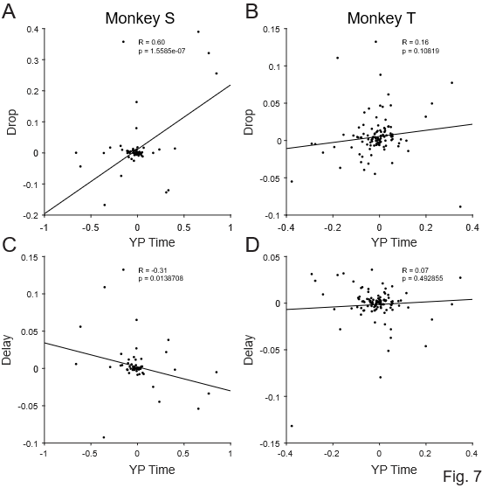

Figure 7. Linear correlation between Drops and model-inferred time (Yellow-Purple time; see methods) neural encoding. Top panels: correlation between Drops and yellow-purple time in Monkey S (A) and Monkey T (B). Bottom panels: correlation between Delay and yellow-purple time in Monkey S (C) and Monkey T (D).

6. Different single-neuron and population value coding across monkeys
We next examined whether the monkeys’ behavioral ranking of offers from lowest to highest discounted value was reflected in neural activity at the single-neuron and population level.
At the single-neuron level, we tested whether firing rates calculated in the first 750 ms of the offer period were linearly modulated by the discounted value calculated from the behavior.
In Monkey S, only 6 out of 63 neurons (10%) showed a significant linear correlation between spike count and discounted value. In contrast, Monkey T showed a higher proportion, with 35 out of 107 neurons (33%) exhibiting such linear coding. This suggests that Monkey T’s dlPFC neurons encode the value of the offer more linearly and uniformly, while Monkey S’s neurons exhibit more heterogeneous or nonlinear patterns of value representation.

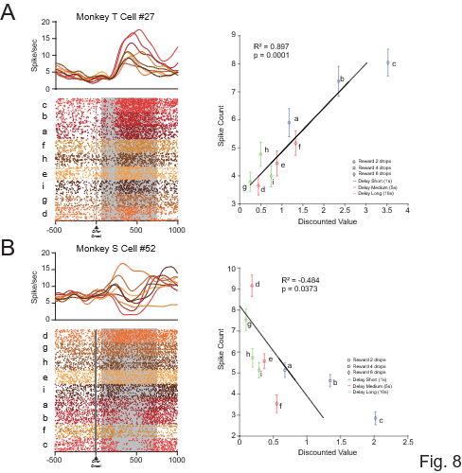

Figure 8. Raster plots and correlation between mean spike count and discounted value. Left panels: example neurons from Monkey T (A) and Monkey S (B). Spike density functions are shown above each raster. Neural activity is aligned to cue onset and split by the nine offers, ordered from highest to lowest mean firing rate (calculated from 75 to 750 ms after cue onset, grey rectangle). Right panels: Linear correlation between the mean spike count for each offer and the behaviorally calculated discounted value, corresponding to the neurons shown in the left panels.

At the population level, we applied PCA dimensionality reduction to visualize neural trajectories across offer conditions. In Monkey S, trajectories for different offer values were entangled, suggesting a complex and nonlinear encoding of value and choice (Figure 9A&C). In Monkey T, trajectories were well separated and arranged in an orderly progression from low (green) to high (red) value offers (green to red in Fig. 9B&D), consistent with a more linear and lower-dimensional population code. This was valid when the neural trajectories were calculated in the first 1000 ms after cue onset (Fig. 9A&B) or in the window from –500 ms before to +500 ms after the first go-signal onset (Fig. 9 C&D). For Monkey T, the mean trajectories for each condition became even more distinct and well separated in the latter period (Fig. 9D).
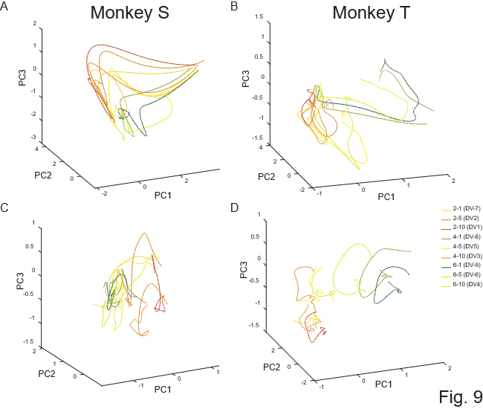

Figure 9. Geometry of neural coding. Population trajectories for each offer in Monkey S (A, C) and Monkey T (B, D). Trajectories are plotted in the 3D space derived from principal component analysis for the first 1000 ms of the offer period (top panels) and from 500 ms before to 500 ms after the first go-signal onset (bottom panels).

7. Monkey S integrates reward and delay in neural population codes
To test to what degree we can decode reward magnitude and delay information from the neural population, we performed a moving window decoding analysis with cross-validation on the pseudo-population (see Methods). For both animals, decoding accuracy was significantly above chance for all three variables (drops, delay, and their interaction). Peak decoding accuracy reached almost 80% for reward and delay (chance is 33%), and more than 60% for their interaction (chance is 11%) (Figure 10, colored lines).
To determine whether reward magnitude and delay were encoded independently or integrated into a joint representation, we compared the observed value for the interaction term with a prediction based on independent encoding.
Specifically, if the neural population is encoding delay and drops independently, without interacting, then the expected interaction decoding accuracy should equal the product of their individual decoding accuracies:
$$\overline{P}\left(interaction\right)=P\left(delay\right)xP\left(drops\right)$$
where $P\left(interaction\right),P\left(delay\right),P\left(drops\right)$ are the decoding performance for each factor, $\overline{P}\left(interaction\right)$ refers to the predicted decoding performance assuming independent representation of delay and drop.
If the observed decoding performance is higher than the predicted performance from the independent encoding of each factor, it would indicate that reward and delay are integrated in the neural representation. We compare the predicted decoding performance of cue $\overline{P}\left(interaction\right)$ with the actual decoding performance $P\left(cue\right)$. We found that $P\left(cue\right)$ is significantly higher than $\overline{P}\left(interaction\right)$ in Monkey S, from around 200ms after cue onset (Fig. 10E). Monkey T did not show such a difference, suggesting that in this animal, reward and delay may be encoded more independently (Fig. 10F).

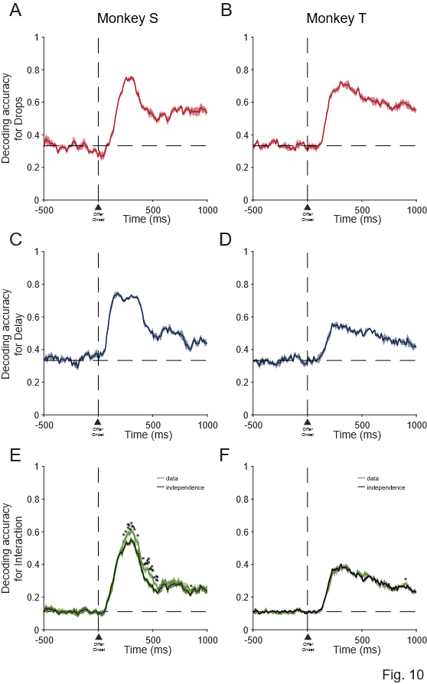

Figure 10. Decoding Analysis: decoding accuracy calculated for each task factor, reward magnitude (top panels), delay (middle panels) and interaction (bottom panels), for Monkey S (A&C&E) and Monkey T (B&D&F), from 500 ms before to 1000 ms after the offer onset.

Discussion
Across both monkeys, consistent with previous studies, dlPFC neurons encoded reward magnitude (drops) and delay in an inverse manner that reflects temporal discounting computations (Kim et al., 2008), confirming that dlPFC contributes to integrating multiple value dimensions. We found that this integration emerged more prominently when the choice became imminent, in both animals.
Our findings go beyond prior studies by showing that the value signal is not static but dynamically adapted to task context and correlated with subject-specific strategy adoption.
Specifically, when we introduce uncertainty about when and what choice could be executed via the two-step go-signal design, dlPFC signals flexibly integrated additional waiting time into valuation, demonstrating context-sensitive adjustments rather than rigid rules. This dynamic integration in dlPFC, where reward and timing are competitively integrated depending on the context, aligns with recent work in rodents showing ramping frontal activity that reflects how reward and time are weighted during decisions (Bukwich et al., 2025).
Crucially, the timing and manner of this integration differed between monkeys, revealing the representation of individual strategies rather than mere noise or random variability.
Monkey S adopted a proactive, goal-directed strategy. Neural activity showed a strong and early inverse correlation between reward and delay immediately after the offer was presented. This suggests an evidence accumulation process that began as soon as the offer was presented, supporting a model-based evaluation where future outcomes and timing contingencies are actively weighed during deliberation. The integration of go-signal timing with reward and delay signals indicates that the dlPFC continuously combines multiple task-relevant features to flexibly compute value.
Monkey T relied on a reactive strategy: the integration of reward and delay emerged only after the first 750 ms of the visual stimulus presentation, closer to the imminent go-signal, which, from a behavioral perspective appeared to act more like an additional visual cue than a temporal marker. This suggests that evidence accumulation in Monkey T was gated by the presence of the go-signal. Consequently, dlPFC activity showed weaker coupling between value features and task timing, consistent with a cue-driven, model-free approach in which decisions were gated by external events.
These neural patterns suggest that decision making can involve either proactive evidence accumulation or reactive, cue-driven process.
These differences show the existence of different strategies to solve apparently similar decisional problems and highlight how individual variability can modify the neural dynamics of valuation. Behavioral model comparisons reinforce this distinction: Monkey S’s choices aligned with the full temporal discounting model, integrating both offer attributes and go-signal timing, whereas Monkey T’s behavior matched the bias model, reflecting cue-driven decisions. These patterns parallel the observed differences in dlPFC coding.
In a similar temporal-discounting task, our previous study showed that in addition to an evidence accumulation process (sampling the visual cue), attractor dynamics underlies value-based decision-making, and reflects decision certainty (Wang, Falcone et al., 2023). Future work is needed to investigate how the timing and strength of such attractor dynamics as well as evidence accumulation processes differ among individuals with different strategies.
In our previous study, we showed that both evidence accumulation and attractor dynamics underlie value-based decision making in a related task. Although we did not perform an evidence accumulation or drift-diffusion modeling here, our findings align with such computational frameworks, indicating that the timing of evidence integration and its neural correlations can vary across individuals and strategies. Future work should include formal analyses to directly test these hypotheses.
These contrasting neural profiles suggest that dlPFC can operate in multiple computational modes: proactive accumulation of evidence vs. reactive cue-driven responses, depending on the cognitive strategy engaged by the subject. Such modes flexibility may be mediated by mechanisms like 1) mixed selectivity (Rigotti et al., 2013), enabling neurons to multiplex different task-related information like reward, delay, and context, or 2) by working memory gating (Miller and Cohen, 2001) that selectively maintains task-relevant variables during deliberation.
Single neuron and population analyses reinforce this interpretation. In Monkey S, only 10% of neurons linearly tracked discounted value, yet the population showed early inverse correlation between reward magnitude and delay. This suggests that value integration in Monkey S is distributed across the population and relies on dynamic, context-sensitive coding rather than fixed, unitary representations. In Monkey T, 33% of neurons showed linear value coding, consistent with a more rigid and uniform representation linked to a reactive strategy to the external cue (the go-signal) to trigger action.
Population trajectory and decoding analyses further showed that Monkey S integrated reward and delay into a unified representation, whereas Monkey T encoded these features more independently and this was more evident once the first go-signal appeared. Decoding analyses confirm this distinction: in Monkey S, interaction decoding accuracy exceeded predictions based on independent encoding, indicating a true neural integration of reward and delay. In Monkey T, decoding performance for the interaction matched the independent prediction, consistent with separate representation of these variables.
Our results extend previous studies by adding a temporal/categorical dimension to prefrontal value encoding, showing that the classic inverse relationship between reward and delay emerges dynamically and varies across individuals. This temporal unfolding emphasizes the role of dlPFC in maintaining context-sensitive value representations that evolve during decision-making.
The pronounced individual differences observed calls for caution when assuming uniform neural mechanisms across subjects.
Such variability may arise from differences in prefrontal dopamine signaling and cognitive control (Cools & D’Esposito, 2011) that can produce different balances between goal-directed and habitual strategies, consistent with theories proposing that the prefrontal cortex dynamically orchestrates multiple modes of decision-making depending on context and individual differences (Koechlin et al., 2003).
These findings raise important questions about how prefrontal circuits may shift between computational modes, such as flexible integration versus rigid stimulus-response mappings, and how these shifts might underline adaptive or maladaptive behavior (Daw et al., 2011; Gillan et al., 2016; Voon et al., 2015).
Limitations of our study include the small sample size and differences in training history: Monkey S had extensive task experience, whereas Monkey T was recorded earlier in training and for a shorter time. Thus, over time, the two monkeys’ strategies – and neural representations in dlPFC- may have become more aligned. Future longitudinal studies are necessary to determine whether these strategies represent stable traits or adaptive responses to experience. Additionally, the recording sites were slightly offset between monkeys: although both arrays targeted the dorsolateral prefrontal cortex, Monkey S’s array was positioned slightly more posteriorly than Monkey T’s. This anatomical difference could contribute to some of the observed differences in neural dynamics. However, the key patterns of neural encoding remain behaviorally relevant, as the correlations between dlPFC activity and each monkey’s choice strategy were robust, supporting the functional significance of our findings.
Future work should also incorporate computational modeling to test whether these dynamics map onto evidence accumulation or attractor-based frameworks (Wang, Falcone et al., 2023).
In summary, our findings show that computations in the dlPFC are flexible and context-dependent, shaped by individual strategies, underscoring the importance of considering variability when studying the neural mechanisms of choice behavior.

Materials and Methods
Subjects
Two male rhesus monkeys, both weighing 9.0 kg were used. The experimental procedures followed the Institute of Laboratory Animal Research Guide for the Care and Use of Laboratory Animals and were approved by the National Institute of Mental Health Animal Care and Use Committee.

Surgical Procedures
Surgical procedures were carried out using sterile technique under general anesthesia in a fully equipped operating room. An initial surgery was performed to place a head fixation post. In monkey 1 an eye coil was implanted, but the eye movement was not monitored. A second surgery was performed to implant the Utah recording arrays. We implanted one Utah array in Monkey T and two Utah arrays in Monkey S. MR scans were obtained later, about 2-4 months after the Utah arrays were implanted to define the recording area (Fig. 3A).

Data Collection
To control stimuli presentation, reward delivery and bar touches a noncommercial software package was used (REX, https://nei.nih.gov/intramural/software; Hays et al., 1982). The eye position was monitored by using the Eye Position measuring system (https://staff.aist.go.jp/k.matsuda/eye/indexe.html) only for some sessions of Monkey S. Neural activity of single units was recorded with Utah arrays (Blackrock Microsystems, Salt Lake City, USA; blackrockmicro.com). Electrical signals were captured, and single units were isolated online with TDT (Tucker-Davis Technologies, TDT, Alachua, USA; tdt.com) system for Monkey T and with Grapevine (Ripple Neuro, Salt Lake City, USA; rippleneuro.com) for Monkey S. Data analyses were performed in MATLAB (http://www.mathworks.com/; R2024b).

Task
The monkey sat in a primate chair with the head fixed, 57 cm away from a video screen (47x30 cm; 1024x768 pixel; 120Hz) placed in front. A touch-sensitive bar was mounted on the chair at the level of the monkeys’ hands. A metal tube was positioned in front of the monkey’s lips to allow the monkey to drink when the reward was delivered.
The monkey worked in a intertemporal discounting task (Fig. 1A). To start a trial the monkey had to touch a lever, hold it for 1000 ms until a red square (0.40º x 0.40º) appeared at the center of the screen. After a variable time of 250 and 500 ms one of 9 possible visual cues (9.2º x 7.3º) appeared at the center of the screen for one of 5 durations between 750 and 2000 ms (step size 313 ms). Each visual cue indicated a particular offer, with the set of offers made by combining one of three reward sizes (2, 4 or 6 drops of liquid reward) with one of three delays to deliver the reward (1, 5 or 10 seconds). The monkey was required to continue to hold the bar and, if it was required, to maintain its gaze within the virtual window until the red square changed color to purple or yellow with equal probability (Fig. 1A). Either the purple or the yellow square served as a prompt to release the bar. Releasing the bar while the purple square was present indicated that the monkey was accepting the offer. Releasing the bar when the yellow square was present indicated that the monkey was refusing the offer. If the animal continued to hold the bar for the duration of the initial purple or yellow period of 1100 ms, the color of the square would change to the alternate color, allowing the animal to accept or refuse in each trial.
For instance, if the animal did not release the bar during the initial purple period, it could continue to hold the bar until the yellow square replaced the initial purple spot and release the bar in the yellow period. The same thing happened if the animal did not release the bar in the initial yellow period: it could hold the bar until the purple square replaced the initial yellow square and then release the bar.
In this design we prevented the monkey from preprogramming the motor response in the cue period, since the monkey could not anticipate whether the acceptance or refusal period would be the first interval or the second.
Upon accepting the offer, the purple square turned green (feedback signal), and the drops of reward were delivered after the delay indicated in the offer. Upon refusing the offer, the cue and fixation target disappeared, and a new trial would immediately begin with a new offer.
For 12/16 sessions the eye of Monkey 2 was monitored. A 20 x 20 degrees virtual window was built around the cue. The monkey was required to maintain his gaze in the virtual window from the appearance of the red spot to the appearance of the go-signal.
If the monkey (a) released the bar during the cue period, (b) didn’t maintain gaze in the virtual window, or (c) failed to release the bar during any of the go periods, an error was registered and an error feedback image (white rectangle with a red cross; 28.7 º x 17.8 º) appeared on the screen for 1000 ms. After an error, the next trial was a correction trial, during which the offer was repeated.

Behavior
For the behavioral analyses, we used data from all the neural recording days (7 for monkey 1 and 16 for monkey 2).
The probability of accepting an offer was calculated independently for each of the 9 offers.
Reinforcement learning models fit the behavior of the two monkeys separately. The probability of choosing to accept an offer is modelled through a SoftMax function as
$$p=\frac{1}{1+e^{β⋅\left(θ-V\left(drop,delay\right)\right)}}$$
Here, $θ$ is decision threshold, $β$ is the temperature term.
$$V\left(drop,delay\right)=\frac{drop}{1+k⋅delay}$$
$k$ is the hyperbolic discounting factor. The free parameters $θ,β,k$ are fit via maximum likelihood estimation.
To test how the timing of action opportunities influences value computation, we compared three models.
The simplest model computes a temporally discounted value, that is then compared to an accept threshold $θ$.
$$DV=\frac{R}{1+k⋅D}$$
Here, DV is the discounted value, D is the delay, R is the reward.
Animals will be more likely to accept when DV is above the acceptance threshold θ, and more likely to reject otherwise. The probability of accepting an offer is modelled using the softmax rule with decision noise σ:
$$p\left(accept\right)=\frac{1}{1+e^{\frac{-V-θ}{σ}}}$$
In this strategy, animals do not pay attention to the go cue and choose solely based on the offer.
In the second YP time model, the full temporal discounting model, animals adjust their discounted value estimate as well as their acceptance threshold based on the go-signal. If the go-signal is yellow, they have to wait for an additional delay Δt before they can accept the offer, as a result, effectively the value of the offer decreases to
$$V^{yellow}=\frac{R}{1+k⋅\left(D+Δt\right)}$$
Since threshold effectively reflects the average expected discounted reward during this task, the total value of choosing to accept a yellow offer becomes
$$U^{yellow}=V^{yellow}+{VF}^{yellow}$$
Where ${VF}^{yellow}$ is the expected future reward, and is θ discounted by the additional waiting time Δt plus the delay:
$${VF}^{yellow}=\frac{θ}{1+k⋅\left(D+Δt\right)}$$
The acceptance threshold would remain at $θ^{yellow}=θ$
However, if the go cue is purple, we compute
$$U^{purple}=V^{purple}+{VF}^{purple}$$
Since they can accept right away, $V^{Purple}=V$ and ${VF}^{purple}=\frac{θ}{1+k⋅D}$,
Rejecting is actually more expensive after purple, as animals have to wait for an additional delay to reject. The acceptance threshold here is essentially the expected discounted value of future rewards after a rejection. This would be
$$θ^{purple}=\frac{θ}{1+k⋅Δt}$$
In either case,
$$p\left(accept\right)=\frac{1}{1+e^{\frac{-U-θ}{σ}}}$$
In the third YP bias model, the bias model, animals simply have a bias for purple or yellow.
$$p\left(acceptpurple\right)=\frac{1}{1+e^{\frac{-U-θ+β}{σ}}}$$
whereas
$$p\left(acceptyellow\right)=\frac{1}{1+e^{\frac{-U-θ-β}{σ}}}$$

Neural Activity
The neural activity of 170 neurons was analyzed using data from 75-750 ms after the appearance of the cue, labeled as Offer Period. This period ended before the prompt to accept (purple go-signal) or refuse (yellow go-signal) first appeared, and therefore before the monkey knew when it needed to make a movement.

1-way ANOVAs
We performed two separate 1-way ANOVAs (p < 0.05) on all 170 recorded cells, for each of nine offers. The first 1-way ANOVA was performed on each offer where the animal responded with at least 5 accepted and 5 refused trials. In the second 1-way ANOVA, each offer was selected based on whether the animal responded by releasing the bar on at least 5 trials on the first go signal and 5 trials on the second go signal, regardless of acceptance or refusal.

ANOVA-sliding window Analysis
A sliding window analysis was performed using the neural activity from all 170 recorded cells, expressed as total spike count. Starting at 500 ms before the cue onset to 1000 ms after the cue onset, 100 ms bins were created with a 10 ms interleave period. The spike count within each bin was used in the 2-way ANOVA sliding window analysis, with drops, delay, independent variables. Choice as factor was included as an additional effect to test whether choice explains additional variance in firing rate, independently of drop and delay.
At each bin we estimated the proportion of cells that were significantly modulated by each factor (2-way ANOVA, p < 0.05).
Additionally, at each bin we extracted the variance explained for each factor, and for the interaction of drops and delay as omega squared (Olejnik and Algina, 2003):
ω² = (SS_{effect} – (df_{effect})(MS_{error}))/ MS_{error} + SS_{total}

Correlation across time
In this analysis, we only included cells that respond to at least one of the task-relevant variables (delay, drop, choice), this leaves 121 cells.
To extract the population encoding dimension for drop and delay, we performed a sliding window ANOVA for each cell, and extracted the regression coefficient for drop and delay, at each time bin, for each cell. The dimension formed by the beta coefficients across cells at each time bin, is the time-dependent encoding dimension of drop or delay.
Population activity that encodes delay is quantified as the population activity projected onto the dimension for delay. Population activity of drops is calculated similarly. For each factor separately, the beta-coefficients for each time bin were correlated with each other and the Pearson correlation was calculated.
A significance threshold of 0.05 was used (uncorrected).

Decoding Analysis
Support vector machine was used as the classifier. Training and testing comprised of non-overlapping trials (75% of trials for training, and 25% for testing). The procedure was repeated 10 times, and the average decoding accuracy was recorded.
Decoding of drops, delay and interaction were carried out separately. For each factor, decoding was done in a sliding window (step 20ms, width 100ms).

References
Ainslie, G. (1975). Specious reward: A behavioral theory of impulsiveness and impulse control. Psychological Bulletin, 82(4), 463–496.

Mazur, J. E. (1987). An adjusting procedure for studying delayed reinforcement. In M. L. Commons, J. E. Mazur, J. A. Nevin, & H. Rachlin (Eds.), Quantitative analysis of behavior: Vol. 5. The effect of delay and of intervening events on reinforcement value (pp. 55–73). Hillsdale, NJ: Erlbaum.

Mischel, W., & Ebbesen, E. B. (1970). Attention in Delay of Gratification. Journal of Personality and Social Psychology, 16, 329-337.

Alice M. Trevail, Jonathan Sharples, Jeff A. Polton, Peter I. Miller, Francis Daunt, Ellie Owen, Mark Bolton, Kendrew Colhoun, Stephen Newton, Gail Robertson and Samantha C. Patrick (2019). Environmental heterogeneity decreases reproductive success via effects on foraging behaviour, Proc Biol Sci, 286(1904):20190795.

Jana A Eccard, Thilo Liesenjohann, Melanie Dammhahn (2020). Among-individual differences in foraging modulate resource exploitation under perceived predation risk. Oecologia, 194(4):621–634.

Walker, R. H., Hutchinson, M. C., Potter, A. B., Becker, J. A., Long, R. A., & Pringle, R. M. (2023). Mechanisms of individual variation in large herbivore diets: Roles of spatial heterogeneity and state-dependent foraging. Ecology, 104(2), e3921.

Reza Shadmehr, Jean Jacques Orban de Xivry, Minnan Xu-Wilson, Ting-Yu Shih (2010). Temporal discounting of reward and the cost of time in motor control. J Neurosci, 30(31):10507-16.

Joseph W Kable , Paul W Glimcher (2007). The neural correlates of subjective value during intertemporal choice. Nat Neurosci, 10(12):1625-33.

Hutcherson, C. A., Plassmann, H., Gross, J. J., & Rangel, A. (2012). Cognitive regulation during decision making shifts behavioral control between ventromedial and dorsolateral prefrontal value systems. Journal of Neuroscience, 32(39), 13543–13554.

Barraclough, D. J., Conroy, M. L., & Lee, D. (2004). Prefrontal cortex and decision making in a mixed-strategy game. Nature Neuroscience, 7(4), 404–410.

Figner, B., Knoch, D., Johnson, E. J., Krosch, A. R., Lisanby, S. H., Fehr, E., & Weber, E. U. (2010). Lateral prefrontal cortex and self-control in intertemporal choice. Nature Neuroscience, 13(5): 538–539.
Hare, T. A., Camerer, C. F., & Rangel, A. (2009). Self-control in decision-making involves modulation of the vmPFC valuation system by the dlPFC. Science, 324(5927): 646–648.

Kim, S., Hwang, J., & Lee, D. (2008). Prefrontal coding of temporally discounted values during intertemporal choice. Neuron, 59(1), 161–172.

Siyu Wang #, Rossella Falcone # , Barry Richmond , Bruno B Averbeck. (2023). Attractor dynamics reflect decision confidence in macaque prefrontal cortex. Nat Neurosci, 26(11):1970-1980. #Equal contribution.

Rigotti, M., Barak, O., Warden, M. R., Wang, X.-J., Daw, N. D., Miller, E. K., & Fusi, S. (2013). The importance of mixed selectivity in complex cognitive tasks. Nature, 497(7451), 585–590.

Miller, E. K., & Cohen, J. D. (2001). An integrative theory of prefrontal cortex function. Annual Review of Neuroscience, 24, 167–202.
Daw, N. D., Gershman, S. J., Seymour, B., Dayan, P., & Dolan, R. J. (2011). Model-based influences on humans’ choices and striatal prediction errors. Neuron, 69(6), 1204-1215.
Gillan, C. M., Kosinski, M., Whelan, R., Phelps, E. A., & Daw, N. D. (2016). Characterizing a psychiatric symptom dimension related to deficits in goal-directed control. eLife, 5, e11305.
Voon, V., Derbyshire, K., Rück, C., Irvine, M. A., Worbe, Y., Enander, J., ... & Roiser, J. P. (2015). Disorders of compulsivity: A common bias towards learning habits. Molecular Psychiatry, 20(3), 345-352.
Cools, R., & D'Esposito, M. (2011). Inverted-U–shaped dopamine actions on human working memory and cognitive control. Biological Psychiatry, 69(12), e113-e125.
Koechlin, E., Ody, C., & Kouneiher, F. (2003). The architecture of cognitive control in the human prefrontal cortex. Science, 302(5648), 1181-1185.

Hays AV Jr., Richmond BJ, Optican LM. (1982). A UNIX-based multiple process system for real-time data acquisition and control. WESCON Conference Proceeding, pp 2/1–1 to 2/1–10. OSTI ID: 5213621.

Michael Bukwich, Malcolm G Campbell, David Zoltowski, Lyle Kingsbury, Momchil S Tomov, Joshua Stern, HyungGoo R Kim, Jan Drugowitsch, Scott W Linderman, Naoshige Uchida. (2025). Competitive integration of time and reward explains value-sensitive foraging decisions and frontal cortex ramping dynamics. Neuron, 6:S0896-6273(25)00515-X.

McClure, S.M., Laibson, D.I., Loewenstein, G., and Cohen, J.D. (2004). Separate neural systems value immediate and delayed monetary rewards. Science 306: 503 - 507.

Tanaka, S.C., Doya, K., Okada, G., Ueda, K., Okamoto, Y., and Yamawaki, S.
(2004). Prediction of immediate and future rewards differentially recruits
cortico-basal ganglia loops. Nat. Neurosci. 7: 887 - 893.

Olejnik, S., & Algina, J. (2003). Generalized Eta and Omega Squared Statistics: Measures of Effect Size for Some Common Research Designs. Psychological Methods, 8(4), 434–447.

