Title: Dynamic temporal integration of reward magnitude and delay in the dorsolateral prefrontal cortex during intertemporal discounting task.

Authors: Rossella Falcone^{1,3}, Siyu Wang¹, David B. Weintraub², Mariko McDougall¹, Mark Eldridge, and Barry J. Richmond^{1*}.

Affiliations:
¹Laboratory of Neuropsychology, NIMH, Bethesda, MD, USA
²Surgical Neurology Branch, NINDS, Bethesda, MD, USA
³Leo M. Davidoff Department of Neurological Surgery, Albert Einstein College of Medicine Montefiore Medical Center Bronx, NY USA.

*Corresponding authors:
Rossella Falcone, PhD
Assistant Professor
Albert Einstein College of Medicine, Bronx, NY, 10461
email: rossella.falcone@einsteinmed.edu

Barry J. Richmond, MD
Chief, Section on Neural Coding and Computation, Laboratory of Neuropsychology, NIMH/NIH/DHHS, Bldg 49, Rm 1B80, Bethesda, MD, 20892
Phone: 301-443-7319
email: bjr@ln.nimh.nih.gov

Numbers of pages:
Numbers of figures:
Numbers of words for Abstract:
Numbers of words for Introduction:
Numbers of words for Discussion:

Conflict of interests: The authors declare no competing financial interests.

Acknowledgments:
The opinions expressed in this article are the authors’ own and do not reflect the view of the US National Institutes of Health, the Department of Health and Human Services, or the United States government.
This research was supported (in part) by the Intramural Research Program of the NIMH and includes the relevant Annual Report number in the following format (???).

Authors contribution:
RF, DW and BR conceived and designed the task. RF, DW and MMcD collected the data.
RF, SW analyzed the data. RF, DW and ME performed surgeries and MRIs.
All authors wrote the paper.

Introduction
When we make decisions between multiple options, several factors determine our choices. The size of the reward, i.e., the amount of the reward, and the delay, i.e., the time it takes to receive the reward, are central to how we evaluate options and ultimately make choices.
The prefrontal cortex (PFC), including the dorsolateral prefrontal cortex (dlPFC), is critical for higher-order executive functions. The dlPFC is particularly involved in encoding these factors during value-based decision-making tasks (ref). One important phenomenon in decision-making is temporal discounting, wherein the perceived value of a reward decreases as the delay to its receipt increases. This process has been studied in relation to PFC function (ref).
Many studies have focused on how the PFC encodes reward magnitude and delay as individual factors, and how these factors interact (ref). However, less is known about how these factors are integrated within the dlPFC and how their dynamic interaction influences decision-making over time.
In this study, we explore the integration of reward magnitude and delay within the PFC in the context of temporal discounting. Specifically, we aim to understand how these two factors interact and shift in their influence over time, particularly as individuals make decisions. To investigate this, we recorded single-neuron activity from the dlPFC of two monkeys performing a temporal discounting task. In this task the monkeys were presented with offers involving one of three reward magnitudes (2, 4, or 6 drops) and one of three delay times (2, 5, or 10 seconds). They had to decide whether to accept or reject the offer based on a visual cue.
Our results show that the encoding of reward magnitude and delay in the dlPFC were negatively correlated. This suggests that the dlPFC may represent these two factors in opposing ways. These findings align with the concept of temporal discounting, where individuals tend to devalue rewards the longer they have to wait to receive them. The negative correlation between reward magnitude and delay suggests that the dlPFC may dynamically adjust its neural representation of these factors in response to the trade-off between immediate and delayed gratification. This dynamic encoding could reflect the brain's attempt to prioritize more immediate rewards when they are larger, effectively reducing the weight placed on delay. Conversely, when faced with longer delays, the dlPFC might shift focus away from reward size, emphasizing the temporal component of the decision-making process and leading to a devaluation of larger rewards.
Interestingly, we observed individual differences between the two monkeys in terms of when this negative correlation emerged. One monkey exhibited a pronounced negative correlation as soon as the visual stimulus appeared while the other monkey showed no significant negative correlation, except that later in time. These differences might reflect distinct cognitive strategies when balancing immediate versus delayed rewards between the two animals. In fact, the first monkey tended to reject often offers with longer delays and smaller rewards, while the second monkey seemed more uncertain, rejecting least valuable options about 50% of the time.
Taken together, these findings provide new insights into how the dlPFC encodes competing aspects of reward processing. This dynamic interaction may help balance the decision-making process, especially when the individuals face a choice between immediate and delayed rewards.
In addition, our study suggests important avenues for future research on individual variability in decision-making processes.

Results
Behavior
Two monkeys performed a temporal discounting task (Fig. 1A; see Methods), in which each of 9 visual cues indicated a different value offer (Fig. 1B). Each offer was a combination of a reward magnitude (2, 4, or 6 drops of liquid reward) and a delay (1, 5, or 10 seconds after the choice). On each trial an offer was presented, and the monkeys had to choose whether to accept or reject the offer. If the offer was accepted, the cue-defined drops were delivered after the corresponding delay (Fig. 1A). If the offer was rejected, the monkey immediately began a new trial.

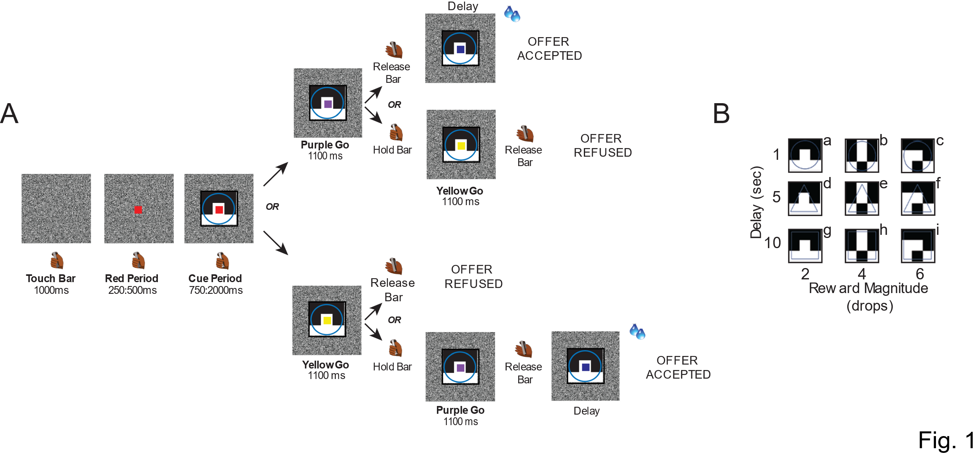

As expected, the probability of accepting the offer was highest for larger, more immediate rewards and lowest for smaller, delayed ones (see Methods, Fig. 2A-B).
We also examined whether the acceptance rate changed based on whether the go-signal was yellow or purple. We found that in most conditions, especially when the offer was the most valuable for the animal, there was no significant difference in the acceptance rate. However, for some conditions, particularly when the go-signal was less valuable, the acceptance rate was lower when the first go-signal was yellow compared to purple (ADD t-test).

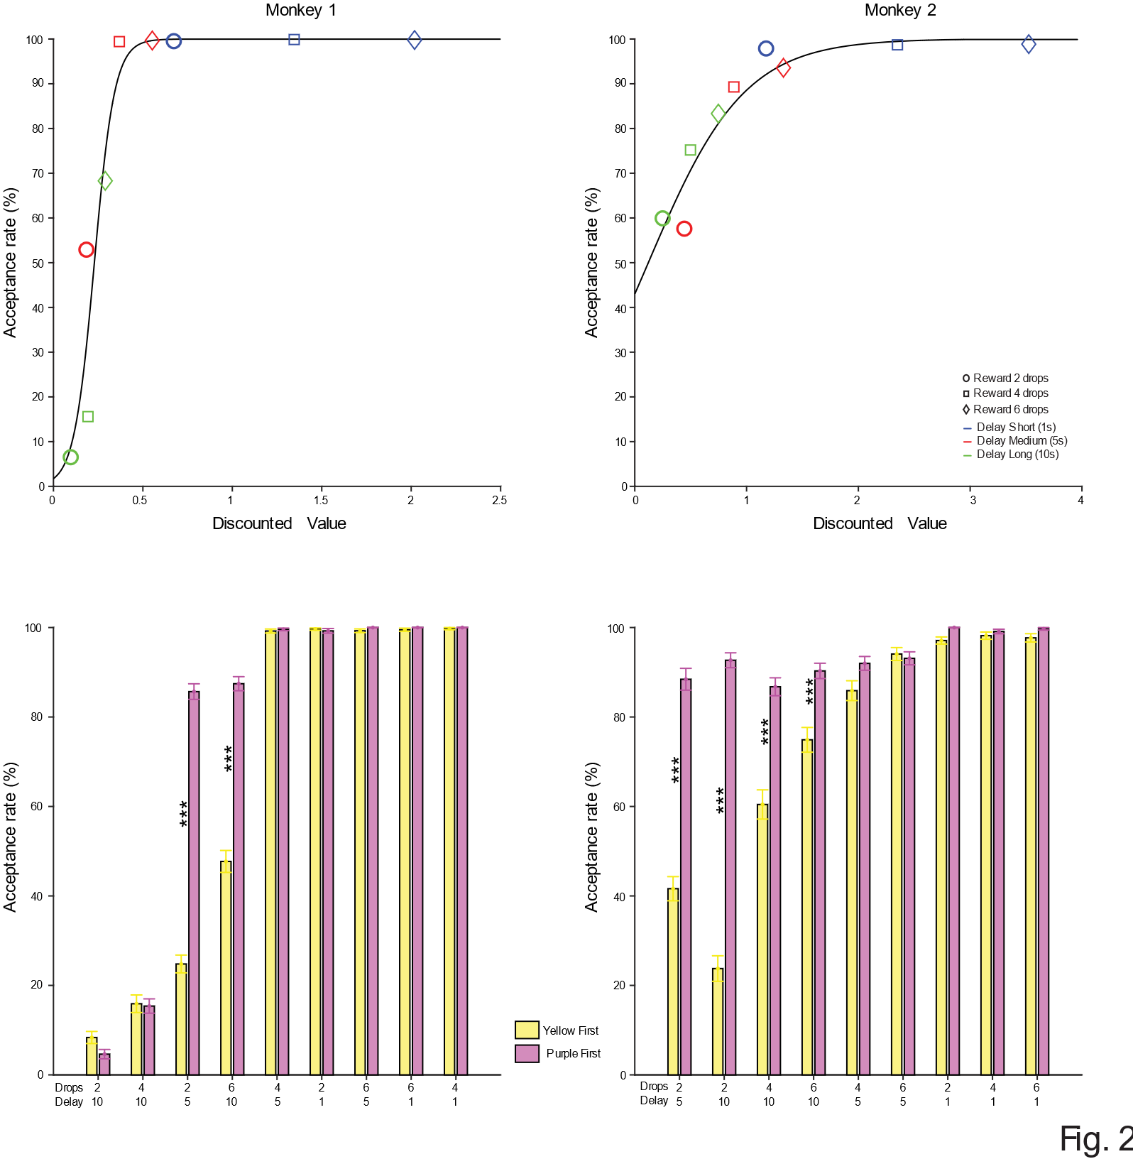

Neural Activity
Neural activity is modulated by the reward-related information signaled by the visual cue.
During task performance, we recorded the activity of 170 neurons from the lower bank of the principal sulcus of the dlPFC (107 neurons in Monkey 1 and 63 neurons in Monkey 2) (Fig. 3A). Soon after the onset of the offer period, the neural activity, expressed as total spike count, was significantly modulated by reward magnitude and/or delay in 121 of the 170 neurons (3-way ANOVA, p < 0.05; Fig. 3B). A sliding window 3-way ANOVA analysis on these 121 neurons (see Methods) showed that the proportion of neurons modulated by each factor began to increase after the cue appeared on the screen (Fig. 3A-B). In Monkey 1, the proportion of neurons modulated by each factor was similar, although more neurons encoding reward magnitude (drops) emerged earlier (Fig. 3A In contrast, Monkey 2 showed a similar number of neurons encoding reward magnitude and delay at the same time, but a greater number of neurons encoded delay throughout the entire offer period, while the number of neurons encoding reward magnitude was reduced later in the period. Fewer neurons responded later to the interaction between reward magnitude and delay (Fig. 3B).
The drop-related signal, expressed as an explained variance (omega squared, see Methods), began earlier than both the delay-related and interaction-related signals. It was also stronger during the initial 500 ms of the offer period, in monkey 1, before becoming similar to the other two signals (Fig. 3C). In Monkey 2, instead, the delay-related signal was higher (Fig. 3D).
For both animals, we did not observe any neurons responsive to the choice, i.e., whether the animal chose to accept or reject the offer (Fig. 3C-D). To examine this further, we analyzed the data on a cell-by-cell basis for each offer with sufficient acceptance and rejections. Two separate 1-way ANOVAs (p < 0.05; see Methods) showed that in the offer period 1) the neural response when the monkey accepted the offer was indistinguishable from that when the monkey refused the offer (N = 770; 35/598 for monkey 1 and 8/172 for monkey 2; Fig. S1A), 2) the neural response when the animal released the bar after the first go signal was indistinguishable from that when the monkey released the bar after the second go signal (N = 1195; 53/903 for monkey 1 and 16/292 for monkey 2; Fig. S1B).
As we saw from the behavior, both animals ranked the offers from lowest to highest valuable (Fig. 2A-B). We observed similar ranking in the neural activity, with neurons that increased or decreased their firing rate as the offer became more valuable (put a percentage; Fig. S2A-B). Other neurons showed more idiosyncratic across different offers (put a percentage; Fig. S2C).

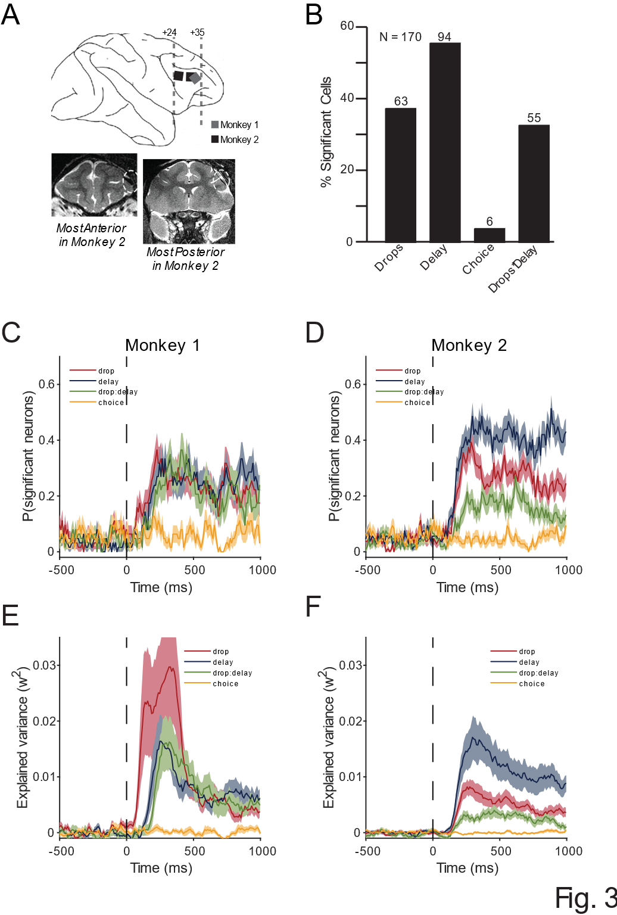

Reward magnitude and delay drive opposing shifts during temporal discounting
We investigated when and how the reward magnitude and delay became correlated, if at all, during the offer period. We found that the encoding dimensions of reward magnitude (drops) and delay were negatively correlated between 750-1000 ms after the onset of the offer (see Methods; Fig. 4A-B), in both monkeys.
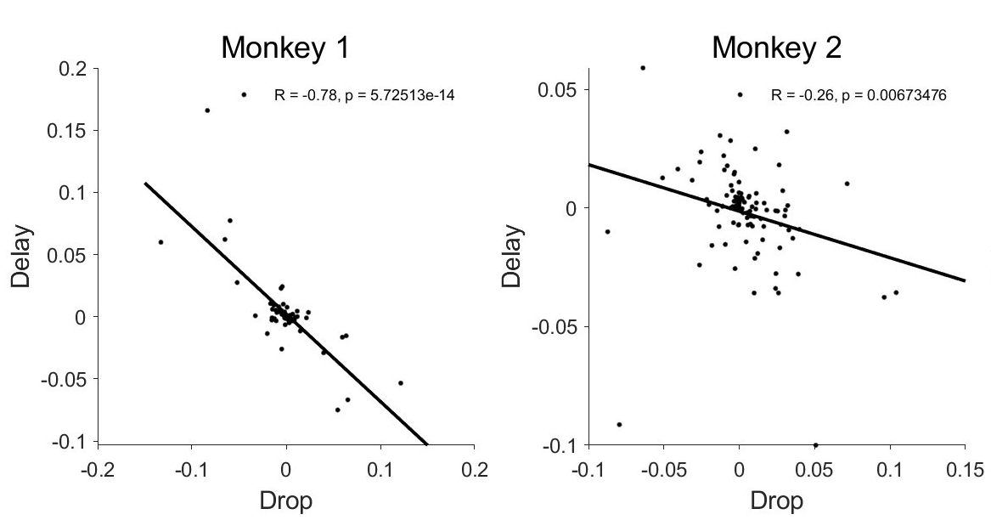

Specifically, Monkey 1 showed this negative correlation as soon as the cue appeared on the screen, while Monkey 2 showed a similar trend, though it did not reach statistical significance (Fig. S3B-D; G-I).

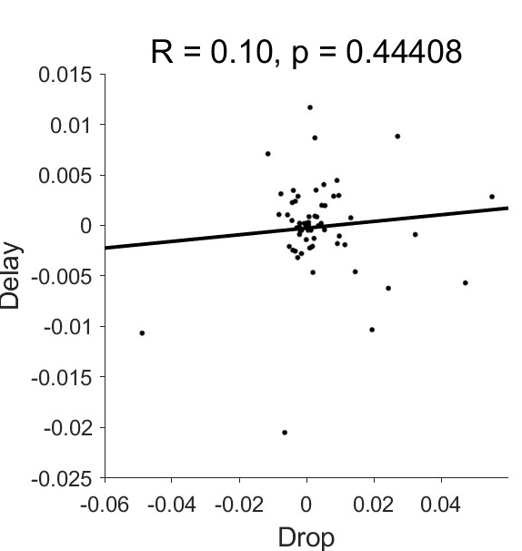
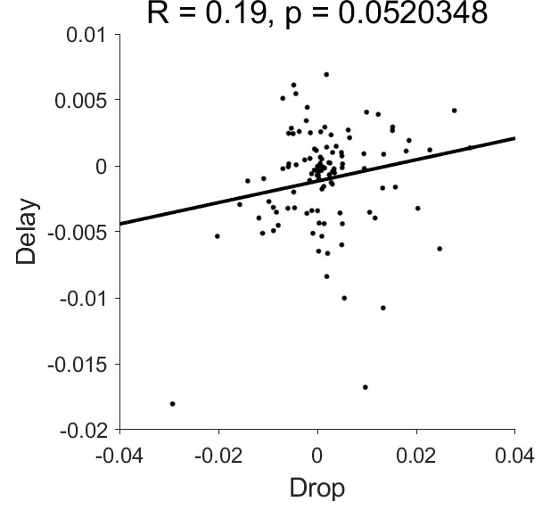
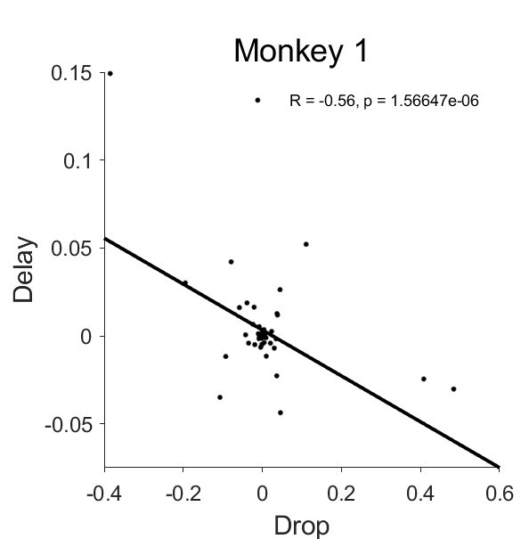
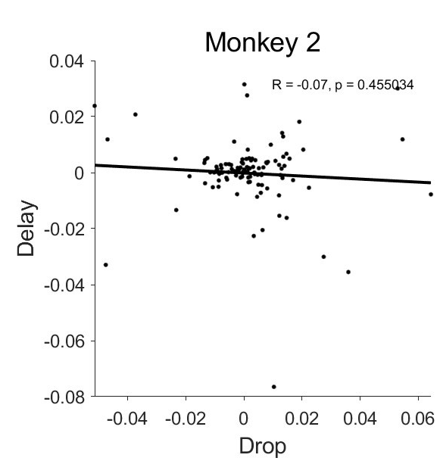
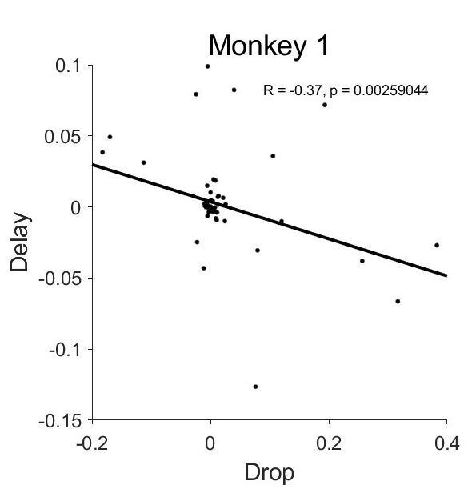
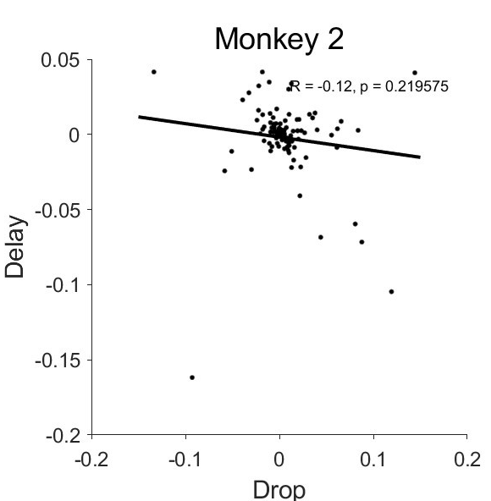
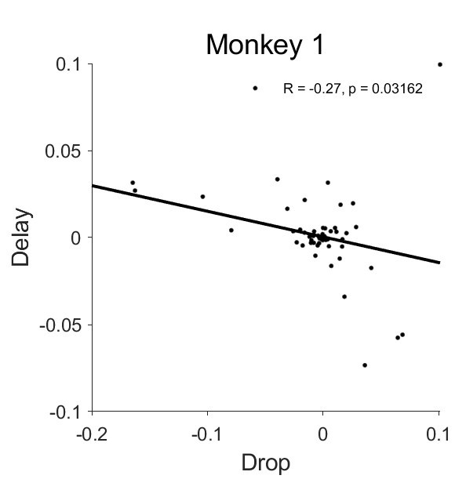
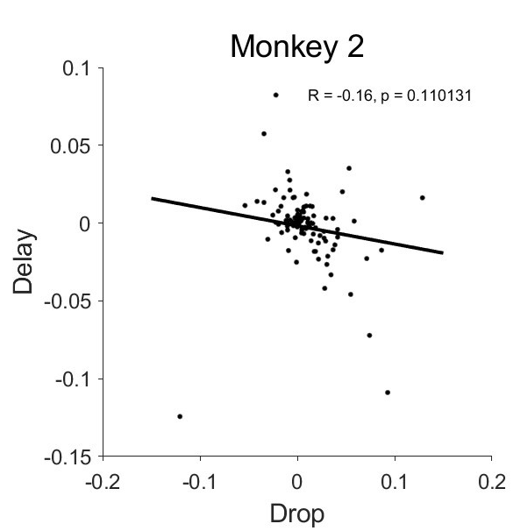
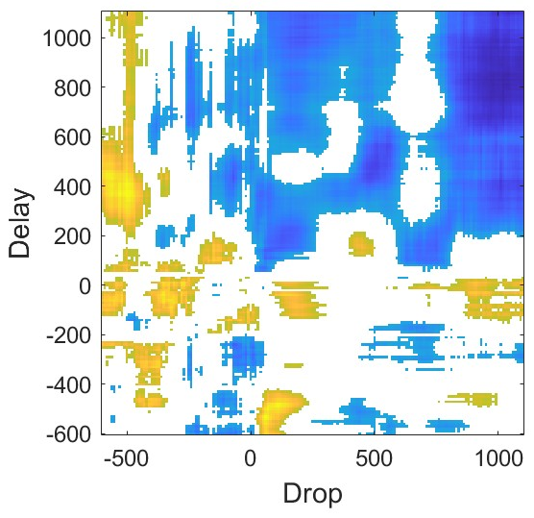
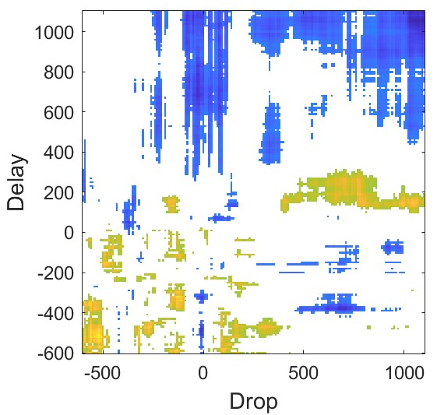
-250:0 ms
75:250ms
250:500 ms
500:750 ms

Further analysis using Beta-coefficients extracted from a 2-way ANOVA with reward magnitude (drops) and delay as continuous variables confirmed this negative correlation over time (Fig. S3F, L), reinforcing the observed shift in encoding during temporal discounting.
In the 250 ms immediately preceding the appearance of the offer, the two factors were not significantly correlated, although a positive trend was observed (Fig S3A, F).

The integrated information goes beyond the concurrent display of drop and delay.
To test to what degree we can decode reward magnitude and delay information from the neural population, we performed a moving window decoding analysis with cross-validation on the pseudo population (see Methods). For each animal, the testing accuracy was significantly above chance for all three variables (drops, delay and their interaction). We can decode drops and delay with a peak accuracy of 80% (chance is 33%), and their interaction at above 60% (chance is 11%) (Figure 5A, colored lines).
Next, whether the neural population is simply encoding delay and drops independently, without interacting with one another. If so, then we would expect that the ability to decode the interaction between drops and delay can be perfectly predicted by how well the networks decodes delay and drops individually. In other words, we would predict that:
$$\overline{P}(interaction) = P(delay) x P(drops)$$
Here, $P\left(interaction\right), P\left(delay\right),P(drops)$ are the decoding performance for each factor, $\overline{P}(interaction)$ refers to the predicted decoding performance assuming independent representation of delay and drop.
If the actual decoding performance is higher than the predicted performance from the independent encoding of each factor, this would indicate integration of the two factors in the neural representation beyond just encoding them separately. We then compare the predicted decoding performance of cue $\overline{P}(interaction)$ with the actual decoding performance $P\left(cue\right)$. We found that $P\left(interaction\right)$ is significantly higher than $\overline{P}(interaction)$ in Monkey S, from around 200ms after cue onset (Fig. 5A, right panel). Monkey T did not show such a difference.

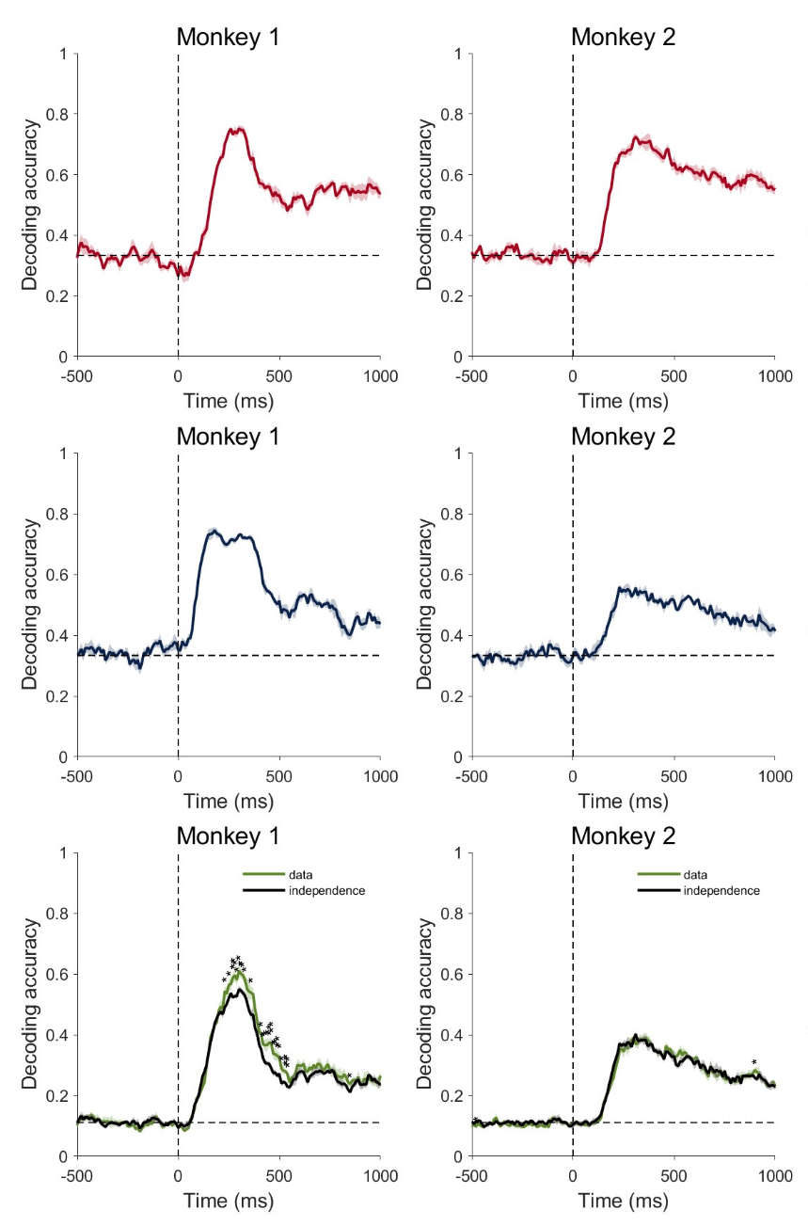

Materials and Methods
Subjects
Two male rhesus monkeys, both weighing 9.0 kg were used. The experimental procedures followed the Institute of Laboratory Animal Research Guide for the Care and Use of Laboratory Animals and were approved by the National Institute of Mental Health Animal Care and Use Committee.

Surgical Procedures
Surgical procedures were carried out using sterile technique under general anesthesia in a fully equipped operating room. An initial surgery was performed to place a head fixation post. In monkey one an eye coil was implanted. A second surgery was performed to implant the Utah recording arrays. We implanted one Utah array in monkey 1 and two Utah arrays in monkey 2. MR scans were obtained later, about 2-4 months after the Utah arrays were implanted to define the recording area (Fig. 3A, bottom panel).

Data Collection
To control stimuli presentation, reward delivery and bar touches a noncommercial software package was used (REX, https://nei.nih.gov/intramural/software; Hays et al., 1982). The eye position was monitored by using the Eye Position measuring system (https://staff.aist.go.jp/k.matsuda/eye/indexe.html) only for some sessions of Monkey 2. Neural activity of single units was recorded with Utah arrays (Blackrock Microsystems, Salt Lake City, USA; blackrockmicro.com). Electrical signals were captured, and single units were isolated online with TDT (Tucker-Davis Technologies, TDT, Alachua, USA; tdt.com) system for Monkey 1 and with Grapevine (Ripple Neuro, Salt Lake City, USA; rippleneuro.com) for Monkey 2. Data analyses were performed in the R statistical computing environment (R Foundation for Statistical Computing, Team R. D. C., 2018), Python (Python Software Foundation, http://www.python.org) and in MATLAB (http://www.mathworks.com/; R2020a).

Task
The monkey sat in a primate chair with the head fixed, 57 cm away from a video screen (47x30 cm; 1024x768 pixel; 120Hz) placed in front. A touch-sensitive bar was mounted on the chair at the level of the monkeys’ hands. A metal tube was positioned in front of the monkey’s lips to allow the monkey to drink when the reward was delivered.
The monkey worked in a intertemporal discounting task (Fig. 1A). To start a trial the monkey had to touch a lever, hold it for 1000 ms until a red square (0.40º x 0.40º) appeared at the center of the screen. After a variable time of 250 and 500 ms one of 9 possible visual cues (9.2º x 7.3º) appeared at the center of the screen for one of 5 durations between 750 and 2000 ms (step size 313 ms). Each visual cue indicated a particular offer, with the set of offers made by combining one of three reward sizes (2, 4 or 6 drops of liquid reward) with one of three delays to deliver the reward (1, 5 or 10 seconds). The monkey was required to continue to hold the bar and, if it was required, to maintain its gaze within the virtual window until the red square changed color to purple or yellow with equal probability (Fig. 1A). Either the purple or the yellow square served as a prompt to release the bar. Releasing the bar while the purple square was present indicated that the monkey was accepting the offer. Releasing the bar when the yellow square was present indicated that the monkey was refusing the offer. If the animal continued to hold the bar for the duration of the initial purple or yellow period of 1100 ms, the color of the square would change to the alternate color, allowing the animal to accept or refuse in each trial.
For instance, if the animal did not release the bar during the initial purple period, it could continue to hold the bar until the yellow square replaced the initial purple spot and release the bar in the yellow period. The same thing happened if the animal did not release the bar in the initial yellow period: it could hold the bar until the purple square replaced the initial yellow square and then release the bar.
In this design we prevented the monkey from preprogramming the motor response in the cue period, since the monkey could not anticipate whether the acceptance or refusal period would be the first interval or the second.
Upon accepting the offer, the purple square turned green (feedback signal), and the drops of reward were delivered after the delay indicated in the offer. Upon refusing the offer, the cue and fixation target disappeared, and a new trial would immediately begin with a new offer.
For 12/16 sessions the eye of Monkey 2 was monitored. A 20 x 20 degrees virtual window was built around the cue. The monkey was required to maintain his gaze in the virtual window from the appearance of the red spot to the appearance of the go-signal.
If the monkey (a) released the bar during the cue period, (b) didn’t maintain gaze in the virtual window, or (c) failed to release the bar during any of the go periods, an error was registered and an error feedback image (white rectangle with a red cross; 28.7 º x 17.8 º) appeared on the screen for 1000 ms. After an error, the next trial was a correction trial, during which the offer was repeated.

Behavior
For the behavioral analyses, we used data from all the neural recording days (7 for monkey 1 and 16 for monkey 2). The probability of accepting an offer was calculated independently for each of the 9 offers.
Siyu, could you provide a short paragraph about modeling behavioral data, here?

Neurophysiology
The neural activity of 170 neurons was analyzed using data from 75-750 ms after the appearance of the cue, labeled either “Cue Period” or “Offer Period”. This period ended before the prompt to accept (purple spot) or refuse (yellow spot) first appeared, and therefore before the monkey knew when it needed to make a movement.

1-way ANOVAs
We performed two separate 1-way ANOVAs (p < 0.05) on all 170 recorded cells, for each of 9 offers.
The first 1-way ANOVA was performed on each offer where the animal responded with at least 5 accepted and 5 refused trials. In the second 1-way ANOVA, each offer was selected based on whether the animal responded by releasing the bar on at least 5 trials on the first go signal and 5 trials on the second go signal, regardless of acceptance or refusal.

ANOVA-sliding window Analysis
For each significant cell (121/170) a sliding window analysis was performed using the neural activity, expressed as total spike count. Starting at 500 ms before the cue onset to 1000 ms after the cue onset, 100 ms bins were created with a 10 ms interleave period. The spike count within each bin was used in the 3-way ANOVA sliding window analysis, with drops, delay, and choice as independent variables. At each bin we estimated the proportion of cells that were significantly modulated by each factor (3-way ANOVA, p < 0.05).
Additionally, at each bin we extracted the variance explained for each factor, and for the interaction of drops and delay as omega squared (Olejnik and Algina, 2003):
ω² = (SS_{effect} – (df_{effect})(MS_{error}))/ MS_{error} + SS_{total}
A separate 3-way ANOVA sliding window analysis was also performed with drops, delay and DV as continuous variables.

Correlation across time
Since there was no choice effect, for each of 121 significant cells, we repeated a 2-way ANOVA sliding window analysis for each of the 121 significant cells, this time using only drops and delay as dependent variables. At each time bin, we extracted the percentage of variance explained as 1-(SSerror/SStotal) and the omega squared for each factor, as above.
For each factor separately, the proportion of variance explained for each time bin was correlated with each other and the Pearson correlation was calculated.
A significance threshold of 0.05 was used.

Decoding Analysis
Support vector machine was used as the classifier. Training and testing sets comprised of non-overlapping trials (75% of trials for training, and 25% for testing). The procedure was repeated 10 times, and the average decoding accuracy was recorded.
Decoding of drops, delay and interaction were carried out separately. For each factor, decoding was done in a sliding window (step 20ms, width 100ms).

Beta Coefficients - Encoding dimension of drop, delay, and value
In order to find the encoding dimension for drops, delay, and DV, we first performed a sliding window 3-way ANOVA analysis including all three factors and treating all three factors as continuous variables. For each neuron $i$, and for each factor $j$, we extract the regression coefficient $β_{i,j}$ from the ANOVA. The encoding dimension for factor $i$is defined as the vector that is comprised of all $β_{i,j}$ for each $j$.
Population activity that encodes delay is quantified as the population activity projected onto the dimension $β_{i,delay}$ for delay. Population activity of drops and DV are calculated similarly.

