Title: Temporal discounting in monkeys: neural integration of reward, delay, and task timing in the dlPFC.

Authors: Rossella Falcone^{1,3}, Siyu Wang¹, David B. Weintraub², Mariko McDougall¹, Mark Eldridge^{1,4}, and Barry J. Richmond^{1*}.

Affiliations:
¹Laboratory of Neuropsychology, NIMH, Bethesda, MD, USA
²Surgical Neurology Branch, NINDS, Bethesda, MD, USA
³Leo M. Davidoff Department of Neurological Surgery, Albert Einstein College of Medicine Montefiore Medical Center Bronx, NY USA.
⁴Mark new affiliation

*Corresponding authors:
Rossella Falcone, PhD
Assistant Professor
Albert Einstein College of Medicine, Bronx, NY, 10461
email: rossella.falcone@einsteinmed.edu

Barry J. Richmond, MD
Chief, Section on Neural Coding and Computation, Laboratory of Neuropsychology, NIMH/NIH/DHHS, Bldg 49, Rm 1B80, Bethesda, MD, 20892
Phone: 301-443-7319
email: bjr@ln.nimh.nih.gov

Numbers of pages:
Numbers of figures:
Numbers of words for Abstract:
Numbers of words for Introduction:
Numbers of words for Discussion:

Conflict of interests: The authors declare no competing financial interests.

Acknowledgments:
The opinions expressed in this article are the authors’ own and do not reflect the view of the US National Institutes of Health, the Department of Health and Human Services, or the United States government.
This research was supported (in part) by the Intramural Research Program of the NIMH and includes the relevant Annual Report number in the following format (???).

Authors contribution:
DW, BR and RF conceived and designed the task. RF, DW and MMcD collected the data. RF and DW sorted the data. SW and RF analyzed the data. RF, DW and ME performed surgeries and MRIs. RF, SW, ME and BR wrote the paper.

Abstract
Every day, we make decisions that require balancing what we want with when we can get it.
The dorsolateral prefrontal cortex (dlPFC) is critical for such choices, but it remains unclear how this brain region integrates various value-related information, such as reward size, delay, and the time available to act, over the course of decision-making.
In this study, we recorded single-neuron activity in the dlPFC of two monkeys performing a temporal discounting task, where they chose whether to accept or refuse offers that varied in both reward magnitude and delay. Critically, we also manipulated the order of the go-signals, cues indicating when a choice could be made, to test how additional time before response influenced value encoding.
We found that dlPFC neurons encoded reward and delay in opposing directions, with this encoding becoming more tightly coupled as the decision point approached, especially in the monkey that made more consistent, goal-directed choices. In this monkey, dlPFC activity also reflected the integration of go-signal timing into value estimates. In contrast, the second monkey showed weaker, later integration, and its behavior was more strongly influenced by the earliest available action, consistent with a simpler, action-driven strategy.
Decoding analyses confirmed that, in the first monkey reward and delay were combined into a unified value signal, whereas in the second monkey they remained largely separable.
Together, these results show that the dlPFC builds value representations dynamically over time, integrating multiple decision-relevant features, including task-imposed timing.
Importantly, how and when this integration happens can vary across individuals, possibly depending on their strategy, experience or cognitive flexibility.

Introduction
Temporal discounting describes the tendency to assign less value to rewards that are delayed in time (Ainslie, 1975; Mazur, 1987). This trade-off between reward size and delay is central to many daily decisions, from choosing something small now to waiting for something larger later.
An example is the marshmallow test, in which children were given a choice between eating one marshmallow immediately or waiting to receive two (Mischel and Ebbesen, 1970) ref). This test revealed individual differences in how children tolerate delay and in self-control, with some children resisting immediate gratification and others were tempted by it.
Similar variability has been observed in animals. In foraging scenarios, animals often face trade-offs between immediate but smaller food sources and delayed but more substantial ones, and their choices can vary depending on environmental conditions, individual experience and individual differences (Trevail et al., 2019; Eccard et al., 2020; Walker et al., 2023).
While temporal discounting is commonly viewed as the result of general valuation processes, these decisions also appear to reflect adaptive strategies shaped by both internal states and external demands.
The brain’s ability to integrate reward and delay information to guide decision-making is not fully understood. Previous research has shown that the dorsolateral prefrontal cortex (dlPFC) plays a key role in value-guided behavior (Barraclough et al., 2004; Hutcherson et al., 2012 ref) and self-control (ref), encoding reward magnitude, delay, and their interaction to compute temporally discounted values (ref).
However, less is known about how these computations evolve over time or whether additional task-related timing, such as delayed opportunity to act, modulates the value computation process.
In this study, we recorded single-neuron activity in the dlPFC of two monkeys performing a temporal discounting task. Each trial involved an offer that varied in reward magnitudes (2, 4, or 6 drops) and delay (1, 5, or 10 seconds). The animals had to decide whether to accept or reject the offer based on a visual cue. Critically, we also manipulated the order of the go-signals, allowing us to examine how task-related timing influences value encoding.
This design enabled us to explore not only how reward and delay are integrated but also how additional temporal cues about when an action can be taken affect the neural representation of value. In some trials, the animal could accept immediately; in others, it had to wait before accepting.
Behaviorally, the two monkeys differed in their responses to low value offers: monkey 1 consistently rejected these offers reliably, while monkey 2 accepted them more often.
At the neural level, we found that dlPFC neurons encoded reward and delay in opposite directions, consistent with temporal discounting. Importantly, this encoding became more tightly coupled as the decision became closer, especially in monkey 1, suggesting a flexible, evolving process of value integration.
We also found that the timing of the go-signal modulated behavior and neural response in monkey 1, whose dlPFC integrated reward, delay, and additional timing to act. In contrast, monkey 2 showed limited sensitivity to these temporal cues, both behaviorally and at neural level.
These results suggest that while the dlPFC is involved in the core processes of evaluating delayed rewards, the integration of reward and delay information may vary across individuals, influenced by factors such as task engagement, strategy, and experience.

Results
Behavior
Two monkeys performed a temporal discounting task (Fig. 1A; see Methods), in which each of 9 visual cues indicated a different value offer (Fig. 1B). Each offer was a combination of a reward magnitude (2, 4, or 6 drops of liquid reward) and a delay (1, 5, or 10 seconds after the choice).
All possible combinations of reward and delay were presented across trials, so that the two factors varied independently. This orthogonal design allowed us to measure the separate and combined effects of reward magnitude and delay on both behavior and neural activity.
On each trial an offer was presented, and the monkeys had to choose whether to accept or reject the offer. If the offer was accepted, the cue-defined drops were delivered after the corresponding delay (Fig. 1A). If the offer was rejected, the monkey immediately began a new trial.

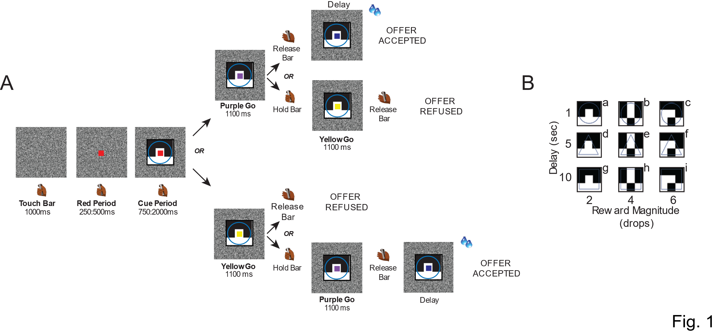

[Maybe here we should mention what model we have used for making Fig. 2A-B (see Methods)]
As expected, the probability of accepting the offer was highest for larger, more immediate rewards and lowest for smaller, delayed ones (Fig. 2A-B).
We also examined whether the acceptance rate changed based on whether the go-signal was yellow or purple. We hypothesized that the value of the offer might decrease following the yellow go-signal, which could explain why we expected a difference in acceptance rates between the two signals. In most conditions, especially when the offer was the most valuable for the animal, there was no significant difference in the acceptance rate between the yellow and purple go-signals. However, in some conditions, particularly when the offer was less valuable, the acceptance rate was lower after the yellow go-signal compared to purple (ADD t-test).
The behavior was modeled by ???? including the time of the first go-signal. We found that the behavior of Monkey 1 is best explained by a full temporal discounting model (YP time), where choices are primarily driven by ??
In contrast, the behavior of Monkey 2 is best explained by a model that has a bias for the purple go-signal (Fig. 2E-F).

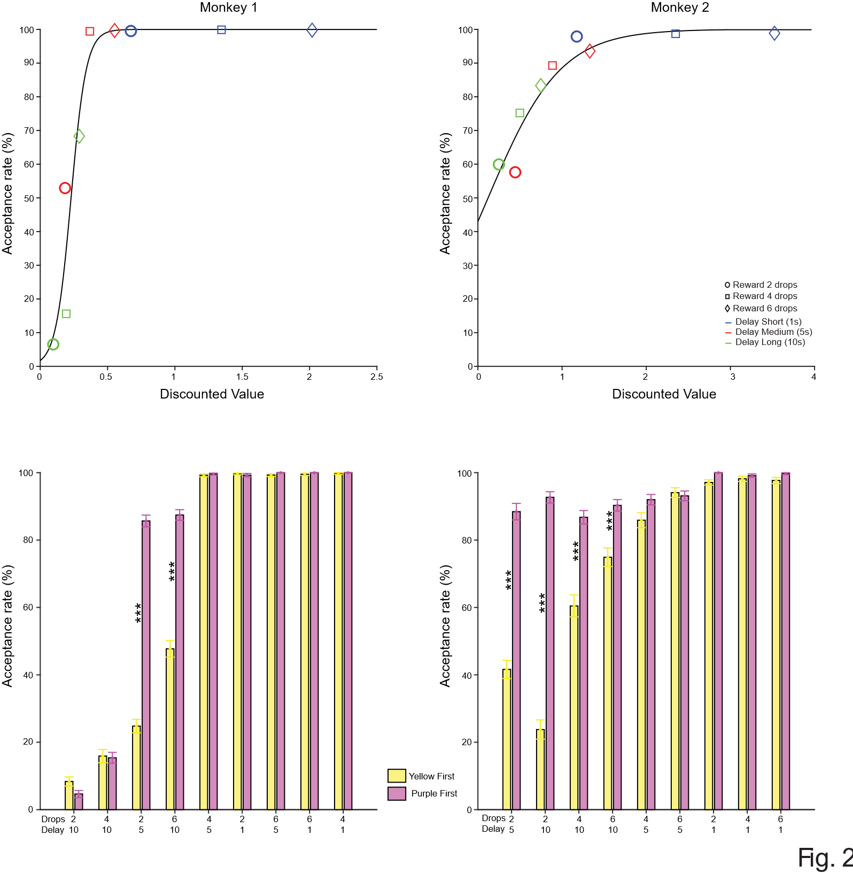

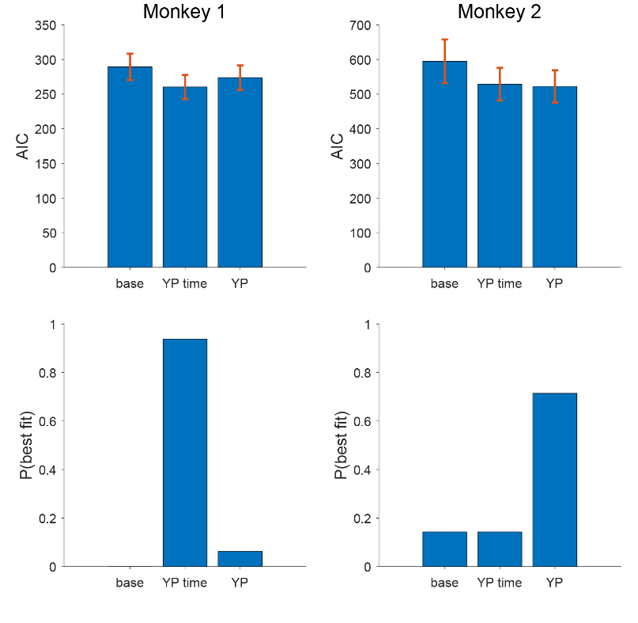

Neural Activity
Neural activity is modulated by the reward-related information signaled by the visual cue.
During the task performance, we recorded the activity of 170 neurons from the lower bank of the principal sulcus of the dlPFC (107 neurons in Monkey 1 and 63 neurons in Monkey 2) (Fig. 3A). Soon after the onset of the offer period, the neural activity, expressed as total spike count, was significantly modulated by reward magnitude and/or delay in 121 of the 170 neurons (3-way ANOVA, p < 0.05; Fig. 3B). A sliding window 3-way ANOVA analysis on all 170 neurons (see Methods) showed that the proportion of neurons modulated by each factor began to increase after the cue appeared on the screen (Fig. 3C-D). In Monkey 1, the proportion of neurons modulated by each factor was similar, although more neurons encoding reward magnitude (drops) emerged earlier (Fig. 3C). In contrast, Monkey 2 showed a similar number of neurons encoding reward magnitude and delay at the same time, but a greater number of neurons were modulated by delay throughout the entire offer period, while the number of neurons encoding reward magnitude was reduced later in the period (Fig. 3D). Fewer neurons responded later to the interaction between reward magnitude and delay (Fig. 3B).
To quantify the strength of encoding for each variable (reward magnitude, delay, and their interaction), we used omega squared (ω²), a measure of effect size that captures the proportion of variance in neural activity explained by each factor (see Methods).
The drop-related signal began earlier than both the delay-related and interaction-related signals. It was also stronger during the initial 500 ms of the offer period, in monkey 1, before becoming similar to the other two signals (Fig. S1A). In Monkey 2, instead, the delay-related signal was higher (Fig. S2).
For both animals, we did not observe any neurons that were above chance in response to the choice, i.e., whether the animal chose to accept or reject the offer (Fig. 3C-D). To examine this further, we analyzed the data on a cell-by-cell basis for each offer with sufficient acceptance and rejections. Two separate 1-way ANOVAs (p < 0.05; see Methods) showed that in the offer period 1) the neural response when the monkey accepted the offer was indistinguishable from that when the monkey refused the offer (N = 770; 35/598 for monkey 1 and 8/172 for monkey 2; Fig. S2A), 2) the neural response when the animal released the bar after the first go signal was indistinguishable from that when the monkey released the bar after the second go signal (N = 1195; 53/903 for monkey 1 and 16/292 for monkey 2; Fig. S2B).
These results suggest that neural activity in the dlPFC during the offer period reflects the evaluation of the offer's value, and not the upcoming choice (accept or reject).
As we saw from the behavior, both animals ranked the offers from lowest to highest valuable (Fig. 2A-B). We observed similar ranking in the neural activity, with neurons that increased or decreased their firing rate as the offer became more valuable (put a percentage; Fig. S3A-B). Other neurons showed more idiosyncratic response across different offers (put a percentage; Fig. S3C).

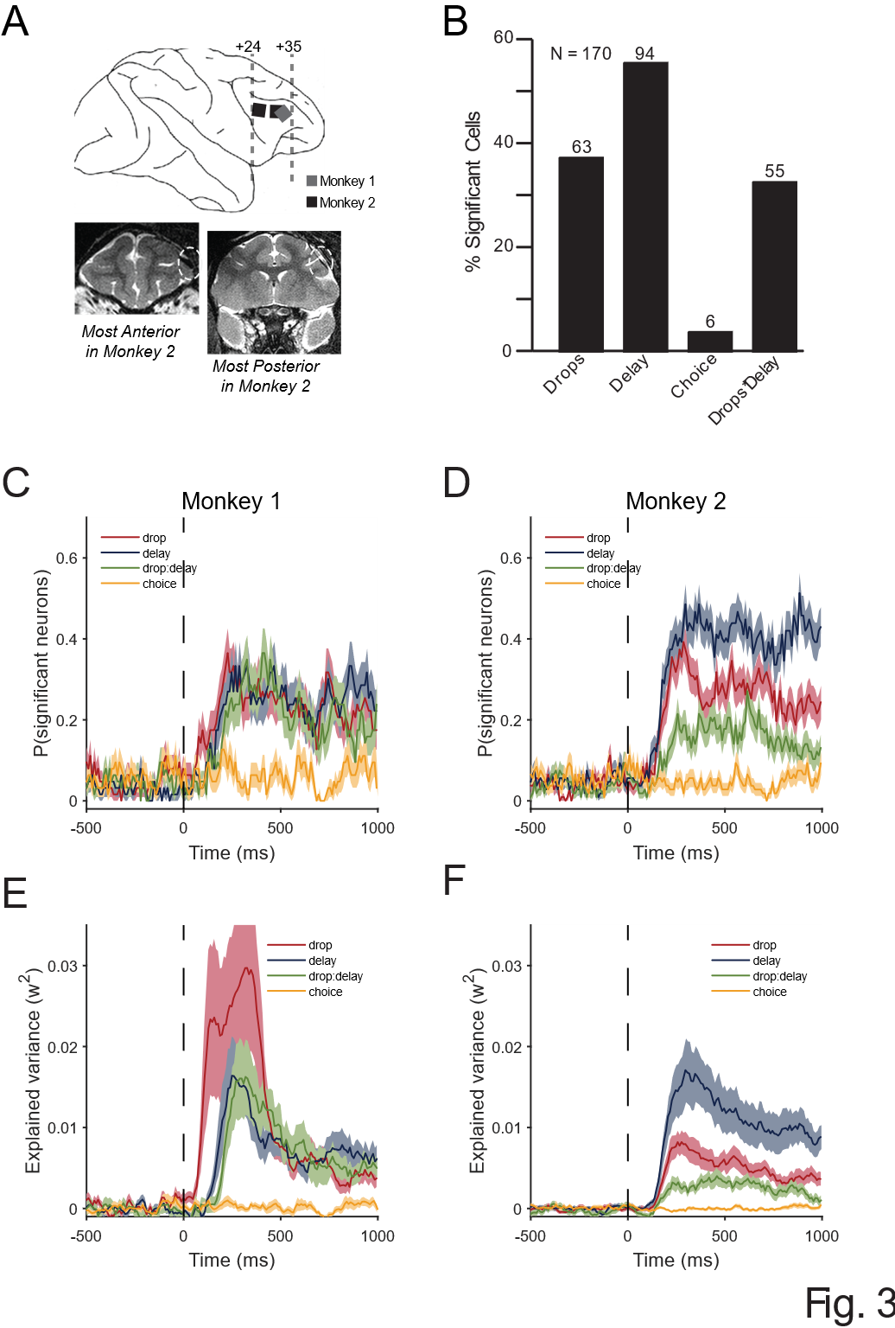

Reward magnitude and delay drive opposing shifts during temporal discounting
We investigated when and how the reward magnitude and delay became correlated, if at all, during the offer period.
We computed a time-resolved correlation across the population between each neuron's beta coefficients for reward magnitude and delay (from a sliding window regression; see Methods).
We observed stronger negative correlation between 750-1000 ms after the onset of the offer (Fig. 4A-B), in both monkeys.
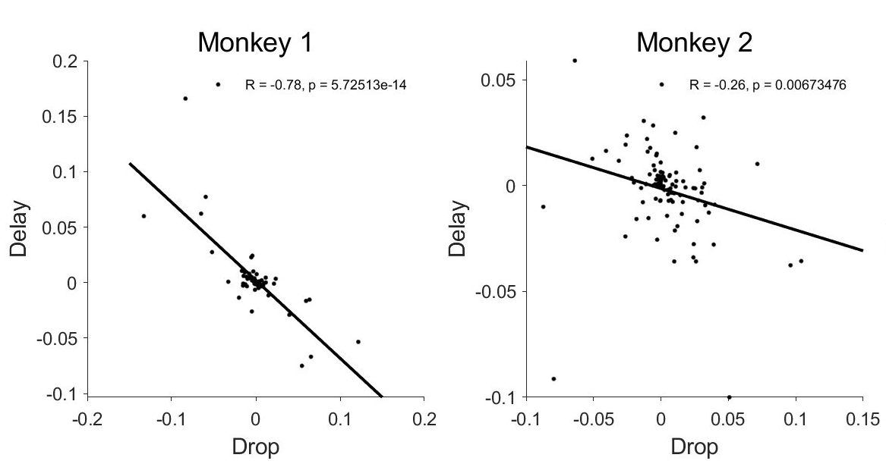
Specifically, Monkey 1 showed this negative correlation as soon as the cue appeared on the screen, that became stronger later. Monkey 2 showed a similar trend, though it did not reach statistical significance (Fig. S3B-D and G-I).
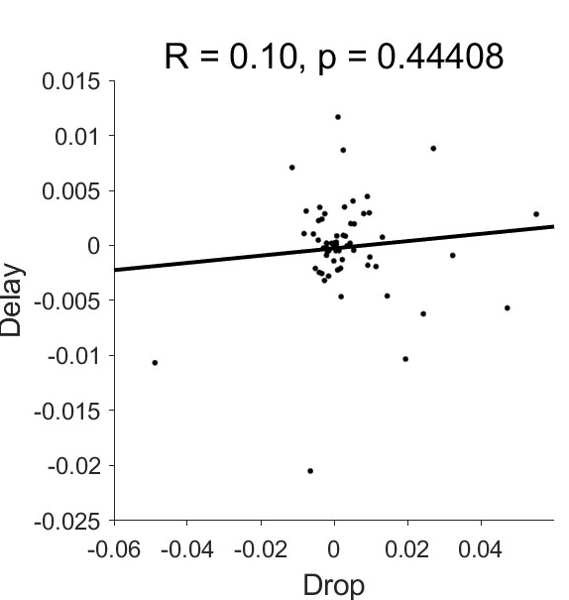
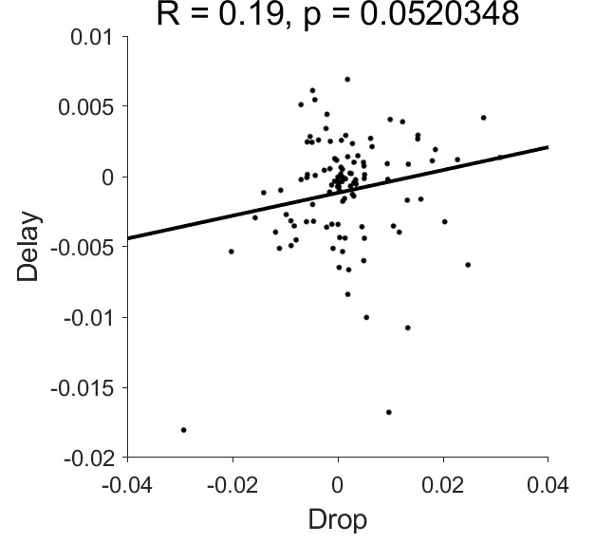
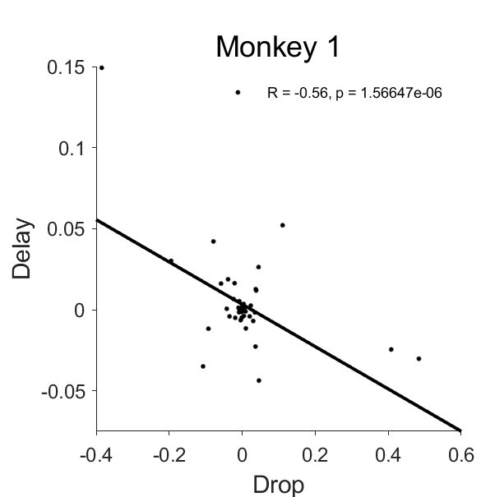
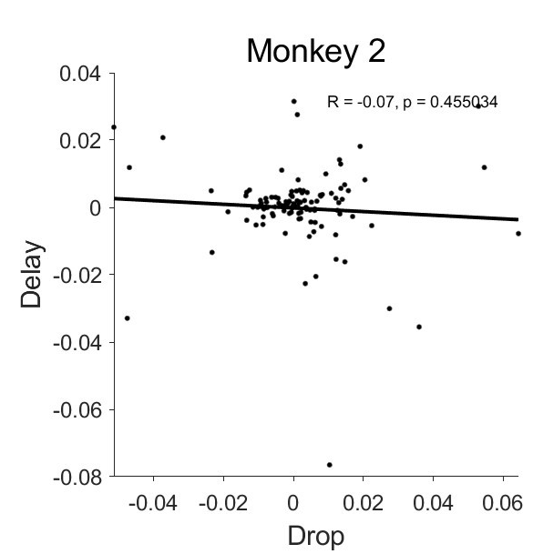
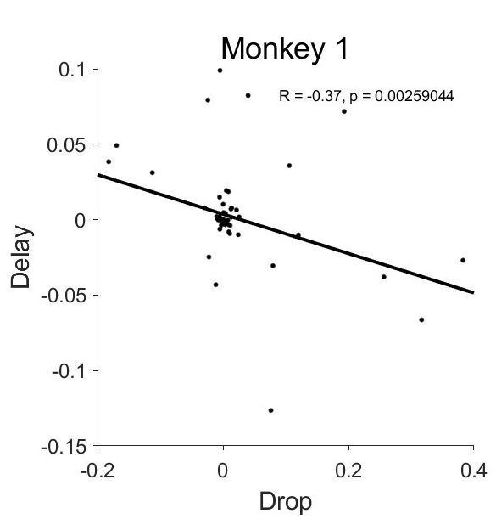
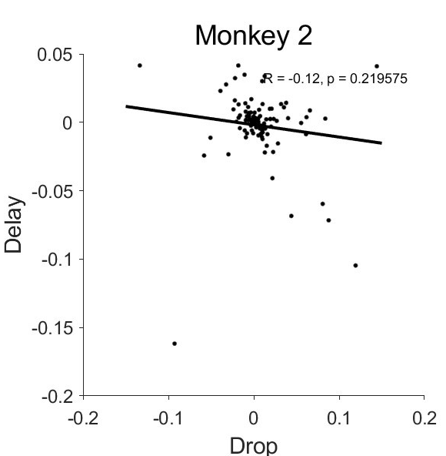
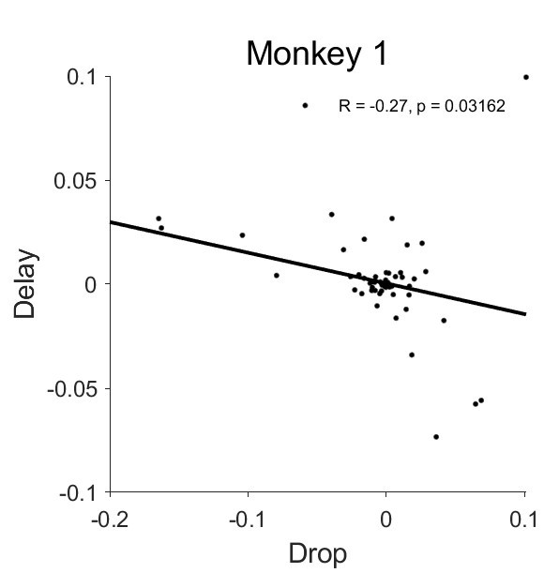
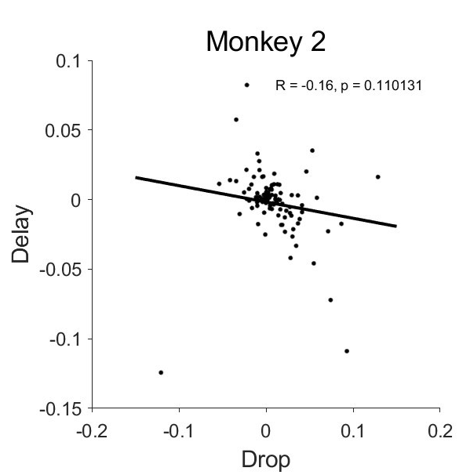
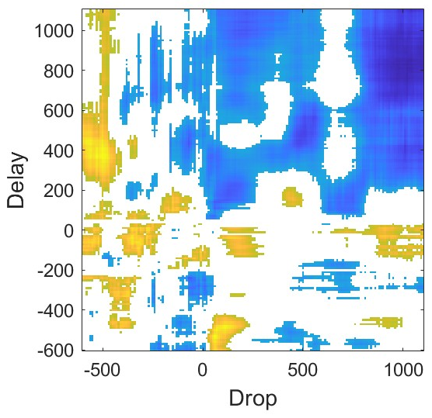
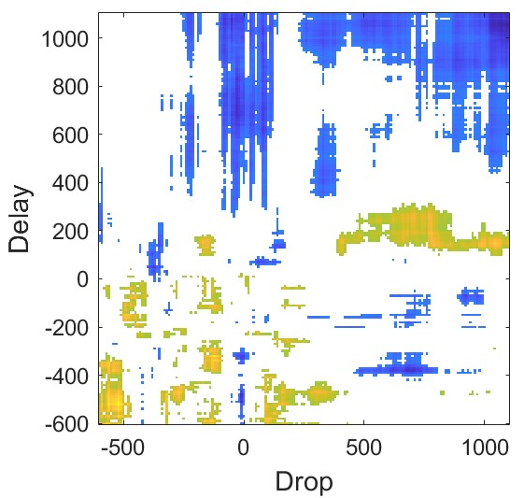
-250:0 ms
75:250ms
250:500 ms
500:750 ms

Further analysis confirmed this negative correlation over time reinforcing the observed shift in encoding during temporal discounting (Fig. S3F&L).
In the 250 ms immediately preceding the appearance of the offer, the two factors were not significantly correlated, although a positive trend was observed in both monkeys (Fig S3A& F).

Effects of the yellow go-signal on reward magnitude and delay encoding
From the behavior, we observed that monkeys accepted offers more often when the first go-cue was purple compared to yellow (Fig 2 C-D). This is plausible because, after the purple go-signal, the monkeys could accept the offer and receive the reward, though with a delay based on the offer. In contrast, when the yellow go-signal appeared first, the monkeys had to wait an additional period for the yellow signal to change to purple before they could accept the offer, resulting in a longer delay before receiving the reward.
We then investigated how the encoding of reward magnitude and delay changed when the yellow go-signal was also considered. For Monkey 1, we found that reward magnitude encoding increased when the first go-signal was yellow (Fig 5A), suggesting that the neural representation of value became stronger when the wait time before a possible acceptance was extended. In contrast, delay encoding decreased with longer yellow-to-purple delays, consistent with a dynamic reweighting of value components based on anticipated wait time (Fig. 5B). For Monkey 2, we did not observe any significant correlations in neural activity, although there was a positive trend in the encoding of reward magnitude, it did not reach statistical significance (Fig. 5C-D). Correlations over time are represented in the heatmap (Fig. 5?? or Fig, Supplementary ??).

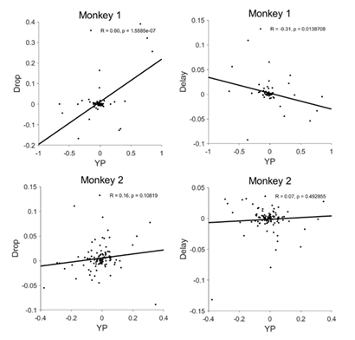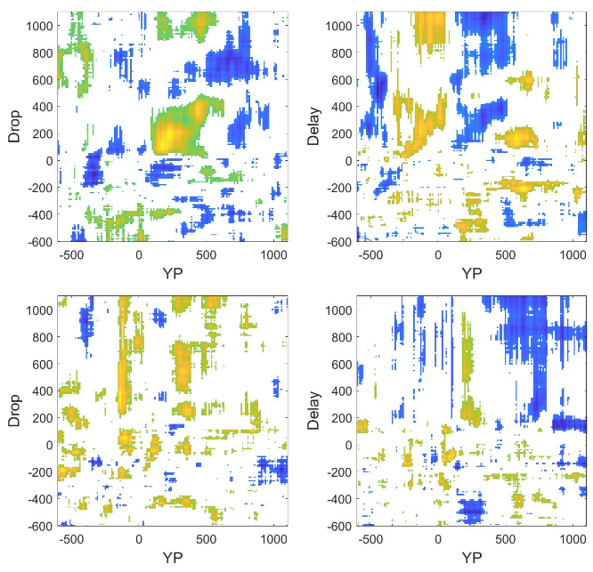

The integrated information goes beyond the separated representation of reward magnitude and delay in monkey 1.
To test to what degree we can decode reward magnitude and delay information from the neural population, we performed a moving window decoding analysis with cross-validation on the pseudo population (see Methods). For each animal, the testing accuracy was significantly above chance for all three variables (drops, delay and their interaction). We can decode drops and delay with a peak accuracy of 80% (chance is 33%), and their interaction at above 60% (chance is 11%) (Figure 6A, colored lines).
Next, to test whether the neural representation of value reflects integrated processing of reward magnitude and delay, or whether these features are encoded independently, we performed a decoding analysis on the neural population.
If the neural population is simply encoding delay and drops independently, without interacting with one another, then we would expect that the ability to decode the interaction between drops and delay can be perfectly predicted by how well the networks decodes delay and drops individually. In other words, we would predict that:
$$\overline{P}(interaction) = P(delay) x P(drops)$$
Here, $P\left(interaction\right), P\left(delay\right),P(drops)$ are the decoding performance for each factor, $\overline{P}(interaction)$ refers to the predicted decoding performance assuming independent representation of delay and drop.
If the actual decoding performance is higher than the predicted performance from the independent encoding of each factor, this would indicate integration of the two factors in the neural representation beyond just encoding them separately. We then compare the predicted decoding performance of cue $\overline{P}(interaction)$ with the actual decoding performance $P\left(cue\right)$. We found that $P\left(interaction\right)$ is significantly higher than $\overline{P}(interaction)$ in Monkey 1, from around 200ms after cue onset (Fig. 6C, left panel). Monkey 2 did not show such a difference (Fig. 6C, right panel).

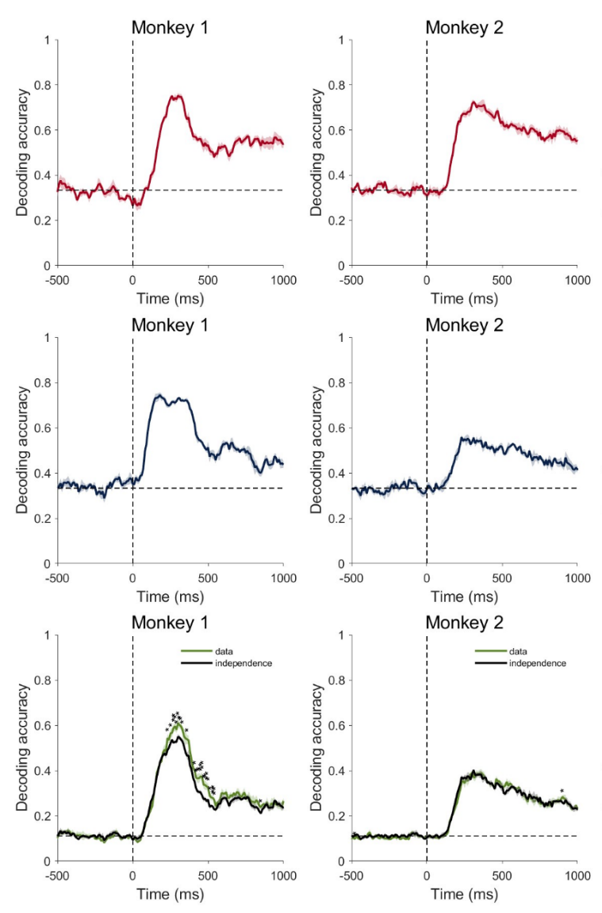

Discussion
In this study, we investigated how the dorsolateral prefrontal cortex (dlPFC) encodes reward magnitude and delay during a temporal discounting task, and how these neural signals relate to behavioral preferences. We also examined how the additional time to take an action modulates value computations in the dlPFC.
Using single-neuron recordings from two monkeys performing a task that required evaluating different rewards of different sizes available after varying delays, we found that dlPFC neurons encoded reward size and delay in opposing directions. This pattern correlates with temporal discounting, where the value of a reward decreases with increasing delays. It is also consistent with previous studies showing that a variety of brain regions often represent reward and delay with opposing tuning (Hori et al., 2021; Kim et al., 2008), suggesting a shared neural coding mechanism for integrating temporally discounted value.
Importantly, this tuning evolved over time rather than remaining constant throughout the trial.
In particular, the negative correlation between reward magnitude and delay strengthened
as the animals approached the decision point, indicating dynamic integration process in the dlPFC, in which the value-related signal becomes more refined over time, possibly reflecting an internal commitment to act. In monkey 1 this integration appeared to begin early and became stronger later from 750 ms post-cue. In monkey 2, emerged only later in the trial from 750 ms post-cue. These results could suggest that value computation is flexible and context-sensitive, occurring only when needed rather than preemptively.
This supports the idea that dlPFC engages in an efficient encoding strategy, optimizing resource use based on behavioral relevance.
This interpretation aligns with models of evidence accumulation (Brody and Hans, 2016), where the gradual accumulation of information favoring one option over another over time until the decision threshold is reached, and a choice is made (Shadlen & Newsome, 2001; Gold & Shadlen, 2007). Hunt and colleagues (2012, 2014) and Yoo and Hayden (2020) have shown that value representations in the prefrontal cortex evolve dynamically and depend on deliberation demands, subspace reorganization, and attribute-specific integration. Rich & Wallis (2016), further demonstrated that orbitofrontal value representations emerge only after deliberation begins, highlighting the temporal and contextual flexibility of value computation.
These dynamic patterns may reflect attractor-like dynamics in prefrontal circuits linked to emerging decision confidence. In our previous work (Wang and Falcone et al., 2023), we found that prefrontal activity shifted toward distinct trajectories based on internal confidence, suggesting that internal state and temporal dynamics co-contribute to commitment signals during choice. Moreover, Tang and colleagues (2021) showed that the flow of information between lPFC subregions is dynamically modulated by the decision type, further supporting the context-dependent nature of prefrontal value processing.
Although both monkeys exhibited a discounting-like signal, opposing tuning for reward and delay, the timing and strength of integration varied.
Monkey 1 showed early and strengthening integration, consistent with more consistent and refined behavior.
Monkey 2, in contrast, showed delayed and weaker integration, possibly reflecting greater uncertainty, ongoing learning, or lower motivation. Monkey 2 also exhibited more variable choices, frequently accepting the least valuable options, which may point to exploration strategies or inconsistent value computation.
These individual differences suggest that while dlPFC supports a general mechanism for value integration, the timing and efficiency of this process may be subject-specific.
This interpretation is supported by previous studies showing that individual differences in the stability of prefrontal neural dynamics can lead to variability in decision-making behavior (Kurokawa et al., (2018) ), suggesting that internal circuit properties may modulate how decision-relevant information, including value, is processed. Halfmann et al. (2016) further demonstrated that older adults exhibit different neural signatures of subjective value in vmPFC and striatum depending on their decision-making profiles, suggesting that value representations are shaped by individual experience and cognitive flexibility.
Repeated experience with the task may also shape these processes. Experience enables subjects to develop refined strategies, respond more consistently, and adjust to task contingencies.
This could explain why Monkey 1, with more task exposure, showed more efficient encoding, while Monkey 2, possibly less experienced, showed simpler or less refined strategies.
Previous studies have shown that experience shapes expectations about outcomes and enables individuals to use that information to guide future behavior (e.g., Daw et al., 2006; Collins & Frank, 2012). This form of adjustment over time is a key component of what is often referred to as adaptive behavior; that is, the capability to flexibly modify responses for better outcomes in changing environments. Adaptive behavior is supported by prefrontal regions, which integrate feedback and task structure to fine-tune behavior. This is consistent with the work of Euston and colleagues (2012) about the role of the medial prefrontal cortex (mPFC) in coordinating long-term goals with new information, a process essential for adjusting strategies during decision-making tasks.
One more implication of these findings is in the differences in cognitive flexibility, as seen between monkeys 1 and 2, may modulate the neural encoding of value over time. While the more refined and consistent behavior of monkey 1 suggests greater cognitive flexibility, the slower and more variable encoding seen in monkey 2 may reflect a need for further adaptive learning or adjustment in decision-making strategies. This suggests the potential influence of learning history and cognitive flexibility on the temporal evolution of value signals in the prefrontal cortex.
Additionally, we cannot exclude that motivational or emotional factors may also contribute to the differences observed between the two monkeys. Variations in motivation or engagement could have influenced the integration rate and decision-making strategy.
Moreover, individual differences in decision-making could have important implications for how we understand decision-making in general. If the way the brain responds varies between individuals, it might challenge the idea that everyone goes through the same process when making decisions. For example, if monkeys 1 and 2 process information differently (such as at different times or in different ways), it could suggest that current models of decision-making need to be updated to account for these individual differences.
Another key manipulation in our task was the manipulation of go-signal order, which allowed us to investigate how temporal cues influence decision-making.
We hypothesized that the yellow go-signal might reduce the perceived value of the offer. This could be due to a motivational shift, where the yellow signal signals an additional wait time before the offer can be accepted, potentially decreasing the immediate desire for the reward. Alternatively, the reduction could be due to a timing or cost-based effect, where the additional delay required by the yellow go-signal increases the expected cost of the reward, leading to a lower acceptance rate.
Behaviorally, both monkeys showed biases, with monkey 2 showing a stronger effect: offers were more likely to be accepted when the first go-signal corresponded to the acceptance option. This preference for acting sooner suggests animals were sensitive not only to reward and delay, but also to when a choice could be made. While the behavior of monkey 1 was best explained by a full temporal discounting model that incorporated go-signal timing, monkey 2 was better explained by a simpler model that has a bias for the acceptance go-signal.
One possible explanation is that monkey 2 has a behavioral bias toward the purple go-signal, rather than a sensitivity to the delay introduced by the yellow cue. This suggests that monkey 2 was more sensitive to when an action could be carried out than to the overall value of the offer. Or it can be habit, since the monkey may have learned that purple signal tends to lead to more immediate rewards; that is, less delayed between the go-signal and reward delivery. Alternatively, this behavioral pattern may reflect a reduced ability to fully integrate the timing structure of the task into value computations, perhaps due to a less developed strategy or limited experience with the task. Indeed, individual history may have contributed to such divergence. Monkey 1, with greater exposure to the task, may have developed more refined strategies, while monkey 2 was still adapting and so it was less sensitive to temporal contingencies present in the task. In this view, the choices of monkey 2 could be driven more by favoring whichever option allows for immediate action, rather than by a full deliberative comparison of reward and delay.
At the neural level, only monkey 1 showed modulation of dlPFC activity by the go-signal structure. For this animal, reward magnitude was positively correlated with the timing of the go-signal, and delay showed a negative correlation. These results suggest that in monkey 1, the dlPFC integrated not only reward and delay but also information about when an action could be performed. This result shows a more complex encoding strategy, where temporal elements of the task, in this case when an action can be executed, are integrated with reward attributes.
This integration of reward, delay and go-signal timing was absent in the dlPFC responses of monkey 2, consistent with a more stimulus-driven strategy, where behavior is guided by external cues rather than internal integration of value over time.
This form of behavior, in which choices are influenced primarily by immediate cues or action opportunities, rather than by a fully integrated value computations, has been reported in both human and animal studies of model-free decision-making, particularly in contexts of uncertainty or limited experience (Daw et al., 2005; Gläscher et al., 2010; Rangel et al., 2008). In these studies, the dlPFC and orbitofrontal cortex (OFC) primarily encode basic reward expectations, but fail to incorporate more complex variables like timing, state transitions, or task structure, reflecting a shift away from model-based processing and toward more reactive decision-making mechanisms that rely on immediate feedback.
Here, we found that this was not true for monkey 1.
To directly assess integration, we performed decoding analyses on pseudo-population activity. In both monkeys, we could reliably decode reward magnitude, delay, and their interaction from neural activity. However, in monkey 1, the ability to decode the interaction term exceeded what would be predicted by independent encoding of reward and delay, indicating that these two variables were not simply represented as separated features, but instead integrated into a unified value signal in the dlPFC.
This effect was absent in monkey 2, where the decoding of the interaction term did not exceed chance levels predicted from the independent contributions of reward and delay.
These results indicate that in Monkey 1, the dlPFC integrates reward and delay into a joint value signal, consistent with the behavior being driven by a full temporal discounting model. In Monkey 2, weaker or absent integration, matches the behavioral pattern dominated by a bias for specific cues.
Our results expand on previous studies that have shown that the dlPFC encodes reward and delay parameters and that it can reflect subjective value during intertemporal decision-making (Kim et al., 2008; Hosokawa et al., 2013). We further show that this encoding is not static but changes over time and can incorporate additional task-relevant variables, like go-signal timing, and varies between individuals.
The observed differences between monkeys in how they incorporate go-signal timing may also reflect individual variability in strategy, task engagement, or experience. Although we did not explicitly manipulate experience directly, the more integrated and temporally sensitive neural responses we see in monkey 1 may reflect greater familiarity with the task structure, allowing for more efficient valuation. Conversely, monkey 2 appeared to rely more on simpler response strategies, such as preferring the first available action, which may reflect a way to deal with uncertainty or a less developed internal model of the task.
This study has several limitations. With only two animals, we cannot confidently generalize the observed neural patterns to broader population, and we cannot disentangle experience from intrinsic individual traits. Future studies with larger samples and longitudinal designs could clarify whether such variability reflects stable traits or learning history.
Moreover, while we found evidence for integration of reward, delay, and timing signals in the dlPFC, our task was not designed to directly test causal contributions of this brain area and behavior. Future work using targeted perturbation or tracking the same animals over time could help clarify the mechanisms of how learning or experience shapes value representations in the dlPFC.
Taken together, our results provide new insight into how dlPFC integrates multiple decision variables, reward, delay and action timing, over the course of a decision. We also show when and how integration happens, and that it can vary across individuals, potentially reflecting differences in strategy, experience, or cognitive flexibility.
This variability cannot be just noise but may represent meaningful differences in how each brain constructs value. Recognizing these individual patterns is important for developing more accurate, generalizable models of decision-making.

Materials and Methods
Subjects
Two male rhesus monkeys, both weighing 9.0 kg were used. The experimental procedures followed the Institute of Laboratory Animal Research Guide for the Care and Use of Laboratory Animals and were approved by the National Institute of Mental Health Animal Care and Use Committee.

Surgical Procedures
Surgical procedures were carried out using sterile technique under general anesthesia in a fully equipped operating room. An initial surgery was performed to place a head fixation post. In monkey one an eye coil was implanted. A second surgery was performed to implant the Utah recording arrays. We implanted one Utah array in monkey 1 and two Utah arrays in monkey 2. MR scans were obtained later, about 2-4 months after the Utah arrays were implanted to define the recording area (Fig. 3A, bottom panel).

Data Collection
To control stimuli presentation, reward delivery and bar touches a noncommercial software package was used (REX, https://nei.nih.gov/intramural/software; Hays et al., 1982). The eye position was monitored by using the Eye Position measuring system (https://staff.aist.go.jp/k.matsuda/eye/indexe.html) only for some sessions of Monkey 2. Neural activity of single units was recorded with Utah arrays (Blackrock Microsystems, Salt Lake City, USA; blackrockmicro.com). Electrical signals were captured, and single units were isolated online with TDT (Tucker-Davis Technologies, TDT, Alachua, USA; tdt.com) system for Monkey 1 and with Grapevine (Ripple Neuro, Salt Lake City, USA; rippleneuro.com) for Monkey 2. Data analyses were performed in MATLAB (http://www.mathworks.com/; R2020a).

Task
The monkey sat in a primate chair with the head fixed, 57 cm away from a video screen (47x30 cm; 1024x768 pixel; 120Hz) placed in front. A touch-sensitive bar was mounted on the chair at the level of the monkeys’ hands. A metal tube was positioned in front of the monkey’s lips to allow the monkey to drink when the reward was delivered.
The monkey worked in a intertemporal discounting task (Fig. 1A). To start a trial the monkey had to touch a lever, hold it for 1000 ms until a red square (0.40º x 0.40º) appeared at the center of the screen. After a variable time of 250 and 500 ms one of 9 possible visual cues (9.2º x 7.3º) appeared at the center of the screen for one of 5 durations between 750 and 2000 ms (step size 313 ms). Each visual cue indicated a particular offer, with the set of offers made by combining one of three reward sizes (2, 4 or 6 drops of liquid reward) with one of three delays to deliver the reward (1, 5 or 10 seconds). The monkey was required to continue to hold the bar and, if it was required, to maintain its gaze within the virtual window until the red square changed color to purple or yellow with equal probability (Fig. 1A). Either the purple or the yellow square served as a prompt to release the bar. Releasing the bar while the purple square was present indicated that the monkey was accepting the offer. Releasing the bar when the yellow square was present indicated that the monkey was refusing the offer. If the animal continued to hold the bar for the duration of the initial purple or yellow period of 1100 ms, the color of the square would change to the alternate color, allowing the animal to accept or refuse in each trial.
For instance, if the animal did not release the bar during the initial purple period, it could continue to hold the bar until the yellow square replaced the initial purple spot and release the bar in the yellow period. The same thing happened if the animal did not release the bar in the initial yellow period: it could hold the bar until the purple square replaced the initial yellow square and then release the bar.
In this design we prevented the monkey from preprogramming the motor response in the cue period, since the monkey could not anticipate whether the acceptance or refusal period would be the first interval or the second.
Upon accepting the offer, the purple square turned green (feedback signal), and the drops of reward were delivered after the delay indicated in the offer. Upon refusing the offer, the cue and fixation target disappeared, and a new trial would immediately begin with a new offer.
For 12/16 sessions the eye of Monkey 2 was monitored. A 20 x 20 degrees virtual window was built around the cue. The monkey was required to maintain his gaze in the virtual window from the appearance of the red spot to the appearance of the go-signal.
If the monkey (a) released the bar during the cue period, (b) didn’t maintain gaze in the virtual window, or (c) failed to release the bar during any of the go periods, an error was registered and an error feedback image (white rectangle with a red cross; 28.7 º x 17.8 º) appeared on the screen for 1000 ms. After an error, the next trial was a correction trial, during which the offer was repeated.

Behavior
For the behavioral analyses, we used data from all the neural recording days (7 for monkey 1 and 16 for monkey 2). The probability of accepting an offer was calculated independently for each of the 9 offers.
Reinforcement learning models fit the behavior of the two monkeys separately. The probability of choosing to accept an offer is modelled through a SoftMax function as
$$p=\frac{1}{1+e^{β⋅(θ-V\left(drop, delay\right))}}$$
Here, $θ$ is decision threshold, $β$ is the temperature term.
$$V\left(drop, delay\right)=\frac{drop}{1+k⋅delay}$$
$k$ is the hyperbolic discounting factor. The free parameters $θ, β, k$ are fit via maximum likelihood estimation.

Neural Activity
The neural activity of 170 neurons was analyzed using data from 75-750 ms after the appearance of the cue, labeled either “Offer Period”. This period ended before the prompt to accept (purple spot) or refuse (yellow spot) first appeared, and therefore before the monkey knew when it needed to make a movement.

1-way ANOVAs
We performed two separate 1-way ANOVAs (p < 0.05) on all 170 recorded cells, for each of 9 offers. The first 1-way ANOVA was performed on each offer where the animal responded with at least 5 accepted and 5 refused trials. In the second 1-way ANOVA, each offer was selected based on whether the animal responded by releasing the bar on at least 5 trials on the first go signal and 5 trials on the second go signal, regardless of acceptance or refusal.

ANOVA-sliding window Analysis
A sliding window analysis was performed using the neural activity from all 170 recorded cells, expressed as total spike count. Starting at 500 ms before the cue onset to 1000 ms after the cue onset, 100 ms bins were created with a 10 ms interleave period. The spike count within each bin was used in the 2-way ANOVA sliding window analysis, with drops, delay, independent variables. Choice as factor was included as
At each bin we estimated the proportion of cells that were significantly modulated by each factor (3-way ANOVA, p < 0.05).
Additionally, at each bin we extracted the variance explained for each factor, and for the interaction of drops and delay as omega squared (Olejnik and Algina, 2003):
ω² = (SS_{effect} – (df_{effect})(MS_{error}))/ MS_{error} + SS_{total}
A separate 3-way ANOVA sliding window analysis was also performed with drops, delay and DV as continuous variables.

Correlation across time
Since there was no choice effect, for each of 121 significant cells, we repeated a 2-way ANOVA sliding window analysis for each of the 121 significant cells, this time using only drops and delay as dependent variables. At each time bin, we extracted the Beta-Coefficients.
For each factor separately, the proportion of variance explained for each time bin was correlated with each other and the Pearson correlation was calculated.
A significance threshold of 0.05 was used.

Decoding Analysis
Support vector machine was used as the classifier. Training and testing sets comprised of non-overlapping trials (75% of trials for training, and 25% for testing). The procedure was repeated 10 times, and the average decoding accuracy was recorded.
Decoding of drops, delay and interaction were carried out separately. For each factor, decoding was done in a sliding window (step 20ms, width 100ms).

Beta Coefficients - Encoding dimension of drop, delay, and value
In order to find the encoding dimension for drops, delay, and DV, we first performed a sliding window 3-way ANOVA analysis including all three factors and treating all three factors as continuous variables. For each neuron $i$, and for each factor $j$, we extract the regression coefficient $β_{i,j}$ from the ANOVA. The encoding dimension for factor $i$is defined as the vector that is comprised of all $β_{i,j}$ for each $j$.
Population activity that encodes delay is quantified as the population activity projected onto the dimension $β_{i,delay}$ for delay. Population activity of drops and DV are calculated similarly.

