Title: Temporal discounting in monkeys: prefrontal encoding of reward, delay, and go-signals.

Authors: Rossella Falcone^{1,3}, Siyu Wang¹, David B. Weintraub², Mark A. G. Eldridge^{1,4}, Mariko McDougall¹, and Barry J. Richmond^{1*}.

Affiliations:
¹Laboratory of Neuropsychology, NIMH, Bethesda, MD, USA
²Surgical Neurology Branch, NINDS, Bethesda, MD, USA
³Leo M. Davidoff Department of Neurological Surgery, Albert Einstein College of Medicine Montefiore Medical Center Bronx, NY USA.
⁴Newcastle University, Newcastle upon Tyne, NE1 7RU

*Corresponding authors:
Rossella Falcone, PhD
Assistant Professor
Albert Einstein College of Medicine, Bronx, NY, 10461
e-mail: rossella.falcone@einsteinmed.edu

Barry J. Richmond, MD
Chief, Section on Neural Coding and Computation, Laboratory of Neuropsychology, NIMH/NIH/DHHS, Bldg 49, Rm 1B80, Bethesda, MD, 20892
e-mail: bjr@ln.nimh.nih.gov

Numbers of pages:
Numbers of figures:
Numbers of words for Abstract:
Numbers of words for Introduction:
Numbers of words for Discussion:

Conflict of interests: The authors declare no competing financial interests.

Acknowledgments:
This research was supported in part by the Intramural Research Program of the National Institutes of Health (NIH). The contributions of the NIH author(s) were made as part of their official duties as NIH federal employees, are in compliance with agency policy requirements, and are considered Works of the United States Government. However, the findings and conclusions presented in this paper are those of the author(s) and do not necessarily reflect the views of the NIH or the U.S. Department of Health and Human Services.
This research was supported (in part) by the Intramural Research Program of the NIMH and includes the relevant Annual Report number in the following format (???).

Authors contribution:
DW, BR and RF conceived and designed the task. RF, DW collected the data. RF and DW sorted the data. SW, RF, MMcD, ME, BR analyzed the data. RF, DW and ME performed surgeries and MRIs. RF, ME SW, and BR wrote the paper.

Abstract
Imagine being offered two options: a small reward now or a larger reward later. Which would you choose? This dilemma, known as temporal discounting, highlights how individuals differ in their ability to weigh future benefits against immediate gratification. Such variability may arise from differences in how the brain integrates value-related features during deliberation.
But what if you first had to wait before being allowed to act? How might that further alter your decision?
We recorded single-neuron activity in the dorsolateral prefrontal cortex (dlPFC) of two monkeys performing a temporal discounting task with manipulated go-signal timing, which indicated when choices could be executed.
In both animals, in line with previous research (CITE Lee Neuron 2014, Elife), we found that dlPFC neurons encoded reward magnitude and delay with an inverse relationship, neurons firing more for larger rewards fired less for longer delays, consistent with temporal discounting. However, this anti-correlated encoding emerged earlier and strengthened as the decision point approached only in one monkey, whose behavior was more consistently goal directed. In this animal, dlPFC activity also integrated go-signal timing with reward and delay, reflecting a flexible, model-based valuation process.
By contrast, the second monkey exhibited weaker integration of reward and delay during the early offer period, with coupling appearing predominantly near the go-signal, which functioned more as a visual cue than a temporal marker. This pattern suggested a more reactive, stimulus-driven decision strategy.
Decoding analyses confirmed these differences, revealing unified value signals in the first monkey but more independent reward and delay representations in the second.
Together, our results demonstrate that dlPFC value computations are dynamically shaped by both offer features and task demands, and that individual differences in these neural integration processes underlie variability in temporal discounting behavior.

Introduction
Temporal discounting refers to the tendency to assign less value to rewards that are delayed in time (Ainslie, 1975; Mazur, 1987). This trade-off between reward magnitude and delay is central to many everyday decisions that involve choosing something small now vs. waiting for something larger later.
A well-known example is the ‘marshmallow’ test, in which children were given a choice between eating one marshmallow immediately or waiting to receive two (Mischel and Ebbesen, 1970) ref). Although confounded with socioeconomic background, this test revealed individual differences in how children tolerate delay and self-control, with some children resisting immediate gratification and others succumbing to it.
Similar variability has been observed in animals. In natural foraging scenarios, animals often face choices between immediate but smaller food sources and delayed but more substantial ones. Their preferences can vary with environmental conditions, prior experience and individual differences (Trevail et al., 2019; Eccard et al., 2020; Walker et al., 2023).
Although temporal discounting is commonly viewed as the result of general valuation processes, emerging evidence suggests these decisions may also reflect adaptive strategies shaped by both internal states and external demands, such as the timing of when a choice can be executed (CITE) and internal motivation (Shadmehr et al., 2010; Kable & Glimcher, 2007). How such factors influence the neural computations of reward and delay remains an open question and is not necessarily consistent across individuals.
The dorsolateral prefrontal cortex (dlPFC) has been implicated in value-guided behavior (Barraclough et al., 2004; Hutcherson et al., 2012 ref) and self-control (ref). Neurons in this area encode reward magnitude, delay, and interaction, supporting the computation of temporally discounted value (ref).
However, it remains unclear how these neural representations evolve during deliberation and whether they are modulated by contextual variables like the timing of choice execution.
To address this, we recorded single-neuron activity in the dlPFC of two monkeys performing a temporal discounting task featuring a two-step go-signal that manipulated the timing of choice execution. We found that although the timing of choice had a significant influence on behavior and neural coding in one animal, the other animal appeared less sensitive to this manipulation. These differences were reflected in both their behavioral strategies and neural dynamics, highlighting individual variability in the integration of contextual information during temporal discounting and pointing to distinct underlying neural mechanisms.

Results
1. Behavioral evidence of temporal discounting
Two monkeys performed a temporal discounting task (Fig. 1A; see Methods), where each of nine visual cues represented an offer of reward (Fig. 1B). Each offer combined reward magnitude (2, 4, or 6 drops of liquid reward) with a delay before delivery (1, 5, or 10 seconds).
By varying reward and delay independently across trials in an orthogonal design, we could dissociate their individual and combined effects on both behavior and neural activity.
On each trial the animal viewed a cue and chose whether to accept or reject the offer. If the offer was accepted, the cue-defined drops were delivered after the corresponding delay (Fig. 1A). If the offer was rejected, the monkey immediately began a new trial. The order of the presentation of ‘accept’ and ‘reject’ choices was counterbalanced.

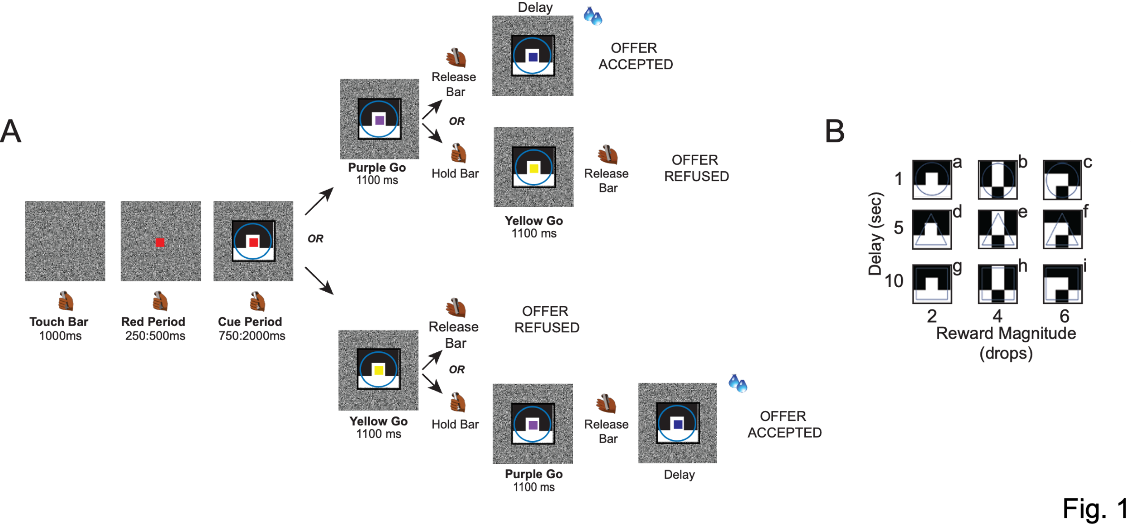

To analyze behavior, we included data from all neural recording days (7 for Monkey 1, 16 for Monkey 2). The monkeys’ choices were modeled using a standard hyperbolic discounting function, where the discounted value increased with reward magnitude and decreased with longer delays (see Methods).
The acceptance probability was fitted with a logistic sigmoid, capturing a smooth transition from rejection to acceptance as discounted value rose (black curves in Fig. 2A-B; see Methods).
As expected, both animals were more likely to accept larger, more immediate rewards and less likely to accept smaller, delayed ones (Fig. 2A-B).
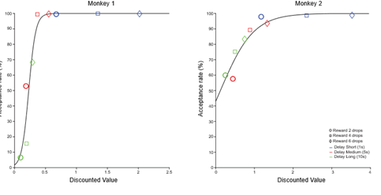

2. dlPFC neurons encode offer value but not choice
We recorded the activity of 170 neurons from the dlPFC, specifically from the lower bank of the principal sulcus (107 neurons in Monkey 1 and 63 neurons in Monkey 2; Fig. 3A), while the animals performed the task.
Soon after offer onset, the firing rates of 121 out of 170 neurons were significantly modulated by reward magnitude and/or delay (2-way ANOVA, p < 0.05; Fig. 3B). Sliding window ANOVA analysis showed that the proportion of neurons modulated by each factor began to increase after the cue appeared on the screen (Fig. 3C-D).
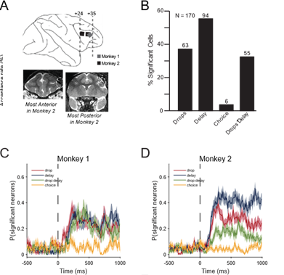
To quantify the strength of encoding for each variable (reward magnitude, delay, and their interaction), we used omega squared (ω²), a measure of effect size that captures the proportion of variance in neural activity explained by each factor (see Methods).
We found that modulation by reward appeared earlier and stronger than modulation by delay, particularly in Monkey 1 during the first 500 ms of the offer period, whereas in Monkey 2 the delay signal was relatively more prominent (Fig. S1A-B).

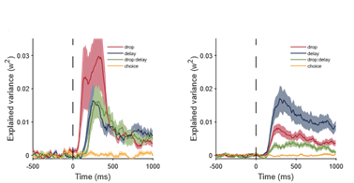
Importantly, we found no evidence that neural activity during the offer period (first 750 ms) encoded the upcoming choice outcome (accept vs. reject) in either animal (Fig. 4C-D).
Cell-by-cell analyses confirmed that spike counts during the offer period did not differ significantly between accepted and rejected offers (N = 770; 35/598 for monkey 1 and 8/172 for monkey 2; 1-way ANOVAs (p < 0.05); Fig. S2A) nor between early and late action initiations following go-signals (N = 1195; 53/903 for monkey 1 and 16/292 for monkey 2; 1-way ANOVAs (p < 0.05); Fig. S2B).
These results indicate that dlPFC neurons encode the value attributes of the offer (reward and delay) during evaluation, but do not represent the animal’s commitment to a choice at this stage.

3. Inverse encoding of reward magnitude and delay in dlPFC neurons
In both animals, dlPFC neurons exhibited an inverse correlation between reward magnitude and delay encoding, consistent with temporal discounting. This relationship became particularly evident after 750 ms from cue onset, a time point corresponding to the earliest possible appearance of the first go-signal (Fig. 4A-B).
In Monkey 1, a significant negative correlation emerged within the first 250 ms of the offer period and persisted throughout cue presentation. In Monkey 2 there was a similar trend during the first 750 ms, but it was weaker and did not reach statistical significance (Fig. S3B–D and G–I).
In the 250 ms preceding cue onset, no significant correlation between reward magnitude and delay encoding was observed, and the trend was positive (Fig S3 A&E).
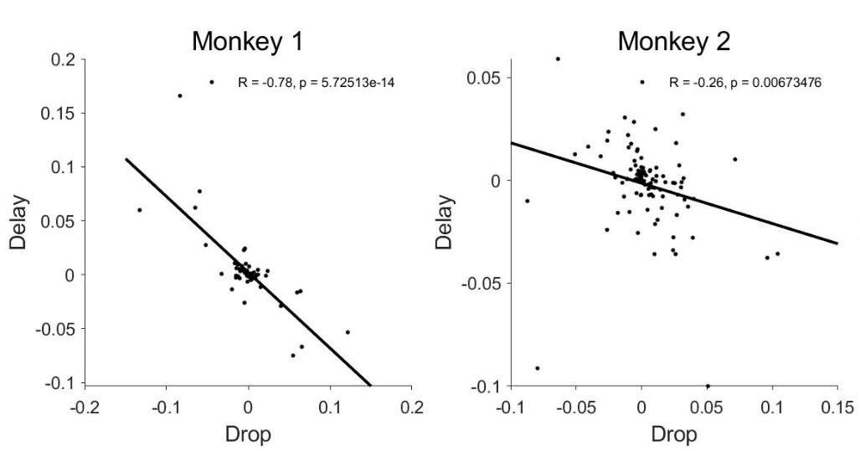

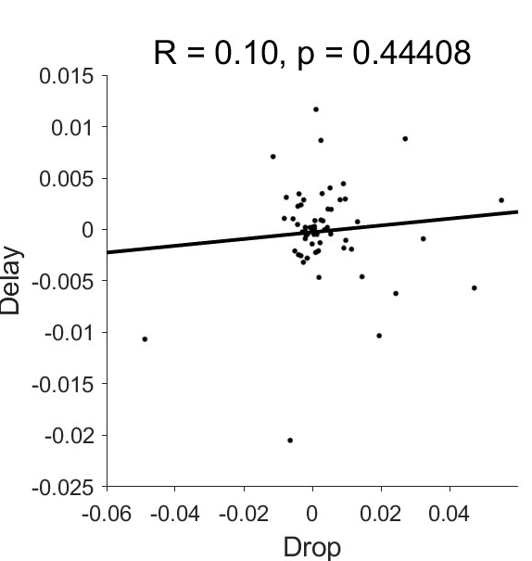
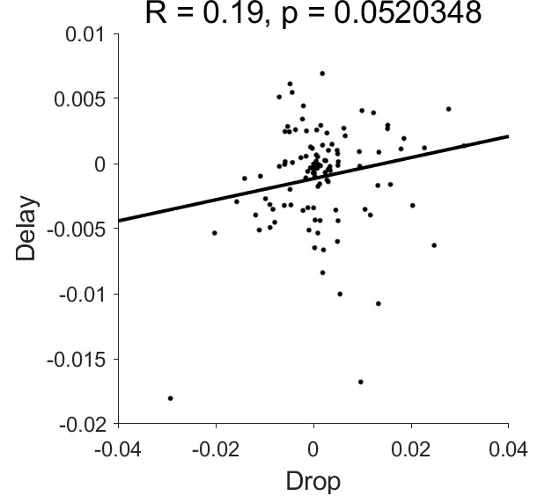
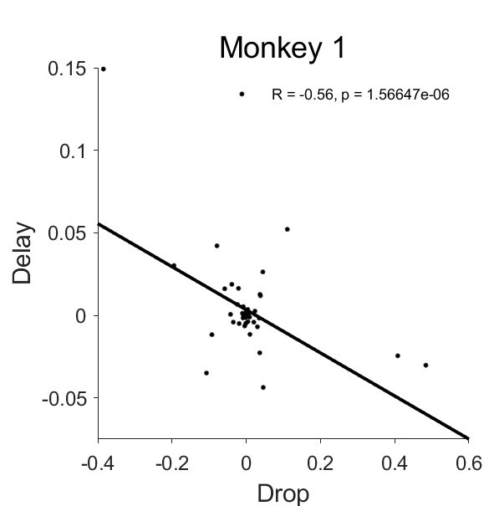
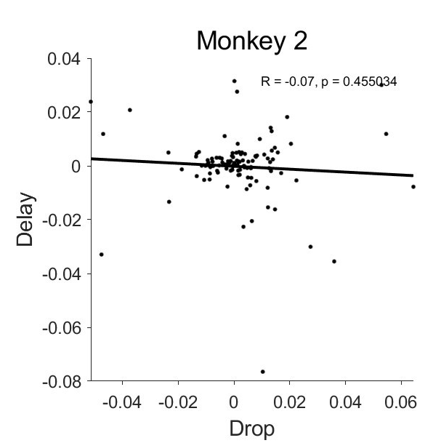
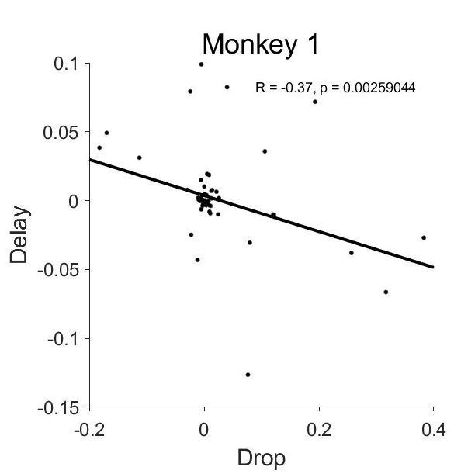
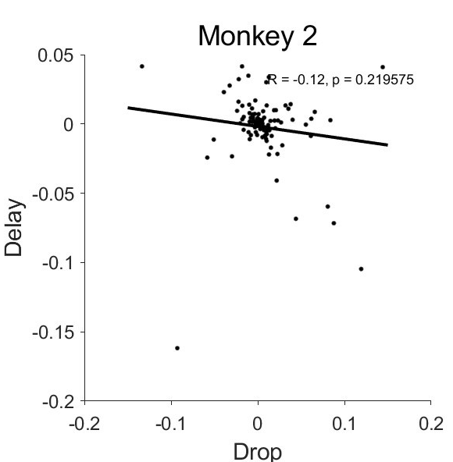
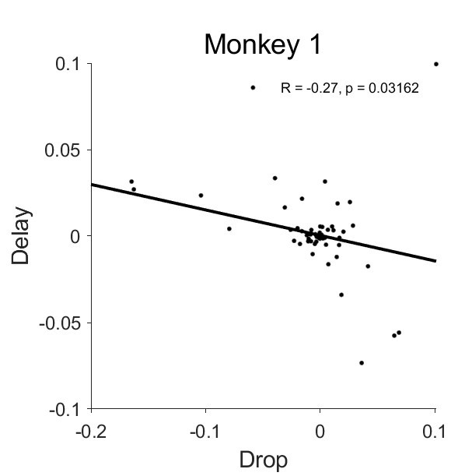
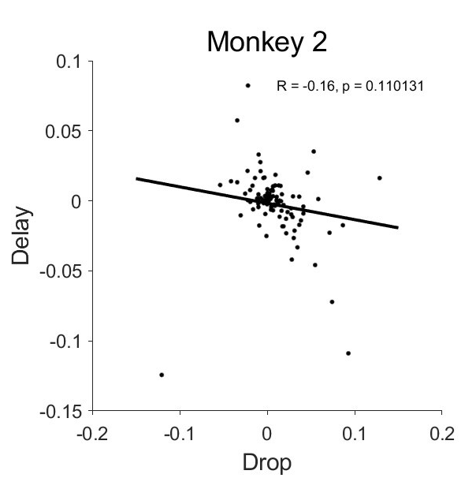
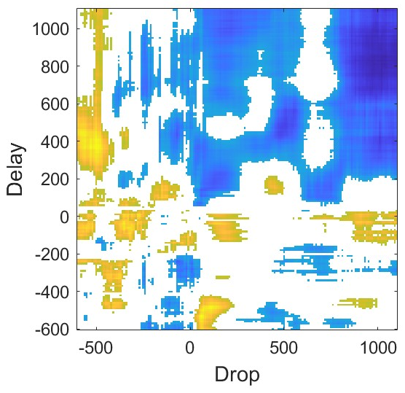
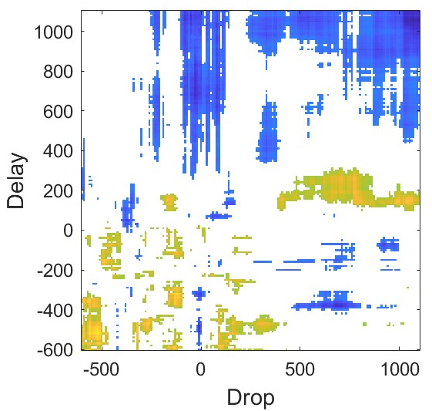
-250:0 ms
75:250ms
250:500 ms
500:750 ms

3. Go-signals affect behavior
Our task design included two potential go-signals (yellow – ‘reject’, and purple – ‘accept’), the order of appearance of which varied randomly across trials. To accept an offer, the animal could only act when the purple signal appeared; if the yellow signal came first, it had to wait for the purple one to act. Conversely, to reject an offer, the animal had to wait for the yellow signal if the purple one appeared first.
This two-step go-signal design enabled us to test whether changing the order of the go-signals influenced the animal’s willingness to accept an offer, as it effectively determined when they were permitted to act.
We hypothesized that if the yellow signal appeared first, delaying the opportunity to act for acceptance, the perceived value of the offer might decrease, leading to lower acceptance rates (Fig. 5). Consistent with this hypothesis, for highly valuable offers, acceptance rates did not differ significantly between yellow-first and purple-first trials. However, for less valuable offers, acceptance rates were significantly lower when the yellow go-signal was presented first. This effect differed between animals: Monkey 1 consistently rejected these low-value offers when delayed by the yellow signal, whereas Monkey 2 was more likely to accept them (Fig. 5A-B).
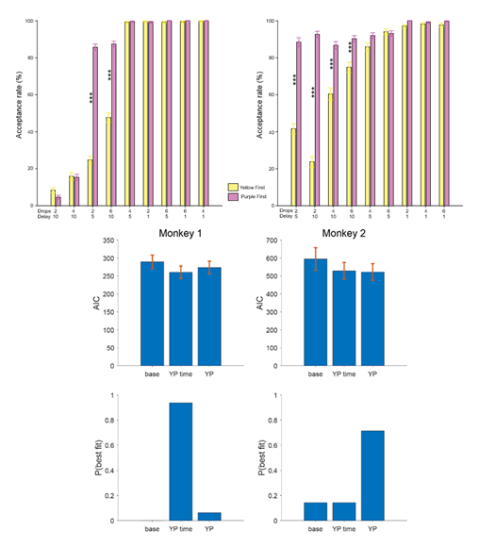
Both animals showed a general preference for accepting when the purple signal appeared first, suggesting an intrinsic motivational asymmetry tied to the meaning of the signal. However, the two animals appeared to interpret the go-signal differently. One possibility is that the go-signal was processed in terms of its temporal aspect, effectively becoming part of the temporal discounting computation. Alternatively, it may have been treated merely as an additional visual cue, required to trigger the choice but not integrated into the valuation process.
To test these possibilities, we compared three behavioral models. The base model considered only the offer attributes (reward magnitude and delay; see Methods for details), ignoring the color and the order of the go-signals. This is the classic temporal discounting model, whereby value depends solely on reward magnitude and delivery delay.
The full temporal discounting model added an extra cost of waiting, assuming that the total delay, including the wait imposed by the go-signal order, affected the decision.
Finally, the bias model treated the go-signal color as a learned cue, assuming choices were shaped by signal-associated preferences rather than by additional temporal costs (see Methods).
Model comparison revealed that Monkey 1’s behavior was best explained by the full temporal discounting model (Fig. 6A&C), suggesting integration of both offer and go-signal timing into value computations. In contrast, Monkey 2’s behavior fit the bias model (Fig. 6B&D), reflecting a strong preference for the purple signal independent of any waiting cost.

4. Neural signatures of go-signal timing and value integration
The two-step go-signal design provided an opportunity to test how the timing of when a choice could be made interacts with the integration of reward and delay in shaping value signals in dlPFC neural activity.
We investigated how the neural encoding of reward magnitude and delay changed when the go-signals were also considered.
For Monkey 1, we found that the reward magnitude encoding was positively linearly correlated with the encoding of the first go-signal (Fig. 7A). This suggests that the neural representation of reward magnitude was stronger when the animal had to wait longer before being allowed to act to accept an offer. In contrast, delay encoding negatively linearly correlated with the first go-signal encoding, consistent with a dynamic reweighting of value components based on anticipated wait time (Fig. 7B). In Monkey 2, no significant differences were found in neural encoding of reward magnitude or delay as a function of go-signal order (Fig. 7C-D).
These findings indicate that in Monkey 1, the timing differences imposed by the two-step go-signal sequence dynamically influenced the neural representation of offer value in the dlPFC, whereas in Monkey 2, such modulation was not evident.

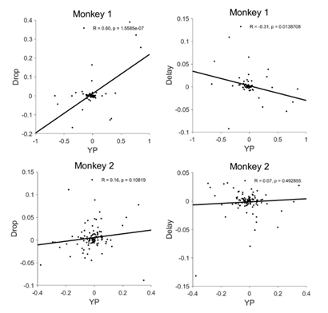

5. Different single-neuron and population value coding across monkeys
We examined whether the monkeys’ behavioral ranking of offers from lowest to highest value was reflected in individual neuron firing rates.
Specifically, we tested whether neurons showed linear modulation of firing rate according to the discounted value of each offer.
In Monkey 1, only 5 out of 63 neurons (8%) displayed a significant linear correlation between spike count and discounted value derived from behavior. In contrast, Monkey 2 showed a higher proportion, with 35 out of 107 neurons (33%) exhibiting such linear coding. This suggests that Monkey 2’s dlPFC neurons encode the value of the offer more linearly and uniformly, while Monkey 1’s neurons exhibit more heterogeneous or nonlinear patterns of value representation.

[Here we can put figure 8 with two neurons showing positive and negative linear correlation e one with more idiosyncratic behavior. We can also put raster plots, which I think is necessary to show because we have nice neurons we can show].

To further probe how offer value was represented at the population level, we performed a dimensionality reduction analysis to visualize neural trajectories across conditions. Preliminary results revealed a striking difference between animals: in Monkey 1, trajectories corresponding to different offer values were entangled, suggesting a complex, nonlinear encoding of value and choice (Figure 9, left panels). In contrast, Monkey 2’s trajectories were well separated and followed a more orderly progression from low (green) to high (red) value offers, consistent with a more linear and lower-dimensional population code (Figure 9, right panels).
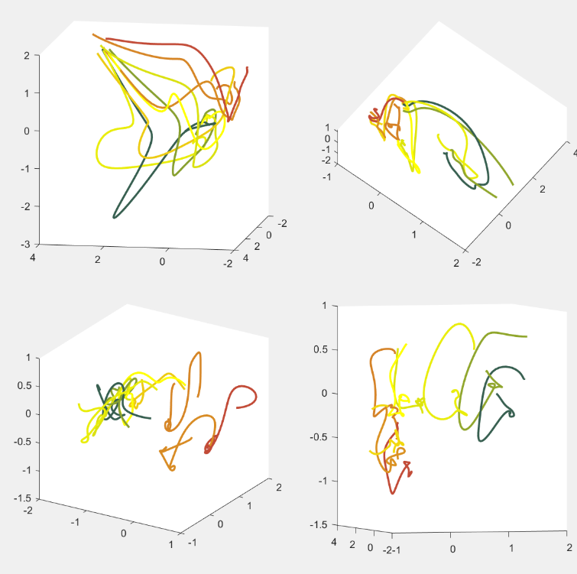

6. Monkey 1 integrates reward and delay in neural population codes
To test to what degree we can decode reward magnitude and delay information from the neural population, we performed a moving window decoding analysis with cross-validation on the pseudo population (see Methods for details). For each animal, the testing accuracy was significantly above chance for all three variables (drops, delay and their interaction). We can decode drops and delay with a peak accuracy of 80% (chance is 33%), and their interaction at above 60% (chance is 11%) (Figure 10A-C, colored lines).
To determine whether the neural representation of value reflects integrated processing of reward magnitude and delay, or whether these features are encoded independently, we performed a decoding analysis on the neural population.
If the neural population is encoding delay and drops independently, without interacting, then we would expect that the ability to decode the interaction between drops and delay can be perfectly predicted by how well the networks decodes delay and drops individually. In other words, we would predict that:
$$\overline{P}(interaction) = P(delay) x P(drops)$$
Here, $P\left(interaction\right), P\left(delay\right),P(drops)$ are the decoding performance for each factor, $\overline{P}(interaction)$ refers to the predicted decoding performance assuming independent representation of delay and drop.
If the actual decoding performance is higher than the predicted performance from the independent encoding of each factor, this would indicate integration of the two factors in the neural representation beyond just encoding them separately. We compare the predicted decoding performance of cue $\overline{P}(interaction)$ with the actual decoding performance $P\left(cue\right)$. We found that $P\left(cue\right)$ is significantly higher than $\overline{P}(interaction)$ in Monkey 1, from around 200ms after cue onset (Fig. 8C, left panel). Monkey 2 did not show such a difference (Fig. 10C, right panel).

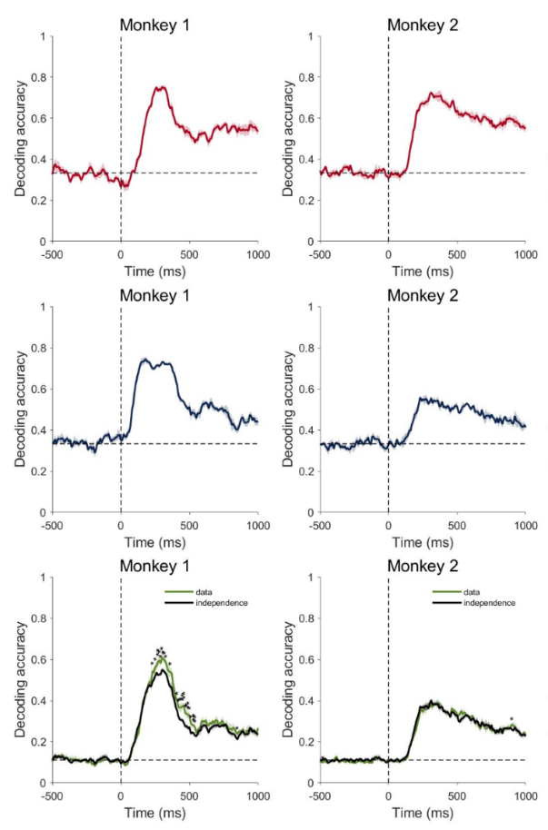

Discussion
Our results highlight that value computation in dlPFC is a dynamic and flexible process shaped not only by offer attributes such as reward magnitude and delay, but also by task context, such as the timing of go-signals.
Crucially, we found that these neural computations differ markedly across individuals, reflecting distinct decision strategies rather than mere noise or variability.
Monkey 1 exemplifies a proactive, goal-directed strategy: neural activity showed a strong and early inverse correlation between reward and delay immediately after cue onset. This pattern suggests an efficient evidence accumulation process that begins as soon as the offer is presented, supporting model-based evaluation where future outcomes and timing contingencies are actively weighed during deliberation. The integration of go-signal timing with reward and delay signals indicates that the dlPFC continuously combines multiple task-relevant features to flexibly compute value.
In contrast, Monkey 2 showed a reactive strategy: the integration of reward and delay emerged only shortly before the go-signal, which, from the behavioral and neural perspective appeared to act more like an additional visual cue than a temporal marker. This suggests that evidence accumulation in Monkey 2 was gated by the presence of the go-signal. Consequently, dlPFC activity showed weaker coupling between value features and task timing, consistent with a stimulus-driven, model-free mode of decision-making where salient cues trigger choices more reflexively.
Although we did not explicitly model accumulation dynamics, our data align well with such computational frameworks, showing how the timing of evidence integration and its neural correlates can vary across individuals and strategies.
These contrasting neural profiles suggest that dlPFC circuits can operate under multiple computational modes: proactive accumulation of evidence or reactive cue-driven responses, depending on the cognitive strategy engaged by the subject. Such flexibility may be mediated by mechanisms like 1) mixed selectivity (Rigotti et al., 2013), the ability of neurons to multiplex different task-related information like reward, delay, and context, or 2) by working memory gating (Miller and Cohen, 2001) that selectively maintains task-relevant variables during decision epochs.
In support of this, we also found that despite Monkey 1 showing an early and strong inverse correlation between reward magnitude and delay in the population, only a small fraction of neurons (8%) scaled their activity linearly with the discounted value. This suggests that value integration in Monkey 1 is distributed across the population and relies on dynamic, context-sensitive coding rather than fixed, unitary representations. Conversely, in Monkey 2, a larger proportion of neurons (33%) directly tracked the discounted value, reflecting a more rigid and uniform representation consistent with a reactive strategy waiting for an external cue (the go-signal) to trigger action.
Our results extend previous studies by adding a fine-grained temporal dimension to prefrontal value encoding, showing that the classic inverse relationship between reward and delay emerges dynamically and varies across individuals. This temporal unfolding emphasizes the role of dlPFC in maintaining context-sensitive value representations that evolve during decision-making.
The pronounced individual differences observed call for caution when assuming uniform neural mechanisms across subjects. These findings raise important questions about how prefrontal circuits may shift between computational modes, such as flexible integration versus rigid stimulus-response mappings, and how these shifts might underline adaptive or maladaptive behavior (Daw et al., 2011; Gillan et al., 2016; Voon et al., 2015).
Variability in prefrontal dopamine signaling and cognitive control can produce different balances between goal-directed and habitual strategies (Cools & D’Esposito, 2011), consistent with theories proposing that the prefrontal cortex dynamically orchestrates multiple modes of decision-making depending on context and individual differences (Koechlin et al., 2003).
Limitations of our study include the small sample size and differences in training history: Monkey 1 had extensive task experience, whereas Monkey 2 was recorded earlier in training. Future longitudinal studies are necessary to determine whether these strategies represent stable traits or dynamic adaptations to experience.
In summary, our findings demonstrate that value computation in the dlPFC is a flexible, context-dependent process shaped by individual decision strategies, underscoring the importance of considering neural variability in the study of choice behavior mechanisms.

Materials and Methods
Subjects
Two male rhesus monkeys, both weighing 9.0 kg were used. The experimental procedures followed the Institute of Laboratory Animal Research Guide for the Care and Use of Laboratory Animals and were approved by the National Institute of Mental Health Animal Care and Use Committee.

Surgical Procedures
Surgical procedures were carried out using sterile technique under general anesthesia in a fully equipped operating room. An initial surgery was performed to place a head fixation post. In monkey one an eye coil was implanted. A second surgery was performed to implant the Utah recording arrays. We implanted one Utah array in monkey 1 and two Utah arrays in monkey 2. MR scans were obtained later, about 2-4 months after the Utah arrays were implanted to define the recording area (Fig. 4A, bottom panel).

Data Collection
To control stimuli presentation, reward delivery and bar touches a noncommercial software package was used (REX, https://nei.nih.gov/intramural/software; Hays et al., 1982). The eye position was monitored by using the Eye Position measuring system (https://staff.aist.go.jp/k.matsuda/eye/indexe.html) only for some sessions of Monkey 2. Neural activity of single units was recorded with Utah arrays (Blackrock Microsystems, Salt Lake City, USA; blackrockmicro.com). Electrical signals were captured, and single units were isolated online with TDT (Tucker-Davis Technologies, TDT, Alachua, USA; tdt.com) system for Monkey 1 and with Grapevine (Ripple Neuro, Salt Lake City, USA; rippleneuro.com) for Monkey 2. Data analyses were performed in MATLAB (http://www.mathworks.com/; R2024b).

Task
The monkey sat in a primate chair with the head fixed, 57 cm away from a video screen (47x30 cm; 1024x768 pixel; 120Hz) placed in front. A touch-sensitive bar was mounted on the chair at the level of the monkeys’ hands. A metal tube was positioned in front of the monkey’s lips to allow the monkey to drink when the reward was delivered.
The monkey worked in a intertemporal discounting task (Fig. 1A). To start a trial the monkey had to touch a lever, hold it for 1000 ms until a red square (0.40º x 0.40º) appeared at the center of the screen. After a variable time of 250 and 500 ms one of 9 possible visual cues (9.2º x 7.3º) appeared at the center of the screen for one of 5 durations between 750 and 2000 ms (step size 313 ms). Each visual cue indicated a particular offer, with the set of offers made by combining one of three reward sizes (2, 4 or 6 drops of liquid reward) with one of three delays to deliver the reward (1, 5 or 10 seconds). The monkey was required to continue to hold the bar and, if it was required, to maintain its gaze within the virtual window until the red square changed color to purple or yellow with equal probability (Fig. 1A). Either the purple or the yellow square served as a prompt to release the bar. Releasing the bar while the purple square was present indicated that the monkey was accepting the offer. Releasing the bar when the yellow square was present indicated that the monkey was refusing the offer. If the animal continued to hold the bar for the duration of the initial purple or yellow period of 1100 ms, the color of the square would change to the alternate color, allowing the animal to accept or refuse in each trial.
For instance, if the animal did not release the bar during the initial purple period, it could continue to hold the bar until the yellow square replaced the initial purple spot and release the bar in the yellow period. The same thing happened if the animal did not release the bar in the initial yellow period: it could hold the bar until the purple square replaced the initial yellow square and then release the bar.
In this design we prevented the monkey from preprogramming the motor response in the cue period, since the monkey could not anticipate whether the acceptance or refusal period would be the first interval or the second.
Upon accepting the offer, the purple square turned green (feedback signal), and the drops of reward were delivered after the delay indicated in the offer. Upon refusing the offer, the cue and fixation target disappeared, and a new trial would immediately begin with a new offer.
For 12/16 sessions the eye of Monkey 2 was monitored. A 20 x 20 degrees virtual window was built around the cue. The monkey was required to maintain his gaze in the virtual window from the appearance of the red spot to the appearance of the go-signal.
If the monkey (a) released the bar during the cue period, (b) didn’t maintain gaze in the virtual window, or (c) failed to release the bar during any of the go periods, an error was registered and an error feedback image (white rectangle with a red cross; 28.7 º x 17.8 º) appeared on the screen for 1000 ms. After an error, the next trial was a correction trial, during which the offer was repeated.

Behavior
For the behavioral analyses, we used data from all the neural recording days (7 for monkey 1 and 16 for monkey 2).
The probability of accepting an offer was calculated independently for each of the 9 offers.
Reinforcement learning models fit the behavior of the two monkeys separately. The probability of choosing to accept an offer is modelled through a SoftMax function as
$$p=\frac{1}{1+e^{β⋅(θ-V\left(drop, delay\right))}}$$
Here, $θ$ is decision threshold, $β$ is the temperature term.
$$V\left(drop, delay\right)=\frac{drop}{1+k⋅delay}$$
$k$ is the hyperbolic discounting factor. The free parameters $θ, β, k$ are fit via maximum likelihood estimation.
To test how the timing of action opportunities influences value computation, we compared three models.
The simplest model computes a temporally discounted value, that is then compared to an accept threshold $θ$.
$$DV=\frac{R}{1+k⋅D}$$
Here, DV is the discounted value, D is the delay, R is the reward.
Animals will be more likely to accept when DV is above the acceptance threshold θ, and more likely to reject otherwise. The probability of accepting an offer is modelled using the softmax rule with decision noise σ:
$$p\left(accept\right)=\frac{1}{1+e^{-\frac{V-θ}{σ}}}$$
In this strategy, animals do not pay attention to the go cue and choose solely based on the offer.
In the second model, animals adjust their discounted value estimate as well as their acceptance threshold based on the go-signal. If the go-signal is yellow, they have to wait for an additional delay Δt before they can accept the offer, as a result, effectively the value of the offer decreases to
$$V^{yellow}=\frac{R}{1+k⋅(D+Δt)}$$
Since threshold effectively reflects the average expected discounted reward during this task, the total value of choosing to accept a yellow offer becomes
$$U^{yellow}=V^{yellow}+{VF}^{yellow}$$
Where ${VF}^{yellow}$ is the expected future reward, and is θ discounted by the additional waiting time Δt plus the delay:
$${VF}^{yellow}=\frac{θ}{1+k⋅(D+Δt)}$$
The acceptance threshold would remain at $θ^{yellow}=θ$
However, if the go cue is purple, we compute
$$U^{purple}=V^{purple}+{VF}^{purple}$$
Since they can accept right away, $V^{Purple}=V$ and ${VF}^{purple}=\frac{θ}{1+k⋅D}$,
Rejecting is actually more expensive after purple, as animals have to wait for an additional delay to reject. The acceptance threshold here is essentially the expected discounted value of future rewards after a rejection. This would be
$$θ^{purple}=\frac{θ}{1+k⋅Δt}$$
In either case,
$$p\left(accept\right)=\frac{1}{1+e^{-\frac{U-θ}{σ}}}$$
In the third model, animals simply have a bias for purple or yellow.
$$p\left(accept purple\right)=\frac{1}{1+e^{-\frac{U-θ+β}{σ}}}$$
whereas
$$p\left(accept yellow\right)=\frac{1}{1+e^{-\frac{U-θ-β}{σ}}}$$

Neural Activity
The neural activity of 170 neurons was analyzed using data from 75-750 ms after the appearance of the cue, labeled as Offer Period. This period ended before the prompt to accept (purple go-signal) or refuse (yellow go-signal) first appeared, and therefore before the monkey knew when it needed to make a movement.

1-way ANOVAs
We performed two separate 1-way ANOVAs (p < 0.05) on all 170 recorded cells, for each of 9 offers. The first 1-way ANOVA was performed on each offer where the animal responded with at least 5 accepted and 5 refused trials. In the second 1-way ANOVA, each offer was selected based on whether the animal responded by releasing the bar on at least 5 trials on the first go signal and 5 trials on the second go signal, regardless of acceptance or refusal.

ANOVA-sliding window Analysis
A sliding window analysis was performed using the neural activity from all 170 recorded cells, expressed as total spike count. Starting at 500 ms before the cue onset to 1000 ms after the cue onset, 100 ms bins were created with a 10 ms interleave period. The spike count within each bin was used in the 2-way ANOVA sliding window analysis, with drops, delay, independent variables. Choice as factor was included as an additional effect to test whether choice explains additional variance in firing rate, independently of drop and delay.
At each bin we estimated the proportion of cells that were significantly modulated by each factor (2-way ANOVA, p < 0.05).
Additionally, at each bin we extracted the variance explained for each factor, and for the interaction of drops and delay as omega squared (Olejnik and Algina, 2003):
ω² = (SS_{effect} – (df_{effect})(MS_{error}))/ MS_{error} + SS_{total}

Correlation across time
In this analysis, we only included cells that respond to at least one of the task-relevant variables (delay, drop, choice), this leaves 121 cells.
To extract the population encoding dimension for drop and delay, we performed a sliding window ANOVA for each cell, and extracted the regression coefficient for drop and delay, at each time bin, for each cell. The dimension formed by the beta coefficients across cells at each time bin, is the time-dependent encoding dimension of drop or delay.
Population activity that encodes delay is quantified as the population activity projected onto the dimension for delay. Population activity of drops is calculated similarly. For each factor separately, the beta-coefficients for each time bin were correlated with each other and the Pearson correlation was calculated.
A significance threshold of 0.05 was used (uncorrected).

Decoding Analysis
Support vector machine was used as the classifier. Training and testing sets comprised of non-overlapping trials (75% of trials for training, and 25% for testing). The procedure was repeated 10 times, and the average decoding accuracy was recorded.
Decoding of drops, delay and interaction were carried out separately. For each factor, decoding was done in a sliding window (step 20ms, width 100ms).

