Title: Strategy dependent coding of reward and delay during temporal discounting in macaque dorsolateral prefrontal cortex

Authors: Rossella Falcone^{1,3,†,*}, Siyu Wang^{1,†}, David B. Weintraub², Mariko McDougall¹, Mark A. G. Eldridge^{1,4}, and Barry J. Richmond^{1,5}.

Author affiliations:
¹Laboratory of Neuropsychology, NIMH, Bethesda, MD, USA
²Surgical Neurology Branch, NINDS, Bethesda, MD, USA
³Leo M. Davidoff Department of Neurological Surgery, Albert Einstein College of Medicine Montefiore Medical Center Bronx, NY USA.
⁴Newcastle University, Newcastle upon Tyne, NE1 7RU.
⁵Senior Investigator, Emeritus.
†Equal contribution.

*Corresponding author:
Rossella Falcone, PhD
Assistant Professor
Albert Einstein College of Medicine, Bronx, NY, 10461
e-mail: rossella.falcone@einsteinmed.edu

Abstract
Some rewards are worth the wait, while others are not. For instance, you might be willing to wait several hours in line to meet an idol, but maybe not to buy a pen. This behavior is governed by temporal discounting, whereby delays reduce the value of future rewards, such that only sufficiently large rewards justify long waits. Individuals differ widely in their strategies to weigh temporally delayed rewards. Prefrontal neurons encode reward and delay; however, it remains unclear whether these neural representations reflect a universal temporal discounting process, or whether they depend on the individual behavioral strategies for trading off reward and time.

In a two-step temporal discounting task, monkeys chose whether to accept or refuse delayed reward offers by releasing a lever at different times contingent on a go signal. The additional delays introduced by the go signal in turn alters the value of the original offer. Behavioral modeling revealed that the two monkeys adopted distinct strategies in response to the go signal. Monkey S re-calculated the discounted value by accounting for the additional delay associated with the go signal, whereas Monkey T treated the go signal as having additive values independent of the original offer.
Although the dorsolateral prefrontal cortex (dlPFC) neurons in both monkeys encoded reward and delay, we found important differences between monkeys in how dlPFC neurons represented reward and delay, which reflected their respective behavioral strategies. Our results revealed a temporal discounting strategy-dependent coding of reward and delay in dlPFC.

Introduction
Temporal discounting, the tendency to assign less value to delayed rewards (1, 2), is central to many everyday decisions, such as deciding whether to wait in line to dine at a restaurant.
Individuals differ widely in their temporal discounting preferences and how they tradeoff reward and time. For instance, as demonstrated by the “marshmallow” test (3), where some children resist immediate gratification while others succumb to it. Similar heterogeneity has been observed in animals (4, 5, 6). The diversity in temporal discounting preferences also reflect potentially diverse strategies adopted by individuals to calculate temporally discounted values.
Temporal discounting preferences are usually considered as traits of an individual which is stable over time, and individual differences in temporal discounting behavior has been associated with a wide range of other cognitive abilities (CITE). Other research has shown that these temporal discounting preferences can change as the environmental conditions change (CITE). It is less studied how individuals adjust their temporal discounting behavior as the expectation for the delay or the reward changes (e.g., a person’s restaurant-line waiting decision might change if a large group of people in front of them suddenly decided to leave the waiting line).
The dorsal lateral prefrontal cortex (dlPFC) has been shown to encode variables important for making temporal discounting calculations, namely reward size and delay, and has been suggested to support temporally discounted value computations (13, 14). In humans, dlPFC activity is observed during intertemporal choice (15), and when learning actions that lead to substantial future rewards despite minor immediate losses (16). However, it remains unclear whether the dlPFC coding of reward and time is a universal temporal discounting process shared across individuals, or instead is dependent on the specific strategies used for computing discounted values.
In this work, we trained two monkey to do
a two-step temporal discounting task in which they chose between accepting or refusing a delayed reward offer. Crucially, to indicate an accept vs reject choice, monkeys had to release a lever at different times that were contingent on a go signal. The additional delay associated with different go signals in theory modifies the discounted value of the original delayed reward offer. This allowed us to study

how animals re-evaluate a delayed reward offer when an additional delay is introduced by the go signal. Behavioral modeling showed that our monkeys adopted different strategies. Neural analysis showed that a
lthough dlPFC neurons of both animals encoded reward size and delay, the neural coding reflected the distinct behavioral strategies adopted by the animal.

Results
Two monkeys performed a two-step temporal discounting task (see Fig. 1A and Methods), in which monkeys chose whether to accept or reject an offer of a delayed reward. Animals were pretrained on the 9 visual cues that signaled different combinations of reward magnitudes (2, 4, or 6 drops of liquid reward) and delays (1, 5, or 10 seconds). Animals indicated their accept vs reject choices by responding to a purple vs yellow go signal respectively. In each trial, after the reward offer was presented, one of the yellow/purple go signals was presented at random, and if monkey did not respond to the first go signal, the other go signal was presented after a fixed delay (1100ms).
For instance, if the purple go signal appeared first, the animal could either release the lever immediately to accept the offer, or held and lever and wait for the yellow go signal and then release the lever to refuse the offer. Conversely, if the yellow go signal appeared first, the animal could either release the lever immediately to refuse the offer, or wait for purple go cue to accept the offer. If the animal accepted the offer, the cue-defined drops were delivered after the corresponding delay. If an offer was rejected, the next trial began immediately with a new offer randomly chosen among the nine.

- Go signal modifies temporal discounting behavior

Across all neural recording days (7 for Monkey T, 16 for Monkey S) both monkeys showed a similar pattern of choices consistent with temporal discounting. They were more likely to accept offers with larger rewards with short delay, and less likely to accept smaller rewards with long delay (Fig. 2A-B). Temporal discounting behavior was modelled with a hyperbolic discounting function to compute discounted value, and a logistic function to compute the acceptance probability as a function of the discounted value (Fig. 2A-B; see Methods).

In our task, to accept an offer, monkeys must release the lever when the purple go cue appears. If the first go cue is purple, animals can release the lever and accept the offer right away, whereas if the first go cue is yellow, animals have to wait for an additional delay (1100ms) until the purple go cue appears to accept the offer. This additional delay when yellow go cue shows first, effectively increases the wait time and reduces the offer value. As a result, we expect that animals have a lower probability of accepting the offer when yellow go cue shows first. Indeed, both animals showed lower probability of accepting an offer when the first go cue is yellow compared to purple (Fig 3. A, B).
- Animals show distinct strategies for adjusting temporal discounting behavior to the go signal.
While Monkey S showed low probability of accepting the worst offer (2 drops, 10 seconds) regardless of whether the first go cue was yellow or purple (Fig. 3A), Monkey T only showed low probability of accepting the worst offer when the first go cue was yellow (Fig. 3B). Interestingly, Monkey T seemed to accept all offers at rates above 80% when the first go cue was purple (Fig. 3B).
The differences between monkeys prompted us to investigate the different strategies that can be used to adjust temporal discounting based on the go cue. The baseline strategy (model 1) is to ignore the go cue and have a fixed acceptance preference for each of the 9 offers, this is clearly not the strategy used by both of our monkeys, but we included this null strategy as a control. The second simplistic strategy (model 2) is to assign values directly with the go cue, and choose to accept if the offer value plus the go cue value exceeds a threshold and choose to reject otherwise. The go cue value is an approximate of how much the go cue increases or decreases the offer value, and assumes that this increase and decrease is independent of the offer. In other words, values of good and bad offers are increased or decreased by the same amount associated with the go cue. The third, optimal strategy (model 3), is instead to account for the delay associated with the go cue when calculating temporally discounted value, and yellow and purple go cue modifies the offer value based on the additional delay introduced by each go cue.
We fit all three models to the monkey behavior.

Model comparison showed that model 1, which assumed a go-cue independent preference for each offer, fit worst for both animals. Monkey S’s behavior was best explained by model 3, suggesting a recalculation of discounted value by accounting for the go-cue induced delay (Fig. 4A and C). In contrast, Monkey T’s behavior was best explained by model 2 (Fig. 4B and D), suggesting using a simpler heuristic. These results suggested that
the two animals rely on distinct strategies to adjust temporally discounted value based on the go cue.

3. The inverse coding of reward and delay in dlPFC reflects the temporal discounting computation.
We first exampled single neuron’s responses to reward and delay. We recorded 170 neurons in dlPFC (107 neurons in Monkey T and 63 neurons in Monkey S; Fig. S1A) while the animals performed the task. During the offer period, 121 out of 170 neurons were significantly modulated by reward magnitude and/or delay (2-way ANOVA, p < 0.05; Fig. S1B). Sliding-window ANOVA analysis showed that the proportion of neurons modulated by each factor increased shortly after cue presentation (Fig. S1C-D). To quantify the strength of encoding for each variable (reward magnitude, delay, and their interaction), we computed omega squared (ω²) which estimates the proportion of variance in neural activity explained by each factor (see Methods). In Monkey S, reward modulation appeared earlier and was stronger than delay modulation during the first 500 ms of the offer period. Monkey T showed stronger delay-related modulation (Fig. S2A-B). Notably, neither monkey showed significant representation of the upcoming choice outcome (accept vs. refuse) after the offer onset (Fig. S1C-D, yellow line and Fig. S2A-B, yellow line), indicating that dlPFC activity during this epoch primarily reflected offer evaluation rather than commitment to a choice.
Next, we defined the population coding dimension of reward and delay based on the beta coefficients of sliding-window the ANOVA analysis. For both animals, prefrontal neurons showed an inverse correlation between the encoding of reward and delay, which reflects temporal discounting computation (Fig. 5A-B). This relationship appeared stronger later in the offer epoch (Fig. S4), As a negative control, we performed the same analysis in the 250 ms window before cue onset , and no significance was found (Fig. S4A, E), suggesting that these relationships were unique to the evaluation period.

Despite that the inverse coding exists in both monkeys, we observed differences between monkeys in when this inverse relationship appeared and for how long it lasted.
For Monkey S, the inverse relationship emerged rapidly within 250ms after cue onset, and persisted throughout cue presentation (Fig. S4B–D). In Monkey T, a similar trend was observed but it did not reach statistical significance during the early epochs (Fig. S4G–I).

4. Neural signatures of the go-signal modulation of value encoding.
Behaviorally, we observed that monkeys’ acceptance rate for offers is modulated by the go cue. Specifically, animals are more likely to accept an offer if the first go cue is purple. Now we look for neural signatures of the go cue.
If the temporally discounted value is adjusted based on the additional delay introduced by the go cue (see behavioral model 3), then compared to the purple go cue which allows accepting the offer immediately, the yellow go cue which requires an additional delay should decrease the discounted value of the original offer. Thus, we would predict that population activity for yellow versus purple go-cue, should negatively align with the coding dimension of discounted value (i.e., positively align with the population coding dimension for reward size, and negatively align with the coding dimension for delay).

We observed this pattern in Monkey S (Fig. 6A and C), but not in Monkey T (Fig. 6 B-D).
This difference in neural encoding mirrors the distinct behavioral strategies employed by the two monkeys, that only Monkey S adjusted temporally discounted value based on the go-cue, and Monkey T instead did not.

5. Differences in the linearity of coding between monkeys
Differential behavioral and neural responses to the go-cue reflect different neural computation adopted by the two monkeys. Next, we examined neural differences in value coding between monkeys at both the single-neuron and population levels.
At the single-neuron level, we tested whether firing rates in the first 750ms of the offer period were linearly modulated by the discounted value inferred from the behavioral model. Only 6 out of 63 neurons (10%) in Monkey S showed a significant linear correlation between spike count and discounted value (Fig. S5B), whereas in Monkey T, 35 out of 107 neurons (33%) exhibited linear coding (Fig. S5A).
These results suggest that the dlPFC neurons of Monkey S exhibited more heterogeneous or nonlinear patterns of value representation, whereas neurons of Monkey T encoded the value of the offer more linearly.
At the population level, principal component analysis (see Methods) revealed qualitative differences in condition-averaged neural trajectories between animals. Consistent with the single-neuron analysis, in Monkey S, the trajectories were entangled reflecting nonlinear population encoding of value (Fig. 7A and C). In contrast, in Monkey T, the trajectories were linearly separated and orderly, progressing orderly from low (green) to high (red) value offers (green to red in Fig. 7B and D). This pattern held both in the first 1000 ms after the visual cue onset (Fig. 7A and B) and in the –500 ms to +500 ms window around the first go-signal (Fig. 7C and D).

6. Population decoding revealed differential integration of reward and delay.
We performed a moving window decoding analysis in which we decoded offer identity, reward size and delay for each trial based on spike count in each time bin (see Methods). For both animals, decoding accuracy was significantly above chance for all three variables (reward size, delay, and offer identity). Peak decoding accuracy reached nearly 80% for reward size and delay (chance is 33%), and over 60% for offer identity (chance is 11%) (Fig. 8, colored lines), indicating that all variables were robustly represented in dlPFC activity.
Next, we quantified the level of integration of reward vs delay, by assessing the level of independence for decoding reward size, delay and offer identity.

Specifically, if the dlPFC neural population encodes reward and delay independently without integration, the expected decoding accuracy for offer identity (i.e., their interaction), Poffer identity, should equal the product of their individual decoding accuracies Preward size and Pdelay:
Poffer identityinteraction=Preward sizedelay⋅xPdelaydrops
Pinteraction,Pdelay,PdropsPinteraction
If the observed decoding performance Poffer identityexceeds the predicted level Poffer identitybased on the independent encoding of each factor, it suggests that reward and delay are integrated and not independently represented. We compared the predicted decoding performance of offer identity Poffer identity, Pinteractionwith the actual decoding performance Poffer identityPcue for the two monkeys. In Monkey S, we found that Poffer identityPcue was significantly higher than Poffer identityPinteraction, from around 200ms after offer onset (Fig. 8E). In contrast, Monkey T did not show such a difference, suggesting that reward and delay were represented independently without integration (Fig. 8F).
These results align with the respective behavioral strategies of the two monkeys.

Discussion
In this work, we trained two monkeys to perform a two-step temporal discounting task in which they made accept or reject decisions of delayed reward offers by releasing a lever when the accept purple go signal or the reject yellow go signal was presented. We showed that both of our monkeys adjusted their temporal discounting behavior based on the go signal. Specifically, when the first go signal was yellow (animals have to wait an additional delay after the yellow go signal to turn purple to accept the offer) compared to purple (animals can accept the offer immediately), both of our animals were less likely to accept the original delayed reward offer due to the additional wait time. Behavioral modeling revealed strategy differences between monkeys. Monkey S recomputed temporally discounted value by considering the additional delay associated with the go signal, whereas Monkey T treated the go signal as having additional additive value without recomputing the temporally discounted value of the original offer. At the neural level, in line with previous research (CITE), we found neural evidence for temporal discounting computation in dlPFC in both monkeys that the population encoding dimension for reward and delay are inversely aligned in dlPFC (8, 13). Despite the similarities, we found that dlPFC neurons encoded reward and time in a way that reflected the behavioral differences between animals, suggesting a strategy-dependent coding of reward and time in dlPFC.

For monkey S, we observed that the population coding dimension for the go cue positively aligns with the coding dimension for value (i.e., positively align with the value-coding dimension, and negatively align with the delay-coding dimension). This suggested that for monkey S, the go-signal modified the discounted value, which is consistent with behavioral modeling results that monkey S re-computed temporally discounted value by considering the additional delay associated with the go signal. For monkey T on the other hand, the yellow/purple coding dimension was orthogonal to the value-coding dimension, which aligned with the behavioral model that monkey T assigned additive values to the go-signal without re-computing the temporally discounted value.
Additional single-neuron and population-level analysis confirmed the neural differences between animals in how dlPFC encoded reward and time. In the first analysis, we looked at the linearity of value coding. In Monkey S, only 10% of the neurons tracked discounted value linearly, yet the population showed an early inverse correlation between reward magnitude and delay. Population trajectories were qualitatively entangled, suggesting that value integration is distributed across the population and had complex non-linear relationships with reward and delay. In contrast, in Monkey T, many more neurons (> 30%) showed linear value coding. Population trajectories were qualitatively unentangled and linear, with low-dimensional population trajectories well separated by value. In the second analysis, we more directly assessed whether reward and delay were represented independently. If reward and delay were independently encoded, we should be able to predict offer identity (i.e., which of the 9 delayed reward offer was presented to the animal) by decoding reward and delay separately. On the other hand, if reward and delay information were integrated non-linearly, then we should be able to decode delayed offer identity better than the independence prediction. We found statistical evidence that

decoding accuracy for offer identity exceeded the independence prediction for monkey S but not monkey T. This agrees with the first analysis of coding linearity.
Together, these results demonstrate the strategy depending coding of reward and time in dlPFC.
The strategy depending coding we observed is consistent with theories that dlPFC can operate in multiple computational modes (21), depending on the environmental demand and the cognitive strategy engaged by the subject. This flexibility may be supported by mechanisms including 1) mixed selectivity (18), which enables neurons to process multiple task-related information (e.g., reward and delay), and 2) working memory gating (19), which selectively maintains task-relevant information during deliberation. In line with these mechanisms, dlPFC may also serve as a key node in the interaction between attention and motor planning (Tremblay et al., 2015; Di Bello et al., 2025), providing the neural substrate that supports the distinct strategies. The neural differences we found between animals may arise from variations in prefrontal dopamine signaling and cognitive control (20). Our findings raise important questions about how prefrontal circuits may shift between different computational modes and how these shifts may support adaptive or contribute to maladaptive behavior (22-24). Future research is needed to characterize dynamical systems mechanisms underlying strategy shift in temporal discounting (14).
Our findings also contribute to the recent effort to find neural underpinnings of individual differences in behavior. For example, Pagan et al., (2025) showed that despite uniformly good task performance, rats can employ distinct combinations of dynamical solutions to implement context-dependent decisions, resulting in heterogeneous neural and behavioral signatures. Similarly, Fascianelli et al., (2024) found that even when monkeys appear to perform a similar task, differences in the geometry of prefrontal neural representations reveal distinct strategies which can be linked to behavioral differences.
The behavioral differences in strategy observed in this study might arise from training history. Monkey S went through more training with the task than Monkey T. It is possible that with more training, Monkey T’s suboptimal strategy will converge to the near-optimal strategy used by Monkey S. Future longitudinal studies would help to clarify whether these strategies reflect innate individual traits or learned responses based on experience.

In summary, our results supported strategy dependent coding of reward and time in dlPFC durng temporal discounting, that dlPFC activity reflected individual differences in temporal discounting strategies. These results emphasize the importance of considering individual differences when studying the neural underpinnings of behavior.

Methods
Subjects
Two male rhesus monkeys, both weighing 9.0 kg each were used. All experimental procedures followed the Institute of Laboratory Animal Research Guide for the Care and Use of Laboratory Animals and were approved by the National Institute of Mental Health Animal Care and Use Committee.

Surgical Procedures
The surgical procedures were performed using a sterile technique and under general anesthesia in a fully equipped operating room. The first surgery was performed to place a head fixation post. Monkey T received an eye coil, but eye movement was not monitored. A second surgery was performed to implant the Utah recording arrays. One Utah array was implanted in Monkey T, and two Utah arrays were implanted in Monkey S. MR scans were obtained about 2 to 4 months after the Utah arrays were implanted to define the recording area (Fig. S1A).

Data Collection
A noncommercial software package was used (REX, https://nei.nih.gov/intramural/software; 25) to control stimuli presentation, reward delivery and bar touches Eye position was monitored by using the Eye Position Measuring System (https://staff.aist.go.jp/k.matsuda/eye/indexe.html), but only during some sessions with Monkey S. Neural activity of single units was recorded using Utah arrays (Blackrock Microsystems, Salt Lake City, USA; blackrockmicro.com). For Monkey T, electrical signals were captured, and single units were isolated online with a TDT (Tucker-Davis Technologies, TDT, Alachua, USA; tdt.com) system. For Monkey S, single units were isolated online with Grapevine system (Ripple Neuro, Salt Lake City, USA; rippleneuro.com) and revised offline with Plexon offline sorting system. Data analyses were performed in MATLAB (http://www.mathworks.com/; R2024b).

Task
The monkey sat in a primate chair with its head fixed 57 cm away from a video screen (47x30 cm; 1024x768 pixel; 120Hz) placed in front of it. A touch-sensitive bar was mounted on the chair at the level of the monkeys’ hands. A metal tube was positioned in front of the monkey’s lips to allow the monkey to drink when the reward was delivered.
The monkey participated in an intertemporal discounting task (Fig. 1A). To start a trial, the monkey had to touch and hold a lever for 1000 ms until a red square (0.40º x 0.40º) appeared at the center of the screen. After a variable time of 250- 500 ms one of 9 possible visual cues (9.2º x 7.3º) appeared at the center of the screen for one of 5 durations between 750 and 2000 ms (step size 313 ms). Each visual cue corresponded to a specific offer. The offers were made by combining one of three reward sizes (2, 4 or 6 drops of liquid reward) with one of three reward delivery delays (1, 5 or 10 seconds). The monkey was required to continue to hold the bar and, if it was required, to maintain its gaze within the virtual window until the red square changed color to purple or yellow with equal probability (Fig. 1A). the purple or yellow spot served as a prompt to release the bar. Releasing the bar while the purple square was present indicated that the monkey was accepting the offer. Releasing the bar when the yellow square was present indicated that the monkey was refusing the offer. If the monkey continued to hold the bar for the entire 1100 ms initial duration of the initial purple or yellow period, the color of the spot would change, allowing the monkey to accept or refuse in each trial.
For example, if the monkey did not release the bar during the initial purple period, it could hold the bar until the yellow spot replaced the purple one. The same thing happened if the monkey did not release the bar during the initial yellow period. It could hold the bar until the purple spot replaced the yellow one and then release the bar.
With this design, we prevented the monkey from anticipating whether the acceptance or refusal period would be the first interval, so it could not preprogram the motor response in the cue period.
When the offer was accepted, the purple square turned green (the feedback signal), and the reward drops were delivered after the delay. When the offer was refused, the cue and fixation target disappeared, and a new trial would immediately begin with a new offer.
The eye of Monkey S was monitored for 12 out of 16 sessions. A virtual window 20 x 20 degrees was built around the cue. The monkey was required to maintain his gaze within the virtual window from the appearance of the red spot until the go-signal appeared.
An error was registered if the monkey (a) released the bar during the cue period, (b) did not maintain gaze in the virtual window, or (c) failed to release the bar during any of the go periods. In this case, an error feedback image (a white rectangle with a red cross measuring 28.7 º x 17.8 º) appeared on the screen for 1000 ms. Following an error, the next trial was a correction trial, during which the offer was repeated.
Behavior
For the behavioral analyses, we used data from all the neural recording days (7 for monkey T and 16 for monkey S).
The probability of accepting an offer was calculated independently for each of the 9 offers.
Behavior was fit separately for the two monkeys using reinforcement learning models, in which the probability of choosing to accept an offer is modelled through a SoftMax function as
$$p=\frac{1}{1+e^{β⋅\left(θ-V\left(drop,delay\right)\right)}}$$
Here, $θ$ is decision threshold, $β$ is the temperature term.
$$V\left(drop,delay\right)=\frac{drop}{1+k⋅delay}$$
$k$ is the hyperbolic discounting factor. The free parameters $θ,β,k$ are fit via maximum likelihood estimation.
To examine how the timing of action opportunities shapes value computation, and whether monkeys show different strategies, we compared three models. These models allowed us to test whether animals 1) compute discounted value independently of the go signal, 2) include the timing of the go signal into value estimation, 3) treat the go signal as a further cue, without using its timing information.

- Simple model
The simplest model computes a temporally discounted value, that is then compared to an accept threshold $θ$.
$$DV=\frac{R}{1+k⋅D}$$
Here, DV is the discounted value, D is the delay, R is the reward.
Animals will be more likely to accept when DV is above the acceptance threshold θ, and more likely to reject otherwise. The probability of accepting an offer is modelled using the softmax rule with decision noise σ:
$$p\left(accept\right)=\frac{1}{1+e^{\frac{-V-θ}{σ}}}$$
In this situation, animals do not pay attention to the go signal and choose solely based on the offer.
- Full Model
In the full model, animals adjust their discounted value estimate as well as their acceptance threshold based on the go signal. If the go signal is yellow, they have to wait for an additional delay Δt before they can accept the offer, as a result, effectively the value of the offer decreases to
$$V^{yellow}=\frac{R}{1+k⋅\left(D+Δt\right)}$$
Since threshold effectively reflects the average expected discounted reward during this task, the total value of choosing to accept a yellow offer becomes
$$U^{yellow}=V^{yellow}+{VF}^{yellow}$$
Where ${VF}^{yellow}$ is the expected future reward, and is θ discounted by the additional waiting time Δt plus the delay:
$${VF}^{yellow}=\frac{θ}{1+k⋅\left(D+Δt\right)}$$
The acceptance threshold would remain at $θ^{yellow}=θ$
However, if the go cue is purple, we compute
$$U^{purple}=V^{purple}+{VF}^{purple}$$
Since they can accept right away, $V^{Purple}=V$ and ${VF}^{purple}=\frac{θ}{1+k⋅D}$,
Rejecting is actually more expensive after purple, as animals have to wait for an additional delay to reject. The acceptance threshold here is the expected discounted value of future rewards after a rejection. This would be:
$$θ^{purple}=\frac{θ}{1+k⋅Δt}$$
In either case,
$$p\left(accept\right)=\frac{1}{1+e^{\frac{-U-θ}{σ}}}$$
3. Bias Model
In the bias model model, animals simply have a bias for the color of the go signal, purple or yellow.
$$p\left(acceptpurple\right)=\frac{1}{1+e^{\frac{-U-θ+β}{σ}}}$$
whereas
$$p\left(acceptyellow\right)=\frac{1}{1+e^{\frac{-U-θ-β}{σ}}}$$

Neural Activity
The neural activity of 170 neurons was analyzed using data from 75 to750 ms after the cue appeared, labeled as the “Offer Period”. This period ended before the prompt to accept (purple go-signal) or refuse (yellow go-signal) first appeared, and therefore before the monkey knew when to move.

One-way ANOVAs
We performed two separate one-way ANOVAs (p < 0.05) on all 170 recorded cells, for each of the nine offers. The first ANOVA was performed on each offer for which the animal responded with at least 5 accepted and 5 refused trials. For the second ANOVA, each offer was selected based on whether the animal released the bar on at least 5 trials with the first go signal and 5 trials with the second go signal, regardless of acceptance or refusal.

ANOVA-sliding window Analysis
A sliding window analysis was performed using the neural activity from all 170 recorded cells, expressed as total spike count. Starting 500 ms before and ending 1000 ms after cue onset, 100 ms bins were created with a 10 ms interleave period. The spike count within each bin was used in the two-way ANOVA sliding window analysis, with drops and delay as independent variables. The choice factor was included as an additional effect to test whether choice explains additional variance in firing rate, independently of drop and delay.
For each bin, we estimated the proportion of cells that were significantly modulated by each factor (two-way ANOVA, p < 0.05).
Additionally, we extracted the variance explained by each factor, and by the interaction between drops and delay, expressed as omega squared (26):
ω² = (SS_{effect} – (df_{effect})(MS_{error}))/ MS_{error} + SS_{total}

Correlation across time
For this analysis, we only included cells that responded to at least one of the task-relevant variables (delay, drop or choice). This left 121 cells.
To extract the population encoding dimension for drop and delay, we performed a sliding window ANOVA on each cell and extracted the regression coefficients for drop and delay at each time bin. The dimension formed by the beta coefficients across cells at each time bin, is the time-dependent encoding dimension of drop or delay.
The population activity that encodes delay is quantified as the activity projected onto the delay dimension. The population activity of drops is calculated similarly. For each factor separately, the beta coefficients for each time bin were correlated with each other, and the Pearson correlation was calculated.
A significance threshold of 0.05 (uncorrected) was used.

Decoding Analysis
A support vector machine was used as the classifier. Training and testing comprised of non-overlapping trials (75% of trials for training, and 25% for testing). This procedure was repeated 10 times, and the average decoding accuracy was recorded.
Decoding of drops, delay and interactions was carried out separately. For each factor, decoding was performed using a sliding window (step size: 20ms, width: 100ms).

References
- G. Ainslie, Specious reward: A behavioral theory of impulsiveness and impulse control. Psychol. Bull. 82, 463-496 (1975).
- J. E. Mazur, An adjusting procedure for studying delayed reinforcement. In M. L. Commons, J. E. Mazur, J. A. Nevin, & H. Rachlin (Eds.), The effect of delay and of intervening events on reinforcement value (pp. 55–73). Lawrence Erlbaum Associates, Inc. (1987).
- W. Mischel, E. B. Ebbesen, Attention in Delay of Gratification. J. Pers. Soc. Psychol. 16, 329-337 (1970).
- A. M. Trevail et al., Environmental heterogeneity decreases reproductive success via effects on foraging behaviour, Proc. Biol. Sci. 286, 20190795 (2019).
- J. A. Eccard, T. Liesenjohann, M. Dammhahn Among-individual differences in foraging modulate resource exploitation under perceived predation risk. Oecologia 194, 621-634 (2020).
- R. H. Walker, M. C. Hutchinson, A. B. Potter, J. A. Becker, R. A. Long, R. M. Pringle, Mechanisms of individual variation in large herbivore diets: Roles of spatial heterogeneity and state-dependent foraging. Ecology 104, e3921 (2023).
- J. W. Kable , P. W. Glimcher, The neural correlates of subjective value during intertemporal choice. Nat. Neurosci. 10, 1625-1633 (2007).
- R. Shadmehr, J. J. Orban de Xivry, M. Xu-Wilson, Ting-Yu Shih, Temporal discounting of reward and the cost of time in motor control. J. Neurosci. 30,10507-16 (2010).
- D. J. Barraclough, M. L. Conroy, D. Lee, Prefrontal cortex and decision making in a mixed-strategy game. Nat. Neurosci. 7, 404410 (2004).
- C. A. Hutcherson, H. Plassmann, J. J. Gross, A. Rangel, Cognitive regulation during decision making shifts behavioral control between ventromedial and dorsolateral prefrontal value systems. J. Neurosci. 32, 13543-13554 (2012).
- B. Figner, D. Knoch, E. J. Johnson, A. R. Krosch, S. H. Lisanby, E. Fehr, E. U. Weber, Lateral prefrontal cortex and self-control in intertemporal choice. Nat. Neurosci. 13, 538-539 (2010).
- T. A. Hare, C. F. Camerer, A. Rangel, Self-control in decision-making involves modulation of the vmPFC valuation system by the dlPFC. Science 324, 646-648 (2009).
- S. Kim, J. Hwang, D. Lee, Prefrontal coding of temporally discounted values during intertemporal choice. Neuron 59, 161-172 (2008).
- S. Wang #, R. Falcone # , B. Richmond , B. B. Averbeck, Attractor dynamics reflect decision confidence in macaque prefrontal cortex. Nat. Neurosci. 26, 1970-1980 (2023). #Equal contribution.
- S. M. McClure, D. I. Laibson, G. Loewenstein, J. D. Cohen, Separate neural systems value immediate and delayed monetary rewards. Science 306, 503-507 (2004).
- S.C. Tanaka, K. Doya, G. Okada, K. Ueda, Y. Okamoto, S. Yamawaki, Prediction of immediate and future rewards differentially recruits cortico-basal ganglia loops. Nat. Neurosci. 7, 887- 893 (2004).
- M. Bukwich, et al., Competitive integration of time and reward explains value-sensitive foraging decisions and frontal cortex ramping dynamics. Neuron 113, 3458-3475 (2025).
- M. Rigotti, O. Barak, M. R. Warden, X.-J. Wang, N. D. Daw, E. K. Miller, S. Fusi, The importance of mixed selectivity in complex cognitive tasks. Nature 497, 585-590 (2013).
- E. K. Miller, J. D. Cohen, An integrative theory of prefrontal cortex function. Annu. Rev. Neurosci. 24, 167-202 (2001).
- R. Cools, M. D' Esposito, Inverted-U–shaped dopamine actions on human working memory and cognitive control. Biol. Psychiatry 69, e113-e125 (2011).
- E. Koechlin, C. Ody, F. Kouneiher, The architecture of cognitive control in the human prefrontal cortex. Science 302, 1181-1185 (2003).
- N. D. Daw, S. J. Gershman, B. Seymour, P. Dayan, R. J. Dolan, Model-based influences on humans’ choices and striatal prediction errors. Neuron 69, 1204-1215 (2011).
- V. Voon, et al., Disorders of compulsivity: A common bias towards learning habits. Mol. Psychiatry 20, 345-352 (2015).
- C. M. Gillan, M. Kosinski, R. Whelan, E. A. Phelps, N. D. Daw, Characterizing a psychiatric symptom dimension related to deficits in goal-directed control. eLife 5, e11305 (2016).
- A. V. Jr. Hays, B. J. Richmond, L. M. Optican, A UNIX-based multiple process system for real-time data acquisition and control. WESCON Conference Proceeding, pp 2/1–1 to 2/1–10. OSTI ID: 5213621 (1982).
- S. Olejnik, J. Algina, Generalized Eta and Omega Squared Statistics: Measures of Effect Size for Some Common Research Designs. Psychol. Methods 8, 434-447 (2003).

Additional Information section
Data availability
Data will be available once the manuscript will be accepted.

Competing Interests
All authors should disclose any competing interests/conflicts of interest in accordance with journal policy.

Author Contribution
DW, BR and RF conceived and designed the task. RF, DW collected the data. SW, RF, MMcD, ME, BR analyzed the data. RF, DW and ME performed surgeries and MRIs. RF, SW, ME and BR wrote the paper.

Funding
This research was supported in part by the Intramural Research Program of the National Institutes of Health (NIH). The contributions of the NIH author(s) were made as part of their official duties as NIH federal employees, are in compliance with agency policy requirements, and are considered Works of the United States Government. However, the findings and conclusions presented in this paper are those of the author(s) and do not necessarily reflect the views of the NIH or the U.S. Department of Health and Human Services.

Acknowledgements
We thank Dr. Andrew Mitz for helping with setting up the recording system, and Dr. Richard Saunders for assisting with surgeries.

Figures
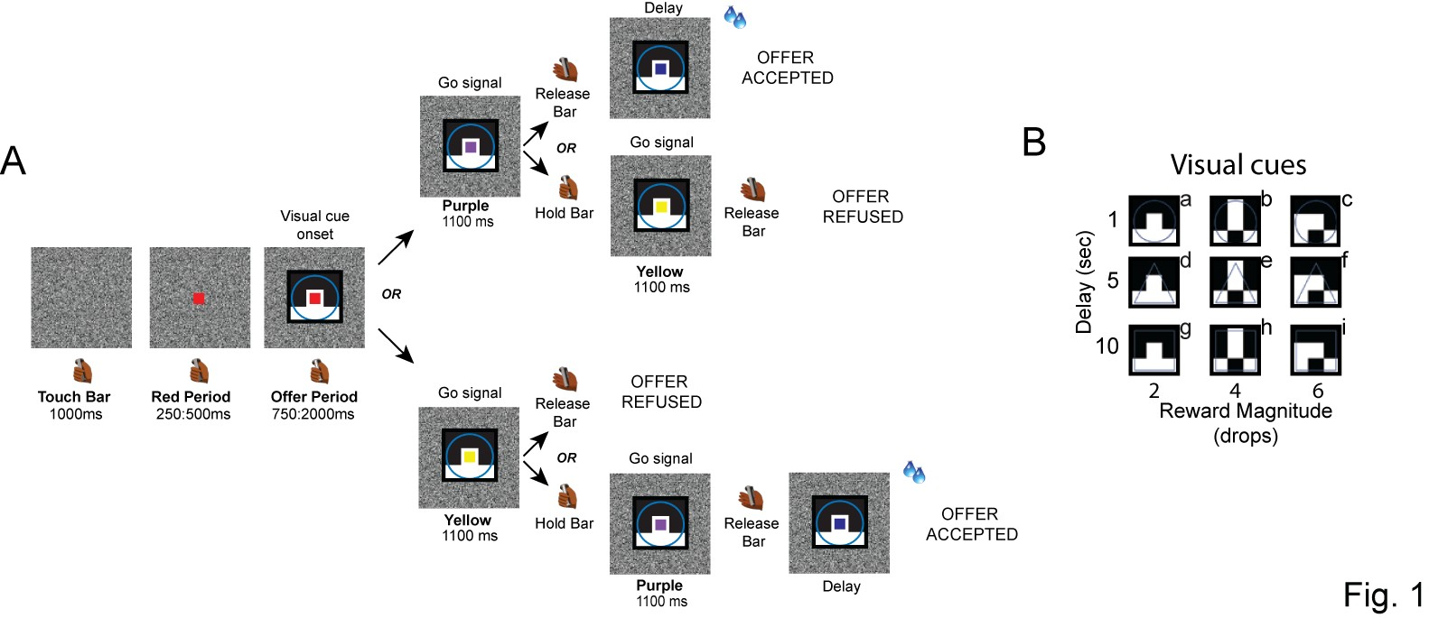
Figure 1. Task description. (A) Each trial begins when the monkey touches and holds a bar. A red square then appears in the center of the screen, followed by a visual cue presented behind the red square. This cue indicates the offer, which is defined by a combination of reward magnitude (2, 4, or 6 drops) and delay (1, 5, or 10 s). Next, the red square changes color to either purple or yellow, serving as a go-signal. If the square turns purple, the monkey can release the bar to accept the offer. The reward is then delivered after the indicated delay. Alternatively, the monkey can continue holding the bar until the purple spot turns yellow to refuse the offer.
If the square turns yellow, the monkey can release the bar to refuse the offer and start a new trial immediately. Alternatively, the monkey can continue holding the bar until the yellow turns purple to accept the offer.
(B) The set of nine visual cues used in the task is labeled from “a” to “i”.

Figure 2. Behavioral performance. Acceptance rate as a function of the discounted value inferred by the model (data: colored points; model: black line) in Monkey S (A) and Monkey T (B). The choices were fitted with hyperbolic discounting and logistic functions to estimate the discounted value and acceptance probability, respectively. Letters from “a” to “i” indicate the nine possible offers. In this analysis the total delay was the cue-indicated delay (1 s, 5 s or 10 s) and the reward magnitude was the cue-indicated number of drops (2, 4 or 6).

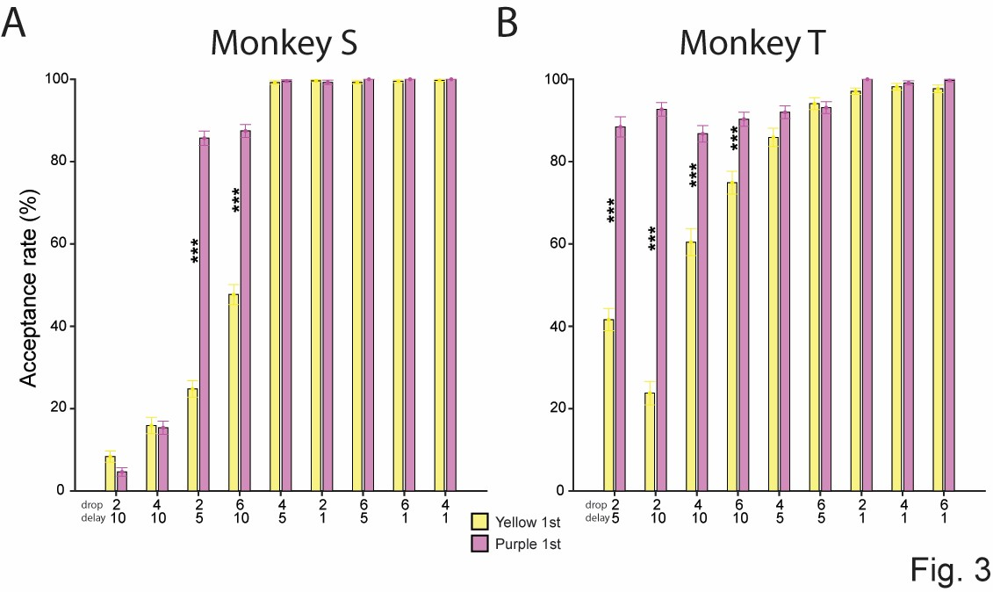Figure 3. Acceptance rate for each offer when the first go-signal was yellow or purple, shown for Monkey S (A) and Monkey T (B). The offers are sorted by their empirical acceptance rate across the nine cues.

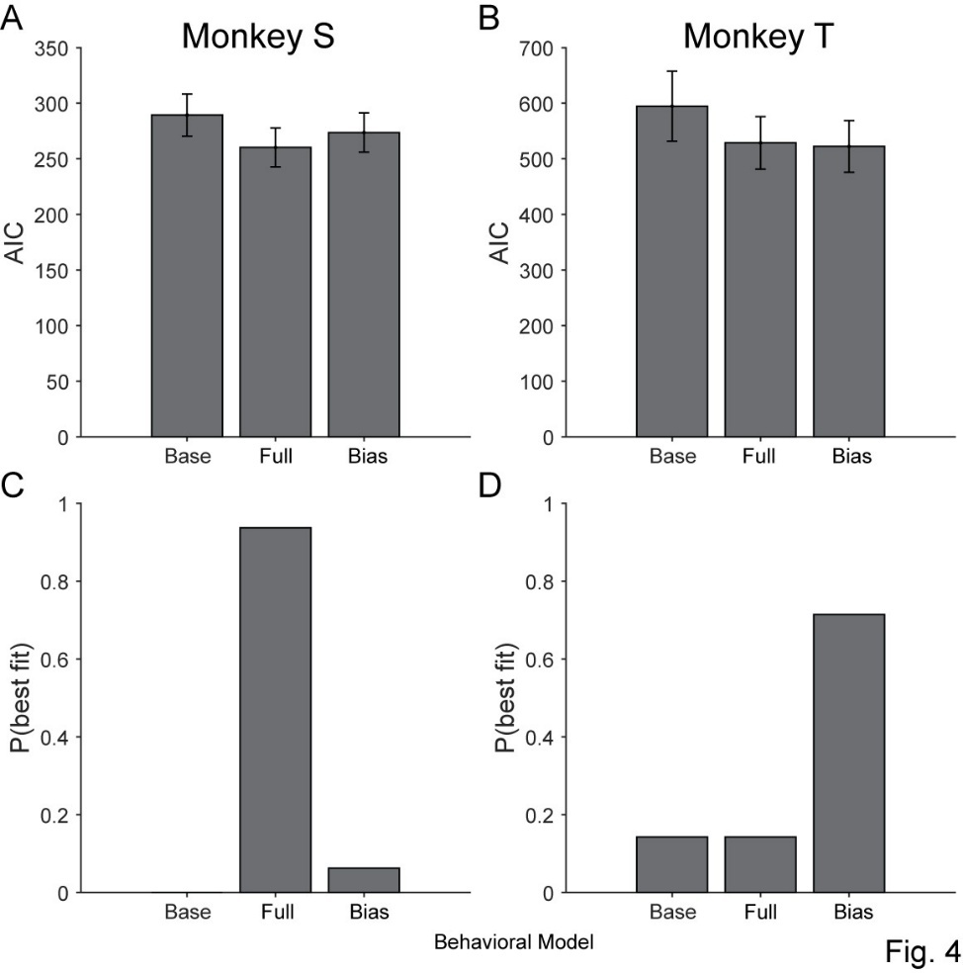
Figure 4. Model comparison of AIC values (A and B) and probability of best fit (C and D) for the base, full, and bias behavioral models in Monkey S (A and C) and Monkey T (B and D).

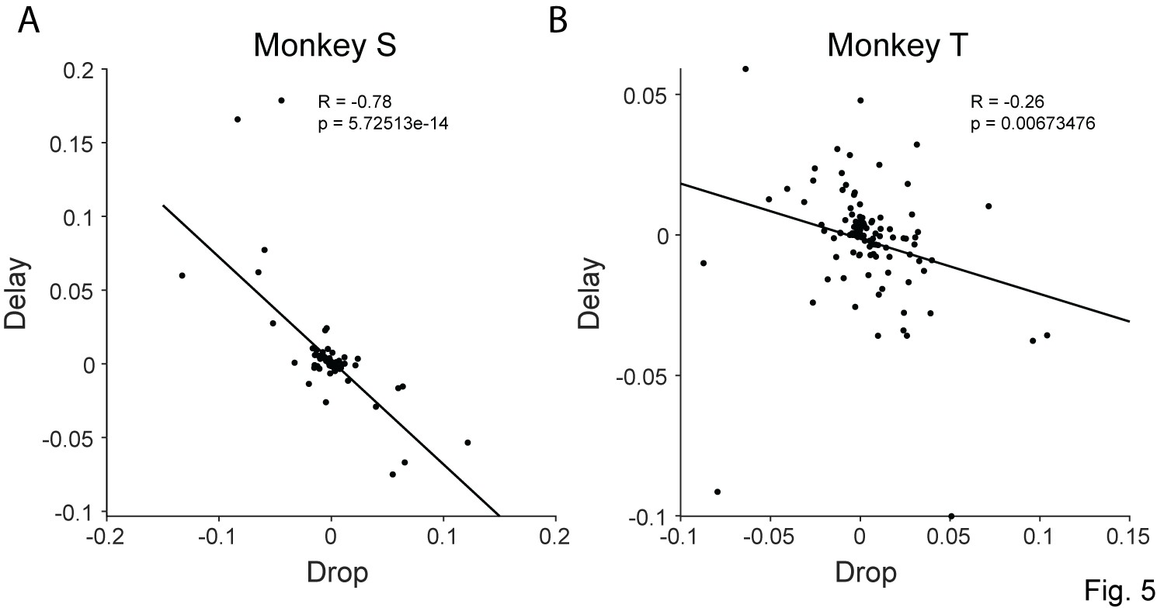
Figure 5. Population encoding dimensions of drop and delay are negatively correlated in Monkey S (A) and Monkey T (B). The population encoding dimensions were estimated using a time window 750ms to 1000ms after cue onset.

Figure 6. Linear correlation between drops and model-inferred time (yellow-purple time; see methods) and neural encoding. Top panels: correlation between drops and yellow-purple time in Monkey S (A) and Monkey T (B). Bottom panels: correlation between delay and yellow-purple time in Monkey S (C) and Monkey T (D).
Figure 7. Geometry of neural coding. Population trajectories for each offer in Monkey S (A, C) and Monkey T (B, D). The trajectories are plotted in the 3D spaces derived from principal component analysis: one for the first 1000 ms of the offer period (top panels) and one for 500 ms before and after the first go-signal onset (bottom panels).
Figure 8. Decoding Analysis: decoding accuracy was calculated for each task factor: reward magnitude (top panels), delay (middle panels), and interaction (bottom panels), this was done for both Monkey S (A, C and E) and Monkey T (B, D and F), from 500 ms before to 1000 ms after the offer onset.

Supplementary Information
Figure S1. Recording sites and neural modulation by task factors. (A) Schematic representation of the Utah array positions in the dlPFC, reconstructed from MRI scans in Monkeys S and T. Bottom panel: the most anterior and posterior MRI slices of Monkey S, with the Utah arrays highlighted by yellow dashed circles. (B) Percentage of neurons significantly modulated by reward magnitude (drops), delay, their interaction, and upcoming choice. (C–D) The time course of the percentage of neurons significantly modulated by each factor, from 500 ms before to 1000 ms after cue onset, in monkey S and monkey T, respectively.

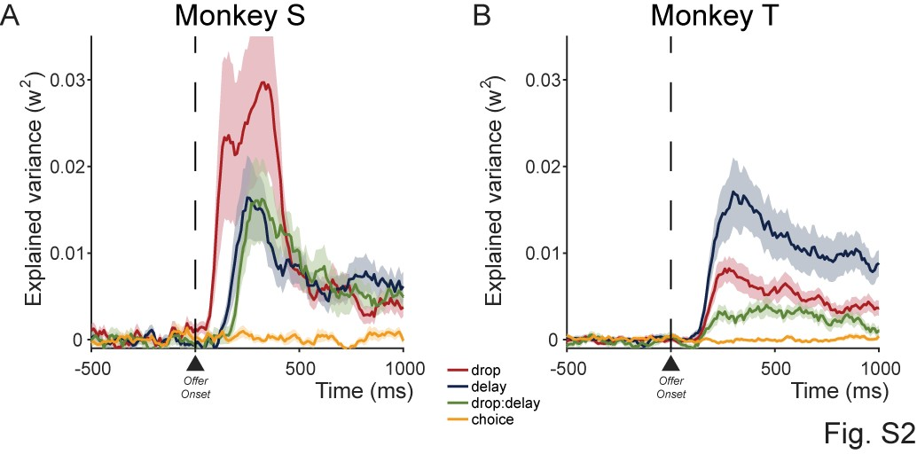
Figure S2. Explained variance is calculated for each task factor over time, from 250 ms before to 1000 ms after the cue onset in Monkey S (A) and Monkey T (B).

Figure S3. Neural response is not related to the predicted choice or to the motor response. Raster displays with spike densities on top from four different neurons are shown for two conditions: when visual cue “h” indicates 4 drops/10 secs of delay (A and B), and when the visual cue “b” indicates 4 drops/1 sec of delay (C and D). These displays were presented toto monkey S and monkey T.
The activity is aligned to the cue onset (time 0). The gray rectangles show the 75–750 ms analysis interval. In panel A, trials are sorted based on choice: accept (black) or refuse (magenta). In panel B, trials are sorted based on whether the response is made after the first go-signal (cyan) or after the second go-signal (blue).

Figure S4. Linear correlations between drops and delay neural encoding, calculated in 250 ms time bins, are shown before and after offer onset (time 0) for Monkey S (A–D) and Monkey T (E–H).
Figure S5. Raster plots and correlation between mean spike count and discounted value. Left panels: example neurons from Monkey T (A) and Monkey S (B). Spike density functions are shown above each raster. The neural activity is aligned to the cue onset and divided into nine offers, which are ordered from the highest to the lowest mean firing rate. The mean firing rate is calculated from 75 to 750 ms after the cue onset (shown by the gray rectangle). Right panels: the linear correlation between the mean spike count for each offer and the behaviorally calculated discounted value, corresponding to the neurons shown in the left panels.

