Reviewer #1: The manuscript addresses the question of whether there is a temporal discounting computation carried out in the prefrontal cortex, and if this is universal or strategy specific. Two monkeys were trained on a two-step temporal discounting task, and neural recordings were conducted in the dlPFC with seven recordings from one monkey and sixteen from the other. The monkeys showed different strategies for temporal discounting, with only Monkey S adjusting the temporally discounted value based on the go signal. The encoding of reward and delay in dlFPC appeared to be integrated in Monkey S, but encoded independently in the Monkey T, reflecting their different temporal discounting strategies. Both monkeys perform temporal discounting; however, the two-step design of the task doesn't impose a necessity for the animals to update primary temporal discounting computations, demonstrated by the monkeys' use of different strategies. The results are interesting and most of my questions are centered on trying to clarify similarities and differences across the animals.
Main comments
1. Monkey T didn't seem to integrate the delay presented by the go signal with the evaluation of reward and delay of the original offer, and encoded reward and delay independently. Inverse coding of reward and delay following cue onset, during the 'evaluation period,' provides evidence for temporal discounting computations in both monkeys, however does this inverse coding persist following the go signal? Monkey S adjusted the temporal discounted value based on the go signal, but Monkey T did not, therefore there could be a presumed difference in this inverse coding following presentation of the go signal.
2. Recording sites on Monkey S and Monkey T were quite different. Do the differences in the linearity of coding between the monkeys (10% in Monkey S and 33% in Monkey T) reflect a true difference in linear processing, or is it due to the neurons being sampled from different sites? Is this difference in coding demonstrated in the neurons that are sampled from overlapping areas recorded across the two monkeys? Are there any other differences in distributions for the other analyses that might correlate with anatomical location?
3. How much more training did Monkey S have compared to Monkey T? Perhaps this task would not evoke different strategies for temporal discounting if training was comparable between monkeys. Did early sessions with Monkey S reflect the strategy that Monkey T used, suggesting that increased experienced in the task resulted in shifting strategies?
4. It seems that the majority of the neural results presented are different between the two animals, which is understandable given the goal of the manuscript and the apparent behavioral differences between the two animals. However, it would be nice to have a positive control. Is there some aspect of the animal behavior and corresponding neural coding that is the same? Responses on opt in vs opt out? Errors? I am curious about those responses as well even if they aren't the same.
Other comments
1. The cues in the task have visual similarities that co-vary with the delay and drops of juice. There are visually responsive neurons in dlPFC. Is it possible to at least partially isolate responses due the cue by examining when the same cue is in different "roles" (e.g., behind a purple vs yellow cue or when it's accepted vs rejected?)
2. The explanation (in words) of Model 2 was even more simple and straightforward in the methods, whereas it was a little hard to follow in the results. Would recommend clarifying/rephrasing in the results.
3. The hand/bar icon on Figure 1 (and the difference between open and closed) is a bit hard to see and it made it a little confusing to initially understand the task.
Main comments
1. Monkey T didn't seem to integrate the delay presented by the go signal with the evaluation of reward and delay of the original offer, and encoded reward and delay independently. Inverse coding of reward and delay following cue onset, during the 'evaluation period,' provides evidence for temporal discounting computations in both monkeys, however does this inverse coding persist following the go signal?
Monkey S adjusted the temporal discounted value based on the go signal, but Monkey T did not, therefore there could be a presumed difference in this inverse coding following presentation of the go signal.

The reviewer is asking for the inversion of the coding at the go signal.
Or we do as the reviewer asks or eventually we reply as per reviewer 2 comment.
2. Recording sites on Monkey S and Monkey T were quite different. Do the differences in the linearity of coding between the monkeys (10% in Monkey S and 33% in Monkey T) reflect a true difference in linear processing, or is it due to the neurons being sampled from different sites? Is this difference in coding demonstrated in the neurons that are sampled from overlapping areas recorded across the two monkeys?
We thank the reviewer for this important point. We agree that differences in recording locations across monkeys could potentially contribute to the difference in the proportion of linearly coding neurons. Although the exact anatomical correspondence between recording sites across animals cannot be established in our dataset, we performed an additional analysis within Monkey S by comparing arrays from different recording locations. In the array that was most comparable to the recording region sampled in Monkey T, we identified only 3 linearly coding neurons out of 44 recorded neurons (~7%), which is substantially lower than the proportion observed in Monkey T.
The difference in recording location alone is unlikely to fully explain the difference, although we cannot completely exclude a contribution from anatomical sampling. However, this comparison is based on a small number of linearly coding neurons in Monkey S and should therefore be interpreted cautiously. We have revised the manuscript accordingly:
Please see the lines ??-??

Are there any other differences in distributions for the other analyses that might correlate with anatomical location?

CAN YOU DO THIS SIYU? IF SO, which analysis we can repeat?
3. How much more training did Monkey S have compared to Monkey T? Perhaps this task would not evoke different strategies for temporal discounting if training was comparable between monkeys. Did early sessions with Monkey S reflect the strategy that Monkey T used, suggesting that increased experienced in the task resulted in shifting strategies?
We appreciate this important comment. Training history may have contributed to the differences. Unfortunately, we only have information for Monkey S. We found that Monkey S at already the first sessions showed a different strategy than the one adopted by Monkey T if we think that the behavior of Monkey T reflects a less experienced one.
The point we want to
make in the manuscript is that distinct behavioral strategies in the task were sustained by differences in neural coding.
Certainly, understanding whether and how behavioral strategies and their neural correlates evolve with experience would require longitudinal studies tracking the same animals across different stages of training.
We have clarified this argument in the discussion. Please see:
4. It seems that the majority of the neural results presented are different between the two animals, which is understandable given the goal of the manuscript and the apparent behavioral differences between the two animals. However, it would be nice to have a positive control. Is there some aspect of the animal behavior and corresponding neural coding that is the same? Responses on opt in vs opt out? Errors? I am curious about those responses as well even if they aren't the same.
Thank you to the reviewer for this comment. As reported in figure 2 of the current manuscript, both monkeys rank the nine offers from lower to higher discounted value, with a similar pattern, showing that both animals rank the offers based on the delay and reward magnitude. Different offers with different delay and magnitude are accepted in a similar way, showing that animals attribute similar value. We found neural encoding of reward, delay and their interaction in both monkeys as shown in figure S1C-D and Fig S2 A-B.
We also found that in both monkeys Delay and Magnitude are inversely correlated, as shown in Figure 5, suggesting temporal discounting.
In both animals we did not find choice signal.
4. Opt-in Opt-out (Siyu can check)
Other comments
1. The cues in the task have visual similarities that co-vary with the delay and drops of juice. There are visually responsive neurons in dlPFC. Is it possible to at least partially isolate responses due the cue by examining when the same cue is in different "roles" (e.g., behind a purple vs yellow cue or when it's accepted vs rejected?)

We thank the reviewer for this point. Because the cue set was constructed by recombining a limited set of simple geometric features encoding reward and delay, visual properties are inherently coupled to task variables.
Therefore, as partial control, we compared neuronal activity elicited by the same offer cue in trials in which the offer was ultimately accepted versus rejected. We did not observe significant differences between these conditions, indicating that the neuronal responses during the offer period were not modulated by the subsequent choice. We acknowledge, however, that this analysis does not rule out the possibility that part of the observed activity reflects visual processing of the cue, and we have added this point as a limitation in the manuscript.

In addition, since each cue simultaneously contains both the reward- and delay-related visual components, if neural activity primarily reflected the visual properties of the cue, one would expect information about these two cue dimensions to emerge with similar temporal dynamics following cue onset. Instead, we observe that delay and reward representations emerge differently, suggesting that the activity reflects the processing of task-relevant information rather than simply the visual features of the stimuli.
2. The explanation (in words) of Model 2 was even more simple and straightforward in the methods, whereas it was a little hard to follow in the results. Would recommend clarifying/rephrasing in the results.
We thank the reviewer for asking us to clarify this point. We have revised the Results section accordingly as
follow:
3. The hand/bar icon on Figure 1 (and the difference between open and closed) is a bit hard to see and it made it a little confusing to initially understand the task.

Reviewer #2: This review identifies several areas where the manuscript would benefit from clearer conceptual and analytical presentation. The main concerns are that the computational models are not specified sufficiently to evaluate the proposed decision processes, key neural analysis terms and methods require clearer definition, and the link between go-signal-related neural activity, recalculated value, and behavioral strategy remains underdeveloped. Overall, the manuscript addresses an interesting question, but stronger model clarity, methodological transparency, and tighter integration between behavioral and neural findings would substantially improve the interpretation of the results.
1. Clarification of the computational models
To model the differential effects of the purple and yellow go signals, the authors compare three models, Models 1-3, that appear to correspond to different hypothesized decision processes. However, in the current version of the manuscript, the models are difficult to evaluate because their details are not described with sufficient clarity. In particular, the same notation appears to be used for different model components, notation is not always consistent within a given model, and some of the equations may contain errors. These issues make it difficult to determine precisely what decision processes the models are intended to represent.

Response R2-1.0:
We thank the reviewer for carefully assessing our behavioral models. We have unified the notations across models to minimize confusion. We also fit 3 additional models to the data (see Response R2-1.3).

We added a paragraph to describe the common features of these models, before diving into each one:

“
Overview of behavioral models
We fitted a total of six behavioral models to the data, consisting of three base models (Model 1, 2, 3) and three model variants (Model 1v, 2v, 3v). The three sets of models (Model 1/1v, 2/2v, 3/3v) made different assumptions on the decision processes (e.g., how the go signal modifies the temporally discounted value). We will first describe the common assumptions adopted by all models.
In all models, it is assumed that animals compute the expected value for accepting the offer $V^{\text{accept}}$, and the expected value for rejecting the offer $V^{\text{reject}}$, and accept/reject decisions are made by comparing $V^{\text{accept}}$ and $V^{\text{reject}}$ using the softmax decision rule:
$$p\left(accept\right)=\frac{1}{1+e^{-\frac{V^{accept}-V^{reject} }{σ}}}$$
Here, $σ$ is a decision noise parameter that captures choice stochasticity.

In all models, it is also assumed that hyperbolic discounting function $h(R, D)$ is used to calculate temporally discounted values. A reward $R$ at a delay $D$ has temporally discounted value $h\left(R,D\right)$
$$h\left(R, D\right)=\frac{R}{1+k⋅D}$$
𝑤here $k$ is the hyperbolic discounting parameter.
”
First, the baseline model, which does not incorporate a go-signal-dependent decision process, does not appear to be a reinforcement-learning model as currently described. Rather, it seems to be identical to Model 1, with the parameters V, θ, and βreplaced by DV, θ, and σ, respectively. In addition, in Model 1, if the discounted value is being compared against a decision threshold, the exponent term would seem more naturally expressed as DV-θ, rather than -V-θ.

Response R2-1.1:

We thank the reviewer for carefully examining our behavioral models. The reviewer is correct that the “baseline model” in Figure 2 is equivalent to “Model 1” in Figure 4. The reviewer is also correct that this is not a reinforcement learning model, but rather a simple decision-making model. We have modified the manuscript to improve clarity, see below:

“
Model 1
Model 1 is a baseline model which assumes that temporal discounting decisions are made, independent of the go signal. The accept/reject decisions are made by comparing the temporally discounted value DV of the offers against a decision threshold $θ$. Animals will be more likely to accept an offer when DV is above θ, and more likely to reject otherwise.
The temporally discounted values are computed for each of the 9 offers. For the drop and delay associated with each offer, we have
$$DV= h\left(\text{drop}, \text{delay}\right)=\frac{\text{drop}}{1+k⋅\text{delay}}$$
The value for accepting the offer is simply the discounted value, $V^{\text{accept}}=DV$, and the value for rejecting the offer is the decision threshold $V^{reject}=θ$.
Thus, via the softmax decision rule, we have
$$p\left(accept\right)=\frac{1}{1+e^{-\frac{DV-θ}{σ}}}$$
”

Second, the authors appear to assume that the yellow and purple go signals add or subtract a fixed bias from the discounted value, and that this bias-modulated discounted value is then compared with a decision threshold to determine whether the offer is accepted or rejected. However, the manuscript formulates this process using (-U-θ±β)/σas the exponent of the softmax function. This expression is difficult to interpret because Uis not defined, and βis also used as the inverse-temperature parameter in the baseline model. To improve clarity, the authors may wish to define all variables explicitly and use distinct notation for different quantities. If the intended model is a threshold-based comparison of a bias-modulated discounted value, the exponent might be more clearly written as:
(DV±Bias-θ)/σ
where DVis the discounted value, Biasis the go-signal-dependent bias, θis the decision threshold, and σcontrols choice stochasticity.

Response R2-1.2:
We apologize for the lack of clarity in our description. The reviewer understood our model correctly. We have modified the manuscript to improve clarity:

“
Model 2
In Model 2, we assume that the go signals have additive values which can bias decisions towards accepting or rejecting. In other words, the go signal may increase or decrease the value of the reward offer by a constant amount, independent of the original discounted value of the offer. The additive value is parameterized symmetrically for the two go signals: $β$ for purple, and $-β$ for yellow. The value for accepting the offer $V^{\text{accept}}$ is the sum of the discounted value of the offer, and the value of the go signal:
$$V^{\text{accept}}=\left\{\begin{aligned}DV+β, &\text{go=}\text{purple} \\ DV-β, &\text{go=}\text{yellow}\end{aligned}\right.$$
The value for rejecting the offer $V^{\text{reject}}=θ$, as in Model 1$.$
The acceptance probability is then:
$$p\left(accept\right)=\frac{1}{1+e^{-\frac{V^{\text{accept}}-θ}{σ}}}$$
”
Third, Model 3 appears to incorporate a hypothesized process in which the discounted value of the offer is recalculated in anticipation of an additional delay, ΔT. The authors then define a quantity referred to as "total value," which appears to be the sum of the recalculated discounted value of the current offer and the average discounted value of future offers in the task, presumably reflecting the expected value associated with rejecting the current offer.
This "total value" formulation would benefit from further clarification. In response to a go signal, the monkeys are presumably deciding whether to accept or reject the current offer. Therefore, it seems that the quantity entering the softmax function should reflect the relative value of accepting versus rejecting the offer, rather than the sum of these values. Specifically, the exponent of the softmax function would seem to depend on:
V_"accept" -V_"reject"
Under this interpretation, for the yellow go signal, the value of accepting would be the recalculated discounted value of the offer incorporating the additional delay:
V_"accept,yellow" =R/(1+k(D+ΔT))
For the purple go signal, the value of accepting would be the original discounted value of the offer:
V_"accept,purple" =DV
The value of rejecting would also depend on the go-signal condition. For the yellow go signal, if the monkey can reject the offer immediately, then:
V_"reject,yellow" =θ
For the purple go signal, if rejection is associated with an additional delay, then the rejection value should be discounted as:
V_"reject,purple" =θ/(1+kΔT)
Thus, if this is the intended decision process, the softmax exponent should be based on the difference between the value of accepting and the value of rejecting, with each term defined according to the specific go-signal condition.

Response R2-1.3:

The reviewer understood our model conceptually. However, the Model 3 (in the original manuscript) had an additional component. We explicitly compared our model and the reduced model that the reviewer described here.

To explain our original model:
In our model, we considered the discounted value of future trials, in addition to the offer value at the current trial. The decision threshold $θ$ (or the value for immediately rejecting the offer) can be viewed as the discounted value of all future trials in a continuous task. When accepting an offer, the value for future trials should be discounted as $h\left(θ, delay\right).$ $h$ is the hyperbolic discounting function (see Response R2-1.0). As a result, the value for accepting the offer $V^{\text{accept}}$, should be the sum of the value of the current offer, and the expected discounted value of all future trials.
$$V^{\text{accept}}={DV}^{current}+ h\left(θ, delay\right)$$

In fact, we realize that we only considered the value of future trials in Model 3, and not in Model 1 and 2. To make a fare comparison, we fitted 6 models in the update manuscript: Model 1,2,3 (without considering value of future trials) and Model 1v,2v,3v (considering future trials).

To clarify, Model1, Model2, and Model 3v are the three models reported in the original manuscript. Model 3 in the original manuscript is renamed to Model 3v in the new manuscript. And the model that the reviewer described here is named Model 3.

We have substantially modified the Methods section and here is the updated text. Hopefully now the model is clear.

“
Model 3
In Model 3, we assume that animals re-calculate the discounted value of offers, in anticipation of an additional delay predicted by the go signal.
If the go signal is purple, animals can accept the offer right away. However, if the go signal is yellow, animals must wait for an additional delay Δt, for the go signal to turn purple, in order to accept the offer. This effectively decreases the value for accepting the offer following the yellow go signal.
On the other hand, if the go signal is yellow, animals can reject right away. However, if the go signal is purple, they must wait for an addition delay, for the go signal to turn yellow, in order to reject the offer. This effectively decreases the value for rejecting the offer following the purple go signal.
Formally, following yellow go signals, the value for accepting the offer $V^{\text{accept}}$ equals the re-computed discounted value
$$V^{\text{accept}}=h\left(drop,delay+Δt\right)=\frac{drop}{1+k⋅(delay+Δt)}$$
and the value for rejecting the offer
$${ V}^{\text{reject}}=θ$$
where $θ$ is the decision threshold.
Following purple go signals, $V^{\text{accept}}$ is the original discounted value
$$V^{\text{accept}}=DV$$
and the value for rejecting the offer is discounted
$${ V}^{\text{reject}}=h\left(θ, Δt\right)=\frac{θ}{1+k⋅Δt}$$
As in previous models, decisions are made via the softmax rule, by comparing $V^{\text{accept}}$ and $V^{\text{reject}}$.
Extended Models
In the base models, the value for accepting the offer is assumed to be the adjusted discounted value of the current offer, without considering discounted values from future trials. Since accepting an offer with longer delay would postpone the start of the next trial, the discounted future reward should be less when accepting offers with longer delays.
The decision threshold $θ$ (or the value for immediately rejecting the offer) can be viewed as the discounted value of all future trials in a continuous task. When accepting an offer, the value for future trials should be discounted as $h\left(θ, delay\right).$ As a result, the value for accepting the offer, should be the sum of the value of the current offer, and the expected discounted value of all future trials.
$$V^{\text{accept}}={DV}^{current}+ h\left(θ, delay\right)$$
The models Model 1v, Model 2v, Model 3v are variants of Model 1, Model 2, Model 3, respectively, and they explicitly account for the discounted value for future trials.
For Model 1v,
$$V^{\text{accept}}=h\left(drop, delay\right)+h\left(θ, delay\right)=DV+h(θ, delay)$$
$$V^{reject}=θ$$
For Model 2v,
$$V^{\text{accept}}=\left\{\begin{aligned}DV+β+h(θ, delay), &\text{go=}\text{purple} \\ DV-β+h(θ, delay), &\text{go=}\text{yellow}\end{aligned}\right.$$
$$V^{reject}=θ$$
For Model 3v,
$$V^{\text{accept}}=\left\{\begin{aligned}h\left(drop,delay\right)+h(θ, delay), &\text{go=}\text{purple} \\ h\left(drop,delay+Δt\right)+h(θ, delay+Δt), &\text{go=}\text{yellow}\end{aligned}\right.$$
$$V^{reject}=\left\{\begin{aligned}h(θ, Δt), &\text{go=}\text{purple} \\ θ, &\text{go=}\text{yellow}\end{aligned}\right.$$
”
More generally, the manuscript would be strengthened by explicitly describing the differential predictions generated by the three models and by reporting the estimated parameters of the best-fitting model. In the absence of these details, it is difficult to assess how the models were fit to the data and how the resulting model comparison supports the authors' interpretation, particularly given the apparent inconsistencies in the current model formulations.

Response R2-1.4:
By comparing goodness-of-fit of the behavioral models to the data, we infer which of the three strategies (Model 1/1t, 2/2t, 3/3t) best describes each animal’s behavior. The best-fit models (among the 6 models) are Model 3v for Monkey S, and Model 2v for Monkey T (see Figure 4 below).
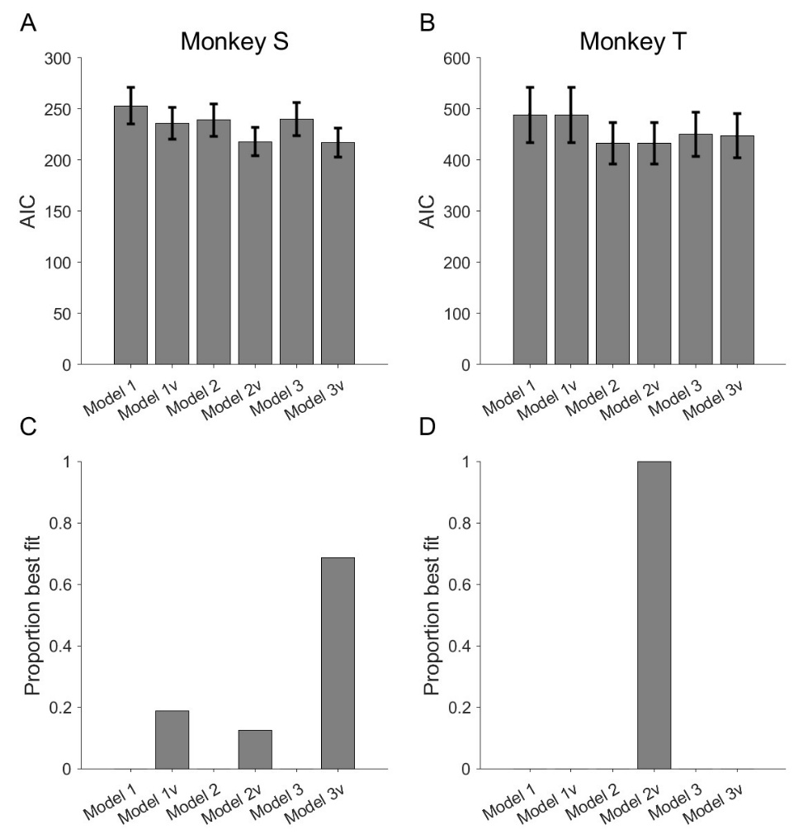

Following the reviewer’s suggestion, we report the parameters of the best-fit models from the two animals. The parameter values look reasonable. For example, the bias parameter $β$ from Model 2v is positive, suggesting that purple go signal increases the value, and yellow go signal decreases the value. 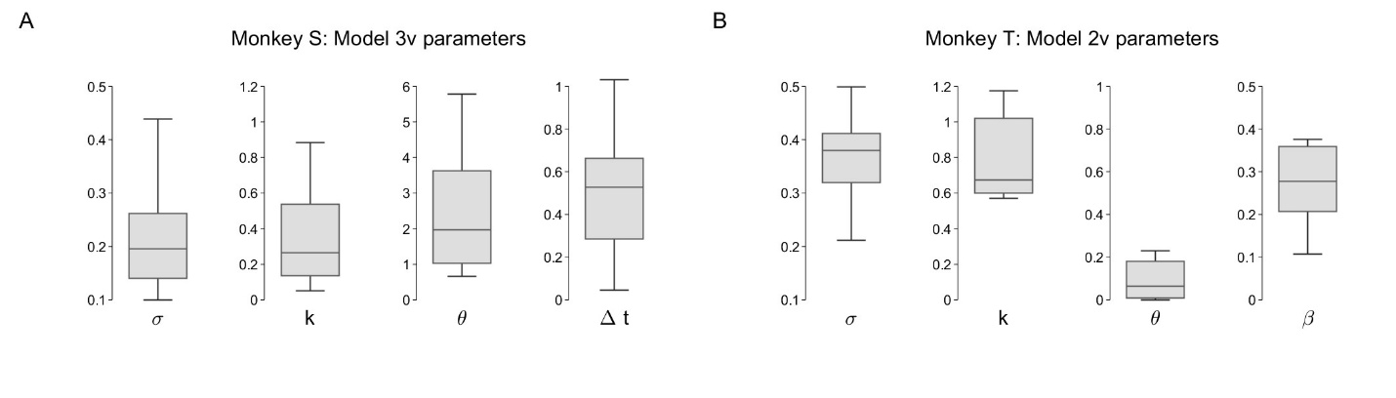To assess whether the model captures behavior, we also plotted and visually examined model predicted acceptance probability against data. Discounted values using best-fit discounting factor $k$ from each model are plotted on the x-axis. For the extended models 1v/2v/3v, given the same discounted value of the offer, the models predict different p(accept) for different delays for Monkey S, but predict similar p(accept) for different delays for Monkey T. This agrees with our interpretation that Monkey S uses delays to adjust temporal discounting calculations (their decision thresholds are delay sensitive), whereas Monkey T treats different go signals just as additional cues and their decision threshold is not adjusted based on delays.
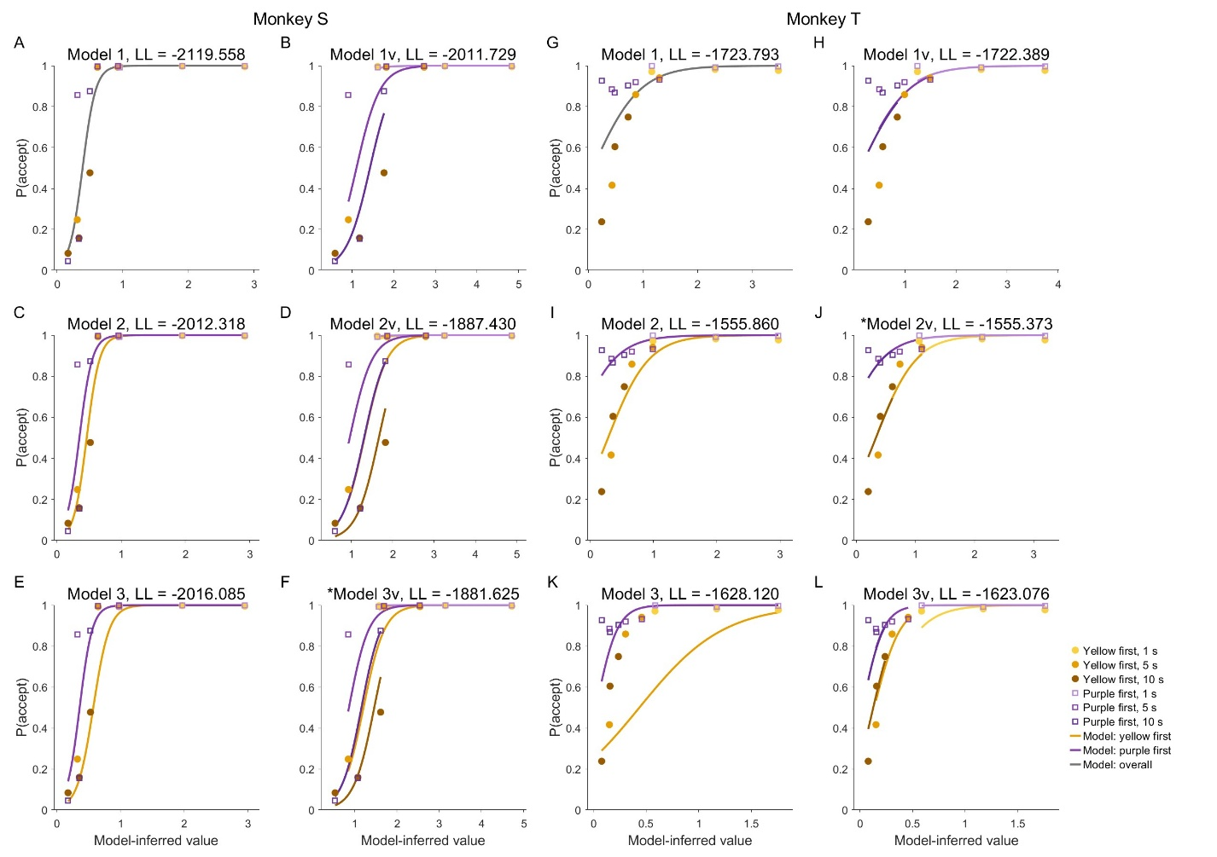
2. Clarification of population coding dimensions
In reporting neural modulation by reward and delay, the authors repeatedly refer to "population coding dimensions" based on beta coefficients from an ANOVA analysis. This approach would benefit from further clarification. In particular, beta coefficients are typically associated with regression models rather than ANOVA, so it would be helpful for the authors to explain how these beta coefficients were obtained from the ANOVA analysis and what specific quantities they represent.
In addition, the definition of "population coding dimensions" should be clarified. For example, are these dimensions intended to represent coordinates or axes defining a subspace of high-dimensional neural activity? Providing a more explicit description of how these dimensions were constructed and how they should be interpreted would make the neural population analyses and the corresponding figures much easier to evaluate.

Response R2-2:
We apologize for the lack of clarity. We rewrote this part of the methods section, and significantly expanded on the method details.
Briefly, the reviewer is correct that the beta coefficients were computed from a linear regression analysis. About the confusion for “beta coefficients from an ANOVA model”: We used the term ANOVA, since ANOVA is a special form of general linear regression. The linear regression model was implemented using MATLAB’s anovan function, which returns both ANOVA statistics and the coefficient estimates from the underlying linear regression model. The β coefficients reported in the manuscript are the slopes from this underlying linear model, rather than ANOVA effect sizes.
The reviewer is also correct that the population dimension is an axes defining a subspace of high-dimensional neural activity. Please see below the modified Methods section for details.
“

Population coding dimensions
In this analysis, we calculate the population coding dimensions for drop, delay and value. The population coding dimension is a direction, represented by a vector of weights of neurons, in the population activity space that tracks a variable of interest (drop, delay and value).
To obtain the population coding dimension for delay and drop, for each neuron and time window of interest, we fitted a general linear model in which firing rate of the neuron $i$ in time window $t$ was predicted by drop and delay. Here, both drop and delay are continuous variables.
$$r_{i}=β_{i}^{0}+β_{i}^{\text{drop}}⋅drop+β_{i}^{\text{delay}}⋅delay+ε_{i}$$
Here, $β_{i}^{\text{drop}}$ represent the expected change in neuron $i$’s firing rate associated with a one-unit increase in drop, holding delay constant, whereas $β_{i}^{\text{delay}}$ represent the expected change in neuron $i$’s firing rate associated with a one-unit increase in delay, holding drop constant.
To construct population coding axes, we concatenate the coefficients for a given predictor, e.g. $β_{i}^{\text{drop}}$, across neurons into a population vector,
$$w^{\text{drop}}={\left[β_{1}^{\text{drop}},…,β_{N}^{\text{drop}}\right]}^{T}$$
and constructed an analogous vector for delay
$$w^{\text{delay}}={\left[β_{1}^{\text{delay}},…,β_{N}^{\text{delay}}\right]}^{T}$$
These vectors define one-dimensional encoding axes in the N-dimensional neural activity space. Their elements are the contributions, or tuning weights, of individual neurons. Because neurons were pooled across recording sessions, these axes were constructed in pseudo-population space.
To compare the similarity of coding dimensions, we computed the cosine similarity, $CS(w^{\text{drop}},w^{\text{delay}})$ between the population vectors.
$$CS(w^{drop},w^{delay}) \text{= }\frac{w^{\text{drop}}⋅w^{\text{delay}}}{|w^{\text{drop}}||w^{\text{delay}}|}$$
This measure reflects the geometric angle between the regression-derived axes in neural population space.

Since $w^{\text{drop}}$ and $w^{\text{delay}}$are obtained from the same regression, to exclude the possibility that the coding dimension similarity between them is an artifact of the fitting process, we adopted a cross-validated cosine similarity metric instead. To do this, we split the data into two halves, and repeated the regression separately on the two halves, and then computed the similarity between $w_{(1)}^{\text{drop}}$ from regression 1, and $w_{(2)}^{\text{delay}}$ from regression 2, and vice versa.
$$CS_{\text{cross-validated}}=\frac{1}{2}\left[CS\left(w_{(1)}^{\text{drop}},w_{(2)}^{\text{delay}}\right)+CS\left(w_{(1)}^{\text{delay}},w_{(2)}^{\text{drop}}\right)\right]$$
A permutation test was adopted to assess statistical significance of the similarity. Specifically, we shuffle the weights across neurons for delay and compute a null distribution of $CS_{\text{cross-validated}}$ by repeating the shuffling 10000 times and computing $CS_{\text{cross-validated}}$ for the shuffled data.

We used a similar approach for defining the population coding dimension for discounted value. A separate regression was carried out with DV as the predictor.
$$r_{i}=β_{i}^{0}+β_{i}^{\text{value}}⋅DV+ε_{i}$$
Population coding dimensions for drop and delay were computed for [-250 0], [0 250], [250 500], [500 750], [750 1000] ms time windows, relative to the offer onset. We also computed it for [-250 0] ms before the go signal. Population coding dimension for value was computed at [-250 0] ms before the go signal.
”
3. Clarification of the analysis relating go-signal modulation to recalculated discounted value
To test whether dlPFC neurons represent a recalculated discounted value at the time of the go signal, the authors examine whether neural activity is modulated by the yellow versus purple go signal in a manner similar to its modulation by reward and/or delay, which are integrated into discounted value. This is an interesting analysis, but several aspects would benefit from further clarification.
First, in the figure corresponding to this analysis, the authors correlate "inferred time" with reward and delay modulation. However, the manuscript does not clearly describe what "inferred time" measures or how it was estimated. Providing a more explicit definition of this variable would help readers interpret the analysis.

Response R2-3.1: First, we actually abandoned this analysis and adopted a simpler and better analysis, following the reviewer’s suggestion, in Response R2-3.2. This figure has been removed from the paper and replaced by the figure in Response R2-3.2.

We apologize for the confusion. It was actually a mistake on our end, and the “inferred time” was an incorrect label. The correct label should be “Y/P coding dimension”. We performed a separate regression analysis, and extracted the coding dimension for the go signal (yellow versus purple). The intention of the figure was to show that in Monkey S (and not Monkey T), the coding dimension for yellow vs purple aligns with the drop/delay coding dimension, at 0-250ms after the go signal. However, as the reviewer pointed out, this analysis was indirect. Now, we adopt a simpler and more direct analysis, to assess how the go signal modifies population encoding of value, by directly plotting the population activity changes along the value dimension before and after the go signal.
Second, it is unclear how neural modulation by the go signal was measured independently of modulation by offer value. The authors present neural activity during the cue period, but not during the period when the go signal was presented, when the potential recalculation of discounted value would presumably occur. In addition, Figures S1 and S2 appear to show that dlPFC neurons exhibit little modulation by the go signal itself. Given this, it is difficult to understand how go-signal-related neural modulation was analyzed in relation to the proposed recalculated discounted value.
If the authors' interpretation is that dlPFC neurons encode an adjustment of discounted value after the go signal, it would be helpful to show this more directly. For example, the analysis would be more compelling if it demonstrated how neural activity changes from the pre-go-signal to post-go-signal period in a way that reflects the proposed value adjustment.

Response R2-3.2: We thank the reviewer for the great suggestion.

Before we dive into the new analysis, we want to briefly clarify Figures S1 and S2. The ANOVA in Figure S1/S2 were carried out at [-500 1000]ms around the offer onset, and not around the go signal. So those figures did not provide information on whether dlPFC neurons are modulated by the go signal itself.

To assess the effect of the go signal on dlPFC neural activity, we computed the population coding dimension of value based on the -250 to 0ms time window before the go signal, projected the population activity from a pseudo population onto the value dimension, and asked how the population activity evolves on the value dimension from the pre-go-signal to post-go-signal period.

4. Relating individual differences in neural modulation to behavioral strategy
The authors report that the two monkeys may have used different behavioral strategies and also describe individual differences in several aspects of neural modulation. It would be helpful if the authors could further discuss how these individual differences in neural activity might relate to the observed differences in decision strategy. For example, do the monkey-specific patterns of neural modulation provide a possible mechanistic explanation for differences in how each animal evaluated or responded to the offers? Clarifying this relationship would help strengthen the link between the neural findings and the behavioral interpretation.

Response R2-4:
We thank the reviewer for carefully reviewing our manuscript. We have substantially modified the methods section of the paper, to improve clarity in both the behavioral modeling, and population-based neural analysis.

% Monkey T purple bias
% rotating axis causes yellow/purple to evolve together
Explain the link between Model 3 and neural result Fig 6 for Monkey S and not monkey T.

