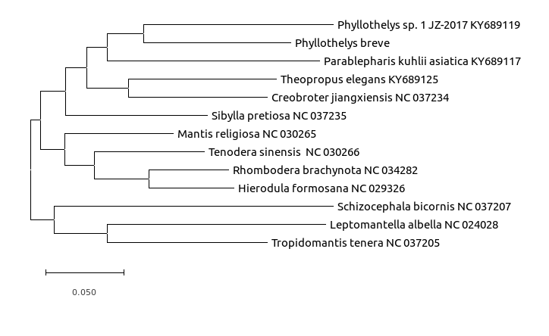

Maximum Likelihood

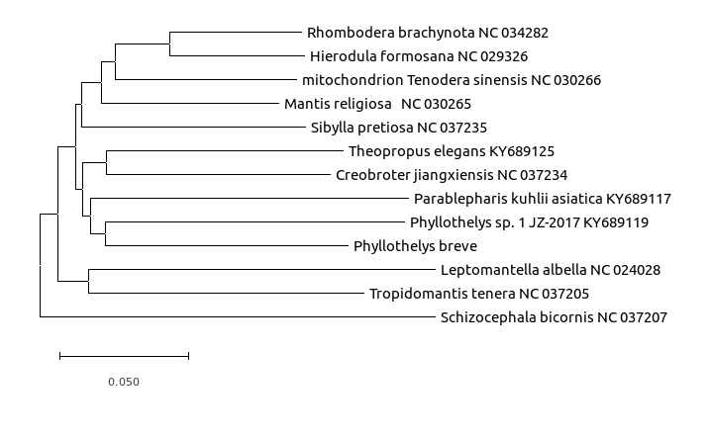

Minimum Evolution

Phyllothelys robusta 没有

|  |  |  |
| --- | --- | --- |
| Phyllothelys breve | | |
| 基因总数 | 15896 | |
| A  T  C  G | 6384  5651  2416  1445 | |
| A  T  C  G | 40.2%  35.5%  15.2%  9.1% | |
| tRNA | 22 | |
| CDS/PCG | 13 | |
| rRNA (2) | | |
|  | total | A+T |
| 16S ribosomal RNA  12S ribosomal RNA | 1314  753 | 78.9%  76.4% |
| D-loop (1) | | |
|  | 948 | 77.4%. |
| start codon 起始密码子 | | |
| ND2  COX1  COX2  ATP8  ATP6  COX3  ND3  ND5  ND4  ND4L  ND6  CYTB  ND1 | ATG  ATT  ATG  ATT  ATG  ATG  ATT  AAA  AAA  TTA  ATC  ATG  TTA | |
| stop codon | | |
| ND2  COX1  COX2  ATP8  ATP6  COX3  ND3  ND5  ND4  ND4L  ND6  CYTB  ND1 | TAA  TAA  AAT  TAA  TAA  TAA  TAA  TAT  TAT  CAT  TAA  TAA  CAT | |

**Abstract:**

In this study, we determined the complete mitochondrial genome sequence of XXX using next-generation sequencing (NGS) method. The mitogenome is 15,896 bp in length, consisting of 13 protein-coding genes (PCGs), two ribosomal RNA genes (rRNAs), 22 transfer RNA genes (tRNAs), and one non-coding control region. The overall nucleotide composition was 40.2% A, 35.5% T, 15.2% C, and 9.1% G, with 75.7% AT, respectively. The gene arrangement is consistent with the typical insect mitochondrial genome. Phylogenetic analysis revealed that P. breve clustered into a clade with Chiagosnius sulcicollis with high bootstrap support.

**Keywords:**

Insecta, molecular, phylogeny, mitochondrial DNA, genetic diversity

Elateridae commonly known as click beetles and contains approximately 10,000 species (Johnson 2002). Chiagosnius vittiger, with dark brown oval marking in the middle of pronotum, mainly distributed in southern China and East Asia (Jiang and Wang 1999). Here, we determined the complete mitochondrial genome of C. vittiger, which is the second mitochondrial genome sequenced to date in the genus of Chiagosnius Fleutiaux, and the first one is Chiagosnius sulcicollis (Wang et al. 2019).

The sampled specimen was collected from Jianfengling National Nature Reserve, Hainan, China (18°44′N, 108°54′E) in May, 2018. The specimen was stored in the Entomological specimen room of Shangluo University (voucher no. CO-2018229). The complete mitochondrial DNA sequence was determined by Illumina HiSeq 2500 Sequencing System (Illumina, San Diego, CA，USA). In total, 5.6 G raw reads were obtained, quality-trimmed, and assembled using MITObim version 1.7 (https://github.com/chrishah/MITObim) (Hahn et al. 2013).

The complete mitochondrial genome of P. breve was 15,896 bp in total length and deposited in GenBank database with an accession number XX. The overall base composition was 40.2% A, 35.5% T, 15.2% C, and 9.1% G, with an A + T ratio of 75.7%. The full mitochondrial genome contains 13 protein-coding genes (PCGs), 22 transfer RNAs (tRNAs), two ribosomal RNAs (rRNAs) and a putative control region (CR). The gene arrangement of P. breve is found to be similar to most insect mitochondrial genomes (XXX). Most PCGs of P. breve have the conventional start codon for invertebrate mitochondrial PCGs (ATN), with the exception of nad1 (TTA) and the start codon of cox1 not determined. Most of the PCGs terminate with the stop codon TAA, whereas cox2, nd4l, nd4, nd5 and nad1 end with the incomplete codon T. Nine PCGs are encoded on the majority strand (J-strand) and four (nad5, nad4, nad4L, and nad1) on the minority strand (N-strand). All 22 tRNA genes can be folded into the typical cloverleaf structure except for trnS1, in which the dihydrouridine (DHU) arm cannot form a stable stem-loop structure but a simple loop. Two rRNA genes (rrnL and rrnS) locate at trnL1/trnV and trnV/control regions, respectively, and both rRNA genes are encoded on the N-strand. The lengths of the two rRNA genes (rrnL and rrnS) in P. breve are about 1314and 753bp, with the A + T contents of 78.9% and 76.4%, respectively. The length of control region is 948 bp, with the AT content of this region is up to 77.4%.

The phylogenetic tree was constructed using the maximum-likelihood method through RaxmlGUI version 1.5 (http://sourceforge.net/projects/raxmlgui/) (Silvestro and Michalak 2012). Results showed that the family Elateridae is monophyletic and the genus Chiagosnius Fleutiaux is sister to Melanotus Eschlscholtz (Figure 1), which was consistent with the previous studies (Lin et al. 2018; Meng et al. 2018; Wang et al. 2019). As a conclusion, we obtained and described the complete mitochondrial genome of P. breve, which constitute a valuable and useful resource for population genetic study and identification efforts on this species.

Figure 1. Phylogenetic relationships based on the 13 mitochondrial protein-coding genes sequences inferred from RaxML. Numbers on branches are bootstrap values (BV).

Elateridae commonly known as click beetles and contains approximately 10,000 species (Johnson 2002). Chiagosnius vittiger, with dark brown oval marking in the middle of pronotum, mainly distributed in southern China and East Asia (Jiang and Wang 1999).

金龟子科，俗称点击甲虫，约有10000种(Johnson 2002)。叉头龙，在叉头龙中间有深棕色的椭圆形斑纹，主要分布于中国南部和东亚地区(Jiang和Wang 1999)。

Here, we determined the complete mitochondrial genome of C. vittiger, which is the second mitochondrial genome sequenced to date in the genus of Chiagosnius Fleutiaux, and the first one is Chiagosnius sulcicollis (Wang et al. 2019).

在这里，我们确定了C. vittiger的完整线粒体基因组，这是迄今为止在雪狐属中测序的第二个线粒体基因组，第一个是雪狐属(Chiagosnius sulcicollis, Wang et al. 2019)。

The sampled specimen was collected from Jianfengling National Nature Reserve, Hainan, China (18 44 N, 108 54 E) in May, 2018. The specimen was stored in the Entomological specimen room of Shangluo University (voucher no. CO-2018229)

标本于2018年5月采集自中国海南尖峰岭国家自然保护区(北纬18 44度，东经108度54度)。标本保存于商洛大学昆虫标本室。有限公司(2018229)

The complete mitochondrial DNA sequence was determined by Illumina HiSeq 2500 Sequencing System (Illumina, San Diego, CA,USA). In total, 5.6 G raw reads were obtained, quality-trimmed, and assembled using MITObim version 1.7

线粒体DNA全序列由Illumina HiSeq 2500测序系统(Illumina, San Diego, CA,USA)测定。总的来说，使用MITObim 1.7版获得了5.6 G的原始读数，并进行了质量调整和组装

The complete mitochondrial genome of C. vittiger was 15,842 bp in total length and deposited in GenBank database with an accession number MN306531. The overall base composition was 41.6% A, 31.1% T, 16.9% C, and 10.4% G, with an A + T ratio of 72.7%.

1. vittiger线粒体基因组全长15842 bp，存入GenBank数据库，登录号MN306531。总碱组成为41.6% A, 31.1% T, 16.9% C, 10.4% G, A + T比例为72.7%。

The full mitochondrial genome contains 13 protein-coding genes (PCGs), 22 transfer RNAs (tRNAs), two ribosomal RNAs (rRNAs) and a putative control region (CR). The gene arrangement of C. vittiger is found to be similar to most insect mitochondrial genomes (Wolstenholme 1992).

整个线粒体基因组包含13个蛋白编码基因(PCGs)、22个转移rna (tRNAs)、两个核糖体rna (rRNAs)和一个假定的控制区(CR)。人们发现，C. vittiger的基因排列与大多数昆虫的线粒体基因组相似(Wolstenholme 1992)。

Most PCGs of C. vittiger have the conventional start codon for invertebrate(无脊椎动物) mitochondrial PCGs (ATN), with the exception of nad1 (TTG) and the start codon of cox1 not determined. Most of the PCGs terminate with the stop codon TAA or TAG, whereas cox2, cox3, and nad5 end with the incomplete codon T. nine PCGs are encoded on the majority strand (J-strand) and four (nad5, nad4, nad4L, and nad1) on the minority strand (N-strand).

除nad1 (TTG)和cox1的起始密码子未确定外，C. vittiger的大多数PCGs都具有无脊椎线粒体PCGs (ATN)的常规起始密码子。大多数PCGs以终止密码子TAA或TAG结束，而cox2、cox3和nad5以不完全密码子t结束。9个PCGs编码在多数链(j链)上，4个编码在少数链(n链)上(nad5、nad4、nad4L和nad1)。

All 22 tRNA genes can be folded into the typical cloverleaf structure except for trnS1, in which the dihydrouridine (DHU) arm cannot form a stable stem-loop structure but a simple loop.

除trnS1外，所有22个tRNA基因均可折叠成典型的三叶草结构，其中双水吖啶(东华大学)臂不能形成稳定的茎环结构，只能形成简单的环。

Two rRNA genes (rrnL and rrnS) locate at trnL1/trnV and trnV/control regions, respectively, and both rRNA genes are encoded on the N-strand.

两个rRNA基因（rrnL和rrnS）分别位于trnL1 / trnV和trnV / control区域，并且两个rRNA基因都编码在N链上。

The lengths of the two rRNA genes (rrnL and rrnS) in C. vittiger are about 1283 and 736 bp, with the A + T contents of 78.7% and 75.9%, respectively. The length of control region is 1230 bp, with the AT content of this region is up to 81.9%.

C. vittiger中两个rRNA基因(rrnL和rrnS)的长度约为1283 bp和736 bp, A + T含量分别为78.7%和75.9%。控制区长度为1230 bp，该区域AT含量达81.9%。

Results showed that the family Elateridae is monophyletic and the genus Chiagosnius Fleutiaux is sister to Melanotus Eschlscholtz (Figure 1), which was consistent with the previous studies (Lin et al. 2018; Meng et al. 2018; Wang et al. 2019).

结果表明，Elateridae为单系，Chiagosnius Fleutiaux属是Melanotus Eschlscholtz的姊妹(图1)，这与以往的研究一致(Lin et al. 2018;孟等，2018;Wang et al. 2019)。

As a conclusion, we obtained and described the complete mitochondrial genome of C. vittiger, which constitute a valuable and useful resource for population genetic study and identification efforts on this species.

作为结论，我们获得并描述了C. vittiger的完整线粒体基因组，这为该物种的种群遗传学研究和鉴定工作提供了宝贵和有用的资源。

Figure 1. Phylogenetic relationships based on the 13 mitochondrial protein-coding genes sequences inferred from RaxML. Numbers on branches are bootstrap values (BV).

图1所示。基于13个线粒体蛋白编码基因序列的系统发育关系。分支上的数字是引导值(BV)。

In this study, we determined the complete mitochondrial genome sequence of click beetle Chiagosnius vittiger (Heyden, 1887) (GenBank accession no. MN306531) using next-generation sequencing (NGS) method.

在本研究中，我们测定了赤蝽的全线粒体基因组序列(Heyden, 1887)。采用新一代测序(NGS)方法。

Elateridae commonly known as click beetles and contains approximately 10,000 species (Johnson 2002). Chiagosnius vittiger, with dark brown oval marking in the middle of pronotum, mainly distributed in southern China and East Asia (Jiang and Wang 1999). Here, we determined the complete mitochondrial genome of C. vittiger, which is the second mitochondrial genome sequenced to date in the genus of Chiagosnius Fleutiaux, and the first one is Chiagosnius sulcicollis (Wang et al. 2019).

金龟子科，俗称点击甲虫，约有10000种(Johnson 2002)。叉头龙，在叉头龙中间有深棕色的椭圆形斑纹，主要分布于中国南部和东亚地区(Jiang和Wang 1999)。在这里，我们确定了C. vittiger的完整线粒体基因组，这是迄今为止在雪狐属中测序的第二个线粒体基因组，第一个是雪狐属(Chiagosnius sulcicollis, Wang et al. 2019)。

样本标本于2018年5月从中国海南剑峰岭国家级自然保护区（北纬18°44′，东经108°54′）采集。标本存放在商洛大学昆虫学标本室（优惠券编号：CO- 2018229）。 线粒体DNA的完整序列通过Illumina HiSeq 2500测序系统（Illumina，圣地亚哥，加利福尼亚，美国）确定。 使用MITObim版本1.7（https://github.com/chrishah/MITObim）（Hahn等人，2013），总共获得了5.6μG的原始读物，对其进行了质量修剪和组装。