**Social Books Web Application**

**Introduction**

The social books web app is based on the idea of a real library with an additional feature of connecting like-minded book lovers. The library has two sections: personal and social. A user can add new books to his library. Moreover, he can search and delete books from the personal library or edit them. Furthermore, books in the personal library can be viewed based on topics/metadata tags. Each book relates to a topic, therefore, when a user selects a topic then all the books under that topic are displayed to the user. In addition to the personal section, the library has a social section where books from other users are recommended by the application. The recommendations are shown when a user has three books in common with another user of the library.

**Tools and Technologies**

For front-end design, we have used HTML, CSS and JavaScript with front-end library (jQuery [1]). Regarding the front-end frameworks, we have used Bootstrap [2], which is a free open-source CSS framework aimed at responsive, mobile-first front-end web development. For back-end development, we used Node.js [3] which is an open-source, event-driven asynchronous I/O famous for building efficient and scalable web servers. We chose Node.js because of the two main advantages, also highlighted by [4]. First, due to familiarity with JavaScript because of its status as an accepted standard for web development. Second, because the use of one language for both front and back end development speeds up the coding since the developers’ brain does not need to switch between different syntaxes. Besides, we have used the Express.js framework [5] that is designed for building web applications and APIs.

Regarding the database choice, we opted for MongoDB [6], which is a schema-less, document-based, general-purpose, distributed database build for the cloud era, focused on modern application developers. MongoDB fascinates us because it uses a JavaScript interface that completes a full-stack JavaScript stack puzzle of server, browser, and database layers. As a result, we can use one language for all of the three layers. [4] also attributed this as a significant advantage of using MongoDB in addition to its performance and scaling. With regards to tools for application development, we have used IntelliJ IDEA [7] and NoSQLBooster [8].

**Use Case Diagram**

The use case diagram shown in figure 1, describes the use cases (a set of actions) that can be performed by the users of our online social library app. The include relationship indicates that “Update a Book” is an including (base) use case but it incomplete without “Search the Book” and “Select the Book”, which are included use cases. The user first has to search and then select a book to perform the update operation. The same goes for the use cases “View Personal Books” and “View Recommended Books”. First, the user has to choose topics/metadata tags for which she wants to view the personal or recommended books, and only then the books would be displayed to her. The extended relationship, on the other hand, defines the optional behavior. For example, if a user wants to “Manage Books” then he might or might not “Update a Book”. He doesn't need to always perform the extended use case (Update a Book) to complete the extending (base) use case.

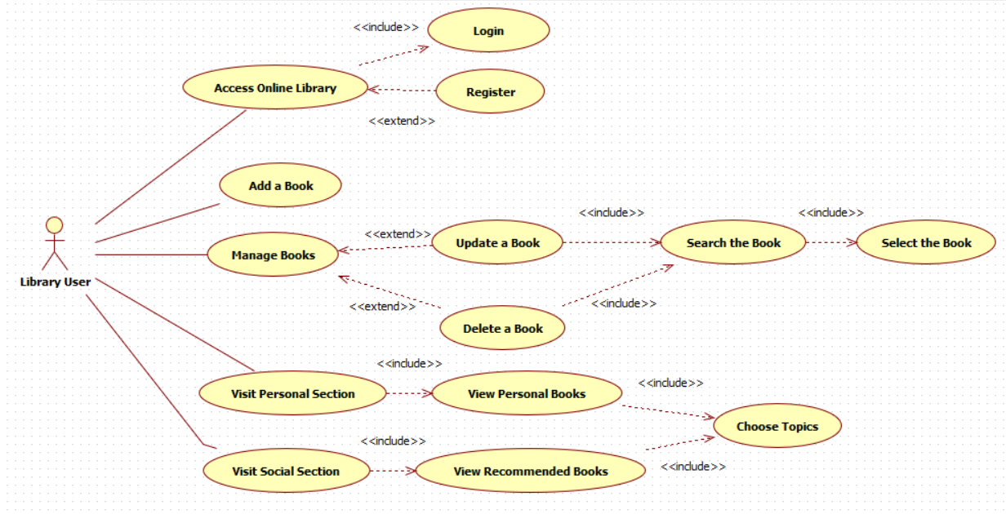

**Figure 1: Social Library Use Case Diagram**

**Web App Architecture**

Figure 2 shows the application architecture and depicts that we have used the Model View Controller (MVC) framework to separate our application into three logical components. Model, View, and Controller indicate data, user-interface, and request-response handler part respectively. The *Model* part shows our data model of MongoDB, the constraints, and the format with which we store the data. For instance, in our case, we store data in JSON format so the *Model* represents this in addition to the collections that we have, such as user and book. View, on the other hand, uses *Model* and presents data to the user in a form that she wants. When a library user makes a request, for example, if she wants to see her social section then *View* would be the part to show the social section page to the user. Different views namely management, personal section, etc. can be seen in the architectural diagram.

Finally, the user’s requests are controlled using the *Controller* part and then an appropriate response is generated that is fed to the library user. The library user will interact with View, thereby, an appropriate request will be generated and handled by the controller. For instance, the user requests to view the personal section, the *controller* will act as a router and direct the request to the psection.js file, which will render appropriate view as a response by using model data. With regards to managing HTTP requests and performing CRUD (Create Read Update Delete) operations, the RESTful API is used. Thus, all the library user’s request including adding, searching, updating, and deleting the books, etc. are managed with it as shown in figure 2.

**Responsive Web Design**

To enhance the user experience, we focused on making responsive web design, and based on that, our web app will change its layout depending on the device the web app is opened at. To do this, we used the Media Query technique that is based on the CSS @media rule. The rule is aimed at including a CSS properties block only when a particular condition is met, that is, changing the style based on the media device. Now our library app, if opened at the mobile browser, doesn’t require zooming to make the text readable and the design elements do not require horizontal scrolling. We have tested the responsiveness of our web app design with *Google’s Mobile-Friendly Test* tool [9]. The test revealed that our social library web application is mobile-friendly.

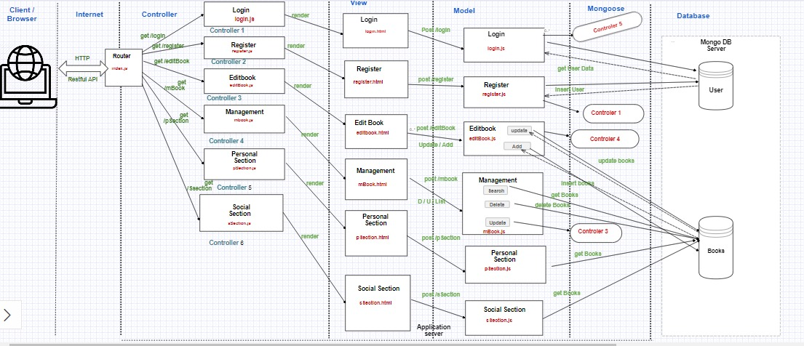

**Figure 2: Architecture of Social Library App**

**Fixing MongoDB Security Problem (MongoDB Blackmail)**

While testing our application, several times we found that the data from our database has been deleted. The problem was that MongoDB was exposed to the public on the internet without any security policy and also, it did not have a password by default so hackers did attempt to scan the database and then deleted the data for blackmailing. Each time the data was deleted, a recovery database instance had been shown to us which provided us a recovery email address that was unknown for us.

To solve the problem, we closed the port 3000 and 27017. By using the AWS security group function, we have set inbound rules and opened the ports 80, 22, and 443 for HTTP, SSH, and Custom TCP Rule traffic types respectively. Port 80 and 443 will allow inbound HTTP access from all IPv4 and IPV6 addresses respectively, while port 22 will allow inbound SSH access to Linux instances from IPv4 IP addresses in our network.

**Jenkins**

We have used Jenkins for automating the software development processes related to Continuous Integration & Continuous Delivery (CI/CD). Before CI/CD, we automated the unit testing by connecting Jenkins with our Git repository so whenever the code was committed to repo, the unit test was triggered. From our git repository, Jenkins would download the code and afterwards, we would build and execute test suit. Once after building, we would move to next steps if test passed. The code would be integrated automatically to main branch when it had been tested. After CI, the code would be continuously delivered. We used static code analysis for identifying potential problem with code and it would execute if build fail.

**Application Deployment**

After developing the application, it is not like we keep our computer running 24/7, therefore, we have hosted our service in a remote environment, that is Amazon Web Services (AWS). AWS [10] aims at providing cloud computing platforms as well as APIs, on-demand, and metered pay as you go basis. Our online library application can now be accessed by any user of the app at any time. With AWS, we have used a virtual server that can be kept on for as long as we need (EC2. Using the [REST](https://en.wikipedia.org/wiki/Representational_State_Transfer) architectural style, offerings of AWS are accessed over HTTP.

To make our application highly available, scalable, and elastic, we needed to have a high-level administration mechanism for coordination between backup and front-line instances. Having a running replica of an instance that has failed recently will not help because the visitors of our library app would not know where to go and find it. For this, we have added a load balancer to the mix for monitoring the health of running instances. In this way, if one instance goes dark, the load balancer will automatically redirect incoming traffic towards active resources. We have used Amazon’s Elastic Load Balancing (ELB) as a load balancing tool and it will not only manage failovers but also focus on balancing traffic loads amongst multiple resources for satisfying defined performance and efficiency needs. After configuring the load balancer with addresses of all of our servers, its network address is now the only URL that our users need to access. The users do not need to know the individual IP addresses of each of our servers.

Although the sudden loss of a server can be accommodated gracefully by the load balancers, they cannot replace the lost capacity originally provided by the now-dead server. In other words, if one out of our three server crashes, the full workload will have to be managed by the remaining servers on their own. The load balancer cannot help us out in this area as it is well beyond its pay scale. And regarding elasticity, load balancer keeps what we have got running nicely, but they are unable to manage change. Furthermore, as we are concerned that increased demand or unexpected server downtime may unable our application to do its job properly, therefore, we found a way of adding capacity using auto-scaling. With auto-scaling, we have automated instance replacement in case of failure. Moreover, depending on the need, the number of running instances can now be increased or decreased.

**References**

[1] https://jquery.com/

[2] <https://getbootstrap.com/>

[3] <https://nodejs.org/en/>

[4] Mardan, Azat. (2018). Full Stack JavaScript: Learn Backbone.js, Node.js, and MongoDB. 10.1007/978-1-4842-3718-2.

[5] <https://expressjs.com/>

[6] <https://www.mongodb.com/>

[7] <https://www.jetbrains.com/idea/>

[8] <https://nosqlbooster.com/>

[9]<https://search.google.com/test/mobilefriendly?utm_source=mft&utm_medium=redirect&utm_campaign=mft-redirect>

[10] <https://aws.amazon.com/>