Capturing Unanticipated Drug Toxicities Using a Machine Learning Approach
Nicole Zatorski^{1, 2*}; Avner Schlessinger^{2*}
¹Department of Internal Medicine, Duke University, Durham, North Carolina 27710 USA
² Small Molecule AI Drug Discovery Center, Department of Pharmacological Sciences, Icahn School of Medicine at Mount Sinai, New York, New York 10029 USA
* Correspondence: nicole.zatorski@duke.edu; avner.schlessinger@mssm.edu

ABSTRACT
Despite rigorous safety evaluations during development, numerous drugs have been withdrawn from the market due to serious toxicities. Here we investigate the features found in drugs with these unanticipated toxicities and apply a machine learning approach to predict if a drug is likely to be withdrawn due to intolerable side effects without the need for human trial data. Our best performing classifiers were an ensemble predictor and a XGB classifier that achieved 0.885±0.091 and 0.905±0.033 (p=0.48) accuracy respectively on 10-fold holdout test set cross validation. In total the training and test sets constituted drug structures represented by molecular fingerprint, drug chemical features, IC50 protein targets, and protein target features (n = 206 withdrawn + 1,089 not withdrawn drugs). Analysis of features predictive of unanticipated toxicity revealed both known factors such as inhibition of cytochrome P450 as well as yet uninvestigated factors including the inhibition of bile salt export pumps. This predictor and subsequent feature analysis pave the way for the larger role of computational methods in screening potential candidates during drug development.
INTRODUCTION
Unanticipated toxicities can emerge when drugs are incorporated into standard of care so numerous regulatory bodies monitor the safety of drugs for side effects after the end of their official clinical testing phase¹⁻⁴. If unexpected side effects are observed, these agencies, such as the United States Federal Drug Administration (FDA) or the European Medicines Agency (EMA), can withdraw the drug from the market¹⁻⁴. In addition to the impact unexpected toxicities have on patients, the decision to discontinue a drug further creates economic burden that prevents recoupment of research and development investment that increase costs of healthcare for patients⁵.
Due to the difficulties resulting from unexpected toxicities and subsequent drug withdrawals, many approaches have been used in an effort to predict toxicity earlier in the development pipeline⁶. Currently, the industry standard relies on laboratory and animal testing followed by Phase 1 trials in healthy volunteers to assess toxic side effects⁷. Traditional computational toxicity prediction approaches have centered around the use of drug Quantitative Structure-Activity Relationships (QSAR)⁸, which typically involve statistical or machine learning models that characterize the relationship between chemical properties of a drug and a phenotypes associated with toxicity. These features are used, for example, to predict a drug’s likelihood of inhibiting a particular protein, such as the hERG channel in the heart, which can precipitate arrhythmias when modulated by a drug⁹. While this system is fairly robust, it fails to capture the long-term use toxicities and very rare side effects uncovered in post marketing surveillance.
In addition, emerging big data analysis and machine learning techniques can be applied preclinically, during the drug development process, to provide a supplemental approach to toxicity prediction and eliminate potentially toxic drug candidates¹⁰. For example, deep neural network models applied to whole-genome DNA microarray data from the Open Toxicogenomics Project-Genomics Assisted Toxicity Evaluation System and DrugMatrix have predicted three liver toxicity endpoints with a range of 56% to 89% accuracy¹¹. Cardio ToxCSM, is a webserver that predicts six cardiac toxicity outcomes from chemical drug structure representations and molecular descriptors achieving areas under the receiver operating characteristic curve (AUROC) ranging from 0.63 to 0.92¹². ProTox-II provides predictions for 33 toxicity endpoints based on drug chemical data and 15 assayed targets¹³. These existing predictors, which are not yet used in established drug development pipelines, focus on detecting organ system or pathway toxicities rather than labeling drugs based on their likelihood of resulting in any side effects that necessitate withdrawal.
Structural features of protein drug targets have great potential for bolstering toxicity predictive models. Because these features describe the underlying structures of proteins, they are more readily able to capture similarities in different proteins¹⁴. These structural similarities, due to the interconnectedness of structure and function, allow structural features to capture functional similarities and therefore similarities in drug effects. Structural features have been used, along with machine learning approaches, to predict protein-protein interactions¹⁵ and to construct genetic disease protein networks¹⁶. Protein structural features also capture patterns in normal human tissues¹⁷, cancer^{14,18}, and drug perturbations^{14,17} from gene expression and proteomics data. These features therefore, combined with current machine learning techniques, hold great potential for revealing unanticipated drug toxicities.
Here we leverage data from 948 protein targets and their structural features with drug structural information to predict drug toxicity as defined by the compound’s withdrawal status. Drug withdrawal based on the recommendation of global drug safety regulatory agencies is a metric for drug toxicity that captures both extremely rare and severe drug side effects that have not been anticipated by traditional screening approaches. We begin with an examination of the different characteristics between withdrawn drugs and those still deemed safe to use. Indeed, through rigorous feature analysis, we identify drug and drug target features correlated with withdrawal drug status which can be used to inform future drug development. We then develop a predictor, named Withdrawal Anticipation and Toxicity Characterization of Hits (WATCH), to determine the likelihood of a drug having unanticipated toxicity leading to regulatory withdrawal. Furthermore, we discuss how WATCH can be applied as a screening tool to anticipate toxicities that may emerge in drugs under investigation by applying the predictor to drugs in clinical trials.

RESULTS
Drug withdrawals categorized by organ system
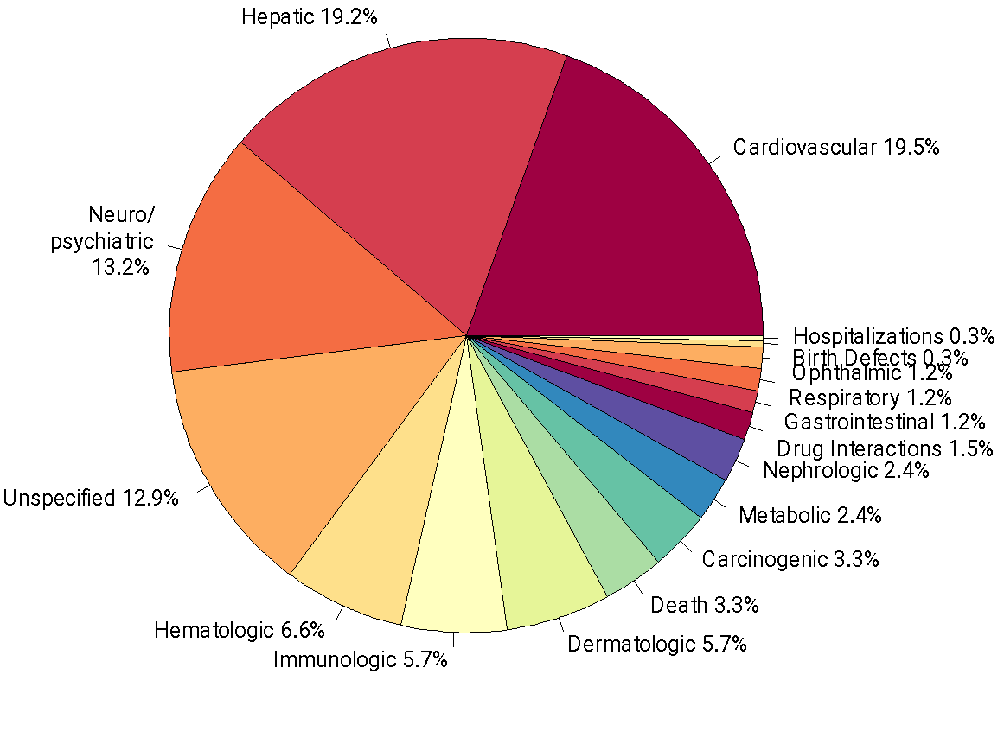
The 120 drugs, found in the ChEMBL database¹⁹, that have been withdrawn by regulatory agencies worldwide have targeted a variety of organ systems (Supplementary Fig. 1). Interestingly, side effects affecting three organ systems make up a majority of reasons for drug withdrawal from the market. Cardiovascular (19.5%), hepatic (19.2%), and neuropsychiatric toxicity (13.2%) are the three largest contributors to drug withdrawal (Fig. 1). Cardiovascular reasons for withdrawal are largely due to arrhythmias and conditions that predispose to arrhythmias: arrhythmias (12%), QT prolongation (6%), ventricular tachycardia (6%), torsade de pointes (6%), ventricular arrhythmias (5%), and repolarization abnormalities (3%) (Supplementary Fig. 2A). This is supported by the focus of early cardiotoxicity screens, which primarily investigate compound interactions with arrhythmia inducing channels such as hERG⁹. Besides general hepatotoxicity, liver failure is the second largest listed reason for hepatotoxicity (8%) (Supplementary Fig. 2B). In contrast to the symptoms associated with hepatotoxicity and cardiotoxicity, the effects of neuropsychiatric toxicities are more varied ranging from abuse (21%) to central nervous system stimulation (2%) (Supplementary Fig. 2C). Neuropsychiatric drugs are well known for their polypharmacology, where individual drugs bind many proteins, which contributes to increased variety, frequency, and severity of toxicity²¹.
Figure 1. Causes of drug withdrawals listed by organ system of impact. Three broad toxicity types, including cardiovascular, hepatic, and neuropsychiatric comprise a majority of reasons for drug withdrawals. Data was compiled from the ChEMBL database (Gaulton, et al., 2017). A single drug can have more than one potential cause for withdrawal.

Comparison between withdrawn and not withdrawn drugs by indication
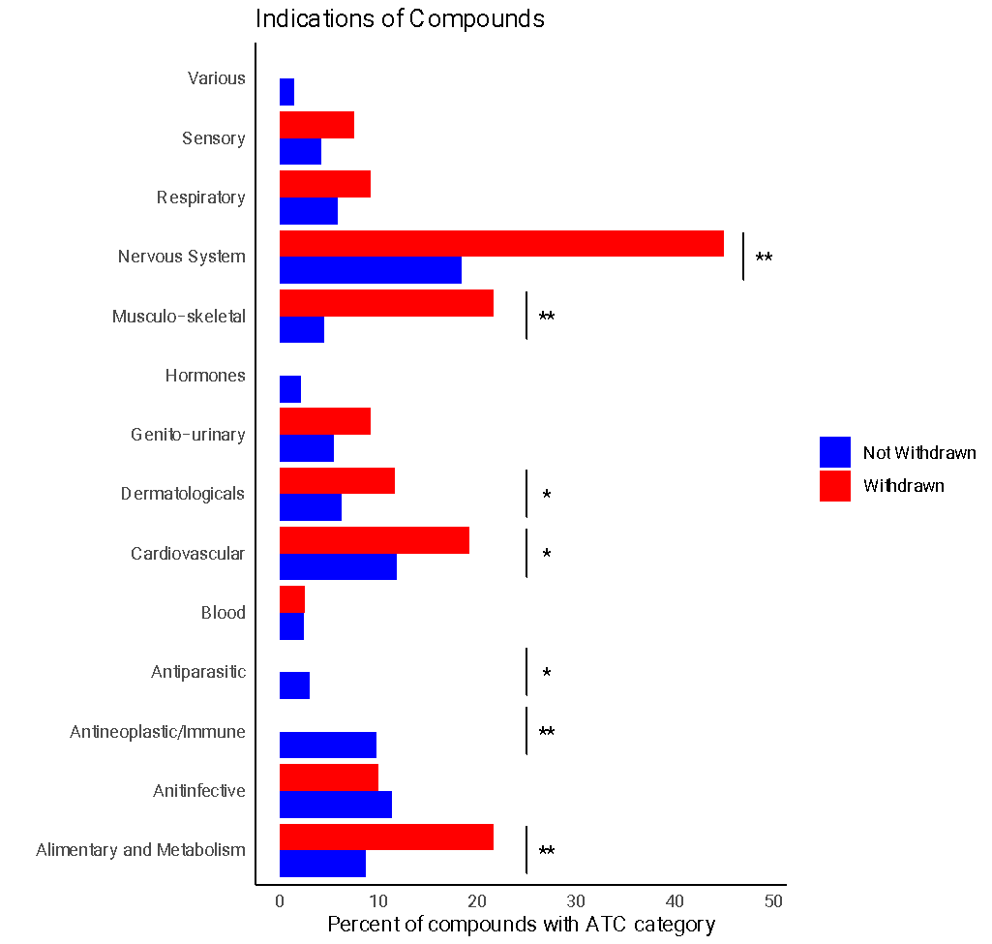
A fisher exact test analysis of drug Anatomical Therapeutic Chemical (ATC) codes²², a hierarchical classification system of medicines maintained by the World Health Organization (WHO), reveals differences in target organ system and disease indication between drugs that are in use and those that have been withdrawn (Fig. 2). Withdrawn drugs have different frequencies of therapeutic indications from drugs that are not withdrawn for various treatment types. For example, neither the antineoplastic nor antiparasitic categories have any withdrawn drugs. Antineoplastics account for 10% of not withdrawn drugs (p=1.66e-5) and antiparasitic drugs comprise 3% of not withdrawn drugs (p=0.0448) (Fig. 2). For other ATC indications, more drugs have been withdrawn than not withdrawn. Drugs that are indicated for diseases of the alimentary and metabolic systems (22% of withdrawn and 9% of not withdrawn p=3.63e-5), cardiovascular system (19% of withdrawn and 12% of not withdrawn p=0.0294), dermatologic system (12% of withdrawn and 6% of not withdrawn p=0.0331), musculo-skeletal system (22% of withdrawn and 5% of not withdrawn p=4.40e-10), and nervous system (45% of withdrawn and 18% of not withdrawn p=1.90e-10) have a higher frequency of withdrawals. A sub analysis of drugs actively in clinical trials reveals that the primary indications of focus are: alimentary and metabolism (16%), antineoplastic and immune (13%), cardiovascular (12%), and nervous system (13%).
Figure 2. Indication of withdrawn drugs compared to indications of approved drugs. Indication are defined based on the first letter (Level 1) of the ATC code. Percent of compounds with that ATC first letter designation compared to the total number of compounds in that category is shown on the horizontal axis. Pairwise comparisons between frequencies of ATC indications performed with a fisher exact test show the following indications have differences between withdrawn and not withdrawn drugs: anti-infective, antineoplastic/immune, antiparasitic, hormones, musculo-skeletal and nervous system. A p-value lower than 0.05 is indicated by a *, and a p-value lower than the Bonferroni corrected significance level is indicated by a **.

Features of withdrawn drugs and their protein targets
To determine the characteristics that mark a drug removed from use due to toxicity, we investigated drug structural and pharmacological features through recursive feature elimination with cross validation (RFECV)²³ using a random forest model, variance threshold, and generic univariate selection (Methods). Feature selection of drug chemical features demonstrates that route of administration, formulation as a prodrug, acidity (as measured by apKa), quantitative estimate of drug-likeness ²⁴, drug identity as a base, number of hydrogen bond acceptors (hba), molecular weight (MW), polar surface area (tPSA), lipophilicity (i.e. logP, logD), and number of heavy atoms are all highly distinguishing features between withdrawn and not withdrawn drugs (Fig. 3, Supplementary Table 1). Consistent with these results, underrepresented features in withdrawn drugs include molecular weight, number of heavy atoms, polar surface area, and quantitative estimate of drug-likeness (Fig. 3).
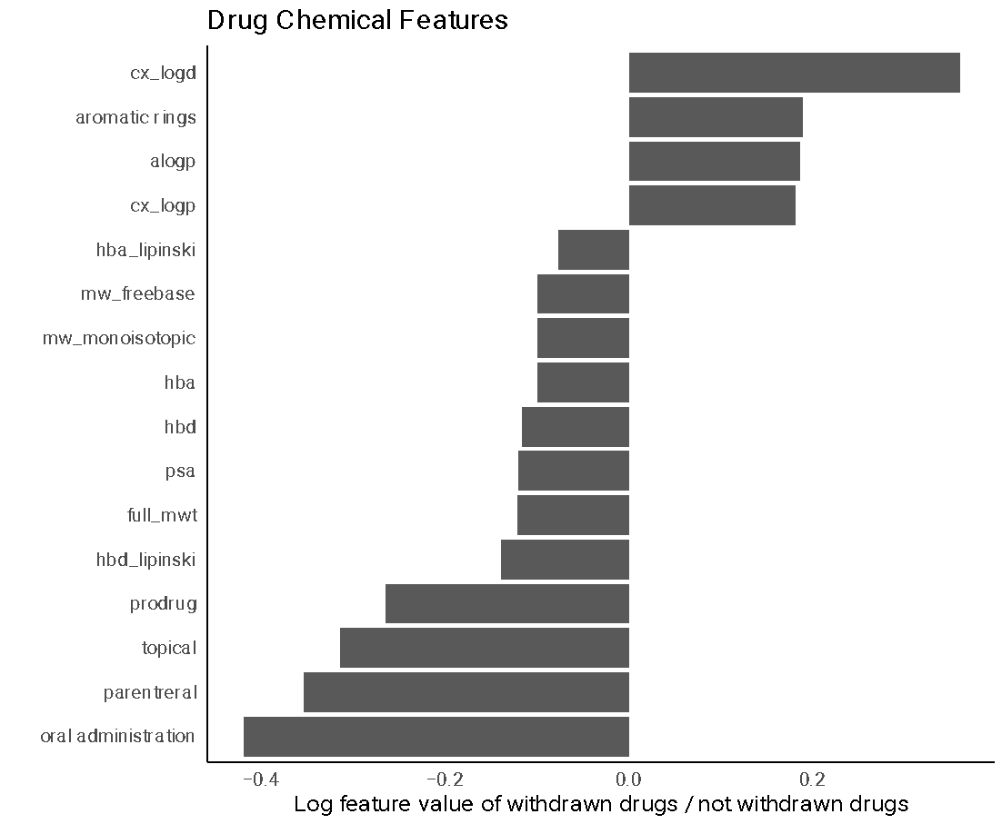
We next applied the feature selection approach to the protein targets, including the protein name, as well as protein structural and functional features, such as secondary structure elements, disordered regions, and coiled-coils. These proteins include intended and unintended targets of the drug. The most informative drug targets include proteins involved in drug absorption, disposition, metabolism, and excretion (ADME) that are screened in drug development as part of drug toxicity target panels, such as the metabolic enzyme Cytochrome P450 (3A4, 2C19, 2J2)²⁵; and the membrane transporters ^{26,27} the ATP-binding cassette sub-family C (members 2-4), the bile salt
Figure 3. Drug chemical features of withdrawn drugs compared to not withdrawn drugs. The average values of continuous variables and the frequency counts normalized by the total number of drugs in each category for categorical variables were calculated for withdrawn and not withdrawn drugs. For each statistically significantly different chemical feature variable, the log base 2 value of the ratio of the withdrawn drug divided by the not withdrawn drug was plotted. Features with positive values are larger in withdrawn drugs than not withdrawn drugs. All features shown have a p-value smaller than 0.05. Feature names correspond to those found in ChEMBL chembl_webresource_client. Features that are over represented in withdrawn drugs include lipophilic characteristics (cx_logd, alogp and cx_logp, which correspond to logD and logP respectively) as well as number of aromatic rings. Features that are under represented in withdrawn drugs include the number of atoms participating in hydrogen bonds (hydrogen bond acceptors and donors- hba, hbd, hba_lipinski, hbd_lipinski), the molecular weight (mw_freebase, mw_monoisotopic, full_mwt), polar surface area (psa), status as a prodrug, and routes of administration (topical, parenteral, and oral administration).

Protein Target^{A} | Gene Name^{B} | Protein Target Name^{C} | Biological Function^{D} | Drugs with lowest IC₅₀ standard values^{E}
O15438 | ABCC3 | ATP-binding cassette sub-family C member 3 | transports drugs across cell membranes | Cyclosporin A, amg-009, olmesartan medoxomil
O95342 | ABCB11 | ATP-binding cassette sub-family B member 11 | transports bile salts across hepatocyte membrane | Alisporivir, BDBM172715, Pioglitazone
O15439 | ABCC4 | Multidrug resistance-associated protein 4 | transports compounds out of cells | Estradiol 3,17-disulfate, Tranilast, Sulfasalazine
P08684 | CYP3A4 | Cytochrome P450 3A4 | mediates metabolism of steroid hormones | BDBM144637, BDBM50448963 , BDBM144636
Q92887 | ABCC2 | ATP-binding cassette sub-family C member 2 | transports drugs across cell membranes | Leukotrien C4, Bilirubin monoglucuronide, Bilirubin bisglucuronide
O15245 | SLC22A1 | Solute carrier family 22 member 1 | transports organic cations | chlorhexidine, SKF550, Decynium-22
Q96FL8 | SLC47A1 | Multidrug and toxin extrusion protein 1 | transports cationic compounds | ondansetron, imatinib, ritonavir
P33261 | CYP2C19 | Cytochrome P450 2C19 | mediates metabolism of fatty acids | Sulconazole, loratadine, Miconazole
Q01959 | SLC6A3 | Sodium-dependent dopamine transporter | mediates dopamine transport | hydroperoxycadiforin, Rhenium complex, BAY-390
P51589 | CYP2J2 | Cytochrome P450 2J2 | mediates metabolism of fatty acids | Chlorzoxazone, Danazol, BDBM235143
export pump (ABCB11), SLC family 22 member 1 (SLC22A1, OCT1), multidrug and toxin extrusion protein 1 (SLC47A1, MATE1), and the ATP-dependent translocase ABCB1 (Table 1, Supplementary Table 3). The feature selection paradigm also uncovers proteins not regularly screened by for activity during drug development, such as the sodium dependent dopamine transporter DAT (SLC6A3). Feature analysis of the structural characteristics of the proteins inhibited by drugs indicate an importance in composition of helical regions, turn regions, and number of amino acid contacts (Supplementary Table 3).
Table 1. Top ten protein targets implicated in drug withdrawal status. Using a combination of 3 feature selection methods, drug protein targets were ranked with their level of informativeness to drug withdrawal status. A. the UniProt accession numbers of the top ten proteins. B. The gene name corresponding to these proteins. C. The names of the top ten proteins targets are listed in the protein target name column. D. The biological function of the target is listed in the biological function column. E. For each of the targets, this column contains three drugs with the lowest IC50 standard values according to ChEMBL.

Prediction of drug withdrawal status
We hypothesized that, using a machine learning approach, the differences between withdrawn and not withdrawn drugs can be exploited to predict if regulatory agencies are likely to withdraw a drug. We developed various classifiers trained on protein targets, protein target structural features, as well as molecular fingerprints of the drug, and other structural features of drugs. We also trained a classifier on all features concatenated into one data matrix. Models were selected and optimized for each dataset separately. Top models were determined by maximizing the sum of model accuracy, F1, Precision, Recall, and MCC. The various datasets, which each contain different types of features, individually display a wide range of performances (Fig. 4BC). Of the individual predictors, the classifier trained on drug features, an extra trees classifier, performed the best with an accuracy of 0.863±0.057, F1 of 0.845±0.074, and an MCC of 0.742±0.101 (Table 2). The classifier trained on inhibited protein features, a multilayer perceptron , performed with an accuracy of 0.823±0.057 (Table 2). The classifier trained on molecular fingerprints, classified with random forest, and inhibited proteins, classified with feature agglomeration and a decision tree classifier , performed with accuracies of 0.682±0.049 and 0.62±0.066 respectively (Table 2).
The predictions from the individually trained classifiers were combined using an ensemble predictor, the Withdrawal Anticipation and Toxicity Characterization of Hits (WATCH) (Fig. 4A). To minimize overfitting, holdout data was used in the training of WATCH (Methods). Application of this ensemble learning approach improved performance of drug prediction of withdrawal status compared to individual models trained on chemical fingerprints, chemical features, inhibited proteins, and features of inhibited proteins respectively (Fig. 4BC).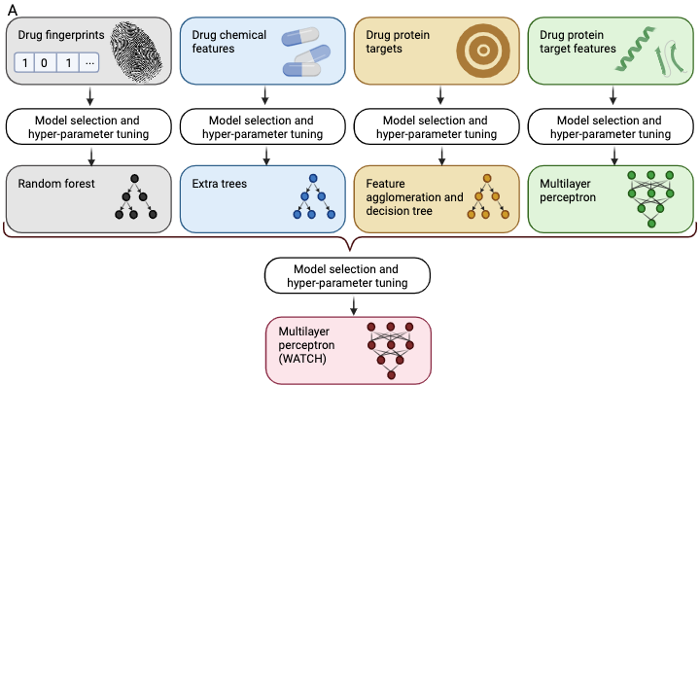

Figure 4. Model predicting drug withdrawal performance on representative test set. Top-performing classifiers are shown for each data set, and are as follows: multilayer perceptron for drug target features, feature agglomeration and decision tree for drug targets, extra trees classifier for drug chemical features, random forest for drug fingerprints, and multilayer perceptron for the ensemble. The optimized predictor trained on all data types simultaneously was extreme gradient boosting. A. Model architecture for the ensemble withdrawn drug predictor. Each data set was divided into three sets: one used to train the individual models, one used to train the ensemble, and one used to test all predictors. TPOT was applied to the training sets to select and tune the hyperparameters for separate models. (Methods) B. Receiver Operating Characteristic (ROC) curve showing predictive model true positive rate compared to false positive rate for each of the models based on different input data as well as the overall ensemble predictor. C. Precision-recall curves for each of the models based on different input data as well as the overall ensemble predictor.

Algorithm | Data | Accuracy | AUROC | F1 | Precision | Recall | MCC
Extreme Gradient Boosting | Features of protein targets, protein targets, molecular fingerprints, and drug features combined into one matrix  (tested on set 1) | 0.948±0.012 | 0.873±0.043 | 0.818±0.051 | 0.891±0.059 | 0.765±0.091 | 0.794±0.051
Extreme Gradient Boosting | Features of protein targets, protein targets, molecular fingerprints, and drug features combined into one matrix  (tested on set 2) | 0.958±0.018 | 0.909±0.042 | 0.867±0.056 | 0.910±0.078 | 0.836±0.086 | 0.846±0.064
Multilayer Perceptron | Features of protein targets  (tested on set 1) | 0.823±0.057 | 0.823±0.057 | 0.851±0.043 | 0.743±0.067 | 1.0±0.0 | 0.692±0.092
Random Forest | Molecular fingerprints  (tested on set 1) | 0.682±0.049 | 0.682±0.049 | 0.687±0.052 | 0.678±0.053 | 0.7±0.078 | 0.368±0.098
ExtraTrees | Drug features  (tested on set 1) | 0.863±0.057 | 0.863±0.057 | 0.845±0.074 | 0.944±0.056 | 0.775±0.116 | 0.742±0.101
Feature Agglomeration and Decision Tree | Protein targets  (tested on set 1) | 0.62±0.066 | 0.62±0.066 | 0.706±0.044 | 0.578±0.048 | 0.91±0.052 | 0.292±0.146
Multilayer Perceptron | Outputs from models trained on features of protein targets, protein targets, molecular fingerprints, and drug features separately  (tested on set 2) | 0.885±0.091 | 0.885±0.091 | 0.879±0.103 | 0.906±0.094 | 0.86±0.126 | 0.775±0.178
Table 2. Performance for each of the top scoring models for the withdrawn drug predictor. The Algorithm column contains the optimal model with hyperparameters tuned using TPOT (Methods) for each data type. The Data column refers to the data set used to train the model. The first row represents an algorithm trained on all data types concatenated together. The last row represents the performance of the ensemble predictor trained on the output of each of the other models trained separately on features of protein targets, molecular fingerprints, drug features, and protein targets. All performance metrics are calculated with 10 fold cross validation and the same test sets were used to evaluate each model.

Overall accuracy of this multilayer perceptron classifier on the test data set was 0.885±0.091, F1 was 0.879±0.103, and MCC was 0.775±0.178 (Table 2). For comparison, the predictions made with a classifier trained on all of the data in the form of a single matrix achieved accuracy of 0.905±0.033 and a MCC of 0.819±0.062 (Table 2).
Drug withdrawal status predictor applied to drugs in clinical trials
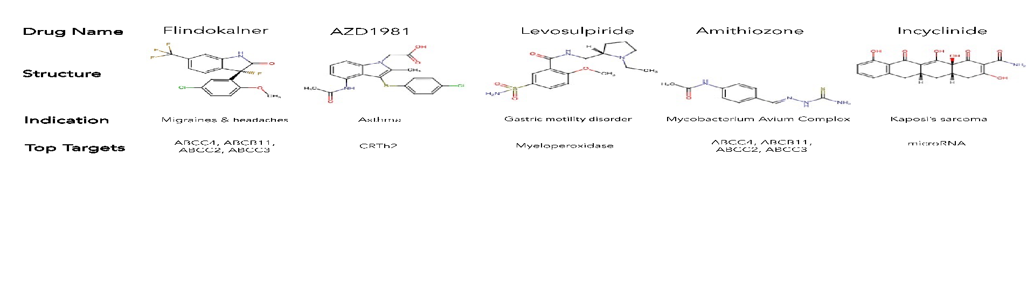
Once WATCH was trained and validated on drug data collected it was tasked with predicting the likelihood that drugs in investigative trials at that time which would ultimately be withdrawn by regulatory agencies due to toxicity. Certain drugs in phase 1-3 clinical trials¹⁹ were predicted to belong to the withdrawn drug class (Supplementary Table 4). Following ten iterations of prediction, a majority of compounds were not predicted to be withdrawn (4 withdrawal predictions or less) (Supplementary Table. 4). Just over 25% of drugs were labeled as likely to be withdrawn in 50% of iterations. There were 5 drugs however that were predicted to be withdrawn in each of the ten iterations: Flindokalner, Levosulpiride, Amithiozone, AZD1981, and Incyclinide (Fig. 5).
Figure 5. Prediction of withdrawal of drugs in clinical trials. The predictor was trained on 10 different random subsets of existing withdrawn and not withdrawn drug data. These independently trained models were applied to new drugs currently in clinical trials to assess future withdrawal status of these candidate compounds. This figure shows structures of compounds that are currently in clinical trials and are predicted to be withdrawn by the predictor in 10 out of 10 prediction iterations. These include three compounds with serious known toxicities and toxic targets.

DISCUSSION
Drug withdrawal from the market is disruptive to patient care and drug development. Regulatory agencies decide to withdraw a drug after serious and unexpected toxicities in patients are observed. These rare or late manifesting toxicities have not been detected during the normal rigorous drug design process. Here we characterize withdrawn drugs using various features and apply this knowledge in combination with an ensemble predictor to anticipate drug withdrawal status earlier in drug development.
Our study provides an overview for landscape of withdrawn drugs. Side-effects associated with withdrawn drugs (derived from ChEMBL) primarily affect three organ systems including the liver, the cardiovascular system, and the neuropsychiatric system (Fig. 1). This is consistent with multiple studies investigating drug toxicity^{28,29}. Moreover, comprehensive analysis of ATC codes (Fig. 2), enabled comparisons of trends in withdrawn and non-withdrawn drugs. In the case of antineoplastic drugs, underlying disease severity and resistance development may influence withdrawal status. For example, although vincristine is associated with serious neuropathy, it is still an important part of the regime used to treat childhood cancers such as acute lymphoblastic leukemia, Hodgkin lymphoma, rhabdomyosarcoma, nephroblastoma, medulloblastoma, and low-grade glioma³⁰. Similarly, the potential for multidrug resistance increases the need for numerous approved antineoplastic therapies in order to allow for multidrug therapies³¹. Antiparasitic drugs also have no withdrawn treatments. However, in contrast to antineoplastic drugs, the shorter treatment course of certain antiparasitic drugs- less than 90 days³²- is hypothesized to play a role in this trend. The high number of withdrawn drugs in other categories could potentially result from the number of other existing treatments for diseases in these categories combined with a different assessment of a toxicity to benefit ratio³³. Taken together, this analysis suggests the possible underlying influence of treatment course and disease severity on withdrawal status, as well as demonstrates current priorities in research and development strategies.
To gain more insight into what makes a drug toxic, we characterized drugs based on their chemical and pharmacological features. Feature selection using a combination of three methods distinguishes important characteristics of globally withdrawn drugs that can be employed in future drug development. Interestingly, the top four chemical features overrepresented in withdrawn drugs as compared to drugs still in use are related to drug lipophilicity. In particular, logP and logD could be informative because they capture drug distribution throughout the body, with higher concentrations of drug in more locations increasing the potential for binding off-target increasing side effects. Consistent with these results, underrepresented features in withdrawn drugs include molecular weight, number of heavy atoms, polar surface area, and quantitative estimate of drug-likeness, which also affect the drug’s ability to cross lipid membrane bilayers, translating to drug oral bioavailability^{24,34}. Route of administration, another set of features extracted by this analysis, is vital for the understanding of the speed and level of systemic reach of a compound upon use. Indeed, chemical features highly correlated with drug withdrawal including route of administration and pKa reflect known pharmacological ADME design trends (Fig. 3). These features can be used in the chemical design process and provide additional confidence in our approach as they overlap with existing drug chemical structure rules^{24,34}. In the future, drugs with properties that have values in the withdrawn range may become candidate for more thorough screening or may be altered chemically during early stages of development.
Similarly, our feature selection approach highlighted the importance of certain drug proteins targets, some of which have known and experimentally validated toxicity. Cytochrome P450 (3A4, 2C19, 2J2), one of the most informative proteins corelated with toxicity according to our feature selection paradigm, is well established as a toxic drug target due to its ability to modulate the metabolism of other drugs²⁵, involvement in drug-drug interactions³⁵ and pharmacogenetics³⁶. Certain membrane transporters, which often have similar pharmacological role to that of metabolic enzymes in controlling drug ADME²⁶, are also implicated in toxicity (Supplementary Table 2). For example, drug modulation of the ATP-binding cassette sub-family results in cardiotoxicity³⁷. The bile salt export pump (ABCB11) has known association with hepatotoxicity³⁸. Interestingly, the sodium dependent dopamine transporter DAT (SLC6A3), which is targeted by many CNS drugs such as SSRIs and SNRIs, was also correlated with toxicity in our study. This transporter is not known to be related to pharmacokinetics, and thus, it is not regularly screened for activity during drug development like the drug ADME transporters above. Features of these proteins such as composition of helical regions and number of amino acid contacts also play a large role in the pattern of drug toxicity further explored by our predictive machine learning model. Interestingly, these features are commonly observed in membrane proteins, such as the transporters discussed³⁹. Our work therefore suggests additional proteins and structural features of proteins which would be beneficial to include in drug toxicity screening panels.
To utilize our new insights on drug toxicity, we developed a screening tool for flagging potentially toxic drugs. We built an ensemble predictor (Fig. 4A), Withdrawal Anticipation and Toxicity Characterization of Hits (WATCH), which applies classifiers to various chemical and protein features to label a drug with its withdrawal potential. The 10-fold cross-validated ensemble predictor assessed on holdout test sets scored an accuracy of 0.885±0.091, F1 of 0.879±0.103, and a MCC of 0.775±0.178 (Table 2). This is statistically no different from the simple model trained on all data features at the same time (Table 3), however, has an added benefit of interpretability as it provides insight into which category of features (drug structures, drug targets, drug features, target features) best predict toxicity. Adding an analysis of individual feature selection further contributes to interpretability and provides scientific insight into important characteristics of molecules and targets in drug development.
We also analyzed the clinical trial drug landscape and applied the WATCH predictor to these compounds. The indications of clinical trial drugs reflect a slight predominance of new drugs targeting the alimentary and metabolism (16%) system. (Supplementary Fig. 3). Additional indications common in drugs currently in clinical trials include antineoplastic and immune (13%), cardiovascular (12%), and nervous system (13%) drugs. With the exception of antineoplastic drugs, which do not have as many drugs available as these other groups, these are all areas in which more drugs have been withdrawn than are currently available (Fig. 2). The preponderance of withdrawn drugs in these categories points to unmet needs that new drugs are being designed to fill. WATCH applied to drugs in clinical trials distinguished a number of drugs that are expected to be withdrawn from the market (Fig. 5). Interestingly, Flindokalner targets potassium ion channels⁴⁰, which overlaps with the know toxic targets found through recursive feature elimination, and is indicated for migraines and post-traumatic headaches (NCT03887325). Levosulpiride is indicated for gastric motility disorders. In trials this drug has been observed to cause severe side effects such as acute dystonias and Parkinson like symptoms⁴¹. Amithiozone has been used as a treatment for tuberculosis, but was replaced with newer, less toxic antibiotics⁴². Currently, Amithiozone is being re-investigated as a therapy for Mycobacterium Avium Complex⁴³. AZD1981 is a CRTh2 receptor antagonist indicated as an asthma therapy⁴⁴. Incyclinide is an antineoplastic agent⁴⁵. In summary, many of the drugs flagged by the withdrawn prediction model, have already begun to demonstrate serious side effects in clinical trials. This demonstrates the applicability of the predictor for future drug toxicity investigations. Furthermore, the characterization of withdrawn drugs and WATCH are meant to serve as tools for drug developers in the ever-evolving endeavor to predict the toxicity of candidate compounds.
METHODS
Drug ATC analysis
Using the withdrawal reasons and ATC datasets, we analyzed the main organ systems that drugs target. We manually grouped the non-standardized labels describing reasons for drug withdrawal (Fig. 1, Supplemental Fig. 2). In addition, to investigate the differences between organ systems of action in withdrawn and not withdrawn drugs, we used the anatomic therapeutic chemical (ATC) code²² designation, the first letter of which indicates anatomical main group⁴⁶. Frequencies of withdrawn and not withdrawn drugs for each therapeutic indication category were compared using the scipy.stats.fisher_exact test 1.6.0 (Fig. 2). Drugs without an ATC code were omitted. The Bonferroni⁴⁷ adjusted p value was 0.0036. It is possible for a drug to have more than one reason for withdrawal and organ system of indication.
Feature selection
Characteristics that most distinguished between withdrawn and not withdrawn drugs were determined with three different feature selection methods on three sets of data features (drug molecular features, drug targets, and drug target features). Specifically, the methods we used were: (i) recursive feature elimination with cross validation (RFECV) in scikit learn 1.1.2. The cross validation splitting strategy (cv) equaled 5 folds, the steps value equaled 1, and the classifier was a random forest model; (ii) Scikit learn 1.1.2. variance threshold with a threshold of 0; and (iii) generic univariate selection for the top 25% of features with a chi squared score function was also applied. These three feature selection methods were applied to each dataset separately 10 times using a random 80% of the data each time and random seeds 0-9. Scores were normalized to be out of 10, where the best features would score a 10, and combined for each feature selection model with equal weights.
For visualization of the drug chemical features, the average values of continuous variables and the frequency counts normalized by the total number of drugs in each category for categorical variables were calculated for withdrawn and not withdrawn drugs. For each statistically significantly different chemical feature variable, the log base 2 value of the ratio of the withdrawn drug divided by the not withdrawn drug was plotted (Fig. 3).
Prediction of compound withdrawal status
Drug withdrawal status for existing drugs was predicted using a variety of machine learning approaches. First the fingerprint, drug chemical features, target, and target feature datasets were used independently to generate predictions. Each of the datasets were randomly split into 60-30-10 percent segments. . The ratio of withdrawn to not withdrawn drugs was maintained within each of the segments of the data set. Each feature was min-max normalized (Equation 1) using the minimum and maximum values of the feature in the training set. The Tree-based Pipeline Optimization Tool (TPOT)⁴⁸ 0.11.7 was used to evaluate algorithms and their hyperparameters for use in the ensemble model. This tool works by applying a genetic programming framework to automatically generate, optimize, and evolve machine learning pipelines composed of preprocessing steps, feature selection methods, model estimators, and hyperparameters, with performance assessed through cross-validated scoring functions. The algorithmic space that the TPOT was given to select from included: neural networks, scikit learn random forest, scikit learn multilayer perceptron, and xgboost extreme gradient boosting. The parameters for the TPOT were: population size of 24, offspring size of 12, early stop of 12, scoring using accuracy, cv of 5, and generations of 5. The parameter search space for each algorithm evaluated with the TPOT are as follows. Random forest: criterion was entropy or gini; max depth was none and 10 through 500; max features were auto, square root, log2 or none; min samples per leaf were 2 through 15, min sample split was 5 through 15; number of estimators were 150 through 500. Multilayer perceptron: activation was identity, loginst, tanh, or relu; hidden layer sizes were 25 through 400; solver was lbfgs, stochastic gradient descent, or adam. Extreme gradient boosting: max depth was none or 10 through 500; number of estimators was 150 through 500. Following hyperparameter tuning, the top performing model was selected for each data set.
Accuracy, area under the receiver operating characteristic curve (AUROC), F1, precision, recall, and Matthews Correlation Coefficient (MCC) were calculated with scikit learn on the first test set.
Equation 1 $normalization=\frac{value-min⁡(feature values)}{\left(feature values\right) -min⁡(feature values)}$
The output of the best overall performing model for each of the 4 datasets was used to generate the training and test data for the meta classifier, Withdrawal Anticipation and Toxicity Characterization of Hits (WATCH). These were the models that maximized the sum of the accuracy, AUROC, F1, precision, recall, and MCC. The ensemble classifier training set contained the predictions on 30% of the original data made by the 4 models previously discussed which had been trained on 60% of the original fingerprint, drug chemical features, target, and target feature datasets respectively. Hyperparameter tuning and model selection for the meta classifier proceeded as previously described. The best meta classifier model, WATCH, was compared to a classifier model that was trained on a combination of 80% of all 4 datasets input as one matrix. Accuracy, area under the receiver operating characteristic curve (AUROC), F1, precision, and recall were calculated with scikit learn on the two test sets. The optimized parameters for each of the classifiers can be found in Supplementary Table X.

Prediction of toxicity for drugs under clinical investigation
We applied WATCH to existing drugs to drugs currently in clinical trials (1216 drugs). The classifier selected for WATCH was the K nearest neighbor meta classifier, which maximized the sum of the accuracy, AUROC, F1, precision, recall, and MCC. WATCH, run 10 times with random states 0-9, was used to classify all drugs found in ChEMBL currently in phase I-III clinical trials (downloaded using chembl-webresource-client 0.10.8 on January 16, 2023). The output for the 10 runs of WATCH for each drug was summed. The closer the resulting value a drug had to 10, the more likely it is to be withdrawn in the future.
DATA AVAILABILITY
Drug datasets
We constructed four drug feature datasets, including drug withdrawal status dataset, drug indication dataset, drug fingerprint dataset, and drug feature dataset. The withdrawal status dataset contains drug withdrawal status and reasons for drug withdrawal collected from ChEMBL¹⁹ using chembl-webresource-client 0.10.8. Of the 230 drugs listed as withdrawn, 120 had reasons for withdrawal found in the database. We manually curated these non-standardized reasons for withdrawals into logical uniform labels (for example “Hepatic toxicity” and “Hepatotoxicity” were combined under the label of Hepatotoxicity). We further grouped each toxicity by the organ system most affected (for example Liver for Hepatotoxicity).
The drug indication dataset contains the anatomic therapeutic chemical (ATC) codes, which classifies drugs by site of action and chemical characteristics³⁵, for withdrawn (n=120) and not withdrawn drugs (n=1511) also determined using ChEMBL¹⁹.
The drug fingerprint dataset contains Morgan fingerprints⁴⁹ with radius 2 and 512 bits as vectors generated with Rdkit 2022.09.1 for withdrawn and not withdrawn drugs.
The drug feature dataset contains chemical features of withdrawn and not withdrawn drugs found in ChEMBL¹⁹. The molecular features included in this dataset are: chirality, partition coefficient (alogp (calculated), cx_logp (generated with ACDlabs v12.01)), number of aromatic rings, full molecular weight (including salts), freebase weight (weight of parent compound), and monoisotopic weight (weight of the monoisotopic parent compound), route of administration (oral, parentreral, or topical), status as a prodrug, distribution coefficient (cx_logd (generated using ACDlabs v12.01), the most acidic acid dissociation constant (cx_most_apka), most basic acid dissociation constant (cx_most_bpka), number of hydrogen bond acceptors (hba, hba_lipinski), number of hydrogen bond donners (hbd, hbd_lipinski), number of heavy atoms, identity as an acid, identity as a base, identity as a neutral molecule, identity as a zwitterion, drug likeness (num_lipinski_ro5_violations (number of rule of 5 violations using Lipinski hydrogen bond acceptor and donor definitions), num_ro5_violations (number of rule of 5 violations using hydrogen bond acceptor and donor definitions), qed_weighted (quantitative estimate of drug likeness²⁴)), polar surface area (psa), rule of three (ro3_pass⁵⁰), and number of rotatable bonds (rtb).

Drug target datasets
We also constructed two drug target feature datasets, including IC₅₀ values dataset, and drug target features. The drug target dataset contains IC₅₀ values for each human protein drug target found in ChEMBL¹⁹.
The drug target features were derived from the amino acid sequence and structural models of the proteins in the drug target dataset (Supplementary Table 3). The method for feature generation has been previously described¹⁴. In brief, structural features, such as protein secondary structure or intrinsically disordered regions, describe characteristics of protein regions. These structural features are determined from either protein sequence, using the methods IUPRED2a⁵¹, ANCHOR⁵², TMHMM 2.0⁵³, PredictProtein⁵⁴, SCOPe⁵⁵; or from three-dimensional model predicted with AlphaFold2⁵⁶, using the methods Dictionary of Protein Secondary Structure (DSSP)⁵⁷, biopython’s pdb parser⁵⁸, Aggrescan3d⁵⁹. Cutoffs for classifying region identity have been determined in previous work¹⁴. Features for each protein were normalized by the length of protein and then weighted according to Equation 2. Where F is the normalization value of the protein feature, f is the unnormalized value of the protein feature, sIC₅₀ is the set of IC₅₀ values for the protein tested with all drugs, and pIC₅₀ is the IC₅₀ of the protein being normalized.
Equation 2 $F= f\frac{\left({sIC}_{50}\right) - {pIC}_{50}+1}{max⁡(s{IC}_{50}) }$
CODE AVAILABILITY
A total of 1,296 compounds (206 withdrawn and 1,089 not withdrawn) were found having fingerprints, targets, target features, and drug molecular features. A full list of drugs and their features can be found in the project GitHub repository: https://github.com/schlessinger-lab/withDRAWN.
ACKNOWLEGMENTS
This work is supported in part by the National Institutes of Health grant F30 HL160179 and T32 HD075735 to N.Z and R01 HD107528 to A.S
AUTHOR CONTRIBUTIONS
N.Z. and A.S. conducted the analysis and wrote this manuscript.
COMPETING INTERESTS
The authors have no conflicts of interest to declare.
REFERENCES
1 Wysowski, D. K. & Swartz, L. Adverse drug event surveillance and drug withdrawals in the United States, 1969-2002: the importance of reporting suspected reactions. Arch Intern Med 165, 1363-1369 (2005). https://doi.org:10.1001/archinte.165.12.1363
2 McNaughton, R., Huet, G. & Shakir, S. An investigation into drug products withdrawn from the EU market between 2002 and 2011 for safety reasons and the evidence used to support the decision-making. BMJ Open 4, e004221 (2014). https://doi.org:10.1136/bmjopen-2013-004221
3 Ishiguro, C., Misu, T., Iwasa, E. & Izawa, T. Analysis of safety-related regulatory actions by Japan's pharmaceutical regulatory agency. Pharmacoepidemiol Drug Saf 26, 1314-1320 (2017). https://doi.org:10.1002/pds.4252
4 Alves, C., Macedo, A. F. & Marques, F. B. Sources of information used by regulatory agencies on the generation of drug safety alerts. Eur J Clin Pharmacol 69, 2083-2094 (2013). https://doi.org:10.1007/s00228-013-1564-y
5 Eichler, H. G. et al. Relative efficacy of drugs: an emerging issue between regulatory agencies and third-party payers. Nat Rev Drug Discov 9, 277-291 (2010). https://doi.org:10.1038/nrd3079
6 Ifeoma Obidike, A. M., Michaela Reddy, Harvey Clewell, Thierry Lave, Melvin Andersen, Ray Greek, Abdelmigid, Nasir Mohamad, Peter Ward, David La, J. Eric McDuffie, Sandra Snook, Elsa Dias, Carina Menezes, Elisabete Valerio, Jose M Fuentes, Jacob John Van Tonder, Mary Gulumian, Vanessa Steenkamp. New Insights into Toxicity and Drug Testing. (InTech, 2013).
7 Lipsky, M. S. & Sharp, L. K. From idea to market: the drug approval process. J Am Board Fam Pract 14, 362-367 (2001).
8 Tropsha, A. Best Practices for QSAR Model Development, Validation, and Exploitation. Mol Inform 29, 476-488 (2010). https://doi.org:10.1002/minf.201000061
9 Raschi, E., Ceccarini, L., De Ponti, F. & Recanatini, M. hERG-related drug toxicity and models for predicting hERG liability and QT prolongation. Expert Opin Drug Metab Toxicol 5, 1005-1021 (2009). https://doi.org:10.1517/17425250903055070
10 Vo, A. H., Van Vleet, T. R., Gupta, R. R., Liguori, M. J. & Rao, M. S. An Overview of Machine Learning and Big Data for Drug Toxicity Evaluation. Chem Res Toxicol 33, 20-37 (2020). https://doi.org:10.1021/acs.chemrestox.9b00227
11 Wang, H., Liu, R., Schyman, P. & Wallqvist, A. Deep Neural Network Models for Predicting Chemically Induced Liver Toxicity Endpoints From Transcriptomic Responses. Front Pharmacol 10, 42 (2019). https://doi.org:10.3389/fphar.2019.00042
12 Iftkhar, S. et al. cardioToxCSM: A Web Server for Predicting Cardiotoxicity of Small Molecules. J Chem Inf Model 62, 4827-4836 (2022). https://doi.org:10.1021/acs.jcim.2c00822
13 Banerjee, P., Eckert, A. O., Schrey, A. K. & Preissner, R. ProTox-II: a webserver for the prediction of toxicity of chemicals. Nucleic Acids Res 46, W257-W263 (2018). https://doi.org:10.1093/nar/gky318
14 Zatorski, N. et al. Structural analysis of genomic and proteomic signatures reveal dynamic expression of intrinsically disordered regions in breast cancer. iScience 27, 1-16 (2024). https://doi.org:10.1016/j.isci.2024.110640
15 Zhang, Q. C. et al. Structure-based prediction of protein-protein interactions on a genome-wide scale. Nature 490, 556-560 (2012). https://doi.org:10.1038/nature11503
16 Wang, X. et al. Three-dimensional reconstruction of protein networks provides insight into human genetic disease. Nat Biotechnol 30, 159-164 (2012). https://doi.org:10.1038/nbt.2106
17 Rahman, R. et al. Protein structure-based gene expression signatures. Proc Natl Acad Sci U S A 118 (2021). https://doi.org:10.1073/pnas.2014866118
18 Zatorski, N., Stein, D., Rahman, R., Iyengar, R. & Schlessinger, A. Structural signatures: a web server for exploring a database of and generating protein structural features from human cell lines and tissues. Database (Oxford) 2022 (2022). https://doi.org:10.1093/database/baac053
19 Gaulton, A. et al. The ChEMBL database in 2017. Nucleic Acids Res 45, D945-D954 (2017). https://doi.org:10.1093/nar/gkw1074
20 Sachana, M., Shafer, T. J. & Terron, A. Toward a Better Testing Paradigm for Developmental Neurotoxicity: OECD Efforts and Regulatory Considerations. Biology (Basel) 10 (2021). https://doi.org:10.3390/biology10020086
21 Schlessinger, A. et al. Structure-based discovery of prescription drugs that interact with the norepinephrine transporter, NET. Proc Natl Acad Sci U S A 108, 15810-15815 (2011). https://doi.org:10.1073/pnas.1106030108
22 Hvidberg, E. & Andersen, A. H. [New classification of drugs. The Medical list and the Drug catalogue are introduced in Anatomical--Therapeutic--Chemical classification code (ACT-code) in 1981]. Ugeskr Laeger 142, 396-397 (1980).
23 Darst, B. F., Malecki, K. C. & Engelman, C. D. Using recursive feature elimination in random forest to account for correlated variables in high dimensional data. BMC Genet 19, 65 (2018). https://doi.org:10.1186/s12863-018-0633-8
24 Bickerton, G. R., Paolini, G. V., Besnard, J., Muresan, S. & Hopkins, A. L. Quantifying the chemical beauty of drugs. Nat Chem 4, 90-98 (2012). https://doi.org:10.1038/nchem.1243
25 Bowes, J. et al. Reducing safety-related drug attrition: the use of in vitro pharmacological profiling. Nat Rev Drug Discov 11, 909-922 (2012). https://doi.org:10.1038/nrd3845
26 International Transporter, C. et al. Membrane transporters in drug development. Nat Rev Drug Discov 9, 215-236 (2010). https://doi.org:10.1038/nrd3028
27 Zamek-Gliszczynski, M. J. et al. Transporters in Drug Development: International Transporter Consortium Update on Emerging Transporters of Clinical Importance. Clin Pharmacol Ther 112, 485-500 (2022). https://doi.org:10.1002/cpt.2644
28 Wong, C. H., Siah, K. W. & Lo, A. W. Estimation of clinical trial success rates and related parameters. Biostatistics 20, 273-286 (2019). https://doi.org:10.1093/biostatistics/kxx069
29 Cook, D. et al. Lessons learned from the fate of AstraZeneca's drug pipeline: a five-dimensional framework. Nat Rev Drug Discov 13, 419-431 (2014). https://doi.org:10.1038/nrd4309
30 van de Velde, M. E. et al. Genetic Polymorphisms Associated with Vincristine Pharmacokinetics and Vincristine-Induced Peripheral Neuropathy in Pediatric Oncology Patients. Cancers (Basel) 14 (2022). https://doi.org:10.3390/cancers14143510
31 Cho, H. & Levy, D. Modeling the chemotherapy-induced selection of drug-resistant traits during tumor growth. J Theor Biol 436, 120-134 (2018). https://doi.org:10.1016/j.jtbi.2017.10.005
32 Kappagoda, S., Singh, U. & Blackburn, B. G. Antiparasitic therapy. Mayo Clin Proc 86, 561-583 (2011). https://doi.org:10.4065/mcp.2011.0203
33 Fung, M., Anna Thornton, Kathy Mybeck, Jasmanda Hsiao-hui Wu, Ken Hornbuckle, and Edmundo Muniz. Evaluation of the characteristics of safety withdrawal of prescription drugs from worldwide pharmaceutical markets-1960 to 1999. Drug Information Journal 35, 293-317 (2001).
34 Lipinski, C. A., Lombardo, F., Dominy, B. W. & Feeney, P. J. Experimental and computational approaches to estimate solubility and permeability in drug discovery and development settings. Adv Drug Deliv Rev 46, 3-26 (2001). https://doi.org:10.1016/s0169-409x(00)00129-0
35 Guengerich, F. P. Role of cytochrome P450 enzymes in drug-drug interactions. Adv Pharmacol 43, 7-35 (1997). https://doi.org:10.1016/s1054-3589(08)60200-8
36 Ingelman-Sundberg, M. Pharmacogenetics of cytochrome P450 and its applications in drug therapy: the past, present and future. Trends Pharmacol Sci 25, 193-200 (2004). https://doi.org:10.1016/j.tips.2004.02.007
37 Couture, L., Nash, J. A. & Turgeon, J. The ATP-binding cassette transporters and their implication in drug disposition: a special look at the heart. Pharmacol Rev 58, 244-258 (2006). https://doi.org:10.1124/pr.58.2.7
38 Kenna, J. G. et al. Can Bile Salt Export Pump Inhibition Testing in Drug Discovery and Development Reduce Liver Injury Risk? An International Transporter Consortium Perspective. Clin Pharmacol Ther 104, 916-932 (2018). https://doi.org:10.1002/cpt.1222
39 Schramm, C. A. et al. Knowledge-based potential for positioning membrane-associated structures and assessing residue-specific energetic contributions. Structure 20, 924-935 (2012). https://doi.org:10.1016/j.str.2012.03.016
40 Sheppard, A. M., Chen, G. D. & Salvi, R. Potassium ion channel openers, Maxipost and Retigabine, protect against peripheral salicylate ototoxicity in rats. Hear Res 327, 1-8 (2015). https://doi.org:10.1016/j.heares.2015.04.007
41 Joe, J. Levosulpiride-Induced Neurological Adverse Effects: A Prospective Study from a Tertiary Care Center. Ann Indian Acad Neurol 23, 174-176 (2020). https://doi.org:10.4103/aian.AIAN_449_18
42 Escovitz, W. E. Disturbance in carbohydrate metabolism associated with amithiozone therapy. Am Rev Tuberc 66, 373-377 (1952).
43 Peloquin, C. A. Controversies in the management of Mycobacterium avium complex infection in AIDS patients. Ann Pharmacother 27, 928-937 (1993). https://doi.org:10.1177/106002809302700722
44 Kuna, P., Bjermer, L. & Tornling, G. Two Phase II randomized trials on the CRTh2 antagonist AZD1981 in adults with asthma. Drug Des Devel Ther 10, 2759-2770 (2016). https://doi.org:10.2147/DDDT.S105142
45 Alaseem, A. et al. Matrix Metalloproteinases: A challenging paradigm of cancer management. Semin Cancer Biol 56, 100-115 (2019). https://doi.org:10.1016/j.semcancer.2017.11.008
46 Pahor, M. et al. Drug data coding and analysis in epidemiologic studies. Eur J Epidemiol 10, 405-411 (1994). https://doi.org:10.1007/BF01719664
47 Bland, J. M. & Altman, D. G. Multiple significance tests: the Bonferroni method. BMJ 310, 170 (1995). https://doi.org:10.1136/bmj.310.6973.170
48 Le, T. T., Fu, W. & Moore, J. H. Scaling tree-based automated machine learning to biomedical big data with a feature set selector. Bioinformatics 36, 250-256 (2020). https://doi.org:10.1093/bioinformatics/btz470
49 Morgan, H. L. The Generation of a Unique Machine Description for Chemical Structures-A Technique Developed at Chemical Abstracts Service. Journal of Chemical Documentation 5, 107-113 (1965). https://doi.org:10.1021/c160017a018
50 Congreve, M., Carr, R., Murray, C. & Jhoti, H. A 'rule of three' for fragment-based lead discovery? Drug Discov Today 8, 876-877 (2003). https://doi.org:10.1016/s1359-6446(03)02831-9
51 Meszaros, B., Erdos, G. & Dosztanyi, Z. IUPred2A: context-dependent prediction of protein disorder as a function of redox state and protein binding. Nucleic Acids Res 46, W329-W337 (2018). https://doi.org:10.1093/nar/gky384
52 Meszaros, B., Simon, I. & Dosztanyi, Z. Prediction of protein binding regions in disordered proteins. PLoS Comput Biol 5, e1000376 (2009). https://doi.org:10.1371/journal.pcbi.1000376
53 Krogh, A., Larsson, B., von Heijne, G. & Sonnhammer, E. L. Predicting transmembrane protein topology with a hidden Markov model: application to complete genomes. J Mol Biol 305, 567-580 (2001). https://doi.org:10.1006/jmbi.2000.4315
54 Bernhofer, M. et al. PredictProtein - Predicting Protein Structure and Function for 29 Years. Nucleic Acids Res 49, W535-W540 (2021). https://doi.org:10.1093/nar/gkab354
55 Fox, N. K., Brenner, S. E. & Chandonia, J. M. SCOPe: Structural Classification of Proteins--extended, integrating SCOP and ASTRAL data and classification of new structures. Nucleic Acids Res 42, D304-309 (2014). https://doi.org:10.1093/nar/gkt1240
56 Jumper, J. et al. Highly accurate protein structure prediction with AlphaFold. Nature 596, 583-589 (2021). https://doi.org:10.1038/s41586-021-03819-2
57 Kabsch, W. & Sander, C. Dictionary of protein secondary structure: pattern recognition of hydrogen-bonded and geometrical features. Biopolymers 22, 2577-2637 (1983). https://doi.org:10.1002/bip.360221211
58 Cock, P. J. et al. Biopython: freely available Python tools for computational molecular biology and bioinformatics. Bioinformatics 25, 1422-1423 (2009). https://doi.org:10.1093/bioinformatics/btp163
59 Kuriata, A. et al. Aggrescan3D (A3D) 2.0: prediction and engineering of protein solubility. Nucleic Acids Res 47, W300-W307 (2019). https://doi.org:10.1093/nar/gkz321

SUPPLEMENTAL INFORMATION TITLES AND LEGENDS
Supplementary Figure 1. Countries of drug withdrawal used for analysis and labeling in the predictor. A large proportion of drugs in this study have been withdrawn by the USFDA. A single drug can be withdrawn from multiple countries.

Supplementary Figure 2. Reasons for Drug withdrawals. A. Hepatotoxicity withdrawal reasons are largely unannotated more specifically. B. Cardiovascular toxicity withdrawal reasons primarily center around arrhythmias. C. Neuropsychiatric toxicity withdrawal reasons are vast and fall into a large number of categories.

Supplementary Figure 3. Indications of drugs in clinical trials based on ATC category. The largest group of drugs under investigation are indicated for alimentary and metabolism while the fewest are antiparasitic.

Supplementary Table 1. Ranking of all drug chemical features in the model. Feature names are taken from the ChEMBL database as accessed with the chembl_webresource_client.

Supplementary Table 2. Ranking of all proteins in the model.

Supplementary Table 3. Ranking of all protein structural features in the model.

Supplementary Table 4. Drugs currently in clinical trials ranked by the number of times the predictor assigned them withdrawal status. The least likely to be withdrawn have rank 0 and the most likely to be withdrawn have rank 10.

