Examination Spring 2012

Geomatics Methodology
Module 2

Module Section Dynamic System Estimation
Prof. Kleusberg

Student ID

Student’s Surname Other Names

Date Student’s Signature

Examination result
Grading in percentage

Date Examiner’s Signature

,

%

Examination Dynamic System Estimation - Spring 2012

Qu. 1 25%
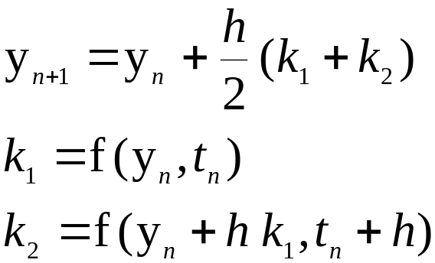The following equations for the second order Runge-Kutta integration algorithm are taken from the lecture notes.

Use these equations to integrate the first order Differential Equation
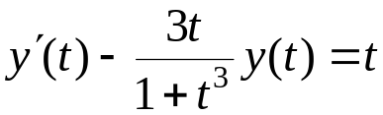

with initial value
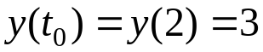

to obtain a solution for t = 2.01; use the step size h = 0.01 (i.e. only one integration step is required!). Write down all intermediate calculations. Retain the accuracy of the result with four decimals. Remark: first transform the Differential Equation into the form
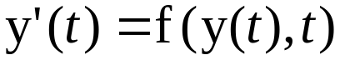

Qu. 2 15%
Numerical integration methods (example: the Runge-Kutta methods) will always produce errors in the integration results. Explain the causes of these integration errors and which measures can be taken to reduce the errors.

Qu. 3 15%
Describe with the help of graphical sketches the covariance functions and the power spectral density functions of the random processes
- White Noise
- 1st Order Gauss-Markov process

Qu. 4 25%
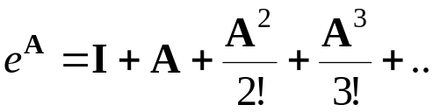The following equation for the computation of the matrix exponential function is taken from chapter 4 of the course material:

Use this equation to compute the matrix exponential for the following matrix A:

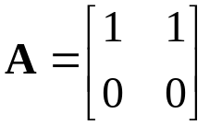

Remark: The powers of this matrix A have a very simple structure; use this!
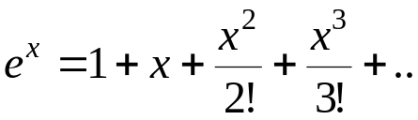Remember: For a scalar x the exponential function is

Qu. 5 20%

Explain under which condition a sequential Least Squares estimation can be performed. Explain differences and similarities between Least Squares estimation and sequential Least Squares estimation.

Total: 100%

