Examination Spring 2013

Geomatics Methodology
Module 2

Module Section Dynamic System Estimation
Prof. Kleusberg

Student ID

Student’s Surname Other Names

Date Student’s Signature

Examination result
Grading in percentage

Date Examiner’s Signature

,

%

Examination Dynamic System Estimation - Spring 2013

Qu. 1 25%
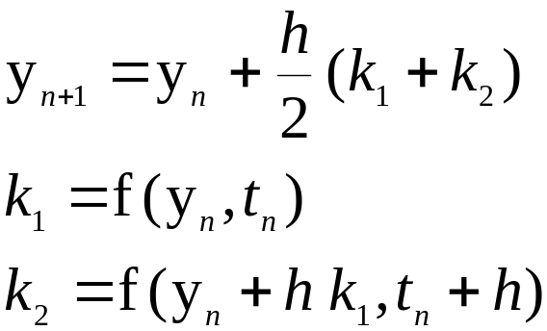The following equations for the second order Runge-Kutta integration algorithm are taken from the lecture notes.

Use these equations to integrate the first order Differential Equation
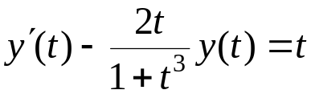

with initial value
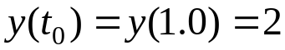

to obtain a solution for t = 1.02; use the step size h = 0.02 (i.e. only one integration step is required!). Write down all intermediate calculations. Retain the accuracy of the result with four decimals. Show explicitly all calculation steps. Remark: first transform the Differential Equation into the form
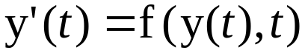

Qu. 2 15%
Attached is one page from chapter 8 of the course material with several equations. Give brief explanations of all quantities appearing in these equations.

Qu. 3 15%
Describe with the help of graphical sketches the covariance functions and the power spectral density functions of the random processes
- White Noise
- Random Constant

Qu. 4 25%
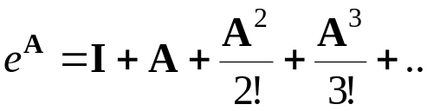The following equation for the computation of the matrix exponential function is taken from chapter 4 of the course material:

Use this equation to compute (numerically, with 4 decimals) the matrix exponential for the following matrix A:

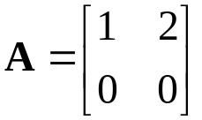

Remark: The powers of this matrix A have a very simple structure; use this!
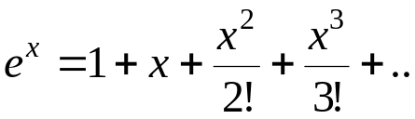Remember: For a scalar x the exponential function is

Qu. 5 20%

Describe (in your own words) the purpose of a Kalman filter (which quantities must be defined in order to get the filter running; which quantities are estimated with the filter; etc).

Total: 100%

