**Report of monitoring Lab 2**

**Group2 Wang Yi 3371561**

**1. Inclination angle**

Firstly we calculate the inclination angle from the inclination changes, using the formula:

$$φ=\frac{1}{2}\left(neig1+neig2\right)$$

$$neig1=\frac{1}{2scale}\left(u11-u21\right)$$

$$neig2=\frac{1}{2scale}\left(u12-u22\right)$$

$$∆φ=φ_{0}-φ_{1}$$

$$φ_{0}=\frac{1}{2}(φ_{0a}+φ_{0b})$$

Hence we get the change of inclination angles and pot the angle diagram:

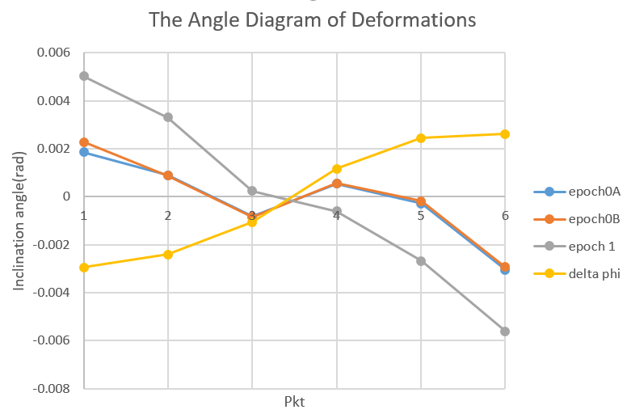

Fig1. Angle diagram

**2. Calculated deformations**

After getting changes of inclination angles, we can calculate the vertical deformation:

$$∆h_{j}=\sum_{i=2}^{j}{(\sin\left(\frac{1}{2}∆φ_{i-1}\right)+}\sin\left(\frac{1}{2}∆φ_{i}\right))∙(s_{i}-s_{i-1}) j=2…6; ∆h_{1}=0$$

With the condition $∆h_{6}=0$, we can eliminate the closure error and get the corrected deformations:

$$∆h_{i}^{corr}=∆h_{i}-\frac{s_{i}}{s_{ges}}∙∆h_{6}$$

And plot the deformations:

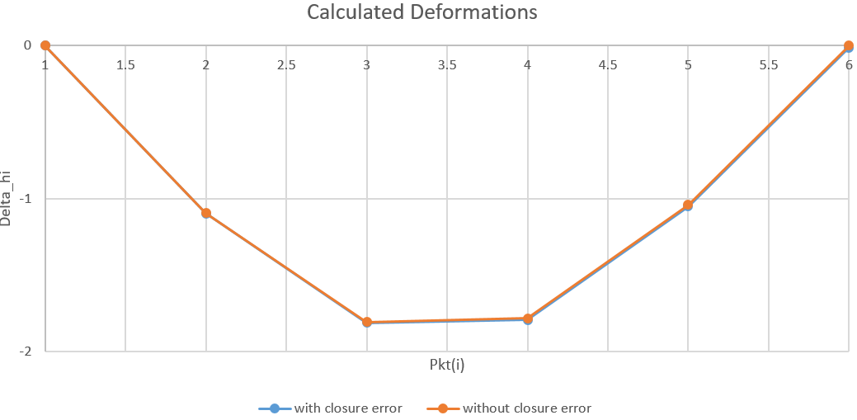

Fig2. Calculated deformations

**3. Results interpretation**

The deformation is the greatest at point 3 in both cases, turning smaller as moving towards the two sides, which is correspond to the reality. To compare the results with the extensometer measurements, we calculate the differences and plot them as follows:

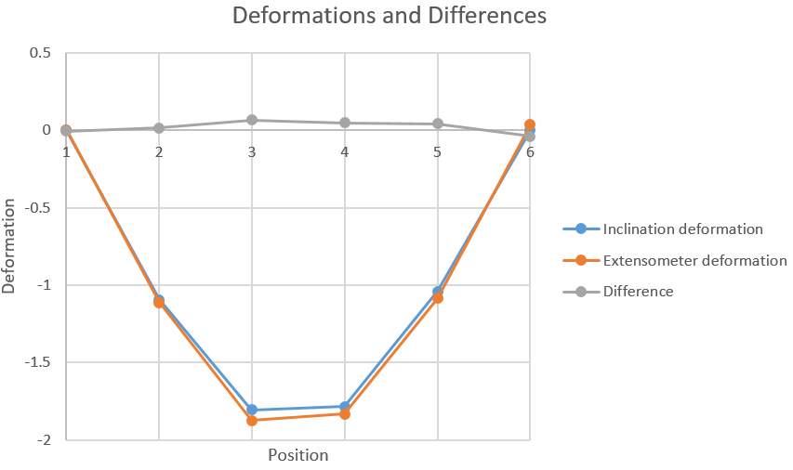

Fig3. Deformations and Differences

Consider the directly measured extensometer results as the control group, we can see from Fig3 that the error grows from -0.00424 mm at point 1 to 0.06747 mm at point 3 and then drops to -0.03805 mm at point 6. One possible reason for this phenomenon is after subtracting from closure error, the middle points go through the most propagates. Consider the accuracy of this calculation, we use the ratio of quadratic sum of deformation differences and measurements, getting an accuracy of 0.11%, which meets the expectation. Other possible errors are like artificial reading errors, environmental errors, unavoidable calculating errors (such as π and sin).

**4. Zero error**

Fig4 shows the time variation of the zero error with a regression line and RMS:

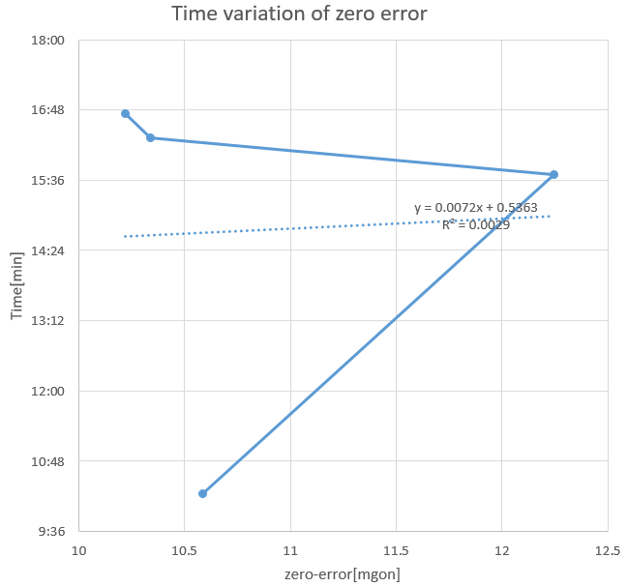

Fig4. Time variation of zero error

From Fig4 we can see obviously that the sensor is not stable over time, the three measurements in the afternoon have a lineal-like relationship, and the one in the morning is isolated.