2013

Qu. 5 20%

Describe (in your own words) the purpose of a Kalman filter (which quantities must be defined in order to get the filter running; which quantities are estimated with the filter; etc).

2012

Qu. 2 15%

Numerical integration methods (example: the Runge-Kutta methods) will always produce errors in the integration results. Explain the causes of these integration errors and which measures can be taken to reduce the errors.

Error Causes: a) truncated series expansion b) numerical error (degree of decimals in each step)

Methods: a) higher order of expansion b) more decimals

Qu. 5 20%

Explain under which condition a **sequential** Least Squares estimation can be performed. Explain differences and similarities between Least Squares estimation and **sequential** Least Squares estimation.

Large time measurements, uncorrelated between each epoch

a) first epoch LSPE, further update

b) real time application

c) final result the same as LSPE (no approximation)

2011

Qu. 2 25%

Chapter 7 of the lecture notes is entitled “State vector augmentation”. It is related to a particular treatment of correlated Random Processes in the context of Linear Models. Explain in your own words, what this chapter is all about.

In reality, the Gaussian white noise is not enough to simulate the system, in other words, the random process may become correlated over time (random walk, gauss-markov, etc.), therefore we need to divide the random process into uncorrelated part w and temporal correlated part c, and finally lead to an augmented state vector.





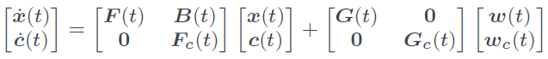

Qu. 4 25%

The following equations describing the prediction step of the Kalman Filter and the computation of the gain matrix have been taken from chapter 8 of the course material:



Give brief explanations of all quantities appearing in these equations.

2010

Qu. 2 25%

Explain how an Ordinary Linear Differential Equation of m-th order is transformed into a system of m Ordinary Linear Differential Equations of first order. What is the purpose of this transformation?

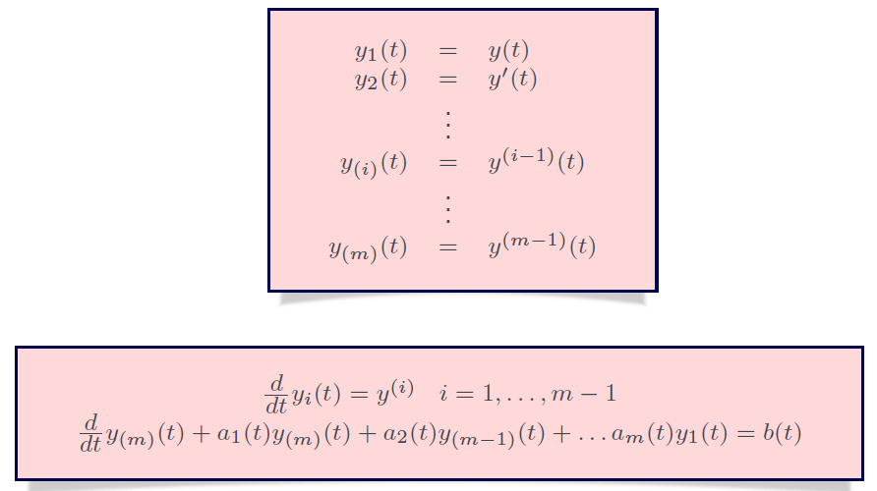

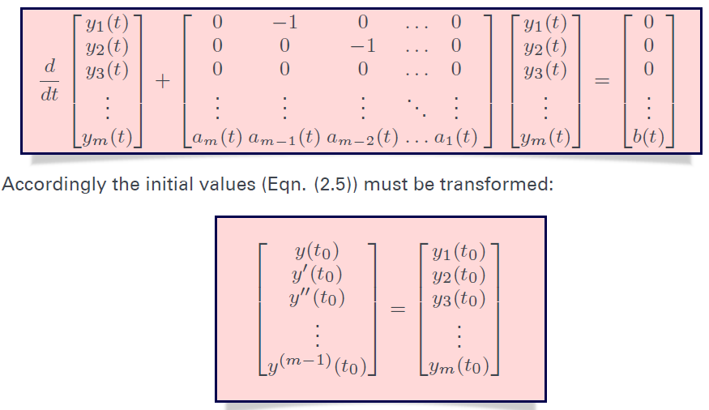

Qu. 4 20%

Describe with the help of graphical sketches the auto-covariance functions and the power spectral density functions of the two random processes “White Noise” and “Gauss-Markov process of first order”. **How can the power spectral density function be computed from the auto-covariance function?**

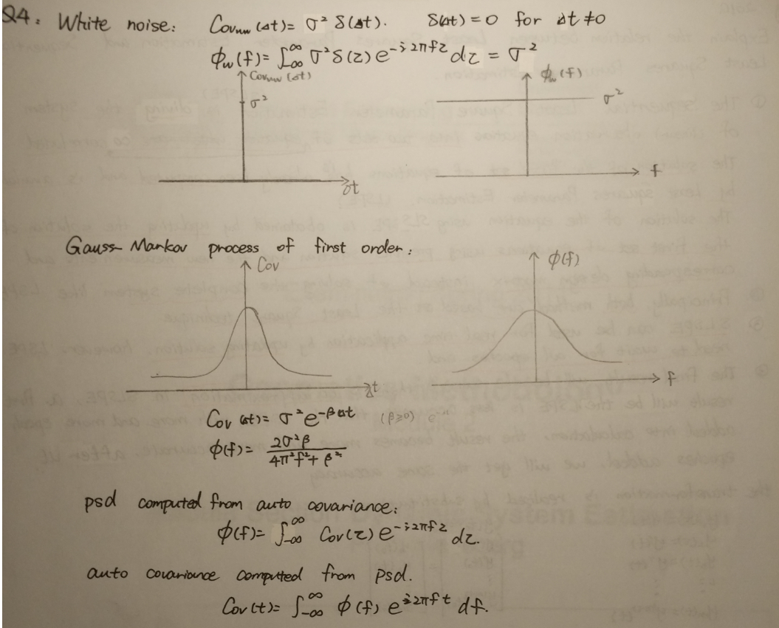

2009

Qu. 2 20%

The Runge-Kutta-Methods (RKM) are a family of numerical integrators for systems of first order Linear Differential Equations. Explain

a) the characteristic property of the RKM compared to other methods

b) the differences between the RKM of first, second, and third order