Task 1

Sequential Adjustment

**Code**:

<https://github.com/wangyi111/Geoengine/blob/master/Dynamic%20System%20Estimation/DSE_Lab1_Sequential%20Adjustment.ipynb>

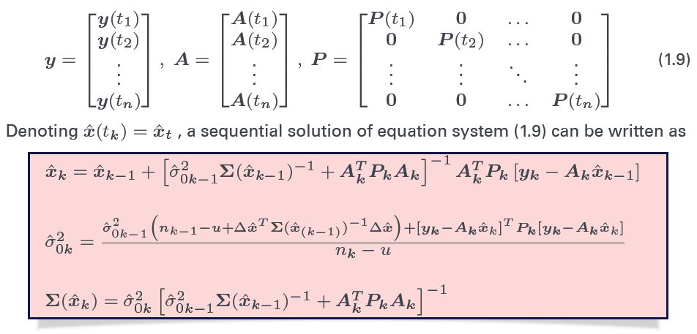

In this case, n=5, size(yn)=6*1, size(An)=6*3, size(P)=6*6. Step by step, we can apply sequential adjustment into this problem.

**Final result:**

Heights 4.914 9.798 15.61

Formal errors

|  |  |  |  |  |  |
| --- | --- | --- | --- | --- | --- |
|  | Ep1 | Ep2 | Ep3 | Ep4 | Ep5 |
| H1 | 0.01258306 | 0.05141741 | 0.06081088 | 0.06890567 | 0.07486383 |
| H2 | 0.01779513 | 0.0727152 | 0.08599957 | 0.09744733 | 0.10587344 |
| H3 | 0.02179449 | 0.08905757 | 0.10532753 | 0.11934812 | 0.12966795 |

Drift of Drones drone3 goes up to 0.61m, while drone1 and 2 go down a little bit

**Plots**

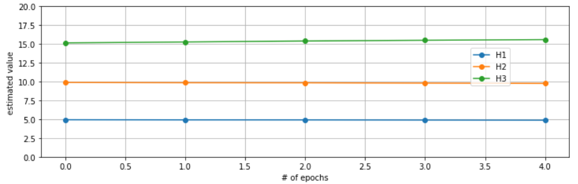

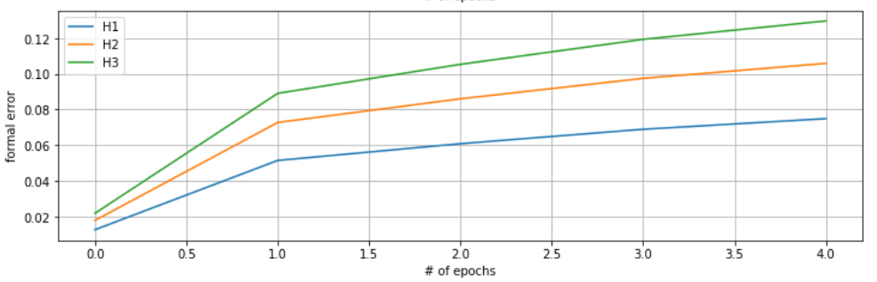

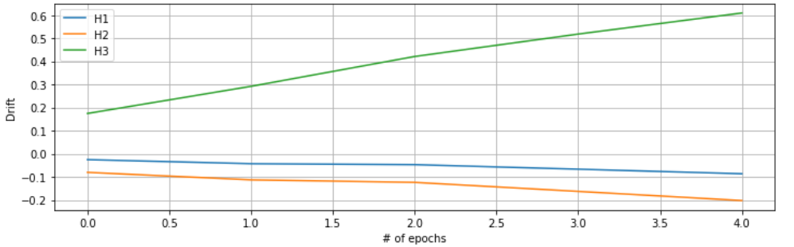

Task 3

Yes, because the epochs are independent of each other.

Yes, show as follows.

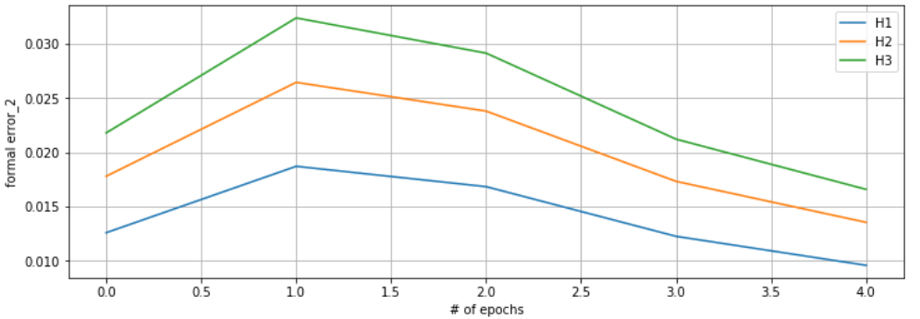

Task 2

If after taking into account the temporal changes, different epochs are still independent of each other, then yes. In this case, the elements of P matrix have to be changed.

Task4

Code: <https://github.com/wangyi111/Geoengine/blob/master/Dynamic%20System%20Estimation/DSE_Lab1_RungeKutta.ipynb>

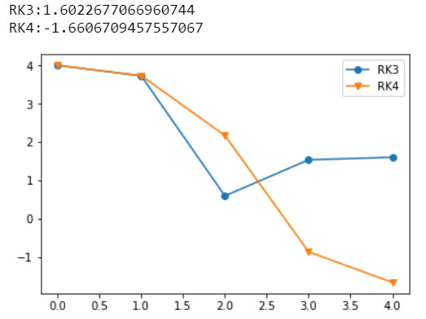

After first two steps, the prediction curves go totally different ways. To check the differences, the analytical solution is acquired:

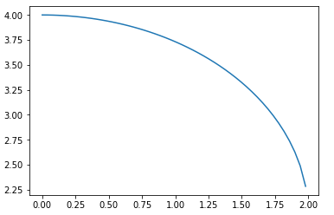

$$y=\frac{\sqrt{-4t^{2}+e^{2ln4}}}{2}+\frac{e^{ln4}}{2}$$

We can see from the analytical expression that when t increases to larger than 2, there is no real value of y. Therefore, the predictions of RK3 and RK4 are meaningless, but their differences come from the different predicting formulas. Meanwhile, the prediction value at t=2 is slightly different because RK4 has a more precise prediction.

Task 5

$$y_{n+m}=y_{n}+m∙h∙c$$

$$σ_{y_{n+m}}^{2}=σ_{y_{n}}^{2}+{(mh)}^{2}∙σ_{c}^{2}$$