**Solution ASSIGNMENT 2, Dynamic System Estimation, 14.05.2019**

**Task 1:**

The transition matrix is obtained by

Phi = exp( -β*dt)

One realization of the Gauss-Markov process is computed by

x(n+1) = Phi * xn + w(t), n = 1:100, x0 = 0, w(t) = Gaussian noise

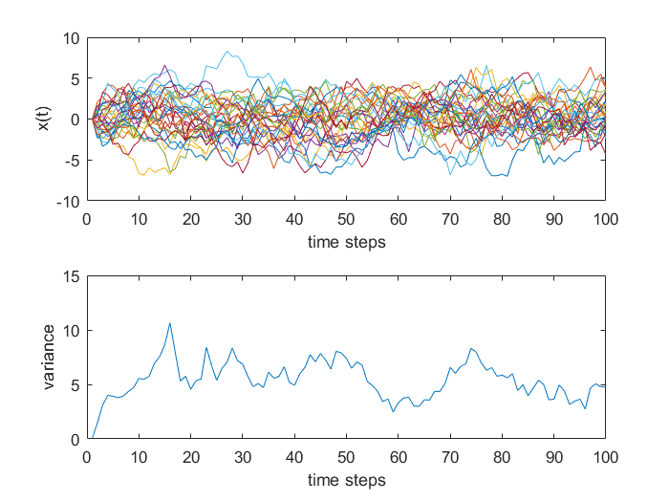

**Task 2:**

Transition matrix: $Phi= \begin{matrix}1 & dt \\ 0 & 1\end{matrix}$

The 100 realizations with 20 time steps are obtained by

${\left[\begin{matrix}x \\ \dot{x}\end{matrix}\right]}_{n+1}= Phi*{\left[\begin{matrix}x \\ \dot{x}\end{matrix}\right]}_{n}+ \left[\begin{matrix}0 \\ w\end{matrix}\right]$, n = 1:20, ${\left[\begin{matrix}x \\ \dot{x}\end{matrix}\right]}_{0}= \left[\begin{matrix}0 \\ 0\end{matrix}\right]$

where *w* is a noise value from the text file *random02.txt.*

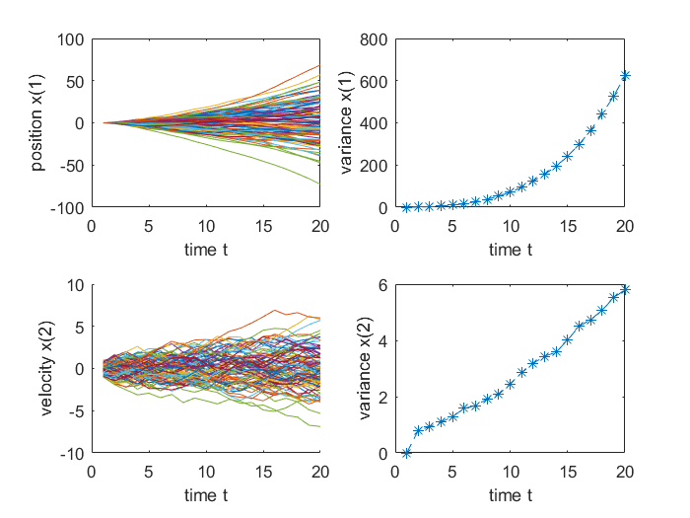

**Task 3:**

$$F= \begin{matrix}0 & -ω3 & ω2 \\ ω3 & 0 & 0 \\ -ω2 & 0 & 0\end{matrix}$$

Transition matrix: Phi = expm( F *dt)

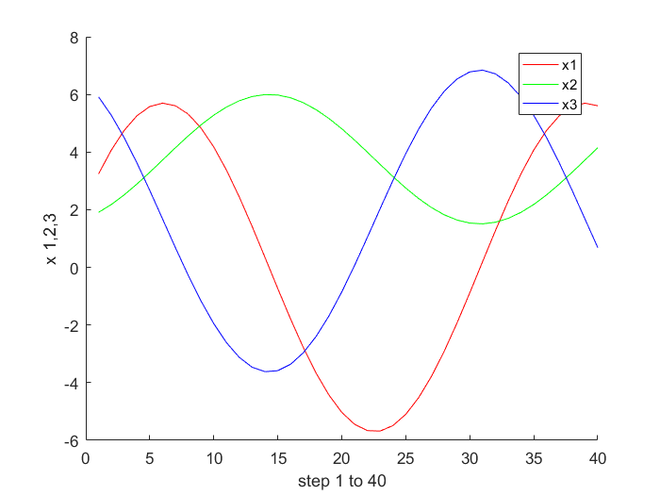

**Task 4**

$$F= \left[\begin{matrix}0 & 0 \\ -ω_{0}² & -2fω_{0}\end{matrix}\right]$$

Transition matrix: Phi = expm(F*dt)

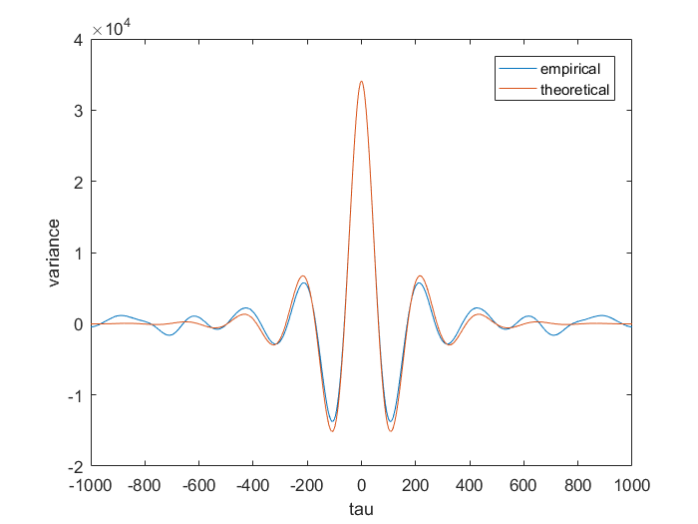

f -> 1, it degenerates into GMP1 with a pure exponential decay.

f -> 0, leads to a pure sinusoidal oscillation.