Integrated

Fieldwork 2019

**WP6: Kinematic Road Survey**

**Supervisor**

Doris Becker

Tomke Lambertus

**Team Member**

Johannes Ernst

Meijie Xiang

Yi Wang

**Contents**

1. Introduction 3

Subtitle 3

2. Next Title here 3

Subtitle 3

3. Next Title here 3

Subtitle 3

# Introduction

* Short overview
* Goal and outcomes of workpackage

## Subtitle

Content here

# Explanation of the System

The integrated POS system for kinematic road survey is described in this part, including the devices together with the vehicle, the integrated coordinates (“Level Arms”) and the system processing principles.

2.1 Devices

As is shown in Fig 2.1.1, the system consists of 4 main devices: POS Computer System (PCS), GPS Antennas (two) with GNSS Azimuth Measurement Subsystem (GAMS), Inertial Measurement Unit (IMU) and Distance Measurement Indicator (DMI).

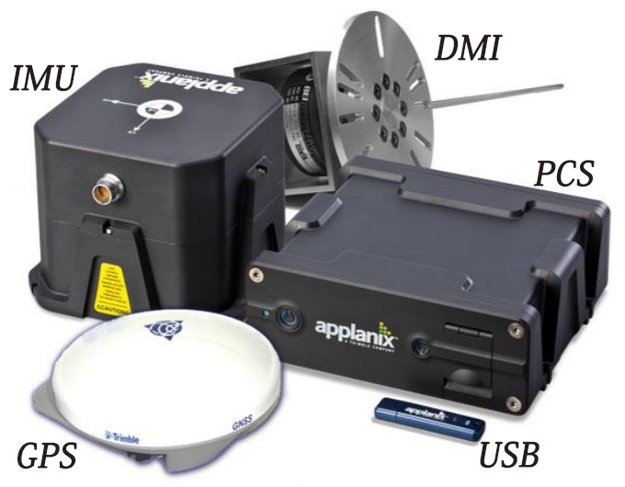

Fig 2.1.1

The installing position of the devices is shown in Fig 2.1.2 and the connecting cabers are shown as Fig 2.1.3. The installation and initialization will be conducted by WP6.

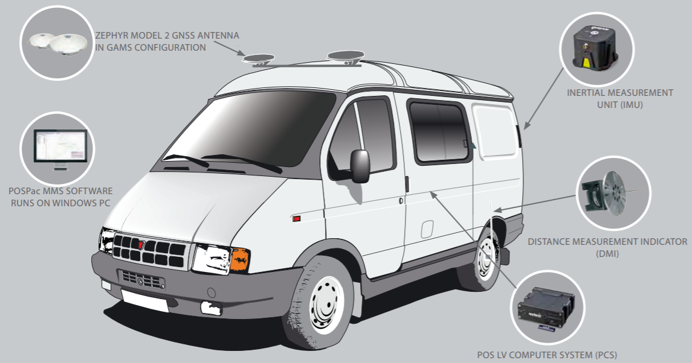

Fig 2.1.2

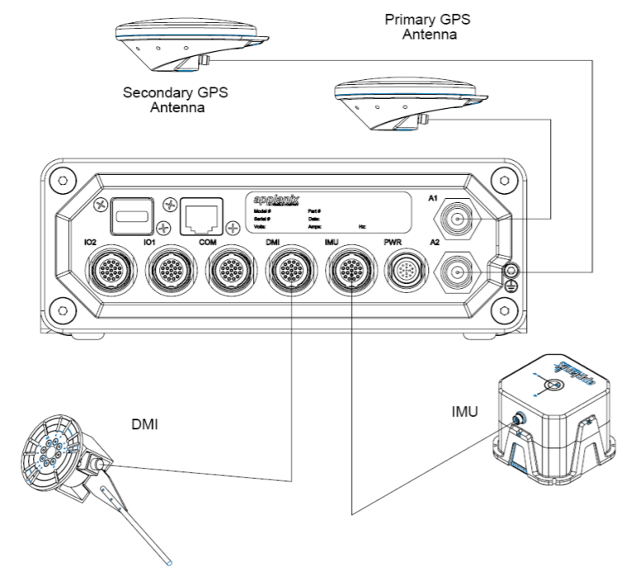

Fig 2.1.3

2.2 Level arms

The so called “Level Arms” is an integrated frame to connect the position and coordinate systems of different devices. As is shown in Fig 2.2, all system components are connected to one uniform reference frame, and later to one uniform coordinate system (e.g. ETRS89-UTM).

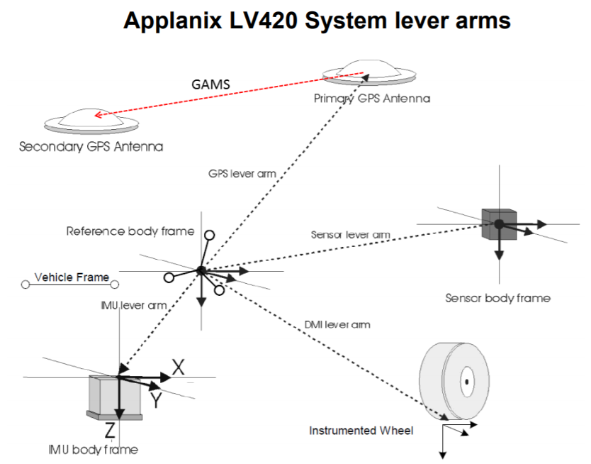

Fig 2.2 Level Arms

2.3 System Processing Principle

Fig 2.3 describes the processing steps of this integrated system. From GPS the rough position is acquired; from IMU, DMI and GAMS we get separately the orientation, the velocity and the azimuth angle. These data work both as the input of the Kalman Filter, which generates the predicted position in the next time point, and the observation of this time point, which corrects and improves the predicting system. Such kind of process is repeated over time, and finally the Smoothed Best Estimate of Trajectory (SBET) is output.

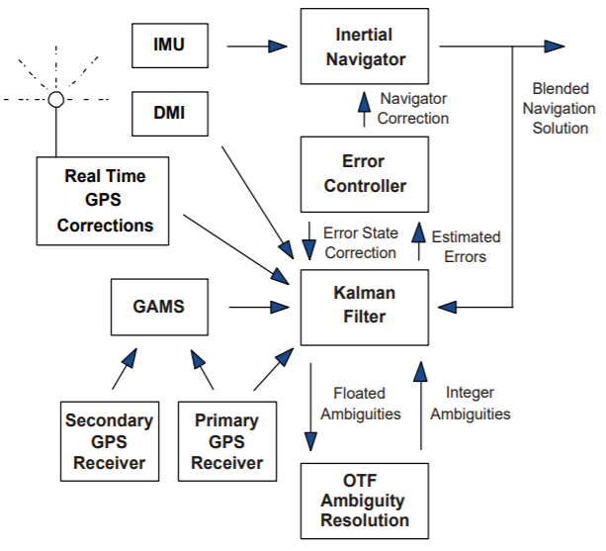

Fig 2.3 System Processing

# Workflow

This part describes the general work procedure and is divided into the three major parts of the mission. There are some parts in the preparation that only have to be done once in the beginning to ensure a proper setup (indicated blue). An appendix of the official “Applanix POS LV Mission Checklist” has been added to this document to further elaborate on the mission workflow (see Part 4).

## 3.1 Preparation

At first all components of the system must be installed on the vehicle. To do that, all parts are mounted on their corresponding place in the vehicle.

Prior to any measurements, the lever arms (vectors) have to be established. To do that, all instruments of the systems are measured with an EDM with respect to the origin of the local coordinate system.

Before moving the car, the following preparation steps must be performed. Please note down on your work sheet for the mission should you run into any errors during your work.

1. Check that the USB is in the processing unit and close the corresponding lid.
2. Turn on the power on the 24 Volt battery, the screen and the PC if it doesn’t start by itself. To log on, use the username “auto” and password “MessAuto”.
3. Once the PC is running press the power button of the processing unit for 3 seconds until it lights up.
4. Open “LV_POSview” on the desktop and make sure it is in “monitor” mode (image).
5. Make sure the interface says “IMU Status: OK”. Then wait for approximately 5 minutes until the lights on “Attitude”, “Heading”, “Position” and “Velocity” are all green. This means all system components are now operating within the predefined threshold.
6. On “View” 🡪 “Antennas” make sure that the primary and secondary receiver are running and have an established connection to enough satellites.
7. Next the lever arms have to be checked by selecting “Installation” 🡪 “Lever Arms &…”. Make sure that the X, Y and Z components of the vectors for the different parts of the system are equal to the parameters on your given work sheet. If you have to make some changes, first select “connect” status in the main window of the software. Additionally, check “Installation” 🡪 “Lever Arms &…” 🡪 “Sensor Mounting” and make sure the scale factor is right.
8. Check “GAMS Parameter Setup” from “Settings” 🡪 “Installation”.
9. Drive to your designated starting point.

## 3.2 Procedures during the Mission

This part describes the measuring process in the field. Each group gets a road segment for the trajectory. The segment should be measured in two ways with two separated files. Each group should write a protocol about their work procedure (using the provided worksheet) including: Start time, drive time, stop time, encountered errors and the driven path indicated on a map. Also add if there was a loss of accuracy during your mission, visible in the main interface of the software and a possible cause for that (e.g. trees block the GNSS signal, sudden shock of the vehicle …). The following steps describe the procedure during the mission:

1. To start measuring, “connect” status must be selected.
2. Go to “Logging” 🡪 “Removable logging Medium” and click on “POSPac” to make sure important parts are selected.
3. Enter a filename for your Group and measurement: “GroupX_Y” (Where X is your group number and Y your measurement). Make sure to change Y once you start your second measurement on the way back.
4. Press “Start Logging” and return to the main interface. There, “Logging: Writing” should be visible.
5. Drive your designated road segment (HOW FAST?) and keep track of the accuracy during the mission (if necessary, make some notes for the protocol).
6. Once you are done with the segment, wait for 1-2 minutes before clicking “Logging” 🡪 “Removable logging Medium” 🡪 “Stop logging” to make sure no data will be lost. Back in the main interface “Logging: Idle” should be visible. The data is now saved on the USB stick.
7. Indicate your driven path on the provided map and add the filename for the segment
8. Start the second measurement to make a trajectory for the way back and follow the steps 1) - 7).
9. Once you are done with measuring, go to “Tools” 🡪 “Shutdown” to turn off the applanix processing unit. Close the program and save changes. Then, shutdown the PC and turn off the battery.

## 3.3 Post-Processing

# Appendix

* POS LV Mission Checklist by Applanix