* Attachment 1: Flow chart diagram

1. Main flow chart.







* Attachment 2: Front panel

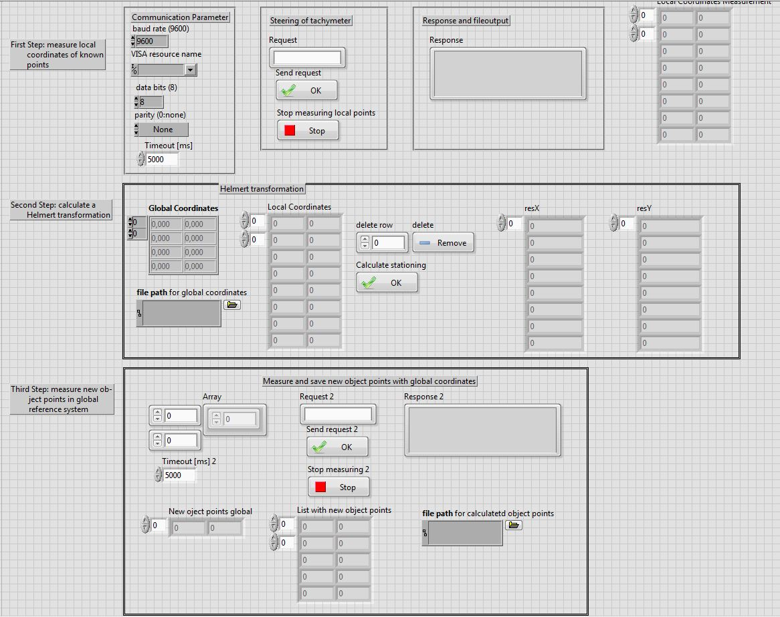

* Attachment 3: Block diagram (two parts)

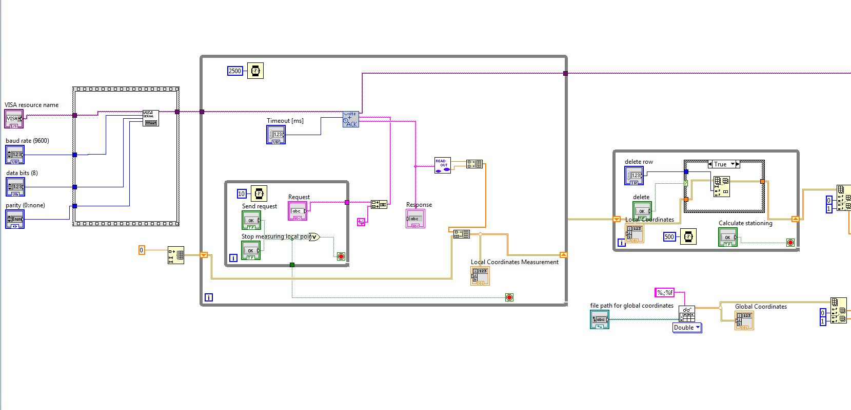

*Part 1*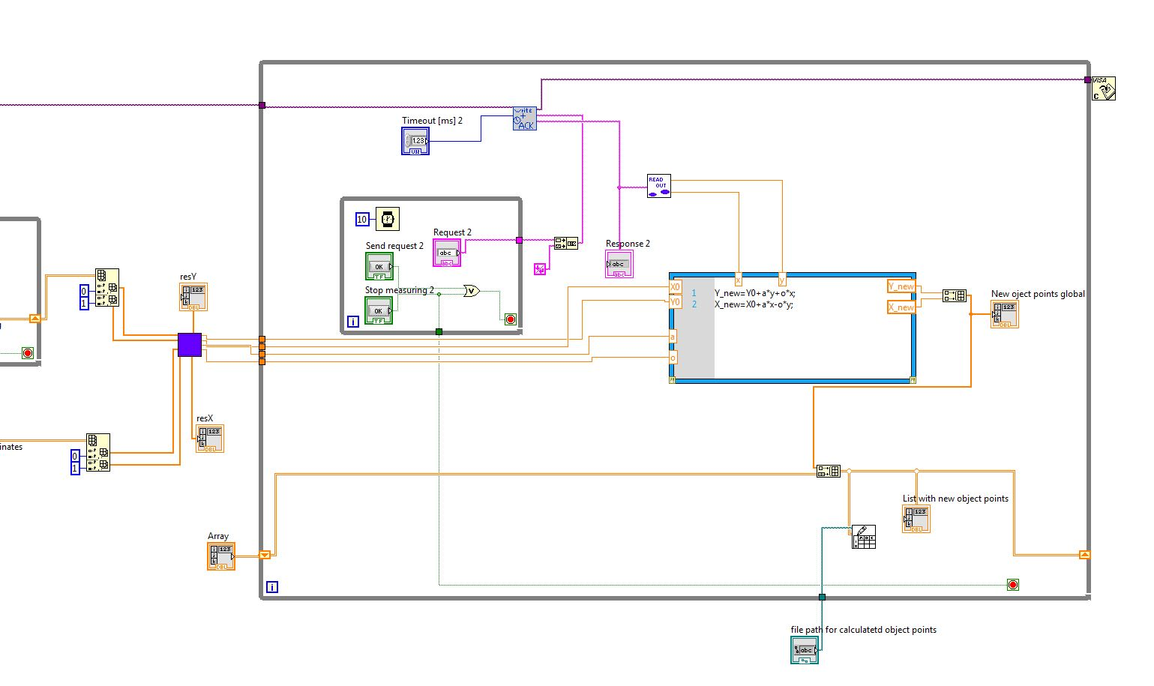

*Part 2*