**Report of Lab 3. Kinematic Tachymeter Measurement**

Name: Nian LIU Matriculation Number: 3294622

1. **Aim of the lab**

Compute the synchronization error for the tachymeter Trimble 5601.

Perform measurements using the linear calibration unit in the measurement cellar. With this linear unit it is possible to simulate movements of a target on a given trajectory. By means of the formulas and the measurement data, the synchronization error, for the used tachymeter Trimble 5601, has to be calculated.

1. **Detailed explanation**

In the beginning we use four prisms to get the precise position of our tachymeter, these data are given. The compute is finished by Labview.

Then we aim the tachymeter to the prism set beyond the target, which has six little prisms, as the target moving, the tachymeter can search for the target by prisms located on the target, and sample the location information by a sampling rate 400ms.

For each velocity, we have to conduct two kinematic measurements (forward and backward), also a different velocity has to be realized by a forward and backward drive.

The second velocity is about two times as the first velocity.

In real experiment, the second velocity data of group 2 is not usable due to the machine’s restarts, thus here in the following steps we use velocity 1 of group 1.

**Given data:**

* In the file “station.csv”: X, Y, Z, orientation angle, residuals of all values of tachymeter.
* In the file “Messdaten.xls”: the time stamp (milliseconds), horizontal angles (gon), vertical angles (gon), distances (meter), Y (meter), X(meter), ds (difference between reference line and actual coordinate, in meter).
* The sampling rate: 400ms.

After all relevant data have been given, the following calculate steps should be run.

We have the lateral deviation as

|  |  |  |
| --- | --- | --- |
|  | $$δ_{lateral deviation}=d_{lateral max}-d_{lateral min}$$ | (2.1) |

Delta distance is the distance between two measurements, obtained by

|  |  |  |
| --- | --- | --- |
|  | $$d_{delta,i+1}=\sqrt{{\left(X_{i+1}-X_{i}\right)}^{2}+{\left(Y_{i+1}-Y_{i}\right)}^{2}}$$ | (2.2) |

Then we have time interval as:

|  |  |  |
| --- | --- | --- |
|  | $${dt}_{i+1}=t_{i+1}-t_{i}$$ | (2.3) |

Velocity of time i+1 can be evaluate as:

|  |  |  |
| --- | --- | --- |
|  | $$v_{i+1}=\frac{d_{delta,i+1}}{dt_{i+1}}$$ | (2.4) |

Mean velocity can be the mean of all velocities:

|  |  |  |
| --- | --- | --- |
|  | $$v_{mean}=\frac{1}{n}∑v$$ | (2.5) |

Thus, synchronization error:

|  |  |  |
| --- | --- | --- |
|  | $$Δt=\frac{Δ_{lateral deviation}}{v_{mean}}$$ | (2.6) |

Real horizontal distance has two parts:

1. Conversion of slope distance to horizontal distance:

|  |  |  |
| --- | --- | --- |
|  | $$S_{H}=S_{slope}*\sin\left(V\right)$$ | (2.7) |

1. Computation of real distance:

|  |  |  |
| --- | --- | --- |
|  | $$S_{real,i+1}=S_{H,i+1}+\frac{Δ_{t}}{t_{i+1}-t_{i}}*\left(S_{H,i}-S_{H,i+1}\right)$$ | (2.8) |

Corrected coordinates

|  |  |  |
| --- | --- | --- |
|  | $$X_{Corr}=X_{S}+S_{real}*cos⁡(Orient+Hz)$$ | (2.9) |
|  | $$Y_{Corr}=Y_{S}+S_{real}*sin⁡(Orient+Hz)$$ | (2.10) |

Above are the theory of this exercise.

1. **Results**
2. **Required figures**

Before plotting all figures, we deleted some redundant data in group 2’s velocity 1.

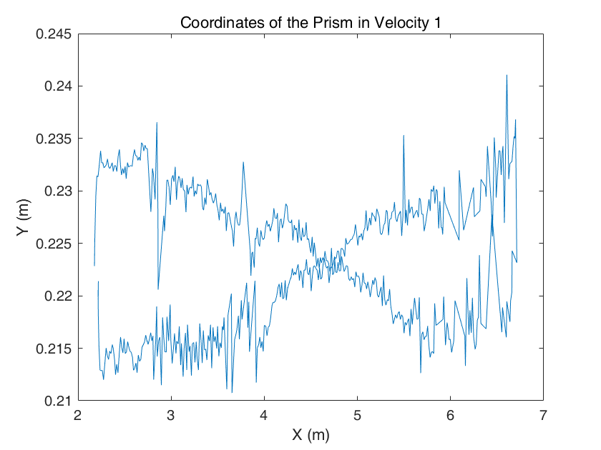

*Fig 1. Coordinates of Prism in Velocity* 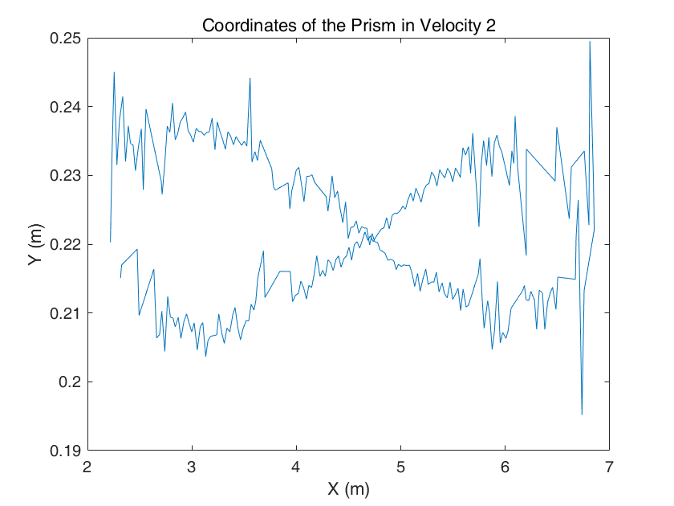

*Fig 2. Coordinates of Prism in Velocity 2*

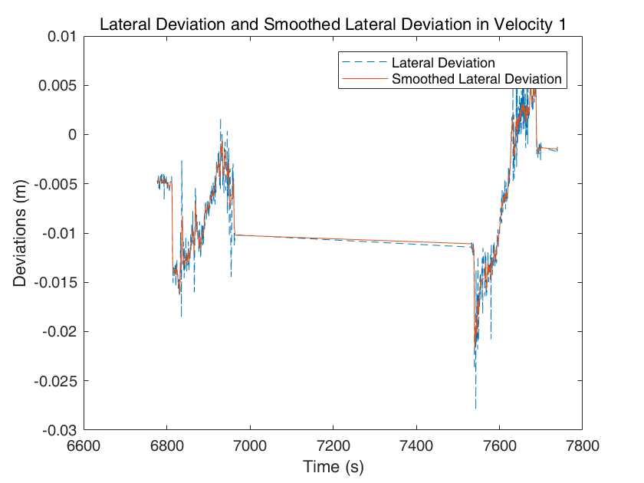

*Fig 3. Lateral Deviation and Smoothed Lateral Deviation in Velocity*

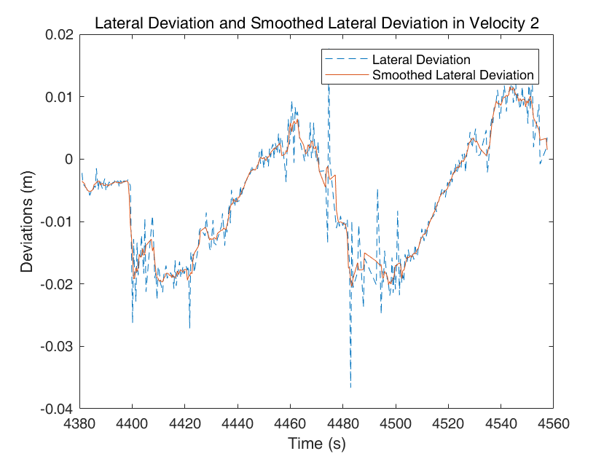

*Fig 4. Lateral Deviation and Smoothed Lateral Deviation in Velocity 2*

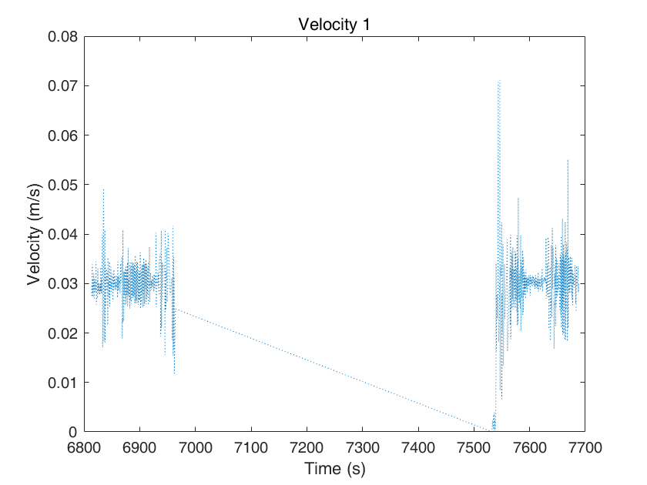

*Fig 5. Velocity 1 as Time pass by***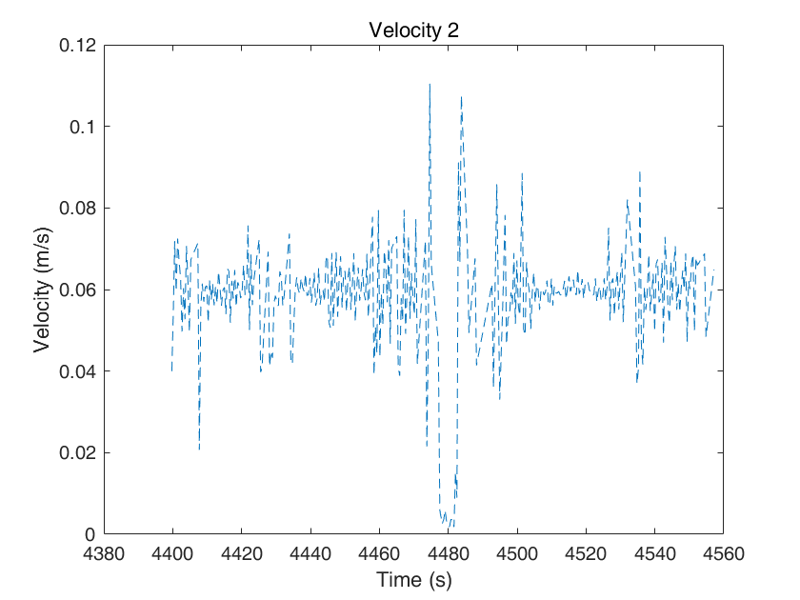**

*Fig 6. Velocity 2 as Time pass by*

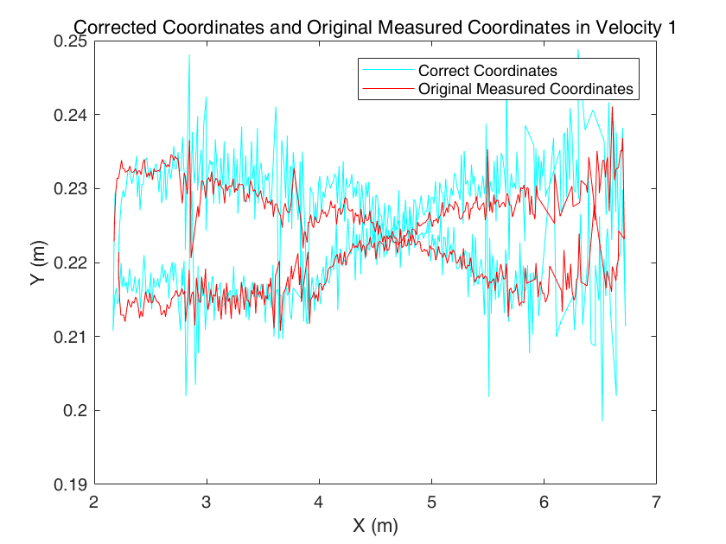

*Fig 7. Corrected Coordinates and Original Measured Coordinates in Velocity 1*

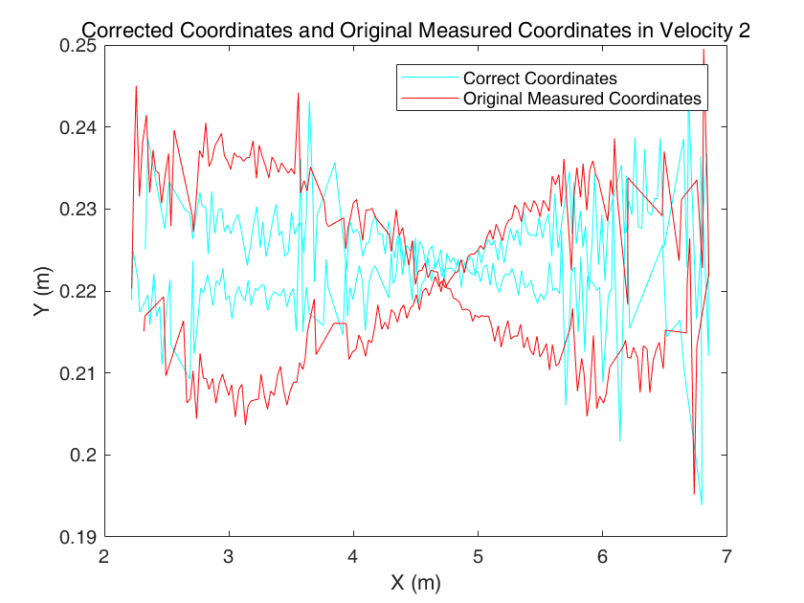

*Fig 8. Corrected Coordinates and Original Measured Coordinates in Velocity 2*

1. **Mean lateral deviations**

The mean lateral deviations show as follow, after deleting some redundant data, we get:

$${{Lateral deviation}_{1}}_{mean}=-0.0068 m$$

$${{Lateral deviation}_{2}}_{mean}=-0.0060 m$$

1. **Mean velocities**

The mean velocities calculate as formula (2.5), after deleting some redundant data, we get:

$${V_{1}}_{mean}=0.0252 m/s$$

$${V_{2}}_{mean}=0.0506 m/s$$

1. **Calculated synchronization errors**

Synchronization errors calculated by formula (2.6). then we get:

$$Δt_{1}=\frac{Δ_{lateral deviation}}{v_{mean}}=1.0984 s$$

$$Δt_{2}=\frac{Δ_{lateral deviation}}{v_{mean}}=0.6322 s$$

Different between two errors is less than 0.5s, which is acceptable.

1. **Corrected coordinates**

The corrected coordinates calculate by formula (2.9) and (2.10). The corrected coordinate results see figure 7 and 8.

1. **Analysis and discussion**

In the figures we can obtain following conclusion:

* From figure 1 and 2: the horizontal coordinates are from 2-7 m, the vertical coordinates are around 0.223 m, which means the target move only in horizontal direction, not in vertical direction.
* From figure 3 and 4: the lateral deviation has some unstable performance, using a smoothed data we can get a rather better results due to the pick-out of extreme points. But actually after change the size of smooth windows of different values, there are not apparently change in the results.
* In each figure with respect to velocity 1 we delete some unused data in between, front and in the end to refine the results.
* From figure 5 and 6: the velocity changes from time to time, but for each velocity, the value is stable around a certain value (the mean velocity). Towards and backwards there is a moment, that the velocity is zero. Part of value has been deleted, thus there is a blank in figure 5.
* From figure 7 and 8: from the corrected coordinates we can see, the actual location should be a little further than the measurements, each extremum comes actually later in measurement due to the synchronization error, thus the result is a falsified position. Also, after correction, the mean value of each coordinate remain almost the same.
* From mean lateral deviations: we can see that two lateral deviations are almost the same, indicate that the relative distance between reference line and actual coordinate is the same, around 0.006m.
* From mean velocities: we can see that the second velocity is almost two times of the first velocity, which shows that we come to a right answer.
* From Synchronization errors: it shows that the faster the velocity is, the less synchronization error is.

In real measurement, we should pay attention to data pre-process, reduce the error caused by the synchronization errors, therefore obtain a better result.