**Report of Lab 4. Kinematic GNSS Measurement**

1. **Aim of the lab**

Perform test drives with different GNSS receivers and to discuss and compare their characteristics.

In this lab we use two receivers. The information of two receivers seen as Table 1.1.

*Tab 1.1 Information of Two Receivers*

|  |  |  |
| --- | --- | --- |
| Device Name | Positioning Solution | Property |
| Leica Viva GS15 | Carrier Phase observations | Connected to SAPOS Network and operate in a Real-Time-Kinematic mode (RTK) |
| Ublox | Code solution | Low cost |

Both antennas will be mounted on the roof of the IIGS bus and will be connected to the appropriate receivers. The collected data from phase and code solution should be compared under aspects of accuracy and reliability.

The test drives take place on the “Cannstatter Wasen” at 15th, Juni.

1. **Detailed explanation**

One member Muyu Liu joined the test drives with the IIGS bus, another member Zhouyan Qiu did the data readout after the test drives.

**Given data:**

* In the file “*KMS_LAB4_GROUP2_GENERAL.txt*”: point ID, time and date, X, Y, Z, latitude, longitude and altitude of Ublox receiver.
* In the file “*KMS_LAB4_GROUP2_GPS_RTK.txt*”: point ID, time and date, latitude, longitude, ellipsoid height of Leica receiver.
* In the file “*KMS_LAB4_GROUP2_GPS_RTK_XYZ.txt*”: point ID, time and date, X, Y, Z of Leica receiver.
* The distance between the two antennas has been measured exactly in advance and introduced as “reference baseline”, with
$$Reference baseline=0.79 m$$

* The route of group 2 as the following figure:

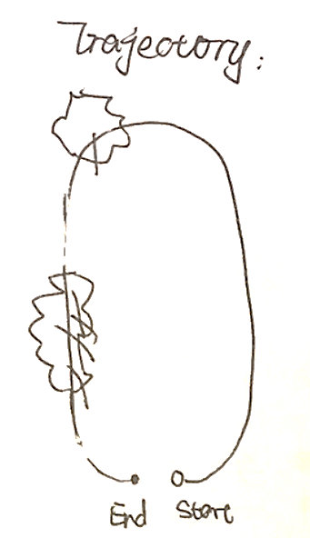

*Fig 2.1 Approximate Trajectory of Group 2*

In the figure 2.1, those 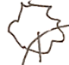 are trees that might have influence on receiving signals.

After all relevant data have been obtained, we go on doing the following steps.

First of all, we should analyze the corresponding points ID of two receivers. After plot the trajectories of two receivers, the relationship between two receivers’ point ID shows as Table 2.1.

*Tab 2.1 Relationship Between Two Receivers’ Corresponding Point ID*

|  |  |  |  |
| --- | --- | --- | --- |
| Ublox’s point ID | Leica GS15’s point ID | Time from beginning (s) | Note |
| 148-152 | 163-169 | Before 162 | From the beginning, stay still or move slightly |
| 153-189 | 170-206 | 163-199 | Corresponding to each other |
| 190-199 | No point | 200-209 | Driving through the trees, RTK lost its’ signal thus no point |
| 200-232 | 207-239 | 210-242 | Corresponding to each other |

*\*here “time” column, using 11:51:15 as 1’15’’, i.e. 75s, 13:52:36 as 2’36’’, i.e. 156s*

1. **Calculation of the distance between the two antennas on the bus’s roof.**

**For the corresponding points in *table 2.1*, we have:**

|  |  |
| --- | --- |
| $$d_{atenna}=\sqrt{{\left(X_{Ublox}-X_{Leica}\right)}^{2}+{\left(Y_{Ublox}-Y_{Leica}\right)}^{2}+{\left(Z_{Ublox}-Z_{Leica}\right)}^{2}}$$ | (2.1) |

1. **Comparison of the calculated distances between the antennas with the “reference baseline”. The differences for each epoch have to be depicted in a figure.**

Distances between the antennas with the “reference baseline” obtained by:

|  |  |
| --- | --- |
| $${difference}_{antenna}=d_{atenna}-Reference baseline$$ | (2.2) |

Depict the differences for each epoch in figure 2.2.

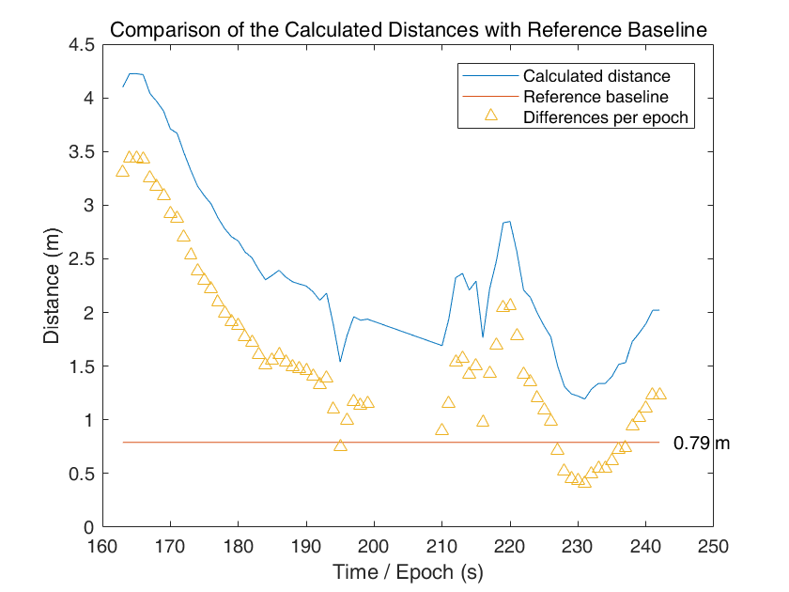

*Fig 2.2 Differences for Each Epoch*

1. **Plot of the driven trajectories for both GNSS receivers. (Please choose an appropriate coordinate system.)**

Driven trajectories can be obtained by given X, Y coordinates. It shows in figure 2.3

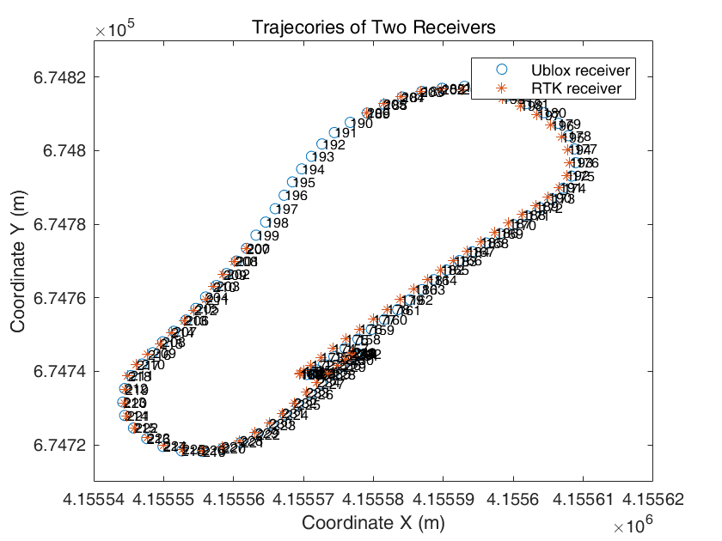

*Fig 2.3 Trajectory of Two Receivers*

1. **Calculation of the velocities for both receivers and then representation in figures.**

Time difference $dt$, distance between two measured epochs ${dist}_{i}$, and the velocities of each epoch are calculated by:

|  |  |  |  |
| --- | --- | --- | --- |
|  | $${dt}_{i}=t_{i+1}-t_{i}$$ | (2.3) | |
| $${dist}_{i}=\sqrt{{\left(X_{i+1}-X_{i}\right)}^{2}+{\left(Y_{i+1}-Y_{i}\right)}^{2}+{\left(Z_{i+1}-Z_{i}\right)}^{2}}$$ | | | (2.4) |
|  | $$v_{i}=\frac{{dist}_{i}}{dt_{i}}$$ | (2.5) | |

The velocities show in figure 2.4

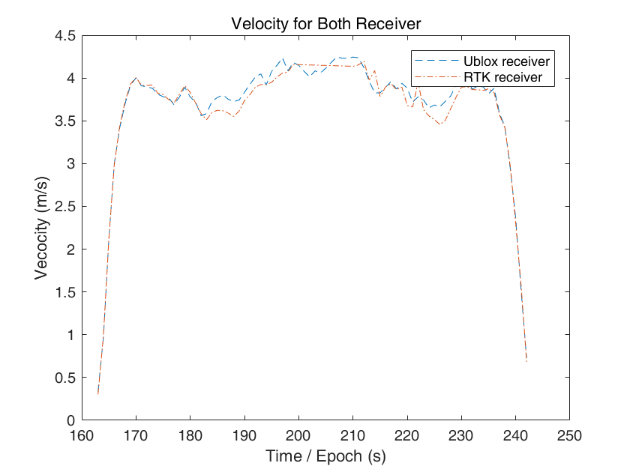

*Fig 2.4 Velocities for Both Receivers*

1. **Plot of height differences between the two receivers.**

To calculate height differences, we use the data “altitude”, minus the corresponding data, we can get the height differences between the two receivers.

|  |  |  |
| --- | --- | --- |
|  | $$ΔH={Altitude}_{Ublox}-Altitude_{Leica}$$ | (2.6) |

The figure 2.5 display the height differences.

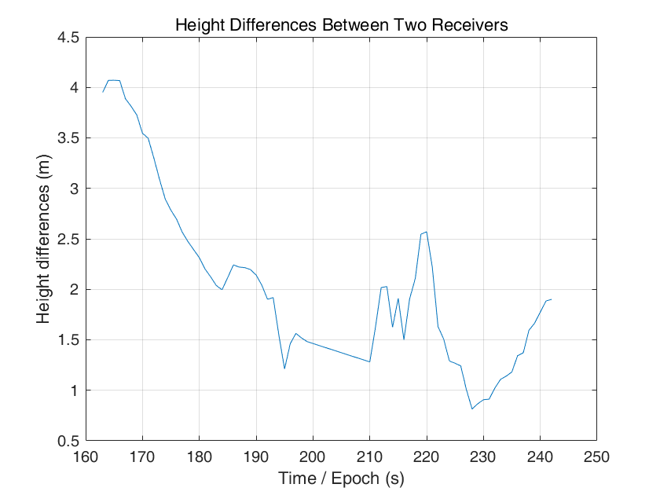

*Fig 2.5 Height Differences Between the Two Receivers*

1. **Discussion of the results under following aspects:**