**WP8 Comparison of results from WP 4 - 6**

1. **Description of the sensor**

The GNSS Leica Viva GS 15 is used to determine the position of the moving model vehicle, where the sensor is installed on the model and receives satellite signals during the test drive.

The global coordinates of the model are obtained directly from the GNSS receiver at discrete time stamps. The accuracy of the measurement is about 8 mm + 1 ppm for horizontal coordinates and about 15 mm + 1 ppm for vertical coordinate using RTK mode (source: https://leica-geosystems.com).

Pros:

* Fully independent code and phase measurements of all frequencies.
* The sensor can give exact position with greater precision and reliability due to the multi-available satellites.

Cons:

* Time for initialization are dependent upon various factors including number of satellites, observation time, atmospheric conditions, multipath etc.
* Vertical accuracy is less than the horizontal one.
* Using the phase observation could have some problems like: unknowns ambiguity for each satellite or cycle slips at tracking (loss of ambiguities), these problems can be solved by:
  + using long observations time
  + using of more than 4 satellites
  + using of linear combination of L1 and L2

*Table 1.1 Technical description of the Sensor[1]*

|  |  |  |  |
| --- | --- | --- | --- |
| **Sensor name** | | | **Leica Viva GS 15** |
| **Number of channels** | | | 555 channels (more signals, fast acquisition, high sensitivity) |
| **Signal tracking** | | | GPS (L1, L2, L2C, L5), Glonass (L1, L2, L2C, L32 ), BeiDou (B1, B2, B32 ), Galileo (E1, E5a, E5b, Alt-BOC, E62 ), QZSS (L1, L2C, L5, L62 ), NavIC L53 , SBAS (WAAS, EGNOS, MSAS, GAGAN), L-band |
| **Data type and recording rate** | | | Leica GNSS raw data and RINEX data up to 20 Hz |
| **Accuracy** | Real-time kinematic | Single baseline | Hz 8 mm + 1 ppm / V 15 mm + 1 ppm |
| Network RTK | Hz 8 mm + 0.5 ppm / V 15 mm + 0.5 ppm |
| Post processing | Static (phase) with long observations | Hz 3 mm + 0.1 ppm / V 3.5 mm + 0.4 ppm |
| Static and rapid static (phase) | Hz 3 mm + 0.5 ppm / V 5 mm + 0.5 ppm |

1. **Description of the controller**

**2.1 P-controller**



*Figure 2.1.1 General characteristic closed-loop-system[2]*

*Where: e (t) control deviation u (t) regulating variable z (t) disturbance quantity w (t) reference variable y (t) controlled variable*

P controller represents a controller whose regulating variable () is proportional to the proportional gain () and control deviation ().

Based on the taken measurement the deviation ds or e (t) can be computed from the measured global coordinates and reference trajectory w (t), this deviation considered as input to controller, which computes the regulating variable y (t) or steering angle of the vehicle.

The controller is described using following formulas:

|  |  |  |
| --- | --- | --- |
|  |  | (2.1.1) |
|  |  | (2.1.2) |

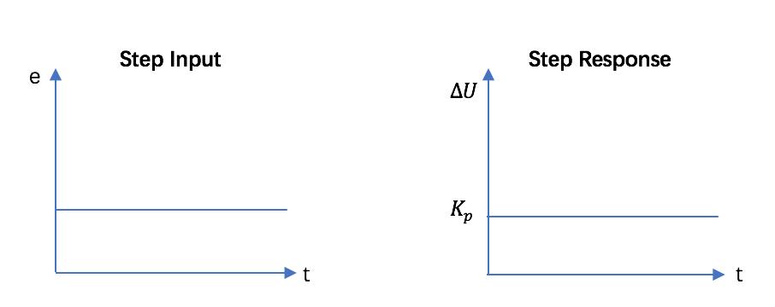

1

*Figure 2.1.2 the step input and response of P-Controller*

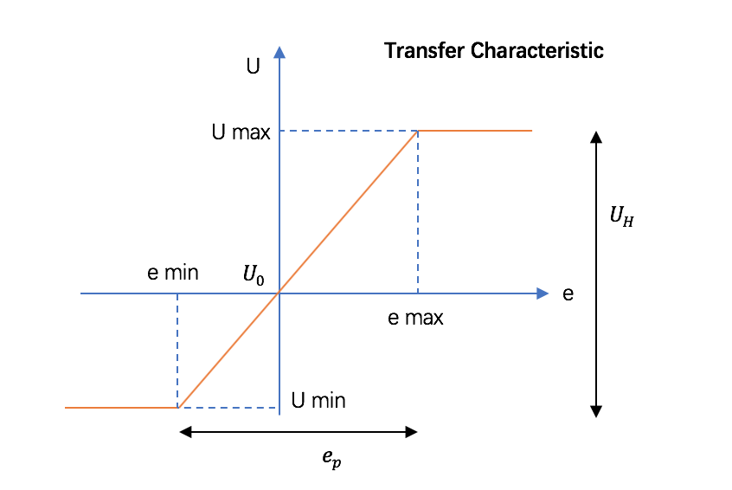

*Figure 2.1.3 Transfer characteristic of P-Controller*

**2.2 PD-controller**

**2.3 PID-controller**

PID controller was used for controlling the vehicle. A proportional-integral-derivative controller is a control loop feedback mechanism used in industrial control systems. it continuously calculates an error as the difference between a desired setpoint and a measured process variable and applies correction based on proportional, integral, and derivative terms (, , and).

Mathematical form of PID controller is

|  |  |  |
| --- | --- | --- |
|  |  | (2.3.1) |

where , , and are coefficients for the proportional, integral, and derivative terms respectively.

The parameters for PID controller in this lab are as following.

*Table 2.1 parameters for PID controller*

|  |  |
| --- | --- |
|  | Value |
|  | 12.3 |
|  | 0.5 |
|  | 0.001 |

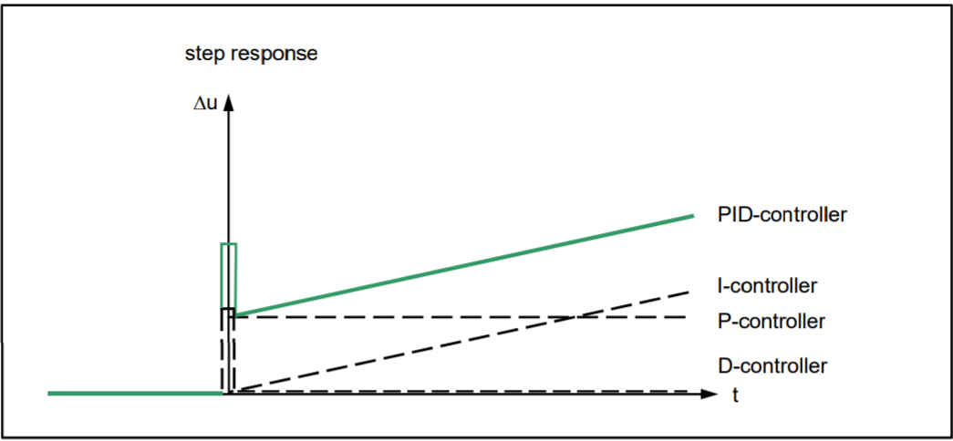

*Figure 2.3.1 the step response of PID-Controller*

Above is the step response of PID controller.

1. **Evaluation**

**3.1 P-controller**

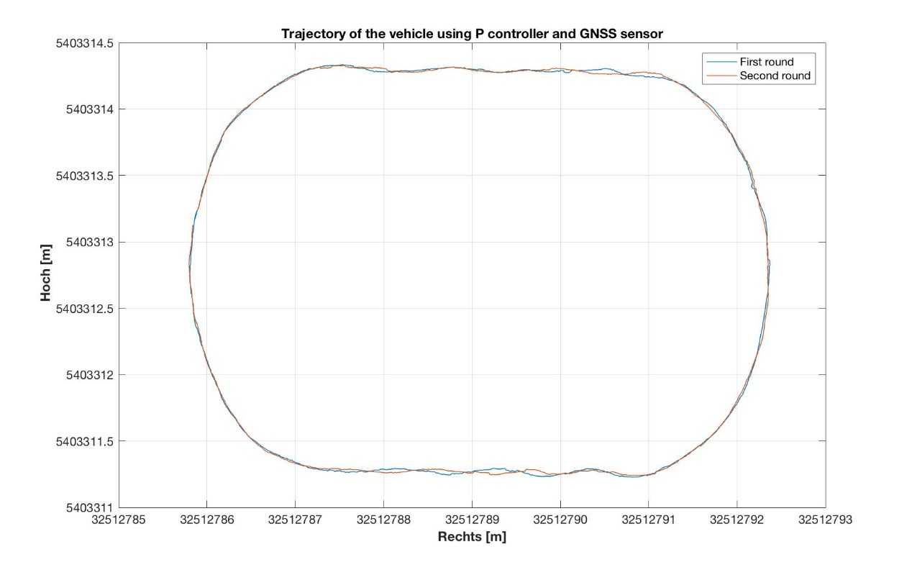

*Figure 3.1.1 Trajectory of the vehicle using P controller and GNSS sensor*

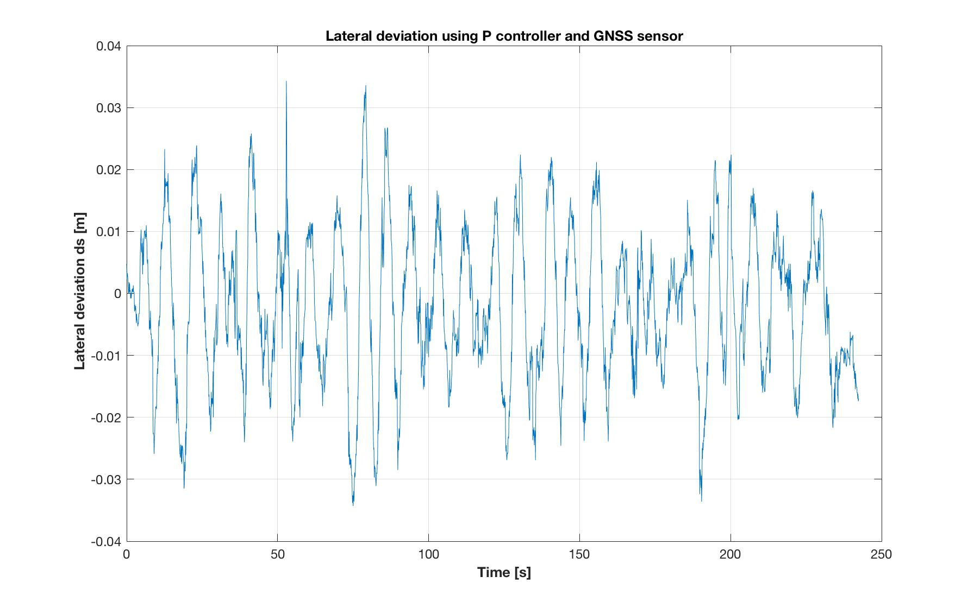*Figure 3.1.2 Lateral deviation using P controller and GNSS sensor*

The test drive is done on ‘Oval’ reference trajectory with 2 Lines, 4 Clothoids, and 2 curves. The velocity must be almost constant during this test drive.

Figure 3.1.1 we can see differences between first and second rounds specially in Lines part, these lead to clear difference in RMS between both rounds. And Figure 3.1.2 give us a straight impression how the lateral deviation will change with time, we can see an oscillating around 0, with average amplitude around 10 mm.

The control quality and measurement accuracy can be analyzed by computing RMS of lateral deviation ds(t) or e(t) using following formula:

|  |  |  |
| --- | --- | --- |
|  |  | (3.1.1) |

*Where: n is number of measurements, and is lateral deviation*

The RMS of first drive could be bigger than second one, due to errors at the beginning of the drive, this measurements could be deleted to have better evaluation, but we didn’t delete it here.

*Table 3.1.1 Computed RMS of lateral deviation*

|  |  |  |  |  |
| --- | --- | --- | --- | --- |
| **Round** | **RMS [m]** | | | |
| **Line** | **Clothoid** | **Curve** | **Total** |
|  | 0.0149 | 0.0145 | 0.0101 | **0.0130** |
|  | 0.0120 | 0.0131 | 0.0104 | **0.0116** |
| **Whole drive** | 0.0135 | 0.0138 | 0.0102 | **0.0124** |

In our test drive the lateral deviation for curve is better than those for straight line and clothoid.

In order to enhance the measuring process many rounds could be driven to have more set of data.

**3.2 PD-controller**

**3.3 PID-controller**

The reference and GNSS trajectories are plotted as following.

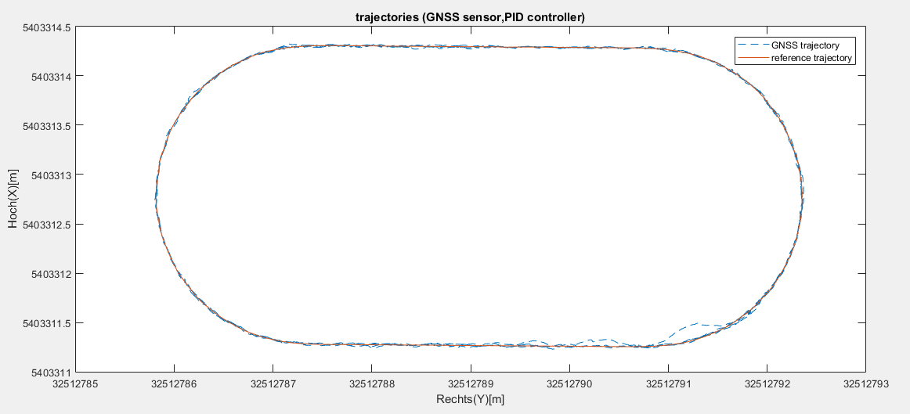

*Figure 3.3.1 trajectory the vehicle using PID controller and GNSS sensor*

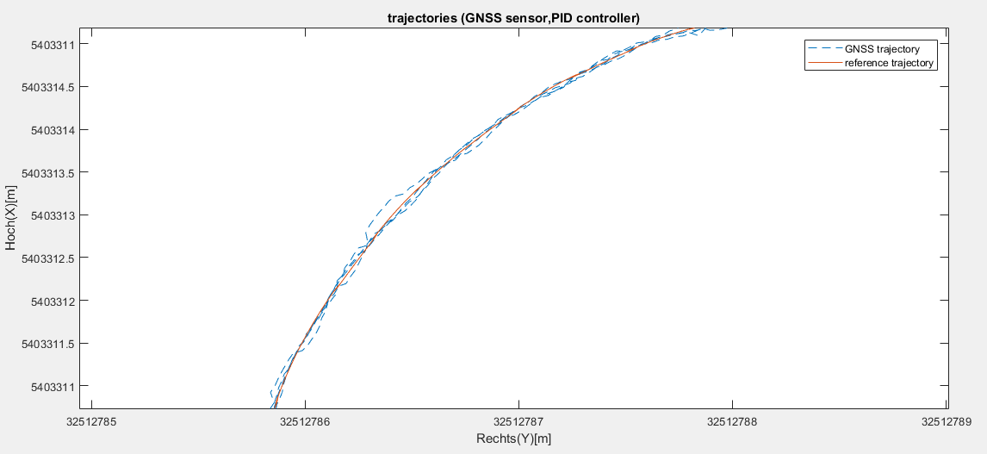

*Figure 3.3.2 trajectory zoomed details*

The lateral deviation corresponds to in controller theory. The lateral deviation of the controller system is plotted for all measurements.

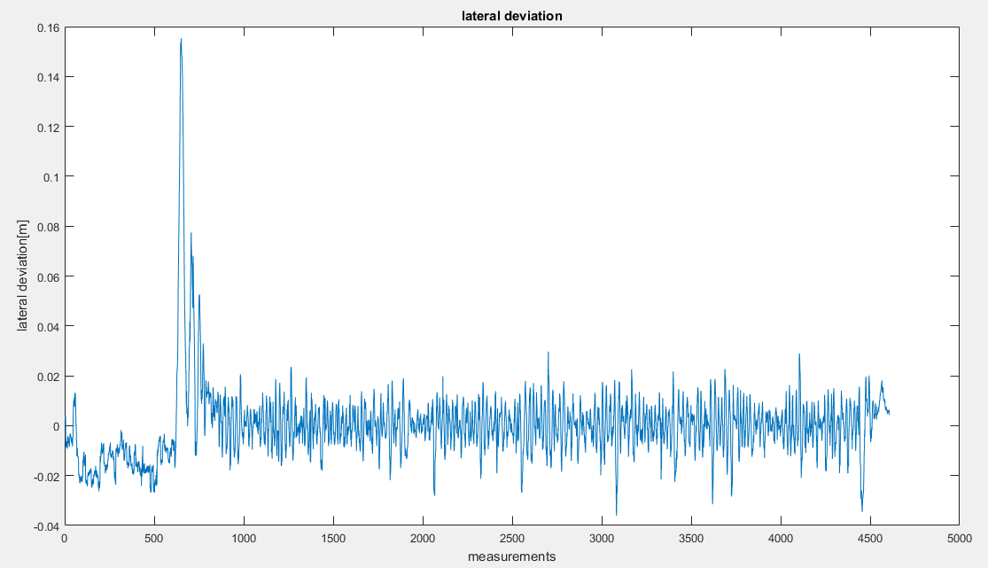

*Figure 3.3.3 plot of lateral deviation*

The control quality will be evaluated based on the RMS of lateral deviation. The formula for calculating RMS of lateral deviation is as formula (3.1.1)

The calculated RMS for all measurements is 0.0151m. However, some of the values of lateral deviation at the beginning are very large, which affects the evaluation of the control quality. We calculated the RMS again for measurements after 1000. The RMS for measurements after 1000 is 0.00822m, which is about the accuracy of the GNSS sensor. That indicates the performance of PID controller is very good.

1. **Comparison of results from different controllers.**

The parameter of controllers seen as table 4.1.

*Table 4.1 WPs and Controllers*

|  |  |  |
| --- | --- | --- |
|  | Controller | Parameters |
| WP4 | P | KP=5 |
| WP5 | PD | KP=20, TD=0.05 |
| WP6 | PID | KP=12.3, TI=0.5, TD=0.001 |

From the above results of different controllers, we can obtain following conclusion.

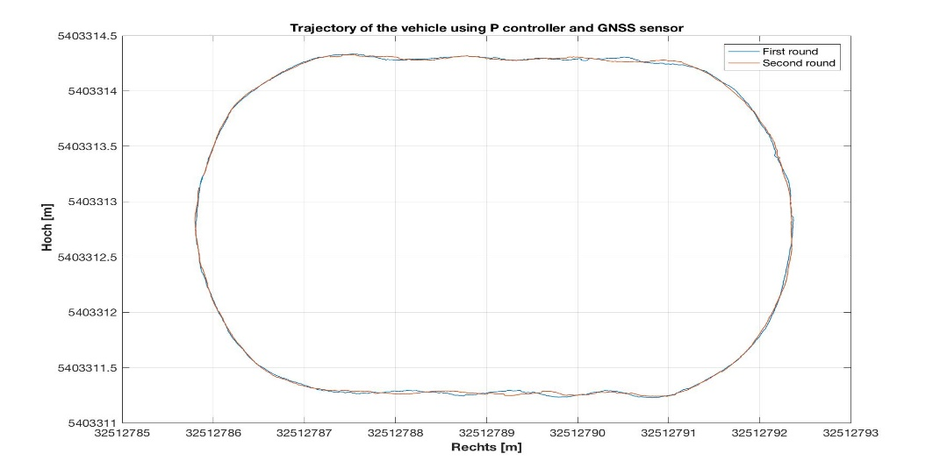

*Figure 4.1 comparison of trajectory*

All three trajectories of different controllers can fit the given trajectory, and it is clear that P controller fits less accurate, PD fits better and PID fits best.

*Table 4.2 comparison of RMS*

|  |  |  |  |
| --- | --- | --- | --- |
|  | P | PD | PID |
| RMS [m] | 0.0124 |  | 0.00822 |

From table 4.2 we can obtain the result that PID has the best performance, and P controller has the worst.

From figure 3.1.2 we can see P controller has a never-ending oscillation. And from figure 3.3.3 the lateral deviation becomes stable after 1000 measurements.

Here we use a close-loop system, which is brought up to stability limit by increasing the amplification, close-loop system is also widely used in industry projects.

We can come to the conclusion: when using GNSS sensor and the system parameters are aligned precisely, we know PID controller should has the best control quality due to the application of correction based on proportional, integral, and derivative terms.

1. source: https://leica-geosystems.com
2. source: Prof. Dr.-Ing. habil. Volker Schwieger