WP6 GNSS PID-controller

1. Description of the sensor

Leica GS25 receiver and Leica AS10 GNSS antenna are used to receive GNSS data. The antenna is connected to the receiver with cable, and the receiver connected to the computer, in order to transfer real-time location to the controller software. The accuracy of the GNSS sensor is about centimeter level. The sampling rate is 0.1s. The requirement of using GNSS sensor is outdoors, with good exposure of the sky. Comparing to total station as sensor, the advantage of GNSS sensor is the sensor is fixed on the vehicle, and it does not require clear view from the sensor to the vehicle. The disadvantage is the trajectory must be outdoors, with clear view to the sky. And also relatively low accuracy.

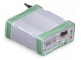

Figure Leica GS25 receiver (left), Leica AS10 antenna (right)

1. Description of the controller

PID controller was used for controlling the vehicle. A proportional-integral-derivative controller is a control loop feedback mechanism used in industrial control systems. it continuously calculates an error $e\left(t\right)$ as the difference between a desired setpoint and a measured process variable and applies correction based on proportional, integral, and derivative terms ($K_{p}$, $K_{i}$, and $K_{d}$).

Mathematical form of PID controller is

$u\left(t\right)=K_{p}e\left(t\right)+K_{i}\int_{0}^{t}{e\left(t^{'}\right)dt^{'}}+K_{d}\frac{de\left(t\right)}{dt}$ (1)

, where $K_{p}$, $K_{i}$, and $K_{d}$ are coefficients for the proportional, integral, and derivative terms respectively.

The parameters for PID controller in this lab are as following.

Table 1 parameters for PID controller

|  |  |
| --- | --- |
|  | Value |
| $$K_{p}$$ | 300000 |
| $$K_{i}$$ | 0.1 |
| $$K_{d}$$ | 0.0001 |

1. Evaluation

The reference and GNSS trajectories are plotted as following.

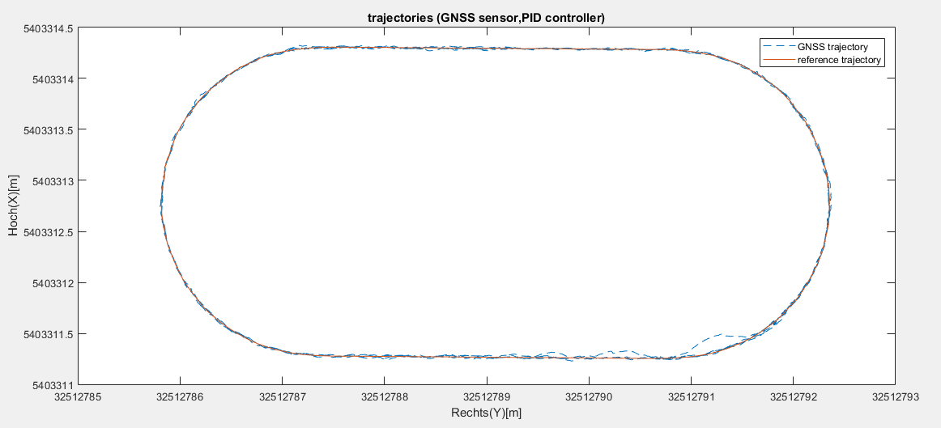

Figure 2 trajectory

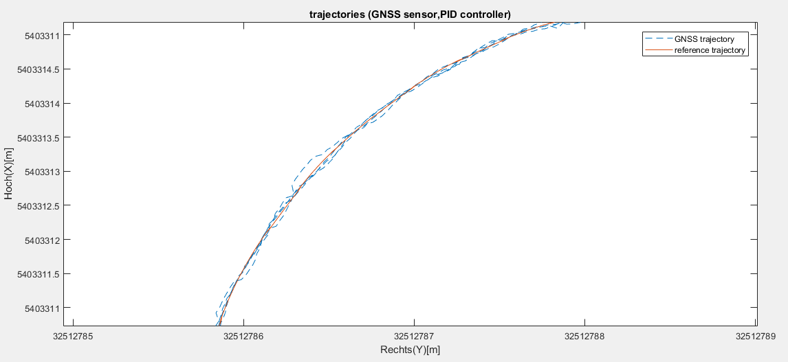

Figure 3 trajectory zoomed details

The lateral deviation $ds$ corresponds to $e_{i}$ in controller theory. The lateral deviation of the controller system is plotted for all measurements.

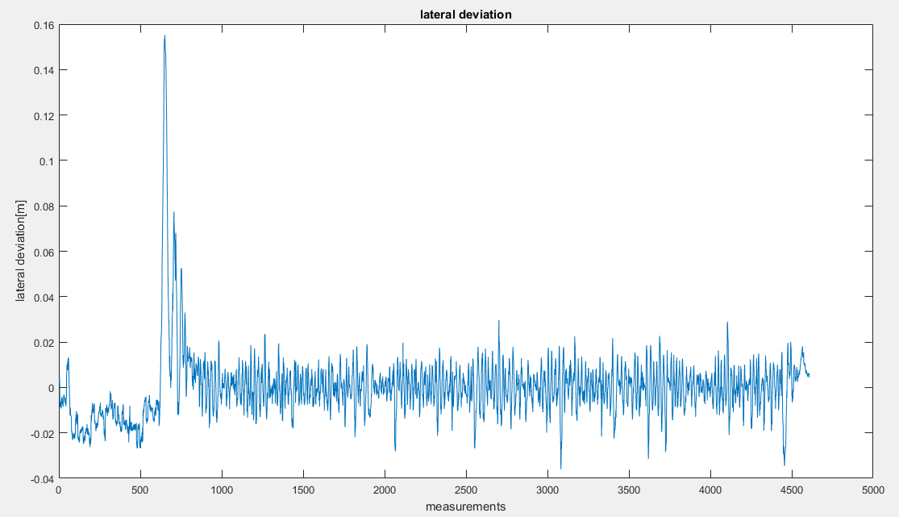

Figure 4 plot of lateral deviation

The control quality will be evaluated based on the RMS of lateral deviation. The formula for calculating RMS of lateral deviation is

$RMS=\sqrt{\frac{\sum_{i=1}^{n}{ds_{i}^{2}}}{n}}$ (2)

, where $ds_{i}$ is lateral deviation at point $i$, which corresponds to $e_{i}$ in controller theory, and $n$ is number of measurements.

The calculated RMS for all measurements is 0.0151m. However, some of the values of lateral deviation at the beginning are very large, which affects the evaluation of the control quality. We calculated the RMS again for measurements after 1000. The RMS for measurements after 1000 is 0.00822m, which is about the accuracy of the GNSS sensor. That indicates the performance of PID controller is very good.