Physical Geodesy Lab 2

|  |  |  |  |
| --- | --- | --- | --- |
| Name | Chen Yiming | Wang Yi | Tan Xiao |
| Student ID | 3371493 | 3371561 | 3371707 |

**Task 1-4**

We model the Earth and Moon as homogeneous solid spheres with constant density as a first approximation. Both masses are sources of the gravitational field. According to the basic parameters of Earth and Moon, and K = 93(last two number of Chen’s student ID), we can design the Matlab functions for the computation of the gravitational potential V(X, Y) and the vector valued gravitational attraction a(X,Y).

The potential of a sphere can be calculated in this formula:





According to them, we write the matlab codes named after ‘V_sphere’ and ‘a_sphere’:

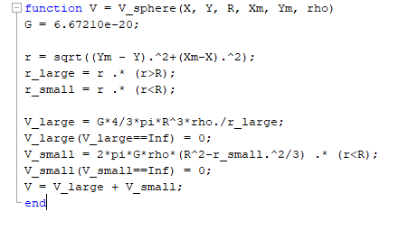

Figure 1. V_sphere

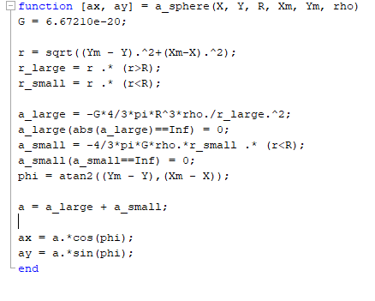

Figure 2. a_sphere

In the function ‘V_sphere’, we use X, Y as matrix which contains all the coordinate data. To make computation easier, we separate the points to outside group and inside group, using different formulas. After removing the nonsense data, we got the hole potential matrix. The function ‘a_sphere’ is written with the same method of V sphere, beside the separation of attraction to x space and y space.

The script of task 1-4 is shown as Figure 3 and 4.

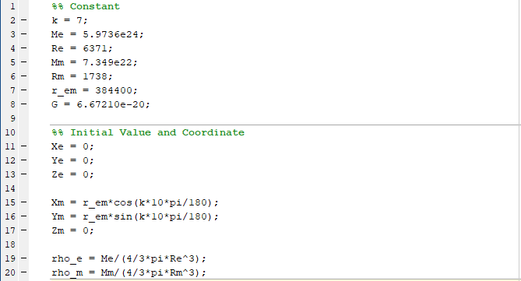

Figure 3. Initial part

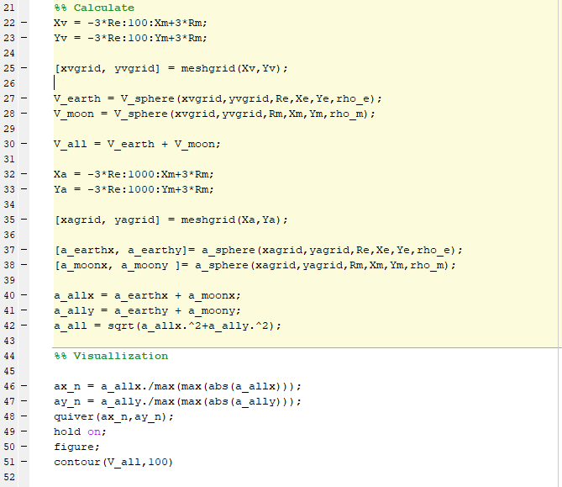

Figure 4. Calculate and plot

We first decide the range of this image, then use the function to calculate all the data required. And then visualize the potential and attraction. Since the potential is just a scalar for every points, and the attraction has been separated into x direction and y direction, we can just add them up to get the complex fields.

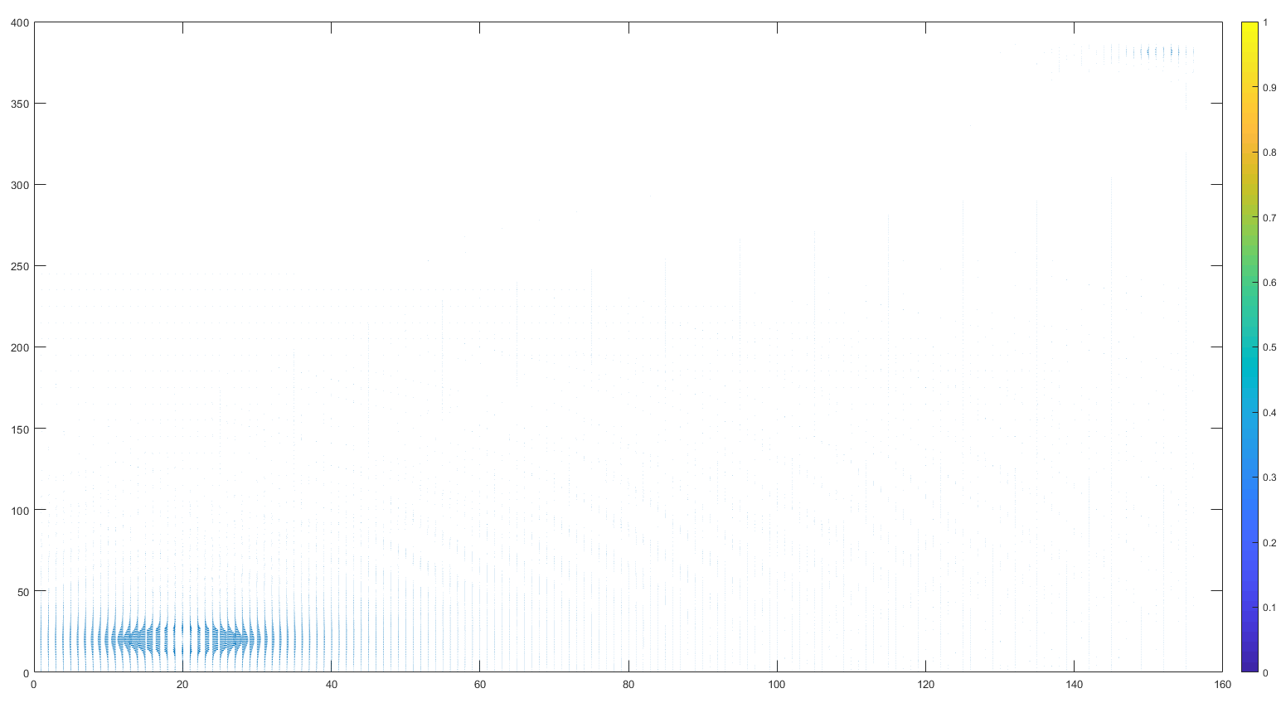

Figure 5. Attractions with orientation

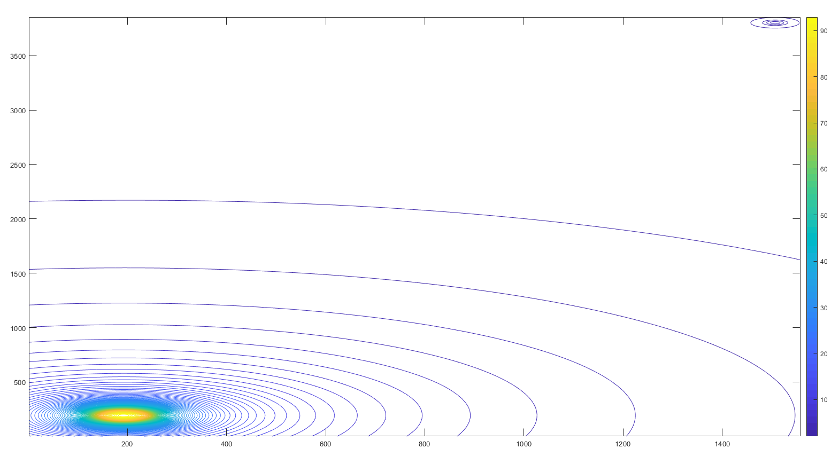

Figure 6. Potential contours

According to the Figure 5 and 6, we can find that the potential change rapidly around two parts, which is larger around the earth than moon, because of the huge mass difference between them. Thus the potential is mainly influenced by the earth. As for attraction, the magnitude of change is similar to potential besides that attractions are vector which means there are orientation changes. According to Figure 6, attraction firstly directs to the earth and with the distance getting larger, attraction directs to moon.

**Task 5-7**

In this part we have an unequally density-distributed sphere, which consists of a solid sphere and a shell. The formula to calculate the potential and attraction of a shell is shown as follows:





In this case, we just need to add the sphere part to obtain the complete potential field and attraction field.

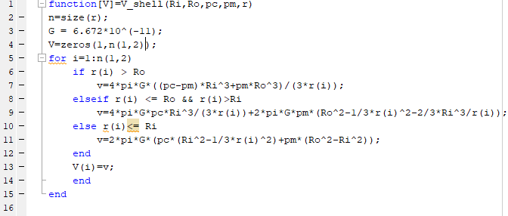

Figure 7. V_shell

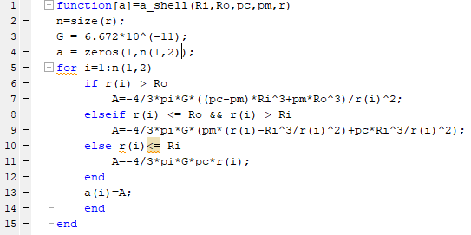

Figure 8. a_shell

The shell codes use radius to present the points, and calculate for every point separately then return all the potentials or attractions.

The script of task 6-7 shows below.

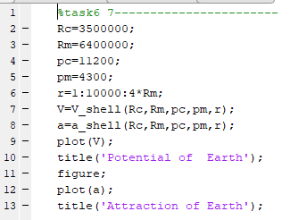

Figure 9. Task 6,7

The plotting results are shown as Figure 10 and 11:

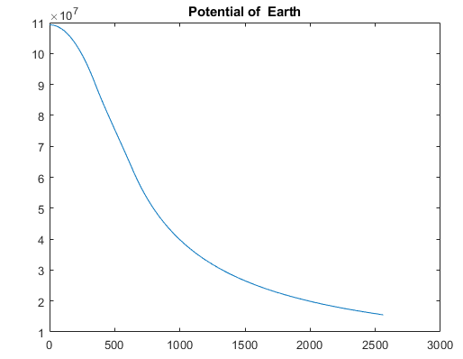

Figure 10. Potential of earth

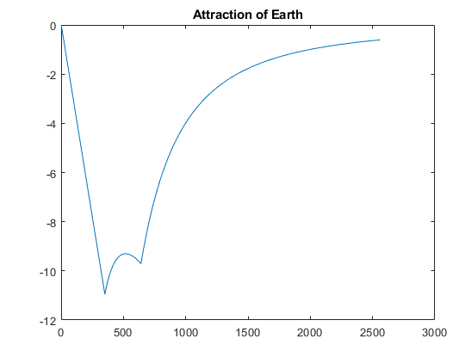

Figure 11. Attraction of earth

**Task 8-10**

In this part the earth model becomes more complex, with plenty of different density layers, i.e. one solid sphere and thousands of shells. However, the basic formulas remain the same, where we see every depth of 1 km as a shell. For any point inside the earth, the gravitational field is generated from its deeper shells, upper shells and the shell it locates in; for any point outside the earth, the gravitational field is generated from a point mass (i.e. the mass of the earth), which we can calculate by numerical integration.

The refined functions are shown below:

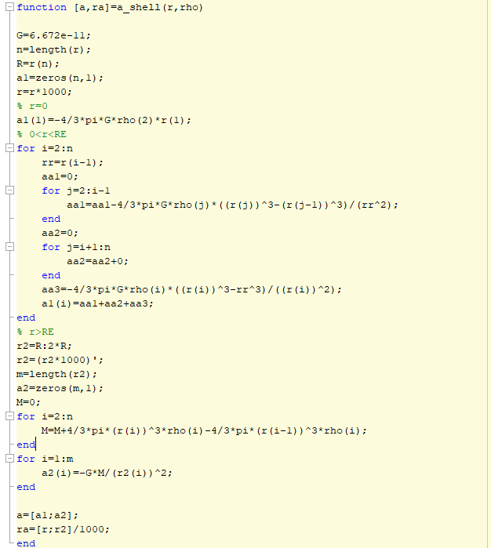

Figure 12. refined a_shell

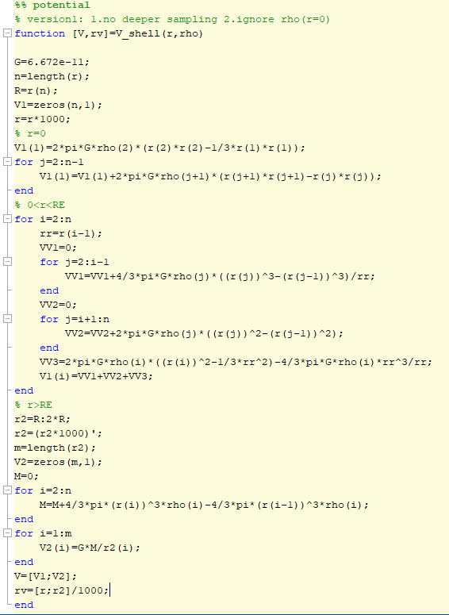

Figure 13. refined V_shell

The plotting script for task 8-10 is shown below:

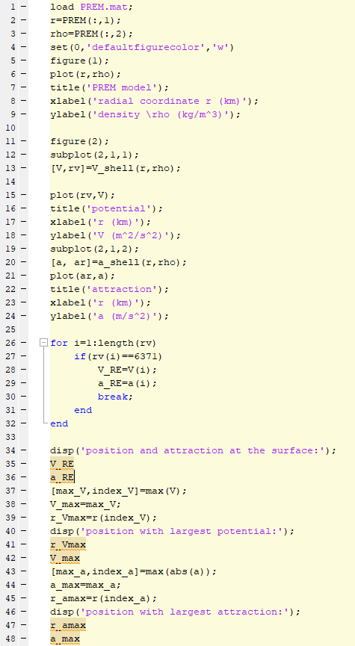

Figure 14. Task 8-10

The sketch for PREM is shown as Figure 15, which indicates the decrease of earth’s density from the core to the surface.

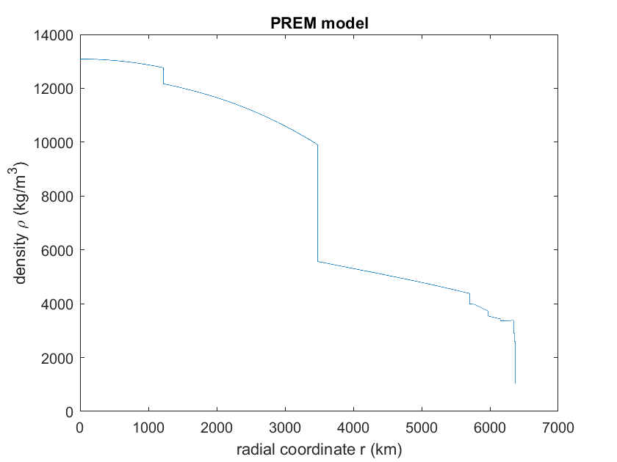

Figure 15. PREM

The sketch for potential and attraction is shown as Figure 16. As can be seen from the figure, the potential goes smaller and smaller from the core; however, the attraction value goes through a step curve, with sharp increase to the maximum point, slowly decrease, and decrease again.

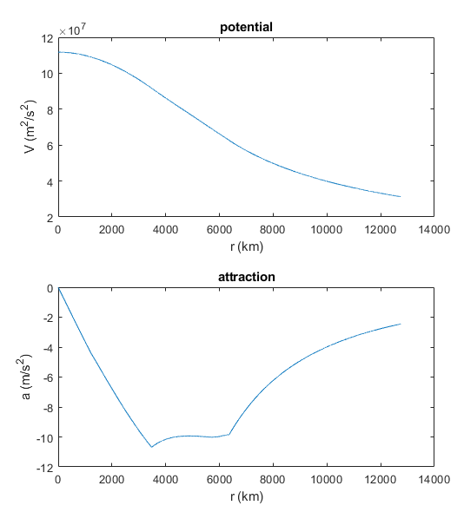

Figure 16. Potential and attraction

The potential and attraction at the surface of the earth is calculated and shown as Figure 16.

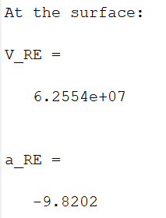

Figure 16. Potential and attraction at the surface

The largest attraction and potential and their positon is shown as Figure 17.

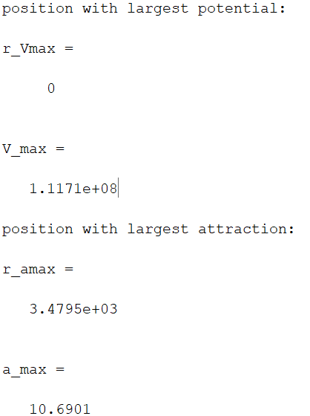

Figure 17. Largest Potential and attraction