**Physical Geodesy Lab3: Gravity and Coriolis accelerations**

Yi Wang 3371561 Bingqing Xu 3374115 Xiao Tan 3371707（k-value: 0）

**Task1: Gravity, gravitation, and centrifugal accelerations**

1.

1.1 Gravitational potential *V*

$$V=\frac{GM}{R}=\frac{G∙4/3πρR^{3}}{R}=\frac{4}{3}πGρR^{2}=6.256×{10}^{7} m^{2}/s^{2}$$

1.2 Centrifugal potential $V_{c}$

$$V_{c}=\int{a_{c}}=\frac{1}{2}w^{2}R^{2}{(cosφ)}^{2}=9.530×{10}^{4} m^{2}/s^{2}$$

1.3 Gravity potential *W*

$$W=V+V_{c}=\frac{4}{3}πGρR^{2}+\frac{1}{2}w^{2}R^{2}{(cosφ)}^{2}=6.266×{10}^{7} m^{2}/s^{2}$$

1.4 Gravitational attraction *a*

$$a=-\frac{GM}{R^{3}}∙\left(\begin{aligned}x \\ y \\ z\end{aligned}\right)=-\frac{GM}{R^{3}}∙\left(\begin{aligned}Rcosφcosλ \\ Rcosφsinλ \\ Rsinφ\end{aligned}\right)$$

$$a=\left|a\right|=\frac{GM}{R^{2}}=9.8197 m/s^{2}$$

1.5 Gravity attraction *g*

Centrifugal attraction

$$a_{c}=-ω×\left(ω×r_{e}\right)=ω^{2}∙\left(\begin{aligned}x \\ y \\ 0\end{aligned}\right)=ω^{2}∙\left(\begin{aligned}Rcosφcosλ \\ Rcosφsinλ \\ 0\end{aligned}\right)$$

Gravity attraction ***g***

$$g=a+a_{c}$$

$$g=\left|g\right|=9.7898 m/s^{2}$$

1.6 Disturbance of the direction $ξ$

$$ξ=\arccos\left(\frac{a∙g}{\left|a\right|\left|g\right|}\right)=0.0633°$$

1.7 Disturbance of the attraction $δ_{g}$

$$δ_{g}=g-a=-0.0299 m/s^{2}$$

2.

2.1 Disturbance of the direction $ξ$

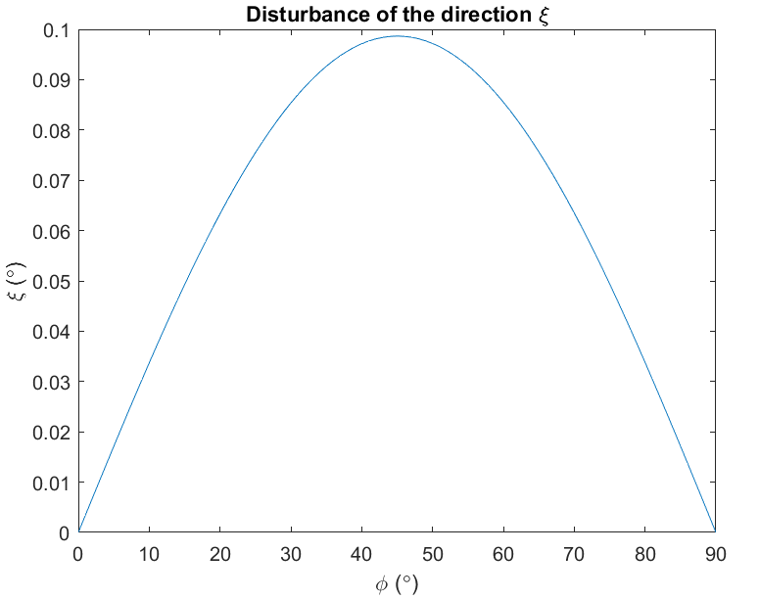

Fig 2.1

2.2 Disturbance of the attraction $δ_{g}$

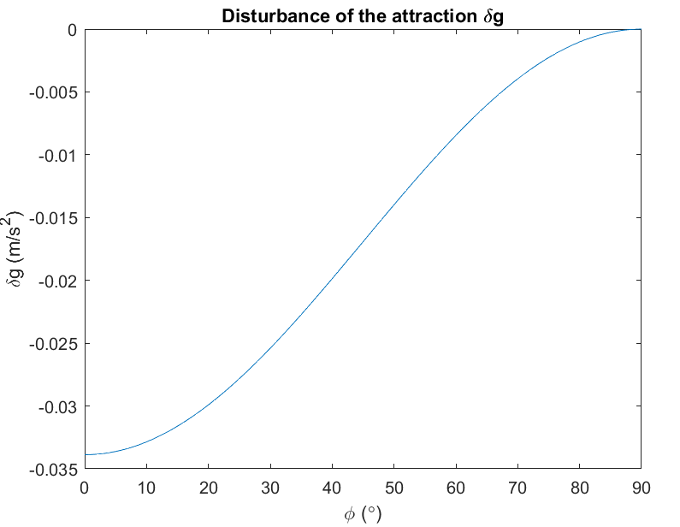

Fig 2.2

2.3 Centrifugal potential $V_{c}$

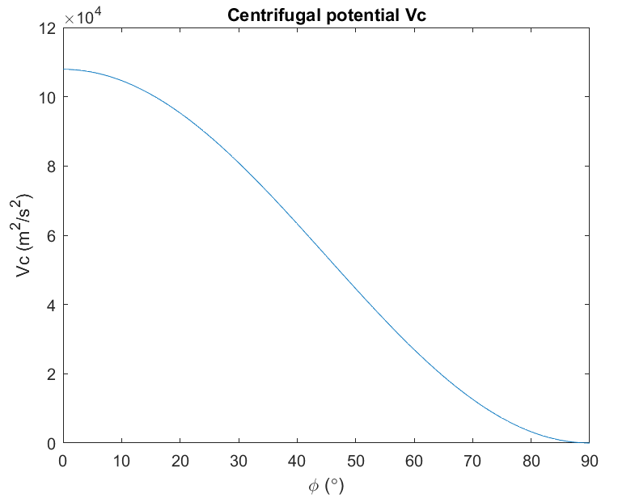

Fig 2.3

**Task 2: Eotvos correction**

3.1 Coriolis acceleration

$$a_{cor,e}=-2∙ω×\dot{r_{e}}=2ω∙\left(\begin{aligned}\dot{y} \\ -\dot{x} \\ 0\end{aligned}\right)=2ω∙\left(\begin{aligned}\begin{aligned}-sinφcosλ∙v_{N}-sinλ{∙v}_{E} \\ -sinφsinλ∙v_{N}+cosλ∙v_{E}\end{aligned} \\ cosφ∙v_{N}\end{aligned}\right)$$

East-West:

$$a_{cor,e}=2ω∙\left(\begin{aligned}\begin{aligned}-sinλ{∙v}_{E} \\ cosλ∙v_{E}\end{aligned} \\ 0\end{aligned}\right)=\left(\begin{aligned}-0.0028 \\ 0.0160 \\ 0\end{aligned}\right)$$

$$a_{cor,e}=0.0162 m/s^{2}$$

North-South:

$$a_{cor,e}=2ω∙\left(\begin{aligned}\begin{aligned}-sinφcosλ∙v_{N} \\ -sinφsinλ∙v_{N}\end{aligned} \\ cosφ∙v_{N}\end{aligned}\right)=\left(\begin{aligned}-0.0107 \\ -0.0019 \\ 0.0120\end{aligned}\right)$$

$$a_{cor,e}=0.0162 m/s^{2}$$

3.2 Eotvos correction

$$a_{cor,t}=S_{1}∙R\left(φ\right)∙R\left(λ\right)∙a_{cor,e}=2ω∙\left(\begin{aligned}-sinφ∙v_{E} \\ sinφ∙v_{N} \\ cosφ∙v_{E}\end{aligned}\right)$$

$$a_{cor,t}=2ω∙\sqrt{v_{E}^{2}+{(sinφ)}^{2}∙v_{N}^{2}}$$

East-West:

$$a_{cor,t}=2ω∙\left(\begin{aligned}-sinφ∙v_{E} \\ 0 \\ cosφ∙v_{E}\end{aligned}\right)=\left(\begin{aligned}-0.0108 \\ 0 \\ 0.0120\end{aligned}\right)$$

$$a_{cor,t}=0.0162 m/s^{2}$$

$$da=2ω∙dv_{E}$$

$$σ_{v}=\frac{σ_{a}}{2ω}=0.0686 m/s$$

North-South:

$$a_{cor,t}=2ω∙\left(\begin{aligned}0 \\ sinφ∙v_{N} \\ 0\end{aligned}\right)=\left(\begin{aligned}0 \\ 0.0108 \\ 0\end{aligned}\right)$$

$$a_{cor,t}=0.0108 m/s^{2}$$

$$da=2ω∙sinφ∙dv_{N}$$

$$σ_{v}=\frac{σ_{a}}{2ω∙sinφ}=0.1025 m/s$$