**Physical Geodesy**

**Assignment 5**

Members:

Chen Chih Chieh (3299599)

Yongxu Duan (3299533)

# **Fully normalized zonal, tesseral, sectorial Legendre functions Plm and spherical harmonics Ylm**

1. **Method Introduction**

Two methods of calculating normalized ALF with degree l=10, and different orders will be implemented in this task:

1. Method one : Ridrigues-Ferrers Method (normalized)

The Legendre Polynomial : (Ridrigues)

The Associated Legendre Function (ALF): (Ferrers)

The normalized ALF:

1. Method two : Recursive Method (normalized)

must be bigger than , otherwise it doesn’t exist and the value should be 0.

The recursive method is implemented in a recursive structure, where there must be base cases for the function to reach an end point.

The following are the two base cases:

And, the following are the **main recursive functions**, where the function will call itself within the function.

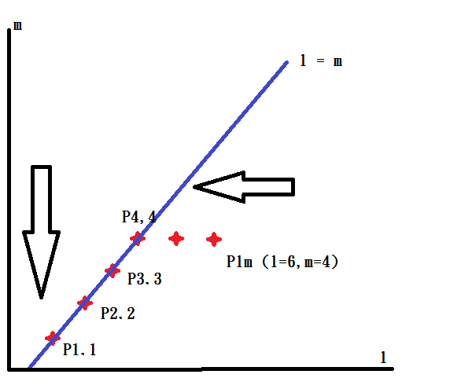

Fig 1 Visualization of Recursive method

Explanation of the recursive function:

Assume we want to calculate the ALF at degree 6, order 4. The recursive function will first call itself and ask the function what is the two ALF in front of it degree-wise, namely P5,4 and P4,4 . (This can be discovered in the above equation eq.2 or in Fig 1 the horizontal direction movement) Once the recursive function reaches the diagonal line(where = m), in this case P4,4. It starts to ask only one ALF in front of it both degree and order-wise, namely P3,3. (This can be discovered in the above equation eq.1 or in Fig 1 the diagonal direction movement). Up to this point, the function is still at a requesting phase. Once it reaches our base case, namely P1,1, the function starts to get answers, and it will transport back to each calling of the function, and at the end give us the final answer of our initial request.

The following are cases of Zonal, Sectorial, and Tesseral ALF and spherical harmonics.

1. **Figures of fully normalized Legendre functions and Spherical harmonics.**

They are divided into three categories from the appearance of the spherical harmonics.

Degree 10 ( = 10) will be examined in the following cases.

1. Zonal case (m = 0)

When the order m = 0, the Legendre function and spherical harmonics has a stripe look in horizontal direction. It divides the Earth into stripes along latitude.

* **Rodrigues-Ferrers Method**

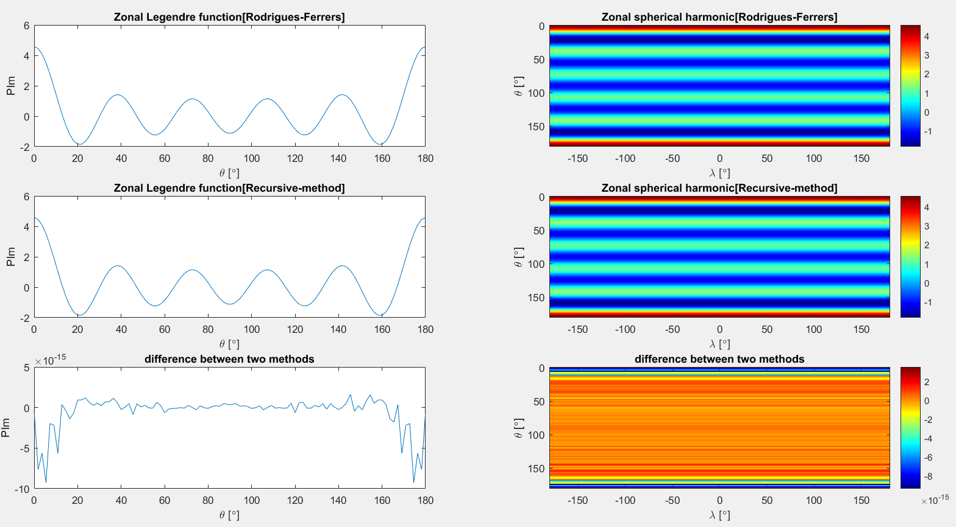

Fig 2. Zonal legendre & harmonics with Rodrigues-Ferrers Method

* **Recursive Method**



Fig 3. Zonal legendre & harmonics with Recursive Method

* Zero crossings of Legendre functions: = 10
* Zero crossings of Spherical harmonics
  + North-South direction(latitude): -m = 10 – 0 = 10
  + East-West direction(longitude): = 0*2 = 0



Fig 4. Difference of two methods

* Difference between two methods

The difference is very small and in a scale of ten to the power of 15. It is larger at the equator (0) and south pole (180), where the ALF or the harmonic are also larger there. We can conclude that this error is not really that actual difference between two calculating methods. The difference is too small to determine within the limitation of float number’s precision. The differences are just random number. It tends to turn bigger when the original value were also bigger.

1. Sectorial Case (m = l)

* Rodrigues-Ferrers Method

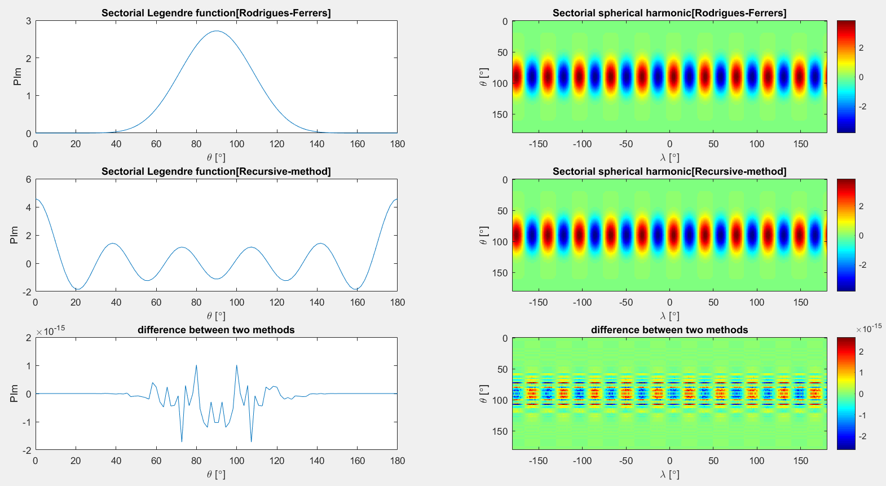

Fig 5. Sectorial legendre & harmonics with Rodrigues-Ferrers Method

* 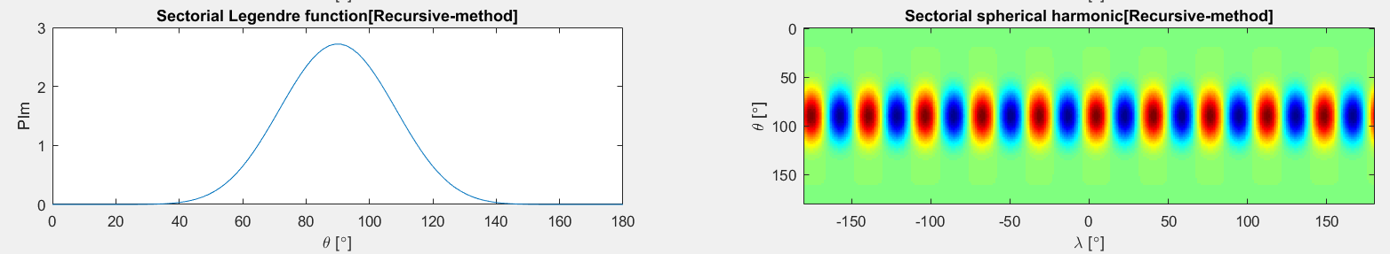Recursive Method

Fig 6. Sectorial legendre & harmonics with Recursive Method

* Zero crossings of Legendre functions: = 10
* Zero crossings of Spherical harmonics
  + North-South direction(latitude): -m = 10 – 10 = 0
  + East-West direction(longitude): = 10*2 = 20

We will have on earth m circles crossing thru north and south poles, and therefore divides the earth into 20 strips. Walking along equator, there will thus be m*2 zero crossings.



Fig 7. Difference of two methods

* Difference between two methods

Again, the difference is really small to determine, and it tend to become bigger when the original value were bigger.

1. Tesseral Case (m ≠ 0 and m ≠ l)

This includes all other cases except the two cases mentioned above. Thus, we only display other orders on ALF figure. For spherical harmonics, we choose to display an order of 4.

* Rodrigues-Ferrers Method

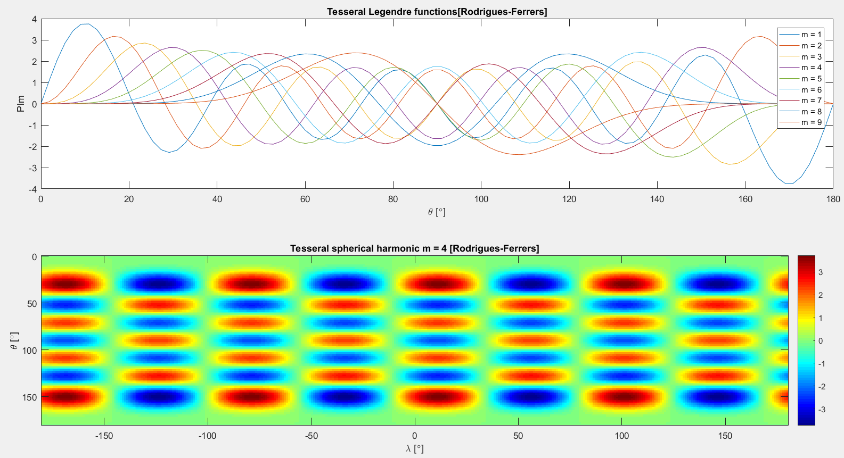

Fig 8. Tesseral legendre & harmonics with Rodrigues-Ferrers Method

* Recursive Method

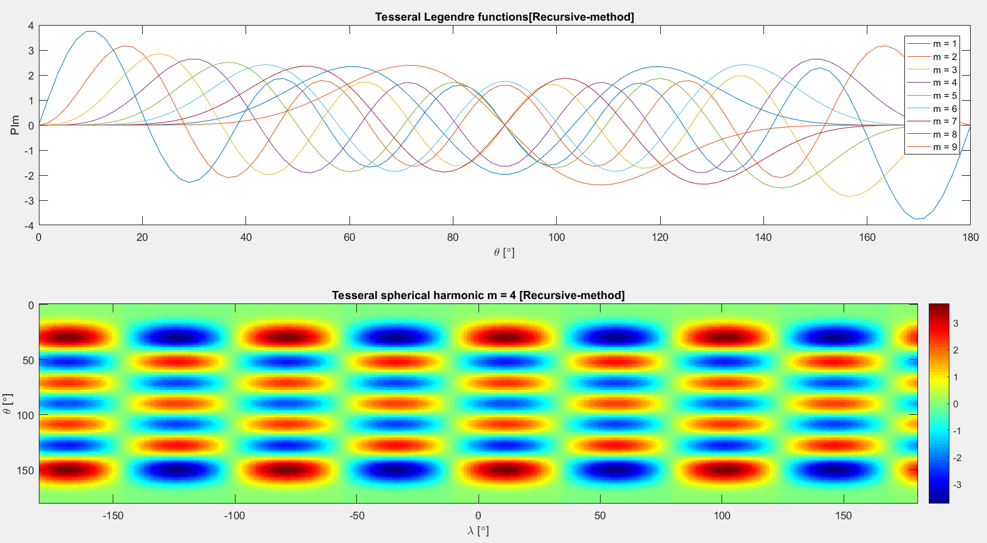

Fig 9. Tesseral legendre & harmonics with Recursive Method

* Zero crossings of Legendre functions: = 10
* Zero crossings of Spherical harmonics
  + North-South direction(latitude): -m = 10 – 4 = 6
  + East-West direction(longitude): = 4*2 = 8

We will have on earth 4 circles crossing thru north and south poles, and therefore divides the earth into 8 strips. Walking along equator, there will thus be 8 zero crossings.

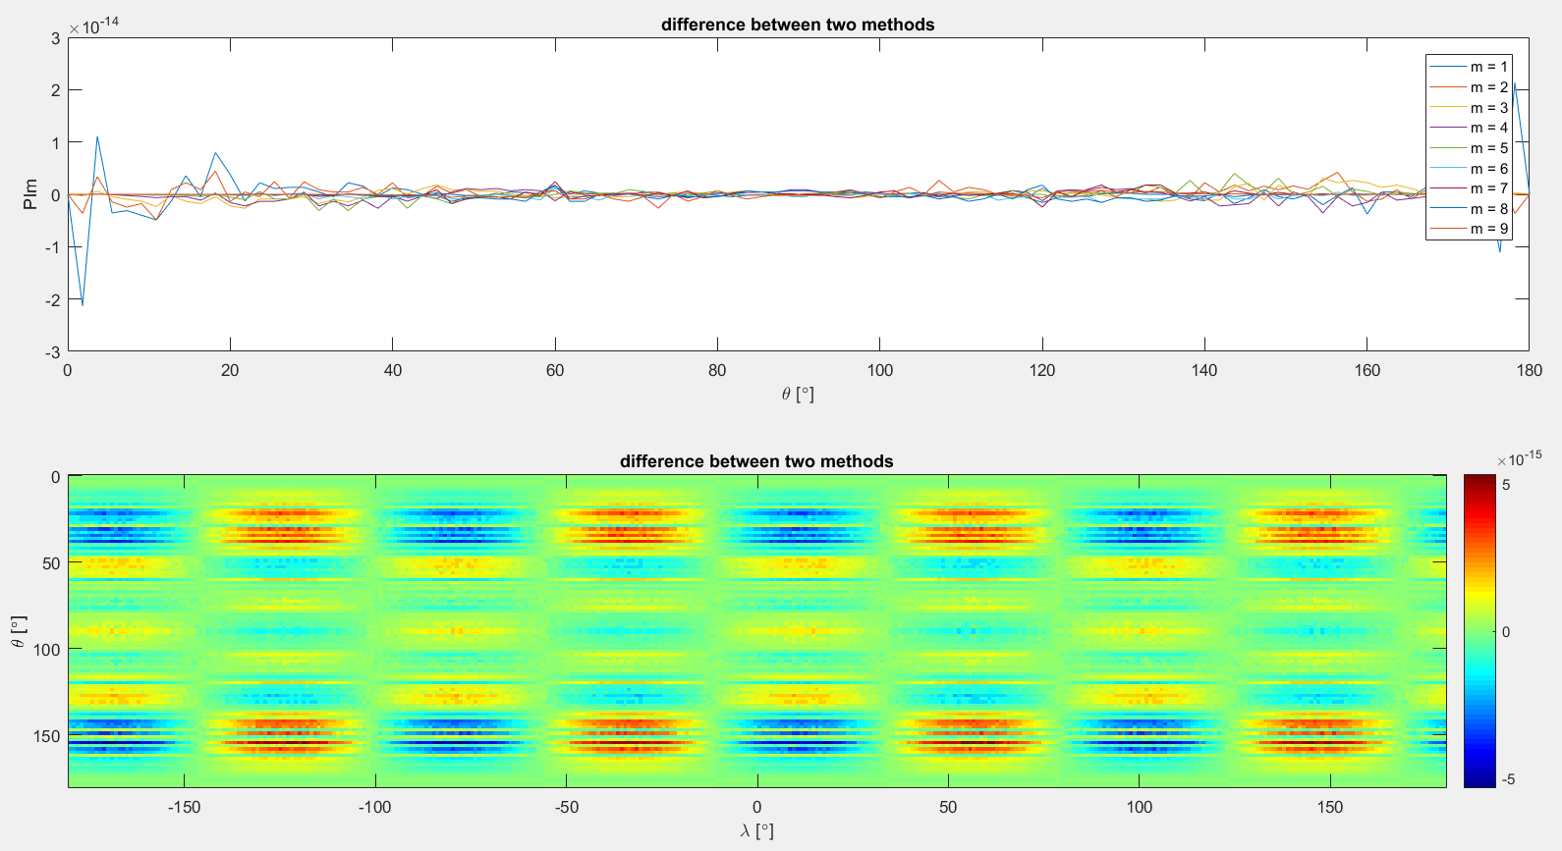

Fig 10. Difference of two methods

* Difference between two methods

Again, the difference is really small to determine, and it tend to become bigger when the original value were bigger.

# **Task 2 Addition Theorem**

1. **Theorem Verification**

The addition theorem is described below, the bar sign indicates ‘normalized’.

To verify this theorem, we will calculate both side of the equation individually and compare them. Here are assumptions and requirements for calculation:

* Assumption 1: P and Q is on the same meridian (), this will simplify the complexity of the equation
* Assumption 2: and , the spherical distance between P and Q () in the left hand side equation will simply become latitude of point P ()
* Requirement: calculate for degree l from 0 to 100

1. **Visualize the result we get in two different ways**

* For every single degree l , the polynomial along each co-latitude entry, is described in one oscillating line
* For every single degree l , the polynomial along each co-latitude entry, is described in one row. The color indicates the value.

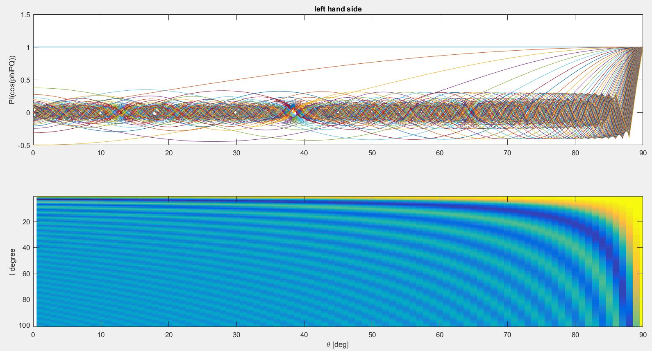

Fig 11. Left hand side of Addition theorem

[ order l from 0 to 100, and ]

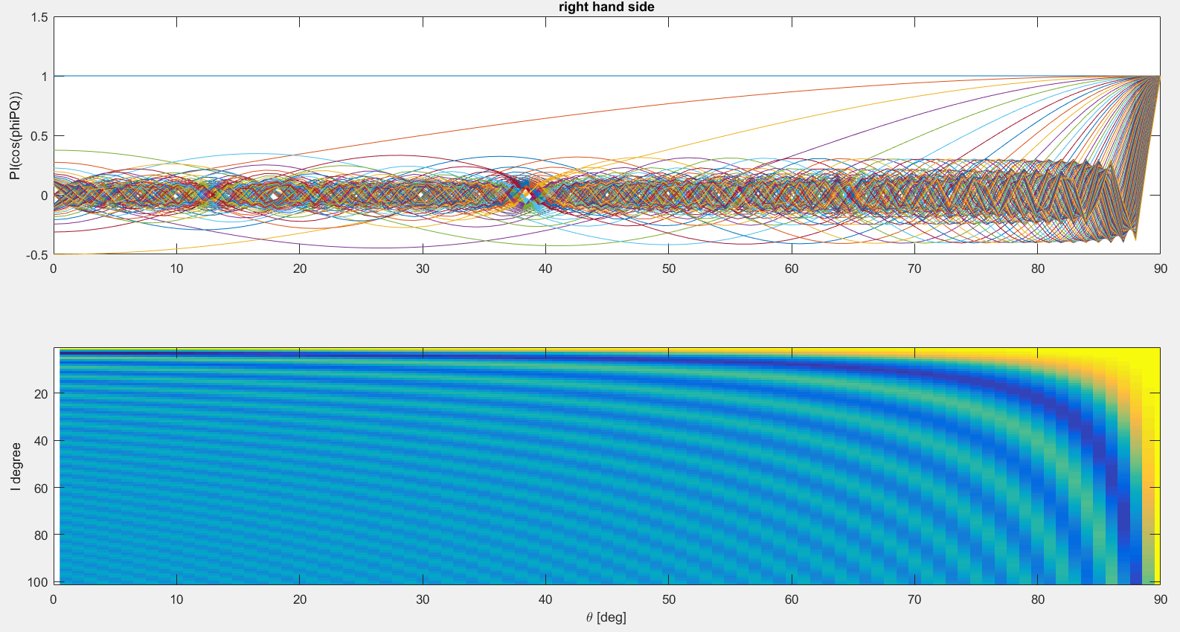

Fig 12. Right hand side of Addition theorem

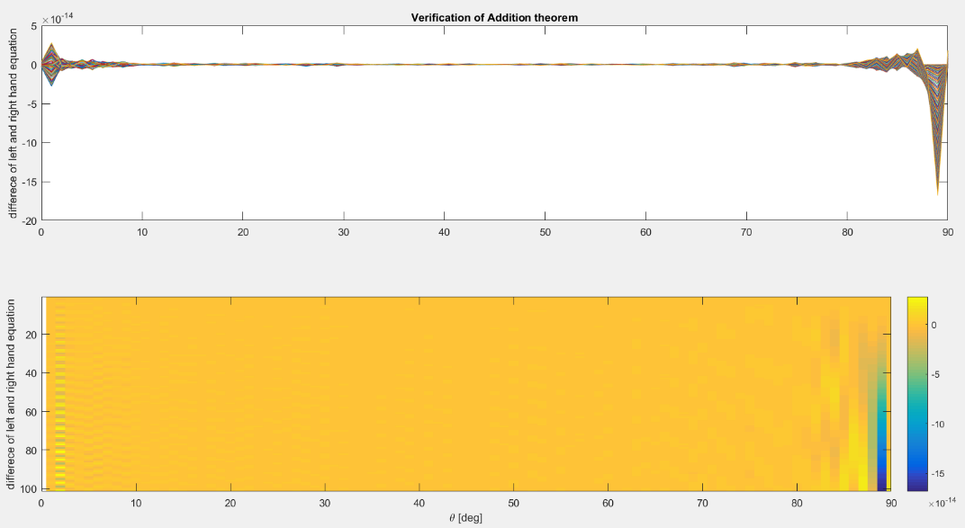

Fig 13. Left - Right hand side

The difference is in a scale of ten to the power of 14. It tends to be bigger when the degree or the colatitude (here, the spherical distance between P and Q) become bigger.

# **Task 3 When Ѳp = Ѳq, display right had side of addition theorem**

Add to our previous two assumptions, also calculate for degree 1 to 100.

* Assumption 3: , this leads to on the left hand side of the equation:

Verify this with

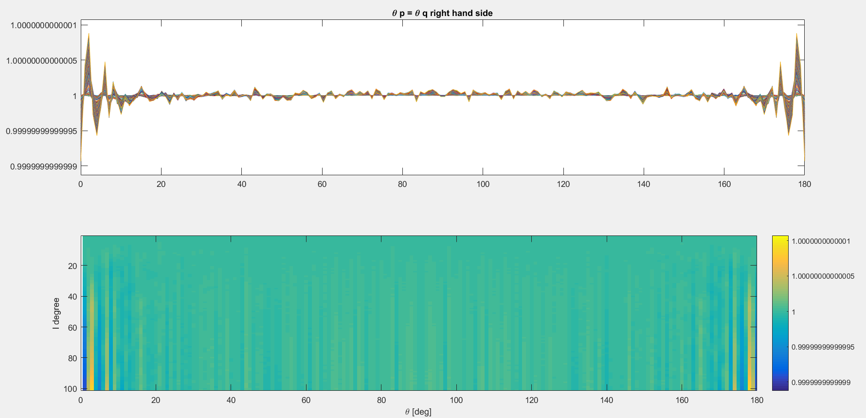

Fig 14.

Both kinds of visualization tells us we will get 1 as results. It has a very high accuracy within .

# **Task 4 Determine gravity and gravitational potential W and V at point P**

The gravitational potential V in the exterior (mass-free) domain is determined by means of a spherical harmonics series expansion as:

The models with coefficients and are given in the EGM96, which have been estimated for instance from the analysis of terrestrial or satellite gravity data. One of these models is the EGM96 of the NASA.

Determine the gravity and gravitational potential W and V at a point P with the following spherical coordinates

Our results: with k = 6 (our average of matriculation number)

* Gravitational potential at P point:
* Gravity potential at P point:

# **Task 5 Discuss how to get better representation of gravity filed**

In this task, we use the spherical harmonic series expression for an airborne gravimetry campaign to represent gravity field. The formula is:

As we can see, the distance between airplane and the center of earth is r, which is on the denominator. The airplane flying height determines the value of r. If airplane flies as high as possible, the r is nearly infinity, then is nearly zero. The V would also be as closer to zero as possible, which is obviously hard to describe the gravity field. When we decrease the value of r, the V would be much closer to the value of gravity on the ground. Hence, the airplane should fly as low as possible to get a better representation of gravity field.