Task 1

1.1 Plm(cos(theta))

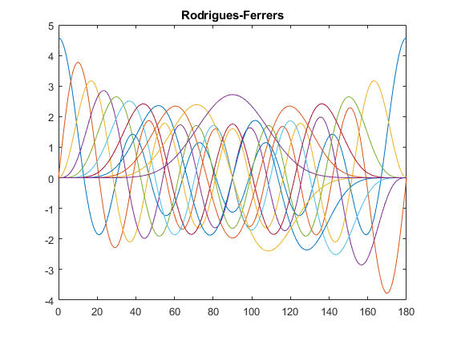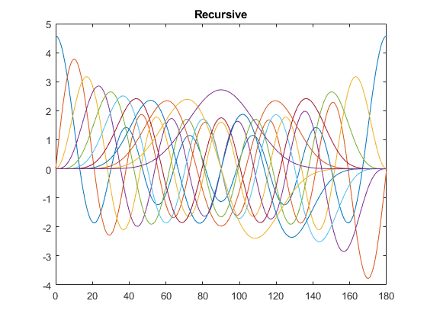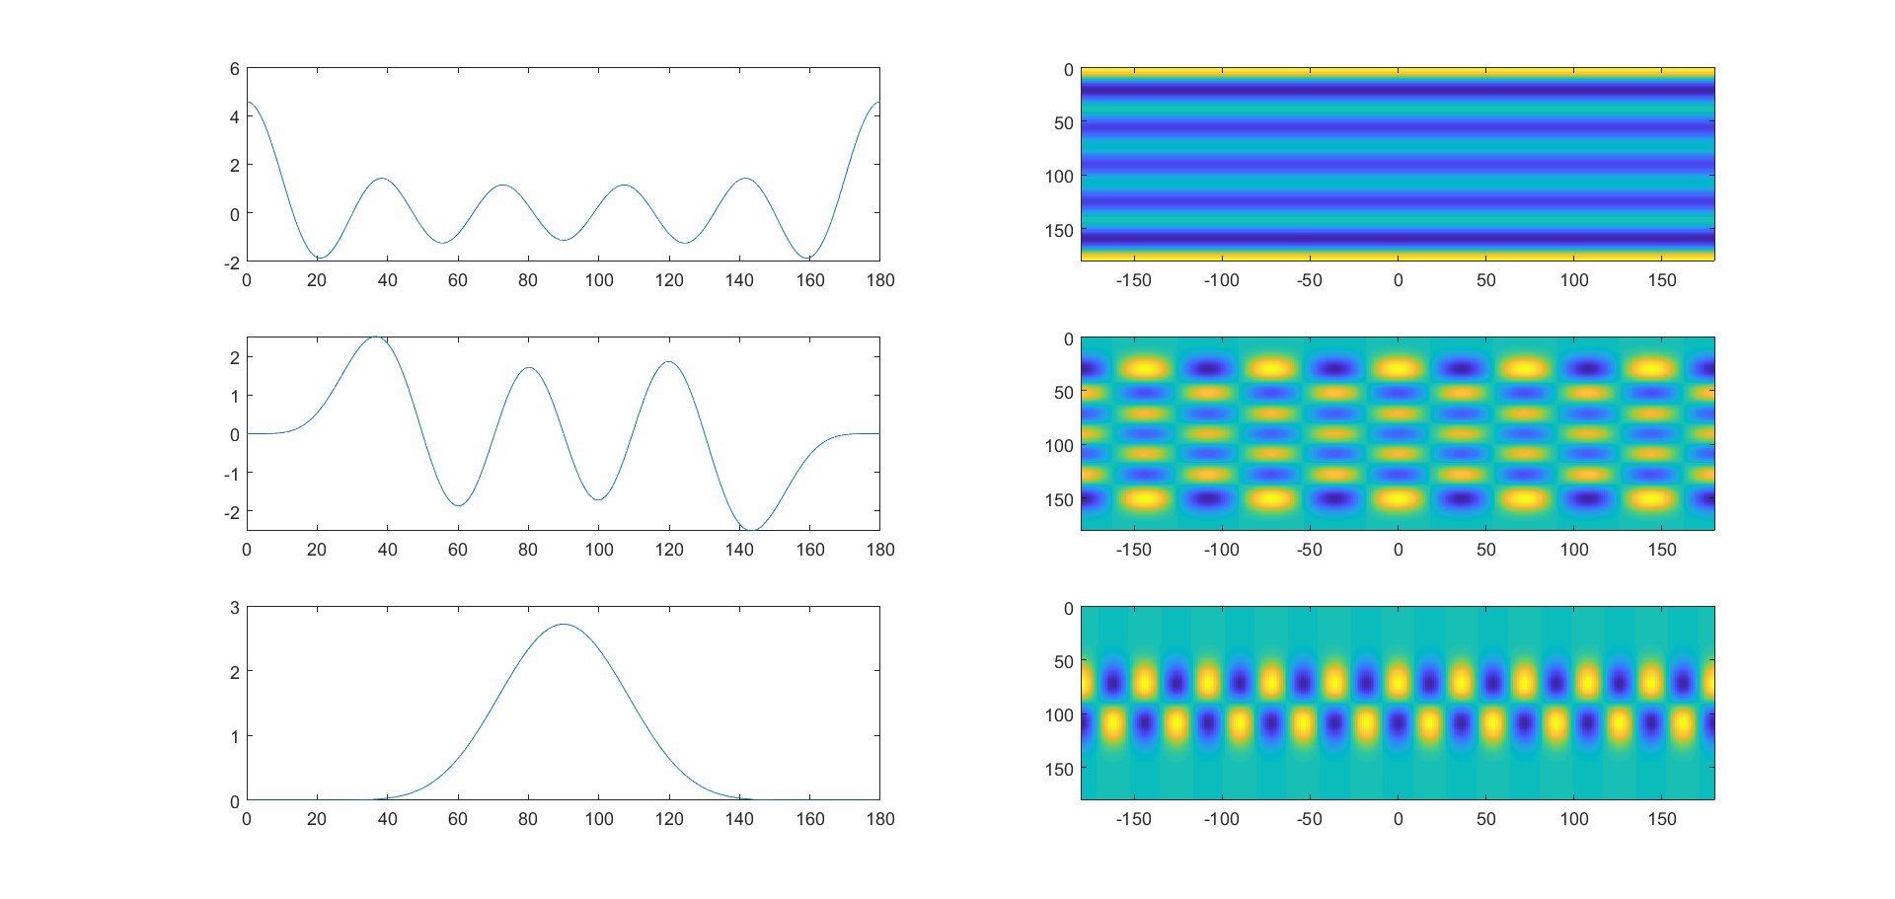

From up tp down: zonal, tesseral, sectorial

1.2

Zero crossings of legendre function: l-m

Zero crossings of spherical harmonics: l-m (n-s) m*2 (w-e)

Task 2

Task 3

Yes for most latitudes

**Task 4**

Gravitational potential:

$$V\left(λ,θ,r\right)=\frac{GM}{R}\sum_{l=0}^{∞}{{\left(\frac{R}{r}\right)}^{l+1}\sum_{m=0}^{l}{{\overline{P}}_{lm}\left({cosθ}_{P}\right)({\overline{c}}_{l,m}cosmλ+{\overline{s}}_{l,m}sinmλ)}}$$

Coefficients ${\overline{c}}_{l,m}$ and ${\overline{s}}_{l,m}$ are given, together with the parameters $λ$, $θ$ and r, we can get the potential:

$$V=6.2512×{10}^{7} m^{2}/s^{2}$$

Then we calculate the centrifugal part:

$$V\left(r,θ,λ\right)=\frac{1}{2}ω^{2}r^{2}\sin^{2}θ$$

Finally we add them to get the gravity:

$$W=V+V_{c}=6.2615×{10}^{7} m^{2}/s^{2}$$