**Image alignment by estimation of a homography**

Yi Wang 3371561

**1. Homography**

**1) Basic Transformation Equation:**

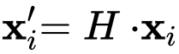

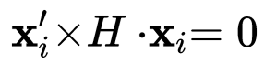

Where,

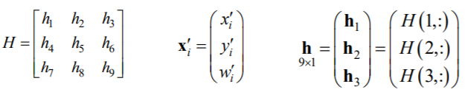

**2) System of Linear Equations**

Therefore,

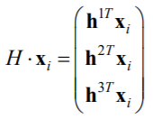

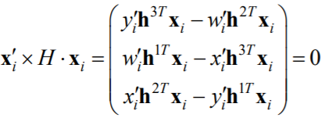

Which results in system of linear equations,

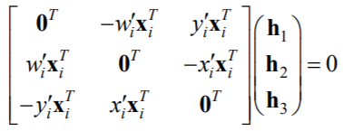

**3) Solution of Linear Equations System**

Row(3) is linear dependent of Row(1) and Row(2), thus we can eliminate that,

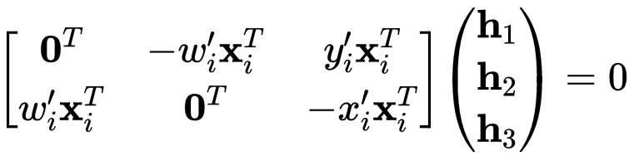

Which can be solved by Singular Value Decomposition (SVD) with at least 4 pairs of identical points. By reshaping h1, h2, h3, we get the final H matrix.

**2. Image Mapping**

1) transformation



2) normalization

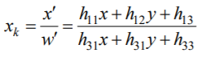

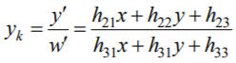

**3. Results**

**1) Gebaeude**

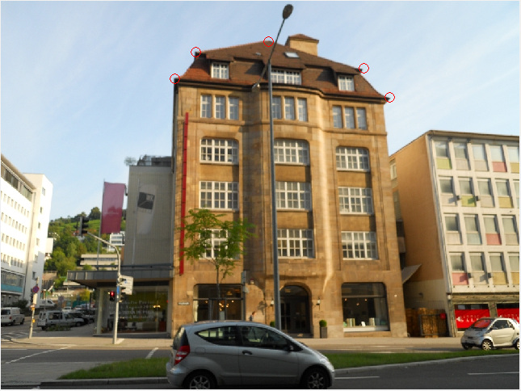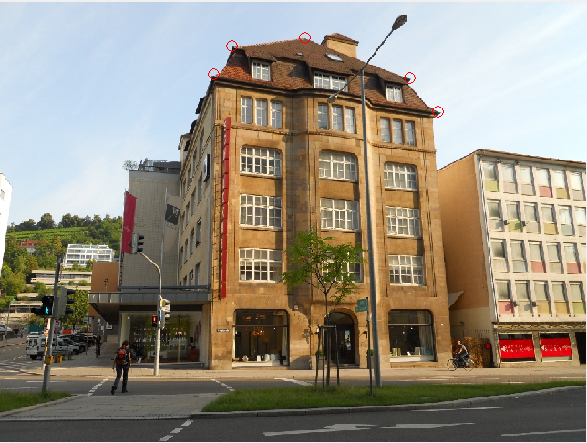

Fig1.1 Identical points

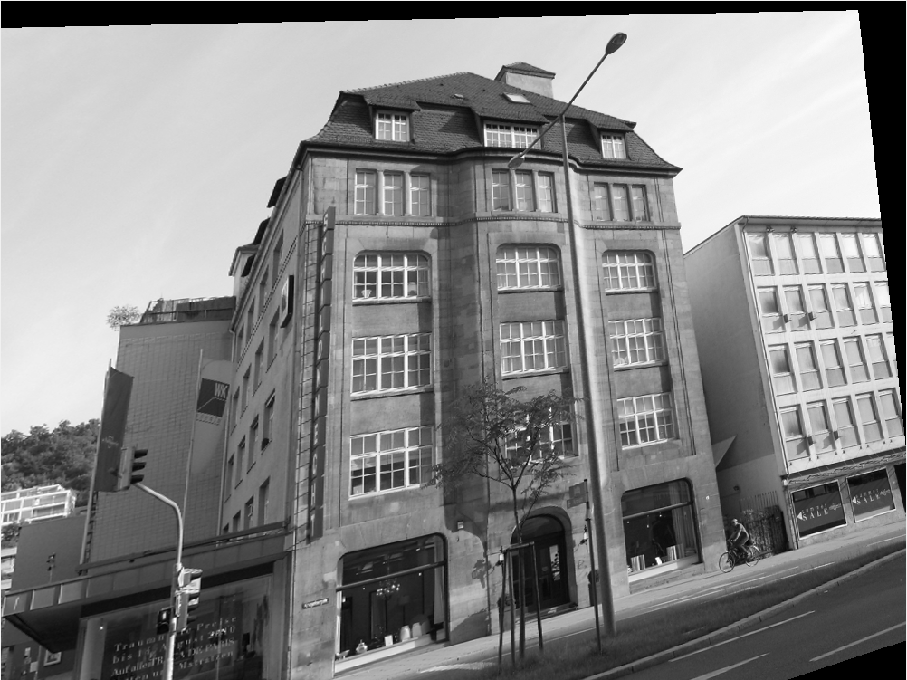

Fig1.2 Gebaeude4 in the geometry of Gebaeude5

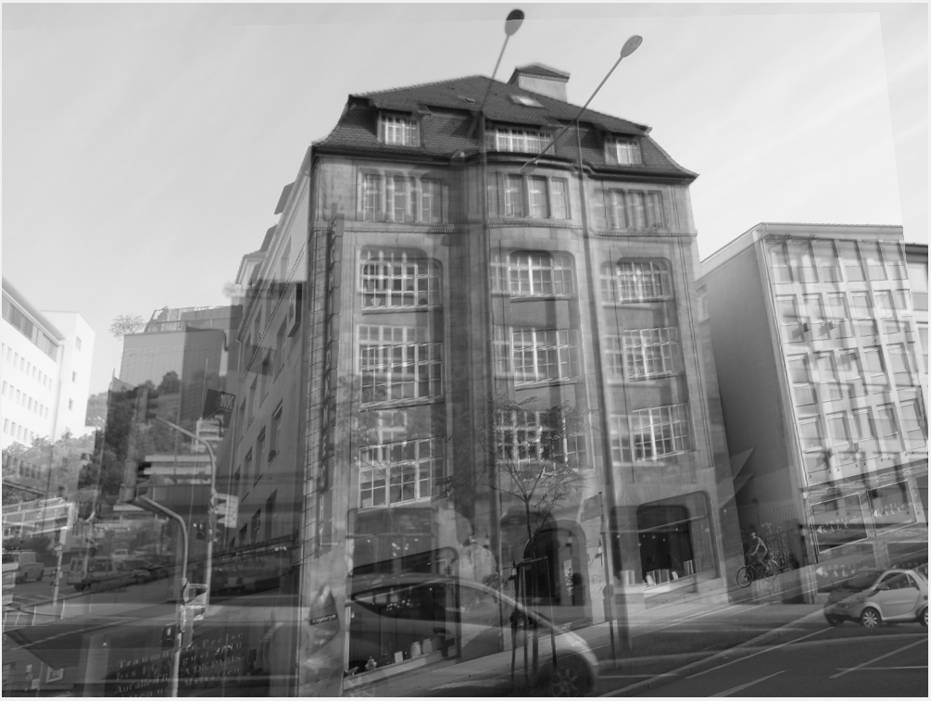

Fig3. Panorama Image

Tabel1 Residuals of Gebaeude

|  |  |  |  |  |  |
| --- | --- | --- | --- | --- | --- |
|  | P1 | P2 | P3 | P4 | P5 |
| x | -0.3506 | 0.4066 | -0.5195 | 0.0996 | 0.2713 |
| y | 1.7821 | -2.0090 | -0.9313 | 4.5227 | -3.3617 |

**2) Geoengine**

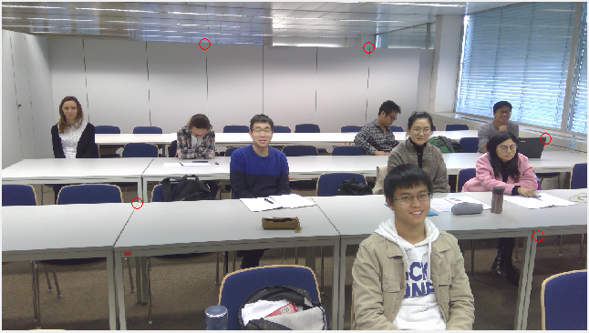

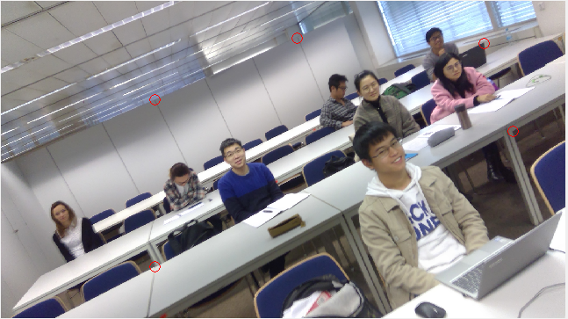

Fig2.1 Identical Points



Fig2.2 Geoengine1 in the geometry of Geoengine2

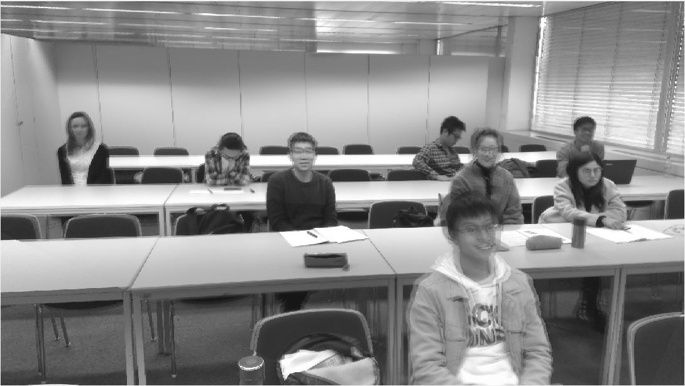

Fig2.3 Panorama Image

Tabel2 Residuals of Geoengine

|  |  |  |  |  |  |
| --- | --- | --- | --- | --- | --- |
|  | P1 | P2 | P3 | P4 | P5 |
| x | -1.3633 | 0.7973 | -0.9560 | 0.1307 | 1.4138 |
| y | 0.7552 | 1.0446 | -4.6337 | 6.1964 | -3.4509 |