Computer Vision Exercise 2

Spatial Intersection and Resection

Yi Wang 3371561 (resubmit)

**I. Processing Steps**

**1. Compute projection matrix & pixel coordinates**

Compute projection matrix:

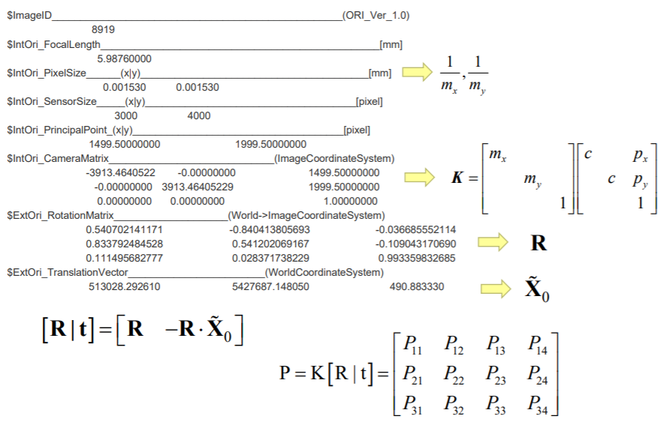

Compute pixel coordinates:



**2. Measure one object**

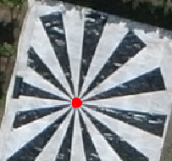

**3. Spatial intersection**

For unknown object coordinate 𝑿 at least two pixel measures 𝒙 and 𝒙′ from two cameras with known projection matrix 𝑷 and 𝑷′are available:



From which we can build identity equation:

 

With

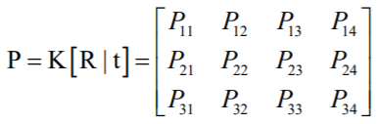

Then we get

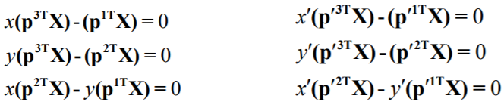

For both x and x’, the third equation is linearly dependent on the other two, therefore we eliminate it and get:



where

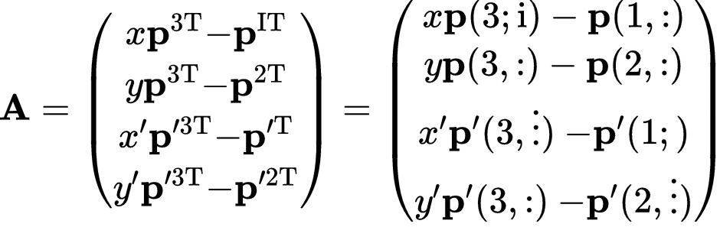

And



Solve this equation using singular vector decomposition, we can get the final object coordinates.

**4. Back transformation and errors**

We apply back transformation with



And calculate the error with

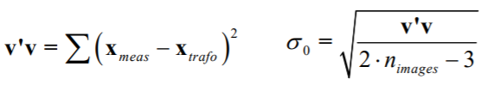

**5. Direct Linear Transformation**

For the direct linear transformation we use the following equation, where P matrix is what we need.

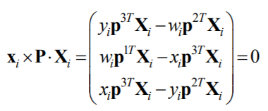

This can be rewritten into

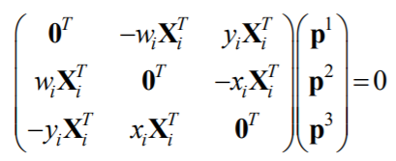

The third row is linear dependent on the first two rows, therefore we can eliminate it:

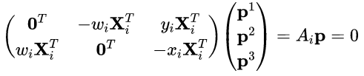

To solve this equation we need more than 6 pairs of points:

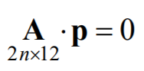

Similar to before, we use singular vector decomposition to calculate the P matrix.

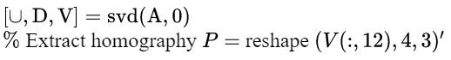

**6. Re-mapping and comparison**

Similar to task 1,  is used to re-compute the mapping

**7. Reconstruct the camera parameters**

**a) translation vector X0**

𝑿0 can be computed from Singular Value Decomposition (SVD) of P:

Where X0 is the last column of V

**b) camera matrix K and rotation matrix R**



Where 𝑴 = 𝑲𝑹 is the left 3x3-Sub-Matrix of P, With matrix 𝑴 can be decomposed into QR decomposition:

And

PS: we have to normalize the K and X0 by the scale factor.

**II. Results**

**1. Fundamental matrix & Pixel coordinates**

Table1. Fundamental matrix P

|  |  |  |  |
| --- | --- | --- | --- |
| 3497.48715935772 | 2083.00231625386 | 1869.39205798182 | -13101021647.8206 |
| 2323.73516206219 | -3332.09572565785 | 997.544343618571 | 16893075551.3581 |
| 0.113062965097000 | -0.0513027902360000 | 0.992262460056000 | 219946.269494256 |

Table2. Pixel coordinates

|  |  |  |  |  |  |  |  |
| --- | --- | --- | --- | --- | --- | --- | --- |
| ID | 15 | 24 | 25 | 32 | 37 | 98 | 99 |
| X (pix) | 3182.8948 | 735.9314 | 626.0374 | 3883.0065 | 4277.4454 | 1950.6201 | 1831.1469 |
| Y (pix) | 2309.9545 | 2663.2930 | 236.2401 | 2654.6698 | 235.6924 | 533.9252 | 502.6307 |

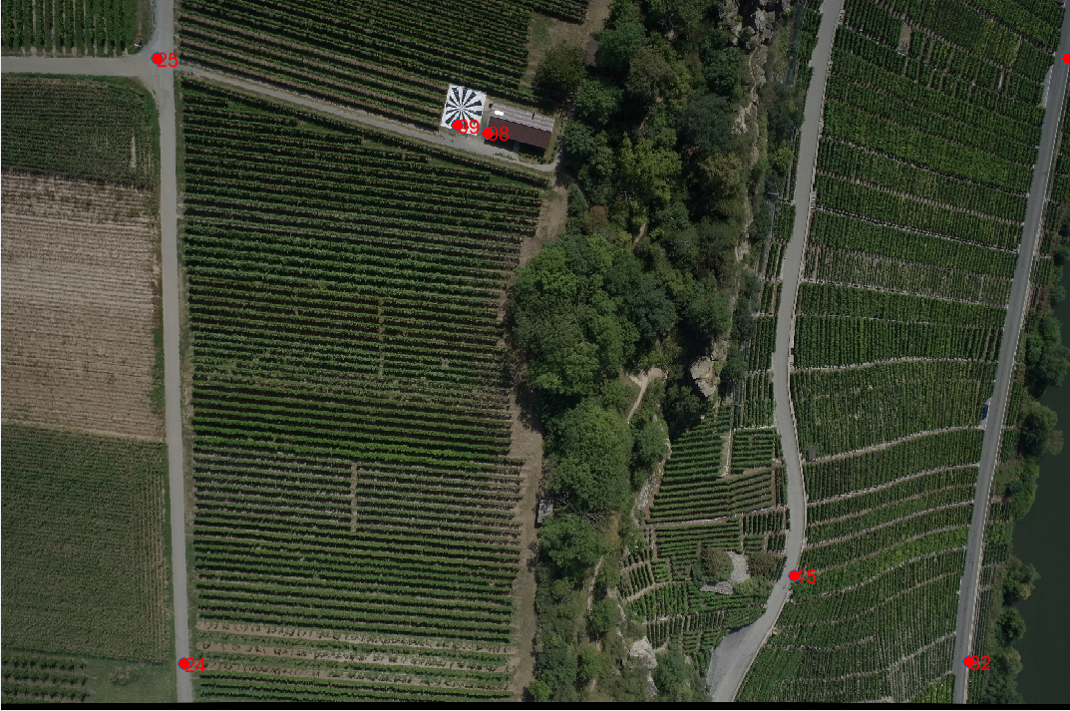

Fig1. Object points in image

**2. Measure an object**



**3. Object Coordinates**

Table3. Calculated object coordinates

|  |  |
| --- | --- |
| X (m) | 512997.1910 |
| Y (m) | 5427680.3764 |
| Z (m) | 326.5378 |

**4. Back transformation errors**

Table4. Differences between pixel coordinates of origin points and back transformed points

|  |  |  |  |  |  |  |  |  |
| --- | --- | --- | --- | --- | --- | --- | --- | --- |
| Photo_ID | 20813 | 20814 | 20815 | 20816 | 20849 | 20850 | 20851 | 20852 |
| Diff_X (pix) | 2.8041 | 0.9643 | -6.1380 | 1.6560 | -5.6518 | 2.7380 | 2.8864 | -0.4562 |
| Diff_Y (pix) | 1.0683 | 0.5424 | -0.2438 | -0.8561 | 0.1675 | -2.2750 | 2.8403 | -0.3507 |

Table5. total transformation error

|  |  |
| --- | --- |
| (pix) | 2.7342 |
| (pix) | 1.0962 |

**5. Direct Linear Transformation**

Table6. P_DLT (without centralization)

|  |  |  |  |
| --- | --- | --- | --- |
| 0 | 0 | 0 | -0.6128 |
| 0 | 0 | 0 | 0.7902 |
| 0 | 0 | 0 | 0 |

Table7. P_DLT (after centralization)

|  |  |  |  |
| --- | --- | --- | --- |
| 0.0052 | 0.0031 | 0.0028 | -0.8836 |
| 0.0035 | -0.0050 | 0.0015 | -0.4681 |
| 0 | 0 | 0 | -0.0003 |

**6. Remapping Difference & Error**

Table8. Remapping differences

|  |  |  |  |  |  |  |  |
| --- | --- | --- | --- | --- | --- | --- | --- |
| ID | 15 | 24 | 25 | 32 | 37 | 98 | 99 |
| X (pix) | 3.15e-08 | -1.32e-08 | -1.64e-08 | 1.13e-07 | 1.05e-07 | -5.16e-08 | -4.64e-08 |
| Y (pix) | 1.39e-08 | -4.08e-08 | -6.92e-09 | 8.10e-08 | 5.60e-09 | -8.54e-09 | -1.85e-08 |

Table9. Remapping error

|  |  |
| --- | --- |
| (pix) | 5.23e-08 |
| (pix) | 2.85e-08 |

**7. Reconstruct Camera Parameters**

**a) reconstructed camera parameters**

X0=

K=

R=

**b) Differences**

X0_difference=

K_difference=

R_difference=

III. re-submit remark

The large differences (my first submission) between origin and remap coordinates and camera parameters in task 5,6 and 7 results from the round error of MATLAB, which moreover comes from the large scale difference between object horizon and vertical coordinates (XY has a scale of but Z only , this leads to a round error when calculating P matrix). To solve this problem, we could simply centralize the object coordinates at the very beginning by subtracting the mean value (see code file also: four more lines in task 5).

X_20851_m = repmat(mean(X_20851'),7,1)';

X_20851_m(4,:) = 0;

X_20851_c = X_20851-X_20851_m; % Centralization