**Computer Vision Exercise 3**

**Epipolar Lines**

*Yi Wang 3371561*

**1. Fundamental matrix**

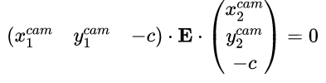

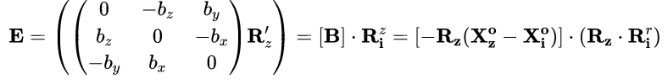

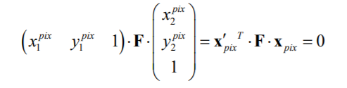



Where E is essential matrix (mapping of camera coordinates) and F is fundamental matrix (mapping of pixel coordinates)

**2. Epipolar lines**

The formula



provides all potential positions of corresponding point x’, then homogenous coordinates x’ of points on line l’ are computed by normal form

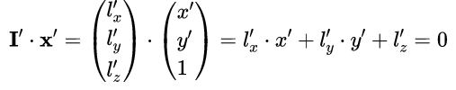

From which we can get the epipolar line:

