Task1

a)

type of receiver and software version: TRIMBLE NETR9 5.37

GNSS systems from which observations are included: G, S, R, E, C

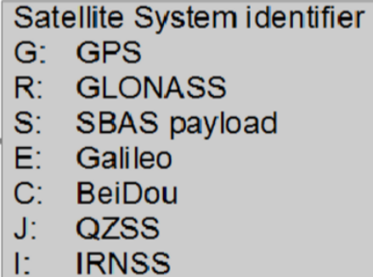

Starting epoch in the corresponding time system: 2019.12.5 12:00:00 GPS

Data rate of the observations: 1s

Main types of observations and their units:

|  |  |  |  |  |
| --- | --- | --- | --- | --- |
| C (Pseudorange C/A) | P (Pseudorange P code) | L (carrier phase) | S (SNR value / Raw signal strength) | D (Doppler) |
| meters | | Full cycles | Receiver dependent  (dB) | Hz |

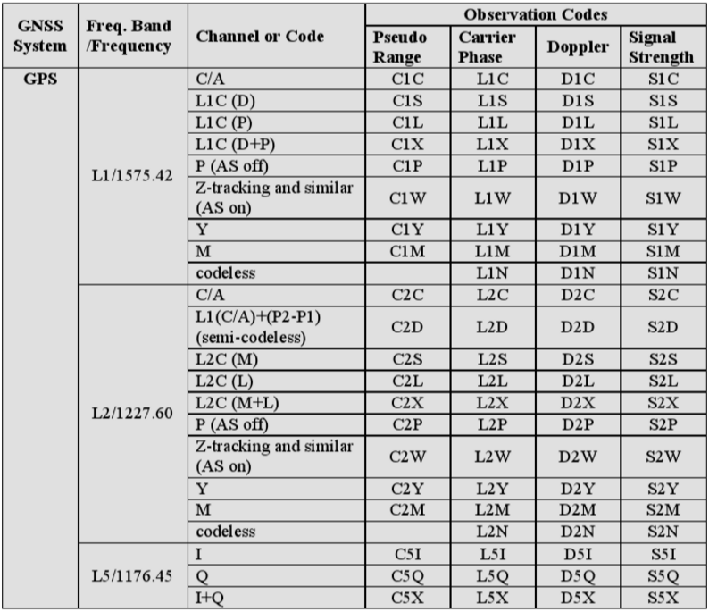

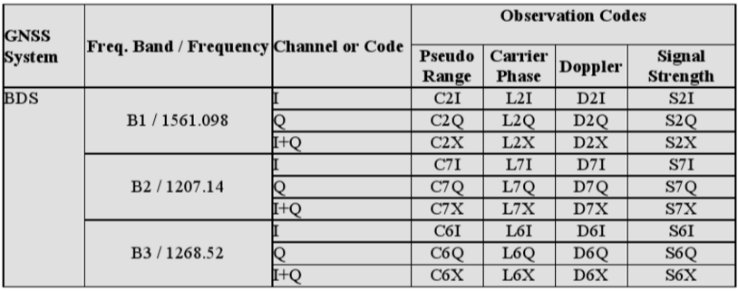

b)