Task 1

1. Comparison of position

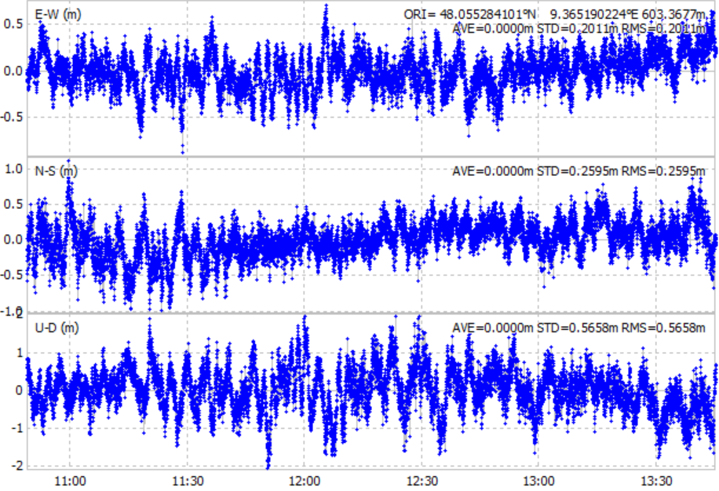

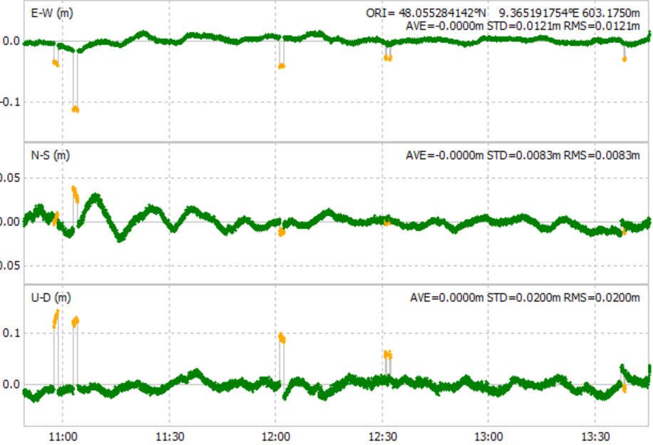

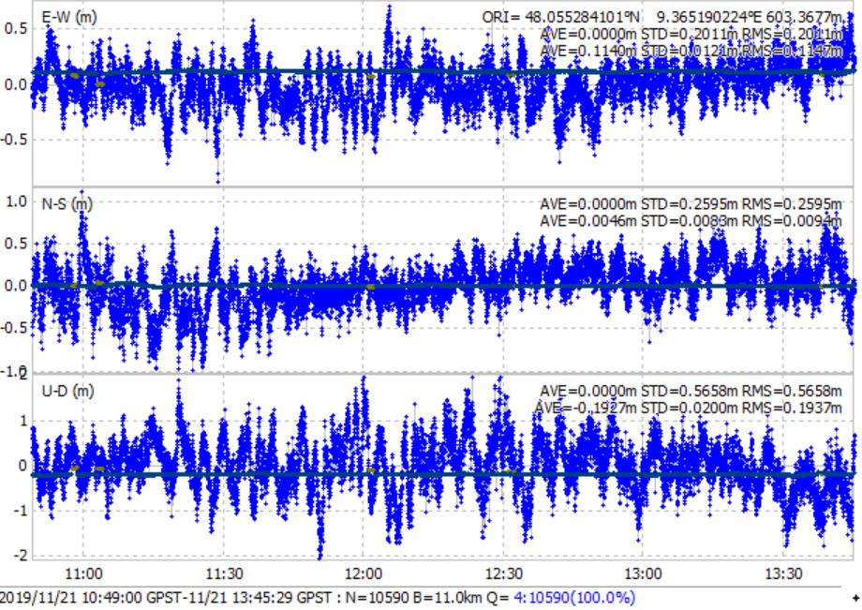

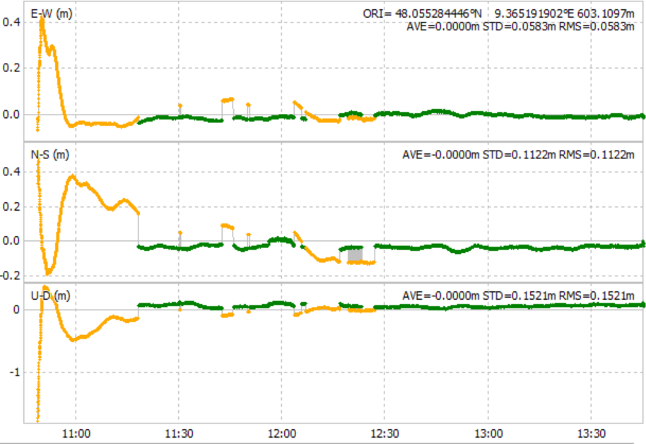

2. ratio factor for AR validation

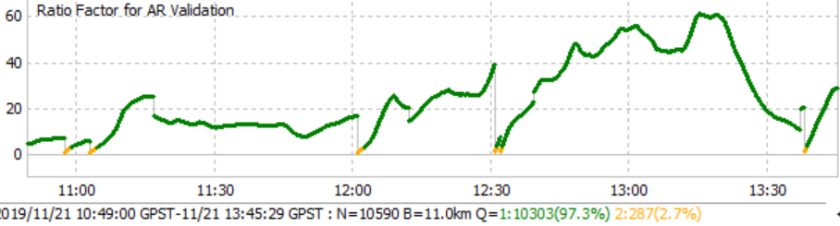

GPS

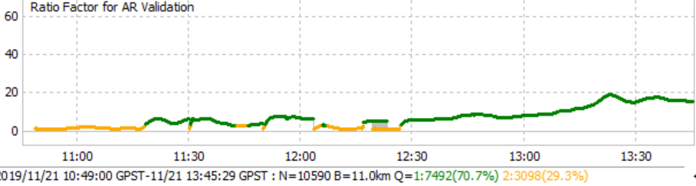

GLONASS

The ratio factor of "ratio-test" for standard integer ambiguity validation strategy. The value means the ratio of the squared sum of the residuals with the second best integer vector to with the best integer vector.

3. percentage of time with fixed/float ambiguities

2.7% vs 29.3%

4. pseudorange/carrier face residuals

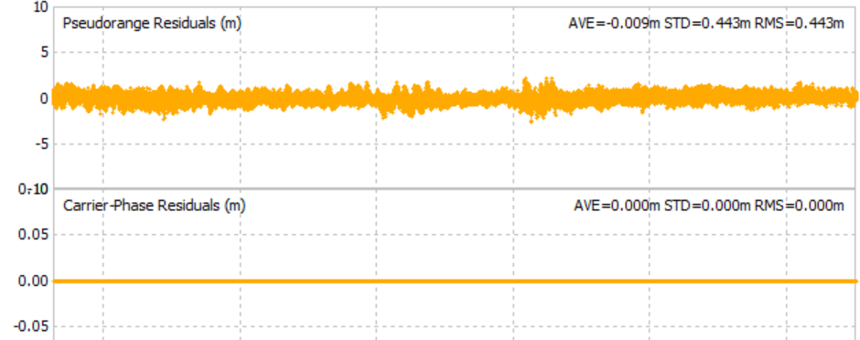

dgps

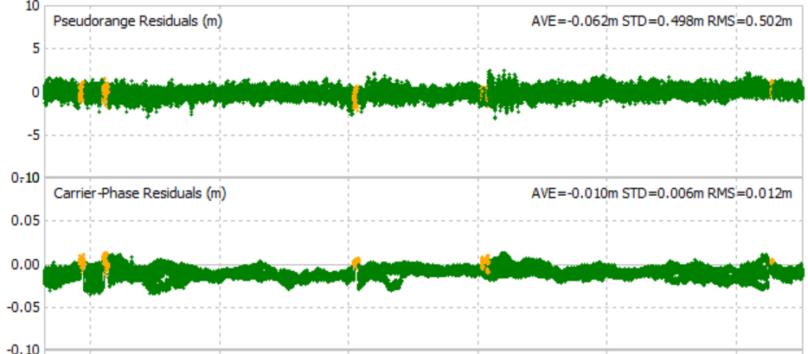

Rtk-gps

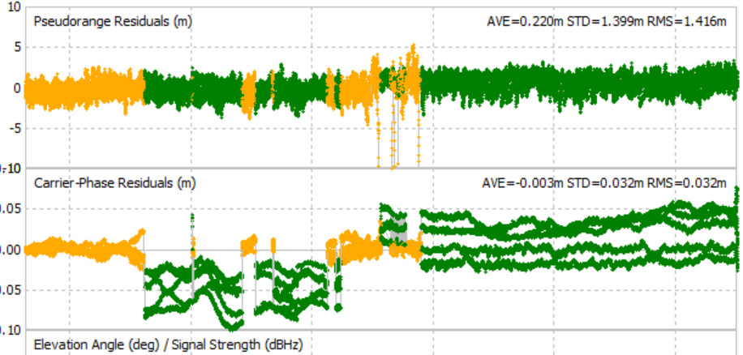

Rtk-glonass

Task 2

1. google earth

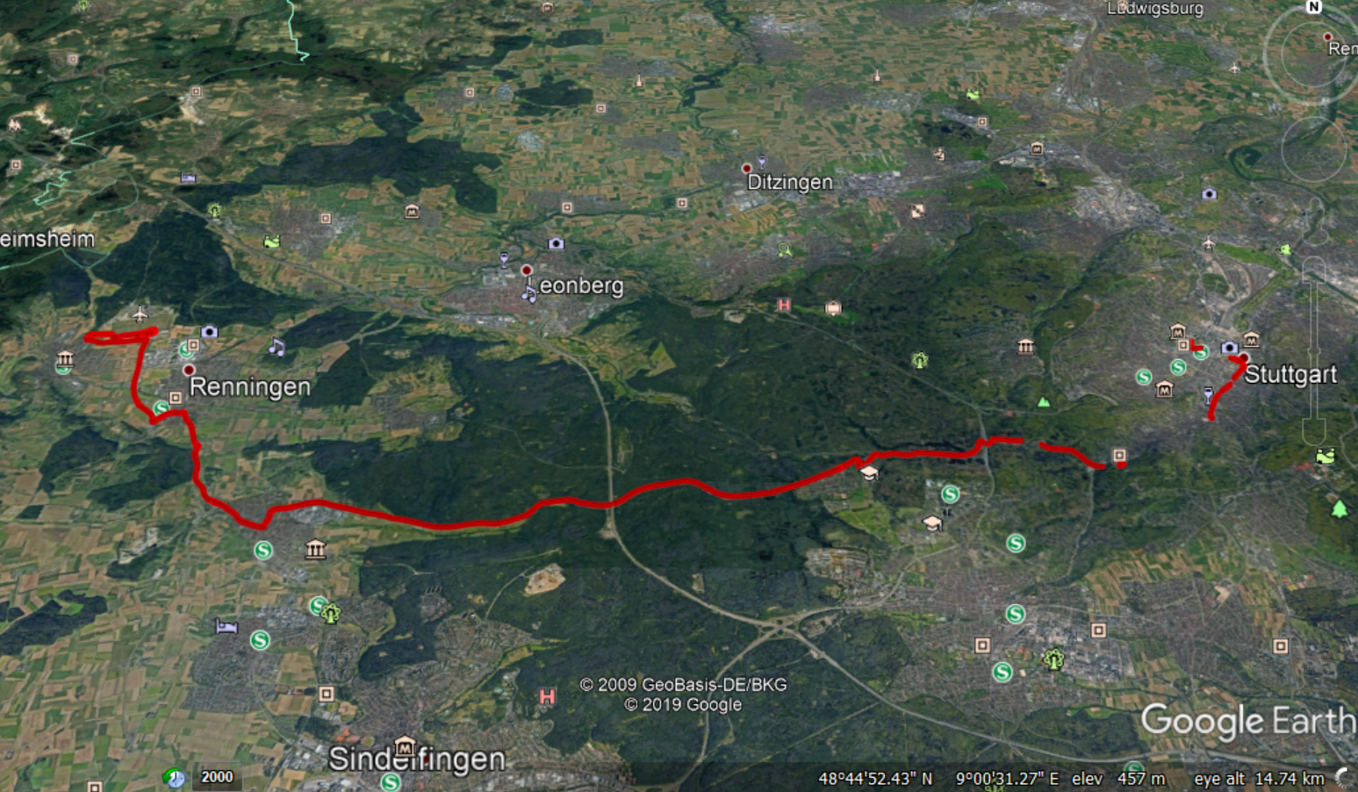

2. position

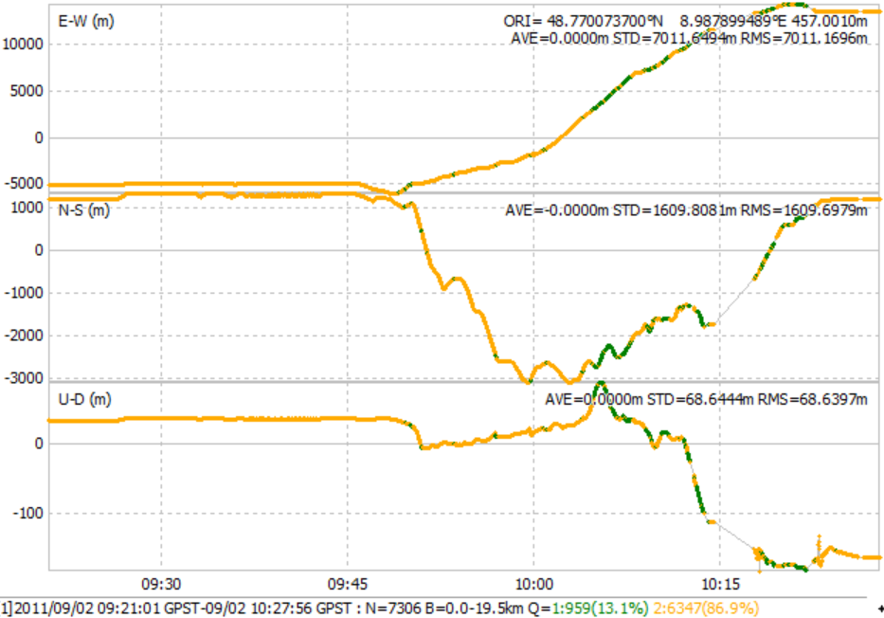

2. percentage of time

13.1% vs 86.9%

3. pseudorange/carrier face residuals

