# 使用外网服务器（QQ）发送邮件

获取QQ服务器地址：

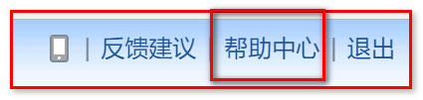

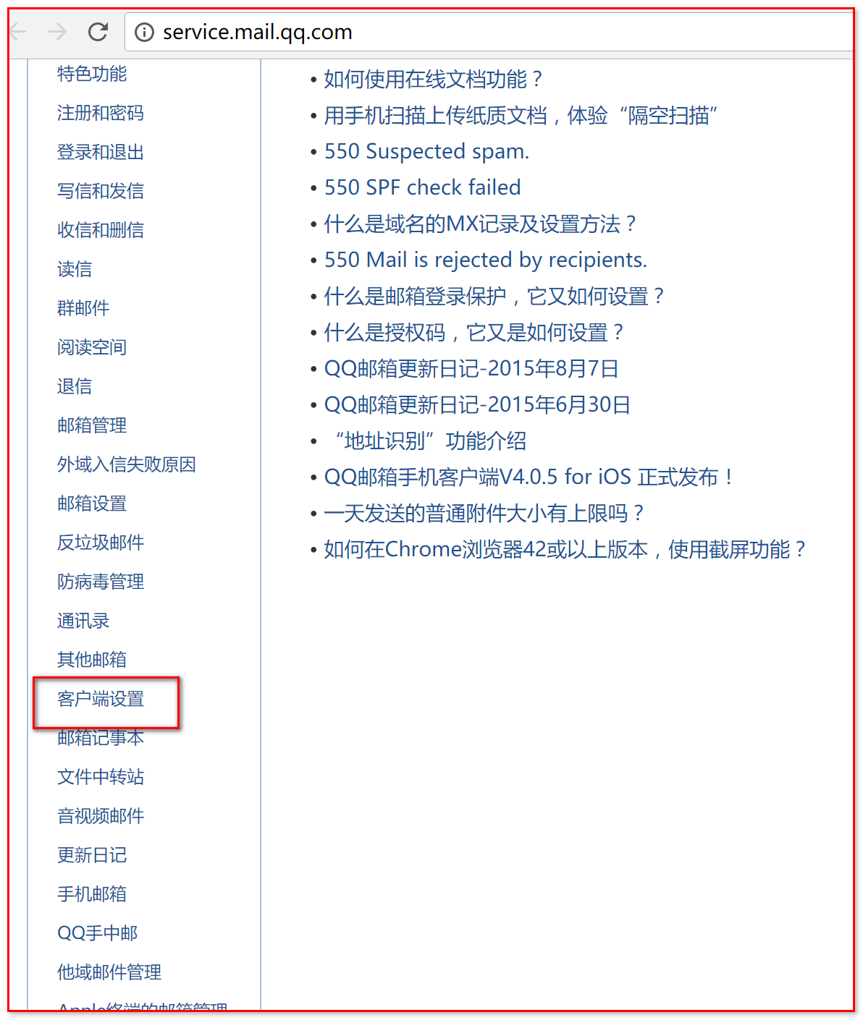

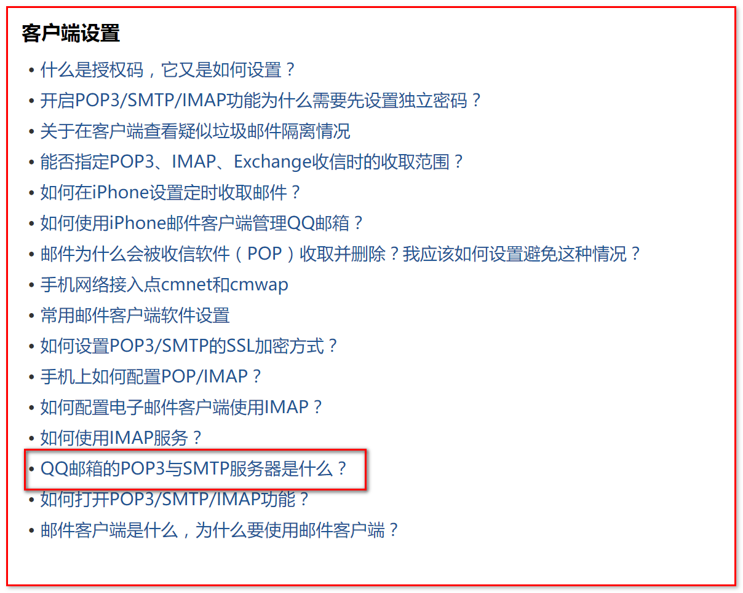

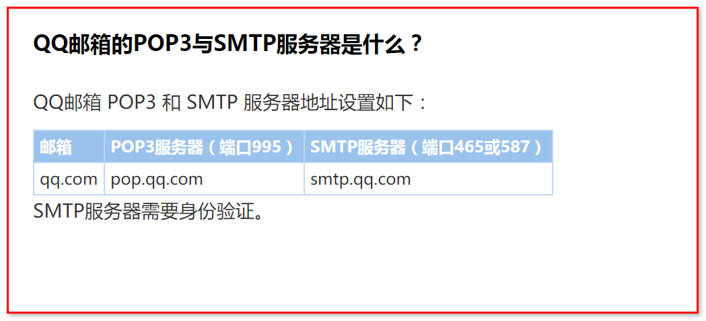

|  |  |  |
| --- | --- | --- |
| **邮箱** | **POP3服务器（端口995）** | **SMTP服务器（端口465或587）** |
| qq.com | pop.qq.com | smtp.qq.com |

修改服务器地址：

props.put("mail.smtp.host", "smtp.qq.com");

错误：需要认证信息

|  |
| --- |
| com.sun.mail.smtp.SMTPSendFailedException: 503 Error: need EHLO and AUTH first !  ;  nested exception is:  com.sun.mail.smtp.SMTPSenderFailedException: 503 Error: need EHLO and AUTH first !  at com.sun.mail.smtp.SMTPTransport.issueSendCommand(SMTPTransport.java:2343)  at com.sun.mail.smtp.SMTPTransport.mailFrom(SMTPTransport.java:1808)  at com.sun.mail.smtp.SMTPTransport.sendMessage(SMTPTransport.java:1285)  at javax.mail.Transport.send0(Transport.java:255)  at javax.mail.Transport.send(Transport.java:124)  at ci.igeek.utils.MailUtils2.sendMail(MailUtils2.java:34)  at ci.igeek.test.MailTest.test1(MailTest.java:11)  at sun.reflect.NativeMethodAccessorImpl.invoke0(Native Method)  at sun.reflect.NativeMethodAccessorImpl.invoke(NativeMethodAccessorImpl.java:57)  at sun.reflect.DelegatingMethodAccessorImpl.invoke(DelegatingMethodAccessorImpl.java:43)  at java.lang.reflect.Method.invoke(Method.java:606)  at org.junit.runners.model.FrameworkMethod$1.runReflectiveCall(FrameworkMethod.java:50)  at org.junit.internal.runners.model.ReflectiveCallable.run(ReflectiveCallable.java:12)  at org.junit.runners.model.FrameworkMethod.invokeExplosively(FrameworkMethod.java:47)  at org.junit.internal.runners.statements.InvokeMethod.evaluate(InvokeMethod.java:17)  at org.junit.runners.ParentRunner.runLeaf(ParentRunner.java:325)  at org.junit.runners.BlockJUnit4ClassRunner.runChild(BlockJUnit4ClassRunner.java:78)  at org.junit.runners.BlockJUnit4ClassRunner.runChild(BlockJUnit4ClassRunner.java:57)  at org.junit.runners.ParentRunner$3.run(ParentRunner.java:290)  at org.junit.runners.ParentRunner$1.schedule(ParentRunner.java:71)  at org.junit.runners.ParentRunner.runChildren(ParentRunner.java:288)  at org.junit.runners.ParentRunner.access$000(ParentRunner.java:58)  at org.junit.runners.ParentRunner$2.evaluate(ParentRunner.java:268)  at org.junit.runners.ParentRunner.run(ParentRunner.java:363)  at org.eclipse.jdt.internal.junit4.runner.JUnit4TestReference.run(JUnit4TestReference.java:86)  at org.eclipse.jdt.internal.junit.runner.TestExecution.run(TestExecution.java:38)  at org.eclipse.jdt.internal.junit.runner.RemoteTestRunner.runTests(RemoteTestRunner.java:459)  at org.eclipse.jdt.internal.junit.runner.RemoteTestRunner.runTests(RemoteTestRunner.java:675)  at org.eclipse.jdt.internal.junit.runner.RemoteTestRunner.run(RemoteTestRunner.java:382)  at org.eclipse.jdt.internal.junit.runner.RemoteTestRunner.main(RemoteTestRunner.java:192)  Caused by: com.sun.mail.smtp.SMTPSenderFailedException: 503 Error: need EHLO and AUTH first !  at com.sun.mail.smtp.SMTPTransport.mailFrom(SMTPTransport.java:1817)  ... 28 more |

添加认证：

在javamail-samples，找到红框内容，查看代码：

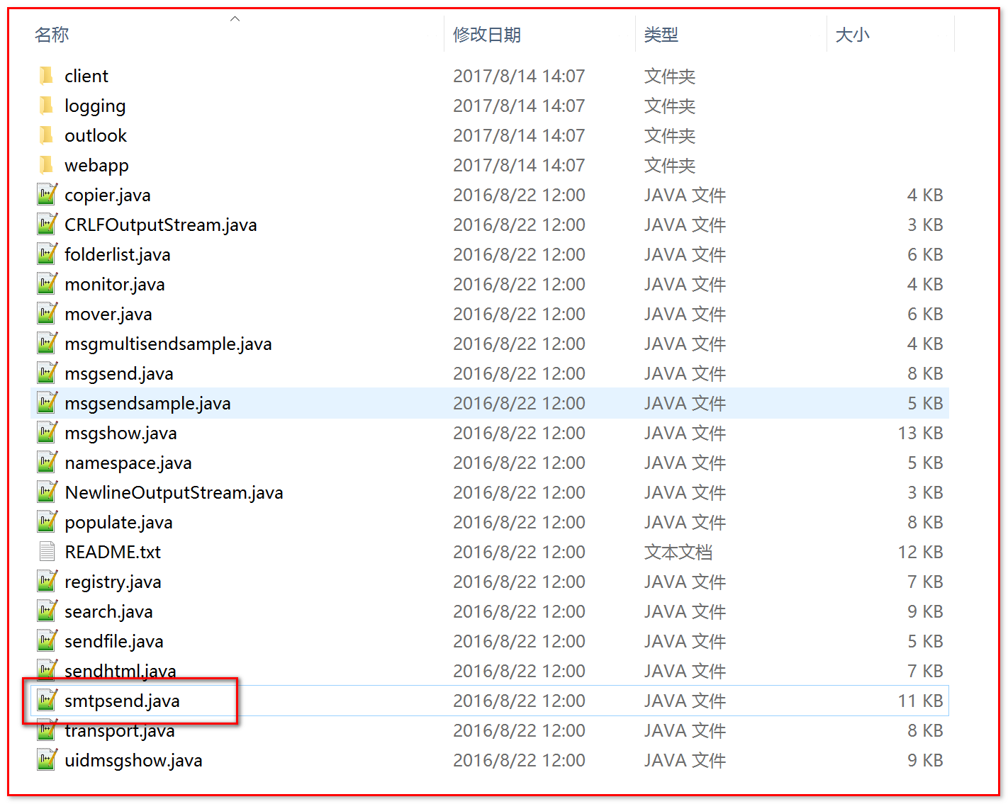

在集合多添加了一行用户认证：

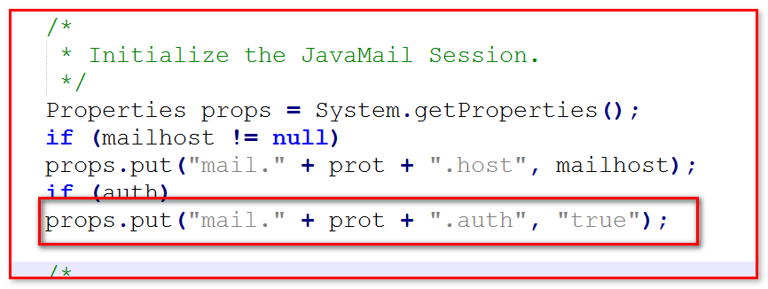

代码添加：认证

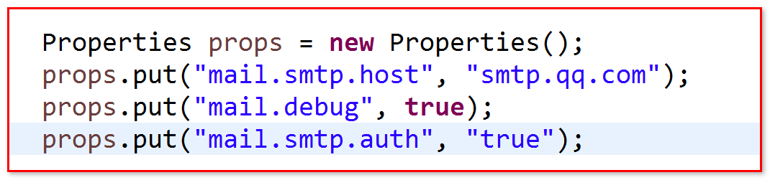

报错：认证需要用户名和密码

|  |
| --- |
| javax.mail.AuthenticationFailedException: failed to connect, no password specified?  at javax.mail.Service.connect(Service.java:400)  at javax.mail.Service.connect(Service.java:246)  at javax.mail.Service.connect(Service.java:195)  at javax.mail.Transport.send0(Transport.java:254)  at javax.mail.Transport.send(Transport.java:124)  at ci.igeek.utils.MailUtils2.sendMail(MailUtils2.java:34)  at ci.igeek.test.MailTest.test1(MailTest.java:11)  at sun.reflect.NativeMethodAccessorImpl.invoke0(Native Method)  at sun.reflect.NativeMethodAccessorImpl.invoke(NativeMethodAccessorImpl.java:57)  at sun.reflect.DelegatingMethodAccessorImpl.invoke(DelegatingMethodAccessorImpl.java:43)  at java.lang.reflect.Method.invoke(Method.java:606)  at org.junit.runners.model.FrameworkMethod$1.runReflectiveCall(FrameworkMethod.java:50)  at org.junit.internal.runners.model.ReflectiveCallable.run(ReflectiveCallable.java:12)  at org.junit.runners.model.FrameworkMethod.invokeExplosively(FrameworkMethod.java:47)  at org.junit.internal.runners.statements.InvokeMethod.evaluate(InvokeMethod.java:17)  at org.junit.runners.ParentRunner.runLeaf(ParentRunner.java:325)  at org.junit.runners.BlockJUnit4ClassRunner.runChild(BlockJUnit4ClassRunner.java:78)  at org.junit.runners.BlockJUnit4ClassRunner.runChild(BlockJUnit4ClassRunner.java:57)  at org.junit.runners.ParentRunner$3.run(ParentRunner.java:290)  at org.junit.runners.ParentRunner$1.schedule(ParentRunner.java:71)  at org.junit.runners.ParentRunner.runChildren(ParentRunner.java:288)  at org.junit.runners.ParentRunner.access$000(ParentRunner.java:58)  at org.junit.runners.ParentRunner$2.evaluate(ParentRunner.java:268)  at org.junit.runners.ParentRunner.run(ParentRunner.java:363)  at org.eclipse.jdt.internal.junit4.runner.JUnit4TestReference.run(JUnit4TestReference.java:86)  at org.eclipse.jdt.internal.junit.runner.TestExecution.run(TestExecution.java:38)  at org.eclipse.jdt.internal.junit.runner.RemoteTestRunner.runTests(RemoteTestRunner.java:459)  at org.eclipse.jdt.internal.junit.runner.RemoteTestRunner.runTests(RemoteTestRunner.java:675)  at org.eclipse.jdt.internal.junit.runner.RemoteTestRunner.run(RemoteTestRunner.java:382)  at org.eclipse.jdt.internal.junit.runner.RemoteTestRunner.main(RemoteTestRunner.java:192) |

填上用户名和密码，继续报错：设置ssl端口587

|  |
| --- |
| javax.mail.AuthenticationFailedException: 530 Error: A secure connection is requiered(such as ssl). More information at http://service.mail.qq.com/cgi-bin/help?id=28  at com.sun.mail.smtp.SMTPTransport$Authenticator.authenticate(SMTPTransport.java:950)  at com.sun.mail.smtp.SMTPTransport.authenticate(SMTPTransport.java:861)  at com.sun.mail.smtp.SMTPTransport.protocolConnect(SMTPTransport.java:766)  at javax.mail.Service.connect(Service.java:366)  at javax.mail.Service.connect(Service.java:246)  at javax.mail.Service.connect(Service.java:267)  at javax.mail.Transport.send0(Transport.java:252)  at javax.mail.Transport.send(Transport.java:174)  at ci.igeek.utils.MailUtils2.sendMail(MailUtils2.java:36)  at ci.igeek.test.MailTest.test1(MailTest.java:11)  at sun.reflect.NativeMethodAccessorImpl.invoke0(Native Method)  at sun.reflect.NativeMethodAccessorImpl.invoke(NativeMethodAccessorImpl.java:57)  at sun.reflect.DelegatingMethodAccessorImpl.invoke(DelegatingMethodAccessorImpl.java:43)  at java.lang.reflect.Method.invoke(Method.java:606)  at org.junit.runners.model.FrameworkMethod$1.runReflectiveCall(FrameworkMethod.java:50)  at org.junit.internal.runners.model.ReflectiveCallable.run(ReflectiveCallable.java:12)  at org.junit.runners.model.FrameworkMethod.invokeExplosively(FrameworkMethod.java:47)  at org.junit.internal.runners.statements.InvokeMethod.evaluate(InvokeMethod.java:17)  at org.junit.runners.ParentRunner.runLeaf(ParentRunner.java:325)  at org.junit.runners.BlockJUnit4ClassRunner.runChild(BlockJUnit4ClassRunner.java:78)  at org.junit.runners.BlockJUnit4ClassRunner.runChild(BlockJUnit4ClassRunner.java:57)  at org.junit.runners.ParentRunner$3.run(ParentRunner.java:290)  at org.junit.runners.ParentRunner$1.schedule(ParentRunner.java:71)  at org.junit.runners.ParentRunner.runChildren(ParentRunner.java:288)  at org.junit.runners.ParentRunner.access$000(ParentRunner.java:58)  at org.junit.runners.ParentRunner$2.evaluate(ParentRunner.java:268)  at org.junit.runners.ParentRunner.run(ParentRunner.java:363)  at org.eclipse.jdt.internal.junit4.runner.JUnit4TestReference.run(JUnit4TestReference.java:86)  at org.eclipse.jdt.internal.junit.runner.TestExecution.run(TestExecution.java:38)  at org.eclipse.jdt.internal.junit.runner.RemoteTestRunner.runTests(RemoteTestRunner.java:459)  at org.eclipse.jdt.internal.junit.runner.RemoteTestRunner.runTests(RemoteTestRunner.java:675)  at org.eclipse.jdt.internal.junit.runner.RemoteTestRunner.run(RemoteTestRunner.java:382)  at org.eclipse.jdt.internal.junit.runner.RemoteTestRunner.main(RemoteTestRunner.java:192) |

添加端口，继续报错：需要授权码（使用第三方客户端登录QQ邮箱），根据网址提示操作

|  |
| --- |
| javax.mail.AuthenticationFailedException: 535 Error: ÇëÊ¹ÓÃÊÚÈ¨ÂëµÇÂ¼¡£ÏêÇéÇë¿´: http://service.mail.qq.com/cgi-bin/help?subtype=1&&id=28&&no=1001256  at com.sun.mail.smtp.SMTPTransport$Authenticator.authenticate(SMTPTransport.java:950)  at com.sun.mail.smtp.SMTPTransport.authenticate(SMTPTransport.java:861)  at com.sun.mail.smtp.SMTPTransport.protocolConnect(SMTPTransport.java:766)  at javax.mail.Service.connect(Service.java:366)  at javax.mail.Service.connect(Service.java:246)  at javax.mail.Service.connect(Service.java:267)  at javax.mail.Transport.send0(Transport.java:252)  at javax.mail.Transport.send(Transport.java:174)  at ci.igeek.utils.MailUtils2.sendMail(MailUtils2.java:36)  at ci.igeek.test.MailTest.test1(MailTest.java:11)  at sun.reflect.NativeMethodAccessorImpl.invoke0(Native Method)  at sun.reflect.NativeMethodAccessorImpl.invoke(NativeMethodAccessorImpl.java:57)  at sun.reflect.DelegatingMethodAccessorImpl.invoke(DelegatingMethodAccessorImpl.java:43)  at java.lang.reflect.Method.invoke(Method.java:606)  at org.junit.runners.model.FrameworkMethod$1.runReflectiveCall(FrameworkMethod.java:50)  at org.junit.internal.runners.model.ReflectiveCallable.run(ReflectiveCallable.java:12)  at org.junit.runners.model.FrameworkMethod.invokeExplosively(FrameworkMethod.java:47)  at org.junit.internal.runners.statements.InvokeMethod.evaluate(InvokeMethod.java:17)  at org.junit.runners.ParentRunner.runLeaf(ParentRunner.java:325)  at org.junit.runners.BlockJUnit4ClassRunner.runChild(BlockJUnit4ClassRunner.java:78)  at org.junit.runners.BlockJUnit4ClassRunner.runChild(BlockJUnit4ClassRunner.java:57)  at org.junit.runners.ParentRunner$3.run(ParentRunner.java:290)  at org.junit.runners.ParentRunner$1.schedule(ParentRunner.java:71)  at org.junit.runners.ParentRunner.runChildren(ParentRunner.java:288)  at org.junit.runners.ParentRunner.access$000(ParentRunner.java:58)  at org.junit.runners.ParentRunner$2.evaluate(ParentRunner.java:268)  at org.junit.runners.ParentRunner.run(ParentRunner.java:363)  at org.eclipse.jdt.internal.junit4.runner.JUnit4TestReference.run(JUnit4TestReference.java:86)  at org.eclipse.jdt.internal.junit.runner.TestExecution.run(TestExecution.java:38)  at org.eclipse.jdt.internal.junit.runner.RemoteTestRunner.runTests(RemoteTestRunner.java:459)  at org.eclipse.jdt.internal.junit.runner.RemoteTestRunner.runTests(RemoteTestRunner.java:675)  at org.eclipse.jdt.internal.junit.runner.RemoteTestRunner.run(RemoteTestRunner.java:382)  at org.eclipse.jdt.internal.junit.runner.RemoteTestRunner.main(RemoteTestRunner.java:192) |

**什么是授权码，它又是如何设置？**

**1、什么是授权码？**

授权码是QQ邮箱推出的，用于登录第三方客户端的专用密码。

适用于登录以下服务：POP3/IMAP/SMTP/Exchange/CardDAV/CalDAV服务。

**温馨提醒：为了你的帐户安全，更改QQ密码以及独立密码会触发授权码过期，需要重新获取新的授权码登录。**

**2、怎么获取授权码？**

先进入设置－》帐户页面找到入口，按照以下流程操作。

（1）点击“开启”（pop3/smtp 服务）

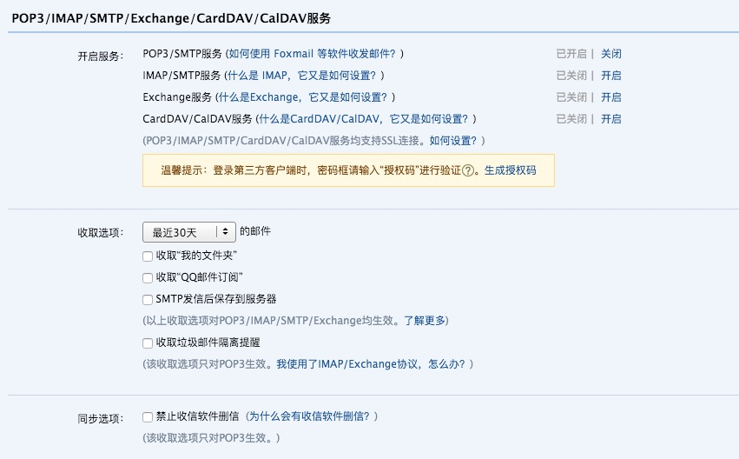

验证：

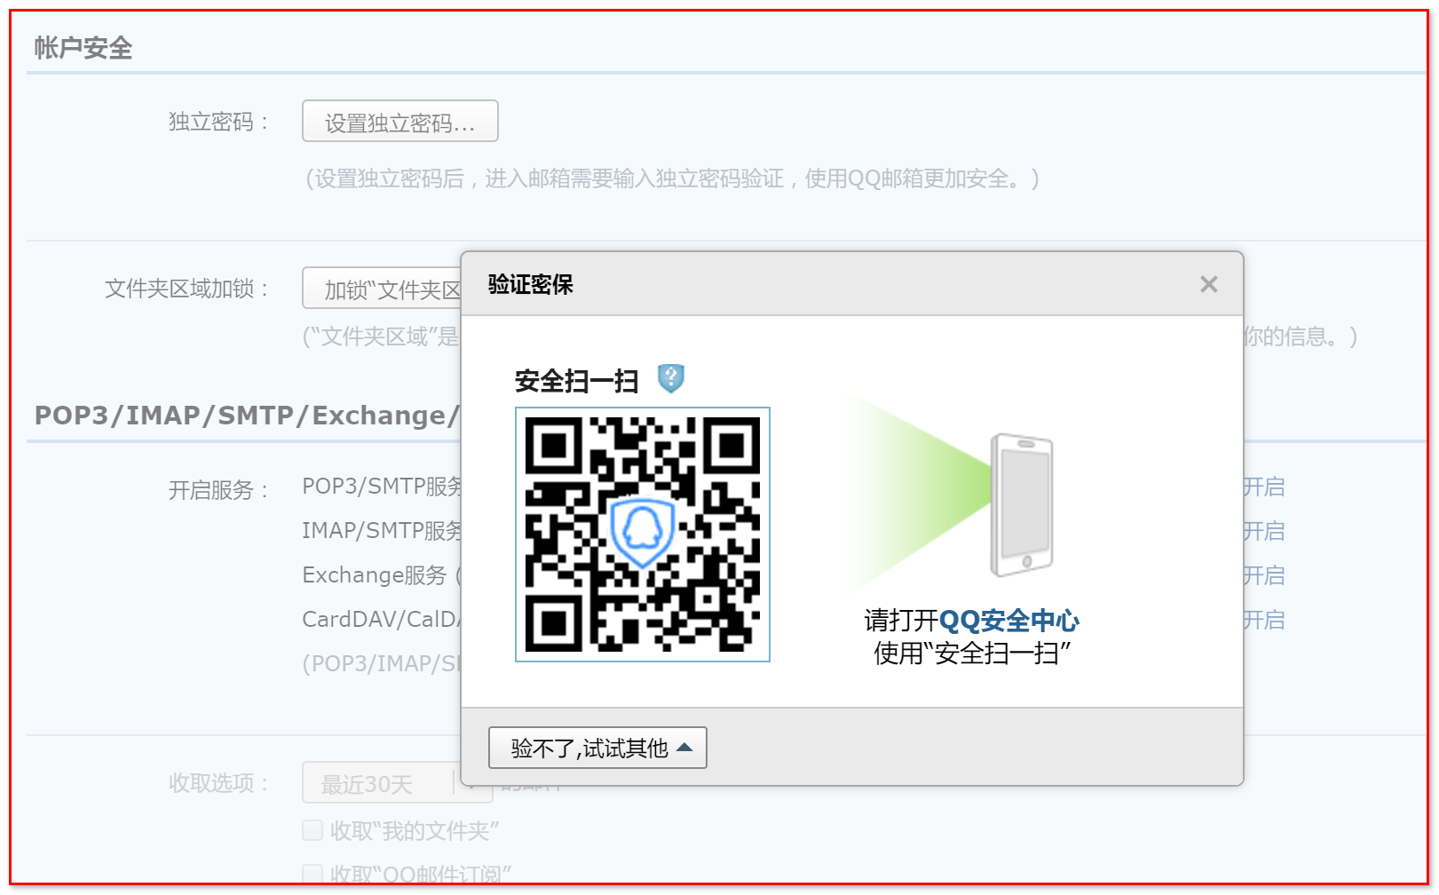

（2）验证密保（手机扫二维码，不用发短信）

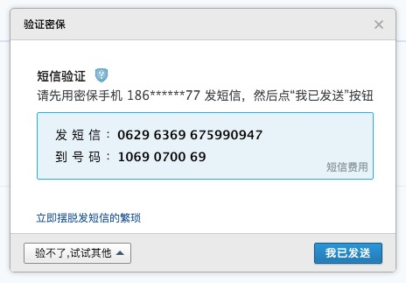

（3）获取授权码

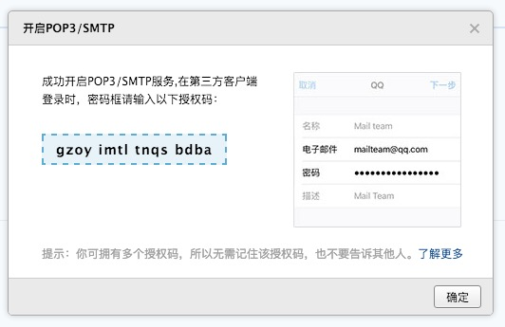

**3、在第三方客户端怎么设置？**

在第三方客户端的密码框里面输入16位授权码进行验证。（涂改处写入授权码）



代码：

|  |
| --- |
| package ci.igeek.utils;  import java.util.Date;  import java.util.Properties;  import javax.mail.Authenticator;  import javax.mail.Message;  import javax.mail.PasswordAuthentication;  import javax.mail.Session;  import javax.mail.Transport;  import javax.mail.internet.InternetAddress;  import javax.mail.internet.MimeMessage;  public class MailUtils2 {  public static void sendMail(String from,String to,String subject,String msgText){    Properties props = new Properties();  props.put("mail.smtp.host", "smtp.qq.com");  props.put("mail.debug", true);  props.put("mail.smtp.auth", "true");  props.put("mail.smtp.port", "587");    Session session = Session.getInstance(props, null);  session.setDebug(false);    try {  MimeMessage msg = new MimeMessage(session);  msg.setFrom(new InternetAddress(from));  InternetAddress[] address = {new InternetAddress(to)};  msg.setRecipients(Message.RecipientType.TO, address);  msg.setSubject(subject);  msg.setSentDate(new Date());  msg.setText(msgText);  //xxx邮箱用户名，yyy，邮箱密码  Transport.send(msg,"xxx","yyy");  } catch (Exception e) {  e.printStackTrace();  }  }  } |

效果：

