**项目管理工具**

**maven**

# 学习目标

掌握Maven的传递依赖

使用Maven构建SSM项目

分模块构建Maven工程

掌握Maven私服的搭建

掌握私服中jar包的上传和下载

# Maven的传递依赖

## 1.1什么是传递依赖

当A 依赖B、B依赖C，在A中导入B后会自动导入C，C是A的传递依赖，如果C依赖D则D也可能是A的传递依赖。

## 1.2依赖版本冲突解决

### 1.2.1什么是依赖版本冲突

当一个项目依赖的构件比较多时，它们相互之前存在依赖，当你需要对依赖版本统一管理时如果让maven自动来处理可能并不能如你所愿。

### 1.2.2依赖调解原则

maven自动按照下边的原则调解：

**1、第一声明者优先原则**

在pom文件定义依赖，先声明的依赖为准。

**2、路径近者优先原则**

例如：A依赖 spirng-beans-4.2.4，A依赖B依赖 spirng-beans-3.0.5，则spring-beans-4.2.4优先被依赖在A中，因为spring-beans-4.2.4相对spirng-beans-3.0.5被A依赖的路径最近。

### 1.2.3排除依赖

依赖版本冲突的问题可以通过排除依赖的方式来解决，将传递依赖中不合理的依赖排除，使用合理的依赖来构建我们的工程。

排除依赖可以在依赖的配置dependency中使用exclusion标签来进行排除操作。

### 1.2.4锁定版本

面对众多的依赖，有一种方法不用考虑依赖路径、声明优化等因素可以采用直接锁定版本的方法确定依赖构件的版本，版本锁定后则不考虑依赖的声明顺序或依赖的路径，以锁定的版本的为准添加到工程中，此方法在企业开发中常用。锁定依赖的版本可以使用dependencyManagement标签来设置。

需要注意的是在工程中锁定依赖的版本并不代表在工程中添加了依赖，如果工程需要添加锁定版本的依赖则需要单独添加<dependencies></dependencies>标签。

# maven构建ssh工程

## 2.1需求

在web工程的基础上实现SSM工程构建，实现对员工和部门的管理。

## 2.2数据库环境

创建数据库：maven

导入，maven.sql创建表

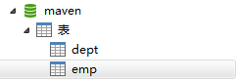

## 2.3定义pom.xml

maven工程首先要识别依赖，web工程实现SSM整合，需要依赖Spring、 springMVC、Mybatis等，在pom.xml添加工程如下依赖：

|  |
| --- |
| <project xmlns=*"http://maven.apache.org/POM/4.0.0"* xmlns:xsi=*"http://www.w3.org/2001/XMLSchema-instance"*  xsi:schemaLocation=*"http://maven.apache.org/POM/4.0.0 http://maven.apache.org/xsd/maven-4.0.0.xsd"*>  <modelVersion>4.0.0</modelVersion>  <groupId>com.igeek.maven</groupId>  <artifactId>ssm</artifactId>  <version>0.0.1-SNAPSHOT</version>  <packaging>war</packaging>  <!-- 添加工程的依赖 -->  <dependencies>  <dependency>  <groupId>junit</groupId>  <artifactId>junit</artifactId>  <version>4.12</version>  <scope>test</scope>  </dependency>  <!-- servlet-api JSP页面编译时需要的包 -->  <dependency>  <groupId>javax.servlet</groupId>  <artifactId>servlet-api</artifactId>  <version>3.0-alpha-1</version>  <scope>provided</scope>  </dependency>  <!-- Spring 以及 SpringMVC需要引入的包，自动引入需要参照的包 -->  <dependency>  <groupId>org.springframework</groupId>  <artifactId>spring-webmvc</artifactId>  <version>4.3.6.RELEASE</version>  </dependency>  <!-- 持久层的包 -->  <dependency>  <groupId>org.mybatis</groupId>  <artifactId>mybatis</artifactId>  <version>3.4.2</version>  </dependency>  <!-- Spring 和 Mybatis的整合包 -->  <dependency>  <groupId>org.mybatis</groupId>  <artifactId>mybatis-spring</artifactId>  <version>1.3.1</version>  </dependency>  <!-- Mysql驱动包 -->  <dependency>  <groupId>mysql</groupId>  <artifactId>mysql-connector-java</artifactId>  <version>5.1.19</version>  </dependency>  <!-- druid数据库连接池 -->  <dependency>  <groupId>com.alibaba</groupId>  <artifactId>druid</artifactId>  <version>1.0.28</version>  </dependency>  <dependency>  <groupId>org.aspectj</groupId>  <artifactId>aspectjweaver</artifactId>  <version>1.8.10</version>  </dependency>  <dependency>  <groupId>org.springframework</groupId>  <artifactId>spring-jdbc</artifactId>  <version>4.3.6.RELEASE</version>  </dependency>  <!-- 打日志的 -->  <dependency>  <groupId>org.slf4j</groupId>  <artifactId>slf4j-log4j12</artifactId>  <version>1.7.24</version>  <scope>runtime</scope>  </dependency>  <dependency>  <groupId>org.slf4j</groupId>  <artifactId>jcl-over-slf4j</artifactId>  <version>1.7.24</version>  <scope>runtime</scope>  </dependency>  <dependency>  <groupId>log4j</groupId>  <artifactId>log4j</artifactId>  <version>1.2.17</version>  <scope>runtime</scope>  </dependency>  <dependency>  <groupId>jstl</groupId>  <artifactId>jstl</artifactId>  <version>1.2</version>  <scope>provided</scope>  </dependency>  </dependencies>  <build>  <finalName>ssm</finalName>  <resources>  <resource>  <directory>src/main/java</directory>  <includes>  <include>**/*.xml</include>  <include>**/*.properties</include>  </includes>  </resource>  <resource>  <directory>src/main/resources</directory>  <includes>  <include>**/*.xml</include>  <include>**/*.properties</include>  <include>**/*.ini</include>  </includes>  </resource>  </resources>  <plugins>  <!-- 设置编译版本为1.8 -->  <plugin>  <groupId>org.apache.maven.plugins</groupId>  <artifactId>maven-compiler-plugin</artifactId>  <configuration>  <source>1.8</source>  <target>1.8</target>  <encoding>UTF-8</encoding>  </configuration>  </plugin>    <!-- Jetty插件，提供一种web容器 -->  <plugin>  <groupId>org.eclipse.jetty</groupId>  <artifactId>jetty-maven-plugin</artifactId>  <version>9.4.2.v20170220</version>  <configuration>  <httpConnector>  <!-- 配置运行的端口号 -->  <port>80</port>  </httpConnector>  <!-- 配置扫描的时间间隔 -->  <scanIntervalSeconds>1</scanIntervalSeconds>  <webApp>  <!-- 配置上下文 -->  <contextPath>/ssm</contextPath>  </webApp>  </configuration>  </plugin>  </plugins>  </build>  </project> |

## 2.4dao

使用Mybatis作为持久层框架，可以使用Mybatis的逆向工程来生成我们需要的代码。

### 2.4.1domain模型类

在src/main/java创建模型类

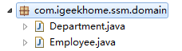

部门实体

|  |
| --- |
| **package** com.igeekhome.ssm.domain;  **import** java.io.Serializable;  **public** **class** Department **implements** Serializable{  **private** Integer deptno;  **private** String dname;  **private** String loc;  **public** Integer getDeptno() {  **return** deptno;  }  **public** **void** setDeptno(Integer deptno) {  **this**.deptno = deptno;  }  **public** String getDname() {  **return** dname;  }  **public** **void** setDname(String dname) {  **this**.dname = dname == **null** ? **null** : dname.trim();  }  **public** String getLoc() {  **return** loc;  }  **public** **void** setLoc(String loc) {  **this**.loc = loc == **null** ? **null** : loc.trim();  }  } |

员工实体

|  |
| --- |
| **package** com.igeekhome.ssm.domain;  **import** java.io.Serializable;  **import** java.math.BigDecimal;  **import** java.util.Date;  **public** **class** Employee **implements** Serializable{  **private** Integer empno;  **private** String ename;  **private** String job;  **private** Integer mgr;  **private** Date hiredate;  **private** BigDecimal sal;  **private** BigDecimal comm;  **private** Integer deptno;  **public** Integer getEmpno() {  **return** empno;  }  **public** **void** setEmpno(Integer empno) {  **this**.empno = empno;  }  **public** String getEname() {  **return** ename;  }  **public** **void** setEname(String ename) {  **this**.ename = ename == **null** ? **null** : ename.trim();  }  **public** String getJob() {  **return** job;  }  **public** **void** setJob(String job) {  **this**.job = job == **null** ? **null** : job.trim();  }  **public** Integer getMgr() {  **return** mgr;  }  **public** **void** setMgr(Integer mgr) {  **this**.mgr = mgr;  }  **public** Date getHiredate() {  **return** hiredate;  }  **public** **void** setHiredate(Date hiredate) {  **this**.hiredate = hiredate;  }  **public** BigDecimal getSal() {  **return** sal;  }  **public** **void** setSal(BigDecimal sal) {  **this**.sal = sal;  }  **public** BigDecimal getComm() {  **return** comm;  }  **public** **void** setComm(BigDecimal comm) {  **this**.comm = comm;  }  **public** Integer getDeptno() {  **return** deptno;  }  **public** **void** setDeptno(Integer deptno) {  **this**.deptno = deptno;  }  } |

### 2.4.2Mapper配置文件

Department配置文件

|  |
| --- |
| <?xml version=*"1.0"* encoding=*"UTF-8"* ?>  <!DOCTYPE mapper PUBLIC "-//mybatis.org//DTD Mapper 3.0//EN" "http://mybatis.org/dtd/mybatis-3-mapper.dtd" >  <mapper namespace=*"com.igeekhome.ssm.dao.DepartmentMapper"* >  <resultMap id=*"BaseResultMap"* type=*"com.igeekhome.ssm.domain.Department"* >  <id column=*"deptno"* property=*"deptno"* jdbcType=*"INTEGER"* />  <result column=*"dname"* property=*"dname"* jdbcType=*"VARCHAR"* />  <result column=*"loc"* property=*"loc"* jdbcType=*"VARCHAR"* />  </resultMap>  <sql id=*"Base_Column_List"* >  deptno, dname, loc  </sql>  <select id=*"selectByPrimaryKey"* resultMap=*"BaseResultMap"* parameterType=*"java.lang.Integer"* >  select  <include refid=*"Base_Column_List"* />  from dept  where deptno = #{deptno,jdbcType=INTEGER}  </select>  <delete id=*"deleteByPrimaryKey"* parameterType=*"java.lang.Integer"* >  delete from dept  where deptno = #{deptno,jdbcType=INTEGER}  </delete>  <insert id=*"insert"* parameterType=*"com.igeekhome.ssm.domain.Department"* >  insert into dept (deptno, dname, loc  )  values (#{deptno,jdbcType=INTEGER}, #{dname,jdbcType=VARCHAR}, #{loc,jdbcType=VARCHAR}  )  </insert>  <insert id=*"insertSelective"* parameterType=*"com.igeekhome.ssm.domain.Department"* >  insert into dept  <trim prefix=*"("* suffix=*")"* suffixOverrides=*","* >  <if test=*"deptno != null"* >  deptno,  </if>  <if test=*"dname != null"* >  dname,  </if>  <if test=*"loc != null"* >  loc,  </if>  </trim>  <trim prefix=*"values ("* suffix=*")"* suffixOverrides=*","* >  <if test=*"deptno != null"* >  #{deptno,jdbcType=INTEGER},  </if>  <if test=*"dname != null"* >  #{dname,jdbcType=VARCHAR},  </if>  <if test=*"loc != null"* >  #{loc,jdbcType=VARCHAR},  </if>  </trim>  </insert>  <update id=*"updateByPrimaryKeySelective"* parameterType=*"com.igeekhome.ssm.domain.Department"* >  update dept  <set >  <if test=*"dname != null"* >  dname = #{dname,jdbcType=VARCHAR},  </if>  <if test=*"loc != null"* >  loc = #{loc,jdbcType=VARCHAR},  </if>  </set>  where deptno = #{deptno,jdbcType=INTEGER}  </update>  <update id=*"updateByPrimaryKey"* parameterType=*"com.igeekhome.ssm.domain.Department"* >  update dept  set dname = #{dname,jdbcType=VARCHAR},  loc = #{loc,jdbcType=VARCHAR}  where deptno = #{deptno,jdbcType=INTEGER}  </update>  </mapper> |

Employee配置文件

|  |
| --- |
| <?xml version=*"1.0"* encoding=*"UTF-8"* ?>  <!DOCTYPE mapper PUBLIC "-//mybatis.org//DTD Mapper 3.0//EN" "http://mybatis.org/dtd/mybatis-3-mapper.dtd" >  <mapper namespace=*"com.igeekhome.ssm.dao.EmployeeMapper"* >  <resultMap id=*"BaseResultMap"* type=*"com.igeekhome.ssm.domain.Employee"* >  <id column=*"empno"* property=*"empno"* jdbcType=*"INTEGER"* />  <result column=*"ename"* property=*"ename"* jdbcType=*"VARCHAR"* />  <result column=*"job"* property=*"job"* jdbcType=*"VARCHAR"* />  <result column=*"mgr"* property=*"mgr"* jdbcType=*"INTEGER"* />  <result column=*"hiredate"* property=*"hiredate"* jdbcType=*"TIMESTAMP"* />  <result column=*"sal"* property=*"sal"* jdbcType=*"DECIMAL"* />  <result column=*"comm"* property=*"comm"* jdbcType=*"DECIMAL"* />  <result column=*"deptno"* property=*"deptno"* jdbcType=*"INTEGER"* />  </resultMap>  <sql id=*"Base_Column_List"* >  empno, ename, job, mgr, hiredate, sal, comm, deptno  </sql>  <select id=*"selectByPrimaryKey"* resultMap=*"BaseResultMap"* parameterType=*"java.lang.Integer"* >  select  <include refid=*"Base_Column_List"* />  from emp  where empno = #{empno,jdbcType=INTEGER}  </select>  <delete id=*"deleteByPrimaryKey"* parameterType=*"java.lang.Integer"* >  delete from emp  where empno = #{empno,jdbcType=INTEGER}  </delete>  <insert id=*"insert"* parameterType=*"com.igeekhome.ssm.domain.Employee"* >  insert into emp (empno, ename, job,  mgr, hiredate, sal,  comm, deptno)  values (#{empno,jdbcType=INTEGER}, #{ename,jdbcType=VARCHAR}, #{job,jdbcType=VARCHAR},  #{mgr,jdbcType=INTEGER}, #{hiredate,jdbcType=TIMESTAMP}, #{sal,jdbcType=DECIMAL},  #{comm,jdbcType=DECIMAL}, #{deptno,jdbcType=INTEGER})  </insert>  <insert id=*"insertSelective"* parameterType=*"com.igeekhome.ssm.domain.Employee"* >  insert into emp  <trim prefix=*"("* suffix=*")"* suffixOverrides=*","* >  <if test=*"empno != null"* >  empno,  </if>  <if test=*"ename != null"* >  ename,  </if>  <if test=*"job != null"* >  job,  </if>  <if test=*"mgr != null"* >  mgr,  </if>  <if test=*"hiredate != null"* >  hiredate,  </if>  <if test=*"sal != null"* >  sal,  </if>  <if test=*"comm != null"* >  comm,  </if>  <if test=*"deptno != null"* >  deptno,  </if>  </trim>  <trim prefix=*"values ("* suffix=*")"* suffixOverrides=*","* >  <if test=*"empno != null"* >  #{empno,jdbcType=INTEGER},  </if>  <if test=*"ename != null"* >  #{ename,jdbcType=VARCHAR},  </if>  <if test=*"job != null"* >  #{job,jdbcType=VARCHAR},  </if>  <if test=*"mgr != null"* >  #{mgr,jdbcType=INTEGER},  </if>  <if test=*"hiredate != null"* >  #{hiredate,jdbcType=TIMESTAMP},  </if>  <if test=*"sal != null"* >  #{sal,jdbcType=DECIMAL},  </if>  <if test=*"comm != null"* >  #{comm,jdbcType=DECIMAL},  </if>  <if test=*"deptno != null"* >  #{deptno,jdbcType=INTEGER},  </if>  </trim>  </insert>  <update id=*"updateByPrimaryKeySelective"* parameterType=*"com.igeekhome.ssm.domain.Employee"* >  update emp  <set >  <if test=*"ename != null"* >  ename = #{ename,jdbcType=VARCHAR},  </if>  <if test=*"job != null"* >  job = #{job,jdbcType=VARCHAR},  </if>  <if test=*"mgr != null"* >  mgr = #{mgr,jdbcType=INTEGER},  </if>  <if test=*"hiredate != null"* >  hiredate = #{hiredate,jdbcType=TIMESTAMP},  </if>  <if test=*"sal != null"* >  sal = #{sal,jdbcType=DECIMAL},  </if>  <if test=*"comm != null"* >  comm = #{comm,jdbcType=DECIMAL},  </if>  <if test=*"deptno != null"* >  deptno = #{deptno,jdbcType=INTEGER},  </if>  </set>  where empno = #{empno,jdbcType=INTEGER}  </update>  <update id=*"updateByPrimaryKey"* parameterType=*"com.igeekhome.ssm.domain.Employee"* >  update emp  set ename = #{ename,jdbcType=VARCHAR},  job = #{job,jdbcType=VARCHAR},  mgr = #{mgr,jdbcType=INTEGER},  hiredate = #{hiredate,jdbcType=TIMESTAMP},  sal = #{sal,jdbcType=DECIMAL},  comm = #{comm,jdbcType=DECIMAL},  deptno = #{deptno,jdbcType=INTEGER}  where empno = #{empno,jdbcType=INTEGER}  </update>  </mapper> |

### 2.4.3Mapper接口

Department持久层接口

|  |
| --- |
| **package** com.igeekhome.ssm.dao;  **import** com.igeekhome.ssm.domain.Department;  **public** **interface** DepartmentMapper {  **int** deleteByPrimaryKey(Integer deptno);  **int** insert(Department record);  **int** insertSelective(Department record);  Department selectByPrimaryKey(Integer deptno);  **int** updateByPrimaryKeySelective(Department record);  **int** updateByPrimaryKey(Department record);  } |

Employee持久层接口

|  |
| --- |
| **package** com.igeekhome.ssm.dao;  **import** com.igeekhome.ssm.domain.Employee;  **public** **interface** EmployeeMapper {  **int** deleteByPrimaryKey(Integer empno);  **int** insert(Employee record);  **int** insertSelective(Employee record);  Employee selectByPrimaryKey(Integer empno);  **int** updateByPrimaryKeySelective(Employee record);  **int** updateByPrimaryKey(Employee record);  } |

### 2.4.4定义配置文件

在src/main/resources配置db.properties

|  |
| --- |
| driverClassName=com.mysql.jdbc.Driver  jdbc_url=jdbc:mysql://localhost:3306/maven?useUnicode=true&characterEncoding=utf8  jdbc_username=root  jdbc_password=root |

在src/main/resources配置log4j.properties

|  |
| --- |
| ### direct log messages to stdout ###  log4j.appender.stdout=org.apache.log4j.ConsoleAppender  log4j.appender.stdout.Target=System.out  log4j.appender.stdout.layout=org.apache.log4j.PatternLayout  log4j.appender.stdout.layout.ConversionPattern=%d{ABSOLUTE} %5p %c**{1}**:%L - %m%n  ### set log levels - for more verbose logging change 'info' to 'debug' ###  #在开发阶段日志级别使用debug  log4j.rootLogger=debug, stdout  ### 在日志中输出sql的输入参数 ###  log4j.logger.org.hibernate.type=TRACE |

在 src/main/resources创建applicationContext.xml定义Spring的配置

|  |
| --- |
| <?xml version=*"1.0"* encoding=*"UTF-8"*?>  <beans xmlns=*"http://www.springframework.org/schema/beans"*  xmlns:xsi=*"http://www.w3.org/2001/XMLSchema-instance"*  xmlns:context=*"http://www.springframework.org/schema/context"*  xmlns:tx=*"http://www.springframework.org/schema/tx"*  xmlns:aop=*"http://www.springframework.org/schema/aop"*  xsi:schemaLocation=*"http://www.springframework.org/schema/beans http://www.springframework.org/schema/beans/spring-beans-4.3.xsd*  *http://www.springframework.org/schema/context http://www.springframework.org/schema/context/spring-context-4.3.xsd*  *http://www.springframework.org/schema/aop http://www.springframework.org/schema/aop/spring-aop-4.3.xsd*  *http://www.springframework.org/schema/tx http://www.springframework.org/schema/tx/spring-tx-4.3.xsd"*>  <!-- 自动扫描,排除扫描控制器，控制器交给SpringMVC进行扫描-->  <context:component-scan base-package=*"com.igeekhome.ssm"*>  <context:exclude-filter type=*"annotation"* expression=*"org.springframework.stereotype.Controller"*/>  </context:component-scan>    <!-- 引入属性文件 -->  <context:property-placeholder location=*"classpath:db.properties"* />  <!-- 配置数据源 -->  <bean name=*"dataSource"* class=*"com.alibaba.druid.pool.DruidDataSource"* init-method=*"init"* destroy-method=*"close"*>  <property name=*"url"* value=*"${jdbc_url}"* />  <property name=*"username"* value=*"${jdbc_username}"* />  <property name=*"password"* value=*"${jdbc_password}"* />  <!-- 初始化连接大小 -->  <property name=*"initialSize"* value=*"0"* />  <!-- 连接池最大使用连接数量 -->  <property name=*"maxActive"* value=*"5"* />  <!-- 连接池最大空闲 -->  <property name=*"maxIdle"* value=*"5"* />  <!-- 连接池最小空闲 -->  <property name=*"minIdle"* value=*"0"* />  <!-- 获取连接最大等待时间 -->  <property name=*"maxWait"* value=*"60000"* />  <!-- 配置间隔多久才进行一次检测，检测需要关闭的空闲连接，单位是毫秒 -->  <property name=*"timeBetweenEvictionRunsMillis"* value=*"60000"* />  <!-- 配置一个连接在池中最小生存的时间，单位是毫秒 -->  <property name=*"minEvictableIdleTimeMillis"* value=*"25200000"* />  <!-- 打开removeAbandoned功能 -->  <property name=*"removeAbandoned"* value=*"true"* />  <!-- 1800秒，也就是30分钟 -->  <property name=*"removeAbandonedTimeout"* value=*"1800"* />  <!-- 关闭abanded连接时输出错误日志 -->  <property name=*"logAbandoned"* value=*"true"* />  <!-- 监控数据库 -->  <property name=*"filters"* value=*"mergeStat"* />  </bean>    <!-- 配置事务管理器 -->  <bean id=*"transactionManager"* class=*"org.springframework.jdbc.datasource.DataSourceTransactionManager"*>  <property name=*"dataSource"* ref=*"dataSource"* />  </bean>  <!-- 拦截器方式配置事物 -->  <tx:advice id=*"transactionAdvice"* transaction-manager=*"transactionManager"*>  <tx:attributes>  <tx:method name=*"add*"* propagation=*"REQUIRED"* />  <tx:method name=*"append*"* propagation=*"REQUIRED"* />  <tx:method name=*"insert*"* propagation=*"REQUIRED"* />  <tx:method name=*"save*"* propagation=*"REQUIRED"* />  <tx:method name=*"update*"* propagation=*"REQUIRED"* />  <tx:method name=*"modify*"* propagation=*"REQUIRED"* />  <tx:method name=*"edit*"* propagation=*"REQUIRED"* />  <tx:method name=*"delete*"* propagation=*"REQUIRED"* />  <tx:method name=*"remove*"* propagation=*"REQUIRED"* />  <tx:method name=*"repair"* propagation=*"REQUIRED"* />  <tx:method name=*"delAndRepair"* propagation=*"REQUIRED"* />  <tx:method name=*"get*"* propagation=*"SUPPORTS"* />  <tx:method name=*"find*"* propagation=*"SUPPORTS"* />  <tx:method name=*"load*"* propagation=*"SUPPORTS"* />  <tx:method name=*"search*"* propagation=*"SUPPORTS"* />  <tx:method name=*"datagrid*"* propagation=*"SUPPORTS"* />  <tx:method name=*"*"* propagation=*"SUPPORTS"* />  </tx:attributes>  </tx:advice>  <aop:config>  <aop:pointcut id=*"transactionPointcut"* expression=*"execution(* com.igeekhome.ssm.service..*Impl.*(..))"* />  <aop:advisor pointcut-ref=*"transactionPointcut"* advice-ref=*"transactionAdvice"* />  </aop:config>    <!-- 配置druid监控spring jdbc -->  <bean id=*"druid-stat-interceptor"* class=*"com.alibaba.druid.support.spring.stat.DruidStatInterceptor"*>  </bean>  <bean id=*"druid-stat-pointcut"* class=*"org.springframework.aop.support.JdkRegexpMethodPointcut"* scope=*"prototype"*>  <property name=*"patterns"*>  <list>  <value>com.igeekhome.ssm.service.*</value>  </list>  </property>  </bean>  <aop:config>  <aop:advisor advice-ref=*"druid-stat-interceptor"* pointcut-ref=*"druid-stat-pointcut"* />  </aop:config>  </beans> |

在 src/main/resources创建mybatis.xml

|  |
| --- |
| <?xml version=*"1.0"* encoding=*"UTF-8"*?>  <!DOCTYPE configuration PUBLIC "-//mybatis.org//DTD Config 3.0//EN" "http://mybatis.org/dtd/mybatis-3-config.dtd">  <configuration>  </configuration> |

在 src/main/resources创建spring-mybatis.xml

|  |
| --- |
| <?xml version=*"1.0"* encoding=*"UTF-8"*?>  <beans xmlns=*"http://www.springframework.org/schema/beans"*  xmlns:context=*"http://www.springframework.org/schema/context"*  xmlns:xsi=*"http://www.w3.org/2001/XMLSchema-instance"*  xsi:schemaLocation=*"http://www.springframework.org/schema/beans http://www.springframework.org/schema/beans/spring-beans-4.3.xsd*  *http://www.springframework.org/schema/context http://www.springframework.org/schema/context/spring-context-4.3.xsd"*>  <!-- myBatis文件 -->  <bean id=*"sqlSessionFactory"* class=*"org.mybatis.spring.SqlSessionFactoryBean"*>  <property name=*"dataSource"* ref=*"dataSource"* />  <property name=*"configLocation"* value=*"classpath:mybatis-config.xml"* />  <!-- 自动扫描entity目录, 省掉Configuration.xml里的手工配置 -->  <property name=*"mapperLocations"* value=*"classpath:com/igeekhome/ssm/mapping/*.xml"* />  </bean>  <bean class=*"org.mybatis.spring.mapper.MapperScannerConfigurer"*>  <property name=*"basePackage"* value=*"com.igeekhome.ssm.dao"* />  <property name=*"sqlSessionFactoryBeanName"* value=*"sqlSessionFactory"* />  </bean>  </beans> |

### 2.4.5单元测试

在src/test/java创建单元测试类

测试Employee的Dao方法

|  |
| --- |
| **package** com.igeekhome.ssm.tests;  **import** org.junit.Test;  **import** org.springframework.context.support.ClassPathXmlApplicationContext;  **import** com.igeekhome.ssm.dao.EmployeeMapper;  **import** com.igeekhome.ssm.domain.Employee;  **public** **class** EmployeeTest {    @Test  **public** **void** testFindEmployeeById(){  //加载配置文件  ClassPathXmlApplicationContext applicationContext = **new** ClassPathXmlApplicationContext(**new** String[]{"applicationContext.xml", "spring-mybatis.xml"});  //获取dao  EmployeeMapper employeeMapper = applicationContext.getBean(EmployeeMapper.**class**);  //查询数据  Employee employee = employeeMapper.selectByPrimaryKey(7369);  //查看数据  System.***out***.println(employee.getEname());  //关闭上下文  applicationContext.close();  }  } |

测试Department的Dao方法

|  |
| --- |
| **package** com.igeekhome.ssm.tests;  **import** org.junit.Test;  **import** org.springframework.context.support.ClassPathXmlApplicationContext;  **import** com.igeekhome.ssm.dao.DepartmentMapper;  **import** com.igeekhome.ssm.domain.Department;  **public** **class** DepartmentTest {  @Test  **public** **void** testFindEmployeeById(){  //加载配置文件  ClassPathXmlApplicationContext applicationContext = **new** ClassPathXmlApplicationContext(**new** String[]{"applicationContext.xml", "spring-mybatis.xml"});  //获取dao  DepartmentMapper departmentMapper = applicationContext.getBean(DepartmentMapper.**class**);  //查询数据  Department department = departmentMapper.selectByPrimaryKey(10);  //查看数据  System.***out***.println(department.getDname());  //关闭上下文  applicationContext.close();  }  } |

## 2.5Service

### 2.5.1定义Service接口

EmployeeService接口

|  |
| --- |
| **package** com.igeekhome.ssm.service;  **import** com.igeekhome.ssm.domain.Employee;  **public** **interface** EmployeeService {  **int** deleteByPrimaryKey(Integer empno);  **int** insert(Employee record);  **int** insertSelective(Employee record);  Employee selectByPrimaryKey(Integer empno);  **int** updateByPrimaryKeySelective(Employee record);  **int** updateByPrimaryKey(Employee record);  } |

DepartmentService接口

|  |
| --- |
| **package** com.igeekhome.ssm.service;  **import** com.igeekhome.ssm.domain.Department;  **public** **interface** DepartmentService {  **int** deleteByPrimaryKey(Integer deptno);  **int** insert(Department record);  **int** insertSelective(Department record);  Department selectByPrimaryKey(Integer deptno);  **int** updateByPrimaryKeySelective(Department record);  **int** updateByPrimaryKey(Department record);  } |

### 2.5.2定义Service接口的实现类

EmployeeService接口实现类

|  |
| --- |
| **package** com.igeekhome.ssm.service.impl;  **import** org.springframework.beans.factory.annotation.Autowired;  **import** org.springframework.stereotype.Service;  **import** com.igeekhome.ssm.dao.EmployeeMapper;  **import** com.igeekhome.ssm.domain.Employee;  **import** com.igeekhome.ssm.service.EmployeeService;  @Service  **public** **class** EmployeeServiceImpl **implements** EmployeeService {  @Autowired  **private** EmployeeMapper employeeMapper;  @Override  **public** **int** deleteByPrimaryKey(Integer empno) {  **return** employeeMapper.deleteByPrimaryKey(empno);  }  @Override  **public** **int** insert(Employee record) {  **return** employeeMapper.insert(record);  }  @Override  **public** **int** insertSelective(Employee record) {  **return** employeeMapper.insertSelective(record);  }  @Override  **public** Employee selectByPrimaryKey(Integer empno) {  **return** employeeMapper.selectByPrimaryKey(empno);  }  @Override  **public** **int** updateByPrimaryKeySelective(Employee record) {  **return** employeeMapper.updateByPrimaryKeySelective(record);  }  @Override  **public** **int** updateByPrimaryKey(Employee record) {  **return** employeeMapper.updateByPrimaryKey(record);  }  } |

DepartmentServiceImpl接口实现类

|  |
| --- |
| **package** com.igeekhome.ssm.service.impl;  **import** org.springframework.beans.factory.annotation.Autowired;  **import** org.springframework.stereotype.Service;  **import** com.igeekhome.ssm.dao.DepartmentMapper;  **import** com.igeekhome.ssm.domain.Department;  **import** com.igeekhome.ssm.service.DepartmentService;  @Service  **public** **class** DepartmentServiceImpl **implements** DepartmentService {  @Autowired  **private** DepartmentMapper departmentMapper;  @Override  **public** **int** deleteByPrimaryKey(Integer deptno) {  **return** departmentMapper.deleteByPrimaryKey(deptno);  }  @Override  **public** **int** insert(Department record) {  **return** departmentMapper.insert(record);  }  @Override  **public** **int** insertSelective(Department record) {  **return** departmentMapper.insertSelective(record);  }  @Override  **public** Department selectByPrimaryKey(Integer deptno) {  **return** departmentMapper.selectByPrimaryKey(deptno);  }  @Override  **public** **int** updateByPrimaryKeySelective(Department record) {  **return** departmentMapper.updateByPrimaryKeySelective(record);  }  @Override  **public** **int** updateByPrimaryKey(Department record) {  **return** departmentMapper.updateByPrimaryKey(record);  }  } |

## 2.6Controller

### 2.6.1定义控制器

|  |
| --- |
| **package** com.igeekhome.ssm.controller;  **import** org.springframework.beans.factory.annotation.Autowired;  **import** org.springframework.stereotype.Controller;  **import** org.springframework.ui.ModelMap;  **import** org.springframework.web.bind.annotation.RequestMapping;  **import** org.springframework.web.bind.annotation.RequestMethod;  **import** com.igeekhome.ssm.domain.Employee;  **import** com.igeekhome.ssm.service.EmployeeService;  @Controller  **public** **class** EmployeeController {  @Autowired  **private** EmployeeService employeeService;    @RequestMapping(value="/emp",method=RequestMethod.***GET***)  **public** String emp(){  **return** "employee";  }    @RequestMapping(value="/emp",method=RequestMethod.***GET***)  **public** String findEmployeeByEmpno(**int** empno,ModelMap map){  Employee employee = employeeService.selectByPrimaryKey(empno);  map.put("employee", employee);  **return** "employee_info";  }  } |

### 2.6.1定义SpringMVC配置文件

在src/main/resources配置spring-mvc.xml

|  |
| --- |
| <?xml version=*"1.0"* encoding=*"UTF-8"*?>  <beans xmlns=*"http://www.springframework.org/schema/beans"*  xmlns:xsi=*"http://www.w3.org/2001/XMLSchema-instance"*  xmlns:context=*"http://www.springframework.org/schema/context"*  xmlns:mvc=*"http://www.springframework.org/schema/mvc"*  xsi:schemaLocation=*"http://www.springframework.org/schema/beans http://www.springframework.org/schema/beans/spring-beans-4.3.xsd*  *http://www.springframework.org/schema/context http://www.springframework.org/schema/context/spring-context-4.3.xsd*  *http://www.springframework.org/schema/mvc http://www.springframework.org/schema/mvc/spring-mvc-4.3.xsd"*>  <!-- 自动扫描controller包下的所有类，使其认为spring mvc的控制器 -->  <context:component-scan base-package=*"com.igeekhome.ssm.controller"* />  <bean class=*"org.springframework.web.servlet.view.InternalResourceViewResolver"*>  <property name=*"viewClass"* value=*"org.springframework.web.servlet.view.JstlView"*></property>  <property name=*"prefix"* value=*"/WEB-INF/jsp"*></property>  <property name=*"suffix"* value=*".jsp"*></property>  </bean>    <mvc:default-servlet-handler/>  <mvc:annotation-driven></mvc:annotation-driven>  </beans> |

定义web.xml配置文件

|  |
| --- |
| <?xml version=*"1.0"* encoding=*"UTF-8"*?>  <web-app xmlns:xsi=*"http://www.w3.org/2001/XMLSchema-instance"*  xmlns=*"http://java.sun.com/xml/ns/javaee"* xmlns:web=*"http://java.sun.com/xml/ns/javaee"*  xsi:schemaLocation=*"http://java.sun.com/xml/ns/javaee http://java.sun.com/xml/ns/javaee/web-app_2_5.xsd"*  id=*"WebApp_ID"* version=*"2.5"*>  <servlet>  <servlet-name>springDispatcherServlet</servlet-name>  <servlet-class>org.springframework.web.servlet.DispatcherServlet</servlet-class>  <init-param>  <param-name>contextConfigLocation</param-name>  <param-value>classpath:spring-mvc.xml</param-value>  </init-param>  <load-on-startup>1</load-on-startup>  </servlet>  <servlet-mapping>  <servlet-name>springDispatcherServlet</servlet-name>  <url-pattern>/</url-pattern>  </servlet-mapping>  <context-param>  <param-name>contextConfigLocation</param-name>  <param-value>classpath:applicationContext.xml,classpath:spring-mybatis.xml</param-value>  </context-param>  <listener>  <listener-class>org.springframework.web.context.ContextLoaderListener</listener-class>  </listener>  <filter>  <description>字符集过滤器</description>  <filter-name>encodingFilter</filter-name>  <filter-class>org.springframework.web.filter.CharacterEncodingFilter</filter-class>  <init-param>  <description>字符集编码</description>  <param-name>encoding</param-name>  <param-value>UTF-8</param-value>  </init-param>  </filter>  <filter-mapping>  <filter-name>encodingFilter</filter-name>  <url-pattern>/*</url-pattern>  </filter-mapping>  </web-app> |

## 2.7Jsp

创建employee.jsp如下：

|  |
| --- |
| <%@ page language=*"java"* contentType=*"text/html; charset=UTF-8"*  pageEncoding=*"UTF-8"*%>  <!DOCTYPE html PUBLIC "-//W3C//DTD HTML 4.01 Transitional//EN" "http://www.w3.org/TR/html4/loose.dtd">  <html>  <head>  <meta http-equiv=*"Content-Type"* content=*"text/html; charset=UTF-8"*>  <title>员工查询</title>  </head>  <body>  <form action=*"emp"* method=*"get"*>  <input type=*"text"* name=*"empno"* placeholder=*"请输入员工编号"*><input type=*"submit"* value=*"查询"*>  </form>  </body>  </html> |

创建employee_info.jsp如下：

|  |
| --- |
| <%@ page language=*"java"* contentType=*"text/html; charset=UTF-8"*  pageEncoding=*"UTF-8"*%>  <%@taglib uri=*"http://java.sun.com/jsp/jstl/fmt"* prefix=*"fmt"*%>  <!DOCTYPE html PUBLIC "-//W3C//DTD HTML 4.01 Transitional//EN" "http://www.w3.org/TR/html4/loose.dtd">  <html>  <head>  <meta http-equiv=*"Content-Type"* content=*"text/html; charset=UTF-8"*>  <title>员工信息</title>  </head>  <body>  员工编号：${employee.empno}<br>  员工姓名：${employee.ename}<br>  员工工作：${employee.job}<br>  员工薪资：${employee.sal}<br>  员工奖金：${employee.comm==null?0:employee.comm}<br>  员工入职日期：<fmt:formatDate value=*"*${employee.hiredate}*"* pattern=*"yyyy-M-d"* /><br>  </body>  </html> |

# 3分模块构建工程

基于上边的三个工程分析,我们将持久层，业务层、控制器和试图表现层可以分为三个不同的模块来处理，创建一个parent工程将通用的pom配置抽取出来，然后聚合多个模块运行。

## 3.1需求

### 3.1.1需求描述

将SSM工程拆分为多个模块开发：

Dao模块

Service模块

Web模块

### 3.1.2理解继承和聚合

通常继承和聚合同时使用。

* 何为继承？

继承是为了消除重复，如果将dao、service、web分开创建独立的工程则每个工程的pom.xml文件中的内容存在重复，如设置编译版本、锁定spring的版本的等，可以将这些重复的配置提取出来在父工程的pom.xml中定义。

* 何为聚合？

开发通常是分组分模块开发，每个模块开发完成要运行整个工程需要将每个模块聚合在一起运行，比如：dao、service、web三个工程最终会打一个独立的war运行。

## 3.2案例实现

### 3.2.1 ssm-parent父模块

#### 3.2.1.1创建父工程

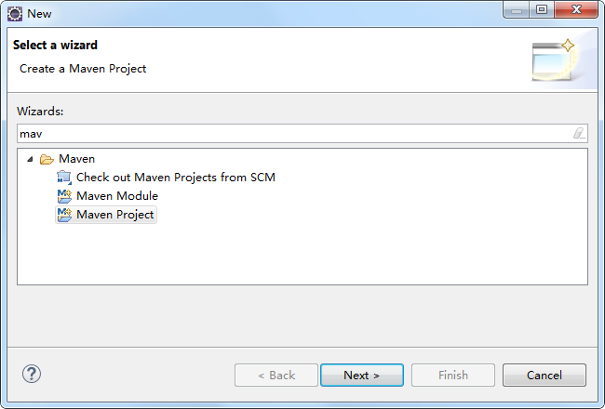

这里选择“跳过骨架选择”

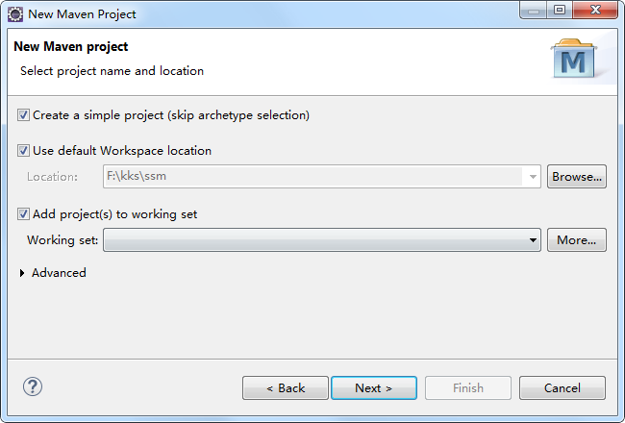

定义坐标：

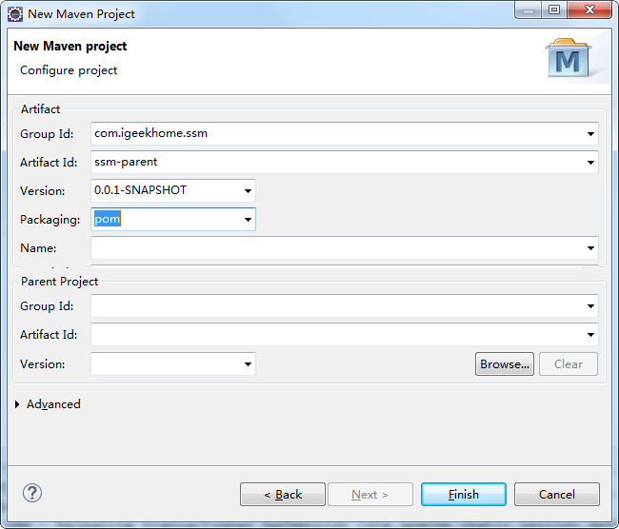

#### 3.2.1.2定义pom.xml

在父工程的pom.xml中抽取一些重复的配置的，比如：锁定jar包的版本、设置编译版本等。

|  |
| --- |
| <project xmlns=*"http://maven.apache.org/POM/4.0.0"* xmlns:xsi=*"http://www.w3.org/2001/XMLSchema-instance"*  xsi:schemaLocation=*"http://maven.apache.org/POM/4.0.0 http://maven.apache.org/xsd/maven-4.0.0.xsd"*>  <modelVersion>4.0.0</modelVersion>  <groupId>com.igeekhome.ssm</groupId>  <artifactId>ssm-parent</artifactId>  <version>0.0.1-SNAPSHOT</version>  <packaging>pom</packaging>  <properties>  <junit.version>4.12</junit.version>  <servlet-api.version>3.0-alpha-1</servlet-api.version>  <spring.version>4.3.6.RELEASE</spring.version>  <mybatis.version>3.4.2</mybatis.version>  <mybatis-spring.version>1.3.1</mybatis-spring.version>  <mysql.version>5.1.19</mysql.version>  <druid.version>1.0.28</druid.version>  <aspectjweaver.version>1.8.10</aspectjweaver.version>  <slf4j.version>1.7.24</slf4j.version>  <log4j.version>1.2.17</log4j.version>  <jstl.version>1.2</jstl.version>  </properties>  <!-- 添加工程的依赖 -->  <dependencyManagement>  <dependencies>  <dependency>  <groupId>junit</groupId>  <artifactId>junit</artifactId>  <version>${junit.version}</version>  <scope>test</scope>  </dependency>  <!-- servlet-api JSP页面编译时需要的包 -->  <dependency>  <groupId>javax.servlet</groupId>  <artifactId>servlet-api</artifactId>  <version>${servlet-api.version}</version>  <scope>provided</scope>  </dependency>  <!-- Spring 以及 SpringMVC需要引入的包，自动引入需要参照的包 -->  <dependency>  <groupId>org.springframework</groupId>  <artifactId>spring-webmvc</artifactId>  <version>${spring.version}</version>  </dependency>  <!-- 持久层的包 -->  <dependency>  <groupId>org.mybatis</groupId>  <artifactId>mybatis</artifactId>  <version>${mybatis.version}</version>  </dependency>  <!-- Spring 和 Mybatis的整合包 -->  <dependency>  <groupId>org.mybatis</groupId>  <artifactId>mybatis-spring</artifactId>  <version>${mybatis-spring.version}</version>  </dependency>  <!-- Mysql驱动包 -->  <dependency>  <groupId>mysql</groupId>  <artifactId>mysql-connector-java</artifactId>  <version>${mysql.version}</version>  </dependency>  <!-- druid数据库连接池 -->  <dependency>  <groupId>com.alibaba</groupId>  <artifactId>druid</artifactId>  <version>${druid.version}</version>  </dependency>  <dependency>  <groupId>org.aspectj</groupId>  <artifactId>aspectjweaver</artifactId>  <version>${aspectjweaver.version}</version>  </dependency>  <dependency>  <groupId>org.springframework</groupId>  <artifactId>spring-jdbc</artifactId>  <version>${spring.version}</version>  </dependency>  <!-- 打日志的 -->  <dependency>  <groupId>org.slf4j</groupId>  <artifactId>slf4j-log4j12</artifactId>  <version>${slf4j.version}</version>  <scope>runtime</scope>  </dependency>  <dependency>  <groupId>org.slf4j</groupId>  <artifactId>jcl-over-slf4j</artifactId>  <version>${slf4j.version}</version>  <scope>runtime</scope>  </dependency>  <dependency>  <groupId>log4j</groupId>  <artifactId>log4j</artifactId>  <version>${log4j.version}</version>  <scope>runtime</scope>  </dependency>  <dependency>  <groupId>jstl</groupId>  <artifactId>jstl</artifactId>  <version>${jstl.version}</version>  <scope>provided</scope>  </dependency>  </dependencies>  </dependencyManagement>  <build>  <finalName>ssm</finalName>  <resources>  <resource>  <directory>src/main/java</directory>  <includes>  <include>**/*.xml</include>  <include>**/*.properties</include>  </includes>  </resource>  <resource>  <directory>src/main/resources</directory>  <includes>  <include>**/*.xml</include>  <include>**/*.properties</include>  <include>**/*.ini</include>  </includes>  </resource>  </resources>  <pluginManagement>  <plugins>  <!-- 设置编译版本为1.8 -->  <plugin>  <groupId>org.apache.maven.plugins</groupId>  <artifactId>maven-compiler-plugin</artifactId>  <configuration>  <source>1.8</source>  <target>1.8</target>  <encoding>UTF-8</encoding>  </configuration>  </plugin>  <!-- Jetty插件，提供一种web容器 -->  <plugin>  <groupId>org.eclipse.jetty</groupId>  <artifactId>jetty-maven-plugin</artifactId>  <version>9.4.2.v20170220</version>  <configuration>  <httpConnector>  <!-- 配置运行的端口号 -->  <port>80</port>  </httpConnector>  <!-- 配置扫描的时间间隔 -->  <scanIntervalSeconds>1</scanIntervalSeconds>  <webApp>  <!-- 配置上下文 -->  <contextPath>/ssm</contextPath>  </webApp>  </configuration>  </plugin>  </plugins>  </pluginManagement>  </build>  </project> |

#### 3.2.1.3将父工程发布至仓库

父工程创建完成执行maven-install将父工程发布到仓库方便子工程继承：

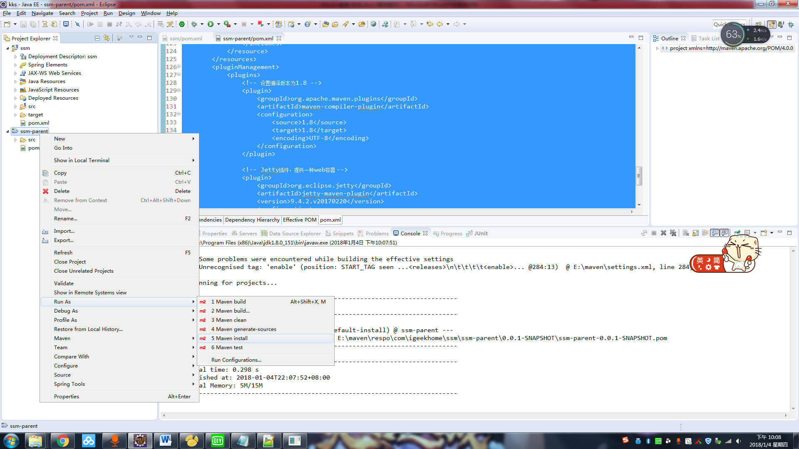

### 3.2.2ssm-dao子模块

#### 3.2.2.1创建dao子模块

选择ssm-parent工程添加模块

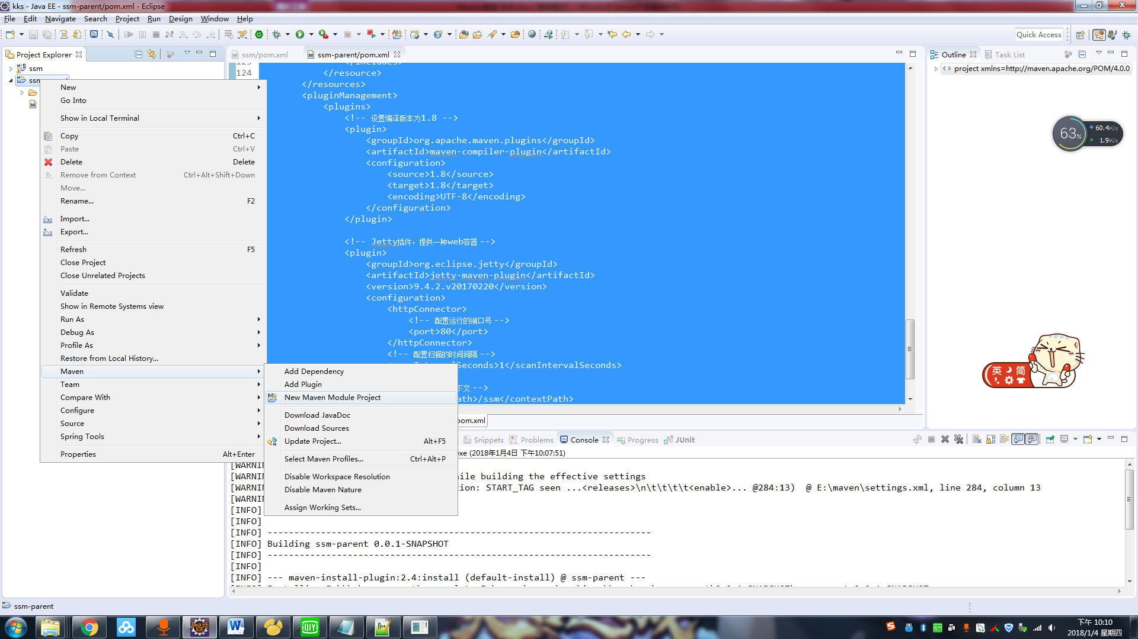

这里指定模块名称，选择“跳过骨架选择”，并设置模块名称

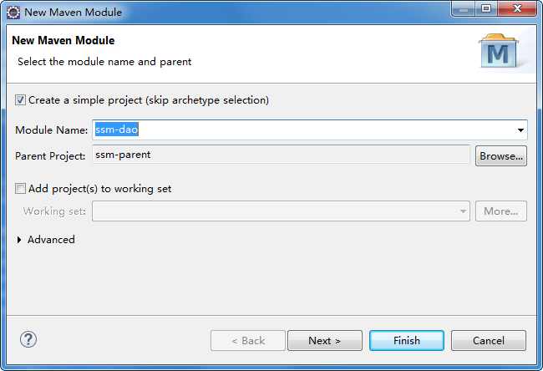

#### 3.2.2.2定义pom.xml

dao模块的pom.xml文件中需要继承父模块，添加持久层需要的依赖坐标：

|  |
| --- |
| <project xmlns=*"http://maven.apache.org/POM/4.0.0"* xmlns:xsi=*"http://www.w3.org/2001/XMLSchema-instance"*  xsi:schemaLocation=*"http://maven.apache.org/POM/4.0.0 http://maven.apache.org/xsd/maven-4.0.0.xsd"*>  <modelVersion>4.0.0</modelVersion>  <parent>  <groupId>com.igeekhome.ssm</groupId>  <artifactId>ssm-parent</artifactId>  <version>0.0.1-SNAPSHOT</version>  </parent>  <artifactId>ssm-dao</artifactId>  <packaging>jar</packaging>  <dependencies>  <dependency>  <groupId>junit</groupId>  <artifactId>junit</artifactId>  <scope>test</scope>  </dependency>  <!-- 持久层的包 -->  <dependency>  <groupId>org.mybatis</groupId>  <artifactId>mybatis</artifactId>  </dependency>  <!-- Spring 和 Mybatis的整合包 -->  <dependency>  <groupId>org.mybatis</groupId>  <artifactId>mybatis-spring</artifactId>  </dependency>  <!-- Mysql驱动包 -->  <dependency>  <groupId>mysql</groupId>  <artifactId>mysql-connector-java</artifactId>  </dependency>  <!-- druid数据库连接池 -->  <dependency>  <groupId>com.alibaba</groupId>  <artifactId>druid</artifactId>  </dependency>  <dependency>  <groupId>org.springframework</groupId>  <artifactId>spring-jdbc</artifactId>  </dependency>  <dependency>  <groupId>org.springframework</groupId>  <artifactId>spring-webmvc</artifactId>  </dependency>  <dependency>  <groupId>org.aspectj</groupId>  <artifactId>aspectjweaver</artifactId>  </dependency>  </dependencies>  </project> |

#### 3.2.2.3dao

将ssm工程中的dao接口，mapper配置文件及domain类拷贝到src/main/java中：

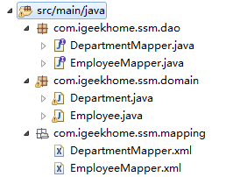

#### 3.2.2.4配置文件

拷贝ssm工程中如下配置文件到dao工程：

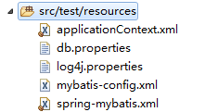

#### 3.2.2.5单元测试

|  |
| --- |
| **package** com.igeekhome.ssm.tests;  **import** org.junit.Test;  **import** org.springframework.context.support.ClassPathXmlApplicationContext;  **import** com.igeekhome.ssm.dao.EmployeeMapper;  **import** com.igeekhome.ssm.domain.Employee;  **public** **class** EmployeeTest {    @Test  **public** **void** testFindEmployeeById(){  //加载配置文件  ClassPathXmlApplicationContext applicationContext = **new** ClassPathXmlApplicationContext(**new** String[]{"applicationContext.xml", "spring-mybatis.xml"});  //获取dao  EmployeeMapper employeeMapper = applicationContext.getBean(EmployeeMapper.**class**);  //查询数据  Employee employee = employeeMapper.selectByPrimaryKey(7369);  //查看数据  System.***out***.println(employee.getEname());  //关闭上下文  applicationContext.close();  }  } |

### 3.2.3ssm-service子模块

#### 3.2.3.1创建service子模块

方法同ssm-dao模块创建方法，模块名称为ssm-service。

#### 3.2.3.2定义pom.xml

service模块的pom.xml文件中需要继承父模块，service依赖dao模块：

|  |
| --- |
| <project xmlns=*"http://maven.apache.org/POM/4.0.0"* xmlns:xsi=*"http://www.w3.org/2001/XMLSchema-instance"*  xsi:schemaLocation=*"http://maven.apache.org/POM/4.0.0 http://maven.apache.org/xsd/maven-4.0.0.xsd"*>  <modelVersion>4.0.0</modelVersion>  <parent>  <groupId>com.igeekhome.ssm</groupId>  <artifactId>ssm-parent</artifactId>  <version>0.0.1-SNAPSHOT</version>  </parent>  <artifactId>ssm-service</artifactId>  <packaging>jar</packaging>  <dependencies>  <dependency>  <groupId>junit</groupId>  <artifactId>junit</artifactId>  <scope>test</scope>  </dependency>  <dependency>  <groupId>com.igeekhome.ssm</groupId>  <artifactId>ssm-dao</artifactId>  <version>0.0.1-SNAPSHOT</version>  </dependency>  </dependencies>  </project> |

#### 3.2.3.3service接口

将ssm工程中的service接口拷贝到src/main/java中：

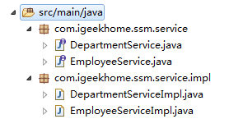

#### 3.2.3.4配置文件

拷贝ssm工程中如下配置文件到service工程：

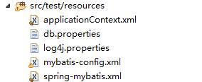

#### 3.2.3.5单元测试

|  |
| --- |
| **package** com.igeekhome.ssm.tests;  **import** org.junit.Test;  **import** org.springframework.context.support.ClassPathXmlApplicationContext;  **import** com.igeekhome.ssm.domain.Employee;  **import** com.igeekhome.ssm.service.EmployeeService;  **public** **class** EmployeeTest {    @Test  **public** **void** testFindEmployeeById(){  //加载配置文件  ClassPathXmlApplicationContext applicationContext = **new** ClassPathXmlApplicationContext(**new** String[]{"applicationContext.xml", "spring-mybatis.xml"});  //获取dao  EmployeeService employeeService = applicationContext.getBean(EmployeeService.**class**);  //查询数据  Employee employee = employeeService.selectByPrimaryKey(7369);  //查看数据  System.***out***.println(employee.getEname());  //关闭上下文  applicationContext.close();  }  } |

### 3.2.4ssm-web子模块

#### 3.2.4.1创建web子模块

方法同ssm-dao模块创建方法，模块名称为ssm-web。

#### 3.2.4.2定义pom.xml

|  |
| --- |
| <project xmlns=*"http://maven.apache.org/POM/4.0.0"* xmlns:xsi=*"http://www.w3.org/2001/XMLSchema-instance"*  xsi:schemaLocation=*"http://maven.apache.org/POM/4.0.0 http://maven.apache.org/xsd/maven-4.0.0.xsd"*>  <modelVersion>4.0.0</modelVersion>  <parent>  <groupId>com.igeekhome.ssm</groupId>  <artifactId>ssm-parent</artifactId>  <version>0.0.1-SNAPSHOT</version>  </parent>  <artifactId>ssm-web</artifactId>  <packaging>war</packaging>  <dependencies>  <dependency>  <groupId>junit</groupId>  <artifactId>junit</artifactId>  <scope>test</scope>  </dependency>  <!-- servlet-api JSP页面编译时需要的包 -->  <dependency>  <groupId>javax.servlet</groupId>  <artifactId>servlet-api</artifactId>  <scope>provided</scope>  </dependency>  <!-- Spring 以及 SpringMVC需要引入的包，自动引入需要参照的包 -->  <dependency>  <groupId>org.springframework</groupId>  <artifactId>spring-webmvc</artifactId>  </dependency>  <!-- 打日志的 -->  <dependency>  <groupId>org.slf4j</groupId>  <artifactId>slf4j-log4j12</artifactId>  <scope>runtime</scope>  </dependency>  <dependency>  <groupId>org.slf4j</groupId>  <artifactId>jcl-over-slf4j</artifactId>  <scope>runtime</scope>  </dependency>  <dependency>  <groupId>log4j</groupId>  <artifactId>log4j</artifactId>  <scope>runtime</scope>  </dependency>  <dependency>  <groupId>jstl</groupId>  <artifactId>jstl</artifactId>  <scope>provided</scope>  </dependency>  <dependency>  <groupId>com.igeekhome.ssm</groupId>  <artifactId>ssm-service</artifactId>  <version>0.0.1-SNAPSHOT</version>  </dependency>  </dependencies>  <build>  <finalName>ssm</finalName>  <resources>  <resource>  <directory>src/main/java</directory>  <includes>  <include>**/*.xml</include>  <include>**/*.properties</include>  </includes>  </resource>  <resource>  <directory>src/main/resources</directory>  <includes>  <include>**/*.xml</include>  <include>**/*.properties</include>  <include>**/*.ini</include>  </includes>  </resource>  </resources>  <plugins>  <!-- 设置编译版本为1.8 -->  <plugin>  <groupId>org.apache.maven.plugins</groupId>  <artifactId>maven-compiler-plugin</artifactId>  <configuration>  <source>1.8</source>  <target>1.8</target>  <encoding>UTF-8</encoding>  </configuration>  </plugin>  <!-- Jetty插件，提供一种web容器 -->  <plugin>  <groupId>org.eclipse.jetty</groupId>  <artifactId>jetty-maven-plugin</artifactId>  <configuration>  <httpConnector>  <!-- 配置运行的端口号 -->  <port>80</port>  </httpConnector>  <!-- 配置扫描的时间间隔 -->  <scanIntervalSeconds>1</scanIntervalSeconds>  <webApp>  <!-- 配置上下文 -->  <contextPath>/ssm</contextPath>  </webApp>  </configuration>  </plugin>  </plugins>  </build>  </project> |

#### 3.2.4.3Controller

将ssm工程中的controller拷贝到src/main/java中：



#### 3.2.4.4配置文件

将ssm工程中的配置文件拷贝到src/main/resources中

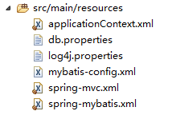

将ssm工程中的WEB-INF中的文件拷贝到项目的webapp中

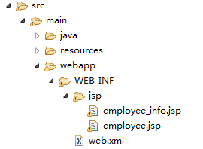

### 3.2.5运行调试

方法1：在maven-web工程的pom.xml中配置tomcat插件运行

运行maven-web工程它会从本地仓库下载依赖的jar包，所以当maven-web依赖的jar包内容修改了必须及时发布到本地仓库，比如：maven-web依赖的maven-service修改了，需要及时将maven-service发布到本地仓库。

方法2：在父工程的pom.xml中配置tomcat插件运行，自动聚合并执行

推荐方法2，如果子工程都在本地，采用方法2则不需要子工程修改就立即发布到本地仓库，父工程会自动聚合并使用最新代码执行。

注意：如果子工程和父工程中都配置了tomcat插件，运行的端口和路径以子工程为准。

# 4maven私服

正式开发，不同的项目组开发不同的工程。dao工程开发完毕，发布到私服。service从私服下载dao。

公司在自己的局域网内搭建自己的远程仓库服务器，称为私服，私服服务器即是公司内部的maven远程仓库，每个员工的电脑上安装maven软件并且连接私服服务器，员工将自己开发的项目打成jar并发布到私服服务器，其它项目组从私服服务器下载所依赖的构件（jar）。 私服还充当一个代理服务器，当私服上没有jar包会从互联网中央仓库自动下载，如下图：

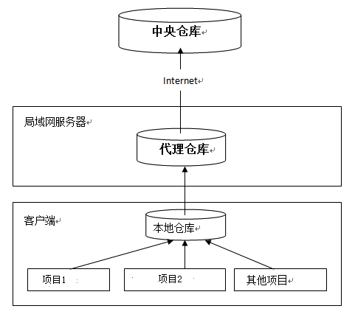

## 4.1搭建私服环境

### 4.1.1下载nexus

Nexus 是Maven仓库管理器，通过nexus可以搭建maven仓库，同时nexus还提供强大的仓库管理功能，构件搜索功能等。

下载Nexus， 下载地址：http://www.sonatype.org/nexus/archived/

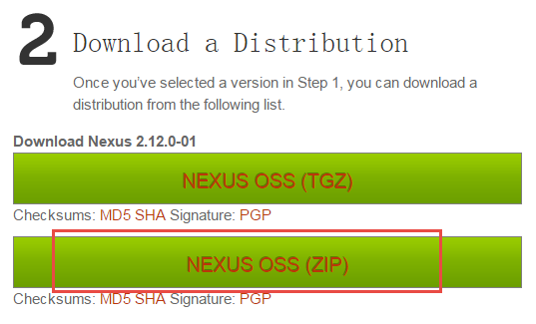

### 4.1.2安装nexus

解压nexus-2.12.0-01-bundle.zip，本教程将它解压在F盘，进入bin目录：

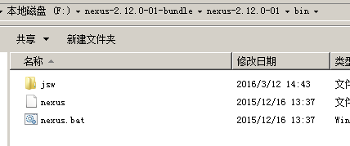

cmd进入bin目录，执行nexus.bat install



安装成功在服务中查看有nexus服务：



### 4.1.3卸载nexus

cmd进入nexus的bin目录，执行：nexus.bat uninstall



查看window服务列表nexus已被删除。

### 4.1.4启动nexus

方法1：

cmd进入bin目录，执行nexus.bat start

方法2：

直接启动nexus服务



查看nexus的配置文件conf/nexus.properties

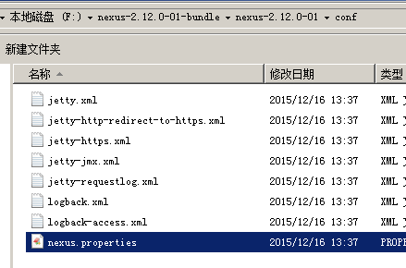

# Jetty section

application-port=8081 # nexus的访问端口配置

application-host=0.0.0.0 # nexus主机监听配置(不用修改)

nexus-webapp=${bundleBasedir}/nexus # nexus工程目录

nexus-webapp-context-path=/nexus # nexus的web访问路径

# Nexus section

nexus-work=${bundleBasedir}/../sonatype-work/nexus # nexus仓库目录

runtime=${bundleBasedir}/nexus/WEB-INF # nexus运行程序目录

访问：

http://localhost:8081/nexus/

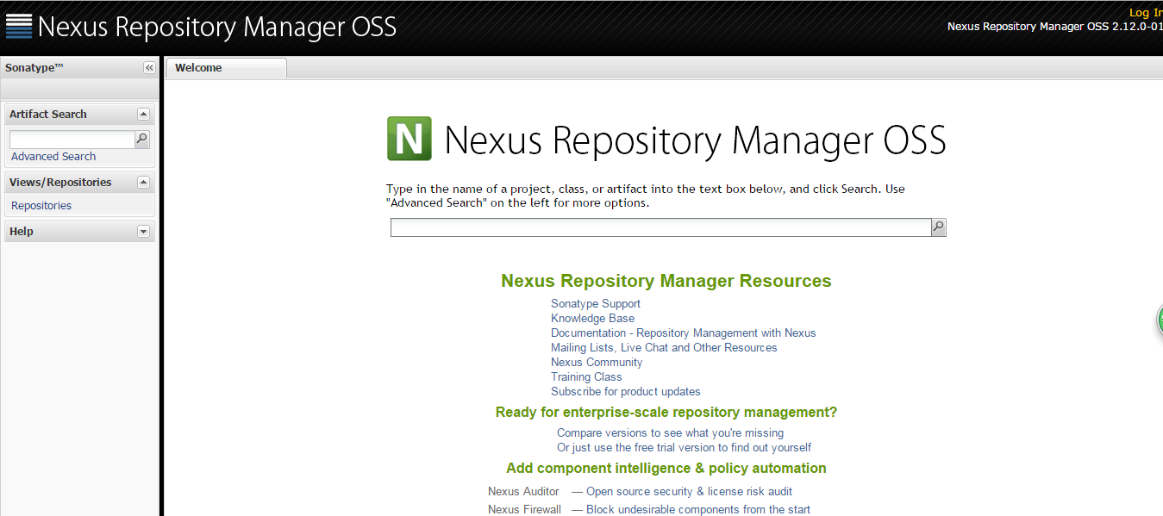

使用Nexus 内置账户admin/admin123登陆：

点击右上角的Log in，输入账号和密码 登陆

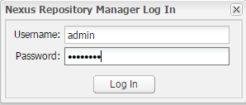

登陆成功：

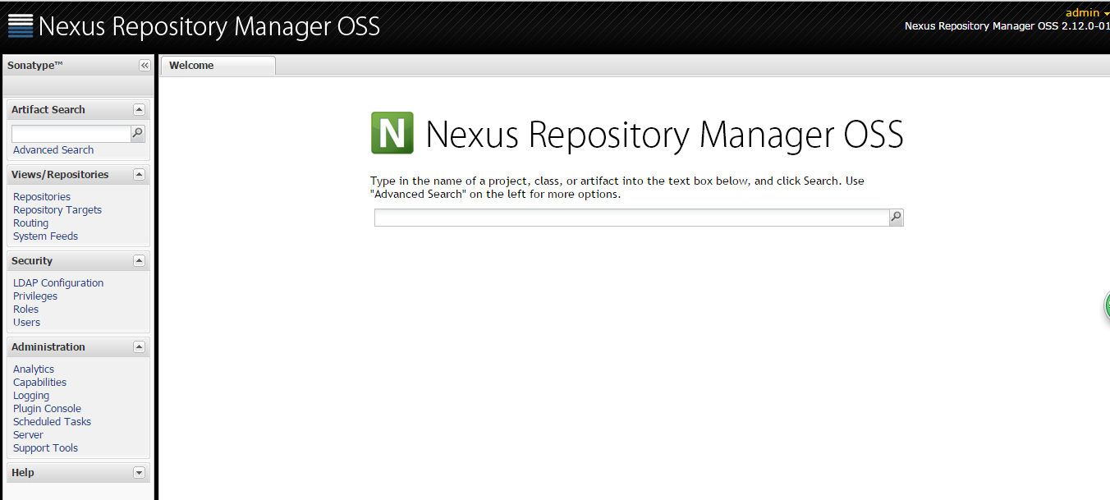

### 4.1.5仓库类型

nexus

查看nexus的仓库：

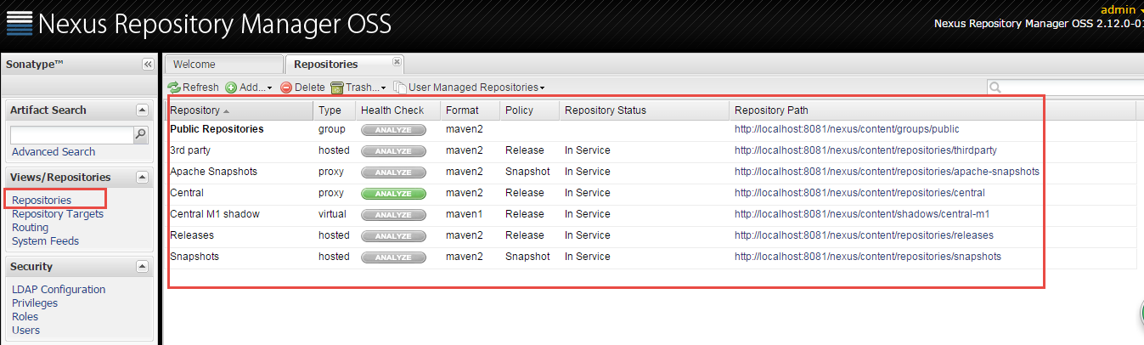

nexus的仓库有4种类型：

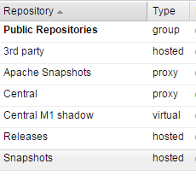

1. hosted，宿主仓库，部署自己的jar到这个类型的仓库，包括releases和snapshot两部分，Releases公司内部发布版本仓库、 Snapshots 公司内部测试版本仓库
2. proxy，代理仓库，用于代理远程的公共仓库，如maven中央仓库，用户连接私服，私服自动去中央仓库下载jar包或者插件。
3. group，仓库组，用来合并多个hosted/proxy仓库，通常我们配置自己的maven连接仓库组。
4. virtual(虚拟)：兼容Maven1 版本的jar或者插件

nexus仓库默认在sonatype-work目录中：

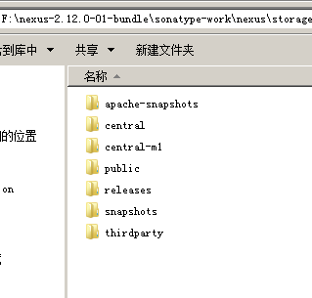

* **central：代理仓库，代理中央仓库**

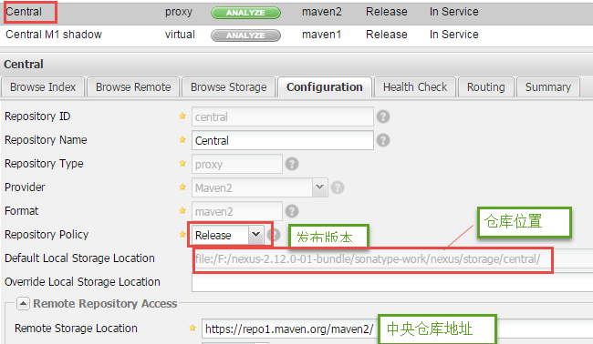

* **apache-snapshots：代理仓库**

存储snapshots构件，代理地址https://repository.apache.org/snapshots/

* **central-m1：**virtual类型仓库，兼容Maven1 版本的jar或者插件
* **releases：本地仓库，存储releases构件。**
* **snapshots：本地仓库，存储snapshots构件。**
* **thirdparty：第三方仓库**
* **public：仓库组**

## 4.2将项目发布到私服

### 4.2.1需求

企业中多个团队协作开发通常会将一些公用的组件、开发模块等发布到私服供其它团队或模块开发人员使用。

本例子假设多团队分别开发dao、service、web，某个团队开发完在dao会将dao发布到私服供service团队使用，本例子会将dao工程打成jar包发布到私服。

私服(服务端)

nexus

dao工程

(客户端)

service工程

（客户端）

上传

上传

### 4.2.2配置

第一步： 需要在客户端即部署dao工程的电脑上配置 maven环境，并修改 settings.xml 文件，配置连接私服的用户和密码 。

此用户名和密码用于私服校验，因为私服需要知道上传都 的账号和密码 是否和私服中的账号和密码 一致。

|  |
| --- |
| <server>  <id>releases</id>  <username>admin</username>  <password>admin123</password>  </server>  <server>  <id>snapshots</id>  <username>admin</username>  <password>admin123</password>  </server> |

releases 连接发布版本项目仓库

snapshots 连接测试版本项目仓库

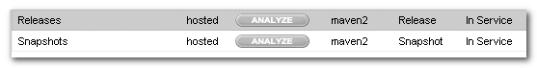

第二步： 配置项目pom.xml

配置私服仓库的地址，本公司的自己的jar包会上传到私服的宿主仓库，根据工程的版本号决定上传到哪个宿主仓库，如果版本为release则上传到私服的release仓库，如果版本为snapshot则上传到私服的snapshot仓库

|  |
| --- |
| <distributionManagement>  <repository>  <id>releases</id>  <url>http://localhost:8081/nexus/content/repositories/releases/</url>  </repository>  <snapshotRepository>  <id>snapshots</id>  <url>http://localhost:8081/nexus/content/repositories/snapshots/</url>  </snapshotRepository>  </distributionManagement> |

注意：pom.xml这里<id> 和 settings.xml 配置 <id> 对应！

### 4.2.3测试

将项目dao工程打成jar包发布到私服：

1、首先启动nexus

2、对dao工程执行deploy命令

根据本项目pom.xml中version定义决定发布到哪个仓库，如果version定义为snapshot，执行deploy后查看nexus的snapshot仓库，如果version定义为release则项目将发布到nexus的release仓库，本项目将发布到snapshot仓库：

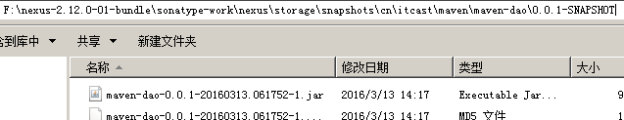

也可以通过http方式查看：

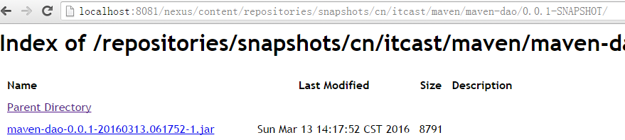

## 4.3从私服下载jar包

### 4.3.1需求

没有配置nexus之前，如果本地仓库没有，去中央仓库下载，通常在企业中会在局域网内部署一台私服服务器，有了私服本地项目首先去本地仓库找jar，如果没有找到则连接私服从私服下载jar包，如果私服没有jar包私服同时作为代理服务器从中央仓库下载jar包，这样做的好处是一方面由私服对公司项目的依赖jar包统一管理，一方面提高下载速度，项目连接私服下载jar包的速度要比项目连接中央仓库的速度快的多。

### 4.3.2管理仓库组

nexus中包括很多仓库，hosted中存放的是企业自己发布的jar包及第三方公司的jar包，proxy中存放的是中央仓库的jar，为了方便从私服下载jar包可以将多个仓库组成一个仓库组，每个工程需要连接私服的仓库组下载jar包。

打开nexus配置仓库组，如下图：

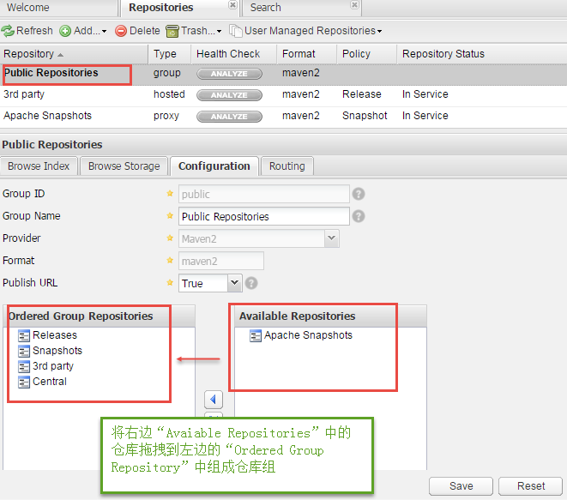

上图中仓库组包括了本地仓库、代理仓库等。

### 4.3.3在setting.xml中配置仓库

在客户端的setting.xml中配置私服的仓库，由于setting.xml中没有repositories的配置标签需要使用profile定义仓库。

|  |
| --- |
| <profile>  <!--profile的id-->  <id>dev</id>  <repositories>  <repository>  <!--仓库id，repositories可以配置多个仓库，保证id不重复-->  <id>nexus</id>  <!--仓库地址，即nexus仓库组的地址-->  <url>http://localhost:8081/nexus/content/groups/public/</url>  <!--是否下载releases构件-->  <releases>  <enabled>true</enabled>  </releases>  <!--是否下载snapshots构件-->  <snapshots>  <enabled>true</enabled>  </snapshots>  </repository>  </repositories>  <pluginRepositories>  <!-- 插件仓库，maven的运行依赖插件，也需要从私服下载插件 -->  <pluginRepository>  <!-- 插件仓库的id不允许重复，如果重复后边配置会覆盖前边 -->  <id>public</id>  <name>Public Repositories</name>  <url>http://localhost:8081/nexus/content/groups/public/</url>  </pluginRepository>  </pluginRepositories>  </profile> |

使用profile定义仓库需要激活才可生效。

|  |
| --- |
| <activeProfiles>  <activeProfile>dev</activeProfile>  </activeProfiles> |

配置成功后通过eclipse查看有效pom，有效pom是maven软件最终使用的pom内容，程序员不直接编辑有效pom，打开有效pom

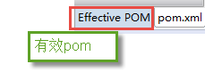

有效pom内容如下：

下边的pom内容中有两个仓库地址，maven会先从前边的仓库的找，如果找不到jar包再从下边的找，从而就实现了从私服下载jar包。

<repositories>

<repository>

<releases>

<enabled>true</enabled>

</releases>

<snapshots>

<enabled>true</enabled>

</snapshots>

<id>public</id>

<name>Public Repositories</name>

<url>http://localhost:8081/nexus/content/groups/public/</url>

</repository>

<repository>

<snapshots>

<enabled>false</enabled>

</snapshots>

<id>central</id>

<name>Central Repository</name>

<url>https://repo.maven.apache.org/maven2</url>

</repository>

</repositories>

<pluginRepositories>

<pluginRepository>

<id>public</id>

<name>Public Repositories</name>

<url>http://localhost:8081/nexus/content/groups/public/</url>

</pluginRepository>

<pluginRepository>

<releases>

<updatePolicy>never</updatePolicy>

</releases>

<snapshots>

<enabled>false</enabled>

</snapshots>

<id>central</id>

<name>Central Repository</name>

<url>https://repo.maven.apache.org/maven2</url>

</pluginRepository>

</pluginRepositories>