图例 web服务器 和 tomcat 之间合作
1.
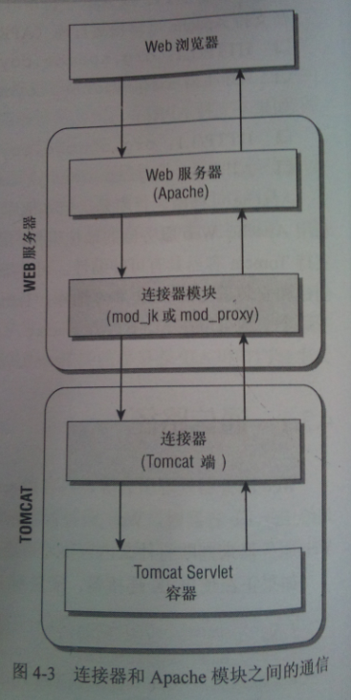
2．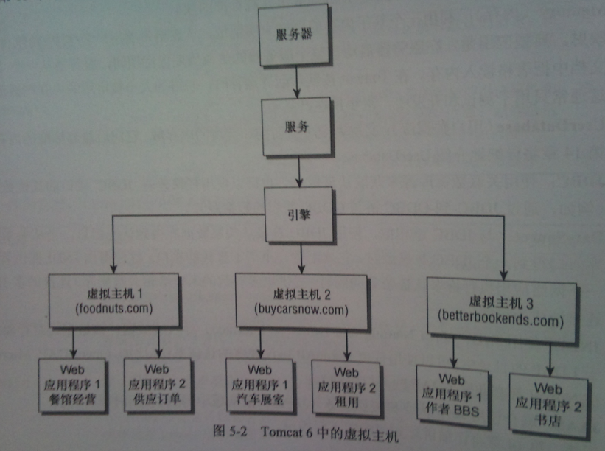
3.
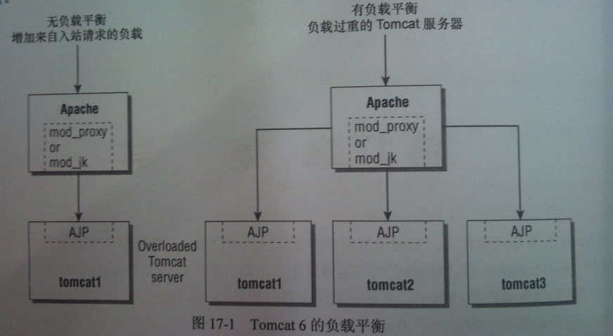
4.
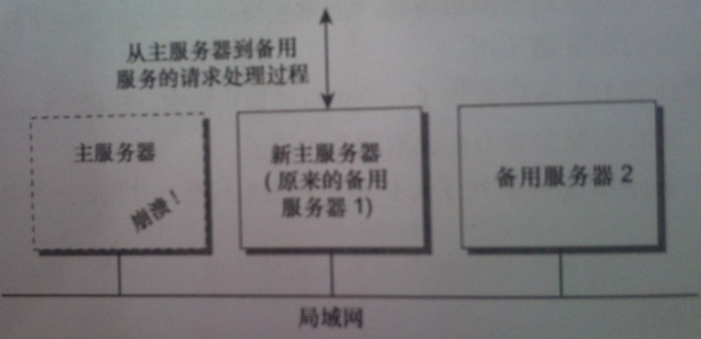
5.
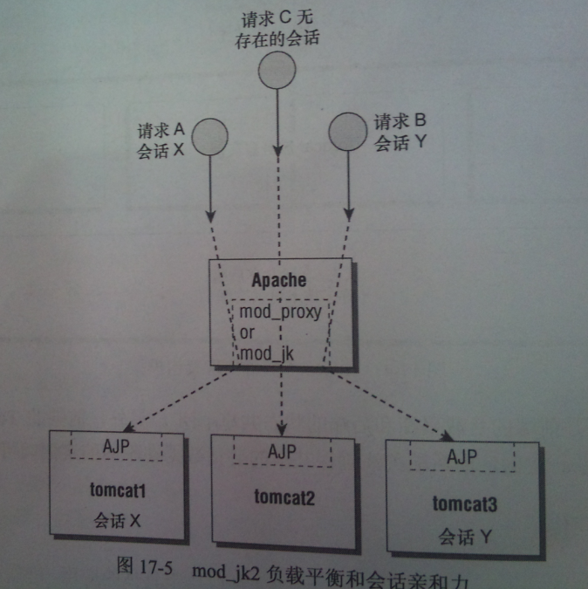
6.集群应用中的Session会话管理
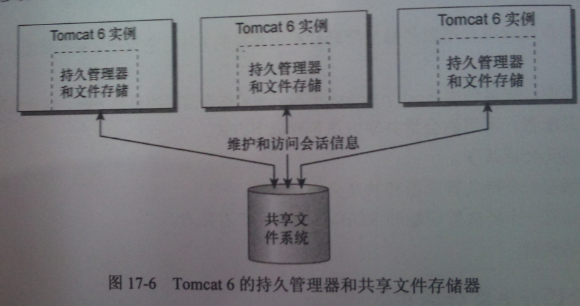

后端会话共享的几个方式:
※内存复制
※永久会话管理器，使用共享文件系统
※永久会话管理器，使用JDBC-to-MySQL RDBMS

使用Apache mod_jk 使负载平衡,准备东西如下：
1.Apache 你懂得..
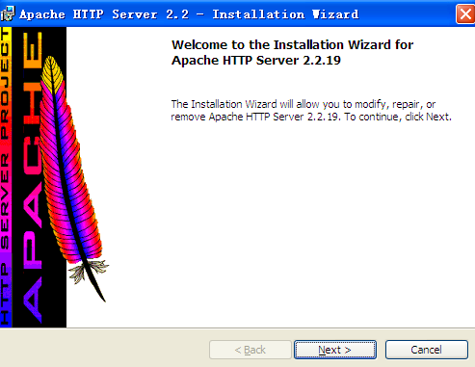
安装过程中的路径问题应该注意.最好不要有空格等特殊字符.如C:\apache22\conf
2. Tomcat你懂得
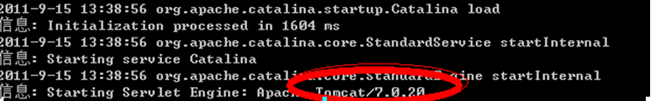这里的文件夹名称只为区分TOMCAT不是真正版本主要为tomcat6 、tomcat7
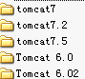
3. JK模块 相关版本下载地址: http://tomcat.apache.org/connectors-doc/index.html
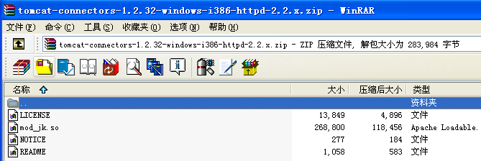
4. apache添加JK模块引用如图
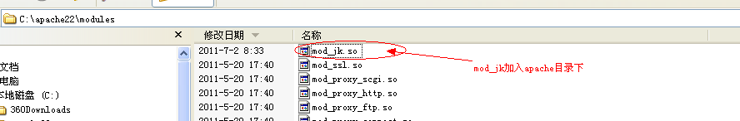
5. 如图
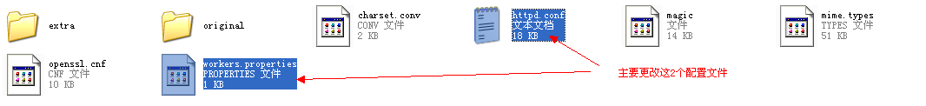
6. httpd.conf中的配置如图
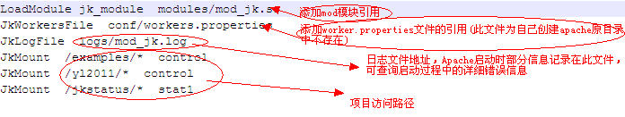
图中标示的项目访问路径在除jkstatus是作为集群状态的监控项目外，其他项目必须手动添加到tomcat中
7. workers.properties和tomcat 中的配置如图
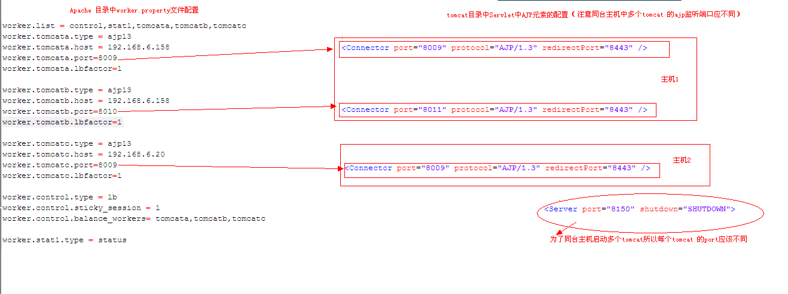
文字版配置信息
---------------------------------------------------------------
worker.list = control,stat1,tomcata,tomcatb,tomcatc
worker.tomcata.type = ajp13
worker.tomcata.host = 192.168.6.158
worker.tomcata.port=8009
worker.tomcata.lbfactor=1

worker.tomcatb.type = ajp13
worker.tomcatb.host = 192.168.6.158
worker.tomcatb.port=8010
worker.tomcatb.lbfactor=1

worker.tomcatc.type = ajp13
worker.tomcatc.host = 192.168.6.20
worker.tomcatc.port=8009
worker.tomcatc.lbfactor=1

worker.control.type = lb
worker.control.sticky_session = 1
worker.control.balance_workers= tomcata,tomcatb,tomcatc

worker.stat1.type = status
---------------------------------------------------------------
8.Tomcat中配置如下: 重要部分已标红
(1)内存复制方式会话共享:
<Server port="8050" shutdown="SHUTDOWN">
<!--APR library loader. Documentation at /docs/apr.html -->
<Listener className="org.apache.catalina.core.AprLifecycleListener" SSLEngine="on" />
<!--Initialize Jasper prior to webapps are loaded. Documentation at /docs/jasper-howto.html -->
<Listener className="org.apache.catalina.core.JasperListener" />
<!-- JMX Support for the Tomcat server. Documentation at /docs/non-existent.html -->
<Listener className="org.apache.catalina.mbeans.ServerLifecycleListener" />
<Listener className="org.apache.catalina.mbeans.GlobalResourcesLifecycleListener" />
<GlobalNamingResources>
<Resource name="UserDatabase" auth="Container"
type="org.apache.catalina.UserDatabase"
description="User database that can be updated and saved"
factory="org.apache.catalina.users.MemoryUserDatabaseFactory"
pathname="conf/tomcat-users.xml" />
</GlobalNamingResources>
<Service name="Catalina">

<Connector port="8010" protocol="AJP/1.3" redirectPort="8443" />
<Engine name="Standalone" defaultHost="localhost" jvmRoute="tomcatb">

<Realm className="org.apache.catalina.realm.UserDatabaseRealm"
resourceName="UserDatabase"/>
<Host name="localhost" appBase="webapps"
unpackWARs="true" autoDeploy="true"
xmlValidation="false" xmlNamespaceAware="false">
<Cluster className="org.apache.catalina.ha.tcp.SimpleTcpCluster"
channelSendOptions="8">

<Manager className="org.apache.catalina.ha.session.DeltaManager"
expireSessionsOnShutdown="false"
notifyListenersOnReplication="true"/>

<Channel className="org.apache.catalina.tribes.group.GroupChannel">
<Membership className="org.apache.catalina.tribes.membership.McastService"
address="228.0.0.4"
bind="192.168.6.158" --本机地址
port="45564"
frequency="500"
dropTime="3000"/>
<Receiver className="org.apache.catalina.tribes.transport.nio.NioReceiver"
address="192.168.6. 158" --本机地址
port="4000"
autoBind="100"
selectorTimeout="5000"
maxThreads="6"/>
<!-- timeout="60000"-->
<Sender className="org.apache.catalina.tribes.transport.ReplicationTransmitter">
<Transport className="org.apache.catalina.tribes.transport.nio.PooledParallelSender" />
</Sender>
<Interceptor className="org.apache.catalina.tribes.group.interceptors.TcpFailureDetector"/>
<Interceptor className="org.apache.catalina.tribes.group.interceptors.MessageDispatch15Interceptor"/>
<Interceptor className="org.apache.catalina.tribes.group.interceptors.ThroughputInterceptor"/>
</Channel>

<Valve className="org.apache.catalina.ha.tcp.ReplicationValve"
filter=""/>
<Valve className="org.apache.catalina.ha.session.JvmRouteBinderValve"/>

<Deployer className="org.apache.catalina.ha.deploy.FarmWarDeployer"
tempDir="/tmp/war-temp/"
deployDir="/tmp/war-deploy/"
watchDir="/tmp/war-listen/"
watchEnabled="false"/>

<ClusterListener className="org.apache.catalina.ha.session.JvmRouteSessionIDBinderListener"/>
<ClusterListener className="org.apache.catalina.ha.session.ClusterSessionListener"/>
</Cluster>

<Valve className="org.apache.catalina.valves.AccessLogValve" directory="logs"
prefix="localhost_access_log." suffix=".txt" pattern="common" resolveHosts="false"/>
</Host>
</Engine>
</Service>
</Server>
(2).共享文件系统
在每个集群项目中的文件夹添加如下配置文件
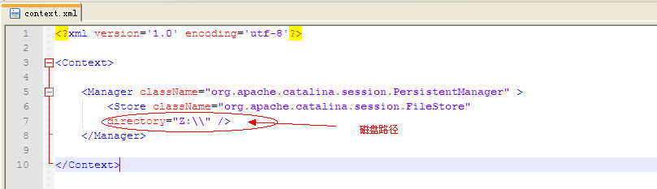
(3)JDBC
在每个集群项目中的文件夹添加如下配置文件
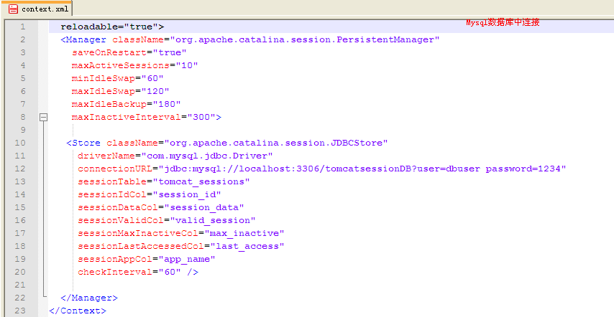

这是建立数据表的SQL语句：
create table tomcat_sessions (
session_id varchar(100) not null primary key,
valid_session char(1) not null,
max_inactive int not null,
last_access bigint not null,
app_name varchar(255),
session_data mediumblob,
KEY kapp_name(app_name)
);
9访问路径：
Http://localhost/jkstatus/
Http://localhost/yl2011/
Http://localhost/examples/

Author : 9l.Sherry
2011-09-15

