# Requirement

Submit a word document that includes the following:

* 1. 4 LucidChart data models (3 transactional applications + 1 data warehouse)
  2. DDL for the four data models
  3. ETL code to populate the data models
  4. The model for your data lake
  5. The code for your analysis patterns

# 4 LucidChart data models (3 transactional applications + 1 data warehouse)

## Inventory Management

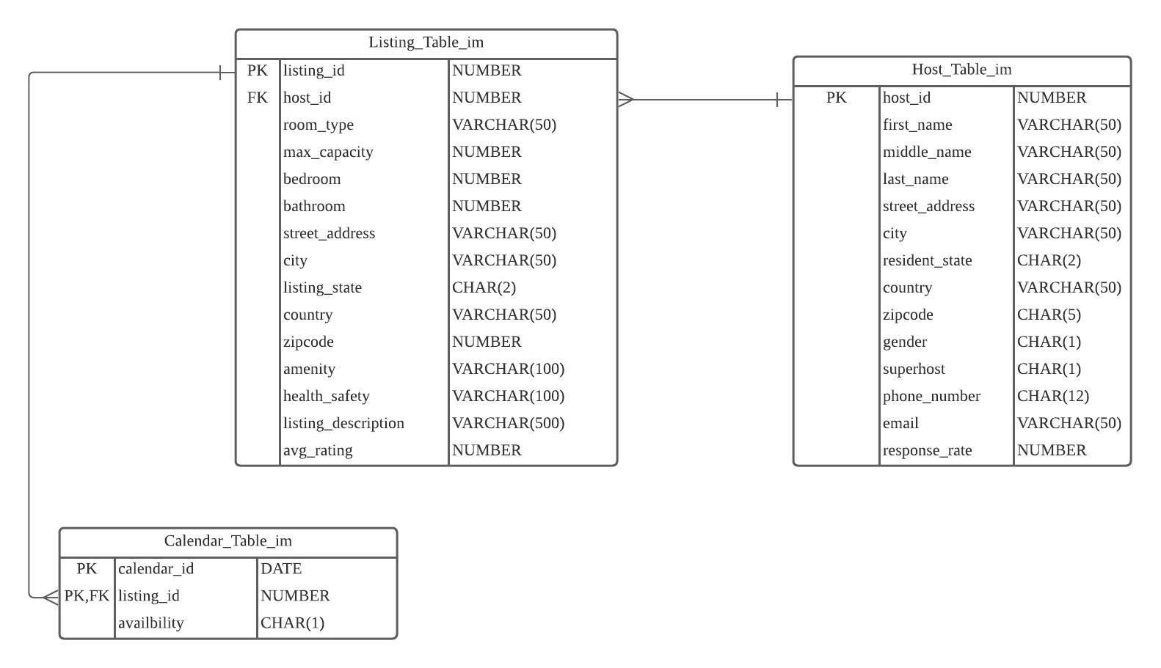

## Customer Reservation

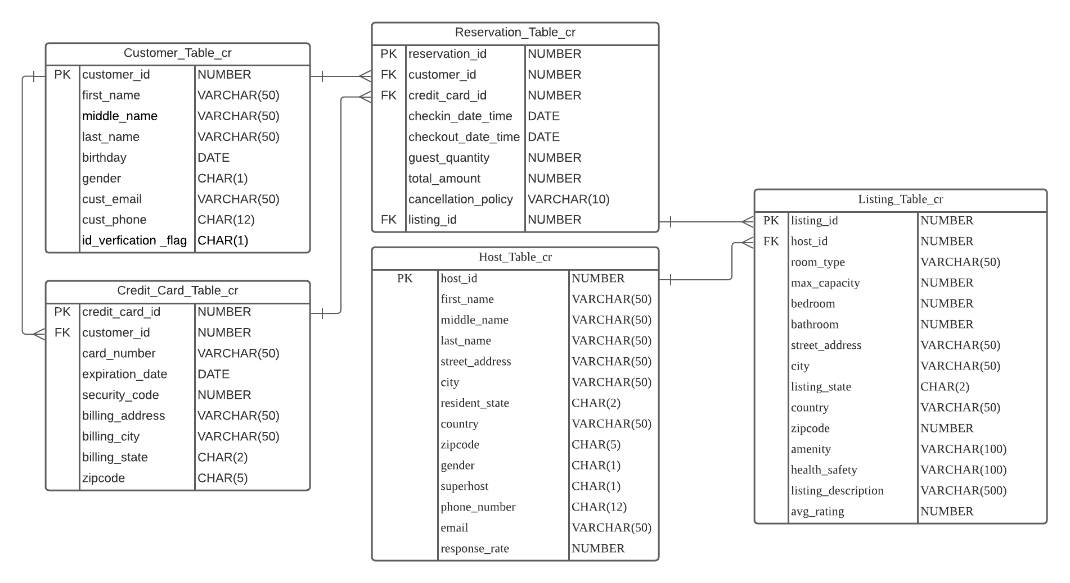

## Account Receivable

## Data Warehouse

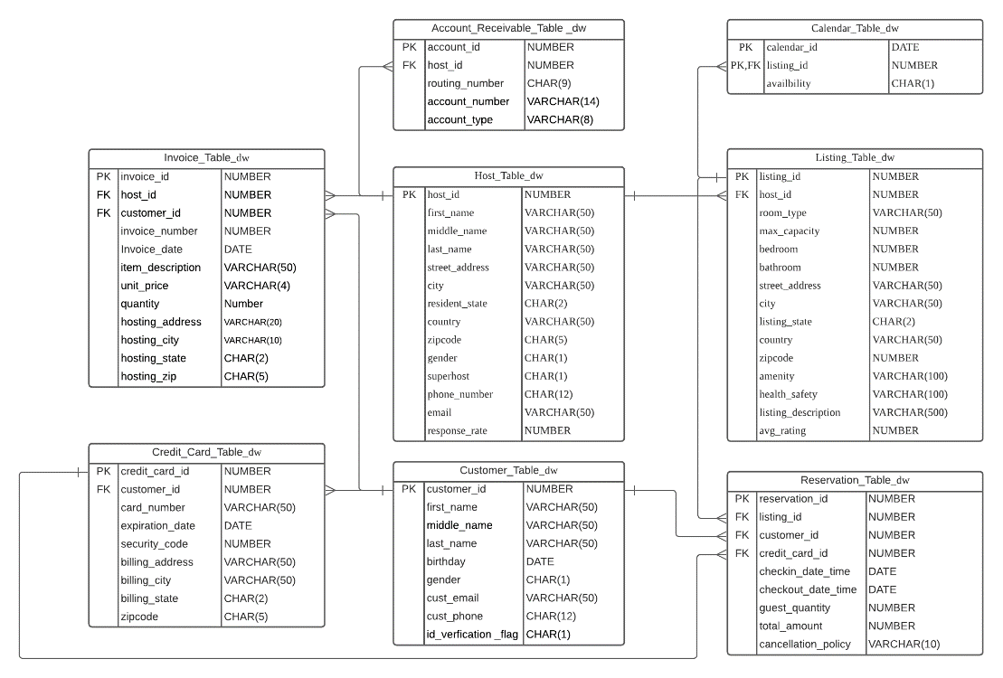

# DDL for the four data models

## Transactional_Database_Inventory_Management

-- Drop Sequence: Drop all the sequence for all the tables(exclude linking table)

Drop Sequence host_id_seq_im ;

Drop Sequence listing_id_seq_im ;

-- Drop Table

DROP TABLE Calendar_Table_im;

DROP TABLE Listing_Table_im;

DROP TABLE Host_Table_im;

-- Create Sequence: Create sequence for all the established tables's PK(exclude linking table)

CREATE Sequence host_id_seq_im

START WITH 1000000 INCREMENT BY 1;

CREATE Sequence listing_id_seq_im

START WITH 1000000 INCREMENT BY 1;

-- Create Table

CREATE TABLE Host_Table_im (

host_id NUMBER DEFAULT host_id_seq_im.nextval PRimARY KEY,

first_name VARCHAR(50) NOT NULL,

middle_name VARCHAR(50),

last_name VARCHAR(50) NOT NULL,

street_address VARCHAR(50) NOT NULL,

city VARCHAR(50) NOT NULL,

resident_state CHAR(2) NOT NULL,

country VARCHAR(50) NOT NULL,

zipcode CHAR(5) NOT NULL,

gender CHAR(1) NOT NULL,

superhost CHAR(1) DEFAULT 'N',

phone_number CHAR(12) NOT NULL,

email VARCHAR(50) NOT NULL UNIQUE,

response_rate NUMBER,

CONSTRAINT email_length_check

CHECK (LENGTHB(email) >= 7)

);

CREATE TABLE Listing_Table_im (

listing_id NUMBER DEFAULT listing_id_seq_im.nextval PRimARY KEY,

host_id NUMBER,

room_type VARCHAR(50) NOT NULL,

max_capacity NUMBER NOT NULL,

bedroom NUMBER NOT NULL,

bathroom NUMBER NOT NULL,

street_address VARCHAR(50) NOT NULL,

city VARCHAR(50) NOT NULL,

listing_state CHAR(2) NOT NULL,

country VARCHAR(50) NOT NULL,

zipcode NUMBER NOT NULL,

amenity VARCHAR(100),

health_safety VARCHAR(100),

listing_description VARCHAR(500),

avg_rating NUMBER,

CONSTRAINT listing_table_host_table_fk

FOREIGN KEY (host_id)

REFERENCES Host_Table_im(host_id)

);

CREATE TABLE Calendar_Table_im (

calendar_id DATE,

listing_id NUMBER,

room_availability CHAR(1) DEFAULT 'Y',

CONSTRAINT calendar_table_pk_listing_table

PRimARY KEY(calendar_id,listing_id),

CONSTRAINT calendar_table_listing_table_fk

FOREIGN KEY (listing_id)

REFERENCES Listing_Table_im(listing_id)

);

-- Insert Data

INSERT INTO Host_Table_im

(first_name,last_name,street_address,city,resident_state,country,zipcode,gender,phone_number,email,response_rate)

VALUES ('shuheng','ma','706','austin','tx','usa','78705','M','123-456-1234','1124498677@qq.com',1.2);

INSERT INTO Host_Table_im

(first_name,last_name,street_address,city,resident_state,country,zipcode,gender,phone_number,email,response_rate)

VALUES ('shuheng2','ma2','7062','austin2','tx','usa','78725','M','123-456-1222','1124228677@qq.com',1.2);

INSERT INTO Listing_Table_im

(host_id,room_type,max_capacity,bedroom,bathroom,street_address,city,listing_state,country,zipcode,amenity,health_safety,listing_description,avg_rating)

VALUES (1000000,'big',5,3,2,'706','austin','tx','usa',78705,'na','nope','pay for it',3.5);

INSERT INTO Listing_Table_im

(host_id,room_type,max_capacity,bedroom,bathroom,street_address,city,listing_state,country,zipcode,amenity,health_safety,listing_description,avg_rating)

VALUES (1000001,'small',1,1,1,'7062','austin','tx','usa',78705,'na','nope','pay for it',5.2);

INSERT INTO Calendar_Table_im

(calendar_id,listing_id,room_availability)

VALUES (TO_DATE('2023/03/10','yyyy/mm/dd'),1000000,'Y');

INSERT INTO Calendar_Table_im

(calendar_id,listing_id,room_availability)

VALUES (TO_DATE('2019/03/11','yyyy/mm/dd'),1000001,'Y');

## Transactional_Database_Customer_Reservation

-- Drop Sequence & Table

DROP TABLE Reservation_Table_CR;

DROP TABLE Credit_Card_Table_CR;

DROP TABLE Listing_Table_CR;

DROP TABLE Host_Table_CR;

DROP TABLE Customer_Table_CR;

DROP SEQUENCE customer_id_seq_CR;

DROP SEQUENCE credit_card_id_seq_CR;

DROP SEQUENCE listing_id_seq_CR;

DROP SEQUENCE reservation_id_seq_CR;

DROP SEQUENCE host_id_seq_CR;

-- Create Sequence & Table

CREATE Sequence customer_id_seq_CR

START WITH 1000010 INCREMENT BY 1;

CREATE Sequence host_id_seq_CR

START WITH 1000010 INCREMENT BY 1;

CREATE Sequence credit_card_id_seq_CR

START WITH 1000010 INCREMENT BY 1;

CREATE Sequence listing_id_seq_CR

START WITH 1000010 INCREMENT BY 1;

CREATE Sequence reservation_id_seq_CR

START WITH 1000010 INCREMENT BY 1;

CREATE TABLE Customer_Table_CR (

customer_id NUMBER default customer_id_seq_CR.NEXTVAL PRIMARY KEY,

first_name VARCHAR(50)NOT NULL,

middle_name VARCHAR(50),

last_name VARCHAR(50)NOT NULL,

birthday DATE NOT NULL,

gender CHAR(1) NOT NULL,

cust_email VARCHAR(50) NOT NULL UNIQUE,

cust_phone CHAR(12) NOT NULL,

id_verification_flag CHAR(1) DEFAULT 'N'

);

CREATE TABLE Host_Table_CR (

host_id NUMBER default host_id_seq_CR.NEXTVAL PRIMARY KEY,

first_name VARCHAR(50) NOT NULL,

middle_name VARCHAR(50),

last_name VARCHAR(50) NOT NULL,

street_address VARCHAR(50) NOT NULL,

city VARCHAR(50) NOT NULL,

resident_state CHAR(2) NOT NULL,

country VARCHAR(50) NOT NULL,

zipcode CHAR(5) NOT NULL,

gender CHAR(1) NOT NULL,

superhost CHAR(1) DEFAULT 'N',

phone_number CHAR(12) NOT NULL,

email VARCHAR(50) NOT NULL UNIQUE,

response_rate NUMBER,

CONSTRAINT email_length_check_cr

CHECK (LENGTHB(email) >= 7)

);

CREATE TABLE Credit_Card_Table_CR (

credit_card_id NUMBER default credit_card_id_seq_CR.NEXTVAL PRIMARY KEY,

customer_id NUMBER,

card_number VARCHAR(50) NOT NULL,

expiration_date DATE NOT NULL,

security_code NUMBER NOT NULL,

billing_address VARCHAR(50) NOT NULL,

billing_city VARCHAR(50) NOT NULL,

billing_state CHAR(2) NOT NULL,

zipcode CHAR(5) NOT NULL,

CONSTRAINT credit_card_Table_CR_customer_Table_CR_fk

FOREIGN KEY (customer_id)

REFERENCES Customer_Table_CR(customer_id)

);

CREATE TABLE Listing_Table_CR (

listing_id NUMBER default listing_id_seq_CR.NEXTVAL PRIMARY KEY,

host_id NUMBER,

room_type VARCHAR(50) NOT NULL,

max_capacity NUMBER NOT NULL,

bedroom NUMBER NOT NULL,

bathroom NUMBER NOT NULL,

street_address VARCHAR(50) NOT NULL,

city VARCHAR(50) NOT NULL,

listing_state CHAR(2) NOT NULL,

country VARCHAR(50) NOT NULL,

zipcode NUMBER NOT NULL,

amenity VARCHAR(100),

health_safety VARCHAR(100),

listing_description VARCHAR(500),

avg_rating NUMBER,

CONSTRAINT listing_Table_CR_host_Table_CR_fk

FOREIGN KEY (host_id)

REFERENCES Host_Table_CR(host_id)

);

CREATE TABLE Reservation_Table_CR (

reservation_id NUMBER default reservation_id_seq_CR.NEXTVAL PRIMARY KEY,

listing_id NUMBER,

customer_id NUMBER,

credit_card_id NUMBER,

checkin_date_time DATE NOT NULL,

checkout_date_time DATE NOT NULL,

guest_quantity NUMBER NOT NULL,

total_amount NUMBER NOT NULL,

cancellation_policy VARCHAR(10) NOT NULL,

CONSTRAINT reservation_Table_CR_listing_Table_CR_fk

FOREIGN KEY (listing_id)

REFERENCES Listing_Table_CR(listing_id),

CONSTRAINT reservation_Table_CR_customer_Table_CR_fk

FOREIGN KEY (customer_id)

REFERENCES Customer_Table_CR(customer_id),

CONSTRAINT reservation_Table_CR_ciredit_card_id_fk

FOREIGN KEY (credit_card_id)

REFERENCES Credit_Card_Table_CR(credit_card_id)

);

INSERT INTO Customer_Table_CR (first_name,last_name,birthday,gender,cust_email,cust_phone,id_verification_flag)

VALUES ('Nicole','Jiang',TO_DATE('1998/03/10','yyyy/mm/dd'),'F','annabelle@outlook.com','512-202-0832','Y');

INSERT INTO Customer_Table_CR (first_name,last_name,birthday,gender,cust_email,cust_phone,id_verification_flag)

VALUES ('Ashley','Smith',TO_DATE('1990/02/04','yyyy/mm/dd'),'F','AshleySmith@utexas.edu','513-000-2140','Y');

INSERT INTO Customer_Table_CR (first_name,last_name,middle_name,birthday,gender,cust_email,cust_phone,id_verification_flag)

VALUES ('Tom','Johnson','Jack',TO_DATE('1996/03/07','yyyy/mm/dd'),'M','TomJohnson@utexas.edu','325-490-0040','N');

INSERT INTO Customer_Table_CR (first_name,last_name,middle_name,birthday,gender,cust_email,cust_phone,id_verification_flag)

VALUES ('Betty','Williams','Kai',TO_DATE('1994/06/12','yyyy/mm/dd'),'F','BettyWilliams@utexas.edu','512-622-7890','Y');

INSERT INTO Customer_Table_CR (first_name,last_name,birthday,gender,cust_email,cust_phone,id_verification_flag)

VALUES ('Katherine','Miller',TO_DATE('1989/05/18','yyyy/mm/dd'),'F','KatherineMiller@utexas.edu','737-490-2247','N');

INSERT INTO Customer_Table_CR (first_name,last_name,middle_name,birthday,gender,cust_email,cust_phone,id_verification_flag)

VALUES ('Shawn','Davis','Mia',TO_DATE('1992/08/17','yyyy/mm/dd'),'M','ShawnDavis@utexas.edu','452-213-2355','Y');

INSERT INTO Customer_Table_CR (first_name,last_name,birthday,gender,cust_email,cust_phone,id_verification_flag)

VALUES ('Ben','Jones',TO_DATE('1996/06/06','yyyy/mm/dd'),'M','BenJones@utexas.edu','213-352-5643','N');

INSERT INTO Credit_Card_Table_CR (card_number,expiration_date,security_code,billing_address,billing_city,billing_state,zipcode,customer_id)

VALUES('1234123412341234',TO_DATE('2025/08/13', 'yyyy/mm/dd'),351,'Greystone Dr','Austin','TX','78731',1000011);

INSERT INTO Credit_Card_Table_CR (card_number,expiration_date,security_code,billing_address,billing_city,billing_state,zipcode,customer_id)

VALUES('4734123412341234',TO_DATE('2026/02/12', 'yyyy/mm/dd'),231,'Balckstone Dr','Austin','TX','78712',1000012);

INSERT INTO Credit_Card_Table_CR (card_number,expiration_date,security_code,billing_address,billing_city,billing_state,zipcode,customer_id)

VALUES('6234123412341234',TO_DATE('2021/12/30', 'yyyy/mm/dd'),325,'6th St','Houston','TX','78214',1000014);

INSERT INTO Credit_Card_Table_CR (card_number,expiration_date,security_code,billing_address,billing_city,billing_state,zipcode,customer_id)

VALUES('4134123522341234',TO_DATE('2030/01/05', 'yyyy/mm/dd'),124,'Congress Dr','Dallas','TX','78351',1000013);

INSERT INTO Host_Table_CR (first_name,last_name,street_address,city,resident_state,country,zipcode,gender,phone_number,email,response_rate)

VALUES ('Nicole','Xu','706','austin','tx','usa','78705','M','123-456-1234','311244498677@qq.com',1.2);

INSERT INTO Host_Table_CR (first_name,last_name,street_address,city,resident_state,country,zipcode,gender,phone_number,email,response_rate)

VALUES ('Jiang','Li','7062','austin2','tx','usa','78725','F','123-456-1222','4232428677@qq.com',1.2);

INSERT INTO Host_Table_CR (host_id,first_name,last_name,street_address,city,resident_state,country,zipcode,gender,phone_number,email,response_rate)

VALUES (1000000,'yiqun','Li','7062','austin2','tx','usa','78725','F','123-456-1222','4232s428677@qq.com',1.2);

INSERT INTO Listing_Table_CR (host_id,room_type,max_capacity,bedroom,bathroom,street_address,city,listing_state,country,zipcode,amenity,health_safety,listing_description,avg_rating)

VALUES (1000010,'big',5,3,2,'706','austin','tx','usa',78705,'na','nope','pay for it',4.8);

INSERT INTO Listing_Table_CR (host_id,room_type,max_capacity,bedroom,bathroom,street_address,city,listing_state,country,zipcode,amenity,health_safety,listing_description,avg_rating)

VALUES (1000011,'small',1,1,1,'7062','austin','tx','usa',78705,'na','nope','pay for it',4.9);

INSERT INTO Reservation_Table_CR (checkin_date_time,checkout_date_time,guest_quantity,total_amount,cancellation_policy,listing_id,customer_id,credit_card_id)

VALUES (TO_DATE('2021/12/30', 'yyyy/mm/dd'),TO_DATE('2021/12/31', 'yyyy/mm/dd'),2,400,'strict',1000011,1000011,1000010);

INSERT INTO Reservation_Table_CR (checkin_date_time,checkout_date_time,guest_quantity,total_amount,cancellation_policy,listing_id,customer_id,credit_card_id)

VALUES (TO_DATE('2020/11/25', 'yyyy/mm/dd'),TO_DATE('2020/11/26', 'yyyy/mm/dd'),1,200,'moderate',1000010,1000014,1000012);

INSERT INTO Reservation_Table_CR (checkin_date_time,checkout_date_time,guest_quantity,total_amount,cancellation_policy,listing_id,customer_id,credit_card_id)

VALUES (TO_DATE('2021/01/12', 'yyyy/mm/dd'),TO_DATE('2021/01/13', 'yyyy/mm/dd'),1,150,'strict',1000011,1000013,1000013);

## Transactional_Database_Account_Receivable

-- Drop Sequence: Drop all the sequence for all the tables(exclude linking table)

Drop Sequence account_id_seq_ar ;

Drop Sequence invoice_id_seq_ar ;

Drop Sequence credit_card_id_seq_ar ;

Drop Sequence host_id_seq_ar ;

Drop Sequence customer_id_seq_ar ;

-- Drop Table

DROP TABLE Account_Receivable_Table_ar;

DROP TABLE Invoice_Table_ar;

DROP TABLE Credit_Card_Table_ar;

DROP TABLE Host_Table_ar;

DROP TABLE Customer_Table_ar;

-- Create Sequence: Create sequence for all the established tables's PK(exclude linking table)

CREATE Sequence account_id_seq_ar

START WITH 1000000 INCREMENT BY 1;

CREATE Sequence invoice_id_seq_ar

START WITH 1000000 INCREMENT BY 1;

CREATE Sequence credit_card_id_seq_ar

START WITH 1000000 INCREMENT BY 1;

CREATE Sequence host_id_seq_ar

START WITH 1000000 INCREMENT BY 1;

CREATE Sequence customer_id_seq_ar

START WITH 1000000 INCREMENT BY 1;

-- Create

CREATE TABLE Customer_Table_ar (

customer_id NUMBER DEFAULT customer_id_seq_ar.nextval PRIMARY KEY,

first_name VARCHAR(50) NOT NULL,

middle_name VARCHAR(50),

last_name VARCHAR(50) NOT NULL,

birthday DATE NOT NULL,

gender CHAR(1) NOT NULL,

cust_email VARCHAR(50) NOT NULL UNIQUE,

cust_phone CHAR(12) NOT NULL,

id_verification_flag CHAR(1) DEFAULT ('N')

);

CREATE TABLE Host_Table_ar (

host_id NUMBER DEFAULT host_id_seq_ar.nextval PRIMARY KEY,

first_name VARCHAR(50) NOT NULL,

middle_name VARCHAR(50),

last_name VARCHAR(50) NOT NULL,

street_address VARCHAR(50) NOT NULL,

city VARCHAR(50) NOT NULL,

resident_state CHAR(2) NOT NULL,

country VARCHAR(50) NOT NULL,

zipcode CHAR(5) NOT NULL,

gender CHAR(1) NOT NULL,

superhost CHAR(1) DEFAULT 'N',

phone_number CHAR(12) NOT NULL,

email VARCHAR(50) NOT NULL UNIQUE,

response_rate NUMBER

);

CREATE TABLE Credit_Card_Table_ar (

credit_card_id NUMBER DEFAULT credit_card_id_seq_ar.nextval PRIMARY KEY,

customer_id NUMBER,

card_number VARCHAR(50) NOT NULL,

expiration_date DATE NOT NULL,

security_code NUMBER NOT NULL,

billing_address VARCHAR(50) NOT NULL,

billing_city VARCHAR(50) NOT NULL,

billing_state CHAR(2) NOT NULL,

zipcode CHAR(5) NOT NULL,

CONSTRAINT credit_card_table_customer_table_fk

FOREIGN KEY (customer_id)

REFERENCES Customer_Table_AR (customer_id)

);

CREATE TABLE Invoice_Table_ar (

invoice_id NUMBER DEFAULT invoice_id_seq_ar.nextval PRIMARY KEY,

host_id NUMBER,

customer_id NUMBER,

invoice_number NUMBER NOT NULL,

Invoice_date DATE NOT NULL,

item_description VARCHAR(50) NOT NULL,

unit_price VARCHAR(4) NOT NULL,

quantity Number NOT NULL,

hosting_address VARCHAR(50) NOT NULL,

hosting_city VARCHAR(50) NOT NULL,

hosting_state CHAR(2) NOT NULL,

hosting_zip CHAR(5) NOT NULL,

CONSTRAINT invoice_table_host_table_fk

FOREIGN KEY (host_id)

REFERENCES Host_Table_AR (host_id),

CONSTRAINT invoice_table_customer_table_fk

FOREIGN KEY (customer_id)

REFERENCES Customer_Table_AR(customer_id)

);

CREATE TABLE Account_Receivable_Table_ar (

account_id NUMBER DEFAULT account_id_seq_ar.nextval PRIMARY KEY,

host_id NUMBER,

routing_number CHAR(9) NOT NULL,

account_number VARCHAR(14) NOT NULL,

account_type VARCHAR(8) NOT NULL,

CONSTRAINT account_receivable_table_host_table_fk

FOREIGN KEY (host_id)

REFERENCES Host_Table_AR(host_id)

);

INSERT INTO Customer_Table_AR (customer_id, first_name, last_name, birthday, gender, cust_email, cust_phone)

VALUES (1000030, 'Yiqun', 'Tian', TO_DATE('1997-02-03', 'YYYY-MM-DD'), 'M', 'yiqun.tian@utexas.edu', '444-333-1111');

INSERT INTO Customer_Table_AR (customer_id, First_name, Last_name, birthday, gender, cust_email, cust_phone)

VALUES (1000031, 'Michael', 'Jordan', TO_DATE('1963-02-17', 'YYYY-MM-DD'), 'M', 'michael.j@utexas.edu', '877-888-3331');

INSERT INTO Customer_Table_AR (customer_id, First_name, Middle_name, Last_name, birthday, gender, cust_email, cust_phone)

VALUES (1000032, 'Kevin', 'Wayne', 'Durant', TO_DATE('1988-09-29', 'YYYY-MM-DD'), 'M', 'kevin.durant@utexas.edu', '744-331-4422');

ALTER SESSION SET NLS_DATE_FORMAT = 'mm/yy';

INSERT INTO Credit_Card_Table_AR (credit_card_id, customer_id, card_number, expiration_date, security_code, billing_address, Billing_city, Billing_state, zipcode)

VALUES (1000030, 1000030, '1234567890123456', '08/24', '123', '913 Pearl Road', 'Tempe', 'AZ', '85288');

INSERT INTO Credit_Card_Table_AR (credit_card_id, customer_id, card_number, expiration_date, security_code, billing_address, Billing_city, Billing_state, zipcode)

VALUES (1000031, 1000031, '1111567890123000', '03/26', '263', '933 N Sunny Road', 'Tempe', 'AZ', '85288');

INSERT INTO Host_Table_AR (host_id, first_name, middle_name, last_name, street_address, city, resident_state, country, zipcode, gender, phone_number, email, response_rate)

VALUES (1000010, 'John', 'Wayne', 'Stevens', '777 W curry Road', 'Austin', 'TX', 'USA', 78700, 'M', '480-477-1131', 'steve121ns.j@gmail.com', 1.5);

INSERT INTO Host_Table_AR (host_id, first_name, middle_name, last_name, street_address, city, resident_state, country, zipcode, gender, phone_number, email, response_rate)

VALUES (1000000, 'John', 'Wayne', 'Stevens', '777 W curry Road', 'Austin', 'TX', 'USA', 78700, 'M', '480-477-1131', 'steve1ns.j@gmail.com', 1.5);

INSERT INTO Host_Table_AR (host_id, first_name, middle_name, last_name, street_address, city, resident_state, country, zipcode, gender, phone_number, email, response_rate)

VALUES (1000030, 'John', 'Wayne', 'Stevens', '777 W curry Road', 'Austin', 'TX', 'USA', 78700, 'M', '480-477-1131', 'stevens.j@gmail.com', 1.5);

INSERT INTO Host_Table_AR (host_id, first_name, last_name, street_address, city, resident_state, country, zipcode, gender, phone_number, email, response_rate)

VALUES (1000031, 'Bain', 'Stevens','675 W Sunny Road', 'Austin', 'TX', 'USA', 78770, 'M', '480-477-1131', 'stevedfrns.j@gmail.com', 2.1);

INSERT INTO Invoice_Table_AR (host_id, customer_id, invoice_number, Invoice_date, item_description, unit_price, quantity, hosting_address, hosting_city, hosting_state, hosting_zip)

VALUES (1000030, 1000030, 1000000, '08/24', 'comfortable, three bedrooms condo', 79, 2,'913 N Pearl Road', 'Phoenix', 'AZ', 85220);

INSERT INTO Invoice_Table_AR (host_id, customer_id, invoice_number, Invoice_date, item_description, unit_price, quantity, hosting_address, hosting_city, hosting_state, hosting_zip)

VALUES (1000031, 1000031, 1000001, '07/14', 'Large, three bedrooms beach house', 150, 7,'983 N Chandler Road', 'Austin', 'TX', 78772);

INSERT INTO Account_Receivable_Table_AR

(host_id,routing_number,account_number,account_type)

VALUES (1000030,123456789,12345678912345,'checking');

INSERT INTO Account_Receivable_Table_AR

(host_id,routing_number,account_number,account_type)

VALUES (1000031,123456789,12345678912345,'checking');

## Data_Warehouse

-- Drop Table

DROP TABLE Account_Receivable_Table_dw;

DROP TABLE Calendar_Table_dw;

DROP TABLE Invoice_Table_dw;

DROP TABLE Reservation_Table_dw;

DROP TABLE Listing_Table_dw;

DROP TABLE Credit_Card_Table_dw;

DROP TABLE Host_Table_dw;

DROP TABLE Customer_Table_dw;

-- Create

CREATE TABLE Customer_Table_dw (

customer_id NUMBER PRIMARY KEY,

first_name VARCHAR(50)NOT NULL,

middle_name VARCHAR(50),

last_name VARCHAR(50)NOT NULL,

birthday DATE NOT NULL,

gender CHAR(1) NOT NULL,

cust_email VARCHAR(50) NOT NULL UNIQUE,

cust_phone CHAR(12) NOT NULL,

id_verification_flag CHAR(1) DEFAULT 'N'

);

CREATE TABLE Host_Table_dw (

host_id NUMBER PRIMARY KEY,

first_name VARCHAR(50) NOT NULL,

middle_name VARCHAR(50),

last_name VARCHAR(50) NOT NULL,

street_address VARCHAR(50) NOT NULL,

city VARCHAR(50) NOT NULL,

resident_state CHAR(2) NOT NULL,

country VARCHAR(50) NOT NULL,

zipcode CHAR(5) NOT NULL,

gender CHAR(1) NOT NULL,

superhost CHAR(1) DEFAULT 'N',

phone_number CHAR(12) NOT NULL,

email VARCHAR(50) NOT NULL UNIQUE,

response_rate NUMBER

);

CREATE TABLE Credit_Card_Table_dw (

credit_card_id NUMBER PRIMARY KEY,

customer_id NUMBER,

card_number VARCHAR(50) NOT NULL,

expiration_date DATE NOT NULL,

security_code NUMBER NOT NULL,

billing_address VARCHAR(50) NOT NULL,

billing_city VARCHAR(50) NOT NULL,

billing_state CHAR(2) NOT NULL,

zipcode CHAR(5) NOT NULL,

CONSTRAINT credit_card_table_customer_dw_fk

FOREIGN KEY (customer_id)

REFERENCES Customer_Table_dw(customer_id)

);

CREATE TABLE Listing_Table_dw (

listing_id NUMBER PRIMARY KEY,

host_id NUMBER,

room_type VARCHAR(50) NOT NULL,

max_capacity NUMBER NOT NULL,

bedroom NUMBER NOT NULL,

bathroom NUMBER NOT NULL,

street_address VARCHAR(50) NOT NULL,

city VARCHAR(50) NOT NULL,

listing_state CHAR(2) NOT NULL,

country VARCHAR(50) NOT NULL,

zipcode NUMBER NOT NULL,

amenity VARCHAR(100),

health_safety VARCHAR(100),

listing_description VARCHAR(500),

avg_rating NUMBER,

CONSTRAINT listing_table_host_dw_fk

FOREIGN KEY (host_id)

REFERENCES Host_Table_dw(host_id)

);

CREATE TABLE Reservation_Table_dw (

reservation_id NUMBER PRIMARY KEY,

listing_id NUMBER,

customer_id NUMBER,

credit_card_id NUMBER,

checkin_date_time DATE NOT NULL,

checkout_date_time DATE NOT NULL,

guest_quantity NUMBER NOT NULL,

total_amount NUMBER DEFAULT 0,

cancellation_policy VARCHAR(10) NOT NULL,

CONSTRAINT reservation_dw_listing_dw_fk

FOREIGN KEY (listing_id)

REFERENCES Listing_Table_dw(listing_id),

CONSTRAINT reservation_dw_customer_dw_fk

FOREIGN KEY (customer_id)

REFERENCES Customer_Table_dw(customer_id),

CONSTRAINT reservation_dw_ciredit_card_dw_fk

FOREIGN KEY (credit_card_id)

REFERENCES Credit_Card_Table_dw(credit_card_id)

);

CREATE TABLE Invoice_Table_dw (

invoice_id NUMBER PRIMARY KEY,

host_id NUMBER,

customer_id NUMBER,

invoice_number NUMBER NOT NULL,

Invoice_date DATE NOT NULL,

item_description VARCHAR(50) NOT NULL,

unit_price VARCHAR(4) NOT NULL,

quantity Number NOT NULL,

hosting_address VARCHAR(20) NOT NULL,

hosting_city VARCHAR(10) NOT NULL,

hosting_state CHAR(2) NOT NULL,

hosting_zip CHAR(5) NOT NULL,

CONSTRAINT invoice_dw_host_dw_fk

FOREIGN KEY (host_id)

REFERENCES Host_Table_dw(host_id),

CONSTRAINT invoice_dw_customer_dw_fk

FOREIGN KEY (customer_id)

REFERENCES Customer_Table_dw(customer_id)

);

CREATE TABLE Calendar_Table_dw (

calendar_id DATE,

listing_id NUMBER,

room_availability CHAR(1) DEFAULT 'Y',

CONSTRAINT calendar_dw_pk_listing_dw

PRIMARY KEY(calendar_id,listing_id),

CONSTRAINT calendar_dw_listing_dw_fk

FOREIGN KEY (listing_id)

REFERENCES Listing_Table_dw(listing_id)

);

CREATE TABLE Account_Receivable_Table_dw (

account_id NUMBER PRIMARY KEY,

host_id NUMBER,

routing_number CHAR(9) NOT NULL,

account_number VARCHAR(14) NOT NULL,

account_type VARCHAR(8) NOT NULL,

CONSTRAINT account_receivable_dw_host_dw_fk

FOREIGN KEY (host_id)

REFERENCES Host_Table_dw(host_id)

);

## ETL code to populate the data models

-- Create DW

-- Create View for Inventoray Management

Create or Replace View Host_Table_im_view as

Select *

From Host_Table_im;

Create or Replace View Listing_Table_im_view as

Select *

From Listing_Table_im;

Create or Replace View Calendar_Table_im_view as

Select *

From Calendar_Table_im;

-- Customer Reservation View

Create or Replace View Host_Table_CR_view as

Select *

From Host_Table_CR;

Create or replace view Customer_Table_CR_view as

select t.*

from Customer_Table_CR t;

Create or replace view Host_Table_CR_view as

select t.*

from Host_Table_CR t;

Create or replace view Credit_Card_Table_CR_view as

select t.*

from Credit_Card_Table_CR t;

Create or replace view Listing_Table_CR_view as

select t.*

from Listing_Table_CR t;

Create or replace view Reservation_Table_CR_view as

select t.*

from Reservation_Table_CR t;

-- Account

Create or Replace View Account_Receivable_Table_ar_view as

Select *

From Account_Receivable_Table_ar;

Create or Replace View Invoice_Table_ar_view as

Select *

From Invoice_Table_ar;

Create or Replace View Credit_Card_Table_ar_view as

Select *

From Credit_Card_Table_ar;

Create or Replace View Host_Table_ar_view as

Select *

From Host_Table_ar;

Create or Replace View Customer_Table_ar_view as

Select *

From Customer_Table_ar;

-- Create Procedure

-- Customer ETL

Create or replace procedure customer_etl_proc

As

Begin

-- customer reservation

MERGE INTO Customer_Table_dw dw

USING Customer_Table_CR_view v

ON (dw.customer_id = v.customer_id)

WHEN MATCHED

THEN UPDATE SET

dw.first_name = v.first_name,

dw.middle_name = v.middle_name,

dw.last_name = v.last_name,

dw.birthday = v.birthday,

dw.gender = v.gender,

dw.cust_email = v.cust_email,

dw.cust_phone = v.cust_phone,

dw.id_verification_flag = v.id_verification_flag

WHEN NOT MATCHED

THEN INSERT (customer_id,first_name,middle_name,last_name, birthday, gender,cust_email,cust_phone,id_verification_flag)

VALUES (v.customer_id,v.first_name, v.middle_name, v.last_name,

v.birthday, v.gender, v.cust_email,v.cust_phone,v.id_verification_flag);

-- account

MERGE INTO Customer_Table_dw a

USING Customer_Table_ar_view b

ON (a.customer_id = b.customer_id)

WHEN MATCHED

THEN UPDATE SET

a.first_name = b.first_name,

a.middle_name = b.middle_name,

a.last_name = b.last_name,

a.birthday = b.birthday,

a.gender = b.gender,

a.cust_email = b.cust_email,

a.cust_phone = b.cust_phone,

a.id_verification_flag = b.id_verification_flag

WHEN NOT MATCHED

THEN INSERT (customer_id,first_name,middle_name,last_name, birthday, gender,cust_email,cust_phone,id_verification_flag)

VALUES (b.customer_id,b.first_name, b.middle_name, b.last_name,

b.birthday, b.gender, b.cust_email,b.cust_phone,b.id_verification_flag);

END;

/

-----------------------------------

-- Host ETL

CREATE OR REPLACE PROCEDURE Host_Table_im_etl_proc

AS

BEGIN

-- Customer Reservation

MERGE INTO Host_Table_dw dw

USING Host_Table_CR_view v

ON (dw.host_id = v.host_id)

WHEN MATCHED

THEN UPDATE SET

dw.first_name = v.first_name,

dw.middle_name = v.middle_name,

dw.last_name = v.last_name,

dw.street_address = v.street_address,

dw.city = v.city,

dw.resident_state = v.resident_state,

dw.country = v.country,

dw.zipcode = v.zipcode,

dw.gender = v.gender,

dw.superhost = v.superhost,

dw.phone_number = v.phone_number,

dw.email = v.email,

dw.response_rate = v.response_rate

WHEN NOT MATCHED

THEN INSERT (host_id,first_name,middle_name,last_name,

street_address, city,resident_state,country,

zipcode,gender,superhost,phone_number,email,response_rate)

VALUES (v.host_id,v.first_name, v.middle_name, v.last_name,

v.street_address, v.city, v.resident_state,v.country,

v.zipcode,v.gender,v.superhost,v.phone_number,v.email,v.response_rate);

-- Account

MERGE INTO Host_Table_dw a

USING Host_Table_ar_view b

ON (a.host_id = b.host_id)

WHEN MATCHED THEN

UPDATE SET

a.first_name = b.first_name,

a.middle_name = b.middle_name,

a.last_name = b.last_name,

a.street_address =b.street_address,

a.city =b.city,

a.resident_state=b.resident_state,

a.country = b.country,

a.zipcode = b.zipcode,

a.gender = b.gender,

a.superhost = b.superhost,

a.phone_number = b.phone_number,

a.email = b.email,

a.response_rate = b.response_rate

WHEN NOT MATCHED THEN

INSERT (host_id,first_name,middle_name,last_name,street_address,city,resident_state,country,zipcode,gender,superhost,phone_number,email,response_rate)

VALUES (b.host_id,b.first_name,b.middle_name,b.last_name,b.street_address,b.city,b.resident_state,b.country,b.zipcode,b.gender,b.superhost,b.phone_number,b.email,b.response_rate);

-- Inventory Management

MERGE INTO Host_Table_dw a

USING Host_Table_im_view b

ON (a.host_id = b.host_id)

WHEN MATCHED THEN

UPDATE SET

a.first_name = b.first_name,

a.middle_name = b.middle_name,

a.last_name = b.last_name,

a.street_address =b.street_address,

a.city =b.city,

a.resident_state=b.resident_state,

a.country = b.country,

a.zipcode = b.zipcode,

a.gender = b.gender,

a.superhost = b.superhost,

a.phone_number = b.phone_number,

a.email = b.email,

a.response_rate = b.response_rate

WHEN NOT MATCHED THEN

INSERT (host_id,first_name,middle_name,last_name,street_address,city,resident_state,country,zipcode,gender,superhost,phone_number,email,response_rate)

VALUES (b.host_id,b.first_name,b.middle_name,b.last_name,b.street_address,b.city,b.resident_state,b.country,b.zipcode,b.gender,b.superhost,b.phone_number,b.email,b.response_rate);

END;

/

-----------------------------------

-- Listing

CREATE OR REPLACE PROCEDURE Listing_Table_im_etl_proc

AS

BEGIN

-- Customer Reservation

MERGE INTO Listing_Table_dw dw

USING Listing_Table_CR v

ON (dw.listing_id = v.listing_id)

WHEN MATCHED

THEN UPDATE SET

dw.host_id = v.host_id,

dw.room_type = v.room_type,

dw.max_capacity = v.max_capacity,

dw.bedroom = v.bedroom,

dw.bathroom = v.bathroom,

dw.street_address = v.street_address,

dw.city = v.city,

dw.listing_state = v.listing_state,

dw.country = v.country,

dw.zipcode = v.zipcode,

dw.amenity = v.amenity,

dw.health_safety = v.health_safety,

dw.listing_description = v.listing_description,

dw.avg_rating = v.avg_rating

WHEN NOT MATCHED

THEN INSERT (listing_id,host_id,room_type,max_capacity,bedroom,

bathroom, street_address,city,listing_state,country,zipcode,amenity,health_safety,listing_description,avg_rating)

VALUES (v.listing_id,v.host_id,v.room_type, v.max_capacity, v.bedroom,

v.bathroom, v.street_address, v.city,v.listing_state,v.country,v.zipcode,v.amenity,v.health_safety,v.listing_description,v.avg_rating);

-- Inventory Management

MERGE INTO Listing_Table_dw a

USING Listing_Table_im b

ON (a.listing_id = b.listing_id)

WHEN MATCHED THEN

UPDATE SET

a.host_id = b.host_id,

a.room_type = b.room_type,

a.max_capacity = b.max_capacity,

a.bedroom = b.bedroom,

a.bathroom = b.bathroom,

a.street_address = b.street_address,

a.city = b.city,

a.listing_state = b.listing_state,

a.country = b.country,

a.zipcode = b.zipcode,

a.amenity = b.amenity,

a.health_safety = b.health_safety,

a.listing_description = b.listing_description,

a.avg_rating = b.avg_rating

WHEN NOT MATCHED THEN

INSERT(listing_id, host_id, room_type, max_capacity, bedroom, bathroom,street_address, city, listing_state, country, zipcode, amenity, health_safety, listing_description, avg_rating)

VALUES(b.listing_id, b.host_id, b.room_type, b.max_capacity, b.bedroom, b.bathroom,b.street_address, b.city, b.listing_state, b.country, b.zipcode, b.amenity, b.health_safety, b.listing_description, b.avg_rating);

END;

/

-----------------------------------

-- Calendar

CREATE OR REPLACE PROCEDURE Calendar_Table_im_etl_proc

AS

BEGIN

-- insert and update from curr_user_view

MERGE INTO Calendar_Table_dw a

USING Calendar_Table_im_view b

ON (a.calendar_id = b.calendar_id and a.listing_id = b.listing_id)

WHEN MATCHED THEN

UPDATE SET

a.room_availability = b.room_availability

WHEN NOT MATCHED THEN

INSERT (calendar_id,listing_id,room_availability)

VALUES (b.calendar_id,b.listing_id,b.room_availability);

-- insert and update from prospective_view

END;

/

-----------------------------------------

-- Credit Card

Create or replace procedure Credit_Card_etl_proc

As

Begin

-- Customer Reservation

MERGE INTO Credit_Card_Table_dw dw

USING Credit_Card_Table_CR_view v

ON (dw.credit_card_id = v.credit_card_id)

WHEN MATCHED

THEN UPDATE SET

dw.customer_id = v.customer_id,

dw.card_number = v.card_number,

dw.expiration_date = v.expiration_date,

dw.security_code = v.security_code,

dw.billing_address = v.billing_address,

dw.billing_city = v.billing_city,

dw.billing_state = v.billing_state,

dw.zipcode = v.zipcode

WHEN NOT MATCHED

THEN INSERT (credit_card_id,customer_id,card_number,expiration_date,

security_code, billing_address,billing_city,billing_state,zipcode)

VALUES (v.credit_card_id,v.customer_id, v.card_number, v.expiration_date,

v.security_code, v.billing_address, v.billing_city,v.billing_state,v.zipcode);

-- Account

MERGE INTO Credit_Card_Table_dw a

USING Credit_Card_Table_ar_view b

ON (a.credit_card_id = b.credit_card_id)

WHEN MATCHED

THEN UPDATE SET

a.customer_id = b.customer_id,

a.card_number = b.card_number,

a.expiration_date = b.expiration_date,

a.security_code = b.security_code,

a.billing_address = b.billing_address,

a.billing_city = b.billing_city,

a.billing_state = b.billing_state,

a.zipcode = b.zipcode

WHEN NOT MATCHED

THEN INSERT (credit_card_id,customer_id,card_number,expiration_date,

security_code, billing_address,billing_city,billing_state,zipcode)

VALUES (b.credit_card_id,b.customer_id, b.card_number, b.expiration_date,

b.security_code, b.billing_address, b.billing_city,b.billing_state,b.zipcode);

END;

/

-------------------------------------------

-- Reservation

Create or replace procedure Reservation_etl_proc

As

Begin

-- Customer Reservation

MERGE INTO Reservation_Table_dw dw

USING Reservation_Table_CR v

ON (dw.reservation_id = v.reservation_id)

WHEN MATCHED

THEN UPDATE SET

dw.listing_id = v.listing_id,

dw.customer_id = v.customer_id,

dw.credit_card_id = v.credit_card_id,

dw.checkin_date_time = v.checkin_date_time,

dw.checkout_date_time = v.checkout_date_time,

dw.guest_quantity = v.guest_quantity,

dw.total_amount = v.total_amount,

dw.cancellation_policy = v.cancellation_policy

WHEN NOT MATCHED

THEN INSERT (reservation_id,listing_id,customer_id,credit_card_id,

checkin_date_time, checkout_date_time,guest_quantity,total_amount,cancellation_policy)

VALUES (v.reservation_id,v.listing_id, v.customer_id, v.credit_card_id,

v.checkin_date_time, v.checkout_date_time, v.guest_quantity,v.total_amount,v.cancellation_policy);

END;

/

-------------------------------

-- Account

CREATE OR REPLACE PROCEDURE Account_Receivable_Table_ar_etl_proc

AS

BEGIN

-- Account

MERGE INTO Account_Receivable_Table_dw a

USING Account_Receivable_Table_ar b

ON (a.account_id = b.account_id)

WHEN MATCHED THEN

UPDATE SET

a.host_id = b.host_id,

a.routing_number = b.routing_number,

a.account_number = b.account_number,

a.account_type = b.account_type

WHEN NOT MATCHED THEN

INSERT(account_id,host_id,routing_number,account_number,account_type)

VALUES(b.account_id,b.host_id, b.routing_number, b.account_number, b.account_type);

END;

/

------------------------------

-- Invoice

CREATE OR REPLACE PROCEDURE Invoice_Table_ar_etl_proc

AS

BEGIN

-- Account

MERGE INTO Invoice_Table_dw a

USING Invoice_Table_ar_view b

ON (a.invoice_id = b.invoice_id)

WHEN MATCHED THEN

UPDATE SET

a.host_id = b.host_id,

a.customer_id = b.customer_id,

a.invoice_number = b.invoice_number,

a.Invoice_date = b.Invoice_date,

a.item_description = b.item_description,

a.unit_price = b.unit_price,

a.quantity = b.quantity,

a.hosting_address = b.hosting_address,

a.hosting_city = b.hosting_city,

a.hosting_state = b.hosting_state,

a.hosting_zip = b.hosting_zip

WHEN NOT MATCHED THEN

INSERT (invoice_id, host_id, customer_id, invoice_number,

Invoice_date, item_description, unit_price, quantity, hosting_address,

hosting_city, hosting_state, hosting_zip)

VALUES (b.invoice_id, b.host_id,b.customer_id, b.invoice_number, b.Invoice_date,

b.item_description, b.unit_price, b.quantity,b.hosting_address,b.hosting_city, b.hosting_state, b.hosting_zip);

END;

/

# The model for your data lake

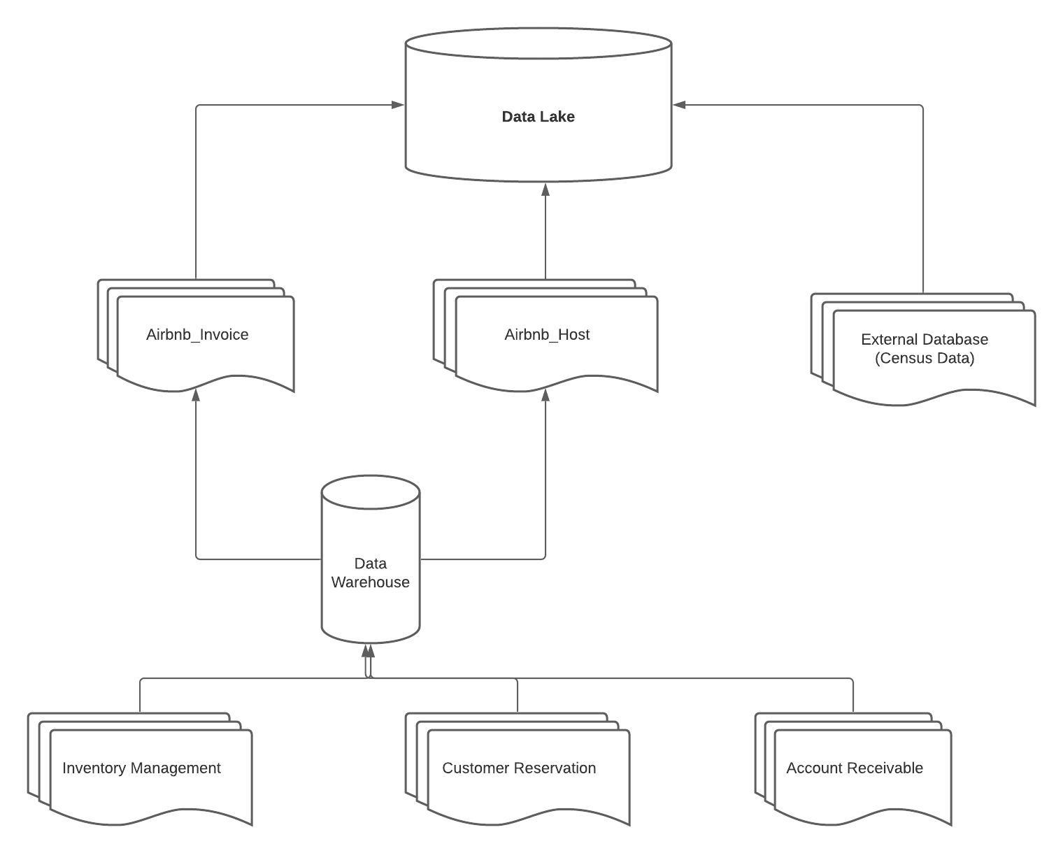

# The code for your analysis patterns

**Read data:**

host_df = spark.read.format("csv").load("dbfs:/FileStore/shared_uploads/mshch96@utexas.edu/DataLake_Host.csv", header=True, inferSchema=True)

host_df.show()

invoice_df = spark.read.format("csv").load("dbfs:/FileStore/shared_uploads/mshch96@utexas.edu/DataLake_Invoice-2.csv", header=True, inferSchema=True)

invoice_df.show()

Texas_census_df = spark.read.format("csv").load("dbfs:/FileStore/shared_uploads/mshch96@utexas.edu/Additional_Data-2.csv", header=True, inferSchema=True)

Texas_census_df.show()

**Convert DF to View:**

host_df.createOrReplaceTempView("host")

invoice_df.createOrReplaceTempView("invoice")

Texas_census_df.createOrReplaceTempView("texas_census")

**Insights 1:**

%sql

SELECT avg(i.unit_price * i.quantity) as avg_revenue, h.superhost

FROM host h INNER JOIN invoice i

ON h.host_id = i.host_id

GROUP BY h.superhost;

**Insights 2:**

%sql

SELECT avg(i.unit_price / t.GDP / t.Population) as price_per_gdp, i.hosting_city

FROM invoice i left join texas_census t

On i.hosting_city = t.city

Group By i.hosting_city;

**Insights 3:**

%sql

SELECT superhost, avg(response_rate)

FROM host

Group By superhost;