**Canal学习手册**

### Mysql安装

配置好yum后,

yum -y install mysql-server 进行安装

修改mysql配置文件 /etc/my.cnf, 增加默认编码

[mysqld]

datadir=/var/lib/mysql

socket=/var/lib/mysql/mysql.sock

user=mysql

**character-set-server=utf8**

**lower_case_table_names=1**

**max_connections=2000**

# Disabling symbolic-links is recommended to prevent assorted security risks

symbolic-links=0

[mysqld_safe]

log-error=/var/log/mysqld.log

pid-file=/var/run/mysqld/mysqld.pid

**default-character-set=utf8**

打开开机自动运行

chkconfig mysqld on

chkconfig --list mysqld

启动mysql

/etc/rc.d/init.d/mysqld start

配置安全

/usr/bin/mysql_secure_installation

创建用户

//登录MYSQL  
@>mysql -u root -p  
@>密码  
//创建用户  
mysql> insert into mysql.user(Host,User,Password) values("localhost","jdlotteryt",password("jdlotteryt "));  
//刷新系统权限表  
mysql>flush privileges;

// 用户授权

Grant all privileges on *.* to 'jdlottery'@'%' identified by 'jdlottery';

**数据库的备份**

有时候做测试,导致数据量较大,所以备份最好只备份基础数据,完事后大概20m左右.

通过 select table_name,table_rows from tables order by table_rows desc; 查询 schema表,

看哪个表数据量较大.

select CONCAT('TRUNCATE TABLE ',TABLE_SCHEMA ,'.',TABLE_NAME,';') from tables WHERE TABLE_ROWS>1000 order by table_rows desc;

通过该语句生成清除数据量大于1000的表数据(由于基础数据的量都比较小)

mysqldump -uroot -p --opt --all-databases > /home/jd-lottery/lottery.sql 导出所有的数据库包含建库语句

**数据库还原**

mysql -u root -p < /home/lottery.sql 到新的服务器上执行即可

### 库binlog-do-db 配置

1、该属性属于必须配置的属性，否则 canal 的客户端感受不到数据库的变更

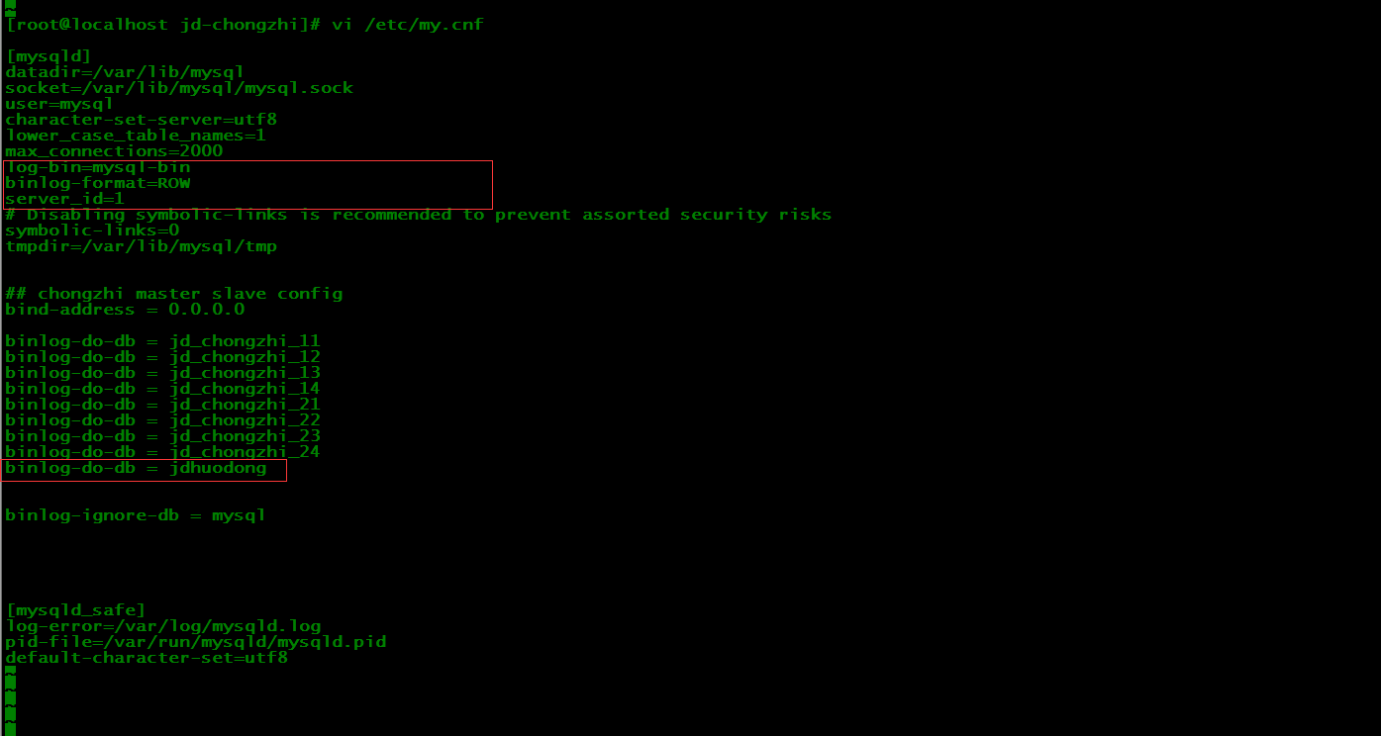

2、可能抛出的异常如下图：

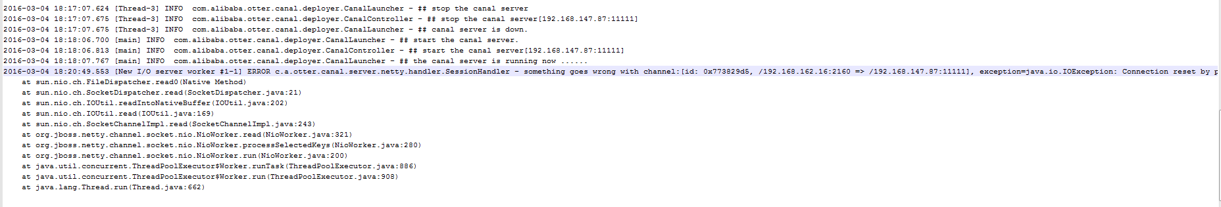

2016-03-04 18:20:49.553 [New I/O server worker #1-1] ERROR c.a.otter.canal.server.netty.handler.SessionHandler - something goes wrong with channel:[id: 0x773829d5, /192.168.162.16:2160 => /192.168.147.87:11111], exception=java.io.IOException: Connection reset by peer

at sun.nio.ch.FileDispatcher.read0(Native Method)

at sun.nio.ch.SocketDispatcher.read(SocketDispatcher.java:21)

at sun.nio.ch.IOUtil.readIntoNativeBuffer(IOUtil.java:202)

at sun.nio.ch.IOUtil.read(IOUtil.java:169)

at sun.nio.ch.SocketChannelImpl.read(SocketChannelImpl.java:243)

at org.jboss.netty.channel.socket.nio.NioWorker.read(NioWorker.java:321)

at org.jboss.netty.channel.socket.nio.NioWorker.processSelectedKeys(NioWorker.java:280)

at org.jboss.netty.channel.socket.nio.NioWorker.run(NioWorker.java:200)

at java.util.concurrent.ThreadPoolExecutor$Worker.runTask(ThreadPoolExecutor.java:886)

at java.util.concurrent.ThreadPoolExecutor$Worker.run(ThreadPoolExecutor.java:908)

at java.lang.Thread.run(Thread.java:662)

### 安装canal服务端

参考文档：

<http://blog.csdn.net/bbirdsky/article/details/41479479>

<https://github.com/alibaba/canal/wiki/AdminGuide>

直接下载 tar 包，解压到服务器目录即可

### canal 集群Ha配置

### canal操作成果

