Topology Figure:

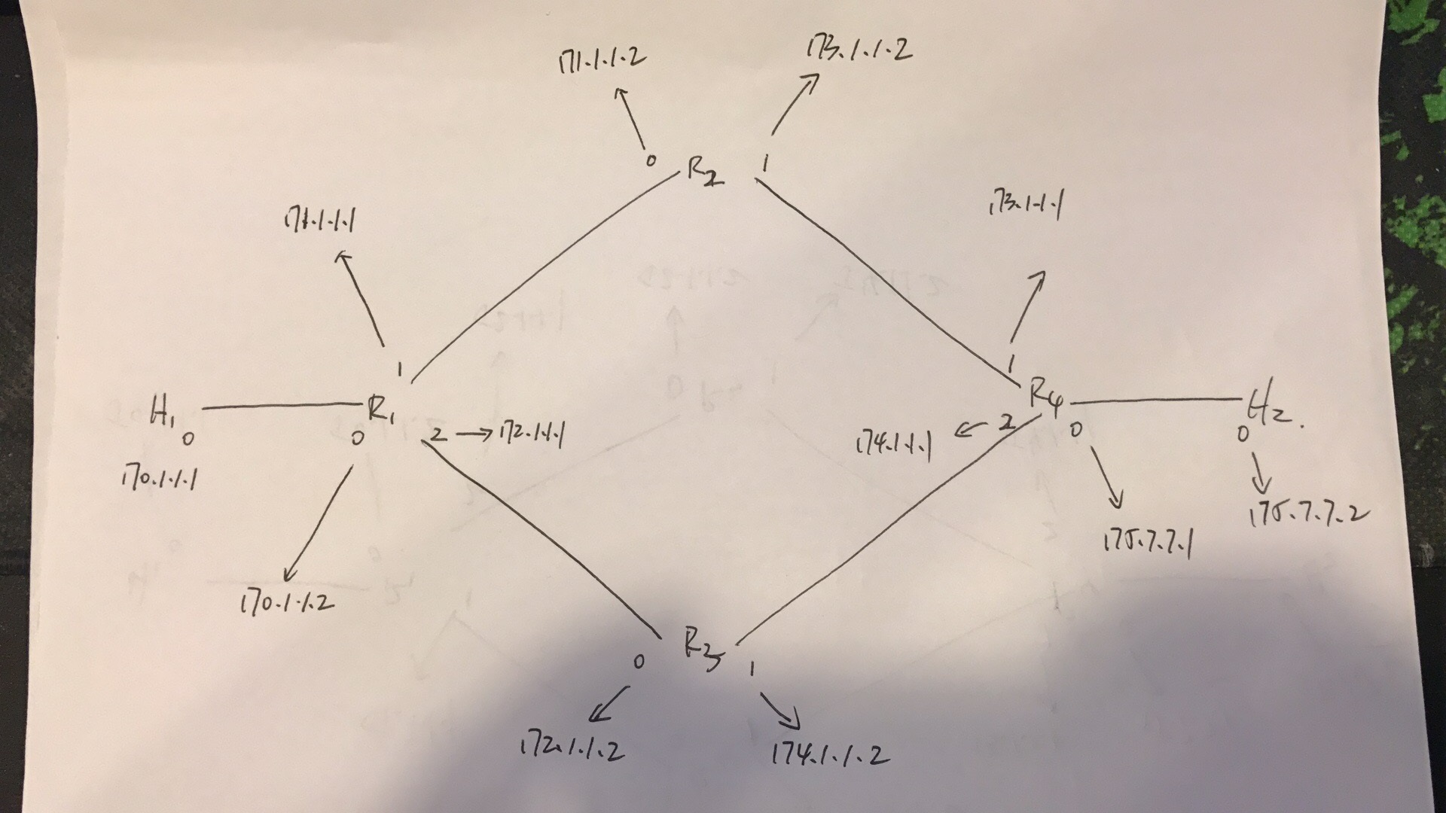

**partA1:**

There are 6 subnets. (netmask is 255.255.255.0). The ip addresses are set as follows:

[H1]:

net.get('H1').cmd('ifconfig H1-eth0 170.1.1.1/24')

[H2]:

net.get('H2').cmd('ifconfig H2-eth0 175.7.7.2/24')

[R1]:

net.get('R1').cmd('ifconfig R1-eth0 170.1.1.2/24')

net.get('R1').cmd('ifconfig R1-eth1 171.1.1.1/24')

net.get('R1').cmd('ifconfig R1-eth2 172.1.1.1/24')

[R2]:

net.get('R2').cmd('ifconfig R2-eth0 171.1.1.2/24')

net.get('R2').cmd('ifconfig R2-eth1 173.1.1.2/24')

[R3]:

net.get('R3').cmd('ifconfig R3-eth0 172.1.1.2/24')

net.get('R3').cmd('ifconfig R3-eth1 174.1.1.2/24')

[R4]:

net.get('R4').cmd('ifconfig R4-eth0 175.7.7.1/24')

net.get('R4').cmd('ifconfig R4-eth1 173.1.1.1/24')

net.get('R4').cmd('ifconfig R4-eth2 174.1.1.1/24')