**partA2:**

1. *change the IP forwarding variable to 1*:

net.get('H1').cmd('sysctl -w net.ipv4.ip_forward=1')

net.get('H2').cmd('sysctl -w net.ipv4.ip_forward=1')

net.get('R1').cmd('sysctl -w net.ipv4.ip_forward=1')

net.get('R2').cmd('sysctl -w net.ipv4.ip_forward=1')

net.get('R3').cmd('sysctl -w net.ipv4.ip_forward=1')

net.get('R4').cmd('sysctl -w net.ipv4.ip_forward=1')

To configure the static route, I use:

<Node> ip route add <destination subnet> via <next hop IP> dev <Node-ethernet interface name>

Ex: H1 ip route add 175.7.7.0/24 via 170.1.1.2 dev H1-eth0

After this I added all the iptable forwarding commands at each intermediate node. All route info and iptable info is saved in “partA2.sh”. *After we run “sudo python ./start.py”, we will run “source partA2.sh”. Then “pingall”. Following is the screenshot.*

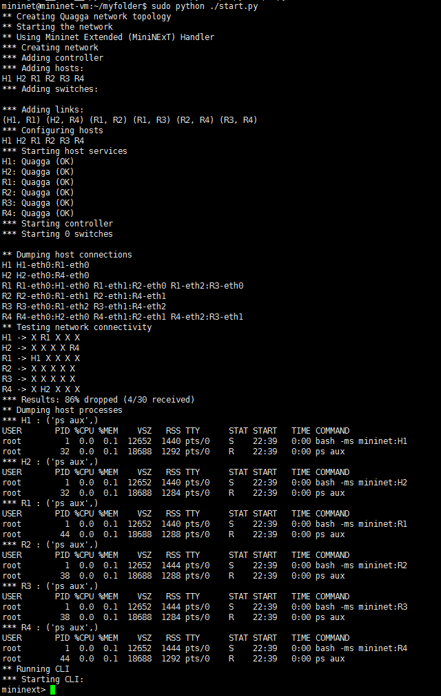

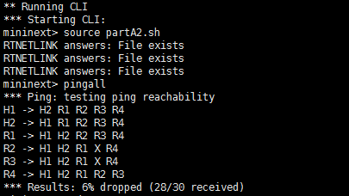

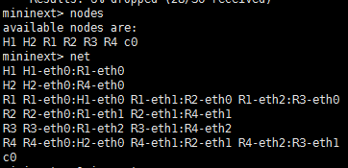

“H1 ping H2” and “H2 ping H1”

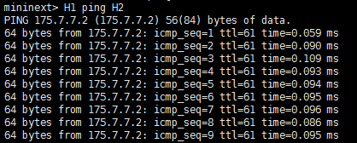

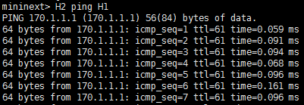

Routing table screenshot: (in ***partA2.sh*** file)

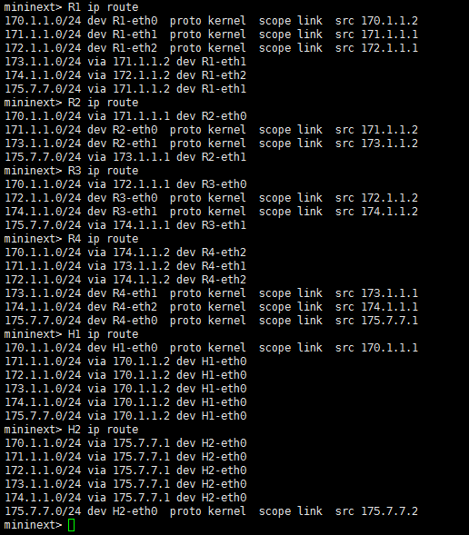

1. H1 traceroute H2:

