**Effects of Mining**

Since the advent of civilization, people have relied upon mining for the extraction of ceramics, stones and metals found on the surface of our planet. ­Even though mining has played a vital role in the development of our civilization it however has adversely affected our environment.

Although mining has adversely impacted several aspects of our environment however its impact on quality of water is perhaps the most significant.

One of the primary ways mining affects the availability and quality of water is acid mine drainage. When metals such as copper, gold, silver as well as molybdenum are mined they are often found in rocks that contain considerable amounts of sulfide minerals. When these sulfides present in the rocks are excavated and when they get exposed to air as well as water they react to produce sulfuric acid. Similarly another area of concern is the erosion of soils and mine wastes into the surface waters. According to a study commissioned by the European Union mining operations disturb large areas of land that results in the exposure of earthen materials and thus the erosion causes a serious concern especially at hard-rock mining sites. The consequent erosion may result in significant loading of sediments along with other chemical pollutants in the water-bodies nearby especially during severe rainfall and storms. Another mining phenomenon that impacts water quality is mine dewatering. This is the process whereby an open pit intersects the water table the groundwater ends up flowing into the open pit. Therefore in order for mining to proceed, mining companies need to pump and then discharge this water to some other location. This pumping and consequent discharging of mine water results in a significantly impacts the environment.

In addition to the water contamination mining also adversely impacts the quality of air. Emissions occur during all the stages of the mining cycle. However the impact is more dominant during the exploration, construction as well as the development stage. The various operations involved in mining result in the mobilization of significant amounts of waste materials that contain particles that can be easily dispersed by the wind. The sources of air pollution during mining activities include matter particles being transported by the wind as a consequent of blasting, excavations, wind erosion as well as waste dumps. Similarly the various gas emissions resulting from the combustion of fuel, explosions, and mineral processing also adversely affect the quality of air. As these pollutants contaminate our atmosphere they experience physical as well as chemical changes as shown in the figure below. These pollutants can therefore adversely affect our environment and consequently result in health problems for humans.

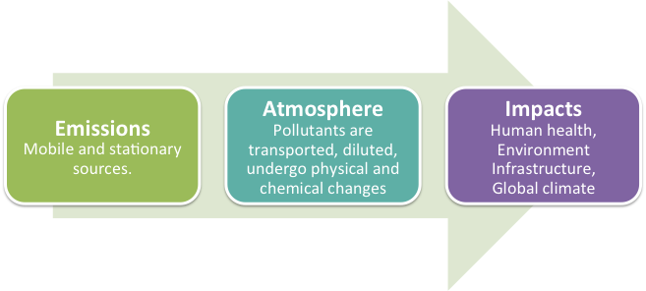

Another serious consequence of mining is the release of mercury in to our atmosphere, which is extremely harmful to the life on our planet. During the excavation of gold, the ores that contain the gold are crushed and then heated in roasters. The mercury existent in these ores is vaporized by this process and released into our planet’s atmosphere. In fact the largest source of mercury emission is the process of roasting gold ores collected through mining.

Similarly, mining activities also significantly contaminate the soil. This drastically impacts agricultural activities close to a mining site. According to a study commissioned by the European Union there are two major risks associated with soil contamination due to mining. Firstly the contaminated soil could be windblown and adversely affect large regions. Secondly the soil may be contaminated by chemical spills and may result in several environmental problems at some mines.

Another environmental concern is the noise pollution caused by mining. During mining activities several vehicle engines are used for loading and unloading of debris, chutes are setup, several explosions may be carried out to provide the miners a path, power-generation is also used in remote mining sites. All of these contribute towards the noise pollution and may very well affect the nearby communities as well as wildlife.

The environmental and health risks associate with mining are usually understated. The hazardous substances released into the water and our atmosphere seriously impact public health. According to the World Health Organization (WHO) mining especially in the developing countries involved in excavation projects for natural resources have several associated adverse long-term health related consequences not only to the local communities but also the wild life.

Reference:

Klemow, Kenneth. "Environmental Effects of Mining." Wilkes. Wilkes University, 24 Jan. 2000. Web. 2 July 2014. <http://www.wilkes.edu/pages/2299.asp>.

Winkler, Mirko. "Assessing health impacts in the mining sector in the tropics: advancing tools and methods." WHO. Department of Public Health and Epidemiology, Swiss Tropical Institute, n.d. Web. 2 July 2014. <http://www.who.int/hia/examples/mining/whohia199/en/>.

Chernaik, Mark. "Overview of Mining and Its Impacts." Guidebook for Evaluating Mining Project EIAs. Eugene OR: Environmental Law Alliance Worldwide (ELAW), 2010. 1-17. Web. <https://www.elaw.org/files/mining-eia-guidebook/Chapter1.pdf>